Scale-bridging Optimization Framework for Desalination Integrated Produced Water Networks
Sakshi Naikª, Miguel Zamarripa^{b}, Markus Drouven^{c}, Lorenz T. Biegler^{a*}
ªCarnegie Mellon University, Pittsburgh, PA, 15232, USA
^{b}National Energy Technology Laboratory, Pittsburgh, PA, 15236, USA
^{c}NETL Support Contractor, Pittsburgh, PA, 15236, USA
Corresponding Author: lb01@andrew.cmu.edu
Abstract
Produced water (PW) management poses a major challenge to U.S. oil and gas development. Due to freshwater scarcity and PW injection curtailments, desalination may become a necessity in some parts of the country. Integrating rigorous desalination process models within a produced water network for co-optimization of desalination design and network operation can be challenging to scale-up due to computational complexity. In this work we use the trust region filter framework to decompose the integrated optimization problem into an optimization master problem consisting of the network model and simplified surrogates for the desalination units and an optimization sub problem for the rigorous desalination unit model. The approach is demonstrated on a multiperiod produced water network from the PARETO library (Drouven et al., 2022) with thermal desalination units.
Keywords: Optimization, Surrogate Models, Sustainability, Energy.
1. Introduction
Hydraulic fracturing has become crucial to U.S. oil & gas development, and it involves the pumping of large amounts of water and some chemicals into the subsurface to extract oil and natural gas from unconventional reservoirs. Along with oil and gas, brackish water - both injected and natural formation water containing high amounts of total dissolved solids (TDS) surfaces back to the earth as PW which needs to be managed efficiently. Large volumes, disposal constraints, and the high salinity of PW serve as strong incentives for integrating desalination technologies into the produced water infrastructure to introduce desalinated water into the water cycle. Thermal desalination technologies like mechanical vapor recompression (MVR) have shown promise to desalinate high TDS produced water (Onishi et al., 2017). Optimizing desalination design and operation in-sync with PW management can yield significant environmental and economic benefits. A framework for integrating rigorous MVR models into a multi-period produced water network optimization has been developed (Naik et al., 2023). For larger networks and complex desalination units, the direct integration of rigorous models into network optimization can be computationally challenging to solve. It is therefore desirable to use shortcut models or simple data driven surrogates which can emulate the original rigorous desalination model for computational efficiency. The main disadvantage of directly replacing the rigorous model using surrogates/shortcut models is the lack of convergence guarantees to the optimum of the rigorous problem. In this work, we use the trust region filter (TRF) proposed by Yoshio and Biegler (2020) approach to decompose the integrated network optimization problem into a master problem consisting of the network equations along with a reduced order model (ROM) to approximate the desalination outputs and trust region constraints. The ROM is updated in each iteration by solving the rigorous desalination optimization problem maintaining the accuracy of the ROM within the trust region. The TRF approach provides guaranteed convergence to the optimum of the rigorous problem. This work supports the development of PARETO, a DOE-sponsored, free, and open-source optimization tool for onshore PW management (www.project-pareto.org), by integrating detailed desalination models into the existing PW management framework.
2. Trust Region Filter Formulation
Given an optimization problem of the form shown in (a), the trust region problem can be written by substituting the rigorous model $d(w)$ with a simplified corrected surrogate model $r_{k}\left(w\right)$ and a trust region constraint on the degrees of freedom $u$, shown in (b).
a) Optimization problem b) Trust region problem (TRP)
$\min_{x}{f(x)}$ $\min_{x}{f(x)}$
s.t. $h\left(x\right)=0$ s.t. $h\left(x\right)=0$
$g\left(x\right)≤0$ $g\left(x\right)≤0$
$y=d(w)$ $y= r_{k}\left(w\right)$
$\left|u-u_{k}\right|≤ ∆_{k}$
The corrected surrogate model in each iteration is given by:
$$r_{k}\left(w\right)= \hat{r}\left(w\right)+\left(d\left(w_{k}\right)- \hat{r}\left(w_{k}\right)\right) + \left(∇d\left(w_{k}\right) - ∇\hat{r}\left(w_{k}\right)\right)\left(w -w_{k}\right)$$
where $\hat{r}\left(w\right)$ is the surrogate model without any correction for inputs $w$, $d\left(w_{k}\right)- \hat{r}\left(w_{k}\right)$ is the zero order correction and $(∇d\left(w_{k}\right) - ∇\hat{r}\left(w_{k}\right))(w -w_{k})$ is the first order correction. At $w=w_{k}$ the corrected surrogate is exact i.e., $r_{k}\left(w_{k}\right)= d(w_{k})$ and $∇r_{k}\left(w_{k}\right)= ∇d\left(w_{k}\right)$. Hence, any choice of $\hat{r}\left(w\right)$ converges to the optimum of the original problem. The zero and first order corrections are obtained by solving the rigorous model at fixed inputs $w_{k}$. The trust region constraint bounds the degrees of freedom $u$ of the master problem to stay in the trust region $∆_{k}$. The TRF algorithm is given in Figure 1.
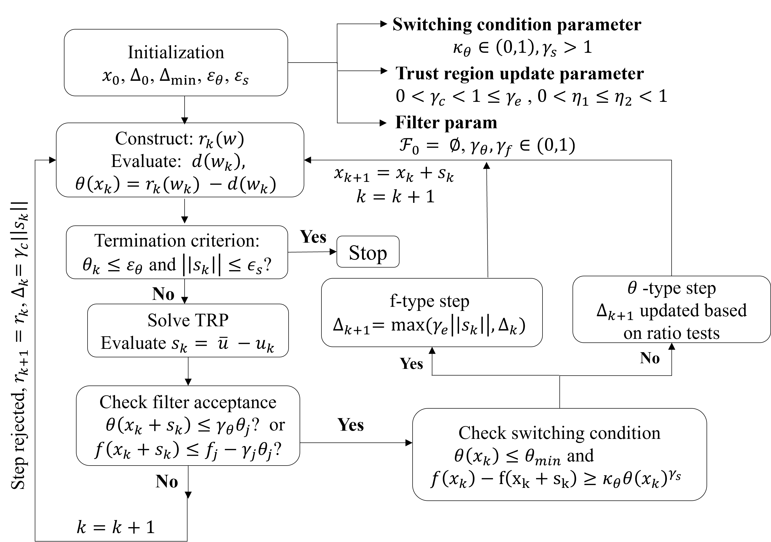
Figure 1. Trust region filter algorithm
An integrated model formulation for optimization of produced water networks with the rigorous desalination models embedded at desalination sites has been developed in Naik et al. (2023). For completeness the integrated formulation is given below:
Linking inlet (flows, concentrations) and outlets (water recovery fractions) from the network model desalination sites to rigorous MVR models
Sum of network costs and MVR CAPEX and OPEX
$$\min{C_{net}+\sum_{n∈N^{T,In}}{\sum_{t∈T}{\left({CAPEX}_{Δt}^{n}+{\overline{OPEX}}_{Δt}^{nt}\right)Δt}}}$$
s.t ${ F}_{nt}^{in}= {\overline{F}}_{nt}^{in} ∀n∈N^{T, In }, t∈T$
$C_{nt}^{in}= {\overline{C}}_{nt}^{in} ∀n∈N^{T, In }, t∈T$
$α_{nt}= {\overline{α}}_{nt} ∀n∈N^{T, In}, t∈T$
${CAPEX}_{n}^{\left(i\right)g,ev}≥{\overline{CAPEX}}_{nt}^{\left(i\right)ev} ∀i∈I,n∈N^{T, In }, t∈T$
Global capacity constraints on CAPEX in every period.
${ CAPEX}_{n}^{g,ph}≥ {\overline{CAPEX}}_{nt}^{ph} ∀n∈N^{T, In }, t∈T$
$${CAPEX}_{n}^{g,comp}≥ {\overline{CAPEX}}_{nt}^{comp} ∀n∈N^{T, In },t∈T$$
${CAPEX}_{Δt}^{n}= {\sum_{i∈I}{CAPEX}}_{n}^{\left(i\right)g,ev}+ {CAPEX}_{n}^{g,ph}+{ CAPEX}_{n}^{g,comp} ∀n∈N^{T, In }$
Network mass balances with concentration tracking
Rigorous steady state MVR models in each period
The variables with an overbar represent the ones from the rigorous desalination models. A detailed description of the variables is given in Table 1. The objective is to minimize the MVR capital cost (from evaporator, compressor, and preheater) and operating cost (from electricity consumption in compressor) along with network cost consisting of transportation, storage, disposal and credits for desalination and removal of water from storage. The flows and concentrations of produced water into the desalination nodes in the network model are linked to the inlet flows and concentrations of the rigorous steady state MVR models in each period. The water recovery fraction from the rigorous desalination models is linked with the water recovery fraction from the desalination site in the network model. To ensure that the built desalination unit has feasible operation in every period of the planning horizon, global capacity constraints are written for the capital cost of evaporators, compressor, and preheater in the MVR model. The TRF master problem in iteration $k$ can be written as:
$$\min{C_{net}+\sum_{n∈N^{T,In}}{\sum_{t∈T}{\left({CAPEX}_{Δt}^{n}+{OPEX}_{Δt}^{nt}\right)Δt}}}$$
s.t $w_{nt}=[F_{nt}^{in}, C_{nt}^{in} ]$ $∀n∈N^{T, In }, t∈T$ Input variables
${α_{nt}= y}_{nt}^{α}=r_{k}^{α}\left(w_{nt}\right) ∀n∈N^{T, In }, t∈T$
$OPEX_{Δt}^{nt}= y_{nt}^{Opex}=r_{k}^{Opex}\left(w_{nt}\right) ∀n∈N^{T, In }, t∈T$
$$y_{nt}^{\left(i\right)C_{ev}}= r_{k}^{\left(i\right)C_{ev}}\left(w_{nt}\right) ∀i∈I,n∈N^{T, In } t∈T$$
$y_{nt}^{C_{ph}}= r_{k}^{C_{ph}}\left(w_{nt}\right) ∀n∈N^{T, In }, t∈T$ Surrogate constraints
$$y_{nt}^{C_{comp}}= r_{k}^{C_{comp}}\left(w_{nt}\right) ∀n∈N^{T, In }, t∈T$$
${CAPEX}_{n}^{\left(i\right)g,ev}≥y_{nt}^{C_{ev}} ∀i∈I,n∈N^{T, In } , t∈T$
${ CAPEX}_{n}^{g,ph}≥ y_{nt}^{C_{ph}} ∀n∈N^{T, In }, t∈T$ Global capacity constraints
$${ CAPEX}_{n}^{g,comp}≥ y_{nt}^{C_{comp}} ∀n∈N^{T, In },t∈T$$
${CAPEX}_{Δt}^{n}={\sum_{i∈I}{CAPEX}}_{n}^{\left(i\right)g,ev}+{CAPEX}_{n}^{g,ph}+{CAPEX}_{n}^{g,comp} ∀n∈N^{T, In }$
$\left|\left|u-u_{k}\right|\right|≤Δ_{k}$ Trust region constraint
Network mass balances with concentration tracking
The degrees of freedom $u$ in the master problem, such as flowrates at the splitter nodes, inventory levels in storage units, fresh water sourced in each period, produced water sent to disposal, and water recovery fractions from the desalination units are bounded to stay within the trust region $Δ_{k}$ by the trust region constraint. A linear ROM given by: $\hat{r}\left(w_{nt}\right)= 0.01w_{nt}^{(1)}+0.001w_{nt}^{(2)}$ is used in the master problem to ensure that the outputs are scaled; the master problem only has bilinear terms and hence is a quadratically constrained program (QCP). The surrogate models are updated from the optimal solution of the rigorous MVR unit subproblems at desalination site$n$ at period $t$, with fixed inputs $w_{nt}^{*}$ obtained from the optimal solution of the master problem. The MVR subproblem is given by:
$$\min{{\overline{CAPEX}}_{Δt}^{n}+{\overline{OPEX}}_{Δt}^{nt} }$$
s.t. ${\overline{F}}_{nt}^{in}=w_{nt}^{*(1)}$
${\overline{C}}_{nt}^{in}=w_{nt}^{*(2)}$
${\overline{CAPEX}}_{Δt}^{n}= {\sum_{i∈I}{\overline{CAPEX}}}_{n}^{\left(i\right)ev}+ {\overline{CAPEX}}_{n}^{ph}+{\overline{CAPEX}}_{n}^{comp}$
Rigorous steady state MVR model in period t at desalination site n
Table 1. Descriptions of sets and variables
Sets |  | Variables
$$N^{T, In }$$ | Desalination inlet node in the network | $${CAPEX}_{n}^{\left(i\right)g,ev}$$ | Global CAPEX for evaporator stage (i) at node n
$$T$$ | Time periods | $${CAPEX}_{n}^{g,ph}$$ | Global CAPEX for preheater at node n
$$I$$ | Evaporator stages in the MVR unit | $${CAPEX}_{n}^{g,comp}$$ | Global CAPEX for compressor at node n
Variables |  | $$F_{nt}^{in}$$ | Inlet flow to MVR unit at node n at time t
$$C_{net}$$ | Sum of network costs (kUSD) | $$C_{nt}^{in}$$ | Inlet concentration to MVR unit at node n at time t
$${CAPEX}_{Δt}^{n}$$ | Capital cost (kUSD/$∆t$) of MVR unit at node n | $$α_{nt}$$ | Water recovery fraction from node n at time t
$${OPEX}_{Δt}^{nt}$$ | Operating cost (kUSD/$∆t$) of MVR unit at node n at time t | $$w_{nt}$$ | Inputs to the MVR subproblem at node n at time t
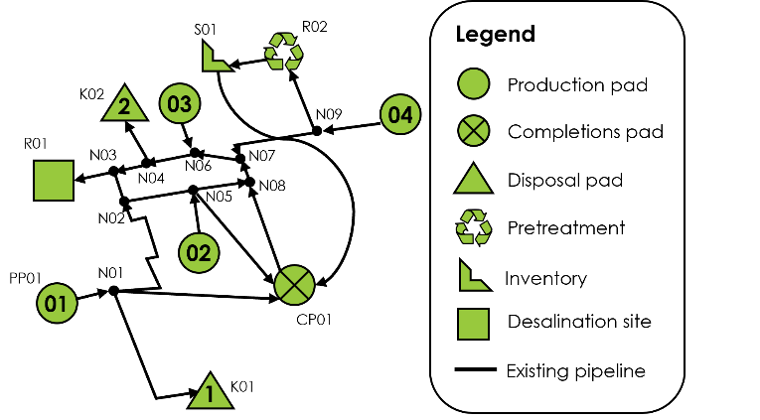
3. Case study
Figure 2. Produced water network case study
In this section we demonstrate the TRF approach on a case study from the PARETO network library (Drouven et al., 2022). The planning horizon is 52 weeks, with one week time periods. The test network consists of four production pads producing water, two disposal sites, two fresh water sources, a single storage site, and a prospective desalination site as shown in Figure 2. The network also has one completion pad with a water demand between weeks 1 to 12 and weeks 45 and 52 and in the remaining time there is completion flowback which means there is no demand for water in the network. At desalination site R01, a single stage MVR unit is installed. The TRF master problem has 4,477 variables and 3,624 constraints and the sub problems in each period have 51 variables and 49 equality constraints. The case study is relatively simple and can be solved using both the TRF formulation and the integrated formulation to validate the results. The models are developed in Pyomo (Hart et al., 2011), solved using the open source NLP solver IPOPT (Wächter and Biegler, 2004) and the Pyomo TRF package is used to implement the TRF approach.
The TRF method converges in 3 iterations and the optimal flow profiles are shown in Figure 3. The optimal desalination unit built has an evaporator with area $372 m^{2}$, a preheater with area $73.8 m^{2}$ and a 2,750 Hp compressor. The optimal solution obtained by using the TRF method matches closely with the optimal solution from the integrated model as shown in Table 2. The overall solution time for the TRF method is about 40% more than the integrated formulation. However, the sensitivity calculation and output computation from the rigorous models can be parallelized for each period. We estimate that this would reduce the overall TRF solution time by a factor of two.
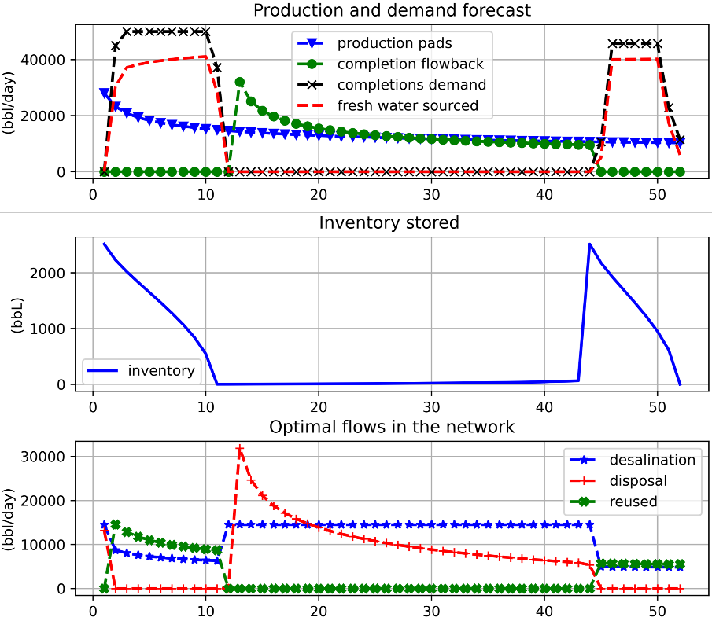
Figure 3. Optimal solution obtained by the TRF method.
Table 2. Optimal costs obtained by the TRF approach and the integrated approach.
Solution approach → | TRF formulation  (kUSD) | Integrated formulation  (kUSD)
Costs ↓
Objective value | 9,884.5 | 9,884.46
Piping cost | 370.05 | 370.04
Disposal | 917.56 | 917.56
Storage | 6.58 | 6.57
Fresh water sourcing | 12,684 | 12,684
Desalination CAPEX | 405.93 | 405.93
Desalination OPEX | 2,144.37 | 2,144.37
Storage credit | 0.50 | 0.50
Desalination credit | 6,643.51 | 6,643.53

Table 3. Computational times
Method | Total time
Integrated formulation | 111 s
TRF formulation | 101 s – Sensitivity calculation ($∇d(w_{k})$)  158 s 12.5 s – Output calculation ($d(w_{k})$)  44.8 s – Other
4. Conclusions and Future Work
The TRF approach is applied to co-optimize rigorous desalination unit design and produced water network operation. The TRF method decomposes the integrated problem into a computationally efficient QCP and smaller NLP subproblems without loss of solution accuracy. The approach provides a scalable framework to integrate rigorous desalination units into larger network case studies. The decomposition also allows for an extension of the network formulation to a mixed integer QCP (MIQCP) to make discrete strategic decisions such as capacity expansion, building additional pipelines, etc. while solving desalination design optimization as NLP subproblems. Future work involves parallelization of the sub-problem optimization in each period to decrease the time taken to compute outputs and sensitivities from the rigorous models in each period.
Acknowledgements
We gratefully acknowledge support from the U.S. Department of Energy, Office of Fossil Energy and Carbon Management, through the Environmentally Prudent Stewardship Program.
Disclaimer: This project was funded by the Department of Energy, National Energy Technology Laboratory an agency of the United States Government, through a support contract. Neither the United States Government nor any agency thereof, nor any of their employees, nor the support contractor, nor any of their employees, makes any warranty, express or implied, or assumes any legal liability or responsibility for the accuracy, completeness, or usefulness of any information, apparatus, product, or process disclosed, or represents that its use would not infringe privately owned rights. Reference herein to any specific commercial product, process, or service by trade name, trademark, manufacturer, or otherwise does not necessarily constitute or imply its endorsement, recommendation, or favoring by the United States Government or any agency thereof. The views and opinions of authors expressed herein do not necessarily state or reflect those of the United States Government or any agency thereof.
References
A. Wächter, L.T. Biegler, 2004, On the implementation of an interior-point filter line-search algorithm for large-scale nonlinear programming, Math. Programming, vol 106, pp. 25-57
M. Drouven, A. Caldéron, M. Zamarripa, K. Beattie 2022, PARETO: An open-source produced water optimization framework, Optimization and Engineering, vol 24. pp. 2229-2249
N. Yoshio, L. T. Biegler, 2020, Demand-based optimization of chlorobenzene process with high-fidelity & surrogate reactor models under trust region strategies, AIChE J., vol 67, e17054
S. Naik, M. Zamarripa, M. Drouven, L.T. Biegler, 2023, Integrating the design of desalination technologies into produced water network optimization, Systems & Control Transactions (Accepted - FOCAPD 2024)
V. Onishi, A. C. Parreño, J. R. Labarta, R. R. Femenia, R. S. Díaz, E. Fraga 2017, Shale gas flowback water desalination: Single vs multiple-effect evaporation with vapor recompression cycle and thermal integration, Desalination, vol. 404, pp. 230–248.
W. Hart, J. P. Watson, and D. Woodruff 2011, Pyomo: modeling and solving mathematical programs in Python, Mathematical Programming Computation, vol.3, no. 3, pp. 219-260.

