Modelling and optimization of ikaite precipitation for CO₂ removal based on ocean alkalinity enhancement
Xuesong Lu, Pranav Thoutam, Aidong Yang
Department of Engineering Science, University of Oxford
{xuesong.lu, Pranav.thoutam, aidong.yang)@eng.ox.ac.uk
Abstract
In this study, numerical modelling that couples mass transfer and reaction kinetics has been performed on a process designed for ikaite production involving dissolution of calcite and the subsequent controlled precipitation to favour ikaite selective crystallization. Multiple configurations regarding supply of calcite particles and agitation were considered to evaluate energy consumption. Through simulation in COMSOL, the results identified the importance of dissolution and crystallisation over degassing, and the significant influence of calcite particle size and agitation speed on total energy demand, which are to be focused on in the subsequent experimental studies.
Keywords: dissolution, crystallization, ikaite, energy efficiency
  - Introduction
In order to reach the goals of the Paris agreement, it has been considered necessary to remove CO₂ from the atmosphere along with significant reduction of emissions. Oceans have been acting as the natural sink for CO₂. To enhance this process as a way to actively remove CO₂ from the atmosphere, it has been proposed to dissolve suitable minerals in seawater to increase alkalinity, which promotes the dissolution of atmospheric CO₂ to form bicarbonates. Especially, calcite (CaCO₃) as a relatively fast dissolving mineral has been suggested for this purpose, which however has already supersaturated the ocean surface, making it impossible to draw down CO₂ from air through its dissolution.
To address this issue, the use of other minerals has been proposed, including particularly hydrated CaCO₃ minerals such as ikaite, which can overcome the limitation of calcite and dissolve in seawater naturally, hence fulfilling the purpose of CO₂ removal (Renforth & Henderson, 2017). However, the natural occurrence of ikaite is extremely low, which means that it needs to be manufactured artificially for use in ocean alkalinity enhancement. To understand the feasibility and cost of ikaite manufacturing, the current work extends an earlier study (Renforth et al., 2022) through process modelling, particularly aiming at quantifying energy consumption of a potentially feasible process.
  - Process configuration and modelling
A COMSOL model consisting of a dissolution reactor, a degasser and a crystallizer was developed to create the ikaite production process (Figure 1), following the configuration and process conditions with constant temperature at 276.15K throughout the system while the dissolution reactor, degasser and crystallizer were maintained at 2, 0.5 and 0.02 bar pressure respectively as proposed by Renforth et al. (2022).
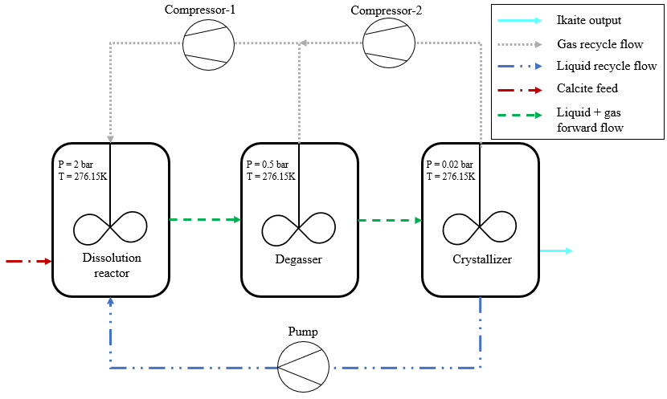
Figure 1. Ikaite production process configuration (Renforth, et al., 2022)
All the three reactors were modelled as stirred tanks, operating in a batch mode. The dissolution reactor was fed with (recycled) CO₂ gas and calcite solid particles to dissolve the latter in water. The dissolution product solution entered the degasser tank where the total dissolved carbon (TDC, including CO₂-aqueous, HCO₃⁻, CO₃²⁻) was partially removed from the solution, with the remaining solution entering the crystallizer. In this final reactor, TDC was further removed due to the pressure difference, and seeded crystallization of ikaite occurs. The evolved CO₂ gas flows from the degasser and the crystallizer were recycled through two compressors back to the dissolution reactor which also received the depleted solution from the crystallizer through a pump.
To model these reactors, calcite particle dissolution was simulated using the particle shrinking model. The chemical reactions depicting calcite dissolution and the aqueous phase reactions were considered following the studies of Plumber and Busenberg (1982) and Cents et al (2005) respectively. The gas-liquid mass transfer followed the same approach in Xing et al (2023). Precipitation of ikaite was modelled using the empirical kinetic equation proposed by Papadimitriou et al. (2014), while the supersaturation and the precipitation constants were calculated according to Strohm et al. (2022). The secondary nucleation and growth equations were utilized in the quadrature method of moments (QMOM) equations (Wei, et al., 2001) to simulate the ikaite precipitation in COMSOL.
  - Energy Calculations and Simulation Cases
The current study explores the direction of optimization guided by the minimization of energy consumption per unit mass production of ikaite. To calculate energy consumption, the following operations have been considered:
- Compressors for the recycling CO₂ gas flows
- Pumping for water recycle
- Agitation in the stirred tanks
- Grinding for preparing calcite particles
Grinding energy was calculated from the method given by Xing et al (2022), while the energy consumption of the other processes was calculated using standard methods.

Through preliminary simulation tests, it became clear that the degassing process was significantly faster than the other two processes which was therefore excluded in the analysis. The duration of dissolution was potentially affected by both gas-liquid mass transfer and the surface dissolution kinetics. Therefore, its stirring speed (affecting mass transfer) and feed calcite particle diameter (affecting area available for surface dissolution) were chosen as key parameters for analysis. Besides, the stirring speed in the crystallizer, which affects the evolution of CO₂ gas through gas-liquid mass transfer, was also chosen to assess its effect. Table 1 shows all the cases comprising combinations of different settings of these parameters.
Table 1. The configurations considered for the energy modulations.
Case no | Stirring speed in dissolution reactor (RPM) | Stirring speed in the crystallizer (RPM) | Particle diameter (µm)
Case1 | 60 | 100 | 10
Case2 | 30 | 30 | 60
Case3 | 60 | 30 | 60
Case4 | 30 | 100 | 60
Case5 | 60 | 100 | 60
Case6 | 100 | 30 | 60
Case7 | 100 | 100 | 60
Case8 | 30 | 60 | 60
Case9 | 60 | 60 | 60
Case10 | 60 | 100 | 180
  - Results and Discussion
Figure 2 shows the key simulation results of the base case. One can see significant CO₂ dissolution (in the dissolution reactor) and evolution (in the crystalliser) within a very short period of operation, followed by more gradual increase or decrease in TDC caused mainly by the dissolution or crystallisation. In contrast, the concentration of calcium ions changed more evenly. In term of the batch duration, dissolution appeared to consume much longer time than crystallisation. On energy consumption, Table 2 shows the results of the base case.

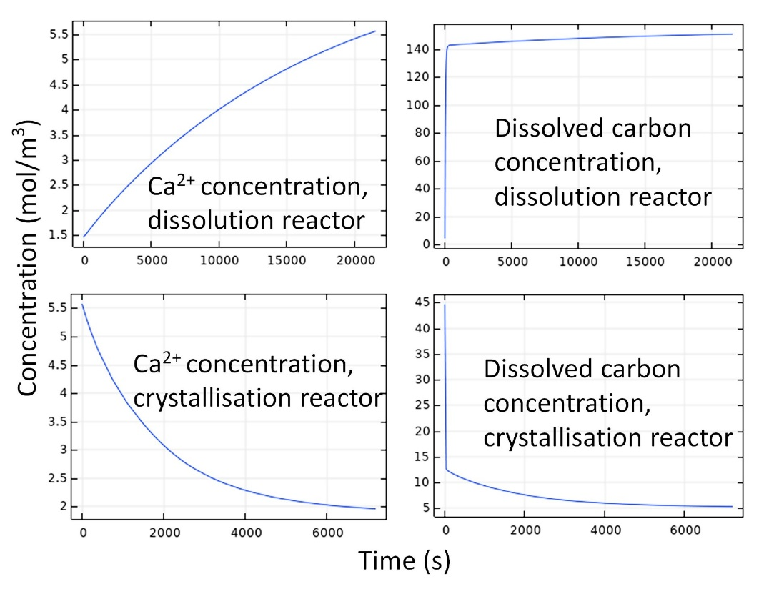
Figure 2. Simulation results of the base case (case 5).
Table 2. Energy consumption during various operations of the base case per kg ikaite.
Operation | Energy Consumption (kJ/kg ikaite)
Compressor1 | 5.92E1
Compressor2 | 8.52E2
Agitation in dissolution reactor | 5.93E2
Agitation in crystallization | 4.05E3
Water pumping | 3.62E2
Grinding | 3.86E1
Total | 5.96E3
The overall energy consumption per one cycle of ikaite production was calculated to be 5.96E3 kJ/kg of ikaite production. Amongst all the operations, agitation was observed to have contributed the highest to the energy consumption followed by compressions.

Figure 3 summarised the energy consumption results of all the simulation cases. It can be seen that the particle diameter has profound influence. Smaller particles, although consuming more grinding energy, lead to a shorter dissolution time and hence lower energy consumption for agitation. A higher stirring speed always leads to the increase in the power required for agitation (while with limited impact on the dissolution rate, not shown) and hence higher energy consumption.

Figure 3. Specific energy consumption by cases listed in Table 1.
Amongst all the cases considered, Case 7, with 100rpm dissolution and crystallizer stirring speeds with 60µm feed particle size was observed to have consumed highest amount of energy with a total of 8.83E3 kJ/kg of ikaite. The minimum energy consumption was observed for the case 2 with 30rpm each with 60µm feed particle size with 1.60E3 kJ/kg of ikaite.
  - Conclusion
This COMSOL based modelling of ikaite precipitation predicted the feasibility of the production of ikaite and identified key parameters for future optimisation in order to reduce energy consumption. More specifically, we observed that the lower stirring speeds would be preferrable, and that using more energy to produce particles at smaller sizes would lead to the reduction of the overall energy demand.
References
Bischoff, J., Fitzpatrick, J. & Rosenbauer, R., 1993. The Journal of Geology, 101(1), pp. 21-33.
Caderbank, P., 1958. Chemical Engineering Research and Design, Volume 36, p. 443.
Caldeira, K. & Rau, G., 2000. Geophysical Research Letters, 27(2), pp. 225-228.
Cents, A., Brilman, D. & Versteeg, G., 2005. Chemical Engineering Science, 60(21), pp. 5830-5835.
Dvorak, B. et al., 1996. Environmental science & technology, 30(3), pp. 945-953..
Edwards, T., Maurer, G., Newman, J. & Prausnitz, J., 1978. AIChE Journal, 24(6), pp. 966-976.
Hughmark, G., 1980. Industrial & Engineering Chemistry Process Design and Development, 19(4), pp. 638-641.
Hu, Y. et al., 2014. Marine Chemistry, Volume 162, pp. 10-18.
Onda, K., Takeuchi, H. & Okumoto, Y., 1968. Journal of chemical engineering of Japan, 1(1), pp. 56-62.
Papadimitriou, S., Kennedy, H., Kennedy, P. & Thomas, D., 2013. Geochimica et Cosmochimica Acta, Volume 109, pp. 241-253.
Papadimitriou, S., Kennedy, H., Kennedy, P. & Thomas, D., 2014. Geochimica et Cosmochimica Acta, Volume 140, pp. 199-211.
Plummer, L. & Busenberg, E., 1982. Geochimica et cosmochimica acta, 46(6), pp. 1011-1040..
Pokrovsky, O., Golubev, S. & Schott, J., 2005. Chemical geology, , 217(3-4), pp. 239-255.
Renforth, P. et al., 2022. Joule, 6(12), pp. 2674-2679.
Renforth, P. & Henderson, G., 2017. Reviews of Geophysics, 55(3), pp. 636-674.
Sjoeberg, E. & Rickard, D., 1984 Chemical Geology, 42(1-4), pp. 119-136.
Stockmann, G. et al., 2018. Applied Geochemistry, Volume 89, pp. 11-22.
Strohm, S. et al., 2022. Chemical Geology, Volume 611, p. 121089.
Tollefsen, E. et al., 2018. Mineralogical Magazine, 82(5), pp. 1119-1129.
Wei, H. et al., 2001. Industrial & engineering chemistry research, 40(23), pp.5255-5261.
Xing, L. et al., 2023. Chemical Engineering Journal, Volume 454, p. 139997.
Xing, L. et al., 2022. Chemical Engineering Journal, Volume 431, p. 134096.

