Pore-Scale Models for Soot and Gaseous Pollutant Conversion in Catalytic Particulate Filters
Ondřej Studeník^{a,b}, Marie Placháª, Martin Isoz^{a,b}, Miloš Svoboda^{c}, Petr Kočíª
¹⁾ University of Chemistry and Technology, Prague, Technická 5, Prague, 166 28, Czechia
²⁾ Institute of Thermomechanics, Czech Academy of Sciences, Dolejškova 5, Prague,
182 00, Czechia
³⁾ New Technologies Research Centre, University of West Bohemia, Univerzitní 8, Pilsen 306 14, Czechia
petr.koci@vscht.cz
Abstract
Tightening emission standards necessitate development and optimization of devices for exhaust gas aftertreatment. Catalytic particulate filter is a multifunctional device that can trap particulate matter (soot and ash) and provide catalytic conversion of gaseous pollutants such as CO, hydrocarbons and NO_{x}. In the present work, we focus on pore-scale simulations of (i) influence of soot deposits on catalytic conversion of gaseous pollutants and (ii) oxidation of soot deposits during filter regeneration. Pore-scale simulations are performed within a section of the filter wall, 3D reconstructed from X-ray tomography (XRT) images of porous structure including distribution of catalytic material [1]. CO oxidation is used as test reaction. First, we assume uniform soot layer inside the porous wall structure and evaluate its impact on CO conversion. Several different thicknesses of soot layer are compared. In the second approach, we virtually load the same amount of soot deposits using a mechanistic filtration model [2], which results in non-uniform soot distribution, and evaluate again the impact on CO conversion.
Subsequently, we introduce a soot oxidation model for the filter regeneration. During oxidation of soot deposits, clusters of particles may detach from the wall and freely travel through wall pores. Such a process can be described with a fully coupled CFD-DEM solver [3], capable of simulating arbitrarily shaped solid particles. The mentioned solver is extended with reactive flows to account for particle oxidation and the related changes in its morphology. All the developed models are implemented in the form of custom-built solvers within the OpenFOAM computational framework.

Keywords: catalytic filters, CFD, OpenFOAM, Automotive exhaust gas aftertreatment
  - Introduction
Present trends in emissions standards and environmental policies further encourage the development of new exhaust gas aftertreatment technologies or optimization of the ones presently available. Catalytic particulate filter is a multifunctional device enabling catalytic conversion of gaseous pollutants such as CO, hydrocarbons, and NO_{x} [1]. Furthermore, it removes the particulate matter (soot and ash) from the exhaust [2]. The catalytic filter is designed as a monolithic reactor structured as a cylinder containing parallel channels with alternating plugs at the channel inlet or outlet. Such design forces exhaust gas to flow through the porous channel walls coated with a catalyst. This enables both catalytic conversion of the pollutants and filtration of the particulate matter. Thus, a catalytical filter allows replacing separate catalytic converters and filter by a single device.
Throughout the filtration operation, a layer of particulate matter gradually forms on the wall surface [2]. The soot deposits lead to an increase in filtration efficiency, pressure drop of the filter, and, consequently, a decrease in catalytic activity. The latter phenomenon is due to diffusion limitations presented by soot cake formed on the active sides of the catalyst obstructing the gas flow towards the catalyst's active sides. The filter can be regenerated by oxidation of the soot deposits. In the following text we focus on pore-scale simulations of how soot deposits influence catalytic conversion of gaseous pollutants. We use CO oxidation as test reaction.
  - Methods
The system is resolved with computational fluid dynamics (CFD). To accurately describe the processes occurring within the catalytic filter wall, we need to consider (i) fluid flow through the porous structure of the wall, (ii) diffusion and catalytic reaction of the chemical species present within the passing gas and (iii) enthalpic balance of the given system. Due to the small size of the described wall segment and low concentrations of key reaction component (CO), the system can be considered isothermal. Furthermore, convection, diffusion and reaction processes are simulated in steady state.
    - Fluid flow
The Navier-Stokes equations describe the gas flow in the described segment of porous wall, and due to the properties of the given structure and operating conditions, several simplifications might be applied. First, the fixed temperature and low-pressure difference between the inlet and outlet of the wall enables us to consider constant density of the passing fluid. Second, most of the pores present have a characteristic dimension of units of micrometres, resulting in low Reynolds criteria values, enabling us to consider flow laminar. Thus, the momentum balance Eq. (1) and mass balance Eq. (2) written as follows
 | $$∇∙\left(u ⨂ u\right)-∇∙\left(ν∇u\right)=-∇\tilde{p}+s$$ | (1)
 | $$∇∙u=0,$$ | (2)
 | $$s=\left\{\begin{aligned} 0 in Ω_{p} \\ \frac{μ}{κ_{s}}u in Ω_{s} \\ \frac{μ}{κ_{c}}u in Ω_{c}\end{aligned}\right.,$$ | (3)
where $u$ is fluid flow, $\tilde{p }$ is kinematic pressure ($\tilde{p }=p/ρ$), and $ν$ is kinematic viscosity. The additional source term $s$ is applied to additional flow resistance according to the given area e.g, free pore$Ω_{p}$soot deposits $Ω_{s}$ and catalyst $Ω_{c}$. The term is defined as following piecewise function
where $κ_{s}$ and $κ_{c}$ are local permeabilities according to Darcys law for soot and catalyst, respectively. Permeability is predicted from the Carman-Kozeny equation [4]. Dynamic viscosity $μ$ is evaluated using the Sutherland equation [5].

Component diffusion
With the gas flow description presented above, the next step is a description of the mass transport of the individual species (O₂, N₂, CO and CO₂). Ideal gas behavior is assumed and low concentrations of the key reactant (CO) enable consideration of Ficks' laws for volume diffusion. Transport equation for i-th species is then
 | $$∇⋅\left(uy_{i}\right)-∇⋅\left(D_{i}^{eff}{∇y}_{i}\right)=\frac{s_{i}^{r}}{c_{T}},$$ | (4)
where $y_{i}$ is the molar fraction of the balanced species, $s_{i}^{r}$ is the reaction source term, and $D_{i}^{eff}$ is effective diffusivity. Its value changes according to domain composition, in a similar manner to the momentum source term (3).
 | $$D_{i}^{eff}=\left\{\begin{aligned} { D}_{i}^{Vol} in Ω_{p} \\ \frac{ε_{s}}{τ_{s}\left(1/{{ D}_{i}^{Vol}+1/{D_{i,s}^{Kn}}}\right)} in Ω_{s} \\ \frac{ε_{c}}{τ_{c}\left(1/{{ D}_{i}^{Vol}+1/{D_{i,c}^{Kn}}}\right)} in Ω_{c} ,\end{aligned}\right.$$ | (5)
where ${ D}_{i}^{Vol}$ is volume diffusion coefficient [6] and $D_{i}^{Kn}$ stands for Knudsen diffusion coefficient depending on mean pore size in the given zone. Porosity and tortuosity for the given region are denoted as $ε$ and $τ$, respectively.

Catalytic reaction
With the definition of mass transport and treatment of diffusion limitations described above, the treatment of chemical reaction needs to be addressed. In the present simulation, we consider the test reaction, oxidation of CO to CO₂ at the $Pt/γ$-$Al_{2}O_{3}$ catalyst as written bellow.
 | $$CO+{\frac{1}{2}O}_{2}\underset{→}{}CO_{2}$$ | (6)
The kinetics is described by the steady-state Langmiur-Hinshelwood [7] mechanism for a dual site reaction on the active surface of the catalyst with dominant inhibition by the adsorbed CO:
 | $$r=k\frac{y_{CO}y_{O_{2}}}{{\left(1+K^{inh}y_{CO}\right)}^{2}}$$ | (7)
Here k represents the rate constant for chemical reaction, $K^{inh}$ is the inhibition constant of gas adsorption to the catalyst surface. The temperature dependence given constants is determined by the Arrhenius equation. The rate of chemical reaction is marked as $r$.
The reaction source term $s_{i}^{r}$ is considered only within the catalyst zones
 | $s_{i}^{r}=\left\{\begin{matrix}0 & in Ω_{p},Ω_{s} \\ ν_{i}r & in Ω_{c}\end{matrix}\right.$, | (8)
where $ν_{i}$ is stoichiometric coefficient for given i-th species.
We implemented the models as custom-built solvers in the CFD framework OpenFOAM.

Results
In the presented study, we focus on a segment of the channel wall of a catalytic filter with catalyst located within the porous wall structure. The simulation part of the channel model has dimensions of 566 $×$ 200 $×$ 204 µm³. The computational domain for the given test was prepared directly from digital reconstruction of the XRT scans to stereolithographic description (STL) for both substrate and catalyst. For the generation of the computational mesh, we used snappyHexMesh for the removal of the substrate structure from the domain and prescribe zones with catalyst. Additionally, we used topoSet to prescribe a uniform layer of soot deposits on the free surface, as shown in Figure 1. Both applications are part of the OpenFOAM framework. The presented study is designed to show the combination of the following influences, the thickness of the soot deposit layer (0, 3.3, 6.6, 9.9 µm) channel velocity of the flowing gas (0.05 m/s, 0.1 m/s) and the device temperature (200, 300, 400, 500, 600 °C). Simulations were performed with material and reaction parameters given in Table 1. Composition of the gas entering the wall segment in the simulation was $y_{O_{2}}=0.05$, $y_{CO}=0.00$1, and the remaining portion was nitrogen (inert).

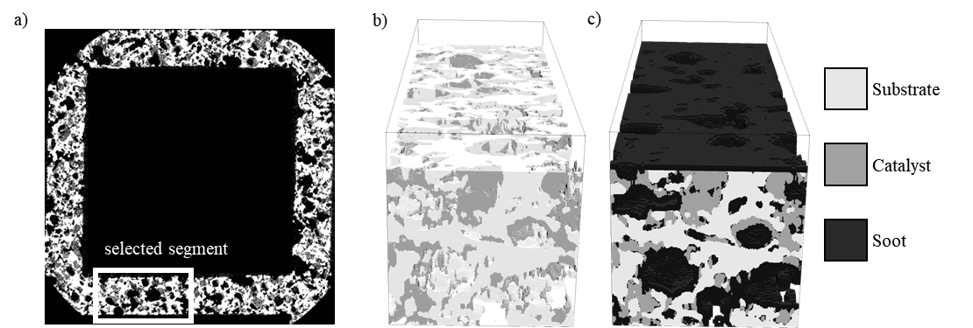
Figure 1. Computational domain: a) slice from the XRT scan of the filter channel with selected segment for the simulation, b) reconstructed STLs for substrate (white) and catalyst (grey), and c) constructed computational domain with added layer of soot deposits (black).

Table 1. Summary of the material and reaction constants applied in the simulations presented (porosity $ε$, tortuosity $τ$, mean pore size ${\overline{d}}_{P},$ preexponential factor $A_{0}$ and activation energy $E_{a}$ from Arrhenius relation for reaction and inhibition [8,9]).
Structural parameters for materials |  |  | Reaction kinetics parameters
Parameter | Catalyst | Soot | Parameter | Value | Unit
$ε$ [-] | $$0.3$$ | $$0.82$$ | $$A_{0}$$ | $$7.84⋅{10}^{16}$$ | mol s⁻¹ m⁻³
$τ$ [-] | $$3.0$$ | $$2.50$$ | $$E_{a}$$ | $$9⋅{10}^{4}$$ | J mol⁻¹
${\overline{d}}_{P}$[m] | $$5.0⋅{10}^{-6}$$ | $$61⋅{10}^{-9}$$ | $$A_{0}^{Inh}$$ | 80 | -
 |  |  | $$E_{}^{Inh}$$ | $${1⋅10}^{3}$$ | K
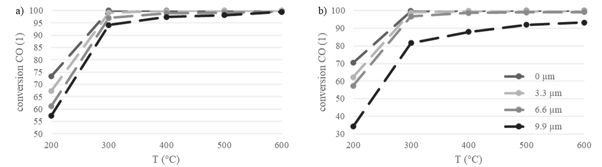
Figure 2. Influence of soot layer thickness on temperature-dependent CO conversion in the simulated segment of the filter wall for superficial gas velocity a) 0.05 m/s, and b) 0.1 m/s.

The results in Figure 2 show an influence of the thickness of the deposited soot layer on the outlet conversion of CO as a function of temperature. For all the tested configurations, the conversion at 200°C is limited by the slow reaction kinetics. The conversion increases readily with temperature and the results suggest complete CO conversion already at 300°C in the case of a clean filter (soot layer thickness 0 µm). The influence of soot deposits is evident – it decreases the CO conversion in all tests by imposing additional diffusion limitation for the access of reactants to the catalytic sites. The diffusion limitation increases with the soot layer thickness. For the lower gas velocity, we notice that full conversion is finally reached at the highest temperature. With the higher gas flow velocity, a decrease in conversion is more severe and a slip of unreacted CO persists up to the highest temperature with the thickest soot layer.

Conclusion
In this text we presented theoretical background, methods, and simplification applied for simulation of soot influence onto catalytic conversion of gaseous pollutants in a catalytic particulate filter. Further work that will be presented as a part of our contribution at the conference includes non-uniform soot distribution obtained from mechanistic filtration model as well as a pilot study of soot oxidation model involving CFD-DEM approach.

Acknowledgement
The work was financially supported by the Czech Science Foundation (GA22-12227S), by the institutional support RVO:6138899

References
[1] P. Kočí, M. Isoz, M. Plachá, A. Arvajová, M. Václavík, M. Svoboda, E. Price, V. Novák, D. Thompsett, "3D reconstruction and pore-scale modeling of coated catalytic filters for automotive exhaust gas aftertreatment", Catalysis Today 320, 165-174 (2019).
[2] M. Plachá, M. Isoz, P. Kočí, M. Jones, M. Svoboda, D. Eastwood, A. York, "Particle accumulation model in 3D reconstructed wall of a catalytic filter validated with time-resolved X-ray tomography", Fuel 356, 129603 (2024).
[3] M. Isoz, M. Kotouč Šourek, O. Studeník, P. Kočí, "HFDIB solver coupled with discrete element method for simulations of flows laden with arbitrarily-shaped particles", Computers & Fluids 244, 105538 (2022).
[4] M. Kaviany, Principles of Heat Transfer in Porous Media, SpringerVerlag, New York, 1995.
[5] Sutherland, W., LII. The viscosity of gases and molecular force. The London, Edinburgh, and Dublin Philosophical Magazine and Journal of Science, 1893. 36 (223).
[6] Fuller, E.N., P.D. Schettler, and J.C. Giddings, New method for prediction of binary gas-phase diffusion coefficients. Industrial & Engineering Chemistry 58(5) (1966).
[7] Voltz, S.E., et al., Kinetic study of carbon monoxide and propylene oxidation on platinum catalysts. Industrial & Engineering Chemistry Product Research and Development, 12(4). (1973)
[8] Brilhac, J.-F., et al., Experimental and theoretical study of oxygen diffusion within packed beds of carbon black. Carbon. 38(7),(2000)
[9] M. Dudák, V. Novák, P. Kočí, M. Marek, P. Blanco-García, G. Jones, Prediction of diffusivity and conversion of n-decane and CO in coated Pt/γ-Al2O3 catalyst depending on porous layer morphology, Applied Catalysis B: Environmental (2014)

