Electrification in the Petrochemical Industry: Can Flexibility Enable Low-Carbon Utility Systems?
Svenja Bielefeld,^{a*} Miloš Cvetković,^{b} Andrea Ramírez Ramirez ^{c}
ªEngineering Systems and Services Department, Faculty of Technology, Policy and Management, Delft University of Technology, Jaffalaan 5 2628 BX Delft, the Netherlands
^{b}Electrical Sustainable Energy Department, Faculty of Electrical Engineering, Mathematics & Computer Science, Delft University of Technology, Mekelweg 4 2628 CD Delft, the Netherlands
^{c}Department of Chemical Engineering, Faculty of Applied Sciences, Delft University of Technology, Van der Maasweg 9 2629 HZ Delft, the Netherlands
s.e.bielefeld@tudelft.nl
Abstract
Electrifying the utility supply of existing petrochemical processes is a potential measure for CO₂ emission reduction in the chemical industry. With an increasing share of variable renewable energy sources in the electricity grid, electricity price fluctuations will become more frequent. However, most existing petrochemical processes operate continuously and, therefore, require a constant supply of utilities. In this paper, we model an electrified utility system that includes different types of storage units to explore how a constant utility demand could be supplied under fluctuating electricity prices. To achieve this, we model a utility system that provides electricity and heat to an olefins plant in the Port of Rotterdam and use mathematical optimisation to capture optimal hourly operations of the plant under fluctuating prices. We find that the cost-optimal utility system consists of electric boilers, integrated thermal energy storage, and technologies for storing and using hydrogen produced on-site. With data for prices of the Dutch electricity grid in 2022, the electrified utility system results in higher costs than a fossil-based system. Increasing price fluctuation levels would lead to lower operational costs as the system's flexibility enables shifting the electricity consumption to the hours with the lowest electricity prices.

Keywords: Electrification, utility system, flexibility, olefins, optimisation
  - Introduction
Climate change and increasing regulation of greenhouse gas (GHG) emissions drive the need for speeding up emission reduction efforts in the chemical industry. The production of olefins like ethylene, propylene, and butadiene from fossil feedstock via steam cracking is currently the most energy-intensive process in the chemical industry (Layritz et al., 2021). Ethylene is a base chemical and building block in about 60 % of global polymer production (Layritz et al., 2021), leading to a demand of 177 million tons in 2022 (Statista, 2023). This demand is expected to continue growing in the coming years in line with the expected growth of the demand for plastics (Layritz et al., 2021). Therefore, emission reduction in ethylene production would have a large impact on the overall emissions of the chemical industry. A promising option is decarbonising the utility supply of olefin plants through electrification as the carbon emission intensity of the electricity grid is decreasing due to a rising share of renewable energy sources (RES) in the electricity generation mix. However, a rising share of renewables is also causing larger electricity price fluctuations due to the intermittent nature of RES, which makes balancing generation and demand more challenging.
CO₂ emission reduction in utility systems of the petrochemical industry has been a research topic for many years. Exergy efficiency enhancement (Luo et al. (2014)), process integration (Han & Lee (2014), Ghiasi et al. (2022)) and Carbon Capture and Storage (CCS) (Han & Lee (2014)) are measures that have been proposed and analysed. Partial fuel switching from fossil sources to renewable energy sources like wind energy, solar power and biomass in combination with thermal energy storage or batteries has also been considered (Qian et al. (2021), Hwangbo et al. (2022), Su et al. (2023)). However, only one study was found that proposed to rely only on electricity and avoid fossil energy use completely. This study (Kim (2022)) considered different possibilities for using heat integration and electrified heating for two chemical processes. The author considered the electrification of the process and utility systems together by using heat pumps, Organic Rankin Cycles, e-heaters and e-furnaces. However, the study assumes steady-state conditions of the electricity supply and focuses on utility systems for (novel) electrified processes and not for existing thermal-based processes. Therefore, it remains unclear what a complete electrification of utility systems of existing fossil-based plants could look like under fluctuating conditions of the electricity supply. It is also unknown whether such a system could be financially viable under current electricity prices and how an increase in price fluctuations impacts the techno-economic performance.
Our study addresses these knowledge gaps by presenting a fully electrified utility system for an existing olefins plant. We explore different types of storage units to cope with electricity price fluctuations. Further, we assess different electricity price curves and present insights into the impact of increasing price fluctuations on the techno-economic performance of fully electrified utility systems.
  - Methods

Our utility system model is connected to the national power grid and has to supply the power and steam demand of an existing olefins plant for each hour of the operational year. To supply the steam demand, the model can choose between an electric boiler (ElB) or a hydrogen boiler (H2B) together with an electrolyser (H2E) that supplies hydrogen on-site. To make the utility system flexible, the model can install different types of storage units: electricity (Bat), thermal energy (TES), and hydrogen storage tanks (H2S). The thermal energy storage is an integrated unit of power-to-heat conversion and sensible heat storage in solid material. Since many combinations of these technologies are possible, mathematical optimisation was used to find the combination with the least investment and operating costs. The model is formulated as an LP to ensure fast solving times. Figure 1 shows the potential configurations of the technologies. The energy demand data (steam, electricity, cooling, chilling) for the olefins plant is taken from an ASPEN Plus model developed in-house. The plant is modelled for a yearly ethylene production capacity of 900 kilotons and mimics the current conditions of an ethylene production plant in the Port of Rotterdam. The optimisation was run for electricity prices of the Dutch Day-Ahead Market in 2022 with a price cap at 0 EUR/MWh for all negative prices.
The objective function is given in Eq. (1) and solved for the operational year of the plant (8000 hours). Capex is the sum over the annualised investment costs of all installed technologies, where $s_{i}$ is the size of technology i, $c_{i}$ the cost per unit capacity of technology i, and ${AF}_{i}$ the annualisation factor of technology I (Eq. (2)).

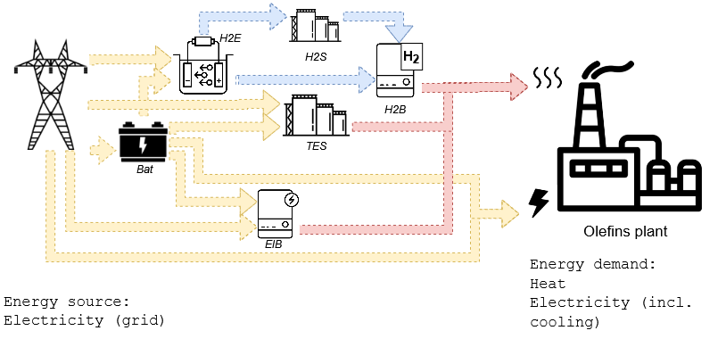
Figure 1. Design options for a fully electrified utility system. Yellow lines indicate potential electricity flows, red lines show potential steam flows and blue lines potential hydrogen flows.
Opex is calculated as the grid consumption at a given moment $P_{gr}\left(t\right)$ of all grid-connected units, multiplied by the cost of electricity at the same moment, $pel,grid\left(t\right)$(Eq. (3)).
$$min \text{Capex}+{\sum_{t=0}^{t=8000}{\text{Opex(t)}}}$$ | (1)
$$\text{Capex}=\sum{s_{i}* c_{i}* {AF}_{i}}$$ | (2)
$$\text{Opex}\left(\text{t}\right)=pel,grid\left(t\right)*\sum{P_{gr}\left(t\right)}* 1h$$ | (3)
The electric boiler, hydrogen boiler and electrolyser are modelled with an equality constraint that determines the energy flow balance (including conversion efficiencies). Their size constrains their maximum energy outflow. The hydrogen storage tank, battery and thermal energy storage are modelled with an equality constraint that describes their state of energy (SoE) as a function of their SoE of the previous time step, the energy inflow, the energy outflow and charge or discharge efficiencies. The maximum SoE is constrained by the size of the unit. Since there are spatial limitations for the utility systems, the sum of the spatial footprint of all units is constrained by the space available in the plant (75 hectares (Wong & Van Dril, 2020)). An equality constraint ensures that the utility system supplies the low-pressure steam and power demand of the olefins plant at every hour of the operational year. Lastly, the total power flow from the grid to the plant is limited to the capacity of the plant’s electricity grid connection. Since the plant requires roughly 400 MW to run, the grid connection capacity is assumed to be 400 MW.
The result of the model is the design of the plant’s utility system comprising the capacities of each technology, as well as the performance in terms of total cost (investment cost and operational cost) and CO₂ emissions (scope 1 and scope 2). Scope 1 emissions are calculated based on the amount of natural gas used and the emission factor of natural gas in the Netherlands. Scope 2 emissions are calculated every hour by multiplying the grid electricity consumption per hour from the grid with its respective emission intensity for the period of the optimisation (i.e., from 01.01.2022 to 01.12.2022). The grid emission intensity data was retrieved from (Electricity Maps, 2023).
The performance of the new system is compared to the performance of a fossil fuel-based utility system, which consists of a 450 MW_{th} combined heat and power plant (CHP) fueled by natural gas and a connection to the national electricity grid. The CHP and the grid connection are assumed to exist already (mimicking the current situation in the Port of Rotterdam), and hence, only operational costs are considered. The operational costs of the fossil-based system are calculated with a scheduling optimisation model, which includes natural gas prices from the Dutch TTF market. All remaining assumptions are the same as in the first model.
To investigate the performance of the CHP and the electrified system in a scenario of higher electricity price fluctuations, we created electricity price curves with higher peaks and lower valleys using Eq. (4), where k determines the increase of the price peaks and valleys. The values applied for k are within a range starting at k = 1.025 and ending at k = 1.2, with a stepwise increase of 0.025. Since price peaks go up to 1000 EUR/MWh for k = 1.2, no higher values were tested. Alike to the original price data (k=1), negative prices were capped at 0 EUR/MWh. The impact of the new price curves on the systems’ performance was found by optimising the operation of the systems under the new price conditions and comparing the resulting costs to those under the original price conditions.
$$pel,grid, new\left(t\right)= pel,grid,old,mean + k \left(pel,grid, old\left(t\right)- pel,grid,old,mean\right)$$ | (4)
  - Results and discussion
Figure 2 shows the energy flows in the electrified system, which relies on 1.25 GWh (integrated) thermal energy storage, 181 MW electric boiler capacity, 22 MW electrolyser capacity, 55.4 GWh of hydrogen storage and 162 MW hydrogen boiler capacity. No batteries are installed. For comparison, Figure 3 shows the energy flows in the fossil-based utility system.
Table 1 presents the costs and CO₂ emissions of the fossil-based and the electrified utility systems. With the price data for 2022, the electrified system is still more expansive than the fossil-based system. Note that the results change when other values for the grid connection capacity (and hence maximum power flow from the grid to the plant) are assumed. The dependency of the costs on the grid connection capacity will be the subject of further research. While scope 1 emissions are reduced to 0, scope 2 emissions remain high due to the CO₂ emission intensity of the Dutch electricity grid in 2022. However, the emission intensity of the electricity supply in the Netherlands is expected to decrease rapidly in the coming years (Rijksoverheid, 2019).

Table 1. Costs and CO₂ emissions of fossil-based and electrified utility system
 | Cost [Million euro] |  |  | CO₂ Emissions [kilotonnes]
 | Capex | Opex | Total | Scope 1 | Scope 2 | Total
Fossil-based system | 0 | 620 | 620 | 723 | 90 | 813
Electrified system | 5 | 654 | 659 | 0 | 776 | 776

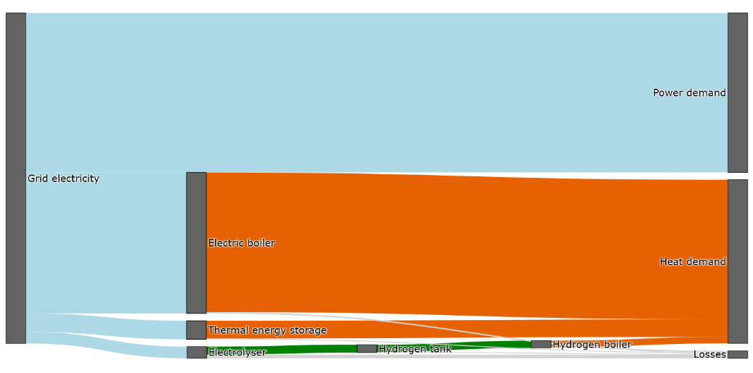
Figure 2. Energy flows in the electrified utility system of the Olefins plant.
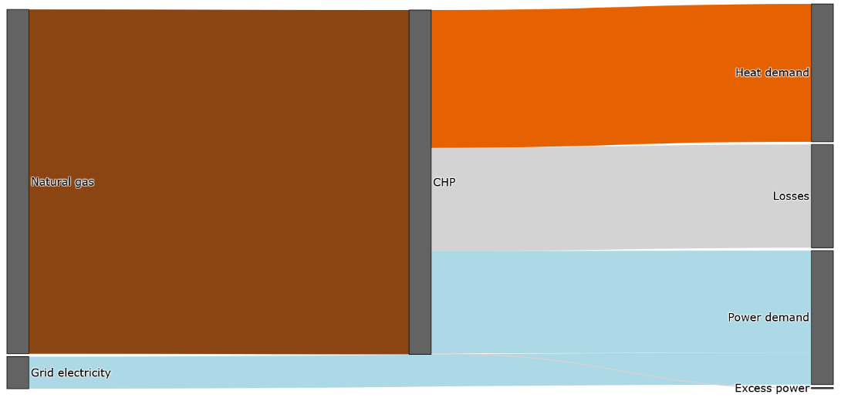
Figure 3. Energy flows in the fossil-based utility system of the Olefins plant.

With increasing price peaks and valleys, the operational cost of the electrified system declines because the system's flexibility allows shifting electricity consumption to hours with lower prices and avoiding hours with higher prices.
Table 2. Operational costs of the electrified system in cases of increased price peaks and valleys
k in Eq. (4) | 1 | 1.025 | 1.05 | 1.075 | 1.1 | 1.125 | 1.15 | 1.175 | 1.2
Opex [Million euro] | 654 | 642 | 641 | 640 | 639 | 638 | 638 | 637 | 636
  - Conclusion
We modelled a fully electrified utility system for an olefins plant with a constant low-pressure steam and electricity demand. The cost-optimal system design includes electric boilers, thermal energy storage, electrolyser capacity, hydrogen tanks and hydrogen boilers. With electricity and natural gas price data for the Netherlands in 2022, the electrified system is 6% more expensive than a fossil-based utility system but reduces scope 1 CO₂ emissions to 0. Increasing electricity price peaks and valleys would reduce operational costs in the electrified system due to its ability to shift electricity consumption to low-price hours.
References
Electricity Maps. (2023, July 1). Data Portal. https://www.electricitymaps.com/data-portal
Ghiasi, M., Manesh, M. H. K., Lari, K., Salehi, G., & Azad, M. T. (2022). A New Algorithm for the Design of Site Utility for Combined Production of Power, Freshwater, and Steam in Process Industries. Journal of Energy Resources Technology, Transactions of the ASME, 144(1). https://doi.org/10.1115/1.4050879
Han, J. H., & Lee, I. B. (2014). A systematic process integration framework for the optimal design and techno-economic performance analysis of energy supply and CO2 mitigation strategies. Applied Energy, 125, 136–146. https://doi.org/10.1016/j.apenergy.2014.03.057
Hwangbo, S., Heo, S. K., & Yoo, C. K. (2022). Development of deterministic-stochastic model to integrate variable renewable energy-driven electricity and large-scale utility networks: Towards decarbonization petrochemical industry. Energy, 238. https://doi.org/10.1016/j.energy.2021.122006
Kim, J.-K. (2022). e-Site Analysis: Process Design of Site Utility Systems With Electrification for Process Industries. Frontiers in Thermal Engineering, 2. https://doi.org/10.3389/fther.2022.861882
Layritz, L. S., Dolganova, I., Finkbeiner, M., Luderer, G., Penteado, A. T., Ueckerdt, F., & Repke, J. U. (2021). The potential of direct steam cracker electrification and carbon capture & utilization via oxidative coupling of methane as decarbonization strategies for ethylene production. Applied Energy, 296. https://doi.org/10.1016/j.apenergy.2021.117049
Luo, X., Hu, J., Zhao, J., Zhang, B., Chen, Y., & Mo, S. (2014). Multi-objective optimization for the design and synthesis of utility systems with emission abatement technology concerns. Applied Energy, 136, 1110–1131. https://doi.org/10.1016/j.apenergy.2014.06.076
Qian, Q., Liu, H., He, C., Shu, Y., Chen, Q. L., & Zhang, B. J. (2021). Sustainable retrofit of petrochemical energy systems under multiple uncertainties using the stochastic optimization method. Computers and Chemical Engineering, 151. https://doi.org/10.1016/j.compchemeng.2021.107374
Statista. (2023). Ethylene demand and production capacity worldwide from 2015 to 2022. https://www.statista.com/statistics/1246694/ethylene-demand-capacity-forecast-worldwide/
Wong, L., & Van Dril, A. W. N. (2020). Decarbonisation options for large volume organic chemicals production, Shell Moerdijk. www.pbl.nl/en.

