Enhanced technosphere-wide life cycle assessment of chemical systems using modified background data
Margarita Athanasia Charalambous,ª Romain Sacchi,^{b} Gonzalo Guillén-Gosálbez^{a,*}
ªInstitute for Chemical and Bioengineering, Department of Chemistry and Applied Biosciences, ETH Zürich, Vladimir-Prelog-Weg 1, 8093 Zürich, Switzerland.
^{b}Laboratory for Energy Systems Analysis, Paul Scherrer Institut, Villigen, Switzerland
gonzalo.guillen.gosalbez@chem.ethz.ch
Abstract
Life cycle assessments of emerging chemical technologies often assume static background data (i.e., secondary supply chain activities connected to the main system under study — foreground activity —), consistent with the current state of the economy. However, the background system within which a process will operate can differ from the one assumed in the environmental database. For example, one may establish a new supply chain with different suppliers or consider future decarbonization and socio-economic trends in the analysis. This work addresses this limitation by adjusting the background data for a more insightful and holistic assessment of the foreground system. We focus on evaluating synthetic diesel fuel in the future, considering projected changes in the technosphere and extending the technological coverage of the background system. To this end, we use inventories from premise, a Python library that provides background data consistent with integrated assessment models and includes additional technologies in the background system to model alternative supply chains with which the main technology (foreground system) could interact with. Our findings reveal that modifying the background data can drastically affect the outcome of the LCA analysis. Overall, this work stresses the importance of jointly defining the foreground and background systems to perform more meaningful and accurate LCAs.
Keywords: prospective life cycle assessment, computational LCA, fuel systems, integrated assessment models
  - Introduction
The power, chemical, and transportation sectors are almost entirely powered by fossil fuels today, contributing to 70 % of global anthropogenic greenhouse gas (GHG) emissions in 2021 (IEA 2023). Consequently, there has been a noticeable shift towards sustainable energy systems and environmentally friendly chemical production. At the core of this transition lies the critical role of environmental assessments, which are essential for guiding policy decisions and experimental work more effectively.
Currently, standard life-cycle assessments (LCAs) retrieve data from life-cycle inventory databases that represent today’s economic structure and assume that such data (background data or upstream supply chain data) will remain the same. Moreover, such assessments rely on static and immutable supply chains in the technosphere (e.g., the same suppliers are considered for all the inputs across the supply chain). However, these data are expected to change following future decarbonization and socio-economic trends. Moreover, future supply chains entailing different technological and regional choices could result in different life cycle impacts.
In recent works, some authors defined background LCA data based on the outcome of Integrated Assessment Models (IAMs) scenarios (Mendoza Beltran, 2018). Specifically, Sacchi et al. (2022), introduced premise, a tool that generates prospective inventory databases by integrating IAM scenarios. This framework enables the creation of library datasets that use future projections for a more accurate assessment of technologies and future supply chains. Prospective environmental assessments can then use these datasets in their background system when assessing emerging technologies (as foreground activities). However, it is important that full integration between the foreground and background data is accomplished, i.e., technologies in the foreground should also be modeled in the markets used in the background to ensure full consistency. In this regard, the LCA framework Brightway2 (Mutel, 2017) offers an excellent platform to implement changes in the background system that would be very hard to model using standard LCA tools. Here, as a representative relevant case, we evaluate transport fuels under modified background data, finding that the results can greatly vary compared to those assuming a fixed background system. Our analysis highlights the advantages of jointly defining the foreground and background systems for more insightful LCAs.
  - Methodology
We assess the future environmental impacts of the diesel fuel market. The functional unit was defined as 1 MJ of fuel. premise is used to create future background data (v.1.5.1), adopting the REMIND (Regional Model of Investment and Development) IAM results consistent with a global atmospheric temperature increase of 1.5 ºC by 2100. The fuel market projected by the IAMs considers fossil, bio-based, and synthetic routes. We increase the technological coverage of synthetic fuel production pathways (i.e., synthetic diesel routes). To this end, we consider four synthetic diesel production pathways where carbon dioxide is captured from the air and hydrogen comes from polymer electrolyte water electrolysis varying the power source (i.e. nuclear, wind, solar, hydro).
Fuel production inventories are modeled with Brightway2 (v.2.4.3). For the diesel scenarios, we assume synthetic Fischer-Tropsch (FT) diesel based on Medrano-García et al. (2022), for carbon dioxide supply, data were retrieved from Keith et al. (2018), and for hydrogen, we follow Bareiß et al. (2019). In this work, we implement the LCA calculations in Python. LCA is performed using the technosphere and biosphere matrix. The technosphere matrix is a square matrix that incorporates all the processes that are present in the economy stored in the columns of the matrix. The rows of the matrix represent the inputs of these processes and are inter-defined in the matrix. Our technosphere matrix incorporates our fuel production inventories, premise inventories, and supply chain projections from IAMs. The biosphere matrix includes all the direct emissions or resources consumption of all the processes present in the technosphere. Matrix modifications and LCA calculations using characterization factors from Brightway2 are performed in Python, using the IPCC 2021 100a as the impact assessment method. Finally, the results are interpreted, and the main conclusions are summarized. As already said, a critical aspect of the analysis is that we vary the background data in a way that is consistent with the foreground system, which we argue is essential particularly when assessing large-scale systems. For example, if one wishes to quantify the impact of e-diesel from captured CO₂ and green H₂ from wind deployed at scale (foreground system), it would be sensible to assume that all the e-diesel in the background would be produced following the same pathway, (or at least deploy such a pathway to some extent) as otherwise, the foreground and background systems would not be consistent with each other, potentially leading to less accurate results.
  - Results and Discussion
Figure 1 shows that global warming impacts of e-diesel, either with premise background or with a background fully consistent with the foreground. In Figure 1a, the impacts of synthetic diesel from DAC/nuclear are displayed, for the two cases, as explained before. Modifying the background system to consider the technology studied (in the foreground) can cause notable differences compared to the standard practice (i.e., using the default future background system as provided by premise). Specifically, a 10% difference is found between using consistent background-foreground systems and the premise background in 2050. This demonstrates the importance of incorporating the assessed foreground activity into the background system, especially in the future, where emerging technologies will occupy larger parts of the market. Therefore, in Figure 1b, we compare the emission trajectories of three different e-diesel pathways (DAC/hydro, DAC/solar, DAC/wind) when employed in the market using a consistent foreground-background system. All scenarios show carbon-negative impacts after 2025, while DAC/solar shows the largest global warming impacts through the years with −40 kg CO_{2eq.} MJ⁻¹ compared to −55 kg CO_{2eq.} MJ⁻¹ of DAC/wind and −78 kg CO_{2eq.} MJ⁻¹ of DAC/hydro in 2030. Overall, DAC/hydro performs the best in 2050 with −85 kg CO_{2eq.} MJ⁻¹.

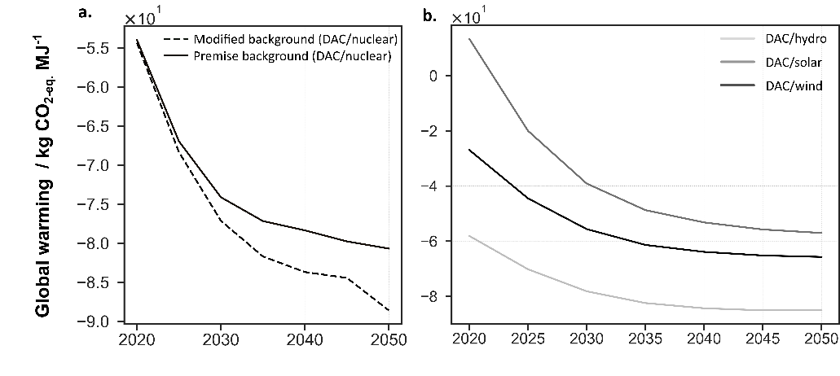
Figure 1: a. Global warming impacts for e-diesel from DAC/nuclear in the diesel market, examining its effects in the foreground and background systems under “Modified background” and “Premise background” scenarios. b. Global warming impacts of three synthetic diesel pathways, (DAC/hydro, DAC/solar, DAC/wind). The trajectories shown here consider a consistent foreground-background system where the diesel market in the background system is modified to consider the synthetic diesel technology assessed in the foreground.
  - Conclusions
In this work, we evaluate the future environmental impacts of synthetic diesel fuel while considering the decarbonization trends outlined by the REMIND IAM, aligning with the Paris Agreement. Additionally, we extend the technological coverage of renewable production pathways considered in the IAM by systematically modifying the technosphere matrix. To our knowledge, this is the first time such fuels are evaluated under future plausible scenarios generated by an IAM with full consistency between the foreground and background data. Notably, we find that the background data can greatly affect the outcome of the analysis, leading in our case study to differences in global warming impact of as much as 10%. Overall, we here stress the importance of adjusting the background data when performing prospective environmental assessments of power and chemical systems.
Acknowledgements
This work was created as part of NCCR Catalysis, a National Center of Competence in Research funded by the Swiss National Science Foundation.
References
IEA, 2023, Energy Technology Perspectives
A. Mendoza Beltran, B. Cox, C. Mutel, DP van Vuuren, D. Font Vivanco, S. Deetman, O.Y. Edelenbosch, J. Guinée, A. Tukker, 2018, When the background matters : using scenarios from integrated assessment models in prospective life cycle assessment, Journal of Industrial Ecology, 24,1, 64-79.
R. Sacchi, T. Terlouw, K. Siala, A. Dirnaichner, C. Bauer, B. Cox, C. Mutel, V. Daioglou, G. Luderer, 2022, Renewable and Sustainable Energy Reviews, 160, 112311.
C. Mutel, Brightway: An Open Source Framework for Life Cycle Assessment, 2017, Journal of Open Source Software, 2 (12), 236
J.D. Medrano-García, M.A. Charalambous, G.Guillén-Gosálbez, 2022, Economic and environmental barriers of CO₂-based Fischer-Tropsch electro-diesel, ACS Sustainable Chemistry & Engineering, 10, 36, 11751-11759.
D.W. Keith, G. Holmes, D. St. Angelo, K. Heidel, 2018, A process for capturing CO₂ from the atmosphere, Joule, 2, 8, 1573-1594.
K. Bareiß, C. de la Rua, M. Möckl, T. Hamacher, 2019, Life cycle assessment of hydrogen from proton exchange membrane water electrolysis in future energy systems, Applied Energy, 237, 862-872.

