The Reverse Water-Gas Shift Reaction as an Intermediate Step for Synthetic Jet Fuel Production: A Reactor Sizing Study at Two Different Scales
Antoine Rouxhet,ª* Grégoire Léonardª
ªChemical Engineering, University of Liège, Allée du 6 Août 13, 4000 Liège, Belgium
antoine.rouxhet@uliege.be
Abstract
This paper presents a reactor model for the reverse water-gas shift reaction (rWGS) implemented in the framework of captured CO₂ conversion. Kinetics are included in the model and validated with experimental data from the literature. The model is used to size a reactor at two scales: a small pilot (inlet H₂ of 1.5 Nm³/h) and a mature plant (inlet H₂ of 1,500 Nm³/h). The designs at both scales differ by the heating configuration; it is assumed that the small-scale unit is isothermal while the industrial-scale unit is adiabatic. For the small-scale unit, it is shown that the equilibrium conversion (65.6 %) can easily be reached within 30 cm at 1 bar. However, this reactor is not optimal for a 20-bar operation as the maximum conversion (65.2 %) is reached in the first centimetres before decreasing to 62.1 %, as methanation occurs, leading to an outlet CH₄ selectivity of 17.3 %. In the large-scale adiabatic unit, both operating pressures lead to a sudden temperature drop due to the endothermic reaction followed by a temperature increase, but this latter is more important at high pressure due to methanation accentuation. This difference in the temperature profile results in a CO₂ conversion of 64.8 % at 20 bar against 51.1 % at 1 bar. In summary, the equilibrium conversion in an isothermal unit is slightly higher at 1 bar, even in a reactor adequately sized for each pressure. In an adiabatic unit, the equilibrium conversion is reached within the same length for both pressures and is significantly higher at 20 bar, at the extent of an accentuated methanation.
Keywords: reverse water-gas shift (rWGS), modelling, kinetics, process design
  - Introduction
The energy sector is the largest contributor to global greenhouse gas emissions, with transportation accounting for around 25 % of energy-related emissions (Ritchie, 2020). Thus, extensive efforts are underway to mitigate this issue. One part of the solution lies in increasing the share of electrified vehicles on the market and developing hydrogen-based transport. Although these solutions might be promising for road transportation, they seem limited options for long-freight ships and aircraft because of too low energy density. Hence, it is crucial to find an alternative, such as high-density fuels with low carbon footprint. In this perspective, Power-to-X processes seem to be an appealing option. The general principle is to combine captured CO₂ with H₂ produced by water electrolysis powered by renewable energies to yield hydrocarbon chains, which can be further upgraded to fuels. When CO₂ is directly captured from the atmosphere with a low-carbon energy, the process becomes circular, as waste CO₂ production is avoided by its reuse as the process feedstock. It leads to a potential net-zero emissions way to synthesise transportation fuels. In this paper, the transition from CO₂ to the hydrocarbon chains is considered to happen in two separate reactors. In the first reactor, the highly stable CO₂ molecule is activated and converted to CO through the rWGS reaction:
$\begin{aligned}CO_{2}+H_{2} ⇌CO+H_{2}O ∆{H°}_{298.15 K}= 41.2\frac{kJ}{mol} \end{aligned}$ (1)
The reactor design dedicated to this reaction is the core of this paper. The resulting syngas (H₂/CO mix) is sent to the second unit to produce the hydrocarbon chains through the Fischer-Tropsch synthesis. The description of this unit is beyond the scope of this work, but it was optimised to yield a mix of hydrocarbons suitable to be upgraded to kerosene, as this latter is the value-added product targeted at ULiège (Morales and Leonard, 2022).
2. Reactor Model Description
The simulation model of the rWGS unit was developed using Aspen Custom Modeler (ACM), a modelling package of AspenTech. This tool was chosen as it enables a complete reactor model construction, including material, heat, and momentum balances while taking advantage of the available physical properties databases. On top of the rWGS reaction (see Eq. (1)), the developed model considers two side reactions, which decrease the CO selectivity, as both yield CH₄:
$\begin{aligned}CO_{2}+{4 H}_{2} ⇌CH_{4}+2 H_{2}O ∆{H°}_{298.15 K}=-165.0 \frac{kJ}{mol}\end{aligned}$ (2)
$\begin{aligned}CO+{3 H}_{2} ⇌CH_{4}+ H_{2}O ∆{H°}_{298.15 K}=-206.2 \frac{kJ}{mol}\end{aligned}$ (3)
These exothermic methanation reactions are not the only side reactions that can appear alongside the rWGS reaction. Coking could also manifest as carbon-containing species, i.e. CO₂, CO and CH₄, could decompose into solid carbon. However, it turns out that coking reactions are exothermic and can generally be neglected when modelling an rWGS reactor. Adelung et al. (2021) showed that, from a thermodynamic equilibrium point of view, carbon formation is suppressed above 600 °C under rWGS conditions, which we verified (Rouxhet et al., 2024). Furthermore, Wolf et al. (2016) stated that these reactions are not likely to be observed due to slow kinetics. The kinetics implemented in this model are based on a Langmuir-Hinshelwood-Hougen-Watson (LHHW) model and were developed by Vidal Vázquez et al. (2017) based on a 2 wt-% Ni/Al₂O₃ catalyst. They selected a mechanistic model from the literature (Xu and Froment, 1989) and regressed the kinetic parameters based on their own experiments. These kinetics have been selected for different reasons. First, the original model developed by Xu and Froment (1989) has already been successfully used in numerous works (Bisotti et al., 2023). Besides, the experiments conducted by Vidal Vázquez et al. (2017) were conducted in a wide range of temperatures (between 550 and 800 °C) and pressures (1 and 30 bar). It is generally not the case for other rWGS experiments, which are more often carried out at atmospheric pressure and lower temperatures (Daza and Kuhn 2016). Finally, these kinetics have presumably been used to model a pilot installation approximately the same size as the one to be installed at ULiège (Vidal Vázquez et al., 2018).
3. Model Validation
The proper implementation of the kinetic model and the material balance is validated with experimental data produced by Vidal Vázquez et al. (2017). For this purpose, the CO₂ conversion at the reactor outlet is calculated between 450 and 850 °C for six operating conditions sets, corresponding to the ones investigated by the authors in their article. The validation is demonstrated here for two sets in Figures 1a and 1b. The curves generated in these figures differ only in the operating pressure while other conditions are kept constant, i.e. an initial H₂/CO₂ ratio of 2, a total catalyst mass of 0.25 g and a total gas flow rate of 2.087 NL/min, including 42.5 % of N₂. It appears that the developed kinetic model can reproduce the 33 experimental points generated by Vidal Vázquez et al. (2017) with satisfying accuracy, as their squared correlation coefficient ($R^{2}$) equals 92.5 %.
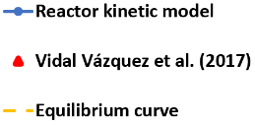
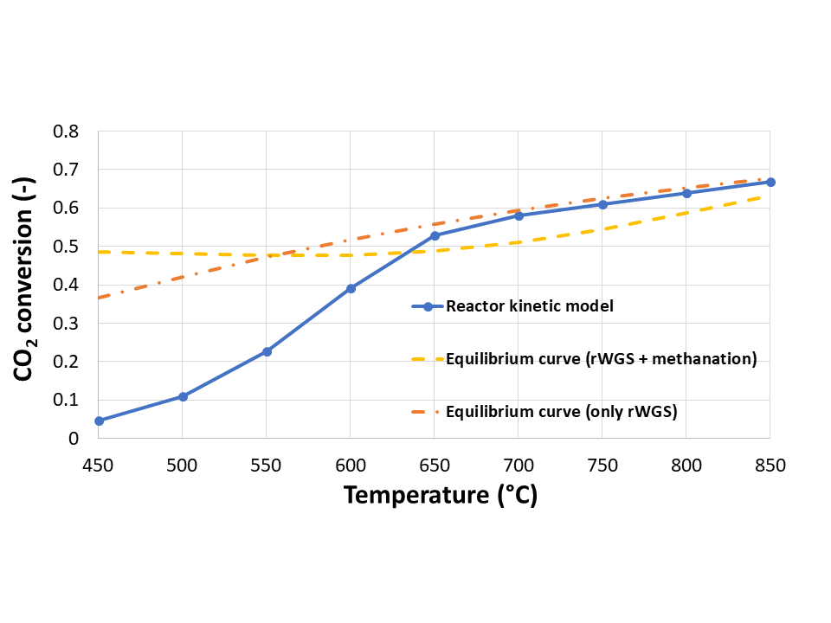
Figure 2 - Kinetic model comparison with two different equilibria (30 bar, inlet H₂/CO₂ = 2, catalyst mass = 0.25 g).
Figure 1 - CO₂ conversion at different temperatures, for an inlet H₂/CO₂ = 2 and a catalyst mass of 0.25 g, at 1 bar (Fig. 1a) and 30 bar (Fig. 1b).
a)
b)

The slight drop in conversion observed in Figure 1a at high temperature is an issue inherent to the model, as it seems that the experimental points are tending towards equilibrium. The authors explain this phenomenon by a lack of experiments conducted at these temperatures. Interestingly, it can also be seen in Figure 1b that at high temperatures, CO₂ conversion is beyond equilibrium. The way this equilibrium curve has been generated must be detailed to understand this trend. The equilibrium conversion is calculated through Gibbs’ free energy minimisation, thus assuming that each chemical reaction reaches its equilibrium, i.e. both the rWGS and the methanation reactions in the present case. Following Eq. (2) and (3), methanation appears favoured at high pressure, inducing a more pronounced parasitic effect at 30 bar. As these reactions require more H₂ molecules to convert one molecule of CO₂, the resulting CO₂ conversion is slightly smaller when methanation is favoured compared to the case where only the rWGS reaction is observed. Now, from a kinetic point of view, if it is true that the rWGS reaction is close to equilibrium at high temperature, it is not the case for the methanation reactions, given their exothermic nature. Thus, the kinetic curve tends towards an equilibrium where only the rWGS reaction would exist, as can be justified with Figure 2 in which the equilibrium curve for this reaction alone is added for the data set at 30 bar.
4. Reactor Design at Two Different Scales
4.1. Small Pilot Scale
The global objective of this project is to build a small-scale Power-to-kerosene pilot plant. Its production rate is based on the electrolysis capacity available at ULiège, which is a maximum of 1.5 Nm³/h of H₂. It is assumed that the rWGS reactor is a tubular fixed bed, which consumes all the available H₂ and that the produced syngas must have an H₂/CO ratio close to 2.1 to satisfy the Fischer-Tropsch unit requirements (Morales and Leonard, 2022). For this small-scale study case, the reactor is assumed to be isothermal at a temperature of 800 °C (González-Castaño et al., 2021), as a greater temperature would require more effort to be kept constant. Moreover, this temperature level corresponds to the higher temperature of any experimental points used to regress the implemented kinetic model. Thermodynamics shows that pressure does not influence the rWGS equilibrium but favours methane production. Still, Fischer-Tropsch synthesis is operated at higher pressure, around 20 bar. Thus, having a rWGS operated at this pressure would eliminate the compression needs between both units (Santos et al., 2023). Hence, Figure 3 displays conversion and selectivity profiles inside the reactor at 1 and 20 bar. Note that this paper presents only the first insights into the unit design. Thus, as a first approach, the constraint imposed on the selected length is that the equilibrium conversion is reached within this length for both pressures. In the future, the optimal outlet conversion should be refined, as it might require unnecessarily more effort to reach the equilibrium conversion.
Figure 3 - Small-scale reactor sizing at 1 and 20 bar and 800 °C based on an H₂ inlet flow rate of 1.5 Nm³/h.

As observable in Figure 3, it turns out that the equilibrium can easily be reached within 30 cm at 1 bar, where the CO₂ conversion equals 65.6 % with only negligible formation of methane. When the pressure is increased to 20 bar, a maximum CO₂ conversion is quickly reached (65.2 %) but then decays to its final value of 62.1 %. This decrease should be seen in conjunction with the increase in methane selectivity up to 17.1 %. The inlet H₂/CO₂ ratio must be close to 2 at both pressures to ensure a 2.1 H₂/CO ratio for the following Fischer-Tropsch synthesis. However, given the higher methane production at 20 bar, 20 % less syngas is produced than at 1 bar. Figure 3 illustrates that the reactor length should be limited at high pressure to prevent a too large methanation extent. Indeed, simulating a 5 cm long reactor at 20 bar yields an equilibrium conversion of 64.8 % and a CH₄ selectivity of only 4.6 %.
4.2. Industrial Scale
A single tubular reactor is still assumed for the industrial scale. The main difference with the small-scale reactor lies in the unit heating. While it is reasonable to have an isothermal pilot-scale reactor, it demands more effort to maintain an industrial unit at such high temperatures. An alternative could be an adiabatic reactor, which only requires gas preheating. The industrial size is determined to be 1,000 times larger than the small-scale unit in terms of inlet H₂ flow rate, which is in line with the current biggest electrolysis units on the market (Shiva Kumar and Lim, 2022). In this adiabatic configuration, with an inlet H₂ flow rate of 1,500 Nm³/h and an inlet temperature of 800 °C, the equilibrium CO₂ conversion is reached at 1 bar and 20 bar roughly after the same reactor length (4 m). At 1 bar, the conversion equals 51.1 % and 64.8 % at 20 bar. The CH₄ selectivity is no longer negligible at 1 bar as it equals 2.2 %, while it is 16.9 % at 20 bar. Figure 4 depicts the temperature profiles in the reactor, which help to explain these results.
Figure 4 - Temperature profiles along the reactor length at 1 and 20 bar for an inlet H₂ flow rate of 1,500 Nm³/h and an inlet temperature of 800 °C.

At 1 bar, the temperature rapidly decreases to 640 °C before stabilising and increasing slowly to 650 °C. This temperature decay is attributed to the endothermicity of the rWGS reaction, which is favoured at the beginning. The temperature in the reactor being globally lower than 800 °C explains the lower CO₂ conversion and the higher CH₄ selectivity, as conditions are more favourable for methanation. At 20 bar, the same phenomenon occurs, but the initial temperature decay is milder due to the higher pressure favouring the methanation. Furthermore, as both the temperature and pressure are now in favour of methanation, the heat released by the side reactions is sufficient to significantly increase the temperature in the reactor, returning to conditions optimal for the rWGS reaction and explaining the high CO₂ conversion at the expense of a higher CH₄ selectivity.
5. Conclusions
This paper treats the development of an rWGS reactor in Aspen Custom Modeler in the framework of captured CO₂ reutilisation. It is shown that Vidal Vázquez et al. (2017)’s experimental results are reproduced with satisfying accuracy ($R^{2}=92.5 \%$). Then, the model is tested isothermally for an inlet H₂ of 1.5 Nm³/h at 1 and 20 bar and leads to the conclusion that the equilibrium conversion is reached in a reactor six times shorter at 20 bar. Thus, if the reaction aims to be tested at both pressures in the same facility, the reactor would be oversized as pressure increases. This oversizing results in a significant propensity for methanation, increasing the outlet CH₄ selectivity. Consequently, a trade-off should be made between sufficient CO₂ conversion at low pressure and sufficiently low methanation at high pressure. The model is also tested in an adiabatic configuration for an inlet H₂ flow of 1,500 Nm³/h. In this case, the same length (4 m) is required to reach the equilibrium conversion irrespective of the operating pressure. It is shown that at both pressures, the temperature drops due to the preponderance of the endothermic rWGS reaction before increasing again. The increase at 20 bar is much more significant because of the temperature and pressure combined effect, favouring methanation reactions. This larger temperature increase at 20 bar enables an outlet conversion greater by more than 25 % compared to the value obtained at 1 bar but at the expense of a larger CH₄ production. This analysis shows that, in adiabatic configuration, the inlet temperature optimisation will be a decisive design factor. In the future, these results will be refined to account for the pressure drop effects on the presented profiles. Besides, the possibility of operating a large-scale unit isothermally will also be investigated.
Acknowledgements
This papper is supported by the Walloon Region as part of a FRIA grant (F.R.S.-FNRS).
References
S. Adelung, S. Maier, and R-U. Dietrich, 2021, ‘Impact of the Reverse Water-Gas Shift Operating Conditions on the Power-to-Liquid Process Efficiency’, Sustainable Energy Technologies and Assessments, 43 (February): 100897.
F. Bisotti, M. Fedeli, P. P. S. Quirino, K. Valverde Pontes, and F. Manenti, 2023, ‘Process Modeling and Apparatus Simulation for Syngas Production’, Advances in Synthesis Gas : Methods, Technologies and Applications, 43–101.
Y. A. Daza, and J. N. Kuhn., 2016, ‘CO₂ Conversion by Reverse Water Gas Shift Catalysis: Comparison of Catalysts, Mechanisms and Their Consequences for CO₂ Conversion to Liquid Fuels’, RSC Advances, 6 (55): 49675–91.
M. González-Castaño, B. Dorneanu, and H. Arellano-García, 2021, ‘The Reverse Water Gas Shift Reaction: A Process Systems Engineering Perspective’, Reaction Chemistry & Engineering, 6 (6): 954–76.
A. Morales, and G. Leonard, 2022, ‘Simulation of a Fischer-Tropsch Reactor for Jet Fuel Production Using Aspen Custom Modeler’, Computer Aided Chemical Engineering, 51:301–6.
H. Ritchie, 2020, ‘Sector by Sector: Where Do Global Greenhouse Gas Emissions Come From?’, OurWorldInData.Org, 2020, https://ourworldindata.org/ghg-emissions-by-sector.
A. Rouxhet, and G. Léonard, 2024, ‘Using H₂ for CO₂ activation on the way towards synthetic fuels’, Under submission for the EPHyC conference 2024, Ghent, Belgium.
M. F. Santos, A. E. Bresciani, N. L. Ferreira, G. S. Bassani, and R. M. B. Alves, 2023, ‘Carbon Dioxide Conversion via Reverse Water-Gas Shift Reaction: Reactor Design’, Journal of Environmental Management, 345 (November): 118822.
S. Shiva Kumar, and H. Lim, 2022, ‘An Overview of Water Electrolysis Technologies for Green Hydrogen Production’, Energy Reports, 8 (November): 13793–813.
F. Vidal Vázquez, P. Pfeifer, J. Lehtonen, P. Piermartini, P. Simell, and V. Alopaeus, 2017, ‘Catalyst Screening and Kinetic Modeling for CO Production by High Pressure and Temperature Reverse Water Gas Shift for Fischer–Tropsch Applications’, Industrial & Engineering Chemistry Research, 56 (45): 13262–72.
F. Vidal Vázquez, J. Koponen, V. Ruuskanen, C. Bajamundi, A. Kosonen, P. Simell, J. Ahola, C. Frilund, J. Elfving, M. Reinikainen, N. Heikkinen, J. Kauppinen, and P. Piermartini, 2018, ‘Power-to-X Technology Using Renewable Electricity and Carbon Dioxide from Ambient Air: SOLETAIR Proof-of-Concept and Improved Process Concept’, Journal of CO2 Utilization, 28 (December): 235–46.
A. Wolf, A. Jess, and C. Kern, 2016, ‘Syngas Production via Reverse Water-Gas Shift Reaction over a Ni-Al₂O₃ Catalyst: Catalyst Stability, Reaction Kinetics, and Modeling’, Chemical Engineering & Technology, 39 (6): 1040–48.
J. Xu, and G. F. Froment, 1989, ‘Methane Steam Reforming, Methanation and Water-Gas Shift: I. Intrinsic Kinetics’, AIChE Journal, 35 (1): 88–96.

