Simulation study of a hybrid cryogenic and membrane separation system for SF₆ recovery from aged gas mixture in electrical power apparatus
Huong Trang Vo ª, Lujia Chen ª, Patricia Gorgojo ^{a,b}
^{a,*}Department of Electrical and Electronic Engineering, The University of Manchester, Manchester M13 9PL, United Kingdom
^{b} Department of Chemical Engineering, University of Zaragoza, Zaragoza 50005, Spain
Email: lujia.chen@manchester.ac.uk
Abstract
Despite its wide use in the electrical industry, sulphur hexafluoride (SF₆) is a potent greenhouse gas with high global warming potential (GWP) and atmospheric lifetime. Therefore, there is a growing interest in recycling, reconditioning, and reusing aged SF₆. In addition, the upcoming F-gas regulation with increasing restrictions imposed on SF₆ could result in banning the production of virgin SF₆, consequently putting pressure on end-users to recycle aged SF₆ for further reuse. Currently, the cryogenic separation process is often utilised to recondition aged SF₆ in electrical power apparatus. However, this method is not suitable to treat mixtures with SF₆ content lower than 40 mol.% and produces a waste gas containing up to 15 mol.% of SF₆. This study aims to tackle the aforementioned limitations of the existing SF₆ reconditioning process by implementing membrane units. For this purpose, a mathematical model of the membrane gas separation process is developed and integrated into an Aspen Plus simulation via CAPE-OPEN interface. A set of cost model equations collected from the open literature is also used to study the cost of the SF₆ recovery process. The simulation for a feed mixture of 20 mol.% SF₆ and 80 mol.% N₂ with a flow rate of 10,000 kg/day demonstrated the system’s capability to recover SF₆ efficiently, achieving the product purity of 98.3 mol.% and SF₆ recovery of 97.5 %. Further optimisation reduced the specific recovery cost and specific energy consumption by 3.1 % and 10.5 %, respectively. The SF₆ content in the waste gases was also reduced to less than 1 mol.%.
Keywords: sulphur hexafluoride; gas separation; membrane; simulation; Aspen Plus.
  - Introduction
Sulphur hexafluoride (SF₆) is highly stable due to its chemical inertness that is comparable to nitrogen (N₂) gas and incombustible nature. Two prominent factors for the use of SF₆ in the electrical industry are its excellent dielectric property, almost 2.5-3 times higher than air, under similar test conditions, and its low dissociation temperature and high dissociation energy, which makes it an excellent insulating and arc-quenching gas medium. However, SF₆ is a potent greenhouse gas with a global warming potential (GWP) 24,300 times higher than carbon dioxide (CO₂) and an atmospheric lifetime of 3,200 years.
Despite these facts, demand for SF₆ in medium- and high-voltage switchgear continues to rise, driven by increasing electricity demand and electrification of transportation. The installed base of medium-voltage switchgear units is expected to increase between 40 to 90 per cent by 2050 (Zhai et al., 2021). In the UK, National Grid is the largest user of SF₆ with an inventory of 920 tonnes with SF₆ presently accounting for 92 % of their Scope 1 emissions (National Grid, 2022). The continued phase-out of SF₆ is paramount to ensure the wider electricity industry in the UK and Europe as a whole can realise the ambition of Net Zero by 2050. Despite decades of research, there is no perfect like-for-like replacement for SF₆ across different power equipment. For example, some SF₆ alternatives, such as fluoronitrile and perfluoroketone, despite having been commercialised and successfully operational in gas-insulated equipment (Hyrenbach et al., 2017; Kieffel and Biquez, 2014), belong to the group of per- and polyfluoroalkyl substances (PFAS), which will potentially be banned according to the EU PFAS Restriction Proposal (Zeinoun and Reisser, 2023). This leaves non-greenhouse gases including N₂ and air to be the only viable option to substitute SF₆. However, due to their low dielectric strength, it would dramatically increase the equipment size and/or the filling pressure of the device by a factor of at least 2.5 (Kieffel et al., 2016). This would not only impact enclosure design, safety and cost but also go against the need to develop more compact electrical equipment in metropolitan areas.
The new proposed F-gas regulation draft prohibits the sale of new SF₆ switchgear starting in 2026 (European Commission, 2022). However, it does not ban the use of existing SF₆ switchgear which has a typical asset lifespan of 20 to 30 years for medium-voltage and >40 years for high-voltage equipment. Hence, there is a growing need to recondition aged SF₆ for further use. The conventional method of reconditioning used SF₆ is a commercialised cryogenic process to recover SF₆ from aged mixtures of SF₆ with other components mainly including N₂ or air (DILO, 2022). The recovered product contains 99 mol.% SF₆ and approximately 85 % recovery of SF₆ is achieved. As shown in Figure 1, the process consists of two separation columns: one operates at relatively lower pressures of approximately 8-14 bara, and the other operates at a higher pressure of up to 40 bara. The refrigeration units are used to cool the gas mixture to the optimal temperature between -40 ℃ to -30 ℃. Note that the operating pressure and temperature of the two separation columns are dependent on the composition of the gas mixture. The main limitation of this process is that it is only suitable for treating insulating gas mixtures with a high content of SF₆ (>60 mol.%), while the SF₆ content in a binary mixture with a buffer gas such as N₂ typically ranges from 5 to 20 mol.% (Hama et al., 2018). In addition, a certain amount of waste gas is produced and cannot be directly released into the atmosphere, which requires a further stage of incineration that can be energy intensive.
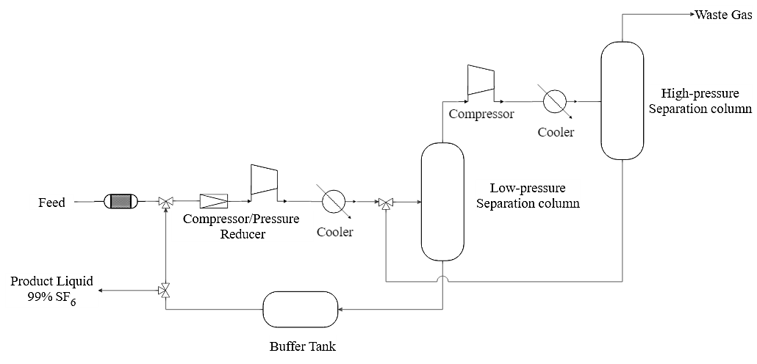
Figure 1: Conventional SF₆ cryogenic process (simplified from (DILO, 2022))
In gas separation applications, there is a growing interest in membrane-based hybrid systems due to their inherent benefits. These include straightforward installation and operation, minimal energy requirements, continuous operation with the option of partial or complete recycling, and the potential for integration with other separation units. This study aims to address the current shortcomings of the SF₆ reconditioning process by introducing a design of a membrane-cryogenic hybrid system.
  - Methodology
    - Aspen Plus simulation
Aspen Plus was used to model a plant capable of treating approximately 10,000 kg/day of SF₆ mixture, a representative scale for a small gas treatment plant. The SF₆ content in the feed mixture was set at 20 mol.% with the remaining gas being N₂. Two membrane units were incorporated: the first one was used to enhance the SF₆ content in the feed for the cryogenic cycle, while the second unit was employed to minimise the SF₆ concentration in the residual gas. A process flow diagram of the process is included in Figure 2.
Since a membrane module is not available in Aspen Plus and in its Model Library, the membrane model was solved numerically in MATLAB and integrated into Aspen Plus as a CAPE-OPEN COM unit operation with a license provided by AmsterCHEM. Additionally, the Peng-Robinson property package was chosen for the simulation.
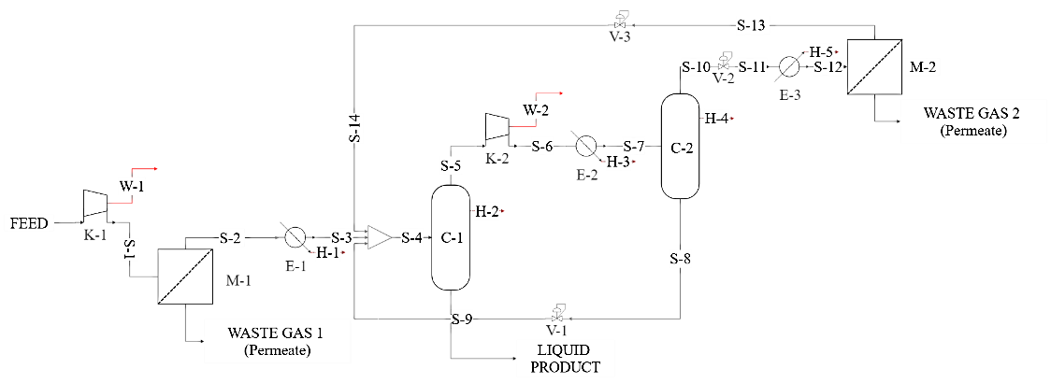
Figure 2: Membrane-cryogenic process
    - Model assumption
The model was assumed to operate for 358 days per year (7 maintenance days) for a period of 5 years. The membrane is assumed to be in constant operation during this period with no decrease in productivity. The process operated at steady state, which means no replacements or adjustments to the production rate were considered and any replacements during the 5-year period were accounted for in the contingency and fee costs (15 % and 3 % of the bare module cost, respectively) (Turton et al., 2018). For simplification, other costs including operational labour, waste treatment and administration were neglected.
The membrane module was simulated as a hollow fibre module using a mathematical model that describes the counter-current flow pattern with bore-side feed, based on a number of assumptions. The most important ones are as follows:
- The permeation rate obeys Fick’s law;
- Permeance of gas components through the membrane is independent of pressure on both sides;
- Plug flow on the feed side with changes in velocity and pressure are assumed to be negligible on the feed side;
- Laminar flow on the permeate side.
- Gas properties including viscosity and specific heat capacity are independent of pressure and temperature.
Before being utilised to examine the plant performance under various operating conditions, the membrane model was validated using experimental data of SF₆/N₂ separation using a commercial membrane from Yamamoto et al. (2002). The analysis revealed that the membrane model aligned well with experiment data for high feed-side pressures of 4 and 5 bara but deviated significantly at a lower pressure of 3 bara. To address this, a corrective factor of 1.12 was applied to the membrane area variable, reducing the model’s average percentage error to 8 %. Turton et al. (2018) reported the correlations of cost estimation in USD back in 2001. Hence, all the costs were updated to 2023 price using cost indexes and converted to GBP adopting the current exchange rate of 1 USD to 0.8 GBP.
    - Simulation study of a hybrid SF₆ recovery system
The simulation of the process was carried out to estimate the key performance indicators including the specific SF₆ recovery cost and energy consumption. Table 1 presents a set of important equations of the membrane and economic models used in this study.
Table 1: Membrane and economic models and equations for key performance indicators
Equation |  | Description | Unit
Membrane model
$A_{m}=$ $N_{T}πD_{i}L$ | (1) | Effective membrane area | m²
$\frac{dN_{t}x_{i}}{dz}={-N}_{T}πD_{i}J_{i}$ | (2) | Molar flow rate profile on the feed side | mol/m·s
$\frac{dN_{s}y_{i}}{dz}=-N_{T}πD_{i}J_{i}$ | (3) | Molar flow rate profile on the permeate side | mol/m·s
$\frac{dp_{s}}{dz}=\frac{192μRT_{s}ND_{o}(D+ND_{o})}{π{(D^{2}-ND_{o}^{2})}^{3}P_{s}}\sum_{i=1}^{nc}{N_{s}y_{i}}$ | (4) | Pressure profile on the permeate side | Pa/m
$\frac{dT_{t}}{dz}={-N}_{T}πD_{i}\left[\frac{\sum_{i=1}^{nc}{J_{i}c_{pi}(T_{t}-T_{s})}}{\sum_{i=1}^{nc}{N_{t}x_{i}c_{pi}}}\right]$ | (5) | Temperature profile on the feed side | K/s
$\frac{dT_{s}}{dz}={-N}_{T}πD_{i}\left[\frac{\sum_{i=1}^{nc}{J_{i}c_{pi}(T_{t}-T_{s})}}{\sum_{i=1}^{nc}{N_{s}y_{i}c_{pi}}}\right]$ | (6) | Temperature profile on the permeate side | K/s
Capital cost
$\log_{10}C_{P}^{0}=K_{1}+K_{2}\log_{10}\left(A\right)+K_{3}{\left[\log_{10}(A)\right]}^{2}$ | (7) | General equipment cost | £
$C_{BM}=C_{P}^{0}F_{BM}$ | (8) | Bare module equipment cost | £
$C_{TM}=\sum_{i=1}^{n}{C_{TM,i}}=1.18\sum_{i=1}^{n}{C_{BM,i}}$ | (9) | Total module cost | £
$C_{M}=1.12A_{m}C_{m}$ | (10) | Membrane cost | £
$C_{TM}=0.2(C_{TM}+C_{M})$ | (11) | Annual capital related cost | £/y
Operational cost
$C_{Elec}=C_{E}∙P_{C}$ | (12) | Annual electricity cost | £/y
$C_{UT}=C_{R}∙Q_{C}+C_{S}∙Q_{H}$ | (13) | Annual utilities cost | £/y
$C_{OPEX}={(C}_{Elec}+C_{UT})∙ τ$ | (14) | Annual operating cost | £/y
Performance indicator
$(C_{TM}+C_{OPEX})/F_{{SF}_{6}}$ | (15) | Specific recovery cost | £/kg SF₆
$(P_{C}+Q_{C}+Q_{H})/F_{{SF}_{6}}$ | (16) | Specific energy consumption | kWh/kg SF₆
    - Optimisation of a hybrid SF₆ recovery system
The operation of the SF₆ recovery system was optimised to ensure the purity of the liquid product is at 99 mol.% SF₆. The feed conditions were fixed at 10,000 kg/day at 25 $℃$ and 4 bara. The nonlinear single-objective optimisation framework can be described as:
Objective function: Minimise specific recovery cost (Equation 15)
Constraint: Minimum purity of 99 mol.% SF₆ in the liquid product
Decision variables: The initial values, lower and upper bounds for the decision variable in the optimisation problem are listed in Table 2
Table 2: Initial values, lower and upper bounds for the decision variables in the optimisation problem
Decision variable | Unit | Initial | Minimum | Maximum
C-1 operating pressure | bara | 9 | 7 | 14
C-1 operating temperature | $$℃$$ | -30 | -40 | -30
C-2 operating pressure. | bara | 38 | 30 | 40
C-2 operating temperature | $$℃$$ | -38 | -40 | -30
M-1 area | m² | 145 | 140 | 160
M-2 area | m² | 45 | 30 | 60

  - Results and discussion
The simulation was first carried out using initial operating conditions as listed in Table 2 and the results obtained are shown in Table 3. Results from the initial simulation show that the hybrid process is capable of treating feed gas with a low concentration of SF₆ of 20 mol.%, while achieving a high SF₆ recovery of 97.5 % and product purity of 98.3 mol.%. The SF₆ content in the waste gas streams was 0.555 and 0.844 mol.%, respectively, which are significantly lower in comparison to that of the conventional cryogenic process.
Table 3: Simulation results using initial operating conditions
SF₆ recovery productivity | Product purity | SF₆ content in Waste Gas 1 | SF₆ content in Waste Gas 2 | SF₆ recovery | Total capital cost | Total operational cost | SF₆ recovery cost | Specific energy consumption
kg/h | mol.% | mol.% | mol.% | % | 10⁶ £/y | 10⁶ £/y | £/kg | kWh/kg
230 | 98.3 | 0.555 | 0.844 | 97.5 | 1.058 | 0.649 | 0.580 | 0.171
Table 4 shows the optimisation results of several performance indicators. In general, there was no significant change in the product purity and SF₆ recovery in comparison to the initial simulation. Notably, the purity of the liquid product was only influenced by the operational parameters of the low-pressure separation column C-1, with a purity of 99 mol.% attainable at operating pressures below 8 bara. The SF₆ content in the waste gas streams was kept below 1 mol.% at 0.539 and 0.549 mol.%, respectively. This could potentially eliminate the requirement of the further destruction of the waste gas. Furthermore, increasing the membrane area in both stages led to a reduction in the total energy consumption, indicating a trade-off between capital and operational costs. Nevertheless, the associated increase in capital costs was negligible, resulting in a lower specific recovery cost by 3.1 %.
Table 4: Optimisation results
Optimised decision variable |  |  | Optimised results
Parameter | Unit | Value | Parameter | Unit | Value
C-1 operating pressure | bara | 8 | SF₆ recovery productivity | kg/h | 230
C-1 operating temperature | $$℃$$ | -33 | Product purity | mol.% | 99.0
C-2 operating pressure | bara | 32 | SF₆ content in Waste Gas 1 | mol.% | 0.539
C-2 operating temperature | $$℃$$ | -40 | SF₆ content in Waste Gas 2 | mol.% | 0.549
M-1 area | m² | 150 | SF₆ recovery | % | 97.8
M-2 area | m² | 50 | Total capital cost | 10⁶ £/y | 1.058
 |  |  | Total operational cost | 10⁶ £/y | 0.531
 |  |  | SF₆ recovery cost | £/kg | 0.562
 |  |  | Specific energy consumption | kWh/kg | 0.153
  - Conclusion
The combination of Aspen Plus simulations with a techno-economic analysis provided an overview of the feasibility of a hybrid membrane-cryogenic plant to recover SF₆ from the aged gas mixture. Firstly, the initial simulation showed success in addressing the two main drawbacks of the current SF₆ reconditioning process: i) capable of treating SF₆/N₂ insulation mixture with a low SF₆ content below 20 mol.%, and ii) achieve high SF₆ recovery of 97.5 % and low SF₆ content of less than 1 mol.% in the waste gas streams. This degree of recovery was significantly higher, as opposed to the 85 % recovery of SF₆ achieved by the conventional cryogenic process. The content of SF₆ in the waste gas streams produced of less than 1 mol.% could potentially obviate the need for additional disposal process of the waste gas. The cost analysis reveals that the compressor cost constitutes the primary component of the overall capital expenditure, whereas the operational cost is predominantly influenced by the combined expenses of electricity required for the compressors and the cost of refrigerants used in the refrigeration unit. Therefore, the incorporation of membrane units does not substantially affect the overall process cost. The determination and optimisation of various process variables has attained the reduction in both SF₆ recovery cost and SF₆ content in waste gas. The specific SF₆ cost, and energy consumption were reduced by 3.1 % and 10.5 % respectively.
Acknowledgement
Authors acknowledge funding support by the School of Engineering of the University of Manchester for this PhD studentship.
References
Hama, H., Buhler, R., Girodet, A., Juhre, K., Kindersberger, J., Lopez-Roldan, J., Neumann, C., Riechert, U., Schichler, U., Yasuoka, T., Okabe, S., Gautschi, D., Hering, M., Kieffel, Y., Koltunowicz, W., Neuhold, S., Pietsch, R., Rokunohe, T., Steyn, D., 2018. Dry air, N2, CO2 and N2-SF6 mixtures for gas-insulated systems. CIGRÉ.
Hyrenbach, M., Paul, T.A., Owens, J., 2017. Environmental and safety aspects of AirPlus insulated GIS. In: CIRED - Open Access Proceedings Journal. Institution of Engineering and Technology, pp. 132–135.
Kieffel, Y., Biquez, F., 2014. SF6 alternative development for high voltage switchgears. In: 33rd Electrical Insulation Conference, EIC 2015. Institute of Electrical and Electronics Engineers Inc., pp. 379–383.
Kieffel, Y., Irwin, T., Ponchon, P., Owens, J., 2016. Green Gas to Replace SF6 in Electrical Grids. IEEE Power and Energy Magazine 14, 32–39.
National Grid, 2022. Re-opener Report MSIP-SF6 Asset Intervention [WWW Document]. URL https://www.nationalgrid.com/electricity-transmission/document/140901/download (accessed 11.29.23).
European Commision, 2022. Proposal for a Regulation of the European Parliament and of the Council on fluorinated greenhouse gases, amending Directive (EU) 2019/1937 and repealing Regulation (EU) No 517/2014. Strasbourg.
DILO, 2022. Separating unit - Translation of original operating manual [WWW Document]. DILO. URL www.dilo-gmbh.com
Turton, R., Shaeiwitz, J.A., Bhattacharyya, D., Whting, W.B., 2018. Analysis, Synthesis, and Design of Chemical Processes, 5th ed. Prentice Hall.
Yamamoto, O., Takuma, T., Kinouchi, M., 2002. Recovery of SF6 from N2/SF6 gas mixtures by using a polymer membrane. IEEE Electrical Insulation Magazine.
Zeinoun, E., Reisser, C., 2023. The EU’s PFAS Restriction Proposal Explained [WWW Document]. APCO worldwide. URL https://apcoworldwide.com/blog/the-eus-pfas-restriction-proposal-explained/#:~:text=The%20proposal%20will%20effectively%20ban%20all%20forms%20of,for%20which%20there%20is%20no%20currently%20known%20alternative. (accessed 9.6.23).
Zhai, P., Pirani, A., Connors, S.L., Péan, C., Berger, S., Caud, N., Chen, Y., Goldfarb, L., Gomis, M.I., Huang, M., Leitzell, K., Lonnoy, E., Matthews, J.B.R., Maycock, T.K., Waterfield, T., Yelekçi, O., Yu, R., Zhou, B., 2021. Climate Change 2021: The Physical Science Basis. Contribution of Working Group I, IPCC.

