Electric Heat Pumps and Combined Heat and Power Systems for the Optimal Decarbonisation of the Integrated UK Energy System
Matthias Mersch,^{a,b,c} Andreas V. Olympios,^{a,c,d} Christos N. Markides,^{a,c}
Niall Mac Dowell^{b,c}*
ªClean Energy Processes (CEP) Laboratory, Department of Chemical Engineering, Imperial College London, London SW7 2AZ, UK
^{b}Centre for Environmental Policy, Imperial College London, London SW7 2AZ, UK
^{c}Sargent Centre for Process Systems Engineering, Department of Chemical Engineering, Imperial College London, London SW7 2AZ, UK
^{d}PV Technology Laboratory, FOSS Research Centre for Sustainable Energy, Department of Electrical and Computer Engineering, University of Cyprus, Nicosia, 2109, Cyprus
niall@imperial.ac.uk
Abstract
Electric heat pumps and combined heat and power (CHP) systems are potentially key technologies to decarbonise heating, which currently accounts for over a third of the UK’s carbon emissions. In this work, we use an integrated energy system optimisation model to investigate the role of both in the energy system transition, studying interactions between the heating and power sectors. To increase the robustness of the analysis, a Monte Carlo approach is used to account for uncertainties in key model input parameters, such as fuel costs and capital costs of key technologies. Results show that heat pumps provide 40 to 80 % of all heat in the UK in 2050, while CHP systems are especially valuable as intermediate technology in the 2030s.
Keywords: Energy system optimisation, heat decarbonisation, heat pump, combined heat and power, integrated energy systems
  - Introduction
Heating accounts for about 37 % of UK carbon emissions (BEIS, 2018) and urgently needs to be decarbonised to meet ambitious climate targets. Currently, heating is mainly provided by natural gas boilers. Low-carbon alternatives such as heat pumps, hydrogen boilers, and CHP systems result in a strong integration of different sectors of the energy system, especially heating and power generation. In this work, we use an integrated energy system optimisation model (Mersch, 2023) to assess the role of heat pumps and CHP systems in the decarbonisation of the UK energy system, considering both individual solutions and district heating networks. Hydrogen boilers are also considered as an alternative, and hydrogen can also be used to power CHP systems.
In their meta-analysis of UK energy system decarbonisation pathways, Dixon et al. (2022) found that in 6 of the 7 reviewed pathways air-source heat pumps (ASHPs) and district heating are the dominant low-carbon heating technologies, while the last one mainly relies on hydrogen boilers. The share of individual heat pumps in UK homes ranges from 27 % to 74 %, while district heating shares range from 10 % to 42 %. Aunedi et al. (2022) soft-linked an electricity system model with a heating model to study optimal heat decarbonisation options for the UK. The authors found a strong role for hybrid heating systems consisting of ASHPs and hydrogen boilers. However, the sectors are only soft-linked, CHP systems are not considered, and no uncertainty analysis is performed. Pavičević et al. (2020) investigated decarbonisation pathways for integrated energy systems and the benefits of sector-coupling in Europe by soft-linking a capacity-expansion and a unit-commitment model. The results showed that in the optimal system about 30 % of heat is provided by biomass and natural gas-fired CHP systems, about 50 % from ASHPs and electric heaters, and the rest from backup gas boilers. Hydrogen heating options are not considered, and no uncertainty analysis is performed. Charitopoulos et al. (2023) used a spatially explicit optimisation model to analyse the impact of fully electrifying domestic heating in the UK on the power sector. The authors showed that if thermal energy storage (TES) is utilised, only a 30 % increase of power generation capacity is required to fully electrify domestic heating, while without TES the required power generation capacity is another 40 % higher. Furthermore, Olympios et al. (2020) compared the deployment of heat pumps and gas-fired CHP systems at household level and in district heating networks. The findings indicated that heat pumps can provide high emission reductions even when powered by the UK electricity grid of 2020 (55 to 62 %), while gas-fired CHP systems integrated within district heating networks are the most cost-effective option in areas with high energy density. Then, Olympios et al. (2022) compared ASHPs and hydrogen heating technologies from a household and whole-energy system perspective, concluding that ASHPs are the least-cost pathway for both, but hydrogen in the context of CHP systems was not considered. In a related study, Hoseinpoori et al. (2022) demonstrated the significant role of ASHPs in UK heat decarbonisation, with hydrogen boilers being identified as a supplementary option. CHP systems at building or district-heating level were not examined.
In this paper, we investigate the role of different low-carbon heating technologies in the UK energy system decarbonisation, using an integrated whole-energy system model that explicitly links the heating, electricity, and hydrogen sectors. The focus lies hereby on heat pumps and CHP systems, which were both shown to have great heat decarbonisation potential. We explicitly account for uncertainties in technology costs and fuel prices, thus providing a more robust analysis that allows for a direct and comprehensive comparison of these technologies within the broader context of the whole energy system.
  - Methodology
The Energy System Optimisation (ESO) model used for the analysis is described in detail in Mersch et al. (2023). The model performs a simultaneous optimisation of capacity expansion from 2020 to 2050, allowing investment decisions every 5 years, and technology dispatch with hourly resolution, using a representative-day approach. This approach allows the model to account for seasonal effects, such as changing demand patterns. Electricity, hydrogen, and CO₂ removal sectors as well as domestic, commercial, and industrial heat are explicitly represented in the model, while for the transport sector assumptions on the uptake of electric vehicles and the corresponding electricity demand are made. The model performs a cost minimisation assuming perfect foresight.
For this work, CHP systems and a representation of district heating networks have been added to the model. Modelled CHP systems are natural gas and hydrogen internal combustion engines (ICEs), which can be deployed either at household, commercial building, or industrial site level, or in district heating networks. Other generation technology options for district heating are ground-source heat pumps (GSHPs), natural gas boilers and hydrogen boilers, while hot water tanks are considered as a TES option. CHP systems are assumed to be able to feed any generated electricity into the grid.
The cost and performance of heating technologies are modelled based on the data collected by Olympios et al. (2021). Key parameters for small-scale household level systems are shown in Table 1, while parameters of larger assets for e.g., district heating systems are shown in Table 2. Note that these are only the baseline parameters. Some parameters are varied during the Monte Carlo study to account for uncertainties, as described below. Efficiencies of ASHPs and GSHPs are calculated using a correlation based on the ambient air and ground temperature, respectively.
Table 1. Key cost and performance parameters of domestic heating technologies.
Technology | Size [kW_{th}] | CAPEX [£] | OPEX [£/y] | Efficiency
Gas boiler | 30 | 2,560 | 100 | 0.9
H₂ boiler | 30 | 2,560 | 100 | 0.9
Small ASHP | 5 | 6,860 | 240 | variable
Large ASHP | 10 | 8,230 | 240 | variable
GSHP | 10 | 18,190 | 240 | variable
Electric backup | 3 | 110 | 0 | 1
Gas ICE | 25 | 37,130 | 100 | 0.67 thermal, 0.27 electric
H₂ ICE | 25 | 37,130 | 100 | 0.67 thermal, 0.27 electric
District heat | 30 | 5,930 | 0 | 0.94
Table 2. Key cost and performance parameters of district heating technologies.
Technology | CAPEX [£/kW] | OPEX [£/kW/y] | Efficiency
Gas boiler | 32 | 6.25 | 0.9
H₂ boiler | 32 | 6.25 | 0.9
GSHP | 299 | 6.67 | variable
Gas ICE | 207 | 10.3 | 0.67 thermal, 0.27 electric
H₂ ICE | 207 | 10.3 | 0.67 thermal, 0.27 electric
District heating is only viable in areas with a high heat demand density. Based on analysis from the UK Department of Business, Energy & Industrial Strategy (BEIS) (2021), district heating is constrained to a maximum of 20 % of domestic and commercial properties. The cost of district heating connections is estimated based on data from a Finnish district heating scheme (Helen, 2023), while the cost of the pipe network is estimated based on the annual delivered heat, using data from the BEIS (2021) report.
    - Monte Carlo Analysis
A Monte Carlo analysis is used to account for uncertainties in key model input parameters, such as capital costs, fuel prices and the interest rate. The uncertain input parameters and respective bounds considered in the sampling are shown in Table 3. The gas price bounds cover the variation seen in the UK since 2021. The biomass availability is included as parameter to account for cases where emission offsetting is much more expensive, while the interest rate influences the trade-off between CAPEX and OPEX.
Table 3. Uncertain input parameters and respective bounds considered in the analysis.
Parameter | Lower bound | Upper bound
Gas price | 10 £/MWh | 150 £/MWh
Biomass availability | 0 % of baseline | 100 % of baseline
Heat pump CAPEX | -50 % | +50 %
CHP CAPEX | -50 % | +50 %
District heating network cost | -50 % | +50 %
Interest rate | 0 %/y | 10 %/y
A Latin hypercube sampling approach is used to effectively cover the parameter space. For the analysis presented here, the optimisation is performed for 100 sets of input parameters to limit the computational complexity.
  - Results and Discussion
Figure 1 shows the share of heat provided by heat pumps across all sectors, including domestic, commercial, and industrial demand as well as district heating, for the different Monte Carlo runs, while Figure 2 shows the share of heat provided by CHP systems.
Not shown in the figures is the degree of district heating deployment, as in every scenario the maximum amount of district heating, corresponding to 20 % of domestic and commercial heat demand, is deployed, regardless of fuel prices and network costs. This highlights the strong potential role for such solutions, which benefit from economies of scale and the ability to easily integrate multiple heating technologies. Results show that in many cases district heating is powered by a combination of both GSHPs and CHP systems, responding to changes in demand in the wider electricity sector.
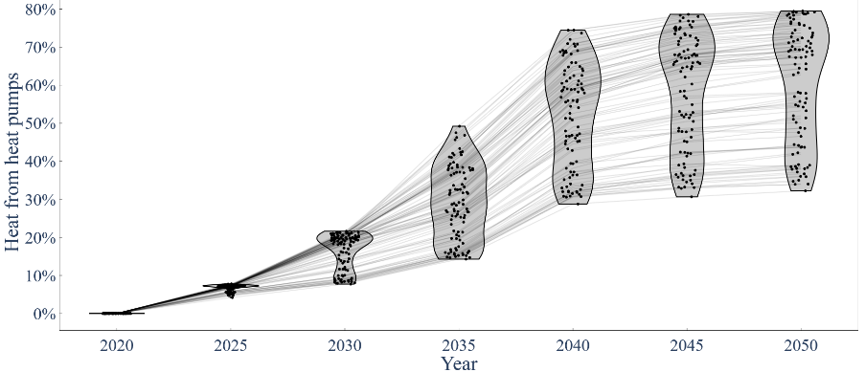
Figure 1. Share of heat provided by heat pumps across all sectors.
Heat pumps play a significant role in every scenario, providing 40 to 80 % of total heat in 2050. As shown in Figure 3, the amount of heat pump deployment is strongly correlated with the natural gas price (Pearson correlation coefficient r = 0.92), as the gas price strongly affects the operating costs of alternative heating solutions. A breakdown of heat pump deployment by sector reveals that in every run all of the low-temperature industrial heat is provided by ASHPs. Due to the assumed flat demand profile and economies of scale, heat pumps appear to be especially cost-effective there. The same applies to district heating and commercial buildings, where the demand profile is not flat, but economies of scale are still strong. GSHPs supply 52 to 97 % of heat for district heating, while ASHPs cover 32 to 72 % of the commercial demand in all scenarios. Deployment in domestic buildings depends strongly on the natural gas price. In scenarios with gas prices near the lower bound no domestic heat pumps are deployed, while in others up to 80 % of the domestic heating demand is supplied by ASHPs.
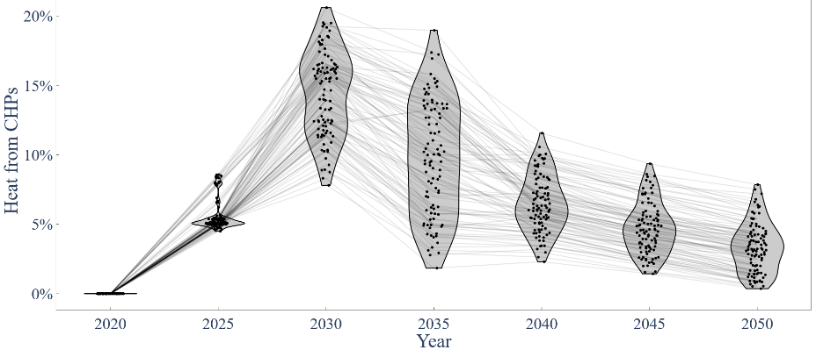
Figure 2. Share of heat provided by CHP systems across all sectors.
CHP systems appear to be especially valuable as transitional technology, as the share of heat provided from CHP systems peaks in 2030 before decreasing towards 2050. Hydrogen ICEs are not competitive; therefore, CHP systems rely mostly on natural gas and are thus associated with emissions, which need to be offset as emission constraints become tighter. Especially for district heating, in most scenarios the heat supply gradually shifts from initially a larger share of CHP systems towards a larger share of heat from GSHPs in 2050. Domestic CHP systems are too expensive and therefore not deployed in any scenario, while larger CHP systems show potential for industrial, commercial and district heating applications. In 2030, natural gas ICE CHP systems provide 16 to 61 % of industrial heat, 5 to 46 % of district heat, and 0 to 22 % of commercial heat. The natural gas price also has the biggest single impact on the degree of CHP deployment (Pearson correlation coefficient r = -0.88, see Figure 3).
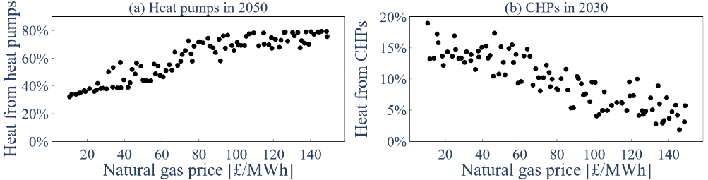
Figure 3. Correlations of (a) share of heat provided by heat pumps in 2050; and (b) share of heat provided by CHPs in 2030 with natural gas prices.
    - Integration between heat and power sectors
The deployment of heat pumps and CHP systems results in a significant integration of the heating and power sectors. The additional annual electricity demand due to heat electrification reaches 100 to 230 TWh in 2050, with peak electricity demands of 17 to 86 GW. To put this into context, the current annual peak electricity demand in the UK is about 50 GW. On the other hand, CHP systems co-generate a maximum of 8 to 15 GW of electricity in 2030, and 19 to 47 TWh annually.
The district heating sector is a good indicator for the interaction between heating and power sectors, as both heat pumps and CHP systems are utilised and can satisfy the same heat demand. CHP systems are primarily used during times of high system electricity demand, while heat pumps primarily operate at off-peak times, and at times with a high availability of renewable energy technologies.
Additionally, 31 to 136 GWh of TES capacity is deployed for district heating alone, which allows shifting electricity demand further. This is especially valuable towards the end of the time horizon when the share of CHP systems in the system is lower.
  - Conclusions
Optimal whole-energy system decarbonisation pathways for the UK have been studied using an integrated energy system optimisation model that explicitly considers the heating, electricity, and hydrogen sectors, as well as negative emission technologies. Both long-term investment decisions and short-term dispatch schedules were optimised simultaneously. A Monte Carlo approach was used to account for uncertainties in key model input parameters, such as fuel costs and capital costs of key technologies.
Heat pumps play a key role in the energy system transition, supplying 40 to 80 % of all heat in 2050. The degree of deployment mainly depends on the natural gas price, though especially for low-temperature industrial heat deployment is consistently high. CHP systems on the other hand are mainly useful during the transition, with utilisation peaking in 2030 before then declining again. District heating is consistently highly deployed.
Heat pumps and CHP systems result in a significant integration of heating and power sectors. District heating networks using both, as well as TES, provide valuable flexibility.
Acknowledgements
This work was supported by the UK Engineering and Physical Sciences Research Council (EPSRC) [grant numbers EP/R045518/1, EP/V042149/1, and EP/T033940/1]. For the purpose of Open Access, the authors have applied a CC BY public copyright licence to any Author Accepted Manuscript version arising from this submission.
References
M. Aunedi, M. Yliruka, S. Deghan, A.M. Pantaleo, N. Shah, G. Strbac, 2022, Multi-model assessment of heat decarbonisation options in the UK using electricity and hydrogen, Renewable Energy, 194, 1261-1276
V.M. Charitopoulos, M. Fajardy, C.K. Chyong, D.M. Reiner, 2023, The impact of 100% electrification of domestic heat in Great Britain, iScience, 26, 11, 108239
Department for Business, Energy & Industrial Strategy (BEIS), 2018, Clean Growth – Transforming Heating. Overview of Current Evidence.
Department for Business, Energy & Industrial Strategy (BEIS), 2021, Opportunity areas for district heating networks in the UK.
J. Dixon, K. Bell, S. Brush, 2022, Which way to net zero? a comparative analysis of seven UK 2050 decarbonisation pathways, Renewable and Sustainable Energy Transition, 2, 100016
Helen, 2023, District heat prices, https://www.helen.fi/en/heating/district-heat/district-heat-prices
P. Hoseinpoori, A.V. Olympios, C.N. Markides, J. Woods, N. Shah, 2022, A whole-system approach for quantifying the value of smart electrification for decarbonising heating in buildings, Energy Conversion and Management, 268, 115952
M. Mersch, C.N. Markides, N. Mac Dowell, 2023, The impact of the energy crisis on the UK’s net-zero transition, iScience, 26, 4, 106491
A.V. Olympios, A.M. Pantaleo, P. Sapin, C.N. Markides, 2020, On the value of combined heat and power (CHP) systems and heat pumps in centralised and distributed heating systems: Lessons from multi-fidelity modelling approaches, Applied Energy, 274, 115261
A.V. Olympios, M. Mersch, P. Sapin, A.M. Pantaleo, C.N. Markides, 2021, Library of price and performance data of domestic and commercial technologies for low-carbon energy systems, Zenodo, https://zenodo.org/doi/10.5281/zenodo.4692648
A.V. Olympios, M. Aunedi, M. Mersch, A. Krishnaswamy, C. Stollery, A.M. Pantaleo, P. Sapin, G. Strbac, C.N. Markides, 2022, Delivering net-zero carbon heat: Technoeconomic and whole-system comparisons of domestic electricity- and hydrogen-driven technologies in the UK, Energy Conversion and Management, 262, 115649
M. Pavičević, A. Mangipinto, W. Nijs, F. Lombardi, K. Kavvadias, J.P. Jiménez Navarro, E. Colombo, S. Qoilin, 2020, The potential of sector coupling in future European energy systems: Soft linking between the Dispa-SET and JRC-EU-TIMES models, Applied Energy, 267, 115100

