Mathematical Modeling of an Enzyme Catalyzed Transamination Reaction with Integrated Product Removal
Jessica Behrens ^{a,}*, Sven Tiedemann ª, Jan Von Langermann ª, Achim Kienle ^{a,b}

ª Otto-von-Guericke-University, Universitätsplatz 2, D-39106 Magdeburg, Germany
^{b} Max-Planck-Institute for Dynamics of Complex Technical Systems, Sandtorstrasse 1, D-39106 Magdeburg, Germany
* jessica.behrens@ovgu.de
Abstract
Enzyme catalyzed reactions have a big potential for the targeted synthesis of fine chemicals and pharmaceuticals. To enable the possibility of time- and resource-saving evaluation of process operation strategies computer-based process simulations can be done. This requires process models being able to reliably predict the process. In this contribution a mathematical model of the enzyme catalyzed transamination reaction for the production of (S)-(3-methoxyphenyl)ethylamine with integrated product removal is proposed and compared to preliminary experimental data. A kinetic model for the trans-aminase-catalyzed reaction is combined with a method-of-moments model for the product crystallization. The model shows great potential for representing the process and builds an important basis for future computer aided design and control strategies.
Keywords: Transaminase-catalyzed reactions, Integrated product removal, Complex mathematical model, King–Altman method, Method of moments
  - Introduction
Transaminase (TA)-catalyzed reactions combine high selectivities with mild reaction conditions and environmentally friendly solvents, and can be deployed for the synthesis of enantiomerically pure amines. However, the product conversion in these biocatalytic reactions are often constrained by an unfavorable chemical equilibrium (Gundersen et al., 2015). To enhance the process performance a variety of strategies are utilized, which range from protein engineering for higher catalytic substrate specificity, to process operation strategies like integrated product and co-product removal. An overview about the different strategies was given by Guo and Berglund (2017) and references therein. The combination of different process strategies renders a high number of degrees of freedom, which makes it time and resource consuming to find optimal operation conditions with common empirical approaches. Process models offer the possibility to study the process in a simulation environment to conduct feasibility studies, examine important process parameters and optimize the process performance. Two examples for simulation studies of process feasibility are the work of Tufvesson et al. (2014), who developed a mathematical model and investigated critical process parameters for co-product removal to estimate the substrate loss and product yields and the work of Esparza-Isunza et al. (2015), who investigated the most important process parameters for a membrane reactor system. Furthermore, process models can be used for online process observation, optimization and control.
In our work we focus on the batch process operation for the production of (S)-(3-methoxyphenyl)ethylamine (3MPEA), a valuable intermediate in the synthesis of Rivastigmine, an important drug for the treatment of Parkinson’s and Alzheimer’s disease. We aim to develop a process model that provides a basis for future model-based design and control. To our knowledge this is the first report of a process model for the production of 3MPEA. The present paper is based on the experimental results in Neuburger et al. (2021). They combined the ω-TA catalyzed reaction with integrated evaporation of the co-product and integrated crystallization of the main product 3MPEA to shift the reaction equilibrium and increase the product yield. In the following sections we will present a process model for the batch production of 3MPEA with focus on the reaction kinetics, the crystallization, donor salt dissolution, miscibility limitations of compounds and the co-product evaporation.
  - Process Model
The mechanisms of the TA catalyzed reaction with integrated product removal is schematically shown in Figure 1. There are 5 interacting thermodynamic phases in the reactor namely two solid phases, two liquid phases and a gas phase. Note, that for reasons of readability the phases are shown separately in the scheme, however, the reactor is continuously stirred and the solid and liquid phases are mixed. The enzyme (E) catalyzed reaction of isopropylamine (IPA) and 3-methoxyacetophenone (3MAP) to the co-product acetone (Ac) and the product (S)-(3-methoxyphenyl)ethylamine (3MPEA) takes place in the aqueous liquid phase. The reaction is shown in the right half of Figure 1. For more information on the biocatalyst and the chemicals, the interested reader is referred to Neuburger et al. (2021). The carbonyl compound 3MAP has a limited miscibility in the polar phase and separates into a second non-polar liquid phase. The amine donor IPA is injected into the system by the donor salt isopropylammonium 3,3-diphenylpropionate (IPA-3DPPA), which forms the first solid phase. It continuously dissolves in the polar liquid phase together with 3,3-diphenylpropionate (3DPPA). The latter acts as counter-ion for the product 3MPEA and both form the product salt (S)-(3-methoxyphenyl)-ethylamine 3,3-diphenylpropionate (3MPEA-3DPPA) by continuous crystallization. The product salt resembles the second solid phase. The co-product Ac is a volatile compound and can be removed from the process by continuous evaporation. Therefore, it leaves the
process via the gas phase. The interactions of the phases with one another are depicted by material fluxes $\dot{N}\left(t\right)$ in terms of molar amounts. To discriminate between the different phases in the process model a short nomenclature is introduced.
Liquid Phase(s)
The liquid phases are denoted by the superscript $'$. The polar liquid phase is further
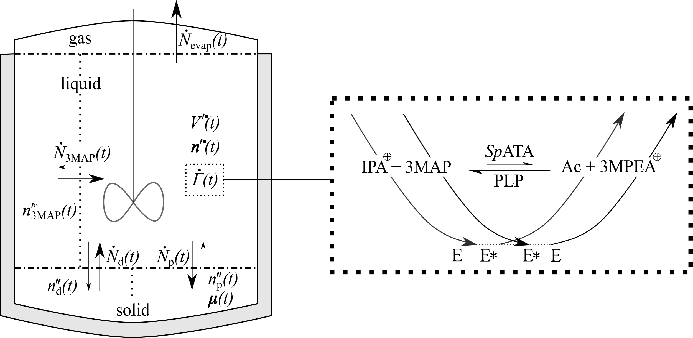Figure 1: Process scheme. The left scheme shows the batch reactor and the right scheme the chemical reaction.
denoted by the superscript $∙$ and the non-polar liquid phase by the superscript $∘$.
The molar amount vector of the compounds in the polar liquid phase is given by
$n^{'∙}\left(t\right)=\left[n_{\text{IPA}}^{'∙}\left(t\right) n_{\text{3MPEA}}^{'∙}\left(t\right) n_{\text{Ac}}^{'∙}\left(t\right) n_{\text{3MAP}}^{'∙}\left(t\right) n_{\text{3DPPA}}^{'∙}\left(t\right) n_{\text{E}}^{'∙}\left(t\right)\right]$. The non-polar liquid phase is resembled by the molar amount of excess 3MAP $n^{'∘}\left(t\right)=n_{\text{3MAP}}^{'∘}\left(t\right)$. The vector containing all molar amounts of the liquid phase is given by $n^{'}\left(t\right)=\left[n^{'∙}\left(t\right) n^{'∘}\left(t\right)\right]$.
Solid Phase(s)
The solid phases are denoted by the superscript $''$. The molar amount of the donor salt IPA-3DPPA is denoted by $n_{\text{d}}^{''}\left(t\right)=n_{\text{IPA-3DPPA}}\left(t\right)$. The molar amount of the product salt 3MPEA-3DPPA is denoted by $n_{\text{p}}^{''}\left(t\right)=n_{\text{3MPEA-3DPPA}}\left(t\right)$. The vector containing all molar amounts of the solid phase is given by $n^{''}\left(t\right)=\left[n_{\text{d}}^{''}\left(t\right) n_{\text{p}}^{''}\left(t\right)\right]$. The moments of the product salt number density distribution are denoted by
$μ_{k}\left(t\right)={\left[μ_{0}\left(t\right) μ_{1}\left(t\right) μ_{2}\left(t\right) μ_{3}\left(t\right)\right]}^{\text{T}}$.
All molar amounts are contained in $n\left(t\right)={\left[n^{'}\left(t\right) n^{''}\left(t\right)\right]}^{\text{T}}$.
2.1 Reaction kinetic
The reaction catalyzed by a ω-transaminase is known to follow a ”ping-pong bi-bi” mechanism (Walsh, 1998). The steady state reaction rate derivation is based on the schematic method of King-Altmann and Cleland. For in depth information the reader is referred to the book of Segel (1993). The formation of nonproductive complexes is neglected in this work. The reaction rate $\dot{Γ}\left(t\right)$ is given by
${\dot{Γ}}_{\text{Nom}}\left(t\right)=V_{\text{f}}V_{\text{r}}\left(c_{\text{IPA}}^{'∙}\left(t\right)c_{\text{3MAP}}^{'∙}\left(t\right)-\frac{c_{\text{Ac}}^{'∙}\left(t\right)c_{\text{3MPEA}}^{'∙}\left(t\right)}{K_{\text{eq}}}\right)$ | (1)
$${\dot{Γ}}_{Denom}\left(t\right)=V_{r}K_{m,IPA}c_{3MAP}^{'∙}\left(t\right)+V_{r}K_{m,3MAP}c_{IPA}^{'∙}\left(t\right)+V_{f}\frac{K_{m,3MPEA}}{K_{eq}}c_{Ac}^{'∙}\left(t\right)$$  $+V_{\text{f}}\frac{K_{\text{m,Ac}}}{K_{\text{eq}}}c_{\text{3MPEA}}^{'∙}\left(t\right)+V_{\text{r}}c_{\text{IPA}}^{'∙}\left(t\right)c_{\text{3MAP}}^{'∙}\left(t\right)+V_{\text{f}}\frac{K_{\text{m,3MAP}}}{K_{\text{i,IPA}}K_{\text{eq}}}c_{\text{IPA}}^{'∙}\left(t\right)c_{\text{Ac}}^{'∙}\left(t\right)$  $$+V_{\text{r}}\frac{K_{\text{m,IPA}}}{K_{\text{i,3MPEA}}}c_{\text{3MPEA}}^{'∙}\left(t\right)c_{\text{3MAP}}^{'∙}\left(t\right)+\frac{V_{\text{f}}}{K_{\text{eq}}}c_{\text{3MPEA}}^{'∙}\left(t\right)c_{\text{Ac}}^{'∙}\left(t\right)$$ | (2)
$$\dot{Γ}\left(t\right)=\frac{{\dot{Γ}}_{\text{Nom}}\left(t\right)}{{\dot{Γ}}_{Denom}\left(t\right)}V^{'∙}\left(t\right)$$ | (3)
with the forward (f) and reverse (r) rate
$$V_{\text{f}}=K_{\text{f}}c_{\text{E}}^{'∙}\left(t\right)$$ | (4)
$$V_{\text{r}}=K_{\text{r}}c_{\text{E}}^{'∙}\left(t\right)$$ | (5)
and the equilibrium constant
$K_{\text{eq}}={\left(\frac{K_{\text{f}}}{K_{\text{r}}}\right)}^{2}\frac{K_{\text{m,3MPEA}}K_{\text{m,Ac}}}{K_{\text{m,3MAP}}K_{\text{m,IPA}}}$. | (6)
The Michaelis constants are denoted by $K_{\text{m}}$ and the inhibition constants by $K_{\text{i}}$ for the respective compounds. The forward and reverse rate constant are denoted by $K_{\text{f}}$ and $K_{\text{r}}$, respectively. The reaction rate is expressed in terms of molar concentrations
$c^{'∙}\left(t\right)=\frac{n^{'∙}\left(t\right)}{V^{'∙^{\left(t\right)}}}$, where $V^{'∙}\left(t\right)$ denotes the volume of the polar liquid phase.
2.2 Crystallization – Moment model
The crystallization of the product salt 3MPEA-3DPPA is modeled by a moment model
approach (Hulbert and Katz, 1964). The crystallization kinetics are restricted to crystal
growth only. Nucleation is neglected due to seeding. The temporal evolution of the
$k$th-moment $μ_{k}\left(t\right)$ of the number density distribution of crystals is given by
$$\frac{dμ_{k}\left(t\right)}{dt}=kG\left(t\right)μ_{k-1}\left(t\right)$$ | (7)
where the crystal growth rate $G\left(t\right)$ is given by
$G\left(t\right)=\left\{\begin{aligned}k_{\text{G}}\left(S_{\text{p}}\left(t\right)-1\right)\text{ if }S_{\text{p}}\left(t\right)>1 \\ 0 \text{if }S_{\text{p}}\left(t\right)≤1\end{aligned}\right.$, $S_{\text{p}}\left(t\right)=\frac{\text{min}\left(n_{\text{3MPEA}}^{'∙}\left(t\right),n_{\text{3DPPA}}^{'∙}\left(t\right)\right)/V'∙\left(t\right)}{c_{\text{sat,p}}}$. | (8)
Crystallization of the product salt is driven by oversaturation $S_{\text{p}}\left(t\right)$ of the solutes 3MPEA and 3DPPA. The saturation concentration of the product salt is denoted by $c_{\text{sat,p}}$ ($≈$4.7 mM). Oversaturation ($S_{\text{p}}\left(t\right)>1$) is reached, when both substance concentrations in the polar liquid phase are higher than the saturation concentration. Otherwise ($S_{\text{p}}\left(t\right)≤1$) no crystal growth occurs. The growth rate constant is denoted by $k_{\text{G}}$. The flux of material for crystal growth from the liquid to the solid phase is given by
$${\dot{N}}_{\text{d}}\left(t\right)=\frac{ρ_{\text{p}}}{M_{w,\text{p}}}Φ3G\left(t\right)μ_{2}\left(t\right)$$ | (9)
and is proportional to the crystal surface, which is expressed by the second moment $μ_{2}\left(t\right)$. The shape of the crystals is assumed to resemble needles, which is considered by the shape factor $Φ$. The molar weight and density of 3MPEA-3DPPA are denoted by $M_{w,\text{p}}$
and $ρ_{\text{p}}$, respectively.
2.3 Donor Salt Dissolution and 3MAP Miscibility
In the experiments of Neuburger et al. (2021) the donor salt IPA-3DPPA and the ketone 3MAP are injected into the process. The salt, as well as the ketone show limited solubility in the liquid polar phase and therefore form additional phases. We model those as material storages and assume a continuous exchange of material from the storages to the polar liquid phase. Both mechanisms are modeled in the same way. The flux from the aqueous phase to the solid phase in the case of donor salt dissolution, and the non-polar phase in the case of 3MAP miscibility, is given by
${\dot{N}}_{\text{X}}\left(t\right)=k_{X}\left(1-S_{X}\left(t\right)\right)n_{X}$with $n_{X} =\left\{\begin{aligned}\text{min}\left(n_{X}^{'∙}\left(t\right)\right)\text{ if }S_{X}>1 \\ n_{X}^{u}\left(t\right)\text{ if }S_{X}≤1\end{aligned}\right.$ | (10)
with the flux constants $k_{\text{X}}$, subscript $X∈\{d,3MAP\}$and superscript $u∈\{^{''},^{'}∘\}$. Driving force for the material flux is the saturation $S_{\text{X}}\left(t\right)$of the compounds in the polar liquid phase
$$S_{X}\left(t\right)=\frac{\text{min}\left(n_{X}^{'∙}\left(t\right)\right)/V^{'∙}\left(t\right)}{c_{\text{sat,X}}}$$ | (11)
The saturation concentration is denoted by $c_{\text{sat,X}}$. The saturation concentration of 3MAP is given by the miscibility limit of 3MAP in the polar liquid phase ($≈$25 mM). The saturation concentration of IPA-3DPPA is the solubility concentration of the salt in the aqueous phase $(≈$55 mM). In case of donor salt storage ($S_{\text{d}}\left(t\right)>1$) the flux ${\dot{N}}_{d}\left(t\right)$ is proportional to the minimal amount of the donor salt solutes in the polar liquid phase $\text{min}\left(n_{\text{d}}^{'∙}\left(t\right)\right)=\text{min}\left(n_{\text{IPA}}^{'∙}\left(t\right),n_{\text{3DPPA}}^{'∙}\left(t\right)\right)$. Otherwise ($S_{\text{d}}\left(t\right)≤1$) it is proportional to the molar amount of the donor salt in the solid phase. In case of an oversaturated polar liquid phase in terms of 3MAP ($S_{\text{3MAP}}\left(t\right)>1$) the material flux ${\dot{N}}_{\text{3MAP}}\left(t\right)$ is proportional to the molar amount in the polar liquid phase $\text{min}\left(n_{\text{3MAP}}^{'∙}\left(t\right)\right)=n_{\text{3MAP}}^{'∙}\left(t\right).$ Otherwise ($S_{\text{3MAP}}\left(t\right)≤1$) the flux is proportional to the molar amount of 3MAP in the non-polar phase.
2.4 Evaporation
The co-product Ac is a volatile compound and can be removed from the process by evaporation. In the experiments of Neuburger et al. (2021) this is achieved by pressure reduction. Based on their data they conclude that low pressures of about 300 mbar are enough to remove the co-product Ac and record their data under reduced pressure conditions. Therefore, it is assumed that the produced Ac is entirely and instantaneously removed from the aqueous phase
${\dot{N}}_{\text{evap}}\left(t\right)=\dot{Γ}\left(t\right)$. | (12)
2.5 Reactor Model
This concludes our model of the process, which is given by
$\frac{dn\left(t\right)}{dt}=\left[\begin{matrix}-1 & 1 & \begin{matrix}0 & 0 & 0\end{matrix} \\ 1 & 0 & \begin{matrix}0 & -1 & 0\end{matrix} \\ \begin{matrix}1 \\ -1 \\ \begin{matrix}0 \\ 0 \\ \begin{matrix}0 \\ 0 \\ 0\end{matrix}\end{matrix}\end{matrix} & \begin{matrix}0 \\ 0 \\ \begin{matrix}1 \\ 0 \\ \begin{matrix}0 \\ -1 \\ 0\end{matrix}\end{matrix}\end{matrix} & \begin{matrix}\begin{matrix}0 \\ 1 \\ \begin{matrix}0 \\ 0 \\ \begin{matrix}-1 \\ 0 \\ 0\end{matrix}\end{matrix}\end{matrix} & \begin{matrix}0 \\ 0 \\ \begin{matrix}-1 \\ 0 \\ \begin{matrix}0 \\ 0 \\ 1\end{matrix}\end{matrix}\end{matrix} & \begin{matrix}-1 \\ 0 \\ \begin{matrix}0 \\ 0 \\ \begin{matrix}0 \\ 0 \\ 0\end{matrix}\end{matrix}\end{matrix}\end{matrix}\end{matrix}\right]$ $\left[\begin{matrix}\dot{Γ}\left(t\right) \\ {\dot{N}}_{d}\left(t\right) \\ \begin{matrix}{\dot{N}}_{\text{3MAP}}\left(t\right) \\ {\dot{N}}_{p}\left(t\right) \\ {\dot{N}}_{\text{evap}}\left(t\right)\end{matrix}\end{matrix}\right],$ $\frac{dμ_{k}\left(t\right)}{dt}=kG\left(t\right)μ_{k-1}$ | (13)
  - Results and Discussion
The process model is fitted to two data sets presented in Neuburger et al. (2021). We use their first data set of the time evolution of the product salt concentration for different biocatalyst loadings (see Figure 2 in Neuburger et al., 2021). However, only measure-ments of the product salt concentration are not sufficient to reliably parameterize the full process model. In a first approximation we use literature values to parameterize the reaction kinetic from a very similar biocatalytic reaction reported in Al-Haque et al. (2012). They propose a robust methodology for the parameter estimation for a biocatalytic reaction kinetic. Their final results are used in this study and given in Table 1. However,
Neuburger et al. (2021) use a different biocatalyst for what reason $K_{\text{f}}$ is estimated from their experimental data. Note that $K_{\text{r}}$is linked to $K_{\text{f}}$ via $K_{\text{eq}}$ and thus differs from Al-Haque et al. (2012) as well. Additionally, the constants $k_{\text{G}}$, $k_{\text{d}}$and $k_{\text{3MAP}}$ are fitted to the experi-mental data. The model is fitted to the data set of 40 U/ml and 60 U/ml, where the parameters were estimated such that the quadratic error between the data points and simulation is minimized. The third set with 80 U/ml is used for validation. The data fit is shown in Figure 2 with the mean estimation error $\overline{E}$. Additionally, the time evolution of the concentrations and molar amounts of the different phases are given for the simulation result with 80 U/ml. Note, that the illustration of Ac is omitted. The simulation of the time evolution of the product salt concentration is in good agreement with the experimental data. The time evolution of the polar liquid phase shows that the concentration of 3MAP is decreasing even though the amount of 3MAP in the non-polar phase is nonzero and thus constantly mixing into the polar phase. A similar dynamic can be observed for the donor salt and its solutes. This is caused by the small estimated diffusion rate $k_{\text{3MAP}}$ and $k_{\text{d}}$, which might be a hint for a lowered 3MAP miscibility or mixing effects and an interesting phenomenon to be analyzed in future experiments. However, the predictive capabilities of the model are limited and the results should be cautiously interpreted. Further individual investigation on the reaction, crystallization and evaporation dynamics need to be done to guarantee a well parameterized process model.
param. | 1/s | param. | mM | param. | mM | param.
$$K_{\text{f}}$$ | 1.05e-2 | $$K_{m,\text{Ac}}$$ | 148.99 | $$K_{m,\text{IPA}}$$ | 101.28 | $$k_{G}$$ | 0.2175$\frac{mm}{s}$
$$K_{\text{r}}$$ | 1.78e-2 | $$K_{m,\text{3MAP}}$$ | 1.85 | $$K_{i,\text{IPA}}$$ | 4.281 | $$k_{\text{3MAP}}$$ | 3.132e-5$\frac{1}{s}$
$$k_{d}$$ | 8.8e-7 | $$K_{m,\text{3MPEA}}$$ | 0.12 | $$K_{i,\text{3MPEA}}$$ | 1e5 | $$K_{\text{eq}}$$ | 0.033
Table 1: Model parameter. The reaction kinetic parameters are taken from Al-Haque et al. (2012). The highlighted values are fitted to experimental data (Neuburger et al., 2021).
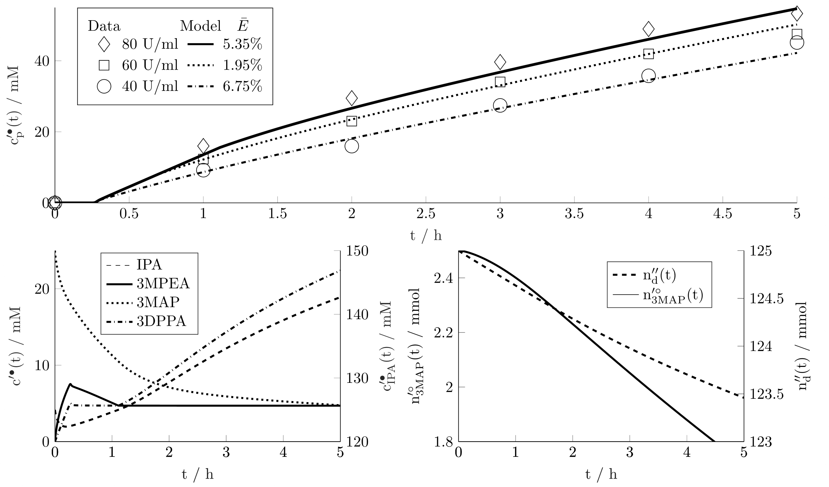
Figure 2: Simulation results. The data is taken from Neuburger et al. (2021). For the simulation with 80 U/ml the time evolution of the concentrations and molar amounts is shown in the lower figures.
  - Conclusion
In this contribution a mathematical model for the batch production of (S)-(3-methoxy-phenyl)ethylamine is presented. The model links the transaminase catalyzed reaction with product crystallization and co-product evaporation. The model shows good agreement with experimental data and builds a basis for further model refinement. In future work we aim to fully parameterize the model and suggest optimal operation strategies for the production of 3MPEA. Furthermore, we aim to use the model for online process observation and to develop process control strategies.
Acknowledgment
We would like to thank Deutsche Forschungsgemeinschaft (DFG, German Research Foundation) for funding our research with the project ID 501735683.
References
N. Al-Haque, P. A. Santacoloma, W. Neto, P. Tufvesson, R. Gani, J. M. Woodley, 2012, Biotechnol. Prog., 28 (5), 1186-1196.
T. Esparza-Isunza, M. González-Brambila, R. Gani, J. M. Woodley, F. López-Isunza, 2015, Chemical Engineering Journal, 259, 221-231.
M. T. Gundersen, R. Abu, M. Schürmann, J. M. Woodley, 2015, Tetrahedron: Asymmetry, 26, 10-11, 567-570.
F. Guo, P. Berglund, 2017, Green Chem., 19, 333-360.
H. M. Hulburt, S. Katz, 1964, Chem. Eng. Sci., 19, 555-574.
J. Neuburger, F. Helmholz, S. Tiedemann, P. Lehmann, P. Süss, U. Menyes, J. v. Langermann, 2021, Chemical Engineering and Processing - Process Intensification, 168, 108578.
I. H. Segel, 1993, Enzyme kinetics: Behavior and Analysis of Rapid Equilibrium and Steady-State
Enzyme Systems, Wiley Classics Library, ISBN: 978-0-471-30309-1.
P. Tufvesson, C. Bach, J. M. Woodley, 2014, Biotechnol. Bioeng., 111, 2, 309-319.
C. Walsh, 1998, Enzymatic Reaction Mechanisms, W. H. Freeman & Co, ISBN:‎ 0716700700.

