Optimal design of an energy-integrated biogas-powered fuel cell system
Vikram Uday, Sujit Jogwar
Department of Chemical Engineering, Indian Institute of Technology Bombay Mumbai-40076, India
jogwar@iitb.ac.in
Abstract
This paper presents an optimal energy-integrated biogas-SOFC system for renewable electricity generation. It explores the impact of biogas upgradation (CO₂ removal) on the material and energy integration between bio-hydrogen production and subsequent power generation. To this end, optimal design of an upgraded biogas system with partial external/internal reforming and co-generation via steam turbine is considered. With the help of two optimization problems - feed minimization and operating cost minimization, along with energy integration using pinch analysis, an optimal energy-integrated system is developed. The proposed design offers 4.4% improvement in net electrical efficiency over a previously reported design.
Keywords: Process design, optimization, SOFC, heat integration, renewable electricity
  - Introduction
Recent push towards sustainable practices has led to increased activity in the area of renewable power production. Biogas has a key role to play in this context as it serves as a source of renewable hydrogen, which can be subsequently converted into electricity using a fuel cell (Galvagno et al 2013). Thus biogas-based power system consists of two steps – biogas reforming for hydrogen production and electrochemical conversion to generate power. Efficient material and energy integration of these steps is crucial in achieving optimal efficiency of the overall process (Uday and Jogwar, 2023).
Biogas contains significant amount of CO₂ which does not have any fuel value. On the contrary, it promotes dry reforming which can have detrimental effect on the fuel cell anode, it dilutes process streams and thus leads to increased capital and operating cost. To this end, biogas upgradation by CO₂ removal has been proposed in literature (Baldienelli, et al., 2017). Among the available biogas upgradation technologies, membrane separation technology is noted as the most cost-effective (Makaruk et al., 2010). Upgradation via membrane separation requires biogas compression and thus can increase capital and operating cost. However, the existing studies exploring this option lack formal optimization to systematically analyze the trade offs associated with biogas upgradation and energy integration strategy to improve system efficiency.
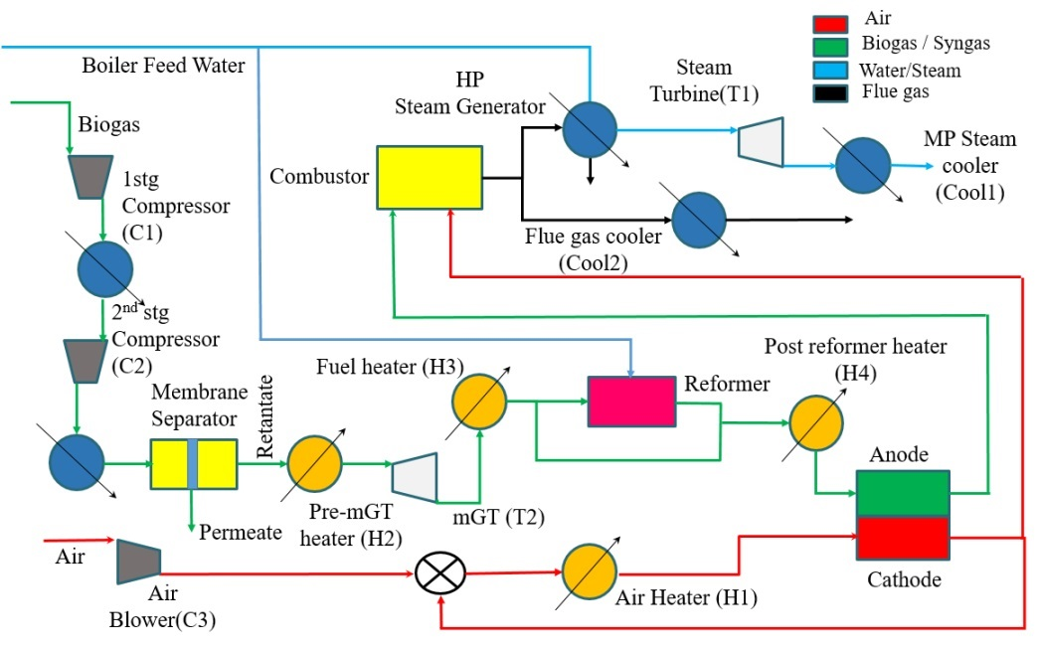
Motivated by this, we explore the impact of biogas upgradation on the integrated biogas-SOFC system using optimization. Firstly, optimal material integration is achieved by solving a feed minimization problem. The heating and cooling demands of this process are matched using pinch analysis to determine the structure of energy integration. Subsequently, operating cost minimization problem is solved to arrive at the optimal integrated flowsheet. Additional features like cogeneration using steam turbine or micro gas turbine, possibility of pre-reforming or cathode gas recycle are also included in the design process. The rest of the paper is organized as follows. Section 2 describes the considered system. Section 3 presents the formulation of the two optimization problems. Section 4 presents key results and comparison with the literature design.
Figure 1: Integrated biogas - SOFC system
  - Process description
The considered process is depicted in Figure 1. Clean biogas is supplied into the process via air blower or a compressor (C3). Biogas is compressed using two compressors (C1) and (C2) with inter-stage and after-stage coolers. The compressed biogas is fed to the membrane separator wherein CO₂ preferentially permeates from the system. The high pressure retentate is expanded over the micro gas turbine (T2) to generate auxiliary power and subsequently sent for reforming. The bypass stream around the reformer controls the relative extents of external and internal reforming. The hydrogen-rich gas from reformer enters the anode section of the SOFC. A part of the cathode exit gas can be recycled back to achieve material and energy integration. The rest of the cathode and anode gas exiting the fuel cell are sent to a combustor. A part of the hot flue gas from the combustor is used to generate high pressure steam, which subsequently generates power through a turbine (T1). The rest of the flue gas can be used to meet heating demands of the process.
The performance of the integrated process is quantified through the net electrical efficiency which is defined as the ratio of the total output electrical power to the thermal energy fed to the system. It is computed using the following equation.
$$η_{net-elec}=\frac{{P_{SOFC} η}_{DC/AC }+ \sum_{j}{W_{turb,j }}- \sum_{j}{W_{comp,j }} }{n_{feed}LHV_{BG}+Q_{HU}}$$ | (1)
where $P_{SOFC}$ and $W_{turb}$ refer to power generation via SOFC and turbine, respectively. $W_{comp}$ refers to power consumption by compressors. $n_{feed}$ represents the biogas feed rate, $LHV_{BG}$ represents the heating value of biogas and $Q_{HU}$ represents the hot utility consumption in the process.

3. Optimization problem formulation
The optimal design of the integrated system involves obtaining operating parameters for each of the process units as well as synthesizing the structure of the heat exchanger network (HEN) for energy integration. As these two tasks are inter-connected, a three-step approach is pursued. In the first step, a base case design with material integration is developed by solving a feed minimization. In the next step, the hot and cold streams are extracted from this design and HEN structure is synthesized using pinch analysis. Subsequently, in the third step, the HEN is integrated with the base case design and optimized for minimization of operating cost. The key decision variables and the corresponding trade-offs are given below.
- SOFC operating pressure (${Pr}_{SOFC})$: High SOFC pressure favors high open circuit voltage and SOFC efficiency, however, it results in increased power consumption in air compressor and lower power production via micro gas turbine.
- SOFC operating temperature ($T_{SOFC}$): High SOFC temperature reduces voltage losses in SOFC, requires less airflow to carry exothermic heat and exit gases have high energy integration potential. However, it reduces open circuit voltage and increases hot utility consumption.
- SOFC Fuel utilization factor ($U_{f}$): It represents the fractional conversion of hydrogen via the electrochemical reaction. A high value of $U_{f}$ increases power generation from the SOFC. However, it leads to increased current density and voltage losses as well as an increase in airflow to maintain SOFC temperature.
- SOFC Air utilization factor ($U_{a}$): It represents the fractional conversion of oxygen in the SOFC. A low value of $U_{a}$ allows for better heat management in SOFC; however, it results in increased air compression power and dilution at cathode.
- Reformer temperature ($T_{ref}$): High reformer temperature results in increased CH₄ conversion and H₂ yield, subsequently leading to high cell voltage and SOFC power generation. However, it also increases the heat load of the reformer and reduces the net electrical efficiency.
- Reformer S/C ratio ($SCR$): A high value of SCR increases H₂ yield. However, it also dilutes the anode gas leading to lower open circuit voltage and increased hot utility for steam generation.
- Reformer bypass fraction ($f_{byp}$): This fraction controls the extents of external and internal reforming. While external reforming results in high hydrogen partial pressure in the SOFC, it also suffers from increased utility requirements and difficult thermal management in the SOFC. On the other hand, direct internal reforming provides better synergy between endothermic reforming and exothermic electrochemical reactions, but results in lower partial pressure of hydrogen and cell voltage.
- Flue gas split fraction ($f_{split}$): This fraction manages the extents of internal energy integration and auxiliary power production via steam turbine. A high fraction going to the steam generator increases turbine power contribution and unloads the SOFC. However, it limits internal energy integration and increases hot utility consumption.
- Cathode gas recycle fraction ($f_{CGR}$): A high value of cathode gas recycle fraction reduces the fresh air flow and the corresponding heating and compression loads. However, it causes dilution of cathode gas and reduces cell voltage.
Eq. (2) describes the feed minimization problem. The optimization variables ($x$) are the decision variables mentioned above. The key equality constraints are material and energy balance equations for each process unit. The key inequality constraint corresponds to net power production and target ($P_{target}$) matching.
$$\min_{x}{n_{feed}}$$  Subject to: Material and energy balance of each unit  $P_{target}≤P_{SOFC}+\sum_{j}{W_{turb,j}}-\sum_{j}{W_{comp,j }}$  $x_{min}≤x≤x_{max}$ | (2)
Eq. (3) describes the operating cost minimization problem. Stream split fractions are included as additional decision variables and two set of constraints are included to ensure feasibility of heat transfer. $C_{biogas}$, $C_{HU}$ and ${∆T}_{min}$ represent cost of biogas, cost of hot utility and the minimum approach temperature.
$$\min_{x,s}{C_{biogas}n_{feed}+C_{HU}\sum_{k}{Q_{H,k}}}$$  Subject to: Material and energy balance of each unit  $P_{target}≤P_{SOFC}+\sum_{j}{W_{turb,j}}-\sum_{j}{W_{comp,j }}$  $${ T}_{H,in,j}-T_{C,out,j}≥{∆T}_{min}$$  $${ T}_{H,out,j}-T_{C,in,j}≥{∆T}_{min}$$  $x_{min}≤x≤x_{max}$ | (3)
Both these NLP problems are formulated on GAMS platform and solved using Baron.
  - Results and discussion
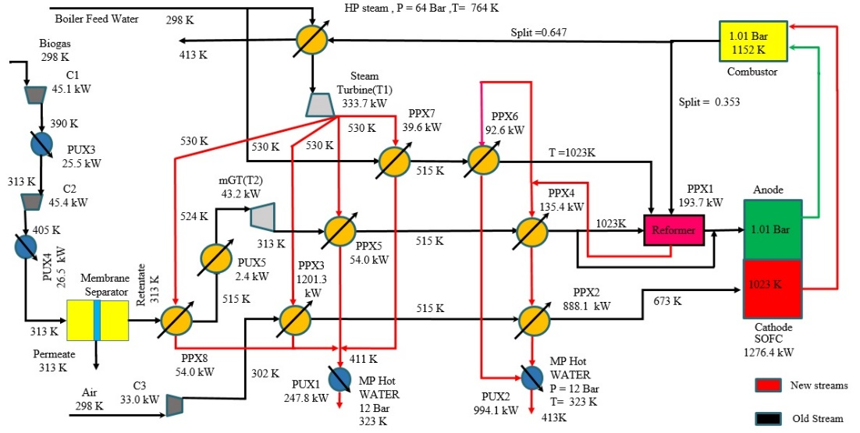
In order to compare with the existing design (Baldienelli et al, 2017), biogas feed composition is taken as 55% CH₄, 35% CO₂ and 10% N₂. A power target of 1402 kW is considered. The solution of the feed minimization problem is given in Table 1. The optimal solution recommends sending only 37% of the upgraded biogas for internal reforming. The SOFC operates at ambient pressure, highest possible temperature and maximum allowed fuel utilization. Similarly, the reformer operates at the highest temperature and minimum SCR. The cathode gas recycle option is not selected as the dilution effects outweigh the integration benefits. As there is no penalty on hot utility consumption, the entire flue gas is used power generation and thus the contribution of SOFC towards the target power is 56%. However, high utility requirement of 6362 kW results in low net electrical efficiency of 17.8%. The corresponding HEN utilizes the heat available with the steam turbine condensate to meet some of the heating demands. This increases the efficiency to 24.4%. In order to determine the energy integration potential of the flue gas, the feed minimization problem was solved without including the steam turbine. The corresponding solution is also presented in Table 1. For this case, the entire heating demands are met by the flue gas and the corresponding net electrical efficiency increases to 41.8%. However, the feed requirement increases by 115%. This suggests that there is an optimal split for the flue gas to achieve a balance between power production.and meeting heat demands. This is essentially exploited by the operating cost minimization problem. The HENs obtained for the first two solutions are merged with to obtained the final energy integration scheme.
Figure 2: Optimal integrated flowsheet
Table 1: Details of optimal solutions
Variable | Feed minimization | Feed minimization without Steam turbine | Operating cost minimization
Operating cost ($/y) | 6,713,449 | 3,904,547 | 2,983,511
$$η_{net-elec}(\%)$$ | 17.8 | 41.8 | 54.67
$P_{SOFC}$(kW) | 782.3 | 1677.3 | 1276.4
$W_{turb,stm}$ (kW) | 782.3 | 0 | 333.7
$W_{turb,gas}$ (kW) | 26.3 | 56.5 | 43.2
$W_{comp}$(kW) | 110.7 | 164.3 | 123.7
$n_{feed}$ (mol/s) | 3.542 | 7.608 | 5.808
$n_{air}$ (mol/s) | 291.4 | 239.7 | 174.3
$n_{BFW}$ (mol/s) | 109.307 | 3.817 | 46.29
${Pr}_{SOFC}$ (bar) | 1.01(LB) | 1.01(LB) | 1.01(LB)
$T_{SOFC}$ (K) | 1073(UB) | 1073(UB) | 1073(UB)
$$U_{f}$$ | .85(UB) | .85(UB) | .85(UB)
$$U_{a}$$ | .054 | .140 | .0.147
$T_{ref}$ (K) | 1023(UB) | 1023(UB) | 1023(UB)
$$SCR$$ | 2(LB) | 2(LB) | 2(LB)
$$f_{byp}$$ | 0.631 | 0.459 | 0.289
$$f_{split}$$ | 1 | 0 | 0.647
$$f_{CGR}$$ | 0 | 0 | 0
The integrated flow sheet resulting from the cost minimization problem is illustrated in Figure 2. It is worth noting that the key system variables like SOFC temperature and pressure, fuel utilization factor, reformer temperature and S/C ratio approach the same bounds as the feed minimization case. The major deviation is in the flue gas split fraction. It can be noted that 65% of the flue gas is directed for power generation and the rest is utilized to meet the energy demands of the process. The exit of the steam turbine provides preheating duty for some of the cold steams. It is interesting to note that the fraction of upgraded biogas going for internal reforming (71%) has increased as compared to the first design (37%). This helps reduce the heating demand for reforming reactions and thus provides a balance between heat integration and auxiliary power production. In the optimal flowsheet, the SOFC contributes to 91% of the target power. Due to effective heat integration, only 2.4 kW of hot utility is required. The synergy between the SOFC and the steam turbine makes the system largely independent of external heat sources, resulting in a substantial increase in net electrical efficiency (54.7%), along with an optimal operating cost of $2,983,511/y. As compared to the flowsheet with feed minimization, there is 67.5% reduction in the operating cost.
Let us now compare the proposed flowsheet with a reported design (Baldienelli et al, 2017). The reported flowsheet does not include micro gas turbine or a steam turbine. Instead, the combustion is carried out at elevated pressure and the flue gas is expanded over a turbine. Only direct internal reforming is considered and energy integration is implemented in an ad hoc manner. In order to meet the same power target of 1402 kW, the reported process requires 6.1 mol/s biogas feed and results in an operating cost of $3,109,758/y with the net electrical efficiency of 52.5%. It can thus be noted that the proposed design reduces the operating cost by 4.1% and improves the net electrical efficiency by 4.2%. This improvement can be linked to increased auxiliary power production, better coordination between external and internal reforming and efficient energy integration.
  - Conclusions
In this paper, an optimal design for a biogas-based fuel cell system is presented. The option of biogas upgrading is considered and its impact on the overall process design is systematically analyzed through formal optimization. The effect of various design alternatives like external versus internal reforming, cathode gas recycle, auxiliary power production via steam turbine is evaluated and it is shown that the trade-offs associated with these options play a significant role in the synthesis of the optimal flowsheet. Specifically, an optimal value of the extent of pre-reforming and the fraction of flue gas enthalpy used for power generation or energy integration is required to minimize the operating cost or maximize the net electrical efficiency. The synergy between the SOFC and the steam/gas turbine towards meeting power target also results in optimal net electrical efficiency. The proposed design results in 4.1% reduction in operating cost and 4.2% increase in net electrical efficiency as compared to a reported design.
References
A. Baldinelli, L. Barelli, G. Bidini, 2017, Upgrading versus reforming: An energy and exergy analysis of two Solid Oxide Fuel Cell-based systems for a convenient biogas-to-electricity conversion, Energy Conversion and Management, 138, 360-374.
A. Galvagno, V. Chiodo, F. Urbani, F. Freni, 2013, Biogas as hydrogen source for fuel cell applications, International Journal of Hydrogen Energy, 38, 3913–3920.
A. Makaruk, M. Miltner, M. Harasek, 2010, Membrane biogas upgrading processes for the production of natural gas substitute, Separation and Purification, 74(1), 83-92.
V. Uday and S. S. Jogwar, 2023, Optimal design of an integrated biogas-based fuel cell system, Industrial and Engineering Chemistry Research, submitted for publication.

