Process Integration of Urea Production with Methane Pyrolysis for Reduced Carbon Emissions
Muhamad Reda Galih Pangestu,ª Umer Zahid ^{a,b*}

ªDepartment of Chemical Engineering, King Fahd University of Petroleum and Minerals, Dhahran 31261, Saudi Arabia
^{b}Interdisciplinary Research Center for Membranes & Water Security, King Fahd University of Petroleum & Minerals, Dhahran 31261, Saudi Arabia
uzahid@kfupm.edu.sa
Abstract
The increasing global population is expected to drive a surge in fertilizer demand in the future. However, traditional ammonia-urea production methods, such as steam methane reforming (SMR), contribute significantly to greenhouse gas (GHG) emissions. The purpose of this study was to mitigate CO₂ emissions during an unbalanced plant load of ammonia and urea, which leads to a CO₂ vent. The introduction of methane pyrolysis (MP) enabled the continuous production of ammonia and urea while concurrently generating marketable solid carbon black as a co-product.
A detailed SMR-ammonia production plant was simulated using Aspen Plus v11 software. The MP unit was then integrated into SMR by splitting the natural gas feed after the sulfur removal unit. Several schemes were conducted to find the most preferable scenario for the industries. The schemes vary in the splitting ratio of natural gas feed to SMR and MP. Techno-economic analysis from this study demonstrates favorable results when incorporating methane pyrolysis into current SMR-ammonia-urea plants. This includes a significant reduction in CO₂ emissions by 71.70% compared to the base case. In a scenario with a carbon black revenue of $0.5/kg and a carbon tax of $20/ton-CO₂e, diverting 15% of the natural gas feed into a methane pyrolysis integration unit could yield an extra annual profit of up to $1.6 million.
Keywords: Ammonia, CO₂ emission, Methane pyrolysis, SMR, Urea.
  - Introduction
Urea is the most widely used nitrogen fertilizer globally. The increasing global population is expected to drive a surge in fertilizer demand in the future. The International Fertilizer Association (IFA) predicts that in 2027, nitrogen-based fertilizer demand will reach 115 million tons or increase by around 9% from 2022 (International Fertilizer Association, 2023). However, traditional ammonia-urea production methods, such as steam methane reforming (SMR) are known as one of the main contributors to greenhouse gas (GHG) emissions. SMR is a highly energy-intensive process that uses natural gas as a raw material to produce hydrogen, which is then used to synthesize ammonia (Pruvost et al., 2022). Ammonia then could be converted to urea.

In recent years, there has been growing interest in developing more sustainable urea production methods. One promising approach is to integrate methane pyrolysis (MP) into the existing SMR-Ammonia-Urea process plant. Methane pyrolysis is a thermochemical process that converts methane into hydrogen and solid carbon in the temperature range of 600 – 1,400 °C. The hydrogen produced from methane pyrolysis can synthesize ammonia, while the solid carbon can be sold as a valuable byproduct (Fromm, 2023). The integration of methane pyrolysis with SMR offers several potential benefits, such as (i) reduced CO₂ emissions: unlike SMR, MP doesn’t have CO₂ as a byproduct; (ii) increased production flexibility: The integrated system can continuously produce ammonia and urea, while also generating marketable solid carbon; (iii) improved economic performance. The sale of solid carbon can offset the cost of methane pyrolysis, making the integrated system more economically viable.

Numerous recent studies indicate that the MP reaction can occur both with and without a catalyst. When employing catalysts, the fluidized bed reactor (FBR) emerges as the optimal option for solid catalysts, typically those based on Nickel, while liquid metal bubble column (LMBC) reactors find application for liquid catalysts, including metals like Ni-Bi or combinations with salts such as KBr (Fan et al., 2021). In the case of non-catalytic reactions, Monolith's plasma reactor has successfully reached an early commercial scale. It is crucial to note that variations in temperature and catalyst choice lead to distinct types of solid carbon co-products (Korányi et al., 2022).

Methane pyrolysis (MP) is a developing technology that has nearly reached a large-scale commercial production plant. However, integrating SMR with MP in an ammonia-urea plant is a new research area. This study will focus on developing the process design for the integration, whereas there are numerous possibilities regarding the splitting of natural gas feed, utilizing the gas product of the MP reactor, including the heat integration. A detailed simulation model of the integrated system is developed using Aspen Plus software. The simulation results are analyzed to assess the environmental and economic performance of the system.
  - Process description
    - Conventional SMR-Ammonia-Urea unit (base case)
Natural gas undergoes pretreatment to eliminate sulfur impurities. The purified gas is then compressed and combined with steam in a certain ratio before being injected into the primary reformer. The steam methane reforming (SMR) process typically employs a nickel catalyst and operates within a temperature range of 800 – 1,000 °C (Katebah et al., 2022). The SMR reaction is followed by the water-gas shift (WGS) reaction, as shown in Reactions (1) and (2).
$CH_{4}+H_{2}O→ {3H}_{2}+CO$ | (1)
$CO+H_{2}O→H_{2}+ CO_{2}$ | (2)
${3H}_{2}+N_{2}→ 2NH_{3}$ | (3)
${2NH}_{3}+{CO}_{2}→ CO{\left(NH_{2}\right)}_{2}+H_{2}O$ | (4)
Reaction (1) + (2) yields hydrogen and carbon dioxide, collectively termed synthesis gas or syngas. The syngas, along with any remaining unreacted gases are subsequently mixed with air to produce ammonia through ammonia synthesis as shown in the Reaction (3). The ammonia synthesis reaction is also endothermic and requires the presence of a catalyst. This process is widely recognized as Haber-Bosch (Ojelade et al., 2023).
Approximately 98% of the produced ammonia and almost all the carbon dioxide co-product are diverted to the urea plant for urea production via an exothermic reaction (4). Urea synthesis demands a high-pressure reactor (150-200 bar) and a temperature range of 180 – 200 °C. Figure 1 provides an overall block diagram of this production process.
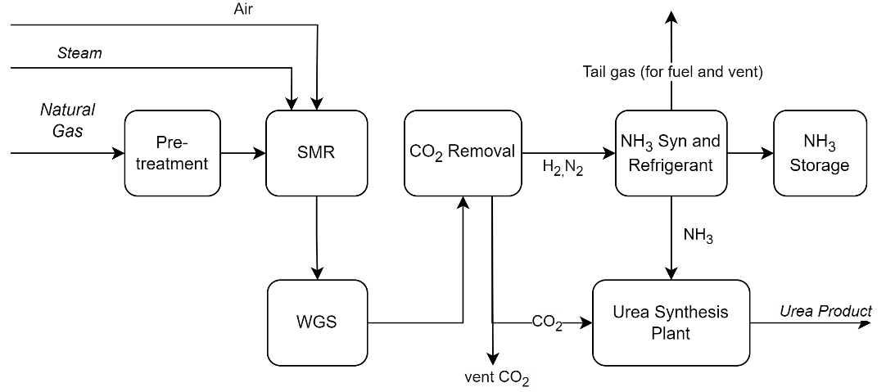
Figure 1. SMR-Ammonia-Urea production overview.
Typically, industrial ammonia and urea plants are designed to operate at full capacity, ensuring a well-balanced production process that prevents the release of CO₂ from the ammonia plant into the atmosphere. These plants are engineered to fully convert the CO₂ co-product from the ammonia plant into urea in the urea plant, with only a minimal amount being vented for safety purposes. However, operational challenges often hinder the achievement of perfect balance within these plants.

Moreover, it is common for companies with ammonia and urea plants also to sell liquid ammonia to their customers. Given that excess ammonia is stored in ammonia storage, retaining it without sales is impractical. During periods of heightened ammonia sales and dwindling storage levels, it becomes necessary to increase the ammonia plant's load or maintain it at full capacity, while simultaneously decreasing the load on the urea plant to replenish ammonia storage levels. Consequently, 15 – 25% of CO₂ can be released into the atmosphere during operational adjustments (SABIC Agri-Nutrients Company, 2022).

    - Methane Pyrolysis and SMR Integration (proposed design)
Methane pyrolysis technology could be a promising solution for balancing ammonia and urea production without worrying about carbon dioxide venting. Methane pyrolysis converts methane into hydrogen gas and solid carbon with or without the help of a catalyst (Fromm, 2023). The methane pyrolysis reaction is shown in reaction (5).
$CH_{4}→ {2H}_{2}+C\left(s\right)$ | (5)
Integrating methane pyrolysis (MP) with steam methane reforming (SMR) process would result in the controlling of hydrogen and carbon dioxide products. Additionally, methane pyrolysis gives valuable solid carbon co-products that can be sold to reduce the overall ammonia and urea production cost. The integration process block diagram is shown in Figure 2.
Techno-economic analysis was conducted for this integration. Detailed methodology and results are discussed in the section below.

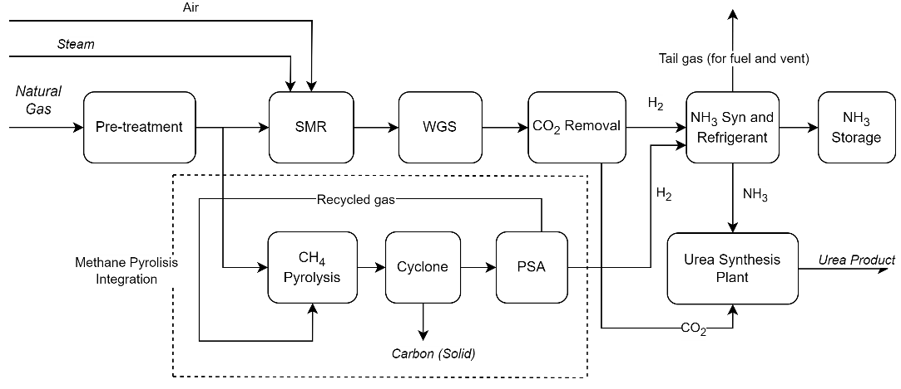
Figure 2. Methane Pyrolysis (MP) integration in SMR-Ammonia-Urea production. Splitting natural gas feed to SMR and MP will control the CO₂ emission.
  - Methodology
The techno-economic analysis was conducted through simulation using Aspen Plus software v11 and the Aspen Process Economic Analyzer (APEA) to evaluate the feasibility and economic viability of the proposed methane pyrolysis integration in the SMR-ammonia-urea production process.
    - Model Basis and Assumptions
The SMR-ammonia plant model was built with a capacity design of 1,000 t/d ammonia production from 21,540 kg/h natural gas feed then the methane pyrolysis unit was integrated into the same flowsheet. Several assumptions are taken into consideration:
- The model is under steady-state conditions.
- The properties method used is RKS-BM for ammonia and methane pyrolysis simulation while for the urea plant using SR-POLAR properties.
- Natural gas (NG) feed pressure is 11 bar and temperature 32 ºC with composition in dry mol basis: CH₄ = 91%; C₂H₆ = 2.88%; N₂ = 2.54%; CO₂ = 1.83% and a small amount of C3, C4, and sulfur.
- Air composition was fixed at 78% mol of N₂, 21% mol O₂ and 1% mol argon.
- The 1,725 t/d urea plant was modeled employing Aspen Plus.
- The reference plant was assumed to only utilize 85% of CO₂ from the ammonia plant to be converted into urea product (SABIC Agri-Nutrients Company, 2022).
- Solid carbon coproduct from methane pyrolysis is carbon black.
    - Economic Analysis
Capital cost was annualized with operational cost (including raw material and utility costs) in every scheme. It was assumed that the natural gas price was $ 6.00/MMBTU; ammonia and urea selling prices were $550/ton and $390/ton respectively. Profit estimation was conducted using a carbon black revenue assumption of $0.5/kg (market value range of 0.4 – 2.0 $/kg) and a carbon tax policy of $20/ton-CO₂e. It also assumed that the operation days in a year is 330 days.
  - Results and Discussion
The integrated simulation of methane pyrolysis and the SMR-ammonia-urea plant was successfully conducted and converged in Aspen Plus v11. Production and emission comparisons from several schemes are shown in Figure 3.

Figure 3. Production and emission outcomes among various schemes: the baseline plant without integration (ORI), MP1 means 15% integration, MP2 is 20%, and MP3 is 30% integration.
All the methane pyrolysis (MP) integration schemes (MP1 to MP3) could reduce the CO₂ emission to around 71.70% (160 kt-CO₂/y) compared to the base case (ORI) emission (223 kt-CO₂/y). The reduced annual CO₂ (160 kt/y) only came from flue gas emissions. MP1 with 15% integration or 15% of natural gas feed directed to MP will result in similar urea production to the base case with additional solid carbon black product (C-PROD) but less ammonia excess. MP2 and MP3 with a higher integration scheme (20% and 30%) will give less urea and less ammonia compared to the base case, but they will give more carbon black products.

Profit estimation and comparison for each scheme are shown in Table 1. The base case shows a good profit revenue with a CO₂ tax policy of $20/ton. However, the MP1 scheme shows the highest profit. The MP1 scheme with 15% natural gas splitting promises an additional profit of 1.6 million USD annually than the base case (ORI). A higher integration scheme (e.g., MP3) will produce more carbon black coproduct but produce less urea. This scheme gained the lowest profit for the assumed product prices scenario but could become the highest profit scheme if the carbon black price increases.
Table 1 Economic comparison for different integration schemes with a solid carbon revenue of $0.5/kg and a CO₂ tax assumption of $20/ton
 | AN.OP.COST | UREA PROD | NH3 EXCS | CO2E EMS | C-PROD | PROFIT EST
 | $/Y | T/Y | T/Y | T/Y | T/Y | $/Y
ORI | 107,988,109 | 483,863 | 55,166 | 223,171 | 0 | 90,880,419
MP1 | 110,506,513 | 483,863 | 30,416 | 159,984 | 17,820 | 92,536,470
MP2 | 109,122,880 | 455,400 | 38,333 | 159,984 | 23,760 | 88,134,654
MP3 | 106,360,780 | 398,475 | 54,166 | 159,984 | 35,640 | 79,474,222

The results also reveal that the annualized operational cost for integration schemes MP1 and MP2 was slightly higher than ORI due to the additional utilities and maintenance costs for the methane pyrolysis unit. However, in the MP3, the operational cost is lower due to the lower load of the urea plant (less energy consumption).
  - Conclusions
Based on the techno-economic analysis conducted, methane pyrolysis integration in existing SMR-ammonia-urea plants shows promising results for lowering CO₂ emissions to 71.70% compared to the existing plant. For a carbon black revenue of $0.5/kg and a carbon tax of $20/ton-CO₂e scenario, splitting 15% of the natural gas feed into a methane pyrolysis integration unit (MP1 scheme) would result in an additional annual profit of up to $1.6 million per year.
Acknowledgment: The authors would like to acknowledge the support provided by the Deanship of Research Oversight and Coordination (DROC) at the King Fahd University of Petroleum and Minerals (KFUPM).
References
Fan, Z., Weng, W., Zhou, J., Gu, D., & Xiao, W. (2021). Catalytic decomposition of methane to produce hydrogen: A review. Journal of Energy Chemistry, 58, 415–430.
Fromm, C. (2023, November 1). Hydrogen Production via Methane Pyrolysis: An Overview of “Turquoise” Hydrogen. https://www.chemengonline.com/hydrogen-production-via-methane-pyrolysis-an-overview-of-turquoise-h2/?printmode=1
International Fertilizer Association. (2023). Public Summary Medium-Term Fertilizer Outlook 2023-2027. https://api.ifastat.org/reports/download/13912
Katebah, M., Al-Rawashdeh, M., & Linke, P. (2022). Analysis of hydrogen production costs in Steam-Methane Reforming considering integration with electrolysis and CO2 capture. Cleaner Engineering and Technology, 10, 100552.
Korányi, T. I., Németh, M., Beck, A., & Horváth, A. (2022). Recent Advances in Methane Pyrolysis: Turquoise Hydrogen with Solid Carbon Production. In Energies (Vol. 15, Issue 17). MDPI.
Ojelade, O. A., Zaman, S. F., & Ni, B. J. (2023). Green ammonia production technologies: A review of practical progress. In Journal of Environmental Management (Vol. 342). Academic Press.
Pruvost, F., Cloete, S., Arnaiz del Pozo, C., & Zaabout, A. (2022). Blue, green, and turquoise pathways for minimizing hydrogen production costs from steam methane reforming with CO2 capture. Energy Conversion and Management, 274, 116458.
SABIC Agri-Nutrients Company. (2022). Performance and Activities of the Company for the Fiscal Year 2021. https://www.sabic.com/en/investors/performance-financial-highlights/annual-report

