Economic Analysis of Liquid Air Energy Storage Systems
Shaylin A. Cetegenª, Truls Gundersen^{b}, Paul I. Bartonª
ªProcess Systems Engineering Laboratory, Dept. of Chemical Engineering, Massachusetts Institute of Technology, Cambridge, MA 02139, United States
^{b}Department of Energy and Process Engineering, Norwegian University of Science and Technology (NTNU), Kolbjørn Hejes Vei 1B, NO-7491, Trondheim, Norway
pib@mit.edu
Abstract
Liquid air energy storage (LAES) is a clean and scalable long-duration energy storage technology capable of delivering multiple GWh of energy storage. The inherent locatability of LAES systems unlocks nearly universal siting opportunities for grid-scale energy storage, which were previously unavailable with traditional technologies such as pumped hydro energy storage (PHES) and compressed air energy storage (CAES). While the technical viability of LAES systems has been demonstrated [1], its economic viability has not yet been established across a broad range of electricity markets. In this work, we perform a high-level economic analysis of LAES systems across various United States domestic and international markets under current levels of renewable energy penetration to provide baseline estimates of LAES economic viability. By simultaneously optimizing the design and operation of LAES systems to maximize their net present value over the project lifespan, we can deliver a yes/no indication of the economic viability of these systems. Our results enable comparison of the economic viability of LAES systems operating in different regions and provide detailed insights into their economic dynamics that can aid in the development of supportive policy and economic incentives to encourage further adoption of LAES. A sensitivity analysis is also performed to provide a better understanding of the potential economic benefit of co-locating LAES systems with other processes to boost LAES round-trip efficiencies by making efficient use of otherwise wasted heating/cooling resources.

Keywords: energy storage, grid-scale energy storage, liquid air energy storage, mixed-
integer linear programming, optimization
  - Introduction
Grid-scale energy storage demand is increasing due to the growing adoption of renew-
able energy sources, which are intermittent and require reliable storage solutions to en-
sure a continuous and stable power supply [2]. PHES and CAES currently supply over 96% of global grid-scale energy storage capacity; however, due to their location constrained nature, both PHES and CAES face severely limited expansion opportunities moving forward. Thus, alternative grid-scale energy storage solutions, such as LAES, are sought to meet growing demand.
  - Background
LAES is a thermo-mechanical grid-scale energy storage technology that serves to balance supply and demand of the electric grid while generating revenue via arbitrage. LAES systems charge when the energy supplied to the grid exceeds demand (i.e., when electricity prices are low) and discharge when demand exceeds supply (i.e., when electricity prices are high). LAES systems operate by intaking ambient air from the atmosphere, cleaning and drying it, compressing it to high pressure through a multi-stage compression train, and cooling it to a liquid state using one or more multi-stream heat exchangers. The liquid air is then stored in insulated tanks at atmospheric pressure and very low temperature (~ 90 K), typically for durations of several hours to days with negligible losses over these periods. Later, when energy demand exceeds supply, the liquid air is pumped out of storage, evaporated/heated, and passed through a multi-stage expansion train with reheating, which drives a generator to recover power. The round-trip efficiency (RTE) of standalone LAES systems currently stands at around 60 %. Hot and cold thermal storages, which recycle compression heat released during charging and high-grade cold generated from exchange with cold air during discharging, are critical to achieving LAES efficiencies over 50 % and thus, are an essential feature of all practical LAES system designs. A high-level flowsheet of the LAES process is shown in Figure 1.

Several key features of LAES make it an attractive grid-scale energy storage solution. First, unlike other energy storage technologies, such as Li-ion batteries and CAES, no rare-earth minerals or carbon emissions are required by or produced through the operation of LAES systems. Second, the unique locatability of LAES unlocks, for the first time, nearly universal siting opportunities for grid-scale energy storage. Third, there exist significant opportunities to co-locate LAES systems with other processes (e.g., waste industrial heat and LNG regasification) to make efficient use of otherwise wasted heating/cooling resources, which can significantly boost LAES RTEs. While the technical viability of LAES has been established in the literature, with reported RTEs of up to 68.2 %, the economic viability of LAES systems has yet to be rigorously established across the broad range of markets in which it could theoretically be implemented [1, 3]. To this end, we perform an economic assessment of LAES systems in several United States (US) domestic and international markets. The sensitivity of LAES economic performance to improvements in RTE resulting from co-location with liquefied natural gas (LNG) regasification is also explored to elucidate the potential value of LAES-LNG co-location.

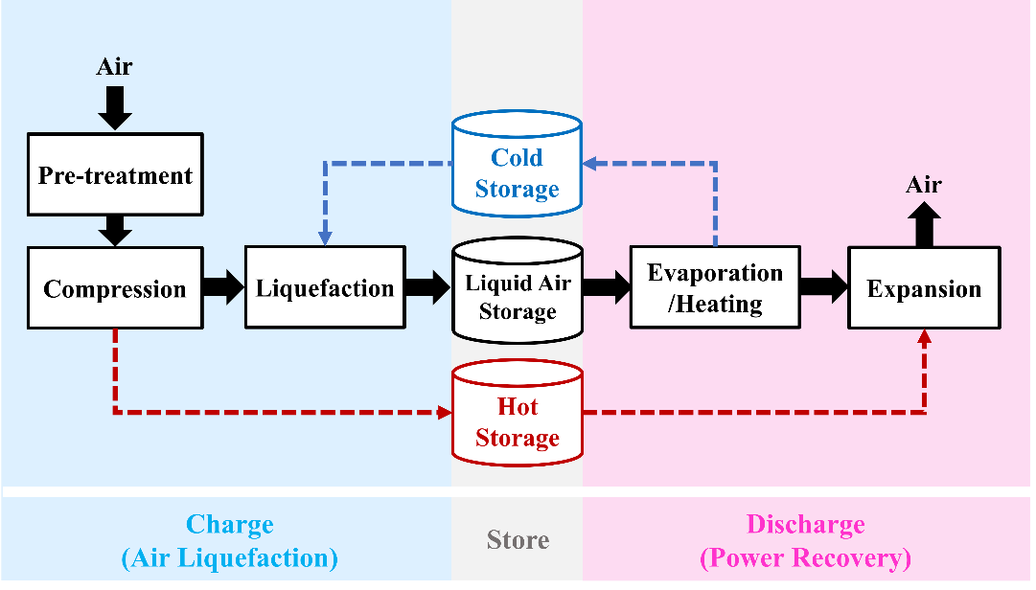
Figure 1: A standalone liquid air energy storage system with hot and cold thermal recycle.
  - Methods
To perform long-term economic optimization of LAES systems in several US domestic and international electricity markets, a mixed-integer linear program (MILP) was formulated to maximize the net present value (NPV) of an LAES system over its expected lifespan. Hourly locational marginal price (LMP) profiles were derived from historical data obtained from the official source for each considered load zone of all US independent system operators (ISOs) or European/Asian transmission system operators (TSOs) and supplied to the optimizer to calculate revenue generation from arbitrage - the strategic buying and selling of electricity over time for profit. The generated electricity price profiles, which contain hourly LMPs for a representative day of each month of the year, are repeated annually over the project horizon. This is likely to yield a conservative estimate of the economic viability of LAES systems because it does not consider an increasing supply of renewables over time, which is expected to result in increased opportunities for arbitrage profitability.

In the optimization formulation, the design and operation of LAES systems are simultaneously optimized to maximize the NPV of the LAES system. The decision variables for this problem were the power rating of the system and the operating schedule of the system over its expected lifespan. A RTE of 60 % was assumed for all systems considered herein, unless otherwise noted, as this efficiency is presently achievable for LAES. A storage capacity of 8 hours (i.e., 800 MWh of storage for a 100 MW system) was used for all systems in this study; however, this can be changed easily by manipulating a parameter in the optimization model. The capital expense (CAPEX) model used for all systems is given by Eq. (1), where $v_{l}$ is the $l^{th}$ element of a user-defined vector of feasible system power ratings and $y_{l}$ is a binary variable used for capacity selection.

$CAPEX\left(y_{l}\right)=5.2307{\left(\sum_{l=1}^{n_{l}}{v_{l}y_{l}}\right)}^{0.76532}$ (1)

This model, which delivers reasonable CAPEX values of 30 - 178 million US dollars (USD) for 10 - 100 MW LAES systems, respectively, was derived from CAPEX estimates available in the literature and was linearized for use in the MILP [1]. Annual operating expenses (OPEX) were set, based on literature estimates, to equal 3 % of the CAPEX for all systems [4]. The MILP formulation contains constraints enforcing single-mode operation, over-cycling prevention, and feasible operation at all times. The objective function is the NPV of the project. This function accounts for CAPEX and OPEX, revenue generation via arbitrage, corporate taxes, tax credits (assumed 30% investment tax credit on all systems) depreciation (5-year modified accelerated cost recovery system depreciation schedule), and cashflow discounting. In order to compare systems of equivalent size across markets, in cases when the optimal NPV was initially found to be nonpositive, the design was fixed at a power rating of 100 MW for the power recovery unit (PRU) and the operating schedule was optimized to obtain the highest possible NPV.
  - Results
The optimization results for LAES systems in 19 load zones across three US ISOs, 27 European TSOs, and two load zones of the Korean TSO are summarized in Figure 2. All NPVs are reported in 2023 US dollars. The best-performing system identified in this study was the system in the WEST load zone of the ERCOT market, located in Texas, which had an NPV of $10.4 million. The positive NPV for this system is likely due to the
Table 1: Optimal solution of LAES system in the WEST load zone of the ERCOT market.
Parameter | Value
Optimal NPV | $10,429,900
PRU Power Capacity | 100 MW
ALU Power Capacity | 50 MW
Storage Capacity | 800 MWh
CAPEX | $177,498,800
Annual OPEX | $5,325,000
Annual Revenue | $20,325,400
Installed Cost | $222/kWh
Levelized Cost of Storage (LCOS) | $119/MWh

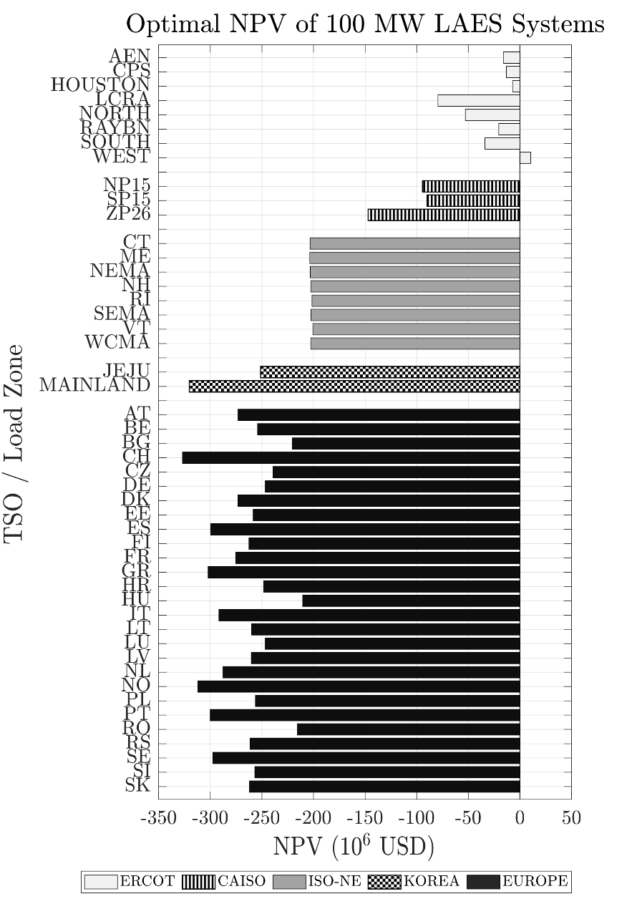

Figure 2: Optimal NPVs of 100MW/800MWh LAES systems in multiple load zones of three US ISOs, two load zones of the Korean TSO, and 27 European TSOs.
combined effects of a deregulated market and high penetration of wind energy in the ERCOT-WEST load zone. The positive NPV indicates that LAES is presently economically viable in this location. The optimal solution for this system is summarized in Table 1 and the levelized cost of storage (LCOS) for this system is $119/MWh, which is within range of the 100 – 150 $/MWh estimates reported by Highview Power, a UK-based company leading LAES implementation efforts. It is interesting to note that the LCOS of the ERCOT-WEST system is lower than the $150/MWh LCOS of Li-ion batteries, which agrees with the recent findings of Vecchi and Sciacovelli (2023).

While the optimal NPVs of a 100 MW / 800 MWh LAES system were negative in all but one of the studied locations, it is important to note that significant increases in NPV are expected to result when an increasing supply of renewables over time is considered in such an analysis. Nevertheless, useful insights can still be gained from these results. For instance, the large range of optimal NPVs identified in the ERCOT, CAISO, KOREA, and EUROPE markets highlight the importance of informed load zone selection. Based on our results, if a US ISO wanted to build an LAES system within their network, informed load-zone selection could result in up to a 39 % or 113 % increase in NPV in the CAISO and ERCOT markets, respectively, compared to a system operating in the worst performing load zone of that market. Each of the markets considered herein has a unique mix of renewables with different levels of renewable penetration at the market and load-zone levels. However, overall, throughout this study, it was observed that locations with high levels of renewable supply are generally best-suited for LAES implementation and that the positive economic influence of any improvements in RTE or potential economic incentives such as CAPEX subsidies are amplified in these regions.

While RTEs above 60 % may be challenging to achieve for standalone LAES systems presently, RTEs of over 100% are theoretically achievable for this technology through co-location with other processes. A unique feature of the Korean market considered in this study is that Korea currently has seven LNG regasification terminals – six on the mainland and one on Jeju Island. The concept of utilizing high-grade cold exergy that is released during LNG regasification to reduce the energy requirement of air liquefaction for LAES has been studied in the literature. Several studies of proposed co-located LAES-LNG systems report RTEs of roughly 70 - 190 % [1, 5].

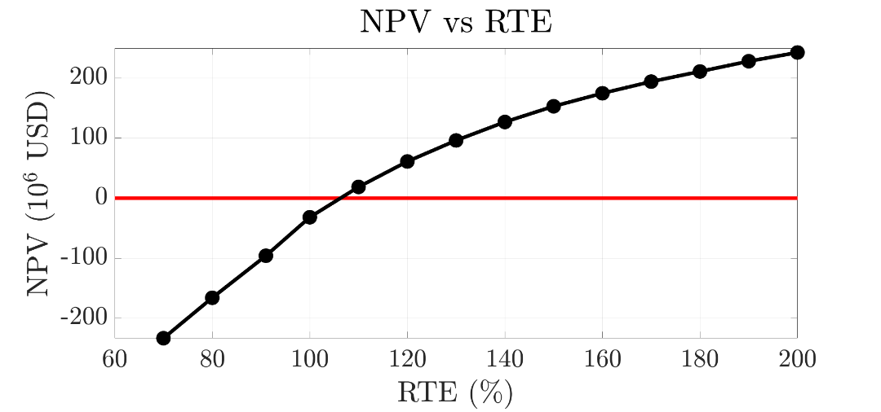
Figure 3: A study of the effect of RTE on NPV for co-located LAES-LNG systems in South Korea’s Jeju Island load zone.
A sensitivity analysis on co-located LAES-LNG systems located in Korea was performed to gain a better understanding of the economic benefits of LAES-LNG co-location. Optimization was performed for 100 MW / 800 MWh LAES-LNG systems with RTEs ranging from 70 - 200 %, as shown in Figure 3. A 10 % increase in CAPEX was included for these systems to account for the added cost of LAES-LNG system interconnections. The air liquefaction unit (ALU) power rating was also adjusted to satisfy a charging time to discharging time ratio of 2:1, as there are typically twice as many hours per day available for charging. A $1250/kW increase/decrease in CAPEX was made based on the deviation of the ALU power rating from the 50 MW ALU for which the original CAPEX function was formulated. As expected, the increased RTEs of co-located LAES-LNG systems results in higher NPVs. Interestingly, while a 60 % RTE standalone LAES system is not presently economically viable in Korea based on our results, a 110+ % RTE co-located LAES-LNG system is. Since achieving these efficiencies is viable today, further investigation into LAES-LNG co-location, including an updated analysis accounting for an increased supply of renewables over time should be explored.
  - Conclusions
In this study, economic optimization of LAES systems was performed across a broad range of US domestic and international markets to gain insights into LAES on both the global (i.e., market) and local (i.e., load zone) levels. Through this study, the economic viability of LAES was established for the WEST load zone of the ERCOT market in Texas. The ability of our approach to serve as a useful planning tool to inform LAES siting was also demonstrated by up to 113 % improvements in NPV achieved through informed load-zone selection. Our results also showed that while standalone LAES systems may not presently be economically viable in Korea, co-located LAES-LNG systems with RTEs above 110 % are, indicating that significant RTE increases attributable to efficient use of otherwise wasted heating/cooling resources from a variety of processes are likely to merit further inquiry.
References
[1] A. Vecchi, Y. Li, Y. Ding, P. Mancarella, & A. Sciacovelli, (2021). Liquid air energy storage (LAES): A review on technology state-of-the-art, integration pathways and future perspectives. Advances in Applied Energy, 3, 100047.
[2] O. Edenhofer, R. Pichs-Madruga, Y. Sokona, K. Seyboth, S. Kadner, T. Zwickel, … & P. Matschoss, (Eds.). (2011). Renewable energy sources and climate change mitigation: Special report of the intergovernmental panel on climate change. Cambridge University Press.
[3] Z. Liu & T. Gundersen. (2022, November 18). Liquid Air Energy Storage – Optimization Opportunities. Presentation presented at 2022 American Institute of Chemical Engineers Annual Meeting, Phoenix, AZ.
[4] T. Liang, T. Zhang, X. Lin, A. Tafone, M. Legrand, X. He, ... & Y. Ding. (2022). Liquid air energy storage technology: a comprehensive review of research, development and deployment. Progress in Energy.
[5] J. Park, S. Cho, M. Qi, W. Noh, I. Lee, & I. Moon (2021). Liquid air energy storage coupled with liquefied natural gas cold energy: Focus on efficiency, energy capacity, and flexibility. Energy, 216, 119308.
[6] A. Vecchi, & A. Sciacovelli, (2023). Long-duration thermo-mechanical energy storage–Present and future techno-economic competitiveness. Applied Energy, 334, 120628.

