Emission oriented scheduling optimization for sustainable processes
Alessandro Di Pretoro^{a*}, Ingy Tageldin^{a,b}, Ludovic Montastrucª
ªLaboratoire de Génie Chimique, Université de Toulouse, CNRS/INP, Toulouse, France
^{b}Technische Universität München, Department of Chemistry, Lichtenbergstraße 4, Garching b. München 85748, Germany
alessandro.dipretoro@ensiacet.fr
Abstract
As a consequence of the continuously increasing attention towards the environmental transition, a considerable mutation of the respective roles between energy and chemicals can be detected in the process industry. This aspect is of non-negligible importance when it comes to decide how to manage the plant sections from an operational perspective. The conventional design of a chemical production plant is based on a given productivity target to be achieved and the duty consumption is adapted consequently. However, this approach is not suitable whether the main focus of a chemical plant is to keep the emissions as low as possible. Whether the purpose of the plant is to use a chemical molecule as energy storage, the usual economic criteria for scheduling optimization could be replaced by new one allowing to take the maximum advantage from renewable energy availability. In this study, the possibility to operate a biomethanol production plant with a sustainable approach according to renewables availability trend is investigated from the design and sizing phase till the production scheduling one. The related emissions are assessed in terms of Global Warming Potential in order to verify the net emitted equivalent CO₂ and minimize it until negative emissions are achieved by this process. This methodology showed good results and proved not only that negative emissions chemical plants are possible but, more importantly, that the sustainability of a process is mainly a matter of methodology. Beyond this preliminary study, this approach is worth further investigation in order to extend the emission-based operation management to the entire production from raw materials supply to final product delivery.
Keywords: demand-side management, scheduling, methanol, renewables.
  - Introduction
The conventional procedure for chemical process scheduling has usually been based on optimization methods able to maximize the economic income for a given product demand to meet. This methodology relies on the principle of unconstrained availability of the energy source and prioritizes economics with respect to other aspects of the process system. However, in case sustainability results to be the major concern of the chemical industry, this approach does not ensure the lowest possible environmental impact. In fact, in order to be certain that the required demand is satisfied, at least one of the exploited energy sources should be largely available with no interruption in the supply. This is obviously not the case of renewable energy, whose nature is variable both in terms of peak power and overall quantity. The consequence of this inconsistency between fixed demand and renewables is the impossibility of ensuring at the same time the most sustainable and the most profitable and satisfactory production system.
However, since the current major concern of the industrial sector is to meet the emissions target fixed by the European Union for 2050 (UE, 2019), the study of the most sustainable process solutions has seen a considerably renewed interest in the engineering domain, even at the cost of a lower income. Based on the previous premises, it becomes evident that scheduling optimization is a fundamental step to achieve the best process operation with respect to renewable energy sources availability. For this reason, Demand-Side Management has become one of the most critical tools in the Process Systems Engineering domain to make the environmental transition a viable solution from both a qualitative and quantitative point of view (Shariatzadeh et al., 2015).
Therefore, in order to reverse the conventional design approach where productivity is targeted as first objective and, for a fixed production layout, emissions are minimized at a second stage, the ideal case of carbon-free utilities coupled with a negative emission chemical plant needs to be studied more in depth. Moreover, this operation layout could be also exploited as a potential storage of renewable energy into chemicals and it could be seen as the highest CO₂ removal potential scenario for the specific process.
Based on this premises, in this research work, a preliminary analysis of the renewable-based scheduling is carried out by using solar energy as CO₂ free source. However, since for safety reason some processes cannot be completely switched off when solar energy is not available, a second scenario exploiting biomass as backup duty is also evaluated and the comparison between the two scenario is performed. The negative emissions case study selected to test this methodology is the biogas-to-methanol process whose details are provided in the next section.
  - Case study
    - Biogas-to-methanol process

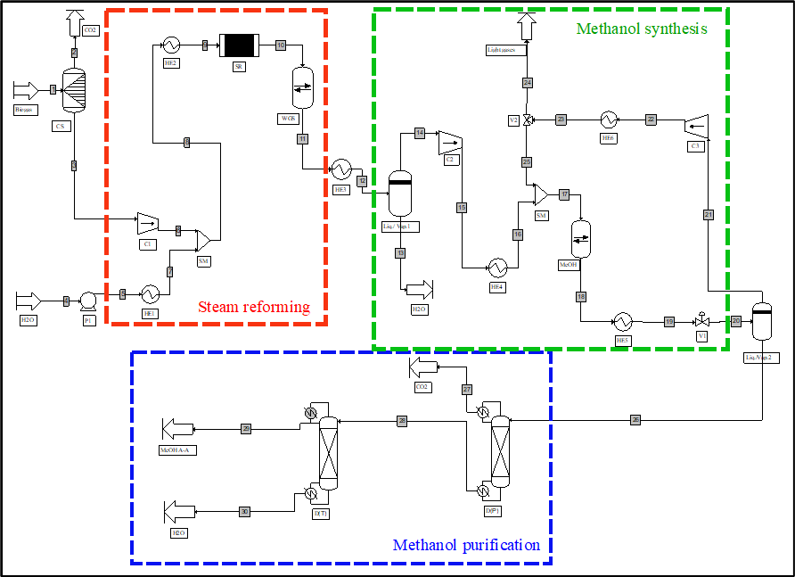
Figure 1 Biogas-to-methanol simulation flowsheet and sections
The selected case study for this research work is the biogas-to-methanol process. The reason behind this choice is based on the fact that it both allows to partially convert CO₂ into methanol (Fedeli et al., 2022) and serves as a power-to-chemical process able to store renewable energy by exploiting chemicals as energy vectors. A simplified flow scheme of the process simulation is presented in Figure 1. As it can be noticed, the plant includes three section as follows: (i) a preliminary steam reforming section where the biogas transformation into biosyngas is carried out; (ii) the reaction section and (iii) the purification section to obtain methanol at the grade AA purity (i.e. 0.9985 w/w). In this specific study, in order to assess the worst case conditions in terms of potential emissions, a layout without any process integration solution is considered. It is finally worth remarking that the case study choice is not restrictive since the proposed methodology can be applied to any process whose carbon balance on the process side is negative.
    - Renewables energy sources
As concerns the utility side, the selected renewable and backup energy sources are solar power and biomass respectively. Solar irradiation trend is the leading criteria for the plant operation scheduling. For this study, data retrieved from Global Solar Atlas concerning Toulouse (43.6047° N, 1.4442° E) were used to outline the average direct irradiation availability trend over the day for each month (cf Figure 2). As a reference for the nominal operating conditions, calculations will be carried out with the trend of August, but the procedure keeps being of general validity independently of the selected month. Details concerning the operation and the energy efficiency are better discussed in the next section. On the backup energy source side, as already mentioned, biomass is used for power and steam generation. The biomass properties in terms of specific net heating value and specific emissions (Phyllis) are provided in Table 1 along with those related natural gas, that is used as a reference value.
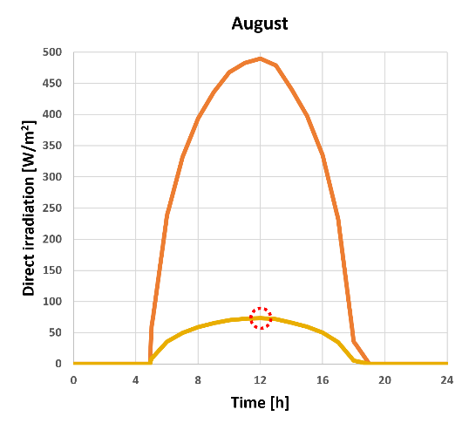
Figure 2 – Average hourly profiles for all months (left) and details for August (right)
Table 1 – Energy sources physical properties
Backup energy nature | Net Heating Value | Unit | Specific emissions | Unit
Photovoltaic | 400 | W/panel | / | kg_{CO2}/kg
Natural gas | 51 600 | kJ/kg | 2.75 | kg_{CO2}/kg
Biomass | 13 000 | kJ/kg | 0,0055 | kg_{CO2}/kg
In the ideal case, the process should be running only when solar power is available according to its intensity but, for safety and operational reasons (Mbatha et al., 2021), this is not always possible. However, the overall process could result in overall negative emissions even if part of the energy comes from non-renewable sources according to a proper scheduling. The methodology to evaluate the environmental indicator known as Global Warming Potential and the details concerning the emission-oriented optimal scheduling strategy are provided in the following section.
  - Methodology
    - Scheduling
With regards to the solar energy availability for scheduling, an overall panel efficiency equal to 15% is considered to assess the effective available solar power per panel unit surface (cf yellow trend in Figure 2 – left). On the process side, in case the reactor cannot be switched off due to the safety and operational constraints, biomass is burnt for steam generation in order to ensure the process functioning at the 10% of its design capacity (Mbatha et al., 2021). However, if the reactor is seized according to the peak energy availability, every time that the solar power falls below this minimum threshold, the biomass source needs to be used to provide the backup duty. As a consequence, the normalized daily energy consumption of the process can be calculated as:
$$E_{tot}=\frac{1}{W_{peak}⋅24}⋅\int_{0}^{24}{W\left(t\right)⋅dt}$$ | (1)
where W_{peak} is irradiation value corresponding to the process design operating conditions, W is the maximum between the available irradiation power and the 10% backup energy threshold and, finally, 24 is the conversion coefficient between day and hours.
However, since photovoltaics have zero specific emissions while backup energy sources correspond to a positive value, the backup energy fraction E^{backup} should be evaluated separately in order to assess the overall balance as better explained in the next section.
    - Emissions calculation
The calculation of the overall environmental impact is carried out by accounting for both process and utility side. To be more precise, the equivalent CO₂ balance is calculated as:
$${GWP}_{tot}=\frac{E^{backup}}{{\hat{E}}^{biomass}}⋅{\hat{CO}}_{2,eq}^{biomass}+CO_{2}^{products}-CO_{2}^{feed}$$ | (2)
where the ${CO}_{2}^{products}$ term accounts for the carbon dioxide content in all process streams leaving the system while ${\hat{E}}^{biomass}$ and ${\hat{CO}}_{2,eq}^{biomass}$ are respectively the biomass specific net heating value and emissions. As concerns the backup energy term ${\hat{E}}^{backup}$, it is different from zero only in case the 10% of the operating conditions should be maintained.
As a final step, the value obtained by equation (2) is normalized with respect to the CO₂ fed to the process side in order to assess the percentage of net converted CO₂ of the process according to the equation:
$$\hat{GWP}=\frac{GWP_{tot}}{CO_{2}^{feed}}$$ | (3)
where the specific $\hat{GWP}$ value, whether negative can be considered as carbon dioxide removal potential. The detailed calculation result is presented in the following section.
  - Results
As a first result, the relative fraction of renewable and backup sources that are used as process duty can be assessed (cf Figure 3). In particular, the yellow curve represents the part of the total solar radiation (i.e. 15%) that is converted into energy by the photovoltaic panels while the green line corresponds to safety threshold, i.e. 10% of nominal operating conditions. In this case, the optimal scheduling trajectory follows the solar power availability curve with the exception of the part where the yellow trend falls below the minimum operating conditions threshold, in this case the backup energy source is used. In particular, three regions can be identified: (i) the yellow region where only photovoltaic power is used, (ii) a hybrid region where both solar irradiation and biomass are employed as energy sources and (iii) a green region where no solar power is available and only biomass is used to ensure the 10% of the operation capacity. From a graphical point of view, the total amount of energy is represented by the integral of the power over the operating time, i.e. the area below the operating curves. The relative weight of the three different utility sources is then quantified as 89% solar only, 1% hybrid and 10% biomass.
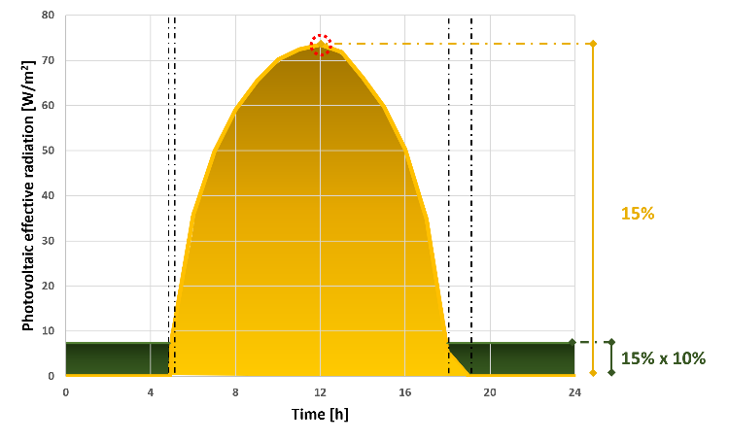
Figure 3 – Daily distribution of different energy sources (yellow-solar, green-biomass)
Given the relative weight of each region, the CO₂ removal potential for the different scenarios can be easily quantified according to the values provided in Table 2. If the process can be thoroughly scheduled according to the availability trend of solar irradiation, the 80% of the CO₂ in the feed is converted into methanol with no carbon dioxide production on the utility side. For this specific process, the -80% value also represents the minimum boundary that cannot be overcome without adjusting the operating conditions. For instance, even in case of an energy integrated configuration, the result would still be the same since the emissions related to the duty are equal to zero.
On the other hand, the worst case scenario (i.e. 100% natural gas as energy source) would generate 4231% of the amount of CO2 fed to the methanol reactor.
Table 2 – Relative emissions vs. energy source
Backup energy nature | CO₂ removal  [kg/kg in the feed] | Percentage of use
Photovoltaic | -80% | 100%
Biomass | 290% | 10.5%
Natural gas | 4231% | 10.5%
When weighing this value with the renewable energy one according to the percentage of use, the overall process emissions would be 340% in case of natural gas used as backup energy source. Finally, when using biomass as backup utility, an intermediate value equal to -41% is obtained. This value comes from the combination of 290% biomass emissions and -80% of solar power weighed with respect to their percentage of use. As a final remark, although the obtained value in the latter case could considerably vary according to the selected biomass, it should always stay within the renewable and natural gas interval [-80, 340]%.
  - Conclusions
The main scope of the presented research work is to evaluate, in terms of sustainability, the effectiveness of an ideal emission-oriented operation scheduling where only renewable energy sources are employed for the production of methanol.
Based on the obtained results, some relevant conclusions can be drawn. First, the maximum carbon removal potential of negative emission processes, obtained by its conversion into chemicals, can be quantitatively assessed with respect to the capacity of the plant. To be more precise, it is achieved for a process scheduling that thoroughly follows the availability of the renewable energy source that is used. Second, whether the system could not be continuously switched on and off for safety or process control reasons, the integration of a backup energy source, such as biomass, can be accounted for by applying analogous calculation. Finally, the proposed procedure can be used to detect the most suitable locations that maximize the CO₂ removal potential for the given process according to the geographical availability of the selected renewable energy source.
Given the positive outcome of this approach, in terms of future perspectives, utilities of different nature as backup option could be compared on an environmental impact basis and systems with different behaviour could be analyzed in order to assess their response.
References
B. Bruns, A. Di Pretoro, M, Grünewald, J. Riese, 2021. Indirect demand response potential of large-scale chemical processes. Industrial & Engineering Chemistry Research, 61(1), 605-620.
The Commission to the European Parliament, the European Council, the Council, the European Economic and Social Committee and the Committee of the Regions, The European Green Deal; 2019. ⟨ https://eur-lex.europa.eu/homepage.html ⟩ (accessed 2023-11-19)
M. Fedeli, F., Manenti, 2022. Assessing process effectiveness with specific environmental and economic impact of heat, power & chemicals (HPC) option as future perspective in biogas. Cleaner Chemical Engineering 2, 100016.
Global Solar Atlas, accessed 02/11/2023 ⟨ https://globalsolaratlas.info/map ⟩
S. Mbatha, R.C. Everson, N.M. Musyoka, H.W. Langmi, A. Lanzini, W. Brilman, 2021. Power-to-methanol process: a review of electrolysis, methanol catalysts, kinetics, reactor designs and modelling, process integration, optimisation, and technoeconomics. Sustainable Energy & Fuels, 5(14), 3490–569.
Phyllis Database, ⟨ https://phyllis.nl/ ⟩, (accessed 2023-11-05).
F. Shariatzadeh, P. Mandal, A. K. Srivastava, 2015. Demand response for sustainable energy systems: A review, application and implementation strategy, Renewable and Sustainable Energy Reviews 45, 343-350.

