Evaluation of Two-Dimensional Pseudo-Homogeneous and Heterogeneous Modeling Approaches in Steam-Methane Reforming Reactors
Chengtian Cui ª, Yufei Zhao ª, Cornelius Masuku ^{a, *}
ª Davidson School of Chemical Engineering, Purdue University, West Lafayette, IN 47907, United States
cmasuku@purdue.edu
Abstract
Steam-methane reforming (SMR) serves as a key method for hydrogen production, using natural gas as the primary feedstock. Traditionally, the simulation of this process has relied on one-dimensional (1D) models, which come in two forms: pseudo-homogeneous or heterogeneous. These models, while useful, neglect the radial gradients in temperature and concentration by assuming perfect radial mixing within the reactor. In contrast, two-dimensional (2D) models offer a detailed view of the reactor radial behavior by incorporating terms for mass dispersion and thermal conduction. When modeling SMR packed-bed reactor, one can opt for a pseudo-homogeneous approach, which employs an effectiveness factor to consider diffusion resistances, or a heterogeneous approach, which calculates diffusion within the catalyst particles by adding a catalyst domain. This work presents a case study of an SMR reactor to evaluate these modeling approaches. Steady-state analysis is given to highlight the distinct outcomes produced by each method.
Keywords: Steam Reforming, Hydrogen Production, Dynamic Modeling, Reaction Engineering.
  - Introduction
Hydrogen is a crucial raw material for numerous industrial sectors, including petroleum refinery, methanol, and ammonia production. Currently, more than 40% of hydrogen is produced via steam-methane reforming (SMR). The SMR reaction proceeds in the following three reaction steps: (I) and (II) show methane reforming, while (III) is the water gas shift reaction.
$$CH_{4}+H_{2}O = CO+3H_{2} ΔH_{298}=206.1 kJ/mol$$ | (I)
$$CH_{4}+{2H}_{2}O = CO_{2}+4H_{2} ΔH_{298}=164.9 kJ/mol$$ | (II)
$$CO+H_{2}O = CO_{2}+H_{2} ΔH_{298}=-41.15 kJ/mol$$ | (III)
These methane reforming reactions are notably endothermic and equilibrium limited. Predominantly, SMR is operated at high-pressure and high-temperature tubular reactors packed with catalyst active for reforming reactions (Kuncharam and Dixon, 2020). The modeling of SMR packed-bed reactors varies in complexity. For the entire reformer flowsheet design, often a simplified one-dimensional (1D) representation of the reactor tubes is used (Rout and Jakobsen, 2015). However, due to the considerable radial temperature gradients, which can surpass 80°C as a result of intense heat transfer through the tube walls (Wesenberg and Svendsen, 2007), it becomes essential to employ two-dimensional (2D) models to accurately depict the radial temperature profile.
Regarding modeling approaches, packed-bed reactor models for the SMR process are typically divided into pseudo-homogeneous and heterogeneous models. The pseudo-homogeneous models disregard any limitations caused by intraparticle diffusion as well as resistances to interparticle mass and heat transfer. If diffusion limitations are significant, they are accounted for by incorporating a constant effectiveness factor (Lao et al., 2016). On the other hand, heterogeneous models take a detailed approach by including the physical presence of solid catalyst and directly assess diffusion limitations within these catalysts, thus eliminating the need for an effectiveness factor (Cruz et al., 2017).
In this study, we examine both 2D pseudo-homogeneous and 2D heterogeneous models in the context of a standard SMR process. We present steady-state results to underscore the unique results obtained from each modeling technique.
  - SMR models
    - 2D pseudo-homogeneous model
Xu and Froment (1989) derived the intrinsic kinetics of the endothermic SMR reactions based on Langmuir-Hinshelwood approach. The intrinsic kinetics are well-known and not presented here. The 2D pseudo-homogeneous model includes mass, energy, momentum balances as well as reaction kinetics (Xing et al., 2021). The main governing equations are listed below while the reaction kinetics are given in the next section:
$$\frac{∂\left(C_{i}U_{z}\right)}{∂z}=ε_{b}D_{i,z}^{e}\frac{∂^{2}C_{i}}{∂z^{2}}+ε_{b}D_{i,r}^{e}(\frac{∂^{2}C_{i}}{∂r^{2}}+\frac{1}{r}\frac{∂C_{i}}{∂r})+(1-ε_{b})ρ_{p}\sum{{η_{j}R}_{j}ν_{ij}}$$ | (1)
$$ρ_{g}C_{p,g}U_{z}\frac{∂T}{∂z}=λ_{z}\frac{∂^{2}T}{∂z^{2}}+λ_{r}(\frac{∂^{2}T}{∂r^{2}}+\frac{1}{r}\frac{∂T}{∂r})+\left(1-ε_{b}\right)ρ_{p}∙\sum{{\left(-∆H_{j}\right)η_{j}R}_{j}}$$ | (2)
$$\frac{∂P}{∂z}=-\frac{G}{ρ_{g}d_{p}}\left(\frac{1-ε_{b}}{ε_{b}^{3}}\right)\left[\frac{150(1-ε_{b})μ_{g}}{d_{p}}+1.75G\right]$$ | (3)
in which $C_{i}$ is the concentration of component i, $U_{z}$ the superficial velocity, $ε_{b}$ the bed porosity, $D_{i}^{e}$ the effective mass dispersion coefficient of component i, $η$ the effectiveness factor, $ρ$ the density, $R_{j}$ the reaction rate of reaction j, $ν_{ij}$ the stoichiometric coefficient of component i in reaction j, $T$ the temperature, $P$ the pressure,$d_{p}$ the catalyst diameter, $μ_{g}$ the viscosity of gas, and $G$ the superficial mass velocity. It is considered that the SMR reactor has a length of $L$, tube radius of $r_{t}$, and wall temperature of $T_{w}$. The boundary conditions are:
$$C_{i}(0,r)=C_{i,0}; \frac{∂C_{i}(L,r)}{∂z}=0; \frac{∂C_{i}(z,0)}{∂r}=0; \frac{∂C_{i}(z,r_{t})}{∂r}=0$$ | (4)
$$T(0,r)=T_{0}; \frac{∂T(L,r)}{∂z}=0; \frac{∂T(z,0)}{∂r}=0; λ_{r}\frac{∂T(z,r_{t})}{∂r}=U(T_{w}-T)$$ | (5)
$$P(0,r)=P_{0}; \frac{∂P(L,r)}{∂z}=0; \frac{∂P(z,0)}{∂r}=0; \frac{∂P(z,r_{t})}{∂r}=0$$ | (6)
    - 2D heterogeneous model
2D heterogeneous model includes separate mass and energy transport equations for the reactor domain and the catalyst domain. These two domains are then coupled together by incorporating mass and energy boundary conditions (Ghouse and Adams, 2013). The pressure drop equation is the same to the pseudo-homogeneous model, while the reactor domain mass and energy equations are listed as follows:
$$\frac{∂\left(C_{i}U_{z}\right)}{∂z}=ε_{b}D_{i,z}^{e}\frac{∂^{2}C_{i}}{∂z^{2}}+ε_{b}D_{i,r}^{e}(\frac{∂^{2}C_{i}}{∂r^{2}}+\frac{1}{r}\frac{∂C_{i}}{∂r})+a_{v}k_{i}(C_{i,p}-C_{i})$$ | (7)
$$ρ_{g}C_{p,g}U_{z}\frac{∂T}{∂z}=λ_{z}\frac{∂^{2}T}{∂z^{2}}+λ_{r}(\frac{∂^{2}T}{∂r^{2}}+\frac{1}{r}\frac{∂T}{∂r})+a_{v}h(T_{p}-T)$$ | (8)
in which $a_{v}$ is external surface area per unit volume of catalyst bed, $k_{i}$ the mass transfer coefficient between fluid and solid, and $h$ the heat transfer coefficient between fluid and solid. The boundary conditions of the heterogenous model in reactor domain are same to that of the pseudo-homogeneous model. For the catalyst domain, we consider a spherical particle. So, the mass and energy balances are:
$$ε_{p}D_{i,ξ}^{e}(\frac{∂^{2}C_{i,p}}{∂ξ^{2}}+\frac{2}{ξ}\frac{∂C_{i,p}}{∂ξ})+(1-ε_{p})ρ_{p}\sum{R_{j}ν_{ij}}=0$$ | (9)
$$λ_{ξ}(\frac{∂^{2}T_{p}}{∂ξ^{2}}+\frac{2}{ξ}\frac{∂T_{p}}{∂ξ})+\left(1-ε_{p}\right)ρ_{p}∙\sum{{\left(-∆H_{j}\right)R}_{j}}=0$$ | (10)
in which $ε_{p}$ is catalyst porosity,$C_{i,p}$ component concentration of i in catalyst particle, and $T_{p}$ the temperature in catalyst particle.
$$C_{i,p}(0,r,ξ)=C_{i,0}; \frac{∂C_{i,p}(L,r,ξ)}{∂z}=0; \frac{∂C_{i,p}(z,0,ξ)}{∂r}=0; \frac{∂C_{i,p}(z,r_{t},ξ)}{∂r}=0$$ | (11)
$$\frac{∂C_{i,p}(z,r,0)}{∂ξ}=0; -ε_{p}D_{i,ξ}^{e}\frac{∂C_{i,p}(z,r,r_{p})}{∂ξ}=k_{i}[C_{i,p}(z,r,r_{p})-C_{i}(z,r)]$$ | (12)
$$T_{p}(0,r,ξ)=T_{0}; \frac{∂T_{p}(L,r,ξ)}{∂z}=0; T_{p}(z,0,ξ)=T(z,0); T_{p}(z,r_{t},ξ)=T(z,r_{t})$$ | (13)
$$\frac{∂T_{p}(z,r,0)}{∂ξ}=0; -λ_{ξ}\frac{∂T_{p}(z,r,r_{p})}{∂ξ}=h[T_{p}(z,r,r_{p})-T(z,r)]$$ | (14)
    - Primary setting
In this works, some of primary assumptions have been made: (1) The reformer tubes are assumed to be homogeneous within the reformer, which means the conditions of any one tube are sufficient to represent all other tubes (Vo et al., 2019). (2) Ideal gas model is used to descript the fluid phase in the SMR reactor. (3) CH₄, CO, CO₂, H₂, H₂O, and N₂ are the components considered in this model. Their initial feed pressures are 5.46 bar, 0 bar, 0.31 bar, 0.68 bar, 18.34 bar, and 0.9 bar, respectively. The length of reactor is 12 m with a tube diameter of 0.1 m. (4) Carbon deposition was not considered in this work, and catalyst partials are considered as spherical form. The diameter of catalyst is 0.01 m. (5) The feed temperature is at 793.15 K, and the tube wall temperature is at 1000 K.
  - Results and discussions
For the selection of effectiveness factor in the 2D pseudo-homogeneous model, Pantoleontos et al. (2012) listed many works with different value, ranging from 0 to 1. Most of works considered 1 to ignore diffusional limitations. In this work, we select the value of 0.01 as the constant effectiveness factor. In the following, the comparison of the pseudo-homogeneous and heterogeneous models is given:
    - Pressure and temperature profiles
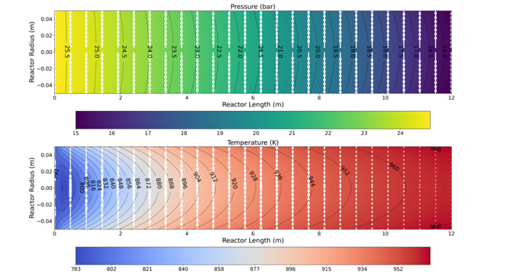
Figure 1. The pressure and temperature profiles of the pseudo-homogeneous model.
Figures 1 and 2 show the pressure and temperature profiles of pseudo-homogeneous and heterogeneous models, respectively. The results demonstrate the pressure profiles of two models are generally flat. However, the temperature profiles are not the case. In the pseudo-homogeneous model, the maximal radial temperature gradient is about 50°C, while this temperature is around 45°C in heterogeneous model.
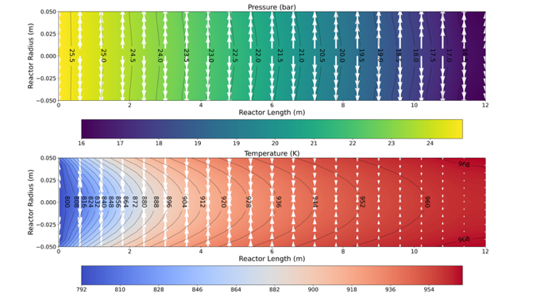
Figure 2. The pressure and temperature profiles of the heterogeneous model.
    - Concentration profiles
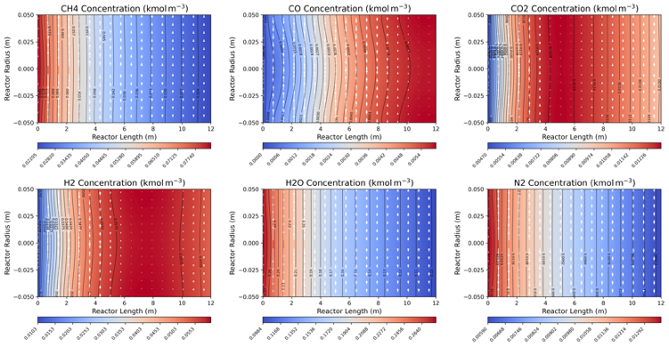
Figure 3. The concentration of each component in the pseudo-homogeneous model.
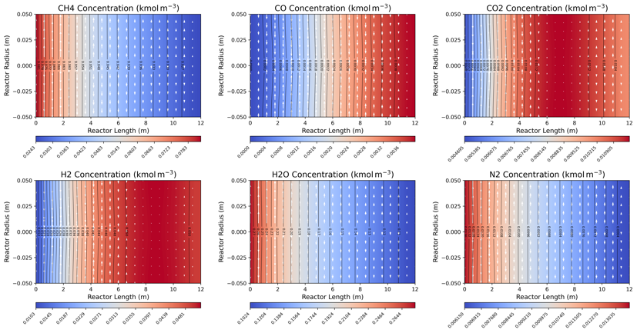
Figure 4. The concentration of each component in the heterogeneous model.
Figures 3 and 4 show the concentration profiles of pseudo-homogeneous and heterogeneous models, respectively. Taking the concentration of hydrogen as an example, in pseudo-homogeneous model, the maximum concentration is appearing in the around 4 – 10 m in the reactor, but it appears in around 6 – 12 m in the heterogeneous model.
    - Composition profiles
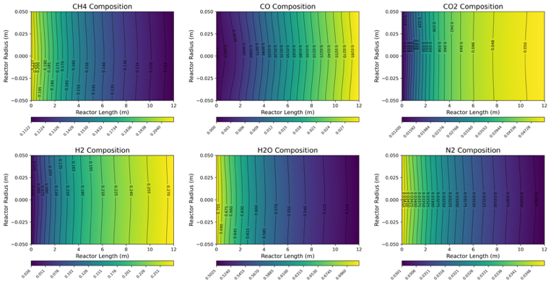
Figure 5. The composition of each component in the pseudo-homogeneous model.
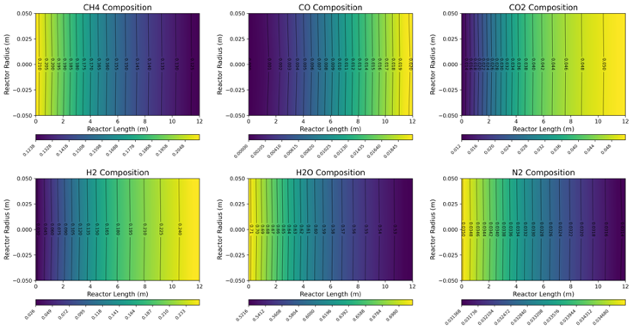
Figure 6. The composition of each component in the heterogeneous model.
Figures 5 and 6 show the composition profiles of pseudo-homogeneous and heterogeneous models, respectively. It can be seen that the composition profile is very flat in the heterogeneous model. This indicate 1D model might be sufficient to present the product distribution, while the pseudo-homogeneous model has slight curved product distributions.
  - Conclusions
In this research, we evaluated the performance of pseudo-homogeneous and heterogeneous models by applying them to SMR processes. The pseudo-homogeneous model offers a less computationally intensive approach as it bypasses direct diffusion calculations through the use of an effectiveness factor. On the other hand, the heterogeneous model, while more detailed and theoretically robust, does not necessarily yield additional insights to justify its higher computational demands. Consequently, for flowsheet simulations where computational efficiency is paramount, 1D models are recommended. However, 2D models, which provide more detailed radial information, should be considered when the specificity of the application demands it.
References
Cruz, F.E.d., Karagoz, S., Manousiouthakis, V.I., 2017. Parametric studies of steam methane reforming using a multiscale reactor model. Industrial & Engineering Chemistry Research. 56, 14123-14139.
Ghouse, J.H., Adams II, T.A., 2013. A multi-scale dynamic two-dimensional heterogeneous model for catalytic steam methane reforming reactors. International Journal of Hydrogen Energy. 38, 9984-9999.
Kuncharam, B.V.R., Dixon, A.G., 2020. Multi-scale two-dimensional packed bed reactor model for indutrial steam methane reforming. Fuel Processing Technology. 200, 106314.
Lao, L., Aguirre, A., Tran, A., Wu, Z., Durand, H., Christofides, P.D., 2016. CFD modeling and control of a steam methane reforming reactor. Chemical Engineering Science. 148, 78-92.
Pantoleontos, G., Kikkinides, E.S., Georgiadis, M.C., 2012. A heterogeneous dynamic model for the simulation and optimisation of the steam methane reforming reactor. International Journal of Hydrogen Energy. 37, 16346-16358.
Rout, K.R., Jakobsen, H.A., 2015. A numerical study of fixed bed reactor modelling for steam methane reforming process. The Canadian Journal of Chemical Engineering. 93, 1222-1238.
Vo, N.D., Oh, D.H., Hong, S.H., Oh, M., Lee, C.H., 2019. Combined approach using mathematical modelling and artificial neural network for chemical industries: Steam methane reformer. Applied Energy. 255, 113809.
Wesenberg, M.H., Svendsen, H.F., 2007. Mass and heat transfer limitation in a heterogeneous model of a gas-heated steam reformer. Industrial & Engineering Chemistry Research. 46, 667-676.
Xing, Y., Masuku, C.M., Biegler, L,T., 2021. Modular gas-to-liquids process with membrane steam-methane reformer and Fischer–Tropsch reactive distillation. AIChE Journal. 67, e17467.
Xu, J., Froment, G.F., 1989. Methane steam reforming, methanation and water-gas shift: I. Intrinsic kinetices. AIChE Journal. 35, 88-96.

