A Solar and Wind Energy-based Biomass-to-Methanol System with Coupling of Different Electrolyzers

Guanxin Xu,a Yan Wu,a,b Yufei Wang,a,* Xiao Feng,c

aSchool of Chemical Engineering and Environment, China University of Petroleum (Beijing), 18 Fuxue Road, Changping, Beijing, 102249, China

bChina Huanqiu Contracting & Engineering CO., LTD, No.1 Chuangda 2nd Road, Laiguangying Hi-tech Industrial Park, Chaoyang District, Beijing, 100012, China

cSchool of Chemical Engineering and Technology, Xi’an Jiaotong University, Xi’an, Shaanxi 710049, China

wangyufei@cup.edu.cn

Abstract

The concepts of renewable energy and low-carbon economy are rapidly emerging. Considering the randomness and volatility of renewable energy sources (RESs), hydrogen production system of water electrolysis could be used. Biomass-to-methanol technology can be combined with solar and wind energy-based water electrolysis system. Between different kinds of electrolyzers, alkaline (ALK) electrolysis is the most common and mature technology with the lowest capital cost. Besides, proton exchange membrane (PEM) electrolyzers have higher sensitivity of response to input power and wider power regulation range, meaning it could make a fuller use of the electricity. In this paper, a method is proposed to design an optimal water electrolysis and methanol production system, taking into account the hourly solar and wind power generation capacity. The operation states of electrolyzer are also considered. In the case study part, a HPS consisting of 72 ALK electrolyzers and 8 PEM electrolyzers was designed, with an annual methanol production of 30.03×104 t/y. According to the result, the annual revenue of the coupling system is 62.6% higher than that of the PEM system. Compared with the ALK system, the scale of hydrogen and energy storage systems decrease significantly. The result shows promise in adapting to the fluctuations in renewable energy generation. Furthermore, the combined environmental and economic performance of the new system indicates its potential for long-term viability and positive impact.

**Keywords**: Coupling of Electrolyzers, Biomass-to-Methanol, Water Electrolysis, Renewable Energy

* 1. Introduction

The global air temperature has continuously increased in nearly two centuries. Climate change and global warming are considered as the most pressing issues (Dogan et al., 2023). Besides, the energy crisis also contributed to the concept of renewable energy sources (RESs) and a low-carbon economy. Thus, developing renewable energy technologies to reduce carbon emissions is crucial (Kojima et al., 2023). In recent decades, renewable energy generation capacity is continually increasing. However, compared to fossil energy sources generation, RESs has the characteristics of randomness, intermittence and fluctuation (Xiong et al., 2023). Thus, energy abandonment generally occurs when RESs power generation exceeds the electricity demand or transmission capacity. This problem could lead to energy resources and economic losses. Therefore, RESs generation is generally combined with hydrogen production system (HPS) of water electrolysis to prevent curtailment. Recently, energy production from biomass has gained interest as a suitable approach for agricultural countries. Combining biomass-to-methanol technology with the HPS of wind and solar power generation can not only increase the utilization of the carbon in the biomass, but also deal with the randomness, intermittence and fluctuation of RESs (Poluzzi et al., 2022).

Electrolyzing water could be carried out via several electrolyzer types, including alkaline (ALK) electrolyzer, proton exchange membrane (PEM) electrolyzer, anion exchange membrane (AEM) electrolyzer, and solid oxide (SO) electrolyzer (Gado & Hassan, 2023). Among them, the ALK and PEM electrolyzers have been applied in industrial production. ALK electrolysis is the most common and mature technology with the lowest capital cost. However, ALK electrolyzers cannot operate at low loads (Squadrito et al., 2023). Although the cost of a PEM electrolyzer is more expensive, the current density rate is higher and the gas crossover rate is lower, leading to higher sensitivity of response to input power. Besides, the operating range and capability is wider than that of ALK ones, meaning they could make a fuller use of the electricity (Mucci et al., 2023).

Recently, many researchers have done many studies on the combination of biomass-to-methanol and hydrogen production through RESs generation. Herdem et al. (2020) proposed a novel non-combustion heat-carrier biomass gasification system, coupled with a solar power plant and ALK water electrolysis system for MeOH production. Fournas and Wei (2022) demonstrated the economic viability of a MeOH production technology combining biomass gasification and PEM electrolysis for decarbonization. However, these studies only used one kind of electrolyzer. In this paper, a method is proposed for designing an optimal water electrolysis and MeOH production system. A HPS coupling ALK and PEM electrolyzers can be developed according to the hourly solar and wind power generation capacity, equipped with the corresponding hydrogen storage and energy storage modules. The model shows the differences between the two electrolyzers from multiple parameters. The operation state is also considered. The hydrogen produced by this system is used for biomass-to-methanol production.

* 1. Mathematical model
     1. System structure

In this paper, the whole system consists of several components: a wind power generation system (WS), a PV power generation system (PVS), a power grid (PG), an energy storage system (ESS), a hydrogen storage system (HSS), a hydrogen production system (HPS) with two types of electrolyzers, a biomass gasification and purification system (BGPS), and a methanol production system (MPS). The electrolyzers operate in groups, and the operating loads of electrolyzers within the same group are set to be consistent. The overall system structure is depicted in Figure 1.

The electricity power could be obtained from WS, PVS and PG. Part of the electricity is able to be stored in the ESS while the electricity price is lower or the renewable energy resources are abundant. Similarly, HSS is applied to ensure the stability of MPS.

* + 1. Biomass-to-methanol processing

Through treatment, gasification and desulfurization of 1 t biomass, 1,020 Nm3 dry gas could be generated. The volume percentages of CO, CO2, H2 and CH4 are 30.22%, 32.69%, 26.93% and 9.8%. CH4 is transported to Partial Oxidation (POX) processing. Half of the CH4 is burned and the other half produces CO and H2 (Ugwu et al., 2020).

For treated gas transported back for MeOH production, the volume percentages of CO, CO2 and H2 (,  and ) are 33.48%, 31.16% and 35.01%. 750 Nm3 CO or CO2 can be used to produce 1 t MeOH. And 2,100 Nm3 hydrogen is required to produce 1 t MeOH from pure CO2 and 1,400 Nm3 is required for pure CO. To ensure sufficient hydrogen supply, 105% of the above data is taken as the calculated value. The relationship between MeOH production and hydrogen supply is as follows:

|  |  |
| --- | --- |
|  | (1) |

where, is the volume of hydrogen supplied by HPS and HSS at time  (Nm3); is the volume of treated gas used for MeOH production at time  (Nm3);  is the total annual operating hours of the system.

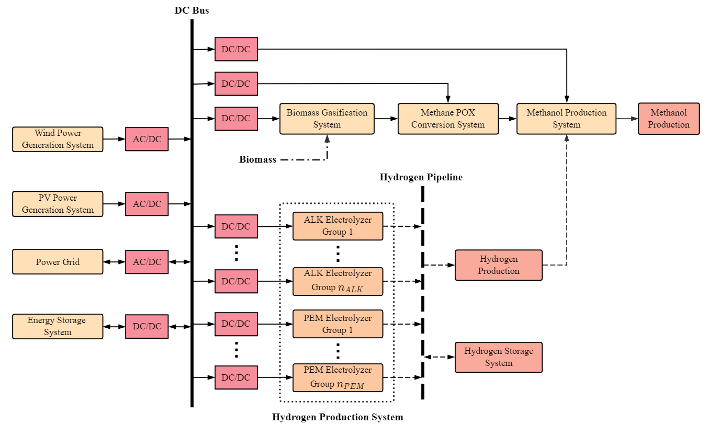

**Figure 1. MeOH production system structure**

* + 1. Hydrogen production system with coupling electrolyzers

The ALK and PEM electrolyzers are coupled in the HPS and operate in groups. A binary variable  determined by input load is introduced as state parameters to describe the operation state. When the operation load is above the lower limit of the hydrogen production load range,  and the electrolyzer could be qualified to produce hydrogen.

|  |  |
| --- | --- |
|  | (2) |

where,  and  are the state parameter and operation loads (kW) of the electrolyzer group  at time ;  and  are respectively the maximum operation loads (kW) and the lowest hydrogen-producing workload ratio of the electrolyzer group ;  is the number of electrolyzer groups.

ALK electrolyzers consume several minutes as start-up time while changing from the UPS to the PS (Buttler & Spliethoff, 2018). By contrast, PEM electrolyzers have higher sensitivity of response to input power, and the starting time can be negligible. To show the difference in the starting speed, a binary variable  is proposed. while the ALK group changing from UPS to PS. Start-up interval takes effect in the model as a penalty on the electrolyzer availability, that is, the hydrogen production capacity.

* 1. Case study

In this case, the data of wind and solar generation capability is taken from Changling County, Jilin Province, China. The scales of WS and PVS are 500 MW and 100 MW respectively. And the scale of MPS is 350,000 t/y. Electricity purchase is allowed, while selling is not allowed. Different parameters of electrolyzers provided by a commercial electrolyzer supplier are shown in Table 1.

**Table1. Parameters of the two kinds of electrolyzers**

|  |  |  |
| --- | --- | --- |
| Electrolyzer type | ALK | PEM |
| Maximum operation load (kW) | 5 | 4.5 |
| Hydrogen production efficiency (Nm3/kW) | 0.2 | 0.22 |
| Lowest hydrogen-producing workload ratio | 0.3 | 0.05 |
| Upper load-extended limit | - | 1.2 |
| Investment cost of an electrolyzer (106 CNY) | 7.5 | 30 |
| Hydrogen production capacity penalty (Nm3) | 640 | - |
| Proportion of the investment cost to the total installment cost | 0.5 | 0.8 |

**Table 2. Optimal results for the different systems**

|  |  |  |  |
| --- | --- | --- | --- |
| System type | ALK+PEM | ALK | PEM |
| Number of ALK groups × Number of electrolyzers in each group | 9×8 | 11×8 | - |
| Number of PEM groups × Number of electrolyzers in each group | 2×4 | - | 15×4 |
| Scale of ESS (MW) | 12.20 | 39.11 | 12.28 |
| Scale of HSS (104 Nm3) | 142.76 | 155.53 | 122.47 |
| Annual total generation capacity (108 kW·h) | 18.16 | 18.16 | 18.16 |
| Annual total power consumption (108 kW·h) | 17.98 | 18.45 | 16.69 |
| Annual total electricity purchase (108 kW·h) | 1.42 | 1.48 | 1.34 |
| Curtailment rate (%) | 4.32 | 1.83 | 11.23 |
| Investment cost (108 CNY) | 76.28 | 76.49 | 84.37 |
| Annual total MeOH production (104 t/y) | 30.03 | 30.11 | 30.11 |
| Carbon emissions (gCO2/kg MeOH) | 389.03 | 398.22 | 360.24 |
| Annual total hydrogen production (108 Nm3/y) | 2.95 | 2.97 | 2.97 |
| Annual earnings (108 CNY/y) | 1.74 | 1.75 | 1.07 |

The systems of coupling ALK and PEM electrolyzers, single ALK and single PEM electrolyzers are designed for comparison. The results are shown in Table 2.

The optimized results indicate that the annual earnings of the coupling system are slightly lower than those of the pure ALK system but significantly higher than those of the pure PEM system. On the other hand, the carbon emissions of the MeOH product from the coupling system are higher than that of the ALK system but lower than that of the PEM system. These results can be attributed to the different characteristics of the electrolyzers. The high investment cost of the pure PEM system, due to the expensive PEM electrolyzers, contributes to its lower earnings. The ALK electrolyzer has a lower cost, but its smaller adjustment load range requires a larger scale of hydrogen storage systems HSS and ESS, affecting its profitability. The coupling system takes advantage of both electrolyzers, resulting in favorable environmental and economic performance. Furthermore, the curtailment rate of the coupling system is within 5%. For the annual MeOH production, the operation load ratio of the MPS is not less than 80% in about 2/3 of the whole year with the minimum one of 69.75%. Thus, the operation of the biomass-to-methanol system is basically stable. This demonstrates that the system is capable of adapting to the volatility of RESs.

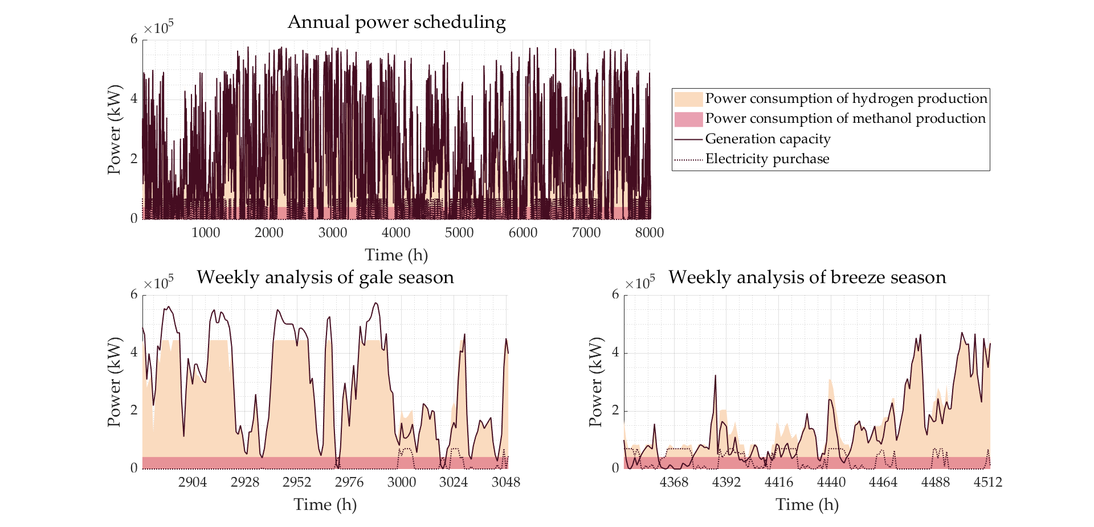

**Figure 2. Diagram of annual and weekly power scheduling**

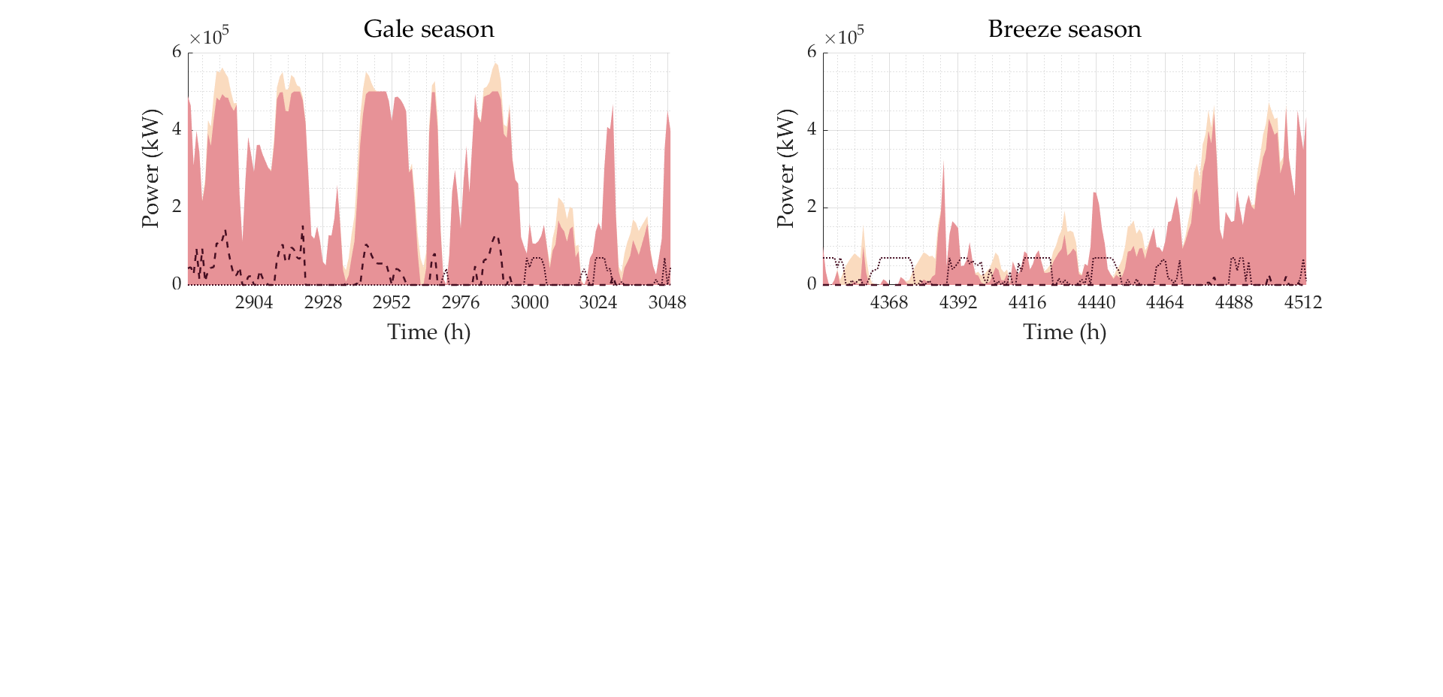



**Figure 3. Weekly power sources and abandon**

Figure 2 illustrates that the electricity purchase during the gale season is significantly lower than during other seasons. Figure 3 further explains that electricity purchases are primarily used to maintain system operation at night when there is no PV power generation during the breeze season. On the other hand, during the gale season, when there is sufficient PV power generation during the day, there is a noticeable phenomenon of power abandonment. This is likely due to the high cost of the batteries used in the ESS. Instead of increasing the scale of the ESS to store the excess power generated during the gale season and use it during the breeze season, it is more economical to abandon the excess power and purchase electricity when RESs are insufficient.

* 1. Conclusion

The proposed method for designing an optimal integrated system of biomass-to-methanol and green hydrogen appears to be innovative and promising. The coupling of both ALK and PEM electrolyzers allows for the combination of their respective advantages. In the case study part, the method is applied to design a system, with an annual revenue of 1.738×108 CNY/y and the carbon emission of 398.03 gCO2/kg MeOH. The ability of the system to adapt to fluctuations in RESs power generation is also a significant advantage according to the annual operating status of MPS.

In future studies, it would be interesting to consider other downstream processes of hydrogen production in order to further optimize the system. Additionally, the existing model could be combined with heuristic algorithms for even greater optimization.

References

1. Buttler, & H. Spliethoff, 2018, Current status of water electrolysis for energy storage, grid balancing and sector coupling via power-to-gas and power-to-liquids: A review, Renewable and Sustainable Energy Reviews, 82

E. Dogan, T. Luni, M. T. Majeed, and P. Tzeremes, 2023, The nexus between global carbon and renewable energy sources: A step towards sustainability, Journal of Cleaner Production, 416

N. D. Fournas, & M. Wei, 2022, Techno-economic assessment of renewable methanol from biomass gasification and PEM electrolysis for decarbonization of the maritime sector in California, Energy Conversion and Management, 257

M. G. Gado, & H. Hassan, 2023, Potential of prospective plans in MENA countries for green hydrogen generation driven by solar and wind power sources, Solar Energy, 263

M. S. Herdem, D. Mazzeo, N. Matera, J. Z. Wen, J. Nathwani, & Z. Hong, 2020, Simulation and modeling of a combined biomass gasification-solar photovoltaic hydrogen production system for methanol synthesis via carbon dioxide hydrogenation, Energy Conversion and Management, 219

H. Kojima, K. Nagasawa, N. Todoroki, Y. Ito, T. Matsui, & R. Nakajima, 2023, Influence of renewable energy power fluctuations on water electrolysis for green hydrogen production, International Journal of Hydrogen Energy, 48, 4572-93

S. Mucci, A. Mitsos, & D. Bongartz, 2023 Power-to-X processes based on PEM water electrolyzers: A review of process integration and flexible operation, Computers & Chemical Engineering, 175

A. Poluzzi, G. Guandalini, S. Guffanti, C. Elsido, S. Moioli, P. Huttenhuis, G. Rexwinkel, E. Martelli, G. Groppi, & M. C. Romano, 2022, Flexible Power & Biomass-to-Methanol plants: Design optimization and economic viability of the electrolysis integration, Fuel, 310

G. Squadrito, G. Maggio, & A. Nicita, 2023, The green hydrogen revolution, Renewable Energy, 216

A. Ugwu, A. Zaabout, J. R. Tolchard, P. I. Dahl, & S. Amini, 2020, Gas Switching Reforming for syngas production with iron-based oxygen carrier-the performance under pressurized conditions, International Journal of Hydrogen Energy, 45, 1267-82

K. Xiong, W. Hu, D. Cao, S. Li, G. Zhang, W. Liu, Q. Huang, & Z. Chen, 2023, Coordinated energy management strategy for multi-energy hub with thermo-electrochemical effect based power-to-ammonia: A multi-agent deep reinforcement learning enabled approach, Renewable Energy, 2141, 216-32