Superstructure Modeling of Lithium-Ion Batteries for an Environmentally Conscious Life-Cycle Design
Tomoya Yonetsuka,ª Ayumi Yamaki,^{b} Aya Heiho,^{c,d} Yuichiro Kanematsu,^{c} Heng Yi Teah,^{c} Yasunori Kikuchi^{a,b,c*}
ª Department of Chemical System Engineering, The University of Tokyo, 7-3-1 Hongo, Bunkyo-ku, Tokyo 113-8656, Japan
^{b} Institute for Future Initiatives, The University of Tokyo, 7-3-1 Hongo, Bunkyo-ku, Tokyo 113-8654, Japan
^{c} Presidential Endowed Chair for “Platinum Society”, The University of Tokyo, 7-3-1 Hongo, Bunkyo-ku, Tokyo 113-8656, Japan
^{d} Faculty of Environmental Studies, Tokyo City University, 3-3-1 Ushikubo-Nishi, Tsuzuki-Ku, Yokohama, Kanagawa 224-8551, Japan
*ykikuchi@ifi.u-tokyo.ac.jp

Abstract
With the introduction of electric vehicles, mineral resource consumption has increased, and the need for metal recycling has grown. This study aimed to evaluate recycling processes for an environmentally conscious life-cycle design of Li-ion batteries (LiB) by life-cycle assessment (LCA) through a superstructure. There are numerous LiB recycling technologies, and for their organization and comparison, a superstructure was constructed through a literature review, bibliometric analysis, and discussion with process engineers. The superstructure included descriptions of available technologies and processes and could provide designers with potential life-cycle options and design variables to consider. This paper focuses on the end of life of LiB cathodes. Various recycling processes described in the superstructure were selected as cases for LCA, and their environmental performance was evaluated. The environmental impacts of the recycling processes varied. For example, in terms of global warming potential, processes such as furnace roasting and solvent extraction could be potential hot spots. In terms of resource consumption, environmental benefits were observed in all cases, indicating the recycling effectiveness in reducing resource consumption. This study provides information that should be considered in future life-cycle design of LiBs.

Keywords: superstructure, LCA, resource circulation, battery recycling, hydrometallurgy.
  - Introduction
The accelerating adoption of electric vehicles (EVs) made the stable procurement and consumption of metal resources such as Co and Li required for Li-ion batteries (LiBs) challenging. Various types of LiB, including Ni-Co-Al oxide (NCA), Ni-Mn-Co oxide (NMC), and Li-Fe phosphate (LFP) batteries, are in use. The resource consumption of NMC, which is a common LiB for EVs, is predicted to grow by a factor of more than 15 from 2020 to 2050, emphasizing the need for resource recycling (Xu et al., 2020). The proposed recycling methods for end-of-life (EoL) LiBs include pyrometallurgy and hydrometallurgy or their combinations (Wei et al, 2023). A closed-loop recycling system is required to convert waste into raw materials for the same product. However, there are multiple technical options for metal recycling, and an optimal recycling process should be designed to match the specific conditions. A superstructure would include all available processes (Restrepo-Flórez and Maravelias, 2021), but to the authors’ knowledge, a superstructure for LiB cathode recycling has not yet been created. The life-cycle assessment (LCA) of a recycling system using pulsed discharging (Tokoro et al., 2021) has shown that because of the scale of the process there are different environmental impacts and different technologies (Kikuchi et al., 2021). By contrast, detailed analyses of hydrometallurgy have not been conducted. In addition, many recycling technologies for LiBs in the development stage are emerging. If these technologies are implemented in society, the LCA of the system becomes vital information for life-cycle designers (Steubing and Koning, 2021).
In this study, we aimed to evaluate recycling processes for an environmentally conscious life-cycle design of LiBs. The environmental impact of recycling processes for automotive LiBs was assessed using LCA. A superstructure was constructed to illustrate various process combinations that a future LiB life cycle can encompass, including recycling technologies implementable in the development stage. The superstructure was used to visualize the recycling process with a combination of available technologies and was also used to set the cases in the LCA.
  - Methods
    - LCA of LiB cathode
The functional unit was set as a 1 kg automotive LiB, NMC111 cathode. Figure 1 presents the life-cycle boundary in this study. The collection and transportation phases are outside the boundary. The recycling targets are Co and Ni; the recovery of Mn and Al is outside the boundary.
Pretreatment includes smelting, roasting, and pulsed discharging, whereas hydrometallurgy involves processes such as acid leaching, solvent extraction, and crystallization. In hydrometallurgy, Co and Ni are recovered as individual elements or sulfate compounds, whereas Li is assumed to be recovered as hydroxides in the cases where pretreatment is different from smelting. Recovered metals are considered to avoid primary material production and therefore have a negative environmental impact in the LCA results (Nordelöf et al., 2019). Direct recycling through pulsed discharging is assumed to recover positive electrode active materials and use them in positive electrode production (Tokoro et al., 2021).
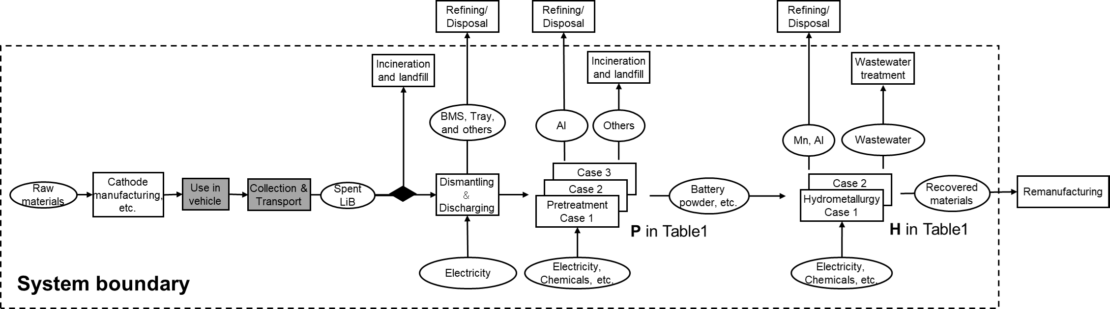
Figure 1 The life-cycle boundary of this study
The inventory data of background processes were extracted from the Inventory Database for Environmental Assessment (IDEA) ver.3.3 (AIST, 2023) and ecoinvent ver.3.8 (ecoinvent, 2021). For the process data, we used a combination of existing LCA papers and papers on the latest recycling technologies. The assessment indicators included five categories: Climate change (LC-GHG), resource consumption (LC-RCP), acidification, carcinogenic human toxicity, and noncarcinogenic human toxicity. Environmental impacts were quantified by the impact assessment method applicable for Japanese ecosystems, i.e., Life-cycle Impact Assessment Method based on Endpoint Modeling2 (Itsubo and Inaba, 2012).
Table 1 Case description, P represents pretreatment and H represents hydrometallurgy.
 | Case | A | B-1 | C-1 | C-2 | D-1 | D-2 | E
 | Production | ✓ | ✓ | ✓ | ✓ | ✓ | ✓ | ✓
 | Smelting |  | ✓
P | Roasting |  |  | ✓ | ✓
 | Pulsed discharging |  |  |  |  | ✓ | ✓ | ✓
 | Acid leaching |  | ✓ | ✓ | ✓ | ✓ | ✓
 | Solvent extraction |  | ✓ | ✓ | ✓ | ✓ | ✓
H | Electrowinning |  | ✓ | ✓ |  | ✓
 | Electrodialysis |  |  | ✓ | ✓ | ✓ | ✓
 | Crystallization |  |  | ✓ | ✓ | ✓ | ✓
 | Incineration and landfill | ✓
 | Recovery of Ni |  | ✓ | ✓ |  | ✓
 | Recovery of NiSO4 |  |  |  | ✓ |  | ✓
 | Recovery of Co |  | ✓ | ✓ |  | ✓
 | Recovery of CoSO4 |  |  |  | ✓ |  | ✓
 | Recovery of LiOH |  |  | ✓ | ✓ | ✓ | ✓
 | Recovery of PE-sheet |  |  |  |  |  |  | ✓
 | (NMC111 oxide)

Seven cases were set up, as shown in Table 1. Case A involves incineration and landfill disposal, B, C, and D involve metal recovery through hydrometallurgy, and E is direct recycling via pulsed discharging. The environmental impacts related to the disposal of waste and wastewater generated from each recycling process are attributed to individual processes. Therefore, in the legend, “incineration and landfill” represents incineration or landfill disposal in the case without recycling (Case A). Case B recovers alloys through smelting in pretreatment, and Li is assumed to be unrecoverable. Case C uses roasting in pretreatment, whereas D uses pulsed discharging. The numbers 1 and 2 indicate differences in the hydrometallurgical process, with 1 considering individual recovery through electrowinning and 2 considering sulfate recovery through crystallization. The metal recovery rates through recycling, regardless of the process, were set according to the European Union (EU) Battery Regulation’s minimum targets by 2027, which are 90% for Co, 90% for Ni, and 50% for Li (EU, 2023). In the case of direct recycling (Case E), a recovery rate of 90% was assumed based on experimental results (Tokoro et al., 2021).
    - Construction of superstructure for life-cycle design
A superstructure was created to visualize the possible LiB life cycle and serve as a tool for life-cycle design. In this study, the superstructure of the LiB cathode recycling was constructed through a literature review, bibliometric analysis, and discussions.
In the literature review, we extracted technical options related to LiB recycling. At the EoL of LiB, there are options such as incineration/landfill disposal and resource recovery through recycling. The positive electrode recycling process can be categorized into pyrometallurgy, hydrometallurgy, and direct recycling. Pyrometallurgy involves melting, pyrolysis, and roasting (Makuza et al., 2021), whereas hydrometallurgy includes leaching and solvent extraction (Meshram et al., 2014). Additionally, direct recycling is a technology that regenerates positive electrode material without separating it into metal through methods like sintering (Xu et al., 2021).
Bibliometric analysis was used to determine the hot topics in academic papers (Kikuchi, 2017) and to incorporate them into the superstructure. The subject of the analysis was academic papers using both the terms “lithium-ion batteries” and “recycle,” published between the years 2016 and 2023. A total of 2,403 papers were retrieved from a web-based literature database, “Web of Science” (Thomson Reuters, 2023). Furthermore, we conducted discussions with process engineers to validate and refine the superstructure.
  - Results and discussion
    - Superstructure of LiB cathode recycling
Figure 2 represents a superstructure created for the recycling of LiB cathodes. Pretreatment was categorized into thermal pretreatment, mechanical pretreatment, and chemical pretreatment. In the hydrometallurgical process, acid leaching seems to be inevitable, and subsequent solvent extraction and precipitation steps are selective. Following solvent extraction, metal recovery can be achieved through processes such as electrowinning or crystallization. In addition, multiple methods were proposed for direct recycling from battery powder. Moreover, the results of the bibliometric analysis indicated that the number of studies on re-lithiation using molten salts is increasing.
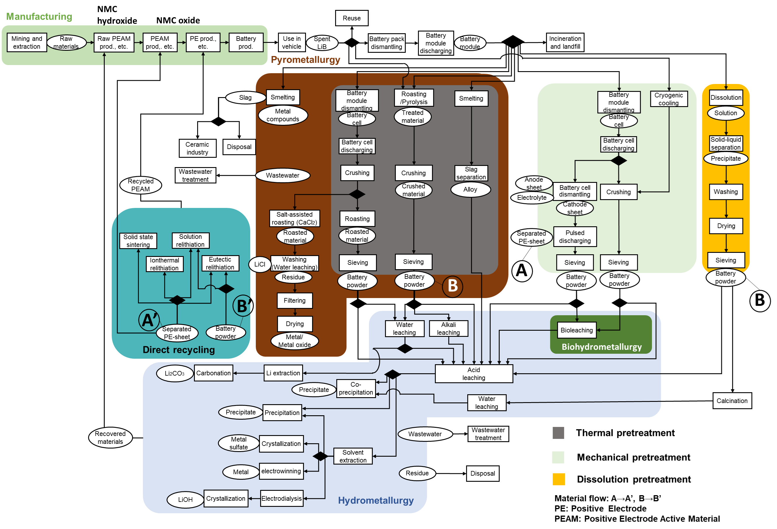
Figure 2 Superstructure of LiB cathode recycling
    - LCA of LiB cathode recycling
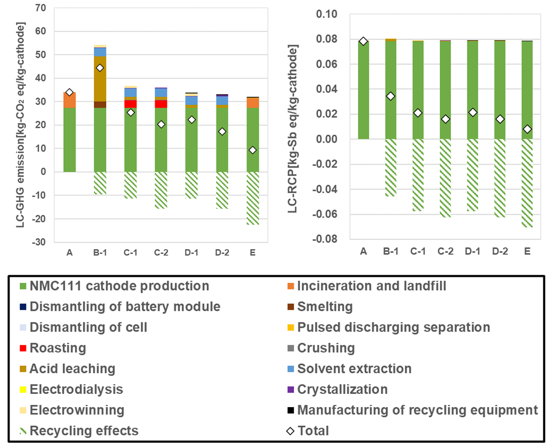
Figure 3 LCA results on LC-GHG and LC-RCP.
The environmental impacts were reduced in all cases compared to A (Figure 3). In terms of LC-GHG emissions, impacts from solvent extraction, roasting, and acid leaching were significant, demonstrating varying environmental impacts from each hydrometallurgical process. However, for LC-RCP, the load of the recycling process was small, and the total resource consumption impact was lower by more than 50% compared to A. Furthermore, comparisons between C-1 and C-2, D-1 and D-2 indicated that the effect of recycling became more significant when recovering as sulfates compared to individual metal recovery at the same recovery rate because the production of metal sulfates has a greater environmental impact. In addition, Case E shows the lowest environmental impact over the entire life cycle. This is because thermal pretreatment and hydrometallurgy can be avoided in this direct recycling process. Acidification and Human toxicity potential showed trends similar to resource consumption. For acidification, the effects of roasting, acid leaching, and solvent extraction were identified. In HTP, the effect of the recycling process was small in both categories, but the effect of equipment manufacturing for pulsed discharging was observed. Overall, recycling reduces the environmental impact of the entire life cycle in all cases in all categories except global warming potential.
  - Conclusions
A superstructure was constructed and a quantitative evaluation was performed using LCA with the aim of designing environmentally conscious recycling processes for LiB. This study systematically organized the LiB recycling processes and presented the varying environmental impacts of some processes, including emerging technologies like pulsed discharging. These LCA results provide valuable information for stakeholders involved in decision-making regarding LiB recycling. Future research should include evaluation of other processes depicted in the superstructure and optimization by setting design variables.
Acknowledgment
This study was financially supported by the New Energy and Industrial Technology Development Organization (NEDO) (Grant number, JPNP21026), This research included the achievements of the JST-MIRAI Program Grant Number JPMJMI19C7, JST COI-NEXT (JPMJPF2003), JSPS KAKENHI Grant Number JP21H03660. The activities of the Presidential Endowed Chair for “Platinum Society” at the University of Tokyo are supported by Mitsui Fudosan Corporation, Sekisui House, Ltd., East Japan Railway Company, and Toyota Tsusho Corporation.
References
Ecoinvent (Swiss Centre for Life Cycle Inventories), 2021. Ecoinvent version 3.8. https://ecoinvent.org/ (accessed 20 November 2023).
European Union, 2023, REGULATION (EU) 2023/1542 OF THE EUROPEAN PARLIAMENT AND OF THE COUNCIL of 12 July 2023 concerning batteries and waste batteries, amending Directive 2008/98/EC and Regulation (EU) 2019/1020 and repealing Directive 2006/66/EC, Official Journal of European Union.
N. Itsubo, A. Inaba, 2012. LIME2 life-cycle impact assessment method based on endpoint modeling. Life-Cycle Assessment Society of Japan, Tokyo, Japan.
Y. Kikuchi, 2017, Simulation-Based Approaches for Design of Smart Energy System: A Review Applying Bibliometric Analysis, J. Chem. Eng. Japan, 50(6) pp. 385–396.
Y. Kikuchi, I. Suwa, A. Heiho, Y. Dou, S. Lim, T. Namihira, K. Mochidzuki, T. Koita, C. Tokoro, 2021, Separation of cathode particles and aluminum current foil in lithium-ion battery by high-voltage pulsed discharge Part II: Prospective life cycle assessment based on experimental data, Waste Manage., 132, 86–95.
B. Makuza, Q. Tian, X. Guo, K. Chattopadhyay, D. Yu, 2021, Pyrometallurgical options for recycling spent lithium-ion batteries: A comprehensive review, J. Power Sources, 491, 229622.
P. Meshram, B. D. Pandey, T. R. Mankhand, 2014, Extraction of lithium from primary and secondary sources by pre-treatment, leaching and separation: A comprehensive review, Hydrometallurgy, 150, 192–208.
National Institute of Advanced Industrial Science and Technology (AIST), Inventory Database for Environmental Assessment (IDEA) version 3.3 (2023/4/15) (2023) https://idea-lca.com/ (accessed 20 November 2023).
A. Nordelof, S. Poulikidou, M. Chordia, F. B. de Oliveira, J. Tivander, R. Arvidsson, 2019, Methodological Approaches to End-Of-Life Modelling in Life Cycle Assessments of Lithium-Ion Batteries, Batteries, 5, 51.
J.-M. Restrepo-Flórez & C. T. Maravelias, 2021, Advanced fuel from ethanol – a superstructure optimization approach, Energy Environ. Sci. 14, 493–506.
B. Steubing, D. de Koning, 2021, Making the use of scenarios in LCA easier: the superstructure approach, Int J Life Cycle Assess., 26, 2248–2262.
Thomson Reuters; Web of Science, 2023, http://wokinfo.com/
C. Tokoro, S. Lim, K. Teruya, M. Kondo, K. Mochidzuki, T. Namihira, Y. Kikuchi, 2021, Separation of cathode particles and aluminum current foil in Lithium-Ion battery by high-voltage pulsed discharge Part I: Experimental investigation. Wast Manage., 125, 58–66.
Q. Wei, Y. Wu, S. Li, R. Chen, J. Ding, C. Zhang, 2023, Spent lithium ion battery (LIB) recycle from electric vehicles: A mini-review, Sci. Total Environ. 866, 161380.
C. Xu, Q. Dai, L. Gaines, M. Hu, A. Tukker, B. Steubing, 2020, Future material demand for automotive lithium-based batteries, Commun. Mater. 1, 99.
P. Xu, D. H. S. Tan, B. Jiao, H. Gao, X. Yu, Z. Chen, 2021, A Materials Perspective on Direct Recycling of Lithium-Ion Batteries: Principles, Challenges and Opportunities, Adv. Funct. Mater., 33, 2213168.

