Enabling Load-Flexible Ammonia Synthesis via Polytropic Fixed-Bed Reactors
Lukas Gottheilª, Jens Bremer^{a,*}
ªClausthal University of Technology, Institute of Chemical and Electrochemical Process Engineering, Leibnizstrasse 17, 38678 Clausthal-Zellerfeld, Germany
bremer@icvt.tu-clausthal.de
Abstract
Establishing an economically and technically viable Power-to-Ammonia process requires a reactor concept capable of operating in multiple steady-states, as well as between these states. In this work, we present a novel approach using polytropic fixed-bed reactors to enable load-flexible ammonia synthesis. Therefore, a dynamic pseudo-homogeneous reactor model, which considers the effects of real gas behavior and intraparticle mass transport limitations, is developed. Detailed dynamic simulation studies demonstrate that the proposed reactor concept is considerably less sensitive to disturbances compared to the conventional adiabatic multi-bed reactor. In fact, even under drastic load changes fast, smooth, and stable transitions among different steady-states were observed. It is also proven that the heat supplied via the cooling jacket adequately preheats the reactants in the first section of the reactor, making feed-effluent heat exchangers obsolete. The polytropic ammonia synthesis reactor can be operated over a remarkably wide load range, even at loads of only 10 %, while achieving high nitrogen conversions of at least 20 %.

Keywords: Ammonia, Polytropic Fixed-Bed Reactor, Load-Flexible Reactor Operation, Dynamic Reactor Simulation
  - Introduction
As the share of renewable energies is continuously increasing, the demand for global energy storage and energy transportation technologies is growing significantly. In this context, chemical-based energy storage via Power-to-X (P2X) processes is one of the most promising concepts for converting renewable energy. Among potential P2X fuels, ammonia stands out by its carbon-free nature, its ease of being liquefied compared to hydrogen and its industrial scale production process that has already been established for decades (Elishav et al., 2020). However, the use of electrolytically produced hydrogen as a reactant for ammonia synthesis introduces new challenges for the process. These mainly arise due to the intermittent nature of renewable energy supply leading to changing hydrogen flows from dynamically operated electrolyzer units. In order to avoid costly intermediate hydrogen storage, a concept for load-flexible ammonia synthesis is required. This implies an ammonia synthesis reactor capable of operating safely and efficiently on a wide load-range in multiple steady-states, including the transition between them.

Today, adiabatic quench-cooled multi-bed reactor systems with heat integration via feed-effluent heat exchangers (i.e. auto-thermal reactor concept) are widely used in industry for continuous steady-state ammonia synthesis. It is reported that this reactor type might operate at loads as low as 20 to 50 % of their nominal capacity (Fahr et al., 2023).
However, dynamic simulations have shown that this system is particularly sensitive to disturbances and can easily exhibit oscillatory behavior if perturbed. For instance, Morud and Skogestad (1998) demonstrated that a pressure drop of 25 % can lead to temperature oscillations with amplitudes of up to 200 °C. Rosbo et al. (2023) recently studied the stability and controllability of this reactor type based on dynamic simulations. Significant differences in the residence time of material and temperature waves as well as the external thermal feedback were identified as key factors causing instabilities. Advanced control strategies were proposed to significantly enhance process stability. Nevertheless, handling changing loads, in particular ramping the reactor from low to high loads, is still challenging and time consuming. Fahr et al. (2023) suggest increasing the dimensions of the feed-effluent heat exchanger to stabilize the reactor inlet temperature and to improve reactor stability.

It is well known that external thermal feedback, e.g. introduced by feed-effluent heat exchangers, can easily cause instabilities during transient transitions. One approach to reduce this issue is stabilizing the temperature profile inside the reactor by polytropic operation (e.g. via reactor wall cooling). With this method, it should be feasible to maintain almost constant reactor exit temperatures regardless of changing inlet conditions. Moreover, polytropic operation, especially in case of catalytic exothermic reactions, can generally be characterized by its improved dynamic behavior (Bremer et al., 2017) and a wider operating range (Bremer and Sundmacher, 2019), enhancing both stability and flexibility.

The aim of this work is to evaluate the feasibility of load-flexible ammonia synthesis via polytropic fixed-bed reactors. For this purpose, we present detailed simulation studies by employing a pseudo-homogenous reactor model, which particularly accounts for the dynamic behavior of ammonia synthesis. Especially the influence of key operational parameters and external heat transfer on the transient behavior (including stability) of the reactor is investigated and compared to the conventional multi-bed concept.

  - Dynamic Reactor Model
For the mathematical description of the polytropic fixed-bed reactor, a one-dimensional dynamic pseudo-homogeneous reactor model, adopted from Bremer and Sundmacher (2019), is used. Based on a differential volume element, mass balances (Eq. (1)), one for each species i ∈ {N₂, H₂, NH₃}, and an energy balance (Eq. (2)) are derived. It was decided to omit the implementation of the dynamic momentum balance to reduce computational effort and to improve stability of the applied numerical solver. Instead, pressure loss is described by Ergun equation (Eq. (3)), as friction typically dominates the dynamic momentum balance of a fixed-bed reactor. Changes in fluid velocity along the reactor axis are caused by mass conservation (Eq. (4)).

The density of the gas mixture ρ_{gas} is calculated according to Peng-Robinson equation of state. Activity-based kinetic models are chosen to describe the reaction rate. For the widely used magnetite-based iron catalyst, the kinetics of Dyson and Simon (1968) are applied. Additionally, a kinetic model provided by Rossetti et al. (2006) is available, to represent more active Ru-based catalysts. This model considers the inhibitory effect of hydrogen on the activity of Ru-based catalysts. In order to account for temperature-dependent intraparticle mass transport limitations within the pseudo-homogeneous model, an effectiveness factor η_{cat}, determined via the Thiele modulus, is included.
$$ερ_{gas}\frac{∂w_{i}}{∂t}=-ρ_{gas}v_{z}\frac{∂w_{i}}{∂z}-\frac{∂\left(j_{z,i}\right)}{∂z}+η_{cat}{\tilde{M}}_{i}ν_{i}\left(1-ε\right)r ,$$ | (1)
$${\left(ρc_{p}\right)}^{eff}\frac{∂T}{∂t}=-ρ_{gas}c_{p,gas}v_{z}\frac{∂T}{∂z}-\frac{∂\left({\dot{q}}_{z}\right)}{∂z}+η_{cat}\left(1-ε\right)r\left(-Δh_{r}\right)-\frac{4}{d}k_{w}\left(T-T_{cool}\right) ,$$ | (2)
$$\frac{∂p}{∂z}=v_{z}\frac{(1-ε)}{ε^{3}}\left(\frac{150(1-ε)μ_{gas}}{d_{p}^{2}}+\frac{1.75ρ_{gas}}{d_{p}}v_{z}\right) ,$$ | (3)
$v_{z}= v_{z,in} \frac{ρ_{gas,in}}{ρ_{gas}} , j_{z,i}= -ρ_{gas} D_{z,i}\frac{∂w_{i}}{∂z} , {\dot{q}}_{z}= -Λ_{z}\frac{∂T}{∂z} .$ | (4)

The effectiveness factor is calculated under the assumption that the diffusion of nitrogen within the catalyst pores is potentially rate limiting. The temperature of the cooling fluid is expected to be constant along the reactor. The heat transfer coefficient k_{W} incorporates heat transfer resistances of the catalytic bed, at the inner reactor wall, inside the wall between tube and shell, and at the wall in the cooling channel. Furthermore, the model features an optional feed-effluent heat exchanger to evaluate its influence on (polytropic) reactor dynamics. A simple NTU-ε approach as shown by Morud and Skogestad (1998) without consideration of process dynamics is used for modeling. The applied boundary conditions are given in Eq. (5). Initial conditions at t = 0 are set according to the dynamic case (e.g., disturbances, start-up, shut-down), respectively.

$${\left.w_{i}\right|}_{z=0}=w_{i,in} ,$$  ${\left.T\right|}_{z=0} =T_{in} .$ | (5)

To solve the reactor model, the four PDEs (Eq. (1-2)) are transformed into ODEs by discretizing the axial domain via the finite volume method. This approach introduces numerical diffusion, which can be utilized to accurately represent the systems overall back-mixing intensity by choosing the correct number of finite volumes. To reflect the expected dispersion, about 400 finite volumes per meter of reactor length were found to be sufficient, as mass and energy-based Bodenstein numbers have similar dimensions with values of around 1800. Consequently, the dispersive fluxes $j_{z,i}$ and ${\dot{q}}_{z}$ in Eq. (1-2) are considered to be zero, and no additional boundary conditions are required. Most of the applied physical relationships and property calculations are explicitly stated and therefore do not appear as algebraic equations. The only implicit expression is the calculation of the reactor pressure (Eq. (3)). This results in a DAE system consisting of approximately 3200 differential states x and an additional 800 algebraic states z. The DAE system is implemented in MATLAB using the state-space representation (Eq. 6) to allow efficient computation. For integration we applied the IDAS solver from SUNDAILS suite. Depending on how much the state variables change during integration, CPU times between 2 and 20 s were achieved for a reactor simulation of about 2400 s.

$$\frac{dx}{dt}=A\left(x\left(t\right),z\left(t\right),u(t)\right)∙x\left(t\right)+f\left(x\left(t\right),z\left(t\right),u\left(t\right)\right) , with x\left(t_{0}\right)=x_{0} ,$$  $$0 =C\left(x\left(t\right),z\left(t\right),u(t)\right)∙z\left(t\right)+g\left(x\left(t\right),z\left(t\right),u\left(t\right)\right) .$$ | (6)
  - Computational Experiments on Load-Flexible Operation
In this study, a GHSV of 7500 h⁻¹ was selected as a reference. The reactor feed is formed by a stoichiometric mixture of H₂ and N₂ at 150 bar. The polytropic reactor is filled with Fe-based catalyst particles. To evaluate our results with respect to an adiabatic multi-bed reactor, we conducted additional simulations as outlined by Morud and Skogestad (1998), with scaled reactor dimensions to match the reference GHSV.

    - Comparison of adiabatic multi-bed and novel polytropic reactor concept

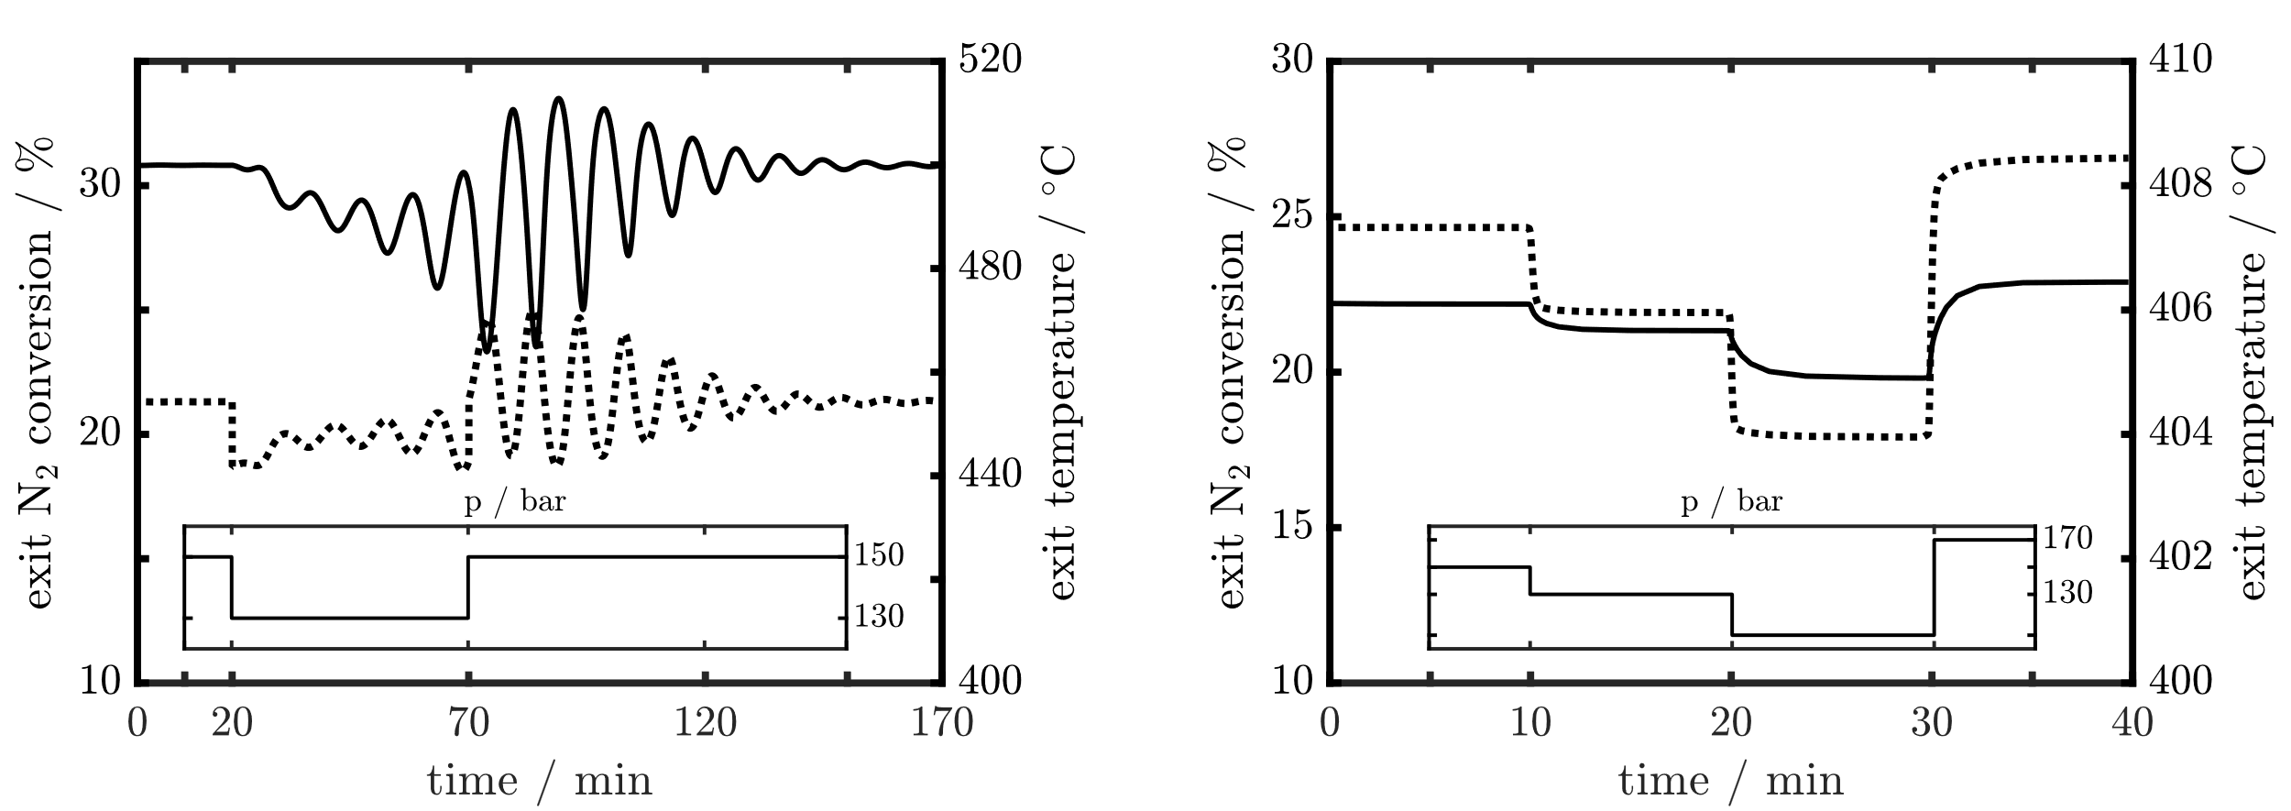
Figure 1: Dynamic simulations of an adiabatic multi-bed reactor (left) and a polytropic fixed-bed reactor (right) subjected to changing feed/reactor pressures ( exit temperature, exit N₂ conversion). In both concepts feed-effluent heat exchangers are considered and a Fe-based catalyst is utilized. Feed temperature is set to 200 °C and GHSV is 7500 h⁻¹.
Fig. 1 illustrates the dynamic responses of an adiabatic multi-bed reactor and a polytropic fixed-bed reactor to sudden pressure changes. The first pressure drop from 150 to 130 bar is identical for both reactor concepts. The feed temperature is set to 200 °C and a feed-effluent heat exchanger is considered in the simulations. In polytropic operation, the reactor is significantly less sensitive to disturbances related to pressure changes. Decreasing the pressure generally reduces the reaction rate and shifts the reaction equilibrium towards lower N₂ conversion. Consequently, under adiabatic conditions, the reactor temperature decreases since less heat is generated. As described by Rosbo et al. (2023), the external thermal feedback then may cause the formation of periodic temperature waves within the reactor. These waves can lead to instabilities during transition between operating points. In our simulations, we observed instabilities with amplitudes of up to 50 °C and maximum temperatures of 515 °C following a pressure drop of 20 bar (Fig. 1 (left)). In contrast, the exit temperature under polytropic operation is only marginally influenced even under significant larger pressure changes (Fig. 1 (right)). The heat transfer via the cooling jacket is sufficient to achieve an almost constant exit temperature, which prevents the external thermal feedback from negatively affecting the reactor stability. However, it should be mentioned that the hot-spot temperature may vary and potentially violate constraints concerning catalyst temperature. This aspect will be further addressed in the following section, utilizing local temperature profiles.
For both concepts, the N₂ conversion is strongly influenced by changing pressure, as the reaction kinetics are pressure dependent. Fig. 1 also shows that under reference conditions (t < 10 min), the polytropic concept achieves higher conversions of about 25 % than the adiabatic concept (21 %), as lower reactor temperatures towards the outlet are thermodynamically favorable.
An analysis of the provided time scales reveals that the polytropic reactor exhibits markedly faster dynamics, resulting in operating point transitions in less than ten minutes. This can be attributed largely to the external heat supply provided by the cooling jacket. In adiabatic operation, the thermal intertia has a noticeably more dominant influence on the energy balance, as heat is only supplied by convection and reaction.

    - Load-flexibility of the polytropic reactor concept
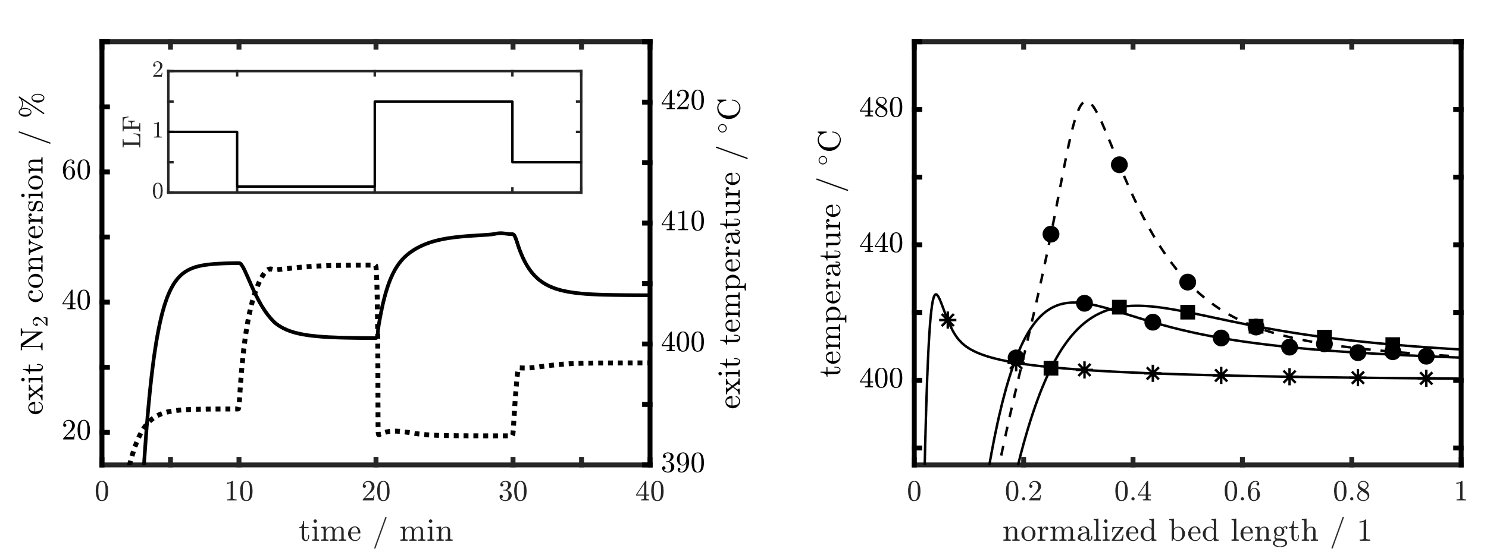
Figure 2: Dynamic simulation results for polytropic operation (left): Exit temperature ( ) and exit N₂ conversion ( ) under changing loads (LF). Feed temperature is set to 20 °C, Fe-based catalyst is utilized and feed-effluent heat exchanger is deactivated. Corresponding steady-state axial temperature profiles (right): (*) LF = 0.1, (●) LF = 1 = 7500 h⁻¹, (■) LF = 1.5. For comparison one simulation utilizing a more active Ru-based catalyst ( ) is shown for LF = 1.
In polytropic operation, a sufficient amount of energy is transferred to the fluid mixture through the cooling jacket within the first reactor section. Therefore, the simulations shown in Fig. 2 were conducted with a reduced feed temperature of 20 °C and without feed-effluent heat exchangers. The calculated conversion is not affected by this and remains at approx. 25 % for the reference case (t < 10 min).
In Fig. 2 (left), rapid load changes (LF = load factor) in periods of about ten minutes are applied to the polytropic reactor. Despite significant changes, no oscillations in the temperature profile nor exit N₂ conversion can be observed during transitions. With increasing loads, exit temperatures are shifted to higher values as the position of the hot-spot moves towards the reactor outlet (Fig. 2 (right)). Both hot-spot and exit temperatures vary by at most 10 °C across the investigated load range and remain well below the critical temperature for catalyst deactivation. The exit N₂ conversion varies over a much wider range from 20 to 45 % as the residence time differs largely for these loads. By adjusting pressure and fluid velocity simultaneously to vary the load, it would be possible to narrow that range. In contrast to adiabatic reactors, the operating range of the polytropic reactor is predominantly constrained by economic considerations rather than stability concerns: At low loads, the space-time yield might be insufficient, while at high loads, the costs for reactant recycling (compression) rises significantly due to the low conversions.
The control scheme proposed by Rosbo et al. (2023) for an adiabatic multi-bed reactor allows the load to be incrementally increased by 10 % of the nominal capacity every ten minutes. As shown in the simulations, much more drastic load changes, i.e. 10 to 150 % at t = 20 min, can be realized safely and rapidly by polytropic reactor operation. This makes the polytropic reactor concept better suited for direct coupling with highly dynamic electrolyzer units.
Fig. 2 (right) also features an axial temperature profile for LF = 1 employing a more active Ru-based catalyst. The higher activity of the catalyst leads to increased hot-spot temperatures, which will increase even further at lower loads. However, the obtained temperatures can still be controlled, and if required, the coolant temperatures could be adjusted. In general, the coolant temperature serves as a crucial control and optimization parameter in the polytropic concept.

  - Conclusion
The presented results indicate that load-flexible ammonia synthesis via polytropic fixed-bed reactors is feasible. In particular, dynamic simulations between steady-states show smooth, safe, and rapid transitions, even for drastic load changes, such as ramping the reactor from 10 to 150 % load in less than 10 minutes. Compared to the conventional adiabatic multi-bed reactor increased N₂ conversions are achievable. Additionally, it has been found that the reactants are adequately preheated by polytropic operation, allowing significantly lower feed temperatures, and making feed-effluent heat exchangers obsolete. This study demonstrates that an efficient cooling concept can prevent potential instabilities and highlights further opportunities to optimize the reactor and its operation.
References
J. Bremer, K. H. G. Rätze, K. Sundmacher, 2017. CO2 Methanation: Optimal Start-Up Control of a Fixed-Bed Reactor for Power-to-Gas Applications. AIChE Journal 63 (1), 23-31.

J. Bremer, K. Sundmacher, 2019. Operating Range Extensions via Hot-Spot Control for Catalytic CO2 Methanation Reaction. Reaction Chemistry & Engineering 4, 1019.

D. C. Dyson, J.M. Simon 1968. Kineitc Expression with Diffusion Correction for Ammonia Synthesis on Industrial Catalyst. Industrial & Engineering Chemistry Researrch 7 (4), 605-610.

O. Elishav, B. M. Lis, E. M. Miller, D. J. Arent, A. Valera-Medina, A. G. Dana, G. E. Shter , G. S. Grader 2020. Progress and Prospective of Nitrogen-Based Alternative Fuels. Chemical Reviews 120, 5352-5436.

S. Fahr, M. Schiedeck, J. Schwarzhuber, S.Rehfeldt, A. Peschel, H. Klein, 2023. Design and Thermodynamic Analysis of a Large-Scale Ammonia Reactor for Increased Load Flexibility. Chemical Engineering Journal 471, 144612.

J. C. Morud, S. Skogestad, 1998. Analysis of Instability in an Industrial Ammonia Reactor. AIChE Journal 44 (4), 888-895.

J. W. Rosbo, T. K. S. Ritschel, S. Hørsholt, J. K. Huusom, J. B. Jørgensen, 2023. Flexible Operation, Optimisation and Stabilising Control of a Quench Cooled Ammonia Reactor for Power-to-Ammonia. Computers & Chemical Engineering 176, 108316.

I. Rossetti, N. Pernicone, F. Ferrero, L. Forni, 2006. Kinetic Study of Ammonia Synthesis on a Promoted Ru/C Catalyst. Industrial & Engineering Chemistry Research 45 (12), 4150-4155.

