Optimisation of a Production Chain for Active Corrosion Protection via Digitalisation
Peter Klein,^{a*} Heinz A. Preisig,^{b} Thomas F. Hagelien, ^{c} Natalia Konchakova ^{d}
ªFraunhofer Institute for Industrial Mathematics, Fraunhofer-Platz 1, 67663 Kaiserslautern, Germany
^{b}Norwegian University of Science and Technology, 7491 Trondheim, Norway
^{c}SINTEF, Otto Nielsens veg 10, 7052 Trondheim, Norway
^{d}Helmholtz-Zentrum Hereon, Max-Planck-Straße 1, 21502 Geesthacht, Germany
peter.klein@itwm.fraunhofer.de
Abstract
Product optimisation is commonly done within a company, even though a product may result from a production chain involving several companies. Exchanging information related to the local optimisation between the involved companies allows for adjusting the local optimisation towards achieving a global optimal product. Making the Pareto fronts of the company-local compromise available to the related partners enables the global optimisation of a B2B2B (Business-to-Business-to-Business). We introduce this technology to manufacturing active corrosion protection coating systems involving nanoparticles, paint producers, and consumers.
Keywords: materials and product digitalisation, optimally distributed production, innovation environment, product design.
  - Introduction
The H2020-funded research and innovation project VIPCOAT [VIPCOAT, 2021] implements a Multi-Criteria Optimization (MCO) technology in an Open Innovation Platform (OIP). The optimisation requires product performance information, which in parts is obtained from the users, from (standardised) experiments and simulations, thus digital twins.
One of the platform's main challenges is bringing together all information in a form that computing devices can process, thus realise the digitalisation of all information [Ekaputra et al, 2022]. It starts with giving things "names" and associating each of these names with a global identifier. Data models that use these global identifiers must be generated for each data stream. The data models can then be shared, allowing for a smooth transfer, thereby guaranteeing data interoperability between all software components. It also enables automating data management and streamlining interaction with (external) databases and data sources [Klein et al, 2023].
Centralising the data also allows for the documentation of the production and the product, which opens the possibility of issuing digital product passports for intermediate and final products. Using IT technologies that build a knowledge graph makes data processing efficient and enables the use of AI technologies for searching, comparison, reasoning, automation, and optimisation.
This paper also discusses the need to digitalise industrial product data and their use for optimisation and documentation to issue digital product passports. The application area is the active protection of metal surfaces in aggressive environmental conditions on the background of having to replace chromates as the main corrosion-protection ingredient.
The project involves three industrial partners: an SME that produces nanoparticles containing the active anti-corrosion component, an international paint producer, and a consumer which is an aeroplane manufacturer.
  - Overall workflow
The design process starts with defining an over-arching objective. A common one is a replacement request, such as a poisonous active component on a material/product, which is augmented with the request of having an equivalent or better or acceptable performance but not being toxic and satisfying a list of constraints associated with operation, application and environment, which leads to the definition of the first task, namely the search for a suitable replacement, which in our demo case is chromates.
The workflow starts with exploring the space where one hopes to find a replacement based on the defined specifications. An AI-based model is trained on this initial information generating an initial set of candidates (feasible component exploration). It is the beginning of an iteration process (experiment, simulations, exploration), which uses experiments and simulations to narrow down the candidate set.
In each iteration step, the candidates' suitability must be verified, defining the next set of performance experiments on probes of the final product, namely the primed metal sheet.
Modelling & simulation augment experimental work. A tight dependency exists between those two efforts, as models require data that can only be obtained from experiments. Figure 1 shows a rough picture of the different components and their interactions.

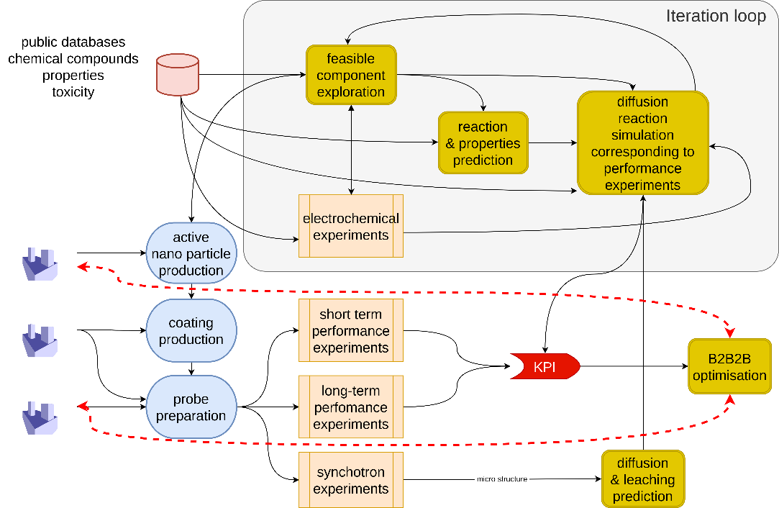

Figure 1: A rough workflow for the chromate-replacement innovation process

Once a set of promising candidates is identified, the iteration loop is extended with coating tests (short & long term). The companies produce a test coating product, and its structure is explored in synchrotron experiments (material’s microstructure), which in turn is utilised to obtain improved estimates on diffusivity. Advanced synchrotron in-situ experiments also lead to the estimation of the leaching kinetics.
Modelling focuses on different aspects of the product with the objective of assessing the performance. It will encompass models for different scales and physical aspects, including the molecular scale, lower granular scale, like particles, agglomerates, and energy dissipation processes driving the macroscopic behaviour.
All these models require input, some of which are generated by experiments, and again, data that are to be connected with the digital environment are being generated.
In each iteration, the candidate set is expected to shrink. Once a reasonable small set is identified, test panels are produced by the coating-producing and the application company, both testing independently the suggested primer for its performance.
In parallel, the obtained information on the product's behaviour is used to define simulations of the panel tests to predict the experimental result and the primer's performance on the application surface.
Key Performance Indicators (KPIs) provide a performance measure and are the main ingredient for the optimisation task spanning the complete production and application sequence and their associated companies.
  - The VIPCOAT Open Innovation Platform
The platform operates with workflows. Some are predefined; others can be built and tailored to the user's needs online.
Data uploading workflow: The various external data streams, mainly experimental and simulation data, are connected to the platform. Each experimental data set is furnished with three metadata sets.
- Cataloguing data resources: Providing high-level information about data resources to enhance the findability and reuse of information. The proper data documentation in a catalogue offers a standardised way of describing and indexing data resources, making it easier for users to locate and utilise the data they need.
- Metadata extraction: Documenting the data's contents in terms of data points. The objective of metadata extraction is to provide a more detailed and accurate description of the data.
- Mapping metadata to standard vocabularies: Often represented as ontological concepts. This step allows semantic interoperability to be achieved, ensuring that external systems can understand the information, which means that the data can be interpreted consistently, regardless of the specific software system or application being used.
The result is a data catalogue and the interoperability of the connected sources. The data are automatically linked to the platform's data exchange space. The connecting operation is done via a semantic service, which takes the metadata and generates a data model. The data model operates like a port definition and is stored in a knowledge graph for application. The port can be accessed over a data pipeline service by any of the platform's processes [Konchakova et al, 2022] giving direct access to the stored data.
Simulation workflows for Inhibitor efficiency prediction: It considers a user case on a prediction of corrosion inhibitors` properties and supports selecting the best inhibitors. The final goal is to assess three relevant KPIs: Inhibition efficiency, Toxicity, and Price. VIPCOAT OIP connects the different simulations via the platform's data space using the APIs generated by the semantic service. For example, information is extracted from the PubChem database. PubChem is a public database that merges more than 750 important international chemical sources such as ECHA, OSHA, etc. Each chemical can be searched and presented at the OIP in the form of the name, CAS number, molecule symbol, or SMILES formula.
Coating Microstructure and Leaching prediction workflow: The second use case deals with the effective medium description (Pseudophase) of the coating and its leaching properties. The detailed morphology of the coat resolving geometrical details at microscales is based on dedicated stochastic geometrical models trained with experimental data from the Synchrotron images. The input parameters for the simulation are collected by the interactive dialogue with the OIP user fixed by the user's active confirmation. The leaching prediction based on generated synthetic morphologies and coating microstructure. The results represent the leaching front and the individual pigment flux that changes over time. This outcome is used for the prediction of the material's behaviour in a coating defect area and simulates the accelerated corrosion test.
Accelerated corrosion test workflow: The corrosion test and respective simulations are done for dynamic and static environmental conditions. Different anti-corrosion pigments are considered, and their influence on coating defects over a metallic substrate is assessed via experiment and multi-ion simulation.
Innovation facilitation workflow: Our aim is to implement an open innovation process using B2B2B digital environment. We focus on automatic knowledge and data exchange thought the OIP by providing efficient operation and giving the owner complete control over accessibility to all (meta-) data. The VIPCOAT project revealed that companies are ready to share their data under these conditions and participate in the co-development and co-creation process in the frame of an innovation project.
VIPCOAT OIP supports innovation processes consisting of 4 steps: Ideas, Project Proposal, Partnerships and Projects (see Figure 2).

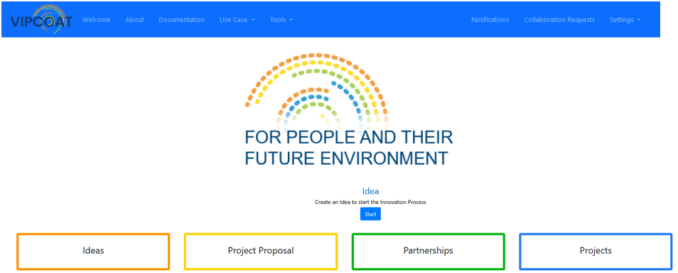

Figure 2: VIPCOAT OIP landing page, https://vipcoat-oip.com/welcome
The platform will serve as a digital environment for an interactive cooperation and co-design of new products – protective coatings. The information generated by the simulations and experiments is utilised to generate Key Performance Indicators (KPI), which, in turn, are the information used in the B2B2B optimisation.
  - Optimisation along a production chain via Digitalisation
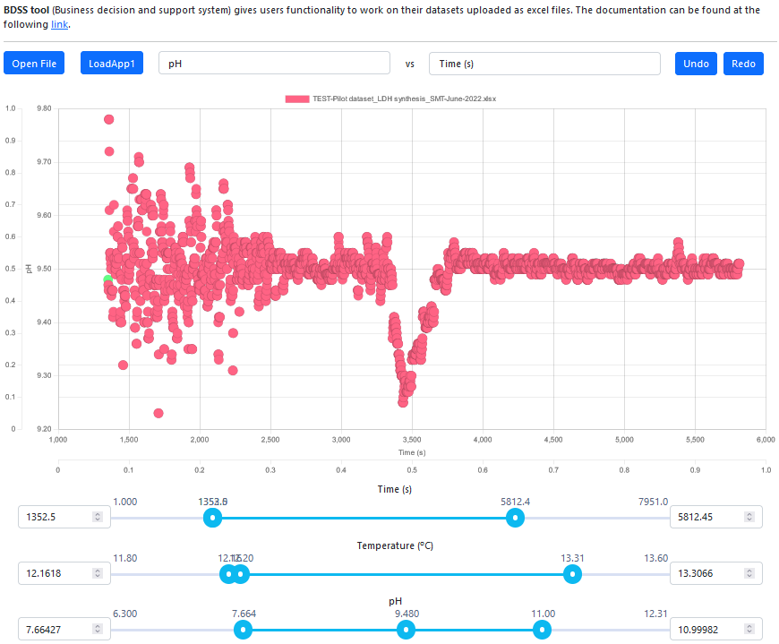
A Multi-Criteria Optimisation (MCO) approach and a decision-making methodology have been used for the business decision support system (BDSS) based on Pareto fronts and implemented on the VIPCOAT platform. The method guidelines the construction of suitable initial and boundary conditions of modelling workflow related to the VIPCOAT use cases and their integration into collaborative industrial decision-making methodologies using MCO in a B2B2B environment, as realised by VIPCOAT industrial partners along a production chain. This optimisation technique allows us to find a set of tuneable design variables satisfying constraints and simultaneously optimise the KPIs. The MCO leads to non-unique solutions. Pareto fronts represent the best possible and feasible compromises among conflicting objectives, for example, quality versus cost (Figure 3)

Figure 3: Pareto front explorer applied to the reactor producing LDH structures.
In the VIPCOAT digital B2B2B environment, the optimisation workflow is guided by a BPMN diagram. A business decision support system integrated into the OIP allows users to find an optimal solution based on identified KPIs. Users can apply their datasets to the system. The platform reads the set and prepares it properly for the interactive graph application. The user can consider different KPIs to select the optimal frame of the product parameters. The analysis could be an iterative one. The optimisation process could be focused on the challenges of only one industrial player or support collaborative decision-making for two (B2B) or more innovation partners (B2B2B). The collaborative MCO has been implemented at VIPCOAT OIP, providing the Pareto front of supplier variants (B2B) for downstream usage in an MCO design space (B2B). The approach allows the execution of a fast technological iteration in case of surprise specifications or requirements:
downstream: technological as quality KPIs;
upstream: technological design options and business KPIs (pricing).
  - Conclusion
Collaborative optimisation and decision-making process unlock hereto hidden product innovation potentials. Following this idea, VIPCOAT consortium successfully works under implementation of the digital environment to support the innovation facilitation and optimization along the production chain for active corrosion protection for airspace. Leading European industry and academia apply modelling and multi-criteria optimization technique to accelerate development a protective coating with best possible corrosion inhibitor replaced hexavalent chromium-based compounds. VIPCOAT platform supports the optimal materials design process based on modelling prediction from describing the materials properties and available data provided by distributed manufacturing, and the involved materials components to new product development. This approach necessarily calls for interoperability along the value-added chain, which requests proper data documentation and ontological representation. VIPCOAT platform is equipped with Application Programmer Interfaces that provide automatic connection to REACH and PubChem data bases. Later provides the end-users with different important information regarding toxicity of investigated chemicals, properties of new inhibitors, list of potential restrictions or other parameters to support the decision making on a production use of potential coating components. It makes VIPCOAT OIP an attractive digital environment for creating a Digital Materials and Product Passport as requested by the EC for different industrial areas. The passport will support co-innovation processes and will be developed based according to industrial needs. The discussed in this paper approach of the optimization along a production chain via Digitalisation is a step forward to implement Circular Economy transition and Safe and Sustainable by Design paradigm.
Acknowledgements: VIPCOAT H2020-NMBP-TO-IND-2020, Grant Agreement No. 952903; MEDIATE European net project; DigiPass HORIZON-CL4-2023-RESILIENCE-01-39, Grant Agreement No. 101138510.
References
Virtual Open Innovation Platform for Active Protective Coatings Guided by Modelling and Optimization (VIPCOAT, Grant Agreement No 952903), https://ms.hereon.de/vipcoat/ , https://cordis.europa.eu/project/id/952903/de
P. Klein, H.A. Preisig, N. Konchakova, 2023, Translation Ontology of optimal Decision Making along a Distributed Production Chain by Example, Computer Aided Chemical Engineering, 52, https://doi.org/10.1016/B978-0-443-15274-0.50333-4
N. Konchakova, H.A. Preisig, C. Kavka, M.T. Horsch, P. Klein, S. Belouettar, 2022, Bringing Together Materials and Business Ontologies for Protective Coatings, CEUR Workshop Proceedings, http://ceur-ws.org/Vol-3240/ .
F.J. Ekaputra, F. Piroi, M. Noeske, J. Friis, Jesper, A. Calvio, N. Konchakova, R. Foidl, W.L. Cavalcanti, L. Foschini, T.F. Hagelien, A. More, C.W. Andersen, B. Andreon, 2022, Towards an Open Translation Environment for Supporting Translators in the Materials Domain, CEUR Workshop Proceedings, http://ceur-ws.org/Vol-3240/ .

https://publications.jrc.ec.europa.eu/repository/handle/JRC128591

