Waste Heat Recovery from PEM Electrolyzer for Desalinated Water Production in Polygeneration Systems
Artur S. Bispo,ª Leonardo O.S. Santana,ª Gustavo S. dos Santos,ª Chrislaine B. Marinho,ª Daniela Hartmann,^{b} Fernando L.P. Pessoa.^{a,c}
ªSENAI CIMATEC, Av. Orlando Gomes, 1845 - Piatã, Salvador - BA, 41650-010, Brazil.
^{b}CNODC Brasil Petróleo e Gás, Botafogo, Rio de Janeiro – RJ, 22250-040, Brazil.
^{c}UFRJ, Av. Athos da Silveira Ramos, 149 - RJ, 21941-909, Brazil.
Artur.bispo@outlook.com.br
Abstract
In the upcoming future hydrogen-based economy, water electrolysis appears as a good alternative for producing clean hydrogen without carbon emissions, however, the rising water scarcity call for the wider adaptation of desalination techniques. One of the most promising desalination techniques is pervaporation (PV), an emerging technology for desalination of water that works by temperature. A mathematical model of the PEM electrolyser heat generation is used and experimental data from literature is used to simulate the pervaporator. The proposed plant led to a polygeneration system that consists of interdependent processes that seek opportunities to increase the thermodynamic efficiency of the system.
Keywords: Water Electrolysis, Water desalination, Emerging membrane technologies, Polygeneration system, process integration.
  - Introduction
In the current global industrial/energy scenario, there has been a growing interest in sustainable energy matrices, driven by the need to reduce dependency on fossil sources and mitigate the impacts arising from GGEs (Greenhouse Gas Emissions). In this context, GH₂ (green hydrogen) emerges as one of the main actors in decarbonization, enabling the efficient storage and transport of energy generated from renewable sources, such as wind and solar power (Atilhan et al., 2021).
GH₂ refers to hydrogen produced specifically through the electrolysis of water using renewable energy sources. Furthermore, among the various electrolysis technologies, PEM (Proton Exchange Membrane) stands out for its advantages in aspects such as energy efficiency, design, H₂ purity, operational conditions, and rapid response time. However, to make this energy vector competitive, several bottlenecks need to be overcome, mostly involving the high costs associated with both the implementation – noble metals in equipment structure and catalysts – and operation – energy and water treatment – of these electrolytic systems (Kumar e Himabindu, 2019).
    - PEM Electrolysis
The structure known as a stack, according to Mehta and Cooper (2003), is composed by a set of electrolytic cells, electrically connected in series, consisting of bipolar plates surrounding the MEA (Membrane-Electrode Assembly). The MEA, in turn, is made up of a polymer membrane, electrocatalysts, and the GDL (Gas Diffusion Layer).
Authors such as Kumar and Himabindu (2019), Rozain et al. (2016), Garcia Valverde et al. (2011) and Wang et al. (2021) explains, in summary, that PEM process begins with water being supplied to the electrolyzer through the anodic channel, where it is split (Eq. 1), with the aid of metallic oxide catalysts, following mechanisms such as AEM and LOM. After crossing the polymer membrane, the protons are reduced to gaseous hydrogen (Eq. 2) at the cathode through Volmer, Heyrovsky, and Tafel mechanisms. Meanwhile, gaseous oxygen molecules (O₂) are generated at the anode, diffusing through the GDL, and being removed as a process byproduct.
$$H_{2}O→{2H}^{+}+1/2O_{2}+{2e}^{-}$$ |  | (1)
$${2H}^{+}+{2e}^{-}→H_{2}$$ | (2)
As for the typical PEM electrolyzers make up materials, specific catalysts are employed at both anode and cathode. At the anode, metallic oxides like RuO₂ and IrO₂ are preferred for their high metallic conductivity properties and favorable molecular characteristics. At the cathode, platinum is the most efficient catalyst, although palladium is also used due to its lower cost and greater abundance. Moreover, Nafion®/PFSA polymer membranes are widely used as solid electrolyte, for their effectiveness in proton conduction and long durability (Kumar and Himabindu, 2019).
    - Pervaporation
Pervaporation (PV) is an emerging membrane desalination technology that uses thermal energy as an external gradient and phase change as physicochemical process (Saavedra, et al. 2021). This technology is widely used in poly and cogeneration systems as it increases the exergy efficiency of energy resources (Kumar et al., 2023).
Therefore, and due to the increase in the world population and urbanization, water scarcity is today one of the most difficult challenges faced by society. Pervaporation is probably the membrane operation with the lowest permeation rate, but providing high salt rejection, so the use of this technology allows drinking water to be obtained more efficiently and with reuse of waste heat (Castro-Muñoz, 2020) such as solar thermal energy. There are several solar-powered desalination systems around the world with internal heat recovery. The system configuration can be seen in Figure 1, heat is required to heat the feed (preheated) to the hot inlet, i.e., from about 72 ◦C to about 80 ◦C (the numbers are given as an example of standard module operation) (Cipollina et al., 2012).
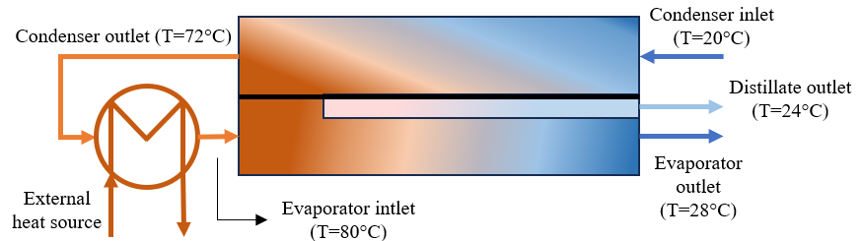
Figure 1. PV system scheme
Considering this entire scenario, the present work aims to assess the energy integration of the GH₂ production by PEM electrolysis, directing the stack waste heat produced during the electrolysis to the feed water treatment process. This approach not only makes feasible the use of the heat generated by the production process itself but also opens up the possibility of using nontraditional water sources, such as seawater, in a polygeneration system that produces potable water, hydrogen and oxygen.
  - PEM modeling
To quantitatively determine the heat generated by a PEM electrolyzer, it is necessary to model the entire process, considering the occurring phenomena and inherent losses. Thus, Eq. (3) works as the modeling basis, determining the stack operating voltage ($V_{stack}$) as a function of phenomenology and non-ideality (losses) of the process (Garcia Valverde et al., 2011).
$$V_{stack}=n_{cell}\left(U_{cell}+η_{act,C}+η_{act,A}+η_{diff}+η_{ohm}\right)$$ | (3)
Where $n_{cell}$ is the number of cells, $U_{cell}$ is the open circuit potential, $η_{act,C}$ and $η_{act,A}$ are the activation overpotentials at the electrodes, $η_{diff}$ is the diffusion or mass transfer overpotential, and $η_{ohm}$ is the ohmic overpotential. For convenience, this work will make use of a more simplified version of this model, disregarding the activation overpotential at the cathode – as it is very small when compared anode side – and the diffusion overpotential – since it can be neglected at operating current densities below 1.6 A/cm² (Agbli et al., 2010).
For the open circuit potential, the empirical Eq. (4) – also used by Garcia Valverde et al. (2011) and Agbli et al. (2011) – was considered, relating it to the process operating temperature.
$$U_{cell}=1,5184-{1,5421*10}^{-3}T+{9,523*10}^{-5}T\ln\left(T\right)+{9,84*10}^{-8}{ T}^{2}$$ | (4)
The anode activation overpotential can be determined from Eqs. (5) and (6), which describes it, based on the Butler-Volmer equation, as a function of operating temperature and current density ($i$) (Garcia Valverde et al., 2011).
$$η_{act,a}=\frac{RT}{αzF}\ln\left(\frac{i}{i_{0}}\right)$$ | (5)
$$i_{0}=i_{0,ref}e^{\frac{-E_{exc}}{R}\left(\frac{1}{T}-\frac{1}{T_{ref}}\right)}$$ |  | (6)
Regarding the ohmic overpotential, it can be described as the ratio of the membrane thickness to its conductivity (Eq. 7). Therefore, according to Bispo et al. (2023), the conductivity can be determined as a function of the temperature and the membrane water content ($λ_{m}$), based on Arrhenius equation, as seen in Eq. (8).
$$η_{ohm}=\frac{t_{m}}{σ_{H^{+}}}$$ | (7)
$$σ_{H^{+}}=\left(0,046459\ln{λ_{m}}-0,051556\right)*e^{\left[1268\left(\frac{1}{298,15}-\frac{1}{T}\right)\right]}$$ |  | (8)
Finally, it is possible to determine the stack heat generation (${\dot{Q}}_{gen}$) from Eq. (9), (Garcia Valverde et al., 2011). The thermoneutral potential ($U_{tn}$), in turn, is calculated using Eqs. (10 – 12), and the experimental parameters from $a$ to $d$ – to a component $j$ – can be found in Marangio et al. (2009).
$${\dot{Q}}_{gen}=\left(V_{stack}-\left[U_{tn}*n_{cell}\right]\right)*\left(i*A\right)$$ |  | (9)
$$U_{tn}=\frac{ΔH}{nF}$$ | (10)
$$ΔH= H_{H_{2}}\left(T\right)+1/2H_{O_{2}}\left(T\right)-H_{H_{2}O}\left(T\right)$$ |  | (11)
$$H_{j}(T)=a_{j}T+4b_{j}\frac{T^{5/4}}{5}+2c_{j}\frac{T^{3/2}}{3}+4d_{j}\frac{T^{7/4}}{7}$$ |  |  | (12)
  - Process Simulation
The simulation of the integrated seawater purification and GH₂ production process was carried out using two software, simultaneously: Excel VBA and Aspen Plus V14. Given the absence of a PEM electrolyzer simulation block in Aspen Plus V14, all the modeling developed and explained in previous section was implemented in Excel VBA, to determine the water consumption and heat generation of a given electrolyzer. The simulated electrolyzer specifications can be seen in Table 1.
Table 1. Electrolyzer Modeling Specs.
Parameter | Symbol | Value | Unit
Temperature | $$T$$ | 353.15 | K
Current density | $$i$$ | 1.35 | A/cm²
Number of cells | $$n_{cell}$$ | 20 | -
Membrane thickness | $$t_{m}$$ | 0.03306 | cm
Water content | $$λ_{m}$$ | 22 | -
Area | $$A$$ | 100 | cm²
Power | $$Pot$$ | 1 | MW
Reference exchange current density | $$i_{0,ref}$$ | 10⁻⁷ | A/cm²
Reference temperature | $$T_{ref}$$ | 353.15 | K
Activation energy | $$E_{exc}$$ | 53.99 | kJ/mol
Transferred electrons | $$z$$ | 2 | -
Charge transfer coefficient | $$α$$ | 0.5 | -
Furthermore, Aspen Plus also lacks a simulation block for defining membrane distillation. Therefore, for simulation purposes and to determine the distillation heat duty, a “Hierarchy” block was used, and the flowsheet shown in Figure 2 was structured.
As explained by Cipollina et al. (2012), brine distillation occurs through the increase of its temperature and, consequently, the evaporation of the solvent. For the simulation, a HeatX was used to simulate this heat transfer and a Heater to describe the fluid heating and the heat duty. Moreover, to 'emulate' the membrane behavior and based on the parameters presented by Khalifa et al. (2017), a Flash2 was used, setting the separation temperature value - 80 °C - and the molar vapor fraction - 4.8 %.
Besides, in order to determine the brine flow to simulated membrane distillation, its output was considered to be equal to the feed of purified water in the electrolyzer described by Table 1. Pressure and temperature conditions where also based on Khalifa et al. (2017) and Cipollina et al. (2012). Finally, the two simulated processes were integrated, with the pervaporator distillate being fed into the stack, and the energy generated by the stack transferred to heat the brine.
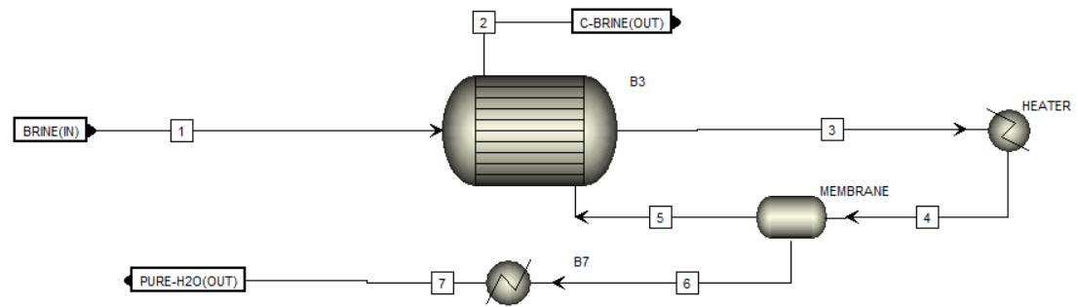
Figure 2. Membrane distillation flowsheet.
  - Results
Figure 3 shows the integrated process flowsheet. Additionally, Table 2 displays the input and output values for each process. As can be observed, the simulation shows that to produce 174.32 kg/h of distilled water – electrolyzer demand, the pervaporator requires 24.56 kW of energy and 4791.81 kg/h of brine (35% NaCl). Furthermore, the stack specified in Table 1 exhibits an overall excess heat of 98.20 kW, therefore, approximately 25 % of this heat needs to be utilized to meet the water purification system demand.
Thus, these results present a promising alternative in the energy integration of the process (considering a conservative scenario in terms of heat recovery), enabling the use of brine in PEM electrolysis systems without the need for an external energy demand for its purification.
Table 2. Simulation results.
Pervaporator |  |  |  | PEM Electrolyzer
stream | Composition |  | Temperature | Voltage | 35,40 | Volts
Brine | H₂O | 3114.68 kg/h | 25 °C | H₂O  feed | 174.32 | kg/h
 | NaCl | 1677.13 kg/h
Pure – h₂o | H₂O | 174.32 kg/h | 24 °C | H₂  Produced | 19.37 | kg/h
 | NaCl | ≅ 0
c-brine | H₂O | 2940.36 kg/h | 28 °C | O₂  Produced | 154.95 | kg/h
 | NaCl | 1677.13 kg/h
Heat duty/ Excess | 24.56 kW |  |  | 98.20 kW
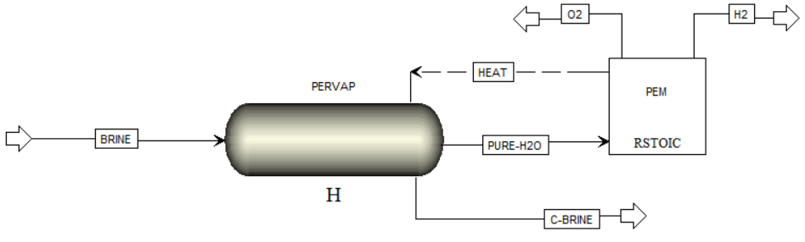
Figure 3. Integrated process flowsheet.
  - Conclusions
Finally, this study demonstrates a novel approach to integrating PEM electrolyzer with a membrane desalination process, effectively utilizing waste heat (with an efficiency of 25%) for desalinated water production in polygeneration systems. The results reveal that the recovered waste heat from the PEM stack significantly enhances the pervaporation process efficiency, contributing to a more energy-efficient water desalination method. In conclusion, this study not only contributes to the field of renewable energy and environmental engineering but also aligns with the global efforts to develop innovative solutions for energy efficiency and water resource management.
References
A. Bispo, C. Marinho, F. Pessoa & J. Almeida (2023). An ajusted model of proton conductivity in Nafion® membranes. Journal of Bioengineering and Technology Applied to Helth.
A. Saavedra, H. Valdés, A. Mahn & O. Acosta (2021). Comparative analysis of conventional and emerging technologies for seawater desalination: Northern Chile as a case study. Membranes, 11(3), 180.
C. Rozain, E. Mayousse, N. Guillet, & P. Millet (2016). Influence of iridium oxide loadings on the performance of PEM water electrolysis cells: Part I–Pure IrO2-based anodes. Applied Catalysis B: Environmental, 182, 153-160.
F. Marangio, M. Santarelli & M. Calì (2009). Theoretical model and experimental analysis of a high pressure PEM water electrolyser for hydrogen production. International journal of hydrogen energy, 34(3), 1143-1158.
G. Kumar, D. Ayou, C. Narendran, R. Saravanan, M. Maiya & A. Coronas (2023). Renewable heat powered polygeneration system based on an advanced absorption cycle for rural communities. Energy, 262, 125300.
K. Agbli, M. Péra, D. Hissel, O. Rallières, C. Turpin & I. Doumbia (2011). Multiphysics simulation of a PEM electrolyser: Energetic Macroscopic Representation approach. International journal of hydrogen energy, 36(2), 1382-1398.
R. Castro-Muñoz (2020). Breakthroughs on tailoring pervaporation membranes for water desalination: A review. Water research, 187, 116428.
R. García-Valverde, N. Espinosa & A. Urbina (2012). Simple PEM water electrolyser model and experimental validation. International journal of hydrogen energy, 37(2), 1927-1938.
S. Atilhan, S. Park, M. El-Halwagi, M. Atilhan, M. Moore, & R. Nielsen (2021). Green hydrogen as an alternative fuel for the shipping industry. Current Opinion in Chemical Engineering, 31, 100668.
S. Kumar, & V. Himabindu (2019). Hydrogen production by PEM water electrolysis–A review. Materials Science for Energy Technologies, 2(3), 442-454.
S. Wang, A. Lu, & C. Zhong (2021). Hydrogen production from water electrolysis: role of catalysts. Nano Convergence, 8, 1-23.
V. Mehta, & J. Cooper (2003). Review and analysis of PEM fuel cell design and manufacturing. Journal of power sources, 114(1), 32-53.

