Modeling and Optimizing Sugarcane-Livestock Integration Systems in Brazil
Igor L. R. Dias^{a*}, Terezinha F. Cardoso^{b}, Ana C. M. Jimenez^{b}, João G. O. Marques^{c}, Luís G. Barioni^{d}, Flávia Barbosa^{e}, Adriano P. Marianoª, Marcelo P. Cunha^{f}, Antonio Bonomi^{b}
ªFaculdade de Engenharia Química (FEQ), Universidade Estadual de Campinas (Unicamp), Av. Albert Einstein, 500, CEP 13083-852, Campinas - SP, Brasil.
^{b} Laboratório Nacional de Biorrenováveis (LNBR), Centro Nacional de Pesquisa em Energia e Materiais (CNPEM), CEP 13083-970, Campinas - SP, Brasil.
^{c}Parrakat, Edinburgh, United Kingdom.
^{d}Embrapa Agricultura Digital - Embrapa, Av. Dr. André Tosello, 209 - Cidade Universitária, 13083-886, Campinas – SP, Brasil.
^{e} INESC TEC, Faculdade de Engenharia, Universidade do Porto, Porto, Portugal.
^{f}Instituto de Economia (IE), Universidade Estadual de Campinas (Unicamp), R. Pitágoras, 353 - Cidade Universitária, 13083-857, Campinas - SP, Brasil.
*i261185@dac.unicamp.br
Abstract
The expansion of ethanol production in Brazil sparks several sustainability concerns, including debates on “food versus fuel”, the environmental impacts of monocultures, and indirect land-use change. Since livestock farming occupies a significantly greater area than sugarcane for ethanol production in Brazil and has a large yield gap, sugarcane-livestock integration can be a promising alternative. This integrated system considers crop production systems, biorefinery processing and meat production in both intensive and extensive livestock farming. Optimizing this system for both economic and environmental aspects can be challenging to implement and computationally expensive as this system’s complexity arises from nonlinear subsystems and their intertwining input-output flows. For these reasons, this paper develops metamodels from detailed models to: (i) Optimize the extensive livestock farming, (ii) Optimize the confined animal feeding, and (iii) Optimize the integrated system. The main objective is to maximize the Net Present Value relative to investment. This study contributes to the literature by developing innovative models for ethanol-beef integrated production systems and methods for optimizing such systems to avoid negative externalities on food security and environmental impacts.

Keywords: Biorefineries, Beef cattle production, Experimental Design, Optimization metamodels, Food versus biofuels

  - Introduction
The production of biofuels, especially ethanol, has been encouraged in Brazil for a long time. Currently, Brazil has a National Biofuels Policy, RenovaBio, whose main objective is to increase the production of biofuels seeking environmental, economic, and social sustainability (UNICA, 2020; ANP, 2020). Under this program, the country's first official carbon credit, CBIO, has been established. The expansion of ethanol production has raised concerns regarding land change, such as competition with food crops and impacts on deforestation (ACHINAS et al., 2019; ALLEN et al., 2019).
Sugarcane-livestock integration systems could improve the sustainability of ethanol production expansion by minimizing negative impacts and improving yields for both sugarcane plantations and livestock (SOUZA et al., 2019). The complexity of this system is evident, including nonlinear models dependent on numerous variables, such as the amount of processed sugarcane, the nutritional quality of feed ingredients, and nitrogen doses for forage production, among others. Therefore, optimizing this system, considering economic and environmental aspects, requires the application of advanced methods, which can be challenging to implement and properly adjust.
This study designs the integrated system by developing metamodels and solving sub-optimization problems. Therefore, this work aims to answer the research question: "Under what conditions is it feasible to expand the area dedicated to biofuel production without negatively impacting food or livestock production while avoiding expansion into natural vegetation areas?".
  - Methodology
    - Description of the system
In the integrated system analyzed (Figure 1), sugarcane is produced and transported to the biorefinery (1G autonomous) for processing. Soybean grains produced in the sugarcane reform area are sold on the market, and their revenues are added to the system. The sugarcane straw and bagasse are used to produce bioelectricity. Ethanol and the surplus of bioelectricity produced in the biorefinery are sold, while part of the excess bagasse is used for animal feed or sold. Livestock farming, in turn, considers only beef cattle fattening.
    - Development of metamodels
A crucial point to consider in optimizing the defined integrated system is that detailed models would render a highly complex or even unsolvable optimization problem, given that these models exhibit varying degrees of mathematical complexity and convergence issues. Furthermore, creating distinct data flow strategies among models built on various platforms would be necessary. To address these challenges, an optimization strategy similar to the one presented by Bressanin et al. (2021) was adopted. This involves creating simplified metamodels derived from more detailed models. To achieve this, several data sampling strategies from the detailed models were employed for each system.
The Virtual Biorefinery (VB) tool was employed as a detailed base for obtaining metamodels of the agricultural and industrial phases of the biorefinery (BONOMI et al., 2016). In the VB, CanaSoft is used to estimate the amount and costs of sugarcane, soybeans production, and sugarcane straw recovery (BONOMI et al., 2016), while the Aspen Plus® commercial process simulator (JUNQUEIRA et al., 2017) is used to simulate the industrial phase. The metamodels for this ethanol production chain were developed using the Factorial Design of Experiment 2^{k} with a Central Composite Circumscribed Design (CCC) based on the sampling and simulation of detailed models from the VB. Seven factors were considered in the crop system to obtain the system outputs (Figure 1). In total, 143 points were collected for each response without repetition at the central point. Likewise, four factors were considered for the industrial system. In total, 25 points were collected for each response without repetition at the central point. Statistical metamodels were generated by second-degree polynomial regression from the datasets (inputs and outputs) obtained from detailed models according to the experimental design matrix. In this fitting process, the main and interaction effects of two factors were tested, adopting a confidence level of 95%. The quality of the fit of the statistical metamodels was assessed using the coefficient of determination (R²) and Analysis of Variance (ANOVA).
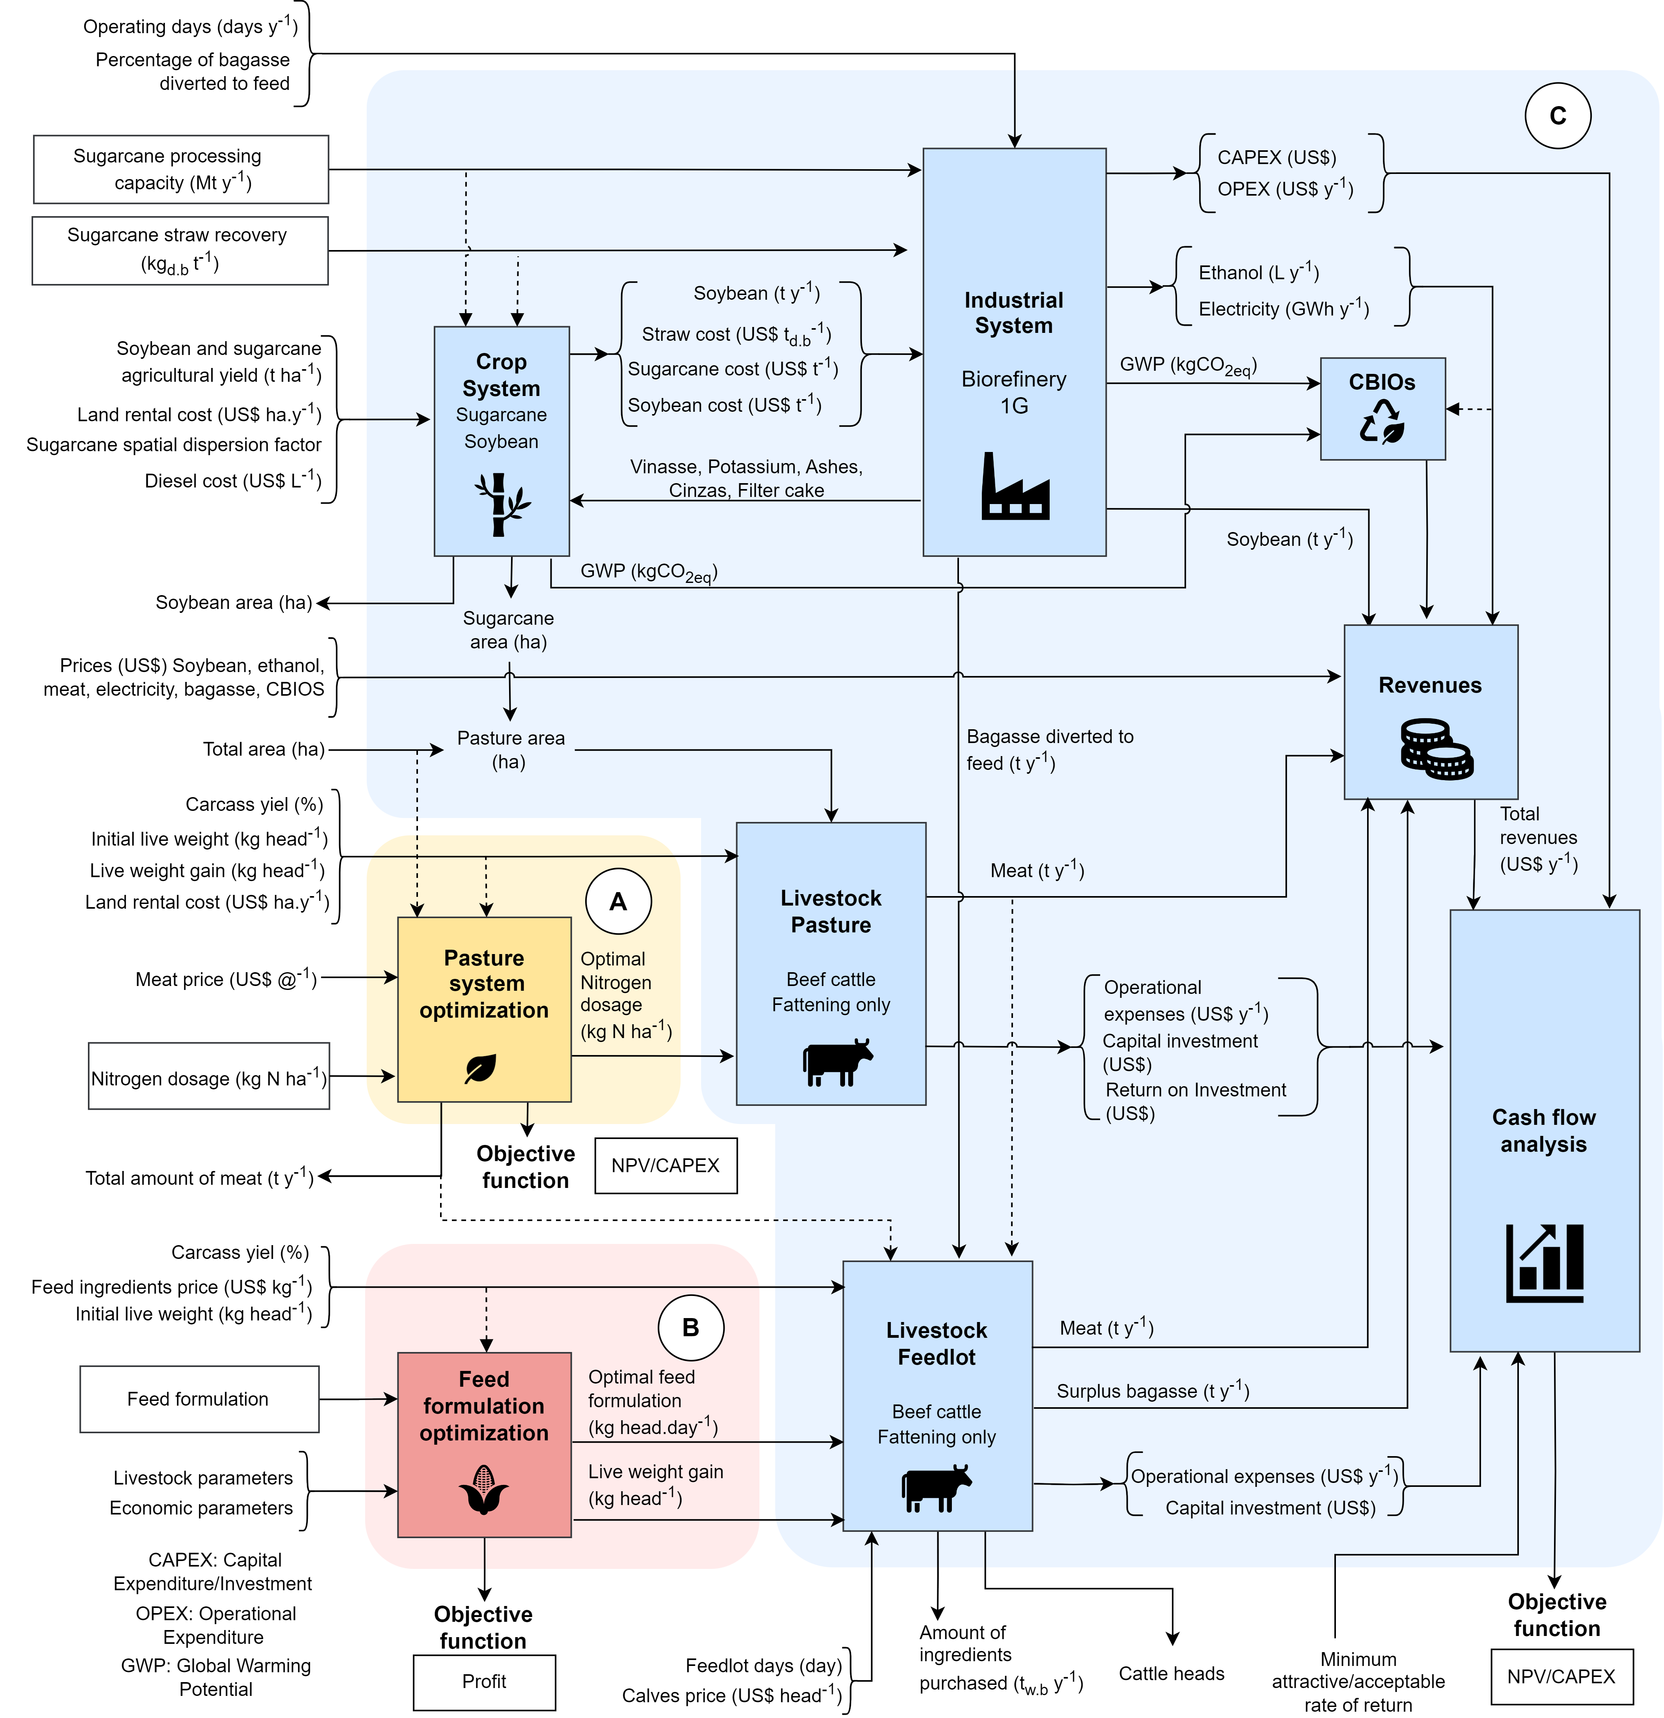
Figure 1. (A) Frontiers of optimizing pasture livestock farming. (B) Frontiers of optimizing feed for confined animals. (C) Frontiers of optimizing the integrated system of the sugarcane and beef cattle production chain
Regarding pasture, detailed models of beef cattle production developed by the Brazilian Agricultural Research Corporation (Embrapa) were used to obtain metamodels. In this analysis, a prototypical farm in São Paulo state (Brazil) was considered. To generate the metamodels, a second-degree polynomial statistical regression was conducted among different scenarios with varying levels of nitrogen fertilization for pasture maintenance. The response variables considered were the cattle stocking rate and the system's operational costs.
In the context of feedlot operations, the total cost per head per day was calculated, considering the costs of animal acquisition and feed, which represent the major portion of daily costs. Other operational costs, such as labor and sanitary management, as well investment costs, were estimated based on Sartorello et al. (2018). Thus, it was possible to estimate the total cost per cycle by providing information on the number of days in the confinement cycle, the number of confined animals, and daily costs.
Estimation of CBIOs generated depends on the biofuel's energy-environment efficiency score based on the life cycle analysis methodology. The sum of the greenhouse gas (GHG) emissions from each phase of the biofuel's life cycle (agricultural, industrial, distribution, and use) results in the biofuel's carbon intensity (emission of g CO₂eq/MJ). When subtracted from the carbon intensity of its equivalent fossil fuel, this intensity generates the biofuel's energy-environment efficiency score. Emissions from the agricultural and industrial phases are estimated using metamodels from the crop and industrial systems. The emissions were estimated using the RenovaCalc methodology and the GHG Protocol emission factors (ANP, 2020).
The profitability analysis was developed to calculate economic performance indicators, such as the Net Present Value relative to the investment (NPV/Investment) and the Internal Rate of Return (IRR). The analysis incorporated a 30-year cash flow projection, a minimum rate of attractiveness (MRA) of 12% per year, linear depreciation over ten years, a 34% corporate tax rate, and working capital equivalent to 10% of the investment (BONOMI et al., 2016).
    - System optimization
Some fundamental assumptions were established to formulate the optimization problem: (i) A total available area needs to be fully utilized with grazing land for cattle or sugarcane cultivation. (ii) The system must meet a meat production requirement, considering as a reference an optimized pasture system that occupies the entire area. (iii) The area allocated for confinement and the industrial sector of the biorefinery is negligible. In addition to metamodels, another strategy employed to optimize the system was to divide it into optimization subproblems, namely:
a) Optimization of beef cattle on pasture across the entire available area (Figure 1A): The pasture was optimized by maximizing the NPV/Investment, with nitrogen dosage as a decision variable. This optimization allows the optimal nitrogen dosage for the pasture to be found and establishes reference meat production (as per assumption ii).
b) Optimization of confined animal feeding formulation (Figure 1B): In this analysis, the Maximum Profit Feed Formulation (RLM) software was used (MARQUES et al., 2022). This optimization aims to find the most profitable diet with high bagasse composition and higher live weight gain of the animals.
c) Optimization of the integrated livestock/biorefinery system (Figure 1C): The results from previous optimizations (nitrogen dosage, meat production requirement, feed formulation, and confinement weight gain) are input parameters for the integrated system optimization. In this context, decision variables include the production capacity of the biorefinery and the straw recovery, aiming to maximize NPV/Investment.
Optimization algorithms were implemented in Python. To solve the optimization problem, the PYOMO library and the IPOPT ("Interior Point Optimizer") solver, which is suitable for nonlinear programming, were utilized. To run the optimization, the input parameter values were considered for São Paulo state (Table 1).

Table 1. Input parameters considered in the optimization for the state of São Paulo (Brazil) – valid for 2019
Variable | Value | Variable | Value
Total area (10³ ha) | 100 | Carcass yield (%) | 54
Sugarcane agricultural yield (t ha⁻¹) | 80 | Feedlot days (day) | 100
Land rental cost (US$ ha.y⁻¹) | 240 | Initial feedlot live weight (kg head⁻¹) | 380
Sugarcane spatial dispersion factor (%) | 24 | Calves price (US$ head⁻¹) | 500
Diesel cost (US$ L⁻¹) | 0.70 | Ethanol price (US$ L⁻¹) | 0.39
Soybean agricultural yield (t ha⁻¹) | 3.2 | Electricity price (US$ MWh⁻¹) | 42.2
Operating days (days y⁻¹) | 200 | Soybean price (US$ (60kg)⁻¹) | 17.6
Bagasse diverted to feed (%) | 10 | Meat price (US$ (15kg)⁻¹) | 51.6
Initial pasture live weight (kg head⁻¹) | 322 | Bagasse price (US$/kg) | 0.03
Pasture live weight gain (kg head⁻¹) | 150 | CBIOS price (US$/un) | 10
  - Results and discussion
The metamodels showed statistical significance, with an R² between 0.95-0.99 for the biorefinery fits and 0.82-0.88 for the pasture-based livestock system.
For the input parameters, the subproblem optimization results were: (a) The optimal nitrogen dose equals 0 kg ha⁻¹, meaning it is economically better not to fertilize the pasture. This system produces 21.5 x 10³ t y⁻¹ of meat, with a maximum NPV/Investment equal to -0.75. (b) The optimal feed consists of 18.9% bagasse, 46.5% corn, 30% DDGS, 1.3% vegetable oil, 0.5% potassium chloride, 1% calcite, 0.8% urea, and 1% mineral salt. This feed results in a weight gain of 170 kg head⁻¹ y⁻¹ (c) The optimal capacity of the biorefinery is 6.33 Mt y⁻¹, and the optimal recovered straw is 6.74 kg_{db} t⁻¹. Under these conditions, sugarcane cultivation occupies the entire available area, and all cattle are confined. The maximum NPV/Investment obtained was 0.81 (IRR = 21.7%).
In the optimization, a sensitivity analysis was performed for different values of meat price and land rent (Figure 2). In Figure 2A, the upper level indicates that all cattle are confined, while the lower level represents the majority kept on pasture, considering the integrated system. With the same meat price, an increase in land rent leads to a shift of cattle from pasture to confinement. For the same land rent, pasture is more valued at higher meat prices. As the meat price increases, it is possible to maintain pasture even with higher rental prices. The NPV/Investment decreases with increasing land rent and decreasing meat price (Figure 2B), and this change in the slope of the curve coincides with the shift in levels in Figure 2A. This curve can be characterized by the junction of two lines (Figure 2C): one where the biorefinery operates at its minimum capacity (2 Mt y⁻¹) and another at its maximum capacity (6.33 Mt y⁻¹), considering the integrated system with livestock. Up to the point of slope change, the 2 Mt y⁻¹ line shows a higher NPV/Investment, making it more advantageous to keep pasture. From this point, the 6.33 Mt y⁻¹ line exhibits a higher NPV/Investment, indicating that it is more advantageous to keep all cattle confined.
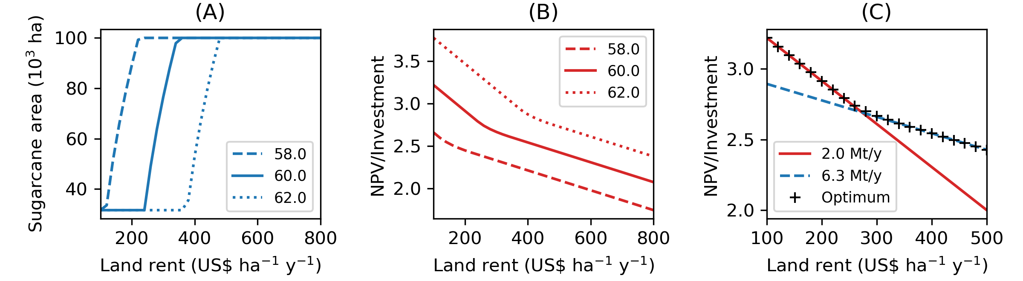
Figure 2. (A) Optimized sugarcane area for different values of meat price (US$ 15kg⁻¹). (B) Optimized NPV/Investment for different values of meat price (US$ 15kg⁻¹). (C) NPV/Investment for an integrated biorefinery of 2.0 and 6.3 Mt y⁻¹, considering 62 US$ 15kg⁻¹ of meat.
  - Conclusion
The methodology presented in this study allows evaluation under which conditions it is feasible to integrate biofuel production with beef cattle farming. In situations with high land rental costs and low meat prices, it is economically advantageous to confine cattle and release the area for the biorefinery. This analysis considers the expansion of sugarcane cultivation without negatively impacting food or livestock production while avoiding expansion into natural vegetation areas. Therefore, this study contributes by developing useful metamodels for ethanol-beef integrated production systems and methods for optimizing such systems, providing insights into the decision-making process. These tools also allow other scenarios to be analyzed to find other economically attractive solutions for the expansion of ethanol production in Brazil, utilizing pasture areas.
Acknowledgments
The authors gratefully acknowledge the financial support received from FAPESP (Grant No: 2017/11523-5) and CNPq (Grant No: 140029/2022-2). Additionally, we extend our appreciation to Embrapa Pecuária Sudeste for their invaluable contributions and support in successfully executing this research project.
References
Achinas, S., Horjus, J., Achinas, V., Euverink, G. J. W. (2019). A PESTLE Analysis of Biofuels Energy Industry in Europe. Sustainability, 11(21), 5981.
Allen, P. E., & Hammond, G. P. (2019). Bioenergy utilization for a low carbon future in the UK: the evaluation of some alternative scenarios and projections. BMC Energy, 1(1), 3.
ANP Agência Nacional de Petróleo, Gás Natural e Biocombustíveis: RenovaBio (2020). URL: https://www.gov.br/anp/pt-br/assuntos/renovabio. (accessed 1.12.23).
Bonomi, A., Cavalett, O., Cunha, M.P., Lima, M.A.P. (2016). Virtual Biorefinery – An Optimization Strategy for Renewable Carbon Valorization. Springer International Publishing, Switzerland.
Bressanin, J. M., Geraldo, V. C., Gomes, F. de A. M., Klein, B. C., Chagas, M. F., Watanabe, M. D. B., Bonomi, A., Morais, E. R. de, Cavalett, O. (2021). Multiobjective optimization of economic and environmental performance of Fischer-Tropsch biofuels production integrated to sugarcane biorefineries. Industrial Crops and Products, 170.
Junqueira, T. L., Chagas, M. F., Gouveia, V. L. R., Rezende, M. C. A. F., Watanabe, M. D. B., Jesus, C. D. F., Cavalett, O., Milanez, A. Y., Bonomi, A. (2017). Techno-economic analysis and climate change impacts of sugarcane biorefineries considering different time horizons. Biotechnology for Biofuels 10(1).
Neves, M. F., Milan, M., Valerio, F. R., Marques, V. N., Delsin, F. G., Cambauva, V., Martinez, L. F., Moreira, M. M., Arantes, S., Teixeira, G. O. (2021) Etanol de Milho: Cenário Atual e Perspectivas para a Cadeia no Brasil. (1.ed) Ribeirão Preto, SP: UNEM. v.1. 116p.
Marques, J. G. O., de Oliveira Silva, R., Barioni, L. G., Hall, J. A. J., Fossaert, C., Tedeschi, L. O., Garcia-Launay, F., Moran, D. (2022). Evaluating environmental and economic trade-offs in cattle feed strategies using multiobjective optimization. Agricultural Systems, 195, 103308.
Sartorello, G. L., Bastos, J. P. S. T., & Gameiro, A. H. (2018). Development of a calculation model and production cost index for feedlot beef cattle. Revista Brasileira de Zootecnia, v. 47.
Souza, N. R. D., Fracarolli, J. A., Junqueira, T. L., Chagas, M. F., Cardoso, T. F., Watanabe, M. D. B., Cavalett, O., Venzke Filho, S. P., Dale, B. E., Bonomi, A., Cortez, L. A. B. (2019). Sugarcane ethanol and beef cattle integration in Brazil. Biomass and Bioenergy, 120, 448–457.
UNICA – União da Indústria de Cana-de-açúcar. RenovaBio (2020). URL: https://unica.com.br/iniciativas/renovabio/. (accessed 1.11.23).

