Spatially Distributed Power-to-Methanol Plants in Dissimilar Locations: Specific or Standardized Designs?
Tibor Svitnič ^{a,}* and Kai Sundmacher ^{a,b}
ª Max Planck Institute for Dynamics of Complex Technical Systems, Department for Process Systems Engineering, Sandtorstr. 1, 39106 Magdeburg, Germany
^{b} Otto von Guericke University, Chair for Process Systems Engineering, Universitätsplatz 2, 39106 Magdeburg, Germany
svitnic@mpi-magdeburg.mpg.de
Abstract
Fossil-based production of methanol is a strong contributor to the greenhouse gas emissions of the chemical industry. The Power-to-MeOH (PtM) process is an emerging alternative, which utilizes renewable resources making its rapid deployment desired in order to mitigate the negative consequences of climate change. This study explores the standardization of Power-to-Methanol (PtM) plants to reduce project timelines and engineering costs. The focus is on standardizing the production capacities of the deployed sub-processes of the production plants across locations with different renewable resource conditions. For this purpose, a multi-objective optimization approach is proposed, where PtM plants are designed for solar-dominant, wind-dominant, and mixed-solar/wind energy resource locations simultaneously, to evaluate the cost trade-off between standard and location-specific designs. Preliminary results, based on time-aggregated renewable resource profiles for one triplet of design locations, indicate that most processes can be standardized with relatively little cost increases due to the reduction of the degrees of freedom. Standardization of the PEM electrolyzer capacities accounts for the major proportion of the cost increases, suggesting it as the process, which should be designed for each location specifically. However, further investigation of additional locations with more detailed renewable resource profiles is needed for a more comprehensive understanding of the balance between design standardization and specificity.
Keywords: distributed production, modular design, standardization, Power-to-X.
  - Introduction
The transition to renewable sources of mass and energy is imperative to mitigate the environmental impact of conventional methanol production, which accounts for a tenth of the greenhouse gas emissions of the chemical sector (Tabibian and Sharifzadeh, 2023). First industrial scale Power-to-Methanol (PtM) production facilities, using captured carbon dioxide and hydrogen produced from water electrolysis are starting to emerge to address this need. Nonetheless, their combined installed capacities represent less than 0.2% of the total methanol production (Tabibian and Sharifzadeh, 2023). With the aim of speeding up the deployment of such facilities and identifying new competitive business cases, it is of interest to explore the concept of design standardization of geographically distributed production plants. This concept is closely tied to modular design principles already penetrating into the process engineering domain (Zhang et al. 2022), which could lead to overall reductions of engineering costs as well as shortening of project timelines (Baldea et al., 2017).

However, in particular, standardization of processes across locations with different renewable resource conditions (e.g. solar irradiation and wind speed profiles) is so far left unexplored. Such standardization could offer an opportunity to streamline the manufacturing and deployment procedures for engineering & construction companies with a global customer base. Yet, standardization inherently comes hand in hand with a reduction of degrees of freedom in the design problem, which could result in additional production costs if it would be too extensive and the specificity of the local renewable energy conditions would be excessively disregarded.

In order to find the right balance between specificity and standardization at an early stage of process synthesis, a multi-objective optimization method for the identification standardized process sections is proposed and applied to the PtM plant design case.
  - Method
Herein the design problems of the PtM plants are solved simultaneously for multiple locations having distinct renewable resource characteristics (in this study: Mejillones, Chile = solar-dominant, Cabo Negro, Chile = wind-dominant and Port Arthur, USA = mixed-solar/wind energy resources) with additional constraints imposing standardization.

The design problems incorporate the selection of installed capacities of the processes among the energy generation, chemical production, utility and storage subsystems together with the fluctuations of the energy resources and waste-heat utilization (Svitnič et al. 2023). The process network for the studied PtM process is shown in Figure 1.

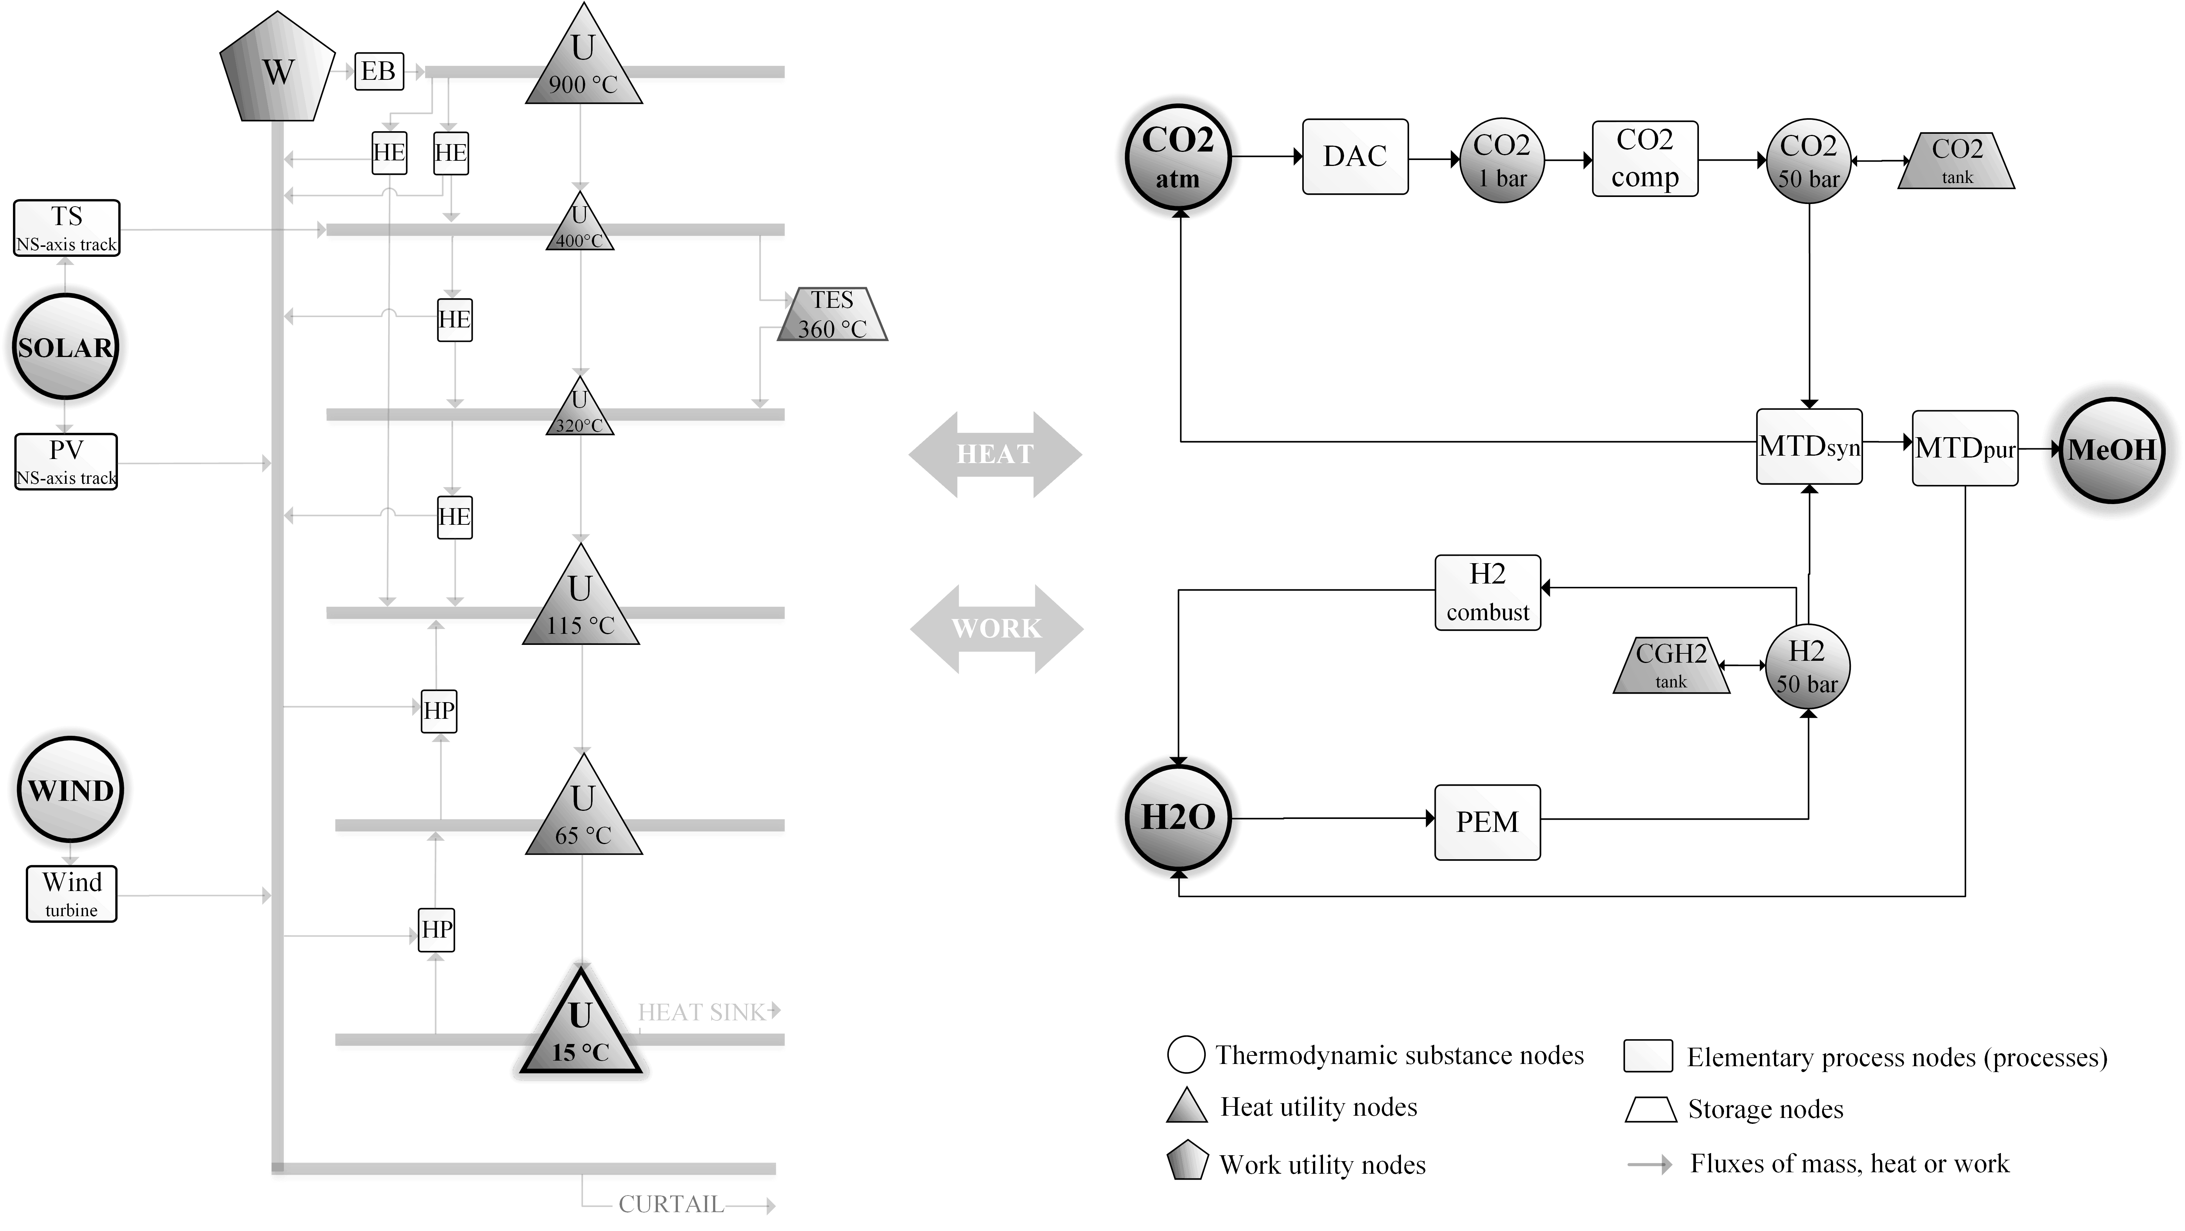
Figure 1 Power-to-Methanol process network showing the different processes considered for the design: DAC = direct air capture of CO₂, CO2comp = CO₂ compressor, CO2tank = CO₂ storage tank, MTDsyn = methanol synthesis process, MTDpur = methanol purification process, H2combust = hydrogen combustion chamber, CGH2 = compressed gaseous hydrogen storage, PEM = proton exchange membrane electrolyzer, EB = electric boiler, HE = heat engines (steam turbines), HP = heat pumps, TES = thermal energy storage (phase change material), TS = thermal solar energy generation (parabolic troughs, sun tracking with horizontal north-south axis), PV = photovoltaic panels (sun tracking with horizontal north-south axis).
Time-aggregation of the yearly renewable resource profiles of solar irradiation (Sengupta et al., 2018) and wind speed (Staffell and Pfenninger, 2016) for the year 2019 with a resolution of 1-hour was implemented based on a k-medoids clustering algorithm to reduce the computational complexity of the model (Kotzur et al., 2018). The underlying modeling approach with constraints and parameters of the optimization problem describing the functioning of the processes, storages and heat integration are described in detail in our previous work (Svitnič and Sundmacher, 2022). Here we report only relevant extensions exclusive to this study.

The objective of the resulting mixed-integer linear programming problem was to minimize the total levelized costs of methanol across all locations, shown in Eq. (1).

$$LCOMeOH_{total}=\sum_{l}{LCOMeOH_{\left(l\right)}} _{l,ll ϵ \{Meji, Cabo, Port Arthur\}}$$ | (1)
The second objective function, used as a measure of standardization, accounted for the total number of standard/common design pairs of processes and storages, which were selected to have equal installed capacities across the different locations. It was included into the optimization problem through the ϵ-constraint method (Eq. (2) and (3)).

$$N_{common} ≥ ϵ_{limit}$$ | (2)

$$N_{common}=N_{common,p}+N_{common,s}$$ | (3)

The numbers of common design pairs were calculated for a subset of processes and storages according to Eq. (4) and (5). The installed capacities for the energy-generation processes (photovoltaic panels, parabolic troughs, wind turbines) with their already standard modular structure were scaled for each location without imposing further standardization constraints to reach a methanol production of 40,000 t/y in each location.

$$N_{common,p}=\sum_{l: ord\left(l\right)>ord(ll)}{\sum_{p_{c}}{{xp}_{com, \left(p_{c}, l,ll\right)}}}$$  $$_{p_{c} ϵ \{PEM, MTD_{syn}, MTD_{pur},DAC, CO2_{comp}, H2_{comb},HE, HP, EB\}}$$ | (4)

$$N_{common,s}=\sum_{l: ord\left(l\right)>ord(ll)}{\sum_{c_{stor}}{{xs}_{com, \left(p_{c}, l,ll\right)}}} _{c_{stor} ϵ \{CGH2, CO2tank,TES\}}$$ | (5)

Binary variables (${xp}_{com}$ and ${xs}_{com}$) were used to identify the design pairs with identical installed process ($λ_{nom}$) or storage ($S_{nom}$) capacities selected across the different locations with the constraints shown in Eq. (6) and (7).

$${xp}_{com, \left(p_{c}, l,ll\right)}=\left\{\begin{aligned}1, { λ}_{nom,\left(p_{c}, l\right)}=λ_{nom,\left(p_{c}, ll\right)} \\ 0, otherwise \end{aligned} _{∀l,ll: ord\left(l\right)>ord(ll)}\right.$$ | (6)

$${xs}_{com, \left(c_{stor}, l,ll\right)}=\left\{\begin{aligned}1, { S}_{nom,\left(c_{stor}, l\right)}=S_{nom,\left(c_{stor}, ll\right)} \\ 0, & otherwise \end{aligned}\right. _{∀l,ll: ord\left(l\right)>ord(ll)}$$ | (7)

The condition using the order function of the location index ($ord\left(l\right)$) imposed on Eq. (6) and (7) makes sure that all of the possible design pairs across the considered locations are accounted for exactly once and no redundant constraints/binary variables are introduced. This can be illustrated with the help of a location matrix (Eq. (8)) created by applying this condition for the studied three-location design case, which marks the design pairs across the different locations to be included in the optimization problem.

$${loc}_{matrix}=\begin{matrix} & \begin{matrix}M & C & P\end{matrix} \\ \begin{matrix}M \\ C \\ P\end{matrix} & \left(\begin{matrix}\begin{matrix}0 & 1 & 1\end{matrix} \\ \begin{matrix}0 & 0 & 1\end{matrix} \\ \begin{matrix}0 & 0 & 0\end{matrix}\end{matrix}\right)\end{matrix} _{ M=Mejillones, C=Cabo Negro, P=Port Arthur}$$ | (8)

  - Results
The main outcomes of this study are Pareto fronts, which highlight the increasing production costs due to reduced design flexibility for different extents of standardization across the various locations for a cost scenario with a reference year of 2018. An example Pareto front for an aggregated time-series using five typical days is shown in Figure 2. Here one can see the production-cost difference between a specific design for each location and a standard design for all locations (including the intermediate design solutions in-between).

The relatively big increase in costs towards the fully standardized design is due to the standardization of the PEM electrolyzer size (Figure 3), which adjusts the installed capacity according to the solar-dominant location, where the electrolyzer needs to be oversized to allow for storage of hydrogen during the night. This installed capacity is then imposed on the locations with stronger wind-energy conditions, where such electrolyzer overcapacity is not needed, leading to an increase of production costs.

Figure 2 Pareto front of the average LCOMeOH in the three design locations and the total number of standardized processes design pairs (N_{common}) as the measure for the extent of standardization for renewable resource profiles aggregated with five typical days.
Figure 3 Selection of particular designs from the Pareto-front showing the installed process capacities of the identified designs with different levels of standardization; N_{common} equal to 0 (bottom) suggests that no standardization is imposed (i.e. fully specific designs), N_{common} equal to 75 (top), which is the maximum possible for our instance of the model, represents a fully standardized design deployed in all 3 locations, N_{common} equal to 71 (middle) is a possible intermediate solution with the only the PEM electrolyzer being designed specifically.
  - Conclusions
The preliminary results, with simplified renewable resource profiles, suggest that most of the processes can be standardized across the locations at a relatively little increase in costs (2.9%). Standardization of the installed capacities of the PEM electrolyzer is responsible for the majority of the cost-increases relative to the specific designs (8.4%, with the total increase of fully standard vs. specific designs being 11.3%), making it a prime candidate process to be designed specifically for each location with the rest of the plant being standardized. Nonetheless, further investigation is needed with more detailed renewable resource profiles for representative plant locations selected according to actual market potential. Additionally, the cost-reductions achievable by a more streamlined deployment of standardized plants, which could offset the identified cost-increases, need to be evaluated including a more detailed look at the intermediate solutions on the specific/standard design spectrum.
Acknowledgement
This work is part of the research initiative “SmartProSys: Intelligent Process Systems for the Sustainable Production of Chemicals” funded by the Ministry for Science, Energy, Climate Protection and the Environment of the State of Saxony-Anhalt.

References
M. Baldea, T.F. Edgar, B.L. Stanley and A.A. Kiss, 2017, Modular manufacturing processes: Status, challenges, and opportunities. AIChE J., 63, 4262-4272, https://doi.org/10.1002/aic.15872

L. Kotzur, P. Markewitz, M. Robinius and D. Stolten, 2018, Time series aggregation for energy system design: Modeling seasonal storage, Applied Energy, 326, 123-135, https://doi.org/10.1016/j.apenergy.2018.01.023.

S.S. Tabibian and M. Sharifzadeh, 2023, Statistical and analytical investigation of methanol applications, production technologies, value-chain and economy with a special focus on renewable methanol, Renewable and Sustainable Energy Reviews, 179, 113281, https://doi.org/10.1016/j.rser.2023.113281.

M. Sengupta, Y. Xie, A. Lopez, A. Habte, G. Maclaurin and J. Shelby, 2018, The National Solar Radiation Data Base (NSRDB), Renewable and Sustainable Energy Reviews, 89, 51-60, https://doi.org/10.1016/j.rser.2018.03.003.

I. Staffell and S. Pfenninger, 2016, Using bias-corrected reanalysis to simulate current and future wind power output, Energy, 114, 1224-1239, https://doi.org/10.1016/j.energy.2016.08.068.

T. Svitnič and K. Sundmacher, 2022, Renewable methanol production: Optimization-based design, scheduling and waste-heat utilization with the FluxMax approach, Applied Energy, 326, 120017, https://doi.org/10.1016/j.apenergy.2022.120017.

T. Svitnič, K. Beer, K. Sundmacher and M. Böcher, 2024, Optimal design of a sector-coupled renewable methanol production amid political goals and expected conflicts: Costs vs. land use, Sustainable Production and Consumption, 44, 123-150, https://doi.org/10.1016/j.spc.2023.12.003

C. Zhang, C. Jacobson, Q. Zhang, L. T. Biegler, J. C. Eslick, M. A. Zamarripa, D. Miller, G. Stinchfeld, J. D. Siirola, C. D. Laird, 2022, Optimization-based Design of Product Families with Common Components, Computer Aided Chemical Engineering, 49, 2022, 91-96, https://doi.org/10.1016/B978-0-323-85159-6.50015-4.

