Towards Intelligent Wastewater Treatment: Prediction of Biodegradation Processes Through the Application of Machine Learning
Jiayuan Ji^{a,*}, Xinwu Zhou^{b}, Yuichiro Kanematsu^{c}, Yasunori Kikuchi^{a,c,d}
ªInstitute for Future Initiatives, The University of Tokyo, 7-3-1 Hongo, Bunkyo-ku, Tokyo 113-8654, Japan
^{b}Institute of Fluid Science, Tohoku University, 2-1-1 Katahira, Aoba-ku, Sendai 980-8577, Japan
^{c}Presidential Endowed Chair for “Platinum Society”, the University of Tokyo, 7-3-1 Hongo, Bunkyo-ku, Tokyo 113-8656, Japan
^{d}Department of Chemical System Engineering, the University of Tokyo, 7-3-1 Hongo, Bunkyo-ku, Tokyo 113-8656, Japan
*Corresponding: kikaen@ifi.u-tokyo.ac.jp
Abstract
With the rapid growth of global population and the change of human living habits, the treatment of municipal wastewater is facing serious challenges. To solve the problems of high energy consumption, big amount of greenhouse gases emission, and huge volume of waste sludge production of the current process, a series of innovations and developments based on anaerobic process are being focused on. However, the processes generally require long experimental cycles because of the biodegradation reaction. If the microbial degradation in anaerobic process is modelled, the experimental period will be drastically reduced, but the traditional modeling methods are less generalizable and thus difficult to be applied. In recent years, artificial intelligence tools have been applied to dealing with complicated situations. This led our research team to the idea of using machine learning approach to model and predict microbial degradation processes. The prediction performance was obtained with good results. Afterwards, the authors recognized that the research work on the construction of dataset is of great importance in the future work.
Keywords: wastewater treatment, machine learning, prediction modeling.
  - Introduction
The contemporary landscape of municipal wastewater treatment grapples with formidable challenges, accentuated by the rapid global population surge and dynamic shifts in human living habits. Central to these challenges is the widely employed activated sludge process, a key process used in the wastewater treatment. Despite its prevalence, this method contends with significant drawbacks, manifesting in heightened energy consumption, substantial greenhouse gas emissions, and the generation of vast volumes of waste sludge.
Among the avant-garde approaches gaining prominence is the strategic application of anaerobic digestion in treating low-strength municipal wastewater. This pioneering process, as previously reported in a review paper (Hu et al., 2020), transcends traditional treatment methodologies. It not only facilitates the recovery of energy and valuable resources from wastewater but also demonstrates promising reductions in greenhouse gas emissions and the generation of waste sludge. However, the efficacy of such technologies is hampered by their inherent reliance on microbial communities for degradation. This reliance, in turn, imposes prolonged experimental cycles, a bottleneck facing the real application emphasized in the previous research work (Ji et al., 2021).
Recognizing the urgency of addressing these challenges, our research team has embarked on a multifaceted exploration of the complex field of modeling microbial degradation processes within anaerobic treatment systems. This scientific work was motivated by the enormous potential to revolutionize wastewater treatment. Traditional modeling methods, although fundamental, have their limitations in terms of generalizability, especially when applied to realistic scenarios (Brdjanovic et al., 2013). The emergence of artificial intelligence, especially in the field of machine learning, provides unprecedented opportunities to overcome these challenges. The seminal work of Bengio et al. (Bengio et al., 2013) revealed the transformative power of these tools in navigating complex situations, prompting our team to utilize the power of machine learning to accurately model and predict microbial degradation processes.
Additionally, our research agenda extends to the field of neural network modeling to include a variety of approaches to further improve the efficiency of microbial degradation prediction. Through this comprehensive exploration, we are harnessing the power of artificial intelligence to model wastewater treatment to provide effective, efficient, and sustainable solutions. In this paper, we briefly describe our recent study (G. Li et al., 2022) in this field and further explore the problems and possibilities.
  - Methodology
    - Wastewater Treatment System
The experimental system was applied anaerobic digestion into municipal wastewater treatment. This is not only aimed at recovering energy and resources, but also at reducing greenhouse gas emissions and sludge generation. Based on the experimental results operation situation, we first meticulously organized and confirmed the operating parameters of the wastewater treatment system, including influent (inf.) characteristics (for example, chemical oxygen demand (COD)), temperature, hydraulic retention time (HRT), pH, and oxidation-reduction reaction potential (ORP) (Ji et al., 2021).
    - Dataset Construction
The core of our approach consists of modeling the microbial degradation processes within an anaerobic treatment system. Therefore, the dataset is a key component. Recognizing the critical importance of datasets in machine learning applications, we began working to optimize the construction of the dataset (Fig. 1). Operation temperature (R-T), temperature of the environment (T-env), temperature of the influent (T-in), influent pH (pH-in), influent COD concentration (COD-in), and flux were selected as the input, and effluent COD concentration (COD-eff), and COD removal efficiency (COD-re) were selected as the predicted outputs (Table 1).
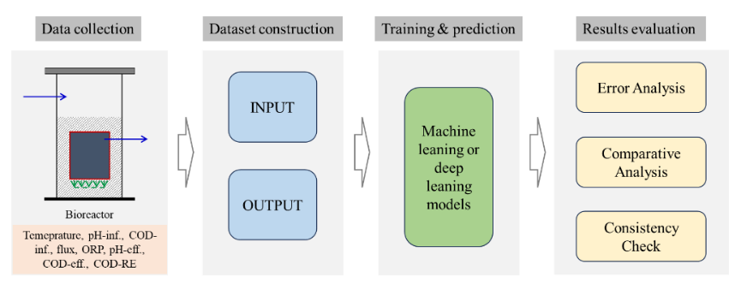
Fig. 1 Dataset Construction and Machine Learning Processes.
Table 1. Characteristics of the dataset.
 | Mean | Standard Error | Minimum | Maximum
T-R | 25.49 | 1 | 20.8 | 30
T-in | 17.83 | 5.49 | 8 | 26.4
T-env | 17.41 | 6.4 | 6.8 | 27.9
pH-in | 7.17 | 0.16 | 6.89 | 7.62
COD-in | 376.2 | 88.85 | 202.88 | 740.33
Flux | 0.2 | 0.06 | 0.07 | 0.35
COD-eff | 44.78 | 9.82 | 19.49 | 87.3
COD-re | 87.57 | 3.6 | 75.82 | 94.86
    - Machine Learning Algorithms and Evaluation Metrics
Our research adopts deep neural networks of Basic Machine Leaning Network, Convolutional Neural Network, and DenseNet to discern patterns and predict the degradation process of wastewater treatment. For specific information on neural networks, refer to the printed paper (G. Li et al., 2022). To rigorously assess the performance of models, we employ a range of evaluation metrics. The mean square error (MSE) was selected as the loss function, as shown in Eq. (1).
$$MSE(y,\hat{y})=\frac{\sum_{a=1}^{b}{{(y_{a}-{\hat{y}}_{a})}^{2}}}{b}$$ | (1)
In addition, the following metrics were applied for evaluation: the mean absolute error (MAE), root mean square error (RMSE), mean relative error (MRE), and Coefficient of determination (R²). The equation for calculate those metrics is shown in Eq. (2), (3), (4), and (5).
$$MAE(y,\hat{y})=\frac{\sum_{i=1}^{N}{\left|y_{i}-{\hat{y}}_{i}\right|}}{N}$$ | (2)
$$RMSE\left(y,\hat{y}\right)=\sqrt{\frac{\sum_{i=1}^{N}{{\left(y_{i}-{\hat{y}}_{i}\right)}^{2}}}{N}}$$ | (3)
$$MRE\left(y,\hat{y}\right)=\frac{\sum_{i=1}^{N}{\frac{\left|y_{i}-{\hat{y}}_{i}\right|}{\left|y_{i}\right|}}}{N}$$ | (4)
$$R^{2}\left(y,\hat{y}\right)=1-\frac{\sum_{i=1}^{N}{{(y_{i}-{\hat{y}}_{i})}^{2}}}{\sum_{i=1}^{N}{{(y_{i}-\overline{y})}^{2}}}$$ | (5)
Where $y$represents the real experimental value,$\hat{y}$ represents the DL predicted value, and $\overline{y}$ is the average value of the experimental values.
    - Iterative Learning Process
Recognizing the dynamic nature of our research domain, we institute an iterative learning process. This involves continuous refinement of our models based on real-time feedback, allowing for adaptability to evolving conditions and insights gained during the course of the study. The number of training epochs (number of training iterations) was set with a number of 1000 for all the above-mentioned evaluation parameters.
  - Results and Discussion
    - Overview of Prediction Results
After completing the machine learning task, a comprehensive assessment of the model performance became the focus of our results. Preliminary observations indicate that these deep learning models we applied are feasible for predicting microbial degradation processes in anaerobic treatment systems. The prediction results are show in Fig. 2. From this figure, it can be seen that the prediction of COD removal efficiency is better that the effluent concentration. However, since this presentation is not clear enough, further analysis becomes especially important.
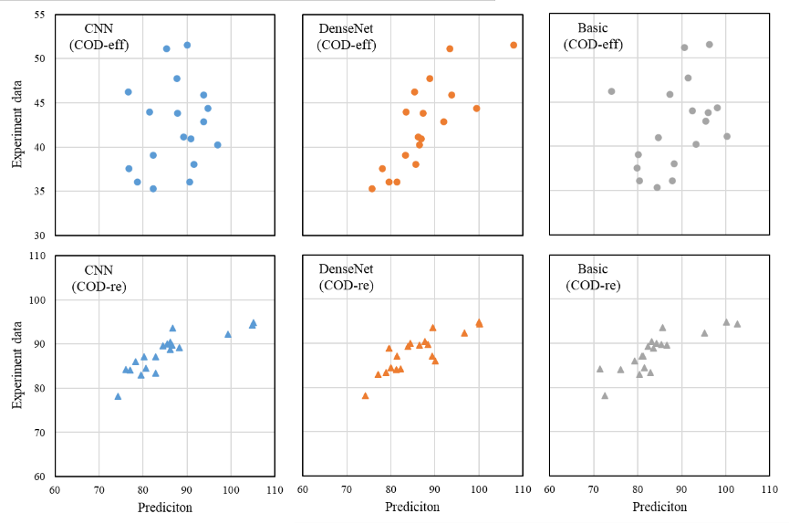
Fig. 2 Prediction results and experiment data shown in yy-plot.
Table 2. The prediction result of applied machine learning.
DL models | Items | COD-eff | COD-re
Basic Machine Leaning Network | MAE | 4.73±2.53 | 5.71±2.73
 | RMSE | 5.34±5.11 | 6.29±6.07
 | MRE | 11.78±6.82% | 6.49±3.17%
 | R² | 0.76 | 1.94 (0.89*)
Convolutional Neural Network | MAE | 5.26±3.90 | 5.34±2.77
 | RMSE | 6.48±7.91 | 5.98±5.69
 | MRE | 13.52±12.67% | 6.02±3.00%
 | R² | 0.31 | 2.28 (0.89*)
DenseNet | MAE | 3.65±3.33 | 4.34±1.83
 | RMSE | 4.88±7.69 | 4.69±4.32
 | MRE | 9.70±11.82% | 4.93±2.05%
 | R² | 0.78 | 2.52 (0.93*)
*The values modified by removed error data.
The evaluation metrics provide quantitative insights into the efficacy of the models in order to compare the accuracy of their predictions (Table 2). From these results, the possibility that neural networks can be applied to wastewater treatment processes using microbial degradation was further demonstrated. Moreover, it makes the evaluation of different models quantifiable. Based on the analysis and evaluation by MAE, RMSE, MRE, and R², it can be concluded that DenseNet performs the best among the three network models. However, it is necessary to mention that for the prediction of COD removal rate, the R² values were beyond 1. This indicates the occurrence of overfitting or error. After checking the predicted values, it was found that there were some values that exceeded 100%, which could not be present in the removal rate values. The optimization for this phenomenon needs to be considered in the following.
Overall, deep neural networks demonstrated successful predictive capabilities for wastewater treatment processes in this study. This exploration reveals the potential benefits of machine learning, especially neural network architectures in interpreting microbial degradation processes.
    - Comparison with other Predictive Models
The evolution from prior predictions, informed by deep networks, to the current study showcases the advancements achieved through dataset optimization and the incorporation of diverse machine learning methodologies. Previous research applied machine learning to the aerobic wastewater treatment process and obtained an sMAPE (Symmetric mean absolute percentage error) result of 5.63% (Zaghloul et al., 2021). Anther research reported that they have obtained the MAE of 4.8~9.6 with algorithms of stacked denoising auto-encoders, traditional backpropagation neural network, support vector regression, extreme learning machine, gradient boosting decision tree, and stacked auto-encoders (Shi & Xu, 2018). However, the data processing in these studies used feature extraction to expand the dataset.
The anaerobic biochemical treatment process of wastewater is characterized by complex mechanisms, high nonlinearity, and instability. To address these characteristics, a recent study has developed an automatic optimization-seeking water quality prediction model based on deep learning, which realizes high-precision prediction of COD and gas production of effluent from anaerobic wastewater treatment systems (J. Li et al., 2022). Not only for modeling and predicting the removal of organic pollutants from wastewater by anaerobic digestion, but machine learning also obtained high prediction outcomes for the process of anaerobic ammonia oxidation for the removal of ammonia nitrogen from wastewater (Ji, 2023). Insights gleaned from this comparative analysis contribute to the broader understanding of predictive modeling in this domain.
    - Practical Implications and Future Directions
The results obtained have a direct impact on the practical advancement of prediction of wastewater treatment processes. Based on our findings, the integration of machine learning approach is expected to optimize the treatment process, minimize environmental impacts, and facilitate the transition to smart wastewater management. In addition, our study paves the way for future research directions, including exploring advanced neural network for biodegradation and integrated real-time monitoring systems for the process.
    - Limitations of the Study
Although we achieved good prediction results and gained some insights into the optimization of the dataset, the future remains challenging. Specifically, first of all, the process flow varies from different wastewater treatment plant or experimental operation. Although with data training and parameter tuning, machine learning can be applied to different process flows, the preliminary preparations, such as the construction and optimization of the dataset, without a unified solution is a problem. Secondly, in some cases the dataset is small or insufficient for training, how to apply the network model already trained by other treatment processes directly to the new prediction is a challenging task. In addition, there are many network models that have been developed to relative sophistication, and it is therefore important to consider how to choose the proper model.
  - Conclusions
In summary, this study demonstrates that machine learning is feasible for prediction in wastewater treatment. Further enhancement of the prediction results is achievable by optimizing the dataset construction and exploring various machine learning algorithms. The results of this research have practical implications for optimizing wastewater treatment methods and promoting sustainable development and environmental management. It not only contributes to the current understanding of predictive modeling, but also helps pioneer the way for future innovations in intelligent and adaptive wastewater treatment strategies.
Acknowledgements
This study was supported by JSPS KAKENHI JP19J12023, JST COI-NEXT JPMJPF2003, NEDO Moonshot R&D Program Grant Number JPNP18016, and the Hirose Foundation. Activities of the Presidential Endowed Chair for “Platinum Society” at the University of Tokyo are supported by Mitsui Fudosan Corporation, Sekisui House, Ltd., the East Japan Railway Company, and Toyota Tsusho Corporation.
References
D. Brdjanovic, S. C. Meijer, C. M. Lopez-Vazquez, C. M. Hooijmans, M. C. van Loosdrecht, 2015, Applications of activated sludge models, IWA publishing, London, United Kingdom.
G. Li, J. Ji, J. Ni, S.Wang, Y. Guo, Y. Hu, S. Liu, S. F. Huang, Y. Li, 2022, Application of deep learning for predicting the treatment performance of real municipal wastewater based on one-year operation of two anaerobic membrane bioreactors, Science of the Total Environment, 813, 151920.
J. Ji, Y. Chen, Y. Hu, A. Ohtsu, J. Ni, Y. Li, S. Sakuma, T. Hojo, R. Chen, Y. Li, 2021, One-year operation of a 20-L submerged anaerobic membrane bioreactor for real domestic wastewater treatment at room temperature: pursuing the optimal HRT and sustainable flux, Science of the Total Environment, 775, 145799.
J. Ji, 2023, Introduction of deep learning networks to predict anammox-based low-carbon biological nitrogen removal processes, The 14th HOPE Meeting with Nobel Laureates, Tsukuba, Japan.
J. Li, Z. Chen, X. Li, X. Yi, Y. Zhao, X. He, Z. Huang, M. A. Hassaan, A. El Nemr, M. Huang, 2022, Water quality soft-sensor prediction in anaerobic process using deep neural network optimized by Tree-structured Parzen Estimator, Frontiers of Environmental Science & Engineering, 17, 6, 67.
M. S. Zaghloul, O. T. Iorhemen, R. A. Hamza, J. H. Tay, G. Achari, 2021, Development of an ensemble of machine learning algorithms to model aerobic granular sludge reactors, Water Research, 189, 116657.
S. Shi, & G. Xu, 2018, Novel performance prediction model of a biofilm system treating domestic wastewater based on stacked denoising auto-encoders deep learning network, Chemical Engineering Journal, 347, 4, 280–290.
Y. Bengio, A. Courville, P. Vincent, 2013, Representation learning: A review and new perspectives, IEEE Transactions on Pattern Analysis and Machine Intelligence, 35, 8, 1798–1828.
Y. Hu, H. Cheng, J. Ji, Y. Li, 2020, A review of anaerobic membrane bioreactors for municipal wastewater treatment with a focus on multicomponent biogas and membrane fouling control, Environmental Science: Water Research & Technology, 6, 10, 2641–2663.

