Evaluation of different water sources for electrolysis: a study case of the priority regions for green hydrogen production in the state of Bahia
Leonardo O. S. Santana,ª Gustavo S. dos Santos,ª Chrislaine B. Marinho,ª Artur S. Bispo,ª José Almeida,ª Fernando L. P. Pessoa^{a,b}
ª SENAI CIMATEC university center, Avenida Orlando Gomes, Salvador 41650-010, Brazil
^{b} Federal University of Rio de Janeiro (UFRJ), Av. Athos da Silveira Ramos, Rio de Janeiro 21941-909, Brazil.
leosantana049@gmail.com
Abstract
Green hydrogen is progressively being recognized as a crucial component in the extended process of reducing carbon emissions from the worldwide energy framework. Water usage in the hydrogen economy is gaining importance in literature, thus, a proper analysis must include four dimensions of sustainability criteria (environmental, social, technical, and economic). This work evaluates the suitability of water sources (WS) for green hydrogen production based on a Multi-Criteria Decision Making (MCDM) Model for Water Assessment in Green Hydrogen Production. The approach was applied to three different sites (A, B, and C) in the Brazilian state of Bahia. As a result, the most suitable water sources were different for each site (seawater, Rainwater, and treated urban wastewater), regarding the different characteristics of each location.
Keywords: Green Hydrogen, Electrolysis, Water Sources, Analytic Hierarchy Process, Decision support system.
  - Introduction
Green hydrogen is progressively being recognized as a crucial component in the extended process of reducing carbon emissions from the worldwide energy framework. This emergence highlights substantial inquiries about sustainability, concerning its creation and global trade in countries where it is produced. Beswick et al. (2021) highlight the potential to significantly reduce carbon emissions by meeting a substantial hydrogen demand in a renewable future. Newborough and Cooley (2021) underscore the substantial water requirements for this transition. Cremonese et al. (2023), determined that issues about freshwater availability carry paramount importance both environmentally and socioeconomically.
In addition, the study of alternative water sources, such as seawater or industrial wastewater, gains prominence due to their potential to alleviate stress on conventional freshwater resources and support large-scale green hydrogen production. This necessitates a comprehensive assessment that considers quantitative metrics and qualitative factors, aligning environmental sustainability with the imperative for water security, as emphasized by Woods et al. (2022) and Winter et al. (2022).
This paper presents a decision support system based on a Multi-Criteria decision-making (MCDM) Model for Water Assessment in Green Hydrogen Production (Santana, et al. 2023) to evaluate from an economic, environmental, and social point of view, the water's resources for green hydrogen production. The approach is implemented using three different sites in the Brazilian state of Bahia, the fifth-largest state in terms of territory. The State of Bahia is energetically strategic, being Brazil’s second generator of wind energy and eighth in solar PV, according to Santos et al. (2023).
  - Methodology
The methodology presented herein is based on the multi-criteria approach of sustainable value methodology proposed by Simões (2021) and Santana (2023). A computational model based on MS Excel was developed for the sustainable assessment of water sources for electrolysis. It was developed by integrating different concepts from distinct subjects such as value analysis, ecoefficiency, energy efficiency, and cleaner production.
The choosing locations of the clusters were based on the green hydrogen map of the state of Bahia (Figure 1): a semi-urban location along the Atlantic coast with cooler summers (site A); a rural area far from the coast with slightly hotter summers (site B); and a semi-urban location far from the coast with intermediated summers (site C). The model uses the analytical hierarchy process to define the weight of each criterion. The weights of each sustainable dimension are determined according to the water exploitation index (WEI+) of the study area.
Figure 2 shows an overview of the approach. The first step was to identify and map all potential water sources (WS) that can input the electrolyzer which was available around the green hydrogen cluster, and then information about distance and elevation (between the water source and the hydrogen plant) and treatment needs were summarized. Then the cost calculations were run, followed by the qualitative evaluation.
Figure 1 – Site locations in the Bahia’s GH2 Map
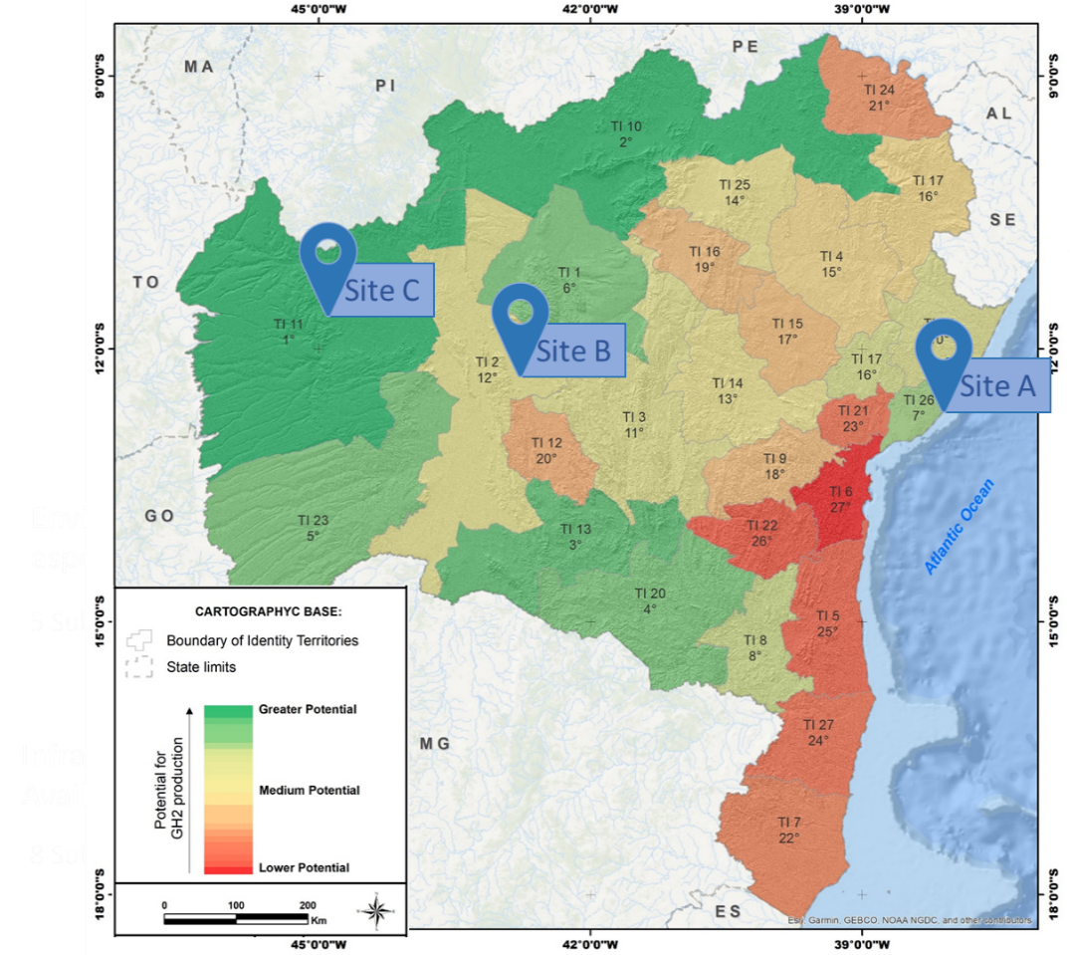
Figure 2 – Overview of considered approach for assessing potential water sources for electrolysis.

A total of seven potential WS were identified (grid “Tap” water (TW), treated industrial wastewater (IW), Treated Urban wastewater (UW), Surface “river/lakes” water (SFW), seawater (SW), rainwater (RW), and groundwater (GW)). The CAPEX and OPEX information were calculated considering water abstraction, transport, and treatment, as in our previous work, Santana et al. (2023a). The hydrogen site capacity was 60MW and the electricity cost considered was R$ 0.575/kWh (CNI, 2021).
For site A, a semi-urban location along the Atlantic coast with cooler summers, all potential WS are available; for the rural area plant, far from the coast with slightly hotter summers (named site B) only three WS were available (SFW, GW, RW); for the site C, the semi-urban location far from the coast with intermediated summers, TW, UW, SFW, GW and RW are available.
Table 1 – Water sources and distances (m) /elevation (m) for each site
Site | A | B | C
Groundwater (GW) | On-site | On-site | On-site
Industrial wastewater (IW) | 5,247/13 | NA | NA
Seawater (SW) | 4,686/40 | NA | NA
Rainwater (RW) | On-site | On-site | On-site
Water grid (TW) | On-site | NA | On-site
Urban wastewater (UW) | 10,000/10 | NA | 5,247/13
Surface water (SFW) | 5,000/10 | On-site | 4,686/40

Table 2 – Treatment and collection costs
WS | Treatment train | W. loses | Process CAPEX (€) | Energy consumption kWh/m3 | Collection (€) | Collection OPEX kW/m3
UW | FS→MF→  RO | 25% | 701,000.00 | 4.5635 | 25,000.00 | -
SFW | FS→ Chempre→MF | 15% | 281,000.00 | 0,1135 | 50,000.00 | -

The considered distance between the local water collection and the electrolysis plant is listed in Table 1. These data are crucial to quantify the capex and Opex related to water in the electrolysis process. Table 2 presents the treatment train and collection costs for the urban wastewater, and surface water. The other water sources costs are listed in our previous work, Santana et al. (2023a).
After cost calculations, each of the potential WS was qualitatively assessed for each site, adopting a functional value approach (equation 1), where W is the weight, and C is the criterion’s performance level), each measure is divided into 4 performance levels, being level 1 the lowest, and 4 the highest level, as mentioned by Santana et al. (2023b), where the function is to supply water for hydrogen production. For this, the following criteria, presented in Table 1, were identified.
$SV α Performance α \sum_{1}^{n}{{(W}_{i} ∙C_{i}})$ (1)
The weight for each criterion described in Table 1 depends on the water exploitation index (WEI+) of the region of study. This index is presented by Baldinelli et al. (2022) as the pressure on the region’s available water, with a maximum limit of 40% (severe scarcity of water resources). Thus, this study classified the regions into five types (Figure 3), depending on the WEI+, regions with water exploitation greater than 40% can’t afford an electrolysis plant. The WEI+ is defined in equation 2, where ABS is the abstraction of water, RET is the return to water sources, and LAAW is the long-term average available water at a given time and place. For this study, the WEI+ considered were 20%, 30%, and 30% for sites A, B, and C respectively.
$WEI+={ABS-RET}/{LAAW}$ (2)
The criteria for Sustainable Value analysis of water sources. The used and their respective weights for each WEI+ level are listed in Figure 3. The criteria description (A to L) can be found in the literature (Santana et al. 2023a) except for “ecological impact” (M- ecological impact on the environment, effect on flora and fauna, related to ecosystem health) and “regulatory compliance” (N- Water usage and disposal regulations. Understanding of local regulations regarding water usage and disposal to ensure compliance).
Figure 3 – Criteria weight for each WEI+ value
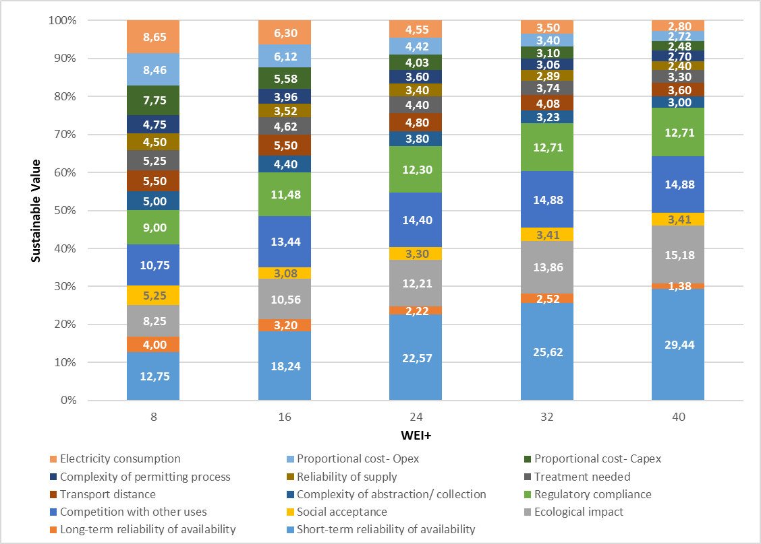
Table 3 – Criteria for Sustainable Value analysis of water sources.
Criteria | Performance Level
 | 1 | 2 | 3 | 4
M | High ecological impacts at the abstraction level | Medium ecological impacts at the abstraction level | Low ecological impacts at the abstraction level | No ecological impacts at the abstraction level
N | High difficulty of environmental licensing and water use granting; involvement of multiple entities with complex procedures and lengthy approval timelines | Moderate difficulty of environmental licensing and water use granting; involvement of a few entities with relatively streamlined procedures and reasonable approval timelines. | Low difficulty of environmental licensing and water use granting; involvement of a single entity with straightforward procedures and efficient approval timelines. | The minimal difficulty of environmental licensing and water use granting; no involvement of additional entities or regulatory hurdles.
3. Results and discussions
After performing each criterion for the water sources of all the sites, the results obtained are presented in Table 4, and Figure 3. It’s possible to visualize the performance of each WS divided into the four sustainable dimensions of the study. The better WS for each criterion is underlined in Table 4.
Table 4 – Sustainable Value analysis of water sources.
 |  | TW | IW | UW | SFW | GW | RW | SW
Site A | Envir | 19 | 28 | 25 | 24 | 28 | 20 | 36
 | Social | 15 | 17 | 20 | 24 | 17 | 30 | 24
 | Tech | 12 | 20 | 20 | 16 | 20 | 13 | 8
 | Econ | 8 | 5 | 5 | 9 | 8 | 11 | 8
Site B | Envir | – | – | – | 22 | 32 | 23 | –
 | Social | – | – | – | 16 | 17 | 31 | –
 | Tech | – | – | – | 10 | 17 | 11 | –
 | Econ | – | – | – | 8 | 6 | 8 | –
Site C | Envir | 29 | – | 42 | 22 | 32 | 23 | –
 | Social | 21 | – | 28 | 16 | 17 | 31 | –
 | Tech | 17 | – | 6 | 10 | 17 | 11 | –
 | Econ | 6 | – | 6 | 8 | 6 | 8 | –
Figure 3 shows the overall performance of the water sources. Presenting the results of this study. Comparing them it’s possible to note that the higher sustainable value is for the urban wastewater in site C. For each site, however, the most suitable WS is seawater for site A, Rainwater (site B), and Urban wastewater for site C. The results show that the most suitable WS depends on the plant capacity and local issues. Still, overall analysis shows that rainwater is a promising water source regarding availability in medium-scale plants even in locals with higher water scarcity. This type of evaluation is extremely necessary when a hydrogen hub is being built.
Figure 3 – Results of water sources evaluation for each Site
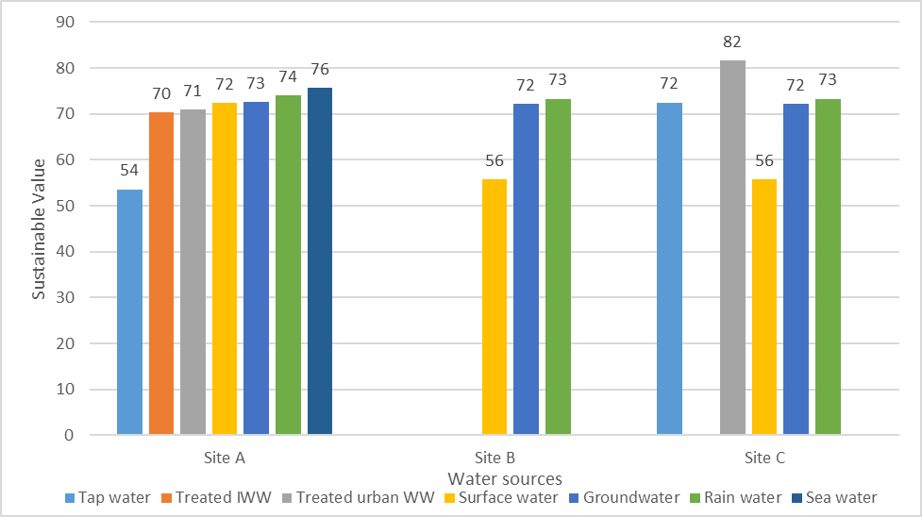
  - Conclusion
A sustainable value indicator allows a relative quantitative comparison of the performance of different water sources for electrolysis. The approach provides elements to support decision-making regarding the most suitable water inputs for H₂ production from water electrolysis: quality and reliability of water sources, treatment needs, the complexity of the permitting process, and associated costs. As a result, the most suitable water sources were different for each site (seawater, rainwater, and treated urban wastewater), regarding the different characteristics of each location.
References
A. Baldinelli, G. Cinti, L. Barelli, G. Bidini, 2022, Hydrogen production from low-quality water: challenges and perspectives, Journal of physics: conference series, 2385,012048.
CNI. (2021). Perfil da industria da Bahia. Retrieved from Portal da industria: https://perfildaindustria.portaldaindustria.com.br/estado/ba
G. S. Santos, C. B. Marinho, L. O. S. Santana, A. S. Bispo, F. L. P. Pessoa, J. L. G. Almeida, E. E. S. Calixto, 2023, Hydrogen production using renewable energy: solar PV and offshore wind power – An economic evaluation in Bahia, Computer aided chemical engineering, 52, 2947-2957.
L. Cremonese, G.K. Mbungu, R. Quitzow, 2023, The sustainability of green hydrogen: An uncertain proposition, International journal of hydrogen energy, 48, 51, 19422-19436.
L. O. S. Santana, A. S. Bispo, G. S. Santos, C. B. Marinho, E. E. S. Calixto, J. L. G. Almeida, F. L. P. Pessoa, 2023, Water sources evaluation for green hydrogen production: a case study in Brazil, Computer aided chemical engineering, 52, 2923-2928.
L. O. S. Santana, J. L. G. Almeida, F. L. P. Pessoa, 2023, Sustainable value approach to evaluate water sources for electrolysis, 24º congresso brasileiro de engenharia química.
M. Newborough & G. Cooley, 2021, Green hydrogen: water use implications and opportunities, Fuel Cells Bulletin, Volume 2021, Issue 12, p 12-15.
P. Woods, H. Bustamente, K. Zinsou, 2022, The hydrogen economy- where is the water? Energy nexus, volume 7.
R. Beswick, A. Oliveira, Y. Yan, 2021, Does the green hydrogen economy have a water problem? ACS Energy Letters, 6, p 3167-3169.
S. Simoes, J. Catarino, A. Picado, T. Lopes, S. di Berardino, F. Amorim, F. Gírio, C. Rangel, T. Ponce de Leão, 2021, Water availability and water usage solutions for electrolysis in hydrogen production, Journal of Cleaner Production, 315, p 128124.

