Waste-to-X: An enviro-economic assessment of circular chemical production via municipal solid waste gasification
Ben Lyons,ª Saxon Stanley,ª Andrea Bernardi,ª Benoît Chachuat^{a,*}
ª The Sargent Centre for Process Systems Engineering, Department of Chemical Engineering, Imperial College London, SW7 2AZ, UK
*b.chachuat@imperial.ac.uk
Abstract
As the generation of municipal solid waste continues to increase, its inadequate disposal is becoming a meaningful threat to the health of both humanity and the planet. Most waste is either landfilled or incinerated, which exacerbates climate change, incidence of respiratory diseases, and damage to marine environments. As the chemical industry moves towards a circular economy model, the gasification of municipal solid waste has garnered increased attention as it offers both an alternative waste management solution and the exploitation of an abundant renewable feedstock. In this work, three distinct municipal solid waste gasification pathways are investigated, with each leading to different chemical products. The routes considered are: i) methanol synthesis; ii) methanol-to-olefins; and iii) ethanol synthesis via dimethyl ether hydrocarbonylation. The results suggest that whilst the methanol route was competitive with the incineration base case in 2017-18 due to elevated methanol prices, all three routes would require higher gate fees on average (up to 3 times higher) to break-even across 2017-22 market conditions. The ethanol route displays the lowest required gate fees on average due to a lower H₂ requirement and lower capital costs. However, all routes achieve a 40-80% reduction in scope 1 and 2 CO₂ emissions when compared to incineration.

Keywords: municipal solid waste, gasification, circularity, economics, CO₂ emissions
  - Introduction
As the world population grows and standards of living improve, the excess generation and inadequate disposal of waste is increasingly becoming a fundamental issue. In 2016, it was estimated that two billion tonnes of waste were generated globally, approximately two thirds of which were either landfilled or openly dumped. This represented a significant contribution to global CO₂ emissions, with 1.6 billion tonnes emitted and is predicted to rise to 2.6 billion tonnes by 2050. Not only does it intensify climate change, but the improper burning and dumping of waste leads to the release of toxins and particulate matter, resulting in respiratory diseases. Additionally, marine ecosystems are damaged as waste runoff infiltrates rivers (Kaza et al., 2018). It is therefore clear that proper waste management is crucial to a lasting and secure future for the planet.

To address this environmental challenge, municipal solid waste (MSW) gasification has garnered increased attention as a more sustainable waste disposal option than landfilling or incineration (Ouedraogo et al., 2021). Historically, both research and implementation of MSW gasification has focused on either waste-to-energy via the combustion of the produced syngas, or fuel production, where the syngas is catalytically converted into fuels (Niziolek et al., 2015; Kumar et al., 2017). However, as the chemical industry is beginning to transition towards a circular economy model, there is a growing research focus on chemical production via MSW gasification. The reported benefits of this route are three-fold: i) it utilizes an abundant waste resource; ii) it offers a more sustainable waste management option as previously mentioned; and iii) it provides an attractive economic element because a gate or tipping fee is typically received for processing the waste. However, syngas is a versatile chemical precursor, and it poses the question of what the optimal use of this syngas is when generated from MSW gasification. In this paper, three alternative chemical production routes via MSW gasification are compared. These routes are: i) methanol synthesis; ii) methanol-to-olefins (MTO); and iii) ethanol synthesis via dimethyl ether (DME) hydrocarbonylation (HC). The main aim of this work is to conduct a comparative assessment between these three routes by considering both their economic performance and their scope 1 and 2 emissions.
  - Methodology
All three processes were modelled using Aspen HYSYS and considered a 360 kt/y feed of MSW. A block flow diagram summarizing the routes is shown in Figure 1.

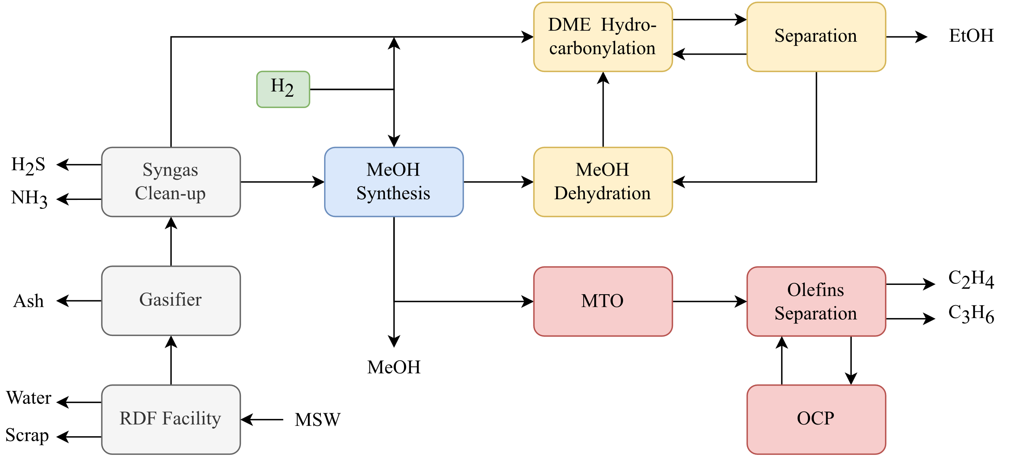
Figure 1: Block flow diagrams for the three routes (blue = methanol; yellow = ethanol; red = olefins)
    - Process Modelling
Feed Preparation: The MSW is first processed in a refuse-derived fuel (RDF) facility. Preprocessing the MSW into RDF reduces the heterogeneity of the feedstock via three main mechanisms: classification i.e., the removal of inert or incombustible materials (e.g., glass, scrap metal etc.), size reduction and drying. First the unwanted material is removed, which is assumed to be 20 wt% of the MSW feed. The remaining waste is then dried to a moisture content of 12 wt%, where the duty for this task is provided by cooling the syngas exiting the gasifier. It is assumed that the RDF facility requires 33 kWh of electricity per tonne of MSW for size reduction and grinding (Nuss et al., 2013). The resulting RDF is modelled as a hypothetical solid in HYSYS, where the elemental composition and lower heating value are taken from Jones et al. (2009). This fixed composition is an important assumption, as in reality it would still vary considerably even with RDF processing.

Gasification: The RDF is fed to a fluidized bed gasifier operating at 750°C and atmospheric pressure (Griggs et al., 2023). Since gasification is a complex process with many potential simultaneous reactions, it is modelled with a conversion reactor and a Gibbs reactor. The conversion reactor splits the RDF into its elemental components: carbon, hydrogen, oxygen, nitrogen, sulphur, and ash, the latter of which is assumed to be SiO₂, CaO, Al₂O₃ and Fe₂O₃. The components are then fed to the Gibbs reactor alongside O₂ and steam as gasifying agents, the flowrates of which were adjusted until the desired outlet temperature and composition was achieved. Since gasification is an autothermal process, the duties of the conversion and Gibbs reactors must sum to zero. The resulting contaminated syngas leaving the Gibbs reactor contains CO, CO₂, H₂, H₂S, NH₃, CH₄ and steam. Tar formation was not modelled in this work, but the cost of a catalytic tar converter is included in the costing of the gasification unit, along with cyclones and particulate matter filters to remove any remaining ash and solids.

The syngas is then cooled (providing the RDF drying duty) and increased in pressure to 20 bar via a multi-stage compressor train. The Rectisol process with refrigerated methanol is then used to reduce H₂S and NH₃ levels to <0.1 ppmv, which is crucial for preventing downstream catalyst poisoning. This process was modelled as a component splitter, but the cost and performance of such a unit is considered (Kreutz et al., 2008). Rectisol also removes CO₂, but it can be recovered separately and re-introduced to the syngas stream to maintain a high carbon efficiency. The clean syngas contains CO₂, CO, H₂ with some CH₄ and can be fed to the subsequent chemical processes.

Methanol Synthesis: The methanol route is based on work by Van-Dal et al. (2013), where the clean syngas is further compressed to 78 bar. Additional H₂ is added to achieve the desired stoichiometric ratio for methanol production. This mixed stream is then fed to a packed-bed isothermal reactor filled with a copper-based catalyst at 250°C, where the reverse-water gas shift reaction takes place alongside methanol synthesis:

CO₂ + 3H₂ → CH₃OH + H₂O | (1)
CO + H₂O → CO₂ + H₂ | (2)

Unreacted syngas is separated in a flash vessel and recycled to the reactor feed. The methanol product is then separated from water in a distillation column.

Methanol-to-Olefins: This route is based on the UOP/Norsk Hydro process where methanol is fed to a circulating fluidized bed reactor with a SAPO-34 catalyst. Here, the methanol undergoes various dehydration reactions to form ethylene and propylene as the desired products. Additional side products include higher olefins, alkanes, coke, H₂, CO, CO₂ and water. This product stream is then sent to an olefins separation section, which includes a water quench, multi-stage compression, CO₂ removal, and a distillation train to separate the olefins and alkanes. An olefin cracking process (OCP) is included to crack the higher olefins into additional ethylene and propylene (Hannula et al., 2015).

Ethanol Synthesis via DME Hydrocarbonylation: In this route, only a small fraction of the clean syngas leaving the Rectisol process is fed to the methanol synthesis section; the rest is diverted to the HC reactor further downstream. The produced methanol is pumped to 12 bar and fed to an adiabatic packed bed reactor to form DME at 250°C in the following dehydration reaction (Ng et al., 1999):

2CH₃OH → CH₃OCH₃ + H₂O | (3)

The DME is separated from unreacted methanol and water (which are sent back to the methanol-water distillation column) and fed to the HC reactor at 220°C and 15 bar. This reactor combines both the carbonylation of DME to form methyl acetate (MA), and the hydrogenation of MA to form ethanol and methanol (Zhang et al., 2010):

CH₃OCH₃ + CO → CH₃COOCH₃ | (4)
CH₃COOCH₃ + 2H₂ → C₂H₅OH + CH₃OH | (5)

The required CO and H₂ is provided by the diverted syngas, which is also topped up with additional H₂ to achieve the desired stoichiometric ratio for DME HC. Note that DME carbonylation requires a 10:1 CO:DME ratio, hence why most of the syngas is diverted away from the methanol synthesis section. The product stream contains a mixture of unreacted syngas, DME, MA, methanol, ethanol and CO₂. The CO₂ is removed first before a flash vessel separates the syngas and most of the DME in the gaseous stream, which is recycled to the HC reactor. The liquid stream consisting of methanol, ethanol, MA and DME is further separated in a sequence of two distillation columns and a dimethyl sulfoxide extractive distillation process to break the MA-methanol azeotrope. DME and MA are recycled to the HC reactor, the methanol is recycled to the DME synthesis reactor, and the ethanol is obtained as the final product.
    - Route Assessment
Economics: The factorial method with purchased equipment costs was used to obtain the total capital investment for each route, where a 20-year lifetime and 10% interest rate was chosen. The cost of the RDF facility, gasifier (with tar conversion and solids separation), and Rectisol process are obtained from Niziolek et al. (2015). The metric used to compare each route is the MSW gate-fee that is required to break-even across 2017-22 market conditions i.e., the break-even gate fee (BEGF). UK wholesale data was used for the natural gas and electricity prices and it is assumed that there is sufficient renewable energy for the generation of green H₂ at 3 USD/kg (IEA, 2019). All costs and prices were adjusted to a USD 2022 basis. The routes were also compared to the most common gate fee range used in Energy-from-Waste (EfW) facilities in the UK (WRAP, 2017-22).

CO₂ Emissions: The scope 1 and 2 emissions for each route were used to compare environmental performance, which accounts for direct emissions from the process and emissions from energy use. The carbon intensity of electricity was taken as the 2022 grid average in the UK (257 gCO₂/kWh) and natural gas was the intensity of heating from a CCGT plant (394 gCO₂/kWh; Staffel, 2017). An EfW plant acts as the base case, where it is assumed that all the carbon in the RDF is converted into CO₂ and the net heat and electricity generation efficiencies are 5% and 22.5% respectively (Hogg, 2023).
  - Results and Discussion
Break-Even Gate Fees: Figure 2(a) shows the calculated BEGF for each route across varying market conditions from 2017-22. All three routes require a higher BEGF than a typical EfW plant in the UK in most of the market conditions considered. The MTO route is the most expensive, with a BEGF ranging from 0.23-0.39 USD/kg_{MSW} or 1.6-2.8 times greater than the EfW base case. This is predominantly caused by the higher capital investment for an additional compression train and refrigeration cycle in the olefins separation section. Olefin prices also dropped from 2019-20 leading to a steady increase in the BEGF. The further increases in BEGF in 2021-22 were both caused by sharp increases in the cost of electricity and natural gas in the UK. The results for the methanol route demonstrate a better economic performance than MTO, with BEGFs ranging from 0.12-0.28 USD/kg_{MSW}. It is also the only route that manages to be both competitive with and cheaper than EfW in 2017-18, when higher methanol prices were coupled with low energy prices. The ethanol route shows the lowest variability in BEGF at 0.15-0.25 USD/kg_{MSW} or 1.2-1.8 times greater than EfW. This route has similar capital costs to the methanol route despite having a more complex process. This is caused by two main factors: i) most of the syngas is diverted away from the high-pressure compressor train for methanol synthesis, so compression costs are substantially reduced; and ii) the route has a lower H₂ requirement as the stoichiometric ratio of H₂:CO for the global hydrocarbonylation reaction is lower than that of methanol synthesis. Coupled with a higher value product, these points lead to a lower BEGF compared to the other two routes.

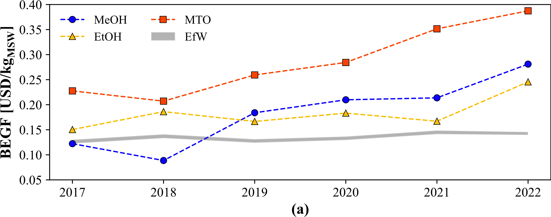
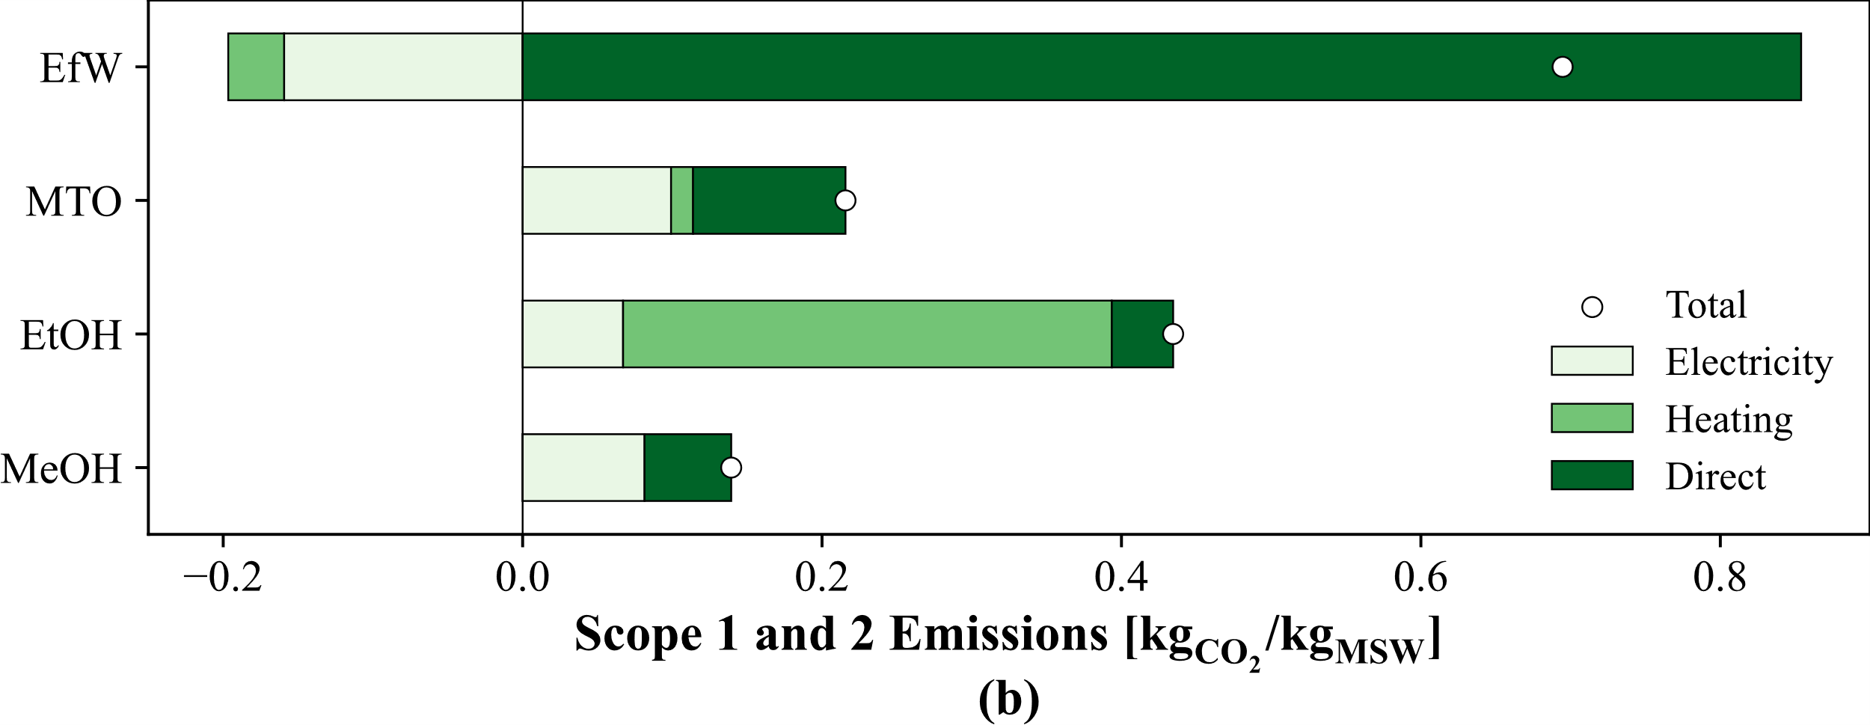
Figure 2: (a) Break-even gate fees and (b) Scope 1 & 2 emissions for each Waste-to-X route.
CO₂ Emissions: Figure 2(b) shows the levelized scope 1 and 2 CO₂ emissions, where each route achieves a substantial reduction in emissions compared to EfW, even after considering the credits for generated heat and electricity. The ethanol route has the greatest emissions of the three routes at 0.43 kg_{CO2}/kg_{MSW}, which still represents a ~40% reduction compared to EfW at 0.70 kg_{CO2}/kg_{MSW}. Most emissions from the ethanol process are due to its high heating requirements, which totals to ~3 MJ/kg_{MSW} with heat integration. The main heating sources are the reboiler duties in the methanol-ethanol and methanol-water distillation columns, for which there is limited potential for integration. A less carbon-intensive heating source would be the main improvement to reduce emissions further in this route. The MTO route has the next highest levelized emissions at 0.22 kg_{CO2}/kg_{MSW}. In contrast to the ethanol route, the MTO option shares most of its emissions equally between direct emissions and electricity. The large direct emissions are due to the combustion of multiple side product streams, including alkanes and coke, whereas the larger electricity requirement comes from the second compression train and refrigeration cycle. Finally, the methanol route has the lowest emissions overall at 0.14 kg_{CO2}/kg_{MSW}, an 80% reduction over EfW. After heat integration, this route has no heating requirement, but it has a higher electricity requirement than the ethanol route since all of the syngas is compressed to 78 bar for methanol synthesis.
  - Conclusions
This paper determined the economic and environmental performance of producing three different chemicals (methanol, ethanol, and light olefins) via municipal solid waste gasification and compared them to an incineration plant (EfW). The economic results revealed that whilst methanol was competitive with EfW in 2017-18, on average all three routes would require higher BEGFs than EfW. The ethanol route had the lowest increase in BEGF on average (between 1.2-1.8 times greater than EfW) due to lower capital costs and a lower green H₂ requirement. MTO was the most expensive route with BEGFs ranging from 1.6-2.8 times greater than EfW, due to a capital-intensive olefins separation section. Environmentally, all three routes had substantially lower scope 1 and 2 CO₂ emissions compared to EfW, with a 40-80% reduction for the ethanol and methanol routes respectively. However, a life cycle assessment is required to quantify the overall environmental impacts of each route. Social impacts should also be considered as these routes may reduce health and safety impacts on local communities and facilitate job creation. The scenario analysis should also be expanded to include both a wider range of market conditions (e.g., include varying H₂ sources and prices), and varying feedstock composition in the underlying MSW feed, which is the largest source of uncertainty.

Acknowledgements: The authors are grateful to the Engineering and Physical Sciences Research Council (EPSRC) for funding the research under the UKRI Interdisciplinary Centre for Circular Chemical Economy programme (EP/V011863/1). BL thanks the Dpt. of Chemical Engineering at Imperial College London for a PhD scholarship.
References
K. Griggs et al., 2023, Waste processing system, US20230012258A1 (US Patent)
I. Hannula et al., 2015, Light olefins and transport fuels from biomass residues via synthetic methanol: performance and cost analysis, Biomass Conversion and Biorefinery, 5, 1, 63-74
D. Hogg, 2023, The Performance of EU Incineration Facilities, Zero Waste Europe
IEA, 2019, The Future of Hydrogen, IEA, Paris
S. Jones et al., 2009, Municipal Solid Waste (MSW) to Liquid Fuels Synthesis, Volume 2: A Techno-economic Evaluation of the Production of Mixed Alchohols, PNNL-188482
S. Kaza et al., 2018, What a Waste 2.0: A Global Snapshot of Solid Waste Management to 2050, Urban Development Series. Washington, DC: World Bank
T. Kreutz et al., 2008, Fischer-Tropsch Fuels from Coal and Biomass, 25th Annual International Pittsburgh Coal Conference
A. Kumar, S. R. Samadder, 2017, A review on technological options of waste to energy for effective management of municipal solid waste, Waste Management, 69, 407-422
K. Ng et al., 1999, Kinetics and modelling of dimethyl ether synthesis from synthesis gas, Chemical Engineering Science, 54, 15-16, 3587-3592
A. Niziolek et al., 2015, Municipal solid waste to liquid transportation fuels – Part II: Process synthesis and global optimization strategies, Computers & Chemical Engineering, 74, 184-203
P. Nuss et al., 2013, Environmental Implications and Costs of Municipal Solid Waste-Derived Ethylene, Journal of Industrial Ecology, 17, 6, 912-925
A. Ouedraogo et al., 2021, Comparative Life Cycle Assessment of Gasification and Landfilling for Disposal of Municipal Solid Wastes, Energies, 14, 21, 7032
I. Staffel, 2017, Measuring the progress and impacts of decarbonising British electricity, Energy Policy, 102, 463-475
E. Van-Dal et al., 2013, Design and simulation of a methanol production plant from CO₂ hydrogenation, Journal of Cleaner Production, 57, 38-45
WRAP, 2017-22, Comparing the costs of alternative waste treatment options, Gate Fees Report
Y. Zhang et al., 2010, Novel Ethanol Synthesis Method via C1 Chemicals without Any Agriculture Feedstocks, Indsutrial & Engineering Chemistry Research, 49, 11, 5485-5488

