Design and Optimization of a sustainable process for the transformation of glucose into high added value products
$${\text{Carlos Rodrigo Caceres B }}^{a}{\text{,Eduardo Sánchez-Ramírez}}^{a},{\text{Juan Gabriel Segovia-Hernández}}^{a,*}$$
ªDepartment of Chemical Engineering, Universidad de Guanajuato, Campus Guanajuato, Guanajuato, 36050, Mexico
$$*\text{gsegovia@ugto.mx}$$
Abstract
This study unveils the design of a sustainable biorefinery for the simultaneous production of levulinic acid (LA), gamma-valerolactone (GVL), furfural (FF), and hydroxymethylfurfural (HMF) from corn stover. The utilization of this raw material enables the revalorization of agricultural residue. Employing Aspen Plus simulation, three distinct scenarios were assessed to achieve a purity exceeding 98% for the four compounds. These scenarios prioritize the preferential production of specific compounds. A sustainable process design was accomplished through multi-objective optimization using the MODE-TL algorithm, incorporating environmental and economic objectives. The optimal design for each scenario was successfully determined. Notably, Scenario 2 demonstrated the most sustainable outcome, with minimal values for annualized total cost (3.157$*{10}^{7}$ dollars/year), environmental impact (7.71$0*{10}^{6}$ points/year), and energy consumption (1.756${*10}^{9}$ MJ/year).
Keywords: biorefinery, sustainability, DETL method.
  - Introduction
Annually, the global accumulation of agricultural waste surpasses 998 million tons, with Mexico contributing a substantial 76 million tons to this staggering figure. Traditionally, these residues have been disposed of through environmentally detrimental burning, exacerbating global CO2 emissions to an alarming 8.68 billion tons. Recognizing the latent potential within lignocellulosic materials, a paradigm shift emerges—biorefineries present a transformative opportunity to convert these residues into high-value-added products. This proactive transition aligns seamlessly with the United Nations' principles of sustainable development, specifically targeting Sustainable Development Goals (SDGs) related to affordable and clean energy, as well as responsible consumption and production. Lignocellulosic biomass, a versatile resource, opens doors to a myriad of possibilities. The US National Renewable Energy Laboratory has identified 30 promising products from lignocellulosic biomass, including levulinic acid (LA), gamma-valerolactone (GVL), furfural (FF), and hydroxymethylfurfural (HMF). These compounds find applications in diverse industries such as pharmaceuticals, polymers, and solvents, serving as intermediates to produce other valuable compounds. Notably, the markets for GVL and FF exceed 700 and 500 million USD/year, respectively, while LA and HMF markets reach 28 and 61 million USD/year. This study leverages Aspen Plus to design a biorefinery for the simultaneous production of these compounds (>98% purity) from corn stover through acid dilute pretreatment. Three scenarios, delineating the division of the LA stream into either purification or transformation into GVL, are explored at proportions of 50/50, 75/25, and 25/75. The optimization of each scenario involves the implementation of Differential Evolution with Tabu List (DETL). The sustainability assessment comprehensively considers total annualized cost (TAC), Eco-99, and energy consumption metrics. This research pioneers the optimization of agricultural waste utilization, placing a strong emphasis on the intersection of economic viability and environmental responsibility, thereby marking a significant stride toward sustainable practices.
2. Methodology
2.1. Biorefinery design: Within an extensive biorefinery framework, the process is methodically segmented into the sections: pretreatment, hydrolysis, reaction, and purification. The objective of pretreatment is to disintegrate the lignocellulosic matter, rendering it more amenable for subsequent processing. In the hydrolysis stage, either enzymes or acidic solutions are deployed to breaking down the biomass into its constituent sugars. The ensuing reaction stage is pivotal, where sugars undergo a transformative process, evolving into chemicals and other valuable products. Finally in the purification section, the desired end-products are isolated. Notably, the conceptualization and design of this process were meticulously formulated based on insights garnered from an exhaustive literature review. Aspen Plus software was used, providing a sophisticated platform for process simulation and optimization. The resolution of the thermodynamic complexities was achieved through the utilization of the NRTL-HOC model. This model accurately forecasts the equilibrium of mixtures of polar compounds, providing a study framework for process design.
The biomass employed is corn stover, a highly abundant residue in Mexico (48.2×10^9 kg/year, Contreras-Zarazúa et al., 2022). The composition of the biomass is (%w/w):44.38 % cellulose, 33.63% hemicellulose and 22.37 % lignin. Calculations are based on a feed rate of 15,000 kg/h, equivalent to 127,500 tons/year. This represents 10% of the corn stover in Guanajuato state in 2015 (SAGARPA ,2015). The biomass undergoes pretreatment in reactor R1, with a water-to-biomass ratio of 2:1. Dilute acid pretreatment was selected because allows shorter residence times and high hemicellulose conversions (Conde-Mejía et al., 2012). The acid-to-water ratio is 0.77 kg of sulfuric acid per 1000 kg of water. The pretreatment conditions are a T=158°C, and P=6.76 bar (Contreras-Zarazúa et al., 2022).

In Figure 1, we present a simplified diagram of the plant. The effluent emerging from pretreatment reactor R1 undergoes neutralization in reactor R2. Through a filtration process, two streams are obtained: a liquid stream rich in hemicellulose (containing 10% xylose), which is directed towards FF production, and a solid stream comprising cellulose and lignin. In reactor R3, cellulose undergoes conversion into glucose, while lignin is separated through filtration from the reactor effluent. Column 1 is used for recovery of sulfuric acid. The bottoms from Column C1, primarily composed of glucose, are divided into two equal parts. One part is utilized to produce levulinic acid and formic acid in reactor R4, while the other is employed in HMF production in reactor R6, the same reactor where xylose is transformed into FF. Most of the sulfuric acid recovery is achieved in bottoms of column 2. The distillate from column C2, which contains levulinic acid as the primary compound of interest is split using splitter 2. Using the splitter 2 this stream can be directed either to the purification stage in column C6 or to reactor R5 to produce GVL, followed by subsequent purification in column C3. Different scenarios were considered for the proportion in which this stream is divided to give precedence to manufacturing a specific compound. Three scenarios resulting from dividing this stream in the proportions: 50/50, 25/75, and 75/25 as shown in Table 1 and Figure 1. Subsequently, the design and optimization were carried out for the three scenarios. Moving towards the lower section of the diagram, following reactor R6, columns C4 and C5 are situated, specifically dedicated to obtaining HMF and FF respectively as the bottom products.

Table 1. Different scenarios according to division of distillate stream of C2
Scenario | Percentage sends to column C6 | Percentage sends to reactor R5
1 (50/50) | 50 | 50
2 (25/75) | 25 | 75
3 (75/25) | 75 | 25

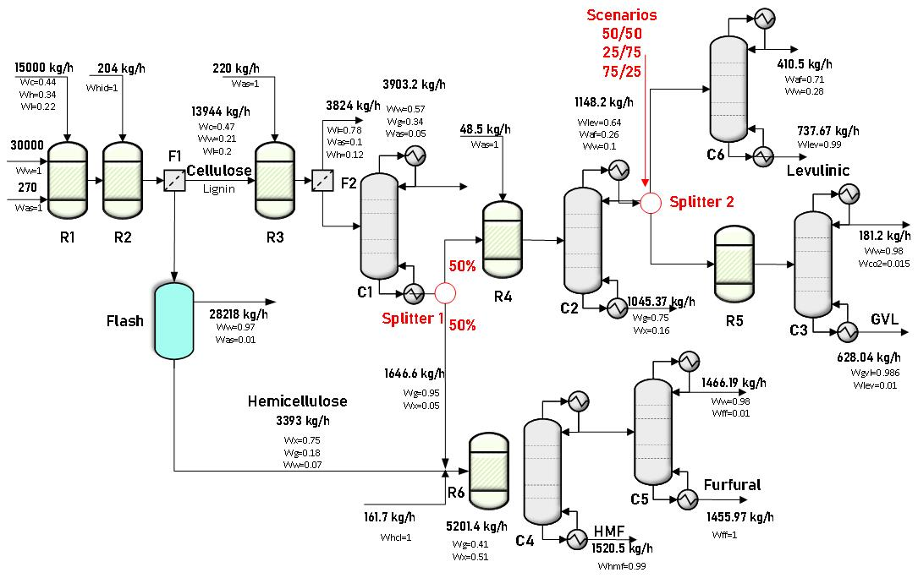
Figure 1. Simplified diagram and mass balance of the scenario 1for proposed biorefinery.

2.2. Optimization: The objective functions are the economics and environmental indices: total annualized cost (TAC), the Eco-indicator-99 (Eco-99) and the total requirement of energy for the process. This guarantee obtains a sustainable design for the biorefinery. The design was carried out by minimizing the multi-objective function:
$Min\left(TAC,EI99,Energía\right)=f(N,N_{f},RR,D,d)$ | (1)
Subject to: $y_{i}P_{c}≥x_{i}P_{c}, w_{i}F_{c}≥u_{i}F_{c}$ .Where N is the number of stages for the distillation columns, Nf is the feed stage, RR is the reflux ratio, D is the distillate flow rate and d is the column diameter. The total number of decision variables was 30. The optimization problem is constrained by ensuring that the purities ($y_{i}P_{c}$) are at least as high as $x_{i}P_{c}$ and that the recovery flows of the products ($w_{i}F_{c}$) are greater than or equal to $u_{i}F_{c}$. To execute the optimization, Aspen Plus was connected to Microsoft Excel via COM technology. Regarding objective functions, the total annualized cost is calculated using the modular cost technique (Turton, 2003). The Eco-indicator 99 is calculated using equation 2 (Contreras et al, 2019). Where:$ω$ is the weighting factor for damage, $δ_{i}$ is the impact value for category i, $αs$, $αsl$ and $αel$ are the steam, steel and electricity required. The energy requirements are the sum of the cooling and heating and are obtained from the simulation.
𝐸co-99=Σ$ω$∙$δ_{i}$∙${αs}_{i}$+$ω$∙$δ_{i}$∙${αsl}_{i}$+Σ$ω$∙$δ_{i}$∙${αel}_{i}$ | (2)
The EDTL method was implemented using Microsoft Excel and Aspen Plus. Excel sends the decision variable vector to Aspen, which evaluates process variables. After simulation, Aspen sends back the resulting vector to Excel, where objective function values are assessed, and new decision variable values are proposed. Parameters included 120 initial individuals, 400 generations, a tabu list of 60 individuals, a tabu radius of 0.0001, and crossover and mutation factors of 0.9 and 0.3, respectively (Alcocer et al., 2019) without tuning. The choice of hyperparameters does not significantly affect the obtained results, however, influences the number of iterations required. Decision variables (Table 2) are the design variables for distillation columns (C1 to C6).

Table 2. Decision variables for optimization
Variable Name | Range of variable | Variable Type
Number of stages, C1 to C6 | 20-100 | Discrete
Feed stage, C1 to C6 | 3-99 | Discrete
Column diameter, C1 to C6, m | 0.5-1.7 | Continuous
Molar reflux ratio C1 | 0.02-0.5 | Continuous
Molar reflux ratio C2 | 1.2-2.2 | Continuous
Molar reflux ratio C3 | 0.02-0.12 | Continuous
Molar reflux ratio C4 | 0.1-0.5 | Continuous
Mass reflux ratio C5 | 10-15 | Continuous
Molar reflux ratio C6 | 0.01-0.3 | Continuous
Distillate flow C1,$kmol h^{-1}$ | 130-144 | Continuous
Distillate flow C2, $kmol h^{-1}$ | 33-41 | Continuous
Distillate flow C3, $kmol h^{-1}$ | 8-10 | Continuous
Distillate flow C4, $kmol h^{-1}$ | 85-105 | Continuous
Distillate flow C5, kg $h^{-1}$ | 1400-1700 | Continuous
Distillate flow C6 $kmol h^{-1}$ | 10-14 | Continuous
3.Results
This section unveils the primary outcomes of the multiobjective optimization process, satisfying all prescribed purity and recovery constraints. The graphical representations depict the Pareto fronts delineating trade-offs between pairs of objective functions. To distill a singular optimal solution the utopia, point methodology was deployed. This method strategically positions an ideal solution at the Pareto front's extremity, where enhancing one objective leads to a compromise in the other. This approach facilitates the selection of an optimal design that strikes a balance between competing objectives.
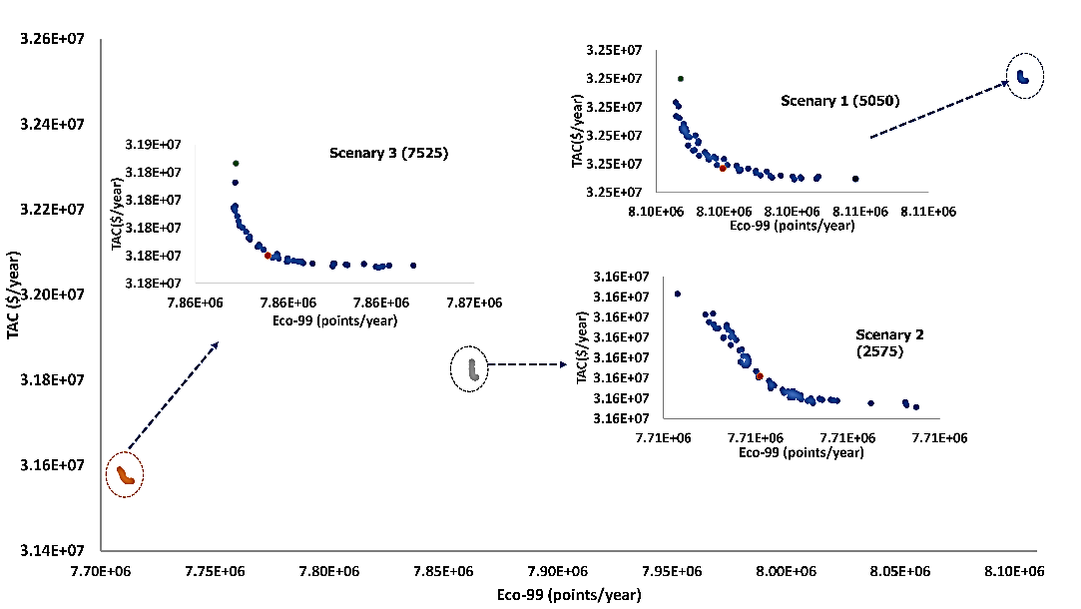
Figure 2. Pareto front between objective functions: TAC and Eco-99

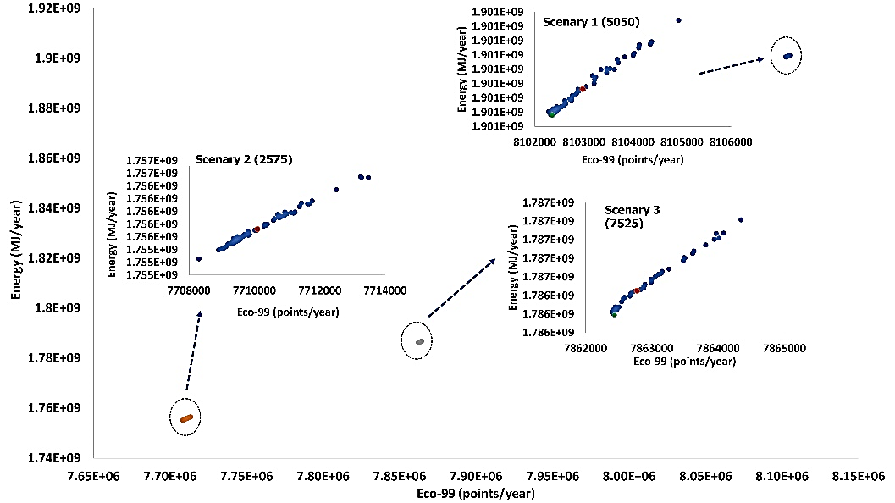
Figure 3. Pareto front between objective functions: Energy and Eco-99

Figure 2 illustrates the TAC vs Eco-99 graph, showcasing a competitive relationship between these functions. This mean, the most cost-effective process tends to have a more pronounced environmental impact. This due to the mutual influence of both objective functions by the reboiler duty. Moving to Figure 3, the plot depicts the relationship between energy and Eco-99, revealing a linear correlation. In distillation columns, the steam flow within the reboiler impacts both Eco-99 values and energy consumption.

Table 3 illustrates objective function values for optimal designs across various scenarios, marked by red points in Figures 2 and 3. The optimal solution within scenario 2 showcases superior values across all objective functions. This scenario prioritizes the highest quantity of GVL. In terms of the eco-indicator, Scenarios 3 and 1 display increments of 2% and 5%, respectively, regarding scenario 2. Moreover, the energy requirement in Scenario 2 was observed at its lowest, with increases of 1.7% and 8% in Scenarios 3 and 1, respectively, emphasizing Scenario 2 as the most sustainable design.
Analysis of decision variables for optimal designs uncovers distinct patterns. Reflux ratios within the columns notably remain modest, resulting in reduced internal flows and energy demands. Additionally, the number of stages exhibits minimal variation across scenarios. This suggests the plant's adaptability and efficiency in producing compounds, enabling fine-tuning to meet varying demand while maintaining operational efficiency."

Table 3. Values for objective functions for optimal designs
Objective Function | Scenario 1 (50/50) | Scenario 2 (25/75) | Scenario 3 (75/25)
TAC (dollars/year) | $${3.250*10}^{7}$$ | $${3.157*10}^{7}$$ | $${3.180*10}^{7}$$
Eco-indicator 99 (points/year) | $${8.105*10}^{6}$$ | $${7.710*10}^{6}$$ | $${7.863*10}^{6}$$
Energy (MJ/year) | $${1.901*10}^{9}$$ | $${1.756*10}^{9}$$ | $${1.786*10}^{9}$$

4.Conclusions
This study concludes with the achievement of an optimal and cost-effective design for the biorefinery, characterized by minimal environmental impact and reduced energy consumption. Focused on the simultaneous production of levulinic acid, furfural, 5-hydroxymethylfurfural, and γ-valerolactone from sugars derived from corn stover, the exploration of three distinct scenarios highlighted the preferential production of specific compounds. Remarkably, Scenario 2 (25/75), prioritizing the maximum yield of γ-valerolactone, not only achieves the optimal design but also ensures the lowest values in all three objective functions. establishing itself as the most sustainable configuration. This success represents a significant advancement in process optimization, underscoring the potential for transformative and environmentally conscious practices in biorefineries.

References
H. Alcocer-García, J.G. Segovia-Hernández, O. Prado-Rubio, E. Sánchez-Ramírez and J.J. Quiroz-Ramírez, Multi-objective optimization of intensified processes for the purification of levulinic acid involving economic and environmental objectives, Chemical Engineering and Processing - Process Intensification, 2019,136, 123–137.
G. Contreras-Zarazúa, M.Martin-Martin, E. Sánchez-Ramirez and J.G. Segovia-Hernández, Furfural production from agricultural residues using different intensified separation and pretreatment alternatives. Economic and environmental assessment, Chemical Engineering and Processing - Process Intensification,2021, 171.
R. Turton, R. C. Bailie, W. B. Whiting, and J. A. Shaeiwitz, Analysis, Synthesis, and Design of Chemical Processes, Second Edition, PrenticeHall, 2003.

