Climate change threatens the food safety of the supply chain
Lydia Katsiniª, Satyajeet S. Bhonsaleª, Styliani Roufou^{b}, Sholeem Griffin^{b}, Vasilis Valdramidis^{b,c}, Simen Akkermansª, Monika Polanskaª,
Jan F.M. Van Impeª*
ªBioTeC+ - Chemical and Biochemical Process Technology and Control, KU Leuven Ghent, Gebroeders De Smetstraat 1, 9000 Ghent, Belgium
^{b}Department of Food Sciences and Nutrition, University of Malta, Malta
^{c}National and Kapodistrian University of Athens, Department of Chemistry, Panepistimiopolis Zografou, Athens, 157 84 Greece
*Email: jan.vanimpe@kuleuven.be
Abstract
Considering the climate change effect on the food system, there is a growing need for scientific research with the aim of strengthening its resilience. From a food safety perspective, certain foods, like pasteurized milk, rely on low temperature during transportation as barrier to pathogen growth, thus any disturbance in the cold supply chain could result in foodborne illness. This study aimed to evaluate the impact of heatwaves on the cold supply chain of pasteurized milk through mathematical modelling for two European regions, i.e., Greece and Belgium. Based on the results, under heatwave scenarios the cold supply chain was disrupted in both regions. This suggests that heatwaves should not only be a concern for the warmer European south but also for central European regions. The presented framework can be adjusted for other products or enriched with more aspects like the temperature variability at the retail to yield more realistic results. Overall, this study highlights the need for future-proofing the cold supply chain of food.
Keywords: climate change scenarios, supply chain, food safety, dairy, modelling
  - Introduction
With rising global temperatures, altered rainfall patterns, and increased frequency of extreme weather events, climate change is expected to drastically affect the food system (Katsini et al., 2019). The food system, according to FAO (2019), includes, besides the production of food, also its transportation. This means that the supply chain is part of the food system, thus it is expected to be affected by climate change. According to Davis et al. (2021) the food supply is highly susceptible to environmental shocks, extreme rainfall and heatwaves. This underlines the vulnerability of the supply chains to such events, which brings food security at risk. However, especially when dealing with the cold supply chain, also the food safety is jeopardized. As low temperature is used to prevent growth of pathogenic bacteria (Wu et al., 2021), any disruption in the cold supply chain threatens food safety. Usually refrigerated goods are transported with cooling trucks, nevertheless, the cooling capacity of a given truck is dependent on the ambient temperature (Song et al., 2022). One of the numerous effects of climate change is the increased frequency of extreme events such as heatwaves. The European regions, and especially the south, are already experiencing this along with its disastrous consequences.
All the above underline the urgent need to evaluate the effect of heatwave conditions on the cold food supply chain in terms of food safety. There is a growing need to build a future proof and resilient food system, guided by evidence-based decision making. Mathematical modelling is a valuable tool in tackling this. Thus, the aim of this paper is to assess the effect of climate change, in terms of heatwaves, on the cold supply chain with respect to food safety by utilizing mathematical modelling. Pasteurized whole milk is considered as the case study, while data from Greece and Belgium are simulated to include two distinct climatological regions.
  - Materials and Methods
As mentioned in the previous section, this is an in silico study, in which three models are utilized: one for describing the temperature of the truck chamber as a function of the ambient temperature, one for describing the milk temperature as a function of the truck chamber temperature, and one for the food safety hazard level as a function of the milk temperature. Four different ambient temperature scenarios are simulated: Greece under summer and heatwave conditions and Belgium under summer and heatwave conditions. The corresponding ambient temperatures for the year 2023 were accessed from the Climate Data Store (CDS) of the Copernicus Climate Change Service (Muñoz Sabater, 2019).
    - Cooling truck chamber temperature model
The model introduced by Fallmann et al. (2023) was applied to obtain the cooling truck chamber temperature, $T^{cc}$[°C], as a function of the ambient temperature, $T^{amb}$[°C], the heat flow from the milk to the chamber, ${\dot{Q}}_{m}$[W], the door openings, $s_{door}∈\{0,1\}$, and the compressor speed, $n_{c}$[rpm]:
$$\frac{dT^{cc}}{dt}=f\left({\dot{Q}}_{m},T^{amb},s_{door},n_{c},θ\right)$$ | (1)
Where $θ$ corresponds to the parameter vector. A detailed description of the model can be found in Fallman et al. (2023). To capitalize on the door openings functionality of the model, each simulation was broken down into three time steps: one for transporting the milk with closed doors, one for keeping the doors open and reducing the amount of cargo to half, and a last one for transporting the remaining milk. For each step, the heat flow from the milk to the chamber, ${\dot{Q}}_{m}$[W], was assumed constant and estimated as:
$${\dot{Q}}_{m}=mc_{p}\left(T_{initial}^{m}-T_{t_{end}}^{cc}\right)/t_{total}$$ | (2)
Where $m$[kg] is the mass of the milk, $c_{p}$[J/kg°C] is the heat capacity of the milk, $T_{initial}^{m}$[°C] is the initial temperature of the milk, $T_{t_{end}}^{cc}$ [°C] is the temperature of the cooling chamber at the end of the simulated time step, and $t_{total}$ [s] is the total time of the simulated time step. Furthermore, the volume of milk transported was estimated based on the dimensions of the considered cooling truck. Heat transfer was assumed to occur at the vertical sides as well as at the top of the cargo.

    - Milk temperature model
A simplistic approach was followed to estimate the milk temperature at time $t$, $T_{t}^{m}$ [°C], based on (Konovalenko et al., 2021):
$$T_{t}^{m}=T_{t}^{cc}+\left(T_{0}^{m}-T_{t}^{cc}\right) exp\left(-\frac{Ah}{mc_{p}}t\right)$$ | (3)
Where $T_{t}^{cc}$ [°C] is the cooling chamber temperature at time $t$, $T_{0}^{m}$ [°C] is the milk temperature at time $t$, $A$ [m²] is the heat transfer surface, and $h$ [W/m²°C] is the heat transfer coefficient for milk. The values of the milk properties were selected from Munir et al. (2016).
    - Food safety hazard model
In terms of food safety, one of the major hazards for the milk cold supply chain is Listeria monocytogenes, therefore, the growth model and the secondary growth model for this pathogen were applied (Alavi et al., 1999):
$$\frac{dN}{dt}=μ_{max} \left(\frac{Q}{Q+1}\right)\left(1-\frac{N}{N_{max}}\right) N$$ | (4)
$$\frac{dQ}{dt}= μ_{max} Q$$ | (5)
$$μ_{max}(t)={\left[b\left(T_{t}^{m}-T_{min}\right)\right]}^{2}\left\{1-exp\left[c\left(T_{t}^{m}-T_{max}\right)\right]\right\}$$ | (6)
Where $N$ [CFU/ml] is the population level, $μ_{max}$ [h⁻¹] is the maximum growth rate, $N_{max}$ [CFU/ml] is the maximum population level, and $Q$ is a measure of the physiological state of the bacterial cells. Eq. (6) describes the temperature dependence of the $μ_{max}$, where $T_{min},T_{max}$ [°C] are the minimum and maximum temperatures for growth, respectively, while $b, c$ are parameters.
  - Results and Discussion
Firstly, the results of the scenarios corresponding to the two temperature models and then the Listeria monocytogenes levels are presented. It is important to note that, based on the current regulation, during the storage and transportation of pasteurized milk, the temperature should not exceed 4 °C, as the shelf life of the product is jeopardized if the temperature increases.
    - Cooling chamber and milk temperature
The three time steps regarding the door opening mentioned in the previous section were selected as: 1 hour for the transport to the first retailer with closed doors, 10 minutes to unload half of the cargo with open doors, and 1 hour for the transport to the second retailer. The compressor speed was selected at 2000 rpm. Based on recent years’ temperature recordings, Belgium, which belongs to the temperate climate based on the Köppen climate classification (Beck et al., 2018), recorded the highest temperature in 2023 on 8 July, at 35 °C based on the downloaded data from the CDS. Therefore, the temperature for the scenarios referring to Belgium was 25 °C for the summer and 35 °C for the heatwave. Figure 1 illustrates the results for these scenarios in terms of temperature evolution for the cooling chamber as well as for the milk.
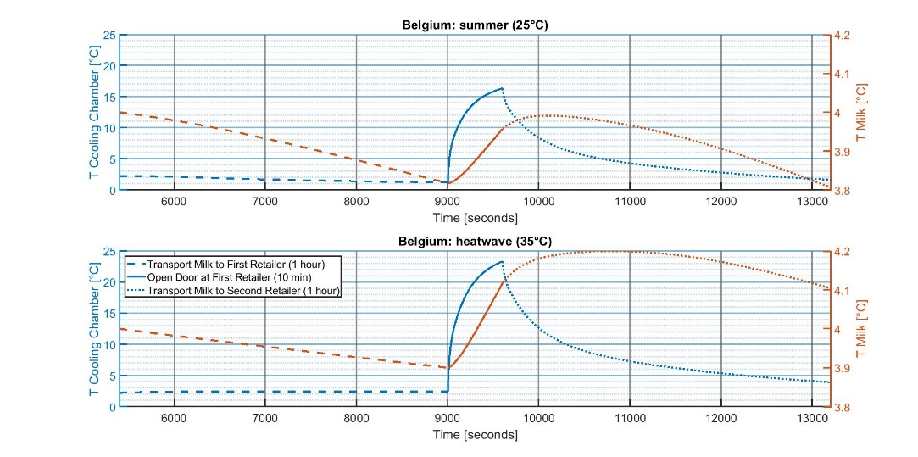
Figure 1: Temperature evolution for the cooling chamber of the truck and the milk for two scenarios (summer and heatwave) referring to Belgium.
Based on these results, the milk temperature did not exceed the 4 °C threshold for the summer scenario, with a maximum milk temperature of 3.99 °C. For the heatwave scenario, nevertheless, the milk temperature reached 4.20 °C, which means that the cold supply chain can be disrupted even for a central European country.
Greece, which belongs to the Mediterranean climate based on the Köppen climate classification (Beck et al., 2018), recorded the highest temperature in 2023 on 23 July, at 45 °C, based on the CDS data. Therefore, the temperature scenarios were 30 °C for the summer and 45 °C for the heatwave, and the results are depicted in Figure 2. In both cases the milk temperature exceeded the 4 °C threshold. For the summer scenario the maximum milk temperature was 4.09 °C, while for the heatwave it was 4.44 °C. These results underline the urgent need for adaptation in the countries that suffer from severe heatwaves. Overall, by comparing Figure 1 with Figure 2, it is clear that as the ambient temperature increased, the maximum milk temperature increased and the time for which the milk had a temperature above 4 °C prolonged.
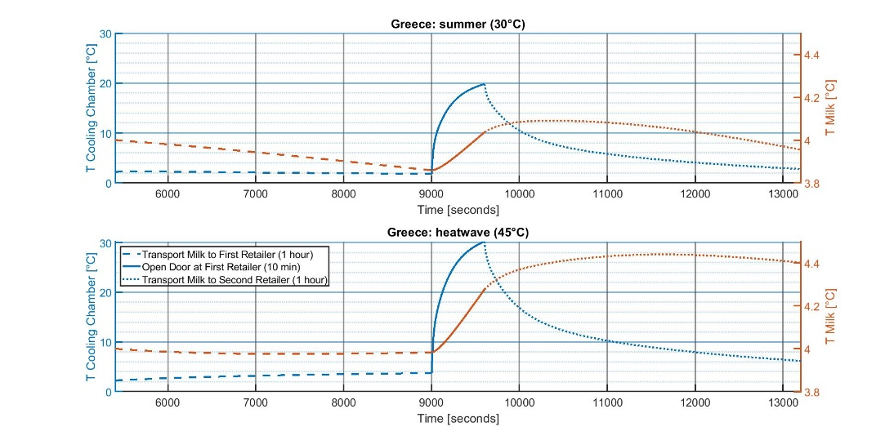
Figure 2: Temperature evolution for the cooling chamber of the truck and the milk for two scenarios (summer and heatwave) referring to Greece.
    - Listeria monocytogenes population level
Based on the above, the evaluation of the Listeria monocytogenes levels was simulated only for the heatwave scenario in Greece. Considering the effect of temperature on the maximum growth rate of Listeria monocytogenes, even though the minimum temperature for growth was below 4 °C, the rate at which the pathogen grew was low. Thus, for the short timeframe of the supply change considered, i.e., about two hours in total, the increase in the population was quite low.
Therefore, for this case, two additional time steps were accounted for: one before the transportation and one after. The first one (1.5 hours) started at the time of contamination, which was assumed to happen at the production facility, until the start of the transportation. For this step, the milk temperature was assumed to be constant at 4 °C. The second one (4 days) started at the end of transportation until the milk purchase, where the milk temperature was considered constant at 4 °C. The reasoning behind this selection was that the shelf life of pasteurized milk in Greece is 5 days by law (Koutsoumanis et al., 2010). The contamination was assumed at 1000 CFU/ml and the resulting population evolution is illustrated in Figure 3. The data were compared with the scenario where the milk temperature is considered constant at 4 °C (no disruption in Figure 3).
As the nature of bacterial growth is exponential, it is expected that at the beginning of the simulation, which corresponded to the cold chain, the population level would be quite low compared to the end of the simulation. By comparing the two cases, the pathogen population at the end of the shelf life was higher for the heatwave scenario, as expected. This shows that an increase in the population of foodborne pathogens is possible due to heatwaves and thus, the food safety of the supply chain is at risk due to climate change.
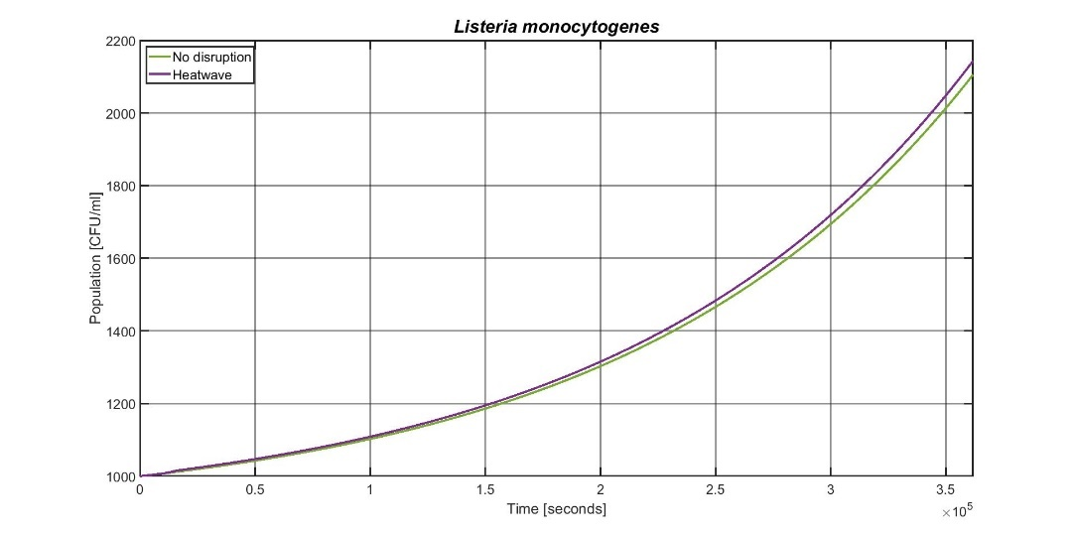
Figure 3: Listeria monocytogenes population for heatwave scenario in Greece.
  - Conclusions
There is a growing concern regarding the effect of climate change on food supply chains, as it endangers food security. From a food safety aspect, transporting and storing certain foods, such as pasteurized milk, is utilized as a barrier to pathogen growth. This means that a disruption in the cold supply chain can potentially lead to foodborne illness. The aim of this paper was to evaluate the effect of heatwaves on the cold supply chain of pasteurized milk, both in terms of temperature disruption and pathogen proliferation by utilizing mathematical modelling. Two distinct regions of Europe were selected (Greece and Belgium), and according to the results, for the heatwave scenario the cold supply chain was disrupted in both regions. This means that heatwaves should be a concerning issue not only for the warmer European south, but also for the central European regions. Even though the difference in the final population of the simulated pathogen, i.e., Listeria monocytogenes, between the heatwave and the scenario without disruption was low, the applied framework can be used in the context of food safety for other products with longer shelf life, where the corresponding difference will be higher due to the exponential growth of pathogenic bacteria. Taking into account the position of the cargo as well as incorporating the spatial aspect for the milk model would increase the accuracy of the results. Furthermore, in this study the possibility of cold chain disruption at the stage of the retailer, which would highlight the difference between the ideal non-disrupted cold chain and reality, was not considered. Overall, this research shows the need to adapt the operation conditions for the cold supply chain in light of the effect of climate change.
Acknowledgement
This work was supported by the PROTECT project funded by the European Union’s Horizon 2020 Research and Innovation Programme [MSCA grant 813329]. Author Simen Akkermans was funded by the Research Foundation Flanders (FWO) under grant number 1224623N.
References
Beck H.E., Zimmermann N.E., McVicar T.R., Vergopolan N., Berg A., Wood E.F., 2018. Present and future Köppen-Geiger climate classification maps at 1-km resolution. Sci Data 5
Davis K.F., Downs S., Gephart J.A., 2021. Towards food supply chain resilience to environmental shocks. Nat Food 2
FAO, 2019. Food systems at risk. New trends and challenges. Rome: FAO-CIRAD-EC
Song H., Cai M., Cen J., Xu C., Zeng Q., 2022. Research on energy saving optimization method of electric refrigerated truck based on genetic algorithm, Int J Refrig 137
Konovalenko I., Ludwig A., Leopold H., 2021. Real-time temperature prediction in a cold supply chain based on Newton's law of cooling. Decis Support Syst 141
Katsini L. Bhonsale S., Akkermans S., Roufou S. Griffin S., Valdramidis V., Misiou O., Koutsoumanis K., Muñoz López C.A., Polanska M., Van Impe J.F.M., 2022. Quantitative methods to predict the effect of climate change on microbial food safety: A needs analysis. Trends Food Sci 126
Koutsoumanis K., Pavlis A., Nychas G.J., Xanthiakos K., 2010. Probabilistic model for Listeria monocytogenes growth during distribution, retail storage, and domestic storage of pasteurized milk. Appl Environ Microbiol 76(7)
Munir M.T., Zhang Y., Yu W., Wilson D.I., Young B.R., 2016. Virtual milk for modelling and simulation of dairy processes. J Dairy Sci 99(5)
Fallmann M., Poks A., Kozek M., 2023. Control-oriented hybrid model of a small-scale refrigerated truck chamber. Appl Therm Eng 220
Muñoz Sabater J., 2019. ERA5-Land hourly data from 1950 to present. Copernicus Climate Change Service (C3S) Climate Data Store (CDS), Accessed on 10-11-2023
Alavi S.H., Puri V.M., Knabel S.J., Mohtar R.H., Whiting R.C., 1999. Development and Validation of a Dynamic Growth Model for Listeria monocytogenes in Fluid Whole Milk, J Food Prot 62(2)
Wu J., Hsiao H., 2021. Food quality and safety risk diagnosis in the food cold chain through failure mode and effect analysis. Food Control 120

