Strategies for Renewable Muconic Acid Production from Lignin-based Aromatics through Rational Metabolic Engineering of Pseudomonas Putida KT2440
Pinelopi Marina Politiª, Ilias Toumpe^{b}, Stefanos Xeniosª, Konstantinos Mexisª, Ljubisa Miskovic^{b}, Vassily Hatzimanikatis^{b} and Antonis Kokossis^{a*}
ª School of Chemical Engineering, National Technical University of Athens, GR 157 72, Athens, Greece

^{b} Laboratory of Computational Systems Biotechnology (LCSB), Swiss Federal Institute of Technology in Lausanne (EPFL), CH 1015, Lausanne, Switzerland
akokossis@chemeng.ntua.gr
Abstract
Pseudomonas putida has significant potential as a cell factory, especially for degrading aromatic polymers like lignin, due to its remarkably versatile metabolism. In this work, we devise rational metabolic engineering strategies for producing muconic acid from lignin-based aromatics using the bacterium Pseudomonas putida KT2440, focusing on increasing the efficiency and yield of these processes. We develop large-scale kinetic models of Pseudomonas Putida KT2440 for biobased cis,cis-Muconic acid (ccMA) production through lignin-related aromatic compounds, such as p-coumarate (pCA), using the ORACLE (Optimization and Risk Analysis of Complex Living Entities) methodology.
The developed large-scale kinetic models are used to derive engineering strategies through Metabolic Control Analysis (MCA) to manipulate the genetic composition of Pseudomonas putida KT2440. This study investigates the effects of uncertainty in the operating directions of reactions in the metabolic network on devised metabolic engineering targets. To this end, we study two cases, differing in the direction the phosphoglucose-isomerase (PGI) reaction, an essential step of the glycolysis and gluconeogenesis pathways, operates. We identify target enzymes for the two cases and propose metabolic engineering strategies for each formulation. The analysis of the two cases revealed that our metabolic engineering decisions are strongly affected by the assumptions on the directionality of PGI. Therefore, to devise reliable metabolic engineering targets, interventions that are consistent in the two cases should be considered. This study also allows us to propose future experiments that would reduce the uncertainty in the system and, therefore, improve the reliability of the developed kinetic models.
This research expands our knowledge about the biochemical capabilities of Pseudomonas putida through the use of developed large-scale kinetic models of this important industrial host.
Keywords: Pseudomonas putida KT2440, Large-scale kinetic models of metabolism, Thermodynamics, Flux Directionality Profile, Metabolic engineering.
Introduction
A promising bacterium for the industrial production of biofuels and biochemicals is Pseudomonas Putida, due to its strong ability to tolerate toxic compounds, as well as its capacity to grow on a wide range of substrates. Pseudomonas putida can depolymerize high molecular weight (HMW) oligomers, thus making complex aromatic polymers potential substrate candidates. A promising source of renewable carbon for the production of high-value chemicals is lignin, a structural component of plant biomass. Despite being the primary large-volume renewable aromatic feedstock in nature, the transformation of lignin into bioproducts presents a substantial bottleneck due to its intrinsic heterogeneity and resistance to depolymerization (Park et al., 2020). Lignin is currently underutilized and routinely combusted to generate process heat in the paper and pulp industry (Wu et al., 2017).

In the context of lignin valorization, this study focuses on muconic acid, an important chemical intermediate that can be produced from lignin-based aromatics. Muconic acid is suitable for polymerization into biobased polyesters since it can be converted through a single-step hydrogenation process to adipic acid, a common monomer in the production of nylon-6,6 (Vardon et al., 2016). Furthermore, transforming cis,cis-muconic acid into trans,trans-muconic acid via isomerization, followed by subsequent reactions, offers a pathway to generate terephthalic acid, a primary building block for Bio-PET.

Genome-Scale Models (GEMs) of Pseudomonas putida have been constructed in the past years, with the most recent one being the iJN1463, consisting of 2153 metabolites, 2927 reactions, and 1462 genes (Nogales et al., 2019). Those models have been used for optimal flux distribution predictions and gene essentiality evaluation. Advancements in computational metabolic engineering have allowed large-scale kinetic models to capture the dynamic metabolic responses of a cell to parameter perturbations (Tokic et al., 2020). However, constructing those models requires experimental datasets to constrain the model’s predictions to a physiologically relevant solution space (Miskovic et al., 2015). Several metabolic engineering and bioprocess development studies have been done, focusing on engineering Pseudomonas putida toward industrially-relevant MA production from aromatic compounds (Sonoki et al., 2014; Kohlstedt et al., 2022; Almqvist et al., 2021; Kuatsjah et al., 2022; Salvachua et al., 2018).

In this work, we develop a systematic approach to lignin valorization through the strain Pseudomonas putida KT2440. We build large-scale kinetic models for two Flux Directionality Profiles (FDPs) of the metabolism of Pseudomonas putida and identify enzyme targets for muconic acid overproduction for each FDP.
Methods & Results
For the purpose of this study, the most recent GEM of Pseudomonas putida iJN1463, was reduced using redGEM (Ataman et al., 2017), a systematic model reduction framework that produces core networks focused around 8 subsystems of interest: glycolysis, glyconeogenesis, pyruvate metabolism, TCA cycle, pentose phosphate pathway, β-ketoadipate pathway, the oxidative phosphorylation (ETC) pathway, as well as phenylalanine, tyrosine and tryptophan biosynthesis pathway. We then apply lumpGEM, an algorithm that forms a lumped reaction to accommodate the production of the necessary biomass building blocks (Ataman & Hatzimanikatis, 2017).
The Optimization and Risk Analysis of Complex Living Entities (ORACLE) methodology (Miskovic & Hatzimanikatis, 2010) is used for the analysis of muconic acid production by Pseudomonas putida KT2440. Cis,cis-muconic acid production is based on p-coumaric acid uptake of the cell, while cell growth is supported by glucose uptake. For this purpose, two gene knockouts and two reaction additions were performed. The reduced model was further constrained with experimental data of uptake, secretion and growth rates and metabolomics data of media metabolites (Kuatsjah et al., 2022). Thermodynamics-based Flux Balance Analysis (TFBA) (Kiparissides & Hatzimanikatis, 2017; Soh & Hatzimanikatis, 2014) was performed, for which the standard Gibbs free energy of formation (ΔGº_{f}) and reaction (ΔGº_{r}) were estimated with the Group Contribution Method (Jankowski et al., 2008). The curated reduced thermodynamic model consists of 365 reactions, 307 metabolites and 364 genes.
However, even with integrating available data certain reactions can still operate in either the forward or reverse direction while remaining consistent with the observed physiology. To build the kinetic model, we need to define an explicit directionality for those reactions (Hameri et al., 2019).
We constructed populations of non-linear large-scale kinetic models for 2 selected FDPs. We generated 50,000 stable kinetic models for each FDP, based on 1,000 steady-state solution samples using the SKiMpy (Symbolic Kinetic Models with Python) package (Weilandt et al., 2022). Each kinetic model consists of 2,692 parameters, capturing the complex cellular physiology of Pseudomonas putida cells.
Here, we investigate how the directionality assumption of the reaction catalysed by enzyme phosphoglucose-isomerase (PGI) that interconverts glucose-6-phosphate and fructose-6-phosphate affects the predictions of the populated kinetic models. Based on this, we sampled the solution space to determine concentrations and fluxes and developed two kinetic models. We performed MCA (Wang et al., 2004) on these models and identified 17 key enzymes for each FDP that affect the production of catechol, the immediate precursor of muconic acid (Figure 1). Three enzyme targets that have a consistent, positive effect on muconic acid production in the two FDPs, are the ones catalysing NADP biosynthesis, 4-hydroxybenzoate degradation and p-coumarate degradation (Figure 1). The first reaction contributes to the overall production of ADP and NADP energy carriers, whereas the latter two take part in the p-coumaric acid degradation pathway, catabolising our main lignin derivative for muconic acid production, pCA. The directionality in the PGI reaction affects the sign of Flux Control Coefficients (FCCs) for several enzymes, such as reaction GLUPRT participating in the 5-aminoimidazole ribonucleotide biosynthesis pathway. PGI reaction is an essential step of the glycolysis and gluconeogenesis pathways, and it was previously reported that it can operate in both directions (Ebert et al., 2011). Therefore, it is an interesting candidate to investigate its flux directionality effect on muconic acid production.

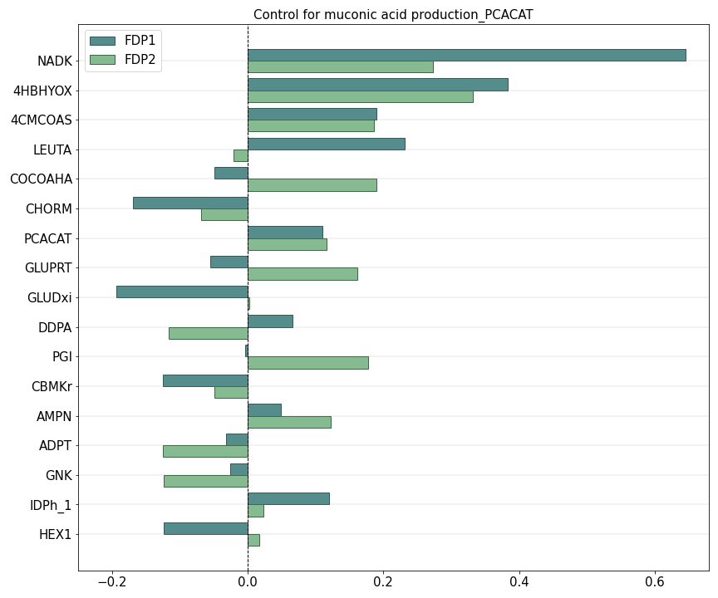
Figure 1. Flux Control coefficients of the production of muconic acid for two different FDPs. Illustration of the top 17 enzymes across the FDPs in terms of absolute control over muconic acid production. The bars correspond to the mean values of FCCs for FDP1, where the directionality of PGI reaction is set forward, and for FDP2 where the directionality of PGI reaction is set backward.
Conclusions
Overall, this project contributes to the advancement of sustainable biobased chemicals and assists in designing future biorefineries. Moreover, the curated genome-scale model of Pseudomonas putida, along with the large-scale stoichiometric and kinetic models, are valuable for future biobased chemical research and development. The study's results may also facilitate the exploration of alternative target enzymes and production pathways that increase robustness to lignin-related feedstocks and muconic acid productivity, thereby propelling the field of biobased chemical production forward.
Acknowledgements
This work was conducted as part of an inter-university research collaboration project between the National Technical University of Athens (NTUA) and the Swiss Federal Institute of Technology in Lausanne (EPFL).
The research project was funded by the Hellenic Foundation for Research and Innovation (H.F.R.I.) under the 2nd Call for H.F.R.I. Research Projects to support Faculty Members & Researchers (Project Number: 3817).
References
Almqvist, H., Veras, H., Li, K., Hidalgo, J. G., Hulteberg, C., Gorwa-Grauslund, M., Parachin, N. S., & Carlquist, M. (2021). Muconic Acid Production Using Engineered Pseudomonas putida KT2440 and a Guaiacol-Rich Fraction Derived from Kraft Lignin. ACS Sustainable Chemistry & Engineering, 9(24), 8097–8106.
Ataman, M., Gardiol, D. F. H., Fengos, G., & Hatzimanikatis, V. (2017). redGEM: Systematic reduction and analysis of genome-scale metabolic reconstructions for development of consistent core metabolic models. PLOS Computational Biology, 13(7), e1005444.
Ataman, M., & Hatzimanikatis, V. (2017). lumpGEM: Systematic generation of subnetworks and elementally balanced lumped reactions for the biosynthesis of target metabolites. PLOS Computational Biology, 13(7), e1005513.
Ebert, B. E., Kurth, F., Grund, M., Blank, L. M., & Schmid, A. (2011). Response of Pseudomonas putida KT2440 to increased NADH and ATP demand. Applied and environmental microbiology, 77(18), 6597–6605.
Hameri, T., Fengos, G., Ataman, M., Miskovic, L., & Hatzimanikatis, V. (2019). Kinetic models of metabolism that consider alternative steady-state solutions of intracellular fluxes and concentrations. Metabolic Engineering, 52, 29–41.
Jankowski, M., Henry, C. S., Broadbelt, L. J., & Hatzimanikatis, V. (2008). Group Contribution Method for thermodynamic analysis of complex metabolic networks. Biophysical Journal, 95(3), 1487–1499.
Kiparissides, A., & Hatzimanikatis, V. (2017). Thermodynamics-based Metabolite Sensitivity Analysis in metabolic networks. Metabolic Engineering, 39, 117–127.
Kohlstedt, M., Weimer, A., Weiland, F., Stolzenberger, J., Selzer, M., Sanz, M. A., Kramps, L., & Wittmann, C. (2022). Biobased PET from lignin using an engineered cis, cis-muconate-producing Pseudomonas putida strain with superior robustness, energy and redox properties. Metabolic Engineering, 72, 337–352.
Kuatsjah, E., Johnson, C. W., Salvachua, D., Werner, A. Z., Zahn, M., Szostkiewicz, C. J., Singer, C. A., Dominick, G., Okekeogbu, I., Haugen, S. J., Woodworth, S. P., Ramirez, K. J., Giannone, R. J., Hettich, R. L., McGeehan, J., & Beckham, G. T. (2022). Debottlenecking 4-hydroxybenzoate hydroxylation in Pseudomonas putida KT2440 improves muconate productivity from p-coumarate. Metabolic Engineering, 70, 31–42.
Miskovic, L., & Hatzimanikatis, V. (2010). Production of biofuels and biochemicals: in need of an ORACLE. Trends in Biotechnology, 28(8), 391–397.
Miskovic, L., Tokic, M., Fengos, G., & Hatzimanikatis, V. (2015). Rites of passage: requirements and standards for building kinetic models of metabolic phenotypes. Current Opinion in Biotechnology, 36, 146–153.
Nogales, J., Mueller, J. L., Gudmundsson, S., Canalejo, F. J., Duque, E., Monk, J. M., Feist, A. M., Ramos, J. L., Niu, W., & Palsson, B. Ø. (2019). High‐quality genome‐scale metabolic modelling of Pseudomonas putida highlights its broad metabolic capabilities. Environmental Microbiology, 22(1), 255–269.
Park, M., Chen, Y., Thompson, M. G., Benites, V. T., Fong, B., Kim, Y., Baidoo, E. E. K., Gladden, J. M., Adams, P. D., Keasling, J. D., Simmons, B. A., & Singer, S. W. (2020). Response of Pseudomonas putida to Complex, Aromatic‐Rich Fractions from Biomass. ChemSusChem, 13(17), 4455–4467.
Salvachua, D., Johnson, C. W., Singer, C. A., Rohrer, H., Peterson, D. J., Black, B. A., Knapp, A., & Beckham, G. T. (2018). Bioprocess development for muconic acid production from aromatic compounds and lignin. Green Chemistry, 20(21), 5007–5019.
Soh, K. C., & Hatzimanikatis, V. (2014). Constraining the flux space using thermodynamics and integration of metabolomics data. In Methods in molecular biology (pp. 49–63).
Sonoki, T., Morooka, M., Sakamoto, K., Otsuka, Y., Nakamura, M., Jellison, J., & Goodell, B. (2014). Enhancement of protocatechuate decarboxylase activity for the effective production of muconate from lignin-related aromatic compounds. Journal of Biotechnology, 192, 71–77.
Tokic, M., Hatzimanikatis, V., & Miskovic, L. (2020). Large-scale kinetic metabolic models of Pseudomonas putida KT2440 for consistent design of metabolic engineering strategies. Biotechnology for Biofuels, 13(1).
Vardon, D. R., Rorrer, N. A., Salvachua, D., Settle, A. E., Johnson, C. W., Menart, M. J., Cleveland, N. S., Ciesielski, P. N., Steirer, K. X., Dorgan, J. R., & Beckham, G. T. (2016). cis,cis-Muconic acid: separation and catalysis to bio-adipic acid for nylon-6,6 polymerization. Green Chemistry, 18(11), 3397–3413.
Wang, L., Birol, İ., & Hatzimanikatis, V. (2004). Metabolic Control Analysis under Uncertainty: Framework Development and Case Studies. Biophysical Journal, 87(6), 3750–3763.
Weilandt, D., Salvy, P., Masid, M., Fengos, G., Eriksson, R. D., Hosseini, Z., & Hatzimanikatis, V. (2022). Symbolic Kinetic Models in Python (SKiMpy): Intuitive modeling of large-scale biological kinetic models. bioRxiv (Cold Spring Harbor Laboratory).
Wu, W., Dutta, T., Varman, A. M., Eudes, A., Manalansan, B., Loque, D., & Singh, S. (2017). Lignin Valorization: Two Hybrid Biochemical Routes for the Conversion of Polymeric Lignin into Value-added Chemicals. Scientific Reports, 7(1).

