Design of a Reverse Supply Chain Network for Photovoltaic Panels
Funda Iseri^{a,b}, Halil Iseri^{b,c}, Natasha J. Chrisandina^{a,b}, Shivam Vedant^{c,d}, Eleftherios Iakovou^{b,c,d}, Efstratios N. Pistikopoulos^{a,b,*}
ª Artie McFerrin Department of Chemical Engineering, Texas A&M University, 3122 TAMU, 100 Spence St., College Station, TX, 77843, USA
^{b} Texas A&M Energy Institute, Texas A&M University, College Station, TX, 77843, USA
^{c} Department of Multidisciplinary Engineering, Texas A&M University, College Station, TX, 77843, USA
^{d} Department of Engineering Technology and Industrial Distribution, Texas A&M University, College Station, TX, 77843, USA
* stratos@tamu.edu
Abstract
The global energy transition towards sustainable energy sources has triggered a significant increase in photovoltaic (PV) panel investments. This remarkable growth has led solar PV to reach the highest generation expansion among all renewable technologies, surpassing wind power. This global surge underscores the urgency of innovating end-of-life (EoL) management for solar panels. Effective EoL management is crucial to ensure that the lifecycle of PV panels is sustainable and environmentally friendly. An effective policy would have to involve the responsible disposal, recycling, and repurposing of solar panels at the end of their service life. This work proposes an efficient, sustainable, and environmentally responsible PV panel recycling system. The Resource-Task-Network (RTN)-based network model, PV recycling, enables strategic decision making for recycling technology selection, resource allocation and location selection for collection and processing facilities within the reverse supply chain. In this manner, this structured framework offers overall reverse supply chain network optimization and scenario-based analysis under different market considerations. The developed decision-making framework would be a vital tool for current and future investment decisions and targeted inventories.
Keywords: End-of-Life Management of photovoltaic panels, supply chain optimization, Resource-Task-Network, decision-making tool
  - Introduction
In the global transition towards sustainable energy, solar energy is a key contributor. However, the surge in PV installations brings a significant challenge regarding managing the increasing volume of solar panel waste. Projections suggest that by 2030, the global waste could reach 1.7 million tons under regular loss scenario, and these figures could escalate to 60 million tons by 2050 (Weckend et al., 2016).
A typical PV solar panel is composed of aluminum, glass, silver, copper, silicon, and polymer. While glass is the component carrying the most weight in a typical PV panel, silver and aluminum constitute the components with the most value. The potential for value creation through raw material recovery from PV recycling is highly remarkable. The value of this recovered material, if fully incorporated back into the economy, is estimated to be around $450 million by 2030, and $15 billion by 2050 (Weckend et al., 2016). Recycling and upcycling materials derived from PV panels presents an effective solution to the escalating volume of EoL panels. The incorporation of these recovered materials can broaden the spectrum of critical resources required for PV manufacturing or other supply chains. This diversification enhances resilience and strengthens these crucial supply chains (Bechtsis et al., 2022).
There has been growing interest and emphasis on the need for EoL management of solar PV panels (Heath et al., 2020 & Salim et al., 2019). However, there is a noticeable lack of quantitative assessments regarding the effectiveness of policies aimed at increasing recycling adoption rates, indicating a need for further research in this area. It is also worth to mention that more research is needed to gather practical insights from industry stakeholders to identify next-generation reverse supply chain management practices, which will help bridge the gap between academic research and industrial practice. This study highlights the necessity for innovative systematic modeling frameworks that should be capable of encapsulating the dynamics among various components of the supply chain. Such a capability would facilitate “what-if” analyses under various market conditions and regulatory structure by optimizing the reverse supply chain system under diverse scenarios and objectives. The proposed methodology is demonstrated through a case study for planning and scheduling of a PV value chain.
  - Methodology
    - Decision making tool designed for PV recycling market
The surge in PV market expansion has triggered a pivotal moment for the industry, where the dominant practice of disposing of PV waste in landfills, primarily driven by cost considerations, poses a substantial challenge to the establishment of a truly sustainable PV market. This economic gap underscores the pressing need for optimized, integrated, cost-competitive, and sustainable solutions within the dynamic PV recycling domain. It is crucial for these solutions to consider potential regulations and incentives, as well as environmental considerations, thereby aligning with the broader objectives of fostering a circular economy within the PV industry. Navigating this dynamic landscape requires a structured framework, a strategic decision-making tool for the optimization of the PV reverse supply chain, focusing on the sustainable and economical recycling of critical materials from PV panels, such as aluminum, silver, copper, glass, and silicon. These materials have the potential to be reintegrated into manufacturing facilities to produce new PV components, or alternatively, be directed to other supply chains to boost the cost competitiveness and create optionality to enhance resilience. As illustrated in Figure 1, an ideal PV reverse supply chain should be modelled with respect to the key pillars as sustainability, sensitivity to incentives/regulations, and cost competitiveness, and the impact of them should be examined on the design and operation of the PV network.
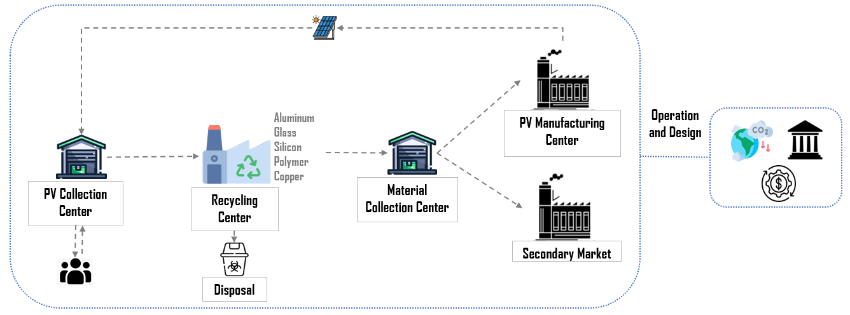
Figure 1. Schematic overview of the investigated PV recycling system
In response to the identified challenges, this study proposes a mathematical model based on an RTN representation, a unified framework for the representation and solution of process scheduling problems where resources and tasks are shown in an interconnected network to transform material and/or energy resources into other resources. The proposed model aims to determine tactical and operational decisions, including facility site, facility, capacity, route, and transport mode selections along with options for recycled materials, for the reverse supply chain network for PVs. Criteria such as cost, the complexities of regulatory compliance, incentives, and environmental considerations under different market settings such as cooperative and competitive environments can be considered in the model, which results in a mixed-integer program (MIP) using energiapy (Kakodkar et al., 2023), and the details of the model will be described in the following section.
      - Nomenclature
The nomenclature used in the rest of this section is outlined below.
Table 1: Sets
$$R$$ | Set of resources | $T$ Set of temporal periods
$$L$$ | Set of facility locations Ɩ | $F$ Set of transport modes ƒ
$$P$$ | Set of processes

Table 2: Parameters
$${Cap}_{l,p,t}^{max}, {Cap}_{l,p,t}^{min}$$ | Max and min production capacity of process p in location Ɩ at time t
$${Capex}_{l,p,t}$$ | Capital expenditure of process p in location Ɩ at time t
$${Vopex}_{l,p,t}$$ | Variable operational expenditure of process p in location Ɩ at time t
$${Price}_{l,r,t}$$ | Purchase Price for resource r in location Ɩ at time t
$${Revenue}_{l,r,t}$$ | Revenue obtained from sales of resource r in location Ɩ at time t
$${Demand}_{l,r,t}$$ | Demand for resource r in location Ɩ at time t
$${Distance}_{l,l'}$$ | Distance between location Ɩ and Ɩ’
$${conv}_{p,r}$$ | Conversion ratio of resource r in process p
$${Tcost}_{f}$$ | Transportation cost for transport mode f
$${TCap}_{f,r}^{max}$$ | Maximum transportation capacity of transport mode f for resource r
$${Tmode}_{f,l,l'}$$ | 1 if transport mode f is available between location Ɩ and Ɩ’

Table 3: Continuous and Binary Variables
Notation | Description | Notation |  | Description
$$P_{l,p,t}$$ | Production of process p in location l at time t | $$S_{l,r,t}$$ | Discharge of resource r in location l at time t
$$C_{l,r,t}$$ | Consumption of resource r in location l at time t
$${Cap}_{l,p,t}^{P}$$ | Installed production capacity for process p in location l at time t | $$x_{l,p,t}^{P}$$ |  | 1 if process p is chosen for location l at time t, 0 otherwise
$${Tr}_{f,l,l^{'},r,t}$$ | Amount of resource r transported by f from location l to l′ at time t | $$x_{f,l,l^{'},r,t}^{F}$$ |  | 1 if resource r is transported by f from location l to l’ at time t, 0 otherwise
      - Constraints
- Inventory balance: at every time period$tϵT^{sch}$, the amount of resource r produced and transported into location l needs to be equal to the amount discharged out of the l.
$$\begin{aligned}\sum_{pϵP}{P_{l,p,t} {conv}_{p,r}+C_{l,r,t}+\sum_{fϵF}{\sum_{l^{'}ϵLՈl}{{Tr}_{f,l,l^{'},r,t}=\sum_{fϵF}{\sum_{l^{'}ϵLՈl}{{Tr}_{f,l,l^{'},r,t}+ S_{l,r,t}}}}}} \left(1\right)\end{aligned}$$
- Production level cannot exceed capacity
$$P_{l,p,t} ≤ {Cap}_{l,p,t}^{P} ∀pϵP, tϵT^{sch } \left(2\right)$$

- Production capacity cannot exceed maximum capacity allowable
$${ Cap}_{l,p,t}^{P} ≤ {Cap}_{l,p,t}^{max}* x_{l,p,t }^{P}∀ lϵL, pϵP,tϵT^{sch } (3)$$

- Production capacity at time t cannot be lower than capacity at time t-1
$${ Cap}_{l,p,t}^{P} ≤ {Cap}_{l,p,t-1}^{P} ∀ lϵL, pϵP,tϵT^{sch } \left(4\right)$$

- Consumption of resource r cannot exceed the maximum availability of the resource
$$C_{l,r,t} ≤ C_{l,r,t}^{max} ∀ lϵL, rϵR,tϵT^{sch } (5)$$

- Amount of resource discharged cannot exceed the demand for that resource
$$\sum_{lϵL}{{Demand}_{l,r,t} ≥ \sum_{lϵL}{S_{l,r,t} ∀ rϵR, tϵT^{sch}}} (6)$$

- Amount of resource transported by transport mode f cannot exceed the capacity of f
$${ Tr}_{f,l,l^{'},r,t}≤ {Tr}_{f,r}^{max}*x_{f,l,l^{'},r,t}^{F} x_{l,p,t }^{P}∀ l,l^{'}ϵL, rϵR,tϵT^{sch}, fϵF (7)$$

      - Objective function
The objective of this problem is to create an optimal network design and schedule for the recycling of solar panels, with a focus on minimizing the overall cost, encompassing both capital and operational expenditures as well as transportation cost and raw material cost.
$$\begin{aligned}\min{\sum_{lϵL}{\left(\sum_{ tϵT^{net}}{\sum_{ pϵP}{{Capex}_{l,p,t}}}{Cap}_{l,p,t}^{P}\right)}}+\sum_{lϵL}{\left(\sum_{ tϵT^{sch}}{\sum_{ rϵR}{{Vopex}_{l,r,t}}}P_{l,r,t}\right)} \\ +\sum_{lϵL}{\sum_{fϵF}{\left(\sum_{ tϵT^{sch}}{\sum_{ l^{'}ϵL}{{Tcost}_{f} {Tr}_{f,l,l^{'},r,t}{ Distance}_{l,l'}}}\right)}}+\sum_{lϵL}{\left(\sum_{ tϵT^{sch}}{\sum_{ rϵR}{C_{l,r,t}}}{Price}_{l,r,t}\right)} \#(8)\end{aligned}$$

3. Case study
3.1. Setup
To illustrate the practical application of the proposed mathematical model formulation for decision-making in the PV recycling supply chain, a case study is presented based on the state of Arizona (see Figure 2). The study considers locations of different facilities within the PV recycling ecosystem: i) Collection Centers (CC1, CC2, CC3): These serve as primary points for collecting PV modules from end users, are strategically located based on the existing places of PV installment companies. ii) Recycling Centers (RC1, RC2, RC3): These are located across the state. iii) Central Manufacturing Center (MC): It acts as a potential purchaser for the recycled materials from these recycling centers to produce PV. iv) Aluminum Collection (AC) and Glass Collection (GC) Centers: These demonstrate additional demand sites for aluminum and glass.
Figure 2. Representation of PV Ecosystem in Arizona
Figure 3 shows the RTN representation of the PV recycling ecosystem, illustrating all potential connections between locations. Each collection center (CC1, CC2, and CC3) is strategically linked to three distinct recycling centers (RC1, RC2, and RC3), thereby offering a variety of options for processing PV waste. Three structured recycling technologies are considered in this case study. Within these designated recycling centers, one of three process technologies as FRELP, ASU, and Hybrid (Curtis et al., 2021) (referred to as P1, P2, and P3 in Figure 3), can be chosen and utilized for the recycling process. Each recycling center could operate at either low or high capacity, allowing for an exploration of the impact of economies of scale. The case study also investigates the recovery and reuse of specific materials such as glass and aluminum, focusing on down-cycling and recycling possibilities. Material collection centers (AC for aluminum and GC for glass) are designed as demand sites for aluminum and glass with low purity and economical prices, while the PV manufacturing center (MC) demands high-purity glass, aluminum, silver, silicon, polymer, and copper at higher costs to produce new PVs.

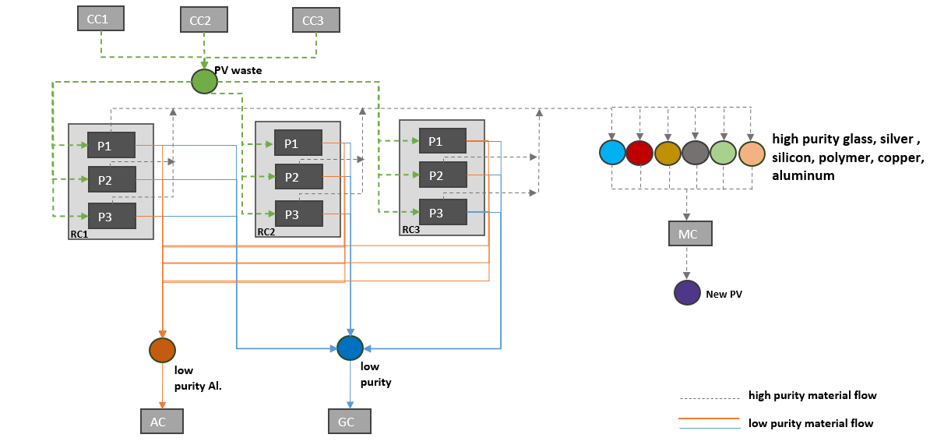
Figure 3. Superstructure representation of the PV recycling network
3.2. Results and Discussion
The results derived from the RTN model reveal that the locations RC2 and RC3 have been selected as the optimal recycling centers as depicted in Figure 4. RC2 is equipped with a high-capacity hybrid process, while RC3 operates a high-capacity FRELP process. These selections were made to achieve elevated production levels, which are based on the demand satisfaction for glass, aluminum, and new PV installments as well as price of the materials by minimizing the total cost involving capital, variable, and fixed costs.
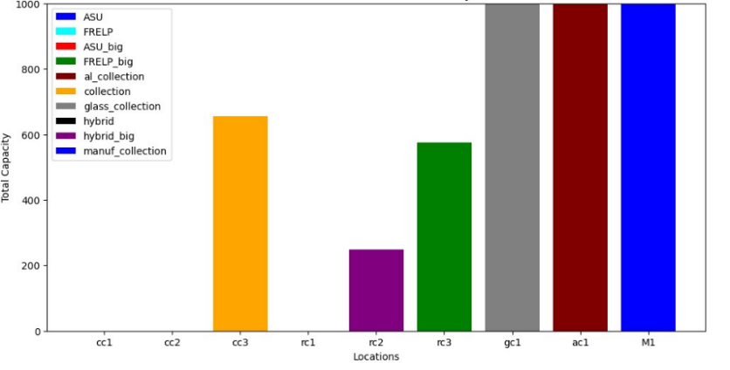

Figure 4. Total production capacity at each location by the selected process

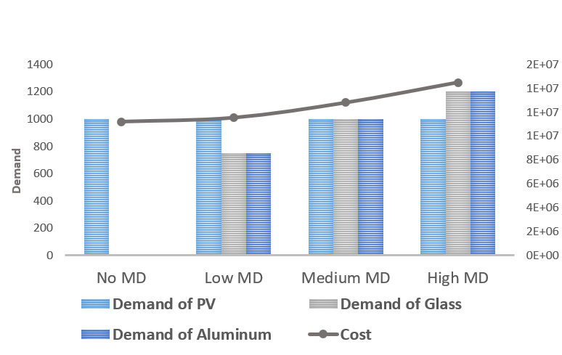
As represented in Figure 5, when the model is given the option to generate additional demand for certain materials (as glass and aluminum), even at a slightly lower selling price, the overall cost does not show a significant increase with the chosen facilities with the same design as shown in Figure 4. Different case studies are investigated including scenarios with no additional material demand (MD), as well as low, medium, and high demand for glass and aluminum, as shown in Figure 5. The findings show that the model helps maximize capacity utilization while minimizing cost for the increased material demand and leading to the efficient use of resources. Therefore, the model exhibits both optionality in its strategic selection of materials, and flexibility in its ability to adapt to varying demand levels without substantial additional costs. The model’s characteristics of optionality and flexibility align well with the principles of sensitivity analysis.
Figure 5. Demand vs Cost for different cases
  - Conclusion
Significant rise in solar PV panel installations and manufacturing brings the challenge of managing EoL PV panels. The key to a sustainable reverse supply chain network for solar PV panels lies in cost optimization efforts supported by enabling policies. In this work, a systematic decision-making modeling framework is proposed as a vital tool for examining different possibilities and scenarios for optimizing solar PV reverse supply chain networks. This framework allows for “what-if” analyses under various market conditions. It captures the dynamics between different components of the supply chain and aids in selecting the optimal location and technology. The RTN-based model is represented as a case study of such a framework, demonstrating its application and benefits in optimizing the reverse supply chain system under different scenarios.
Acknowledgments
This research was supported by the NSF Convergence Accelerator Program under the Grant titled “Securing Critical Material Supply Chains by Enabling Photovoltaic Circularity (SOLAR)” with Grant No49100423C0005. The authors also gratefully acknowledge support from Texas A&M University, Texas A&M Energy Institute.
References
S. Weckend, A. Wade, and G. A. Heath. End-of-life management: solar photo-voltaic panels. Technical report, IEA and International Renewable Energy Agency, 2016.
D. Bechtsis, N. Tsolakis, E. Iakovou, and D. Vlachos. Data-driven secure, resilient and sustainable supply chains: gaps, opportunities, and a new generalised data sharing and data monetisation framework. International Journal of Production Research, 60(14):4397–4417, 2022.
H. K. Salim, R. A. Stewart, O. Sahin, and M. Dudley. Drivers, barriers and enablers to end-of-life management of solar photovoltaic and battery energy storage systems: A systematic literature review. Waste Management, 537–554, 2019.
G. A. Heath, T. J. Silverman, M. Kempe et al. Research and development priorities for silicon photovoltaic module recycling to support a circular economy. Nature Energy, 5(7): 502–510, 2020.
R. Kakodkar, E. Pistikopoulos. Energiapy-an Open Source Python Package for Multiscale Modeling & Optimization of Energy Systems. AIChE Annual Meeting, 2023.
T. L. Curtis, H. Buchanan, G. Heath, L. Smith, and S. Shaw. Solar photovoltaic module recycling: A survey of US policies and initiatives. Technical report, NREL, US, 2021.

