Coupling Rule-based reasoning, Exergy analysis and Pinch analysis to optimize and improve the Energy efficiency of Processes
Noha-Lys Senoussaoui,ª Raphaële Théry Hétreux,ª Gilles Hétreux,ª
ªLaboratoire de Génie Chimique, Département PSI, 4 allée Emile Monso, 31432 Toulouse CEDEX 4, France
nohalys.senoussaoui@toulouse-inp.fr
Abstract
Global efforts target carbon neutrality by 2050, with a focus on Carbon Capture Utilization and Storage in industries like, for example, methanol production. While sustainability analysis like exergy analysis lacks practical solution proposals, integrating artificial intelligence allows to bridges this gap. The COOPERE approach combines pinch analysis, exergy analysis and optimization for the design and retrofit of processes. This study applies COOPERE to a methanol production process with CO₂ recovery, and highlighting the strength of the rule-based reasoning tool in suggesting improvements. COOPERE significantly reduces energy and electric consumption, offering economic benefits with initial investments.
Keywords: Rule-based reasoning, Exergy analysis, Energy integration, Superstructure optimisation, decarbonation.
  - Introduction
Efforts worldwide to combat climate change, like Europe's Fit for 55 plan, aim for carbon neutrality by 2050 (European Commission, 2019). In the industrial sector, Carbon Capture Utilization and Storage (CCUS) technologies are being explored, such as for methanol production processes (Nami et al., 2019). In addition, the implementation of innovative and conceptual approaches stands as a key to the emergence of more sustainable and sober production paths. Innovative approaches like pinch analysis, life cycle assessment, and exergy analysis already enhance sustainability (Bachmann et al., 2023; Blumberg et al., 2017; Kemp, 2011). However, these approaches while insightful, often lacks practical improvement solutions and usually relies on engineer’s expertise. The integration of artificial intelligence (AI), discussed by (Venkatasubramanian, 2019), addresses this gap for chemical engineering. The COOPERE approach was developed at the Toulouse Chemical Engineering Laboratory by (Gourmelon et al., 2017) to associate pinch analysis, exergy analysis and optimization to propose retrofitted process structures. To fill the gap between diagnosis and practical solutions, a case-based reasoning was first introduced, but has proven its limits because of its inability to express general knowledge. Moreover, case based reasoning requires an extensive cases database which is difficult to build when there is only a scarce number of relevant cases (Prentzas and Hatzilygeroudis, 2007). A Rule based expert systems (RBES) seems to be a more suitable approach as it could lead to the intuitive application of the appropriate set of heuristics to a given defect. This paper demonstrates the COOPERE approach's application to a methanol production process presented by (Yang et al., 2018), emphasizing the role of the developed rule-based reasoning tool in suggesting improvements.
  - Principle of the COOPERE method
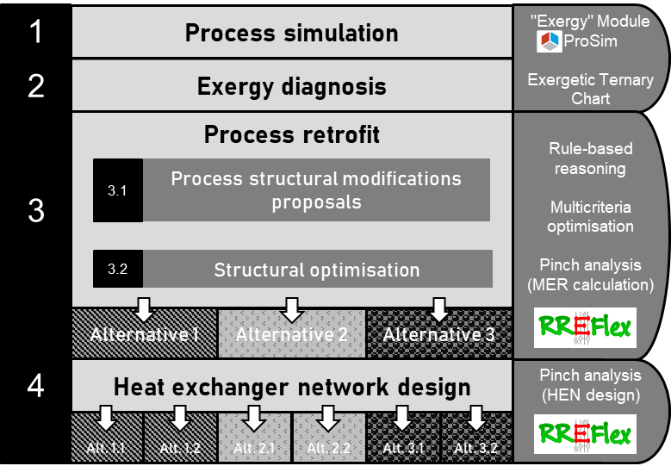
The COOPERE method supports the engineer in the retrofit or the design of energetically efficient chemical processes. This approach is divided in four steps as in Figure 1. (1) First, data is collected and a process simulation is built on ProSimPlus, a flowsheeting software that proposes automatic energy and exergy balance on any simulated process (Gourmelon et al., 2014). (2) Then, the exergy analysis of the process is carried out and the exergy ternary diagram is displayed to pinpoint the most critical exergy losses in the process. (3) Based on this exergy diagnosis, the process retrofit is performed. Solutions for improvement are proposed for each operation or set of operations using a RBES knowledge base that was recently introduced. These improvement suggestions consisting of a set of structural modifications and ranges for operating parameters are combined to build a process superstructure. This superstructure enables the user to get an overall view of the suggested solutions for each part of the process. To determine the set of alternative scenarios combining solutions that fit best together, a multicriteria multivariable optimization is performed using a MIDACO optimization algorithm embedded on the ProSimPlus simulator. This solver is able to solve multiobjective MINLP relying on an extended evolutionary Ant Colony Optimization and the Oracle Penalty Method, enabling to find a global optimum. (4). Lastly, a heat exchanger network is designed for each alternative process proposed, then ensuring a compromise between economic viability and heat recovery.
Figure 1: The COOPERE approach to improve the energy efficiency of processes

  - Presentation of the process
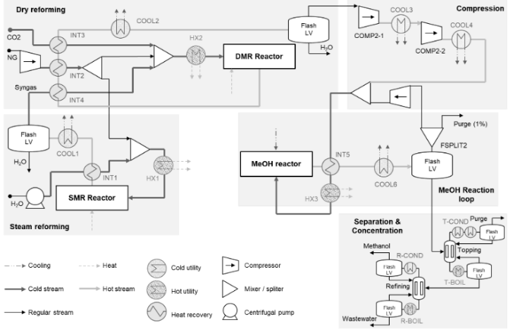
The investigated process, depicted in Figure 2, involves the production of methanol (MeOH) and was detailed by (Yang et al., 2018). To reduce CO₂ footprint of the process, they introduced an original parallel-series methane reforming reactors configuration. This configuration enables to optimize syngas production by incorporating a proper amount of carbon monoxide (CO). This, enhances the conversion of CO₂ in the methanol reaction loop. The process comprises two reactors: the first operates independently for steam methane reforming (parallel part), and its products are then introduced as reactants into the second reactor (series part) for dry methane reforming. (Yang et al., 2018) reported a significant improvement in carbon efficiency, increasing from 93.34% to 97.35%, and a decrease in the total annual cost compared to their reference scenario. However, the overall energetic performance of the process remained unexplored. To address this gap, the present article aims to investigate the system's energy efficiency using the COOPERE method. The goal is to identify and rectify potential irreversibilities, ensuring that any improvements do not compromise the process's energy consumption.
Figure 2: Schematic diagram of the methanol production process (Yang et al., 2018)
  - Analysis of the methanol process using the COOPERE approach
    - Step 1: Process simulation
The process proposed by (Yang et al., 2018) is replicated and enriched in ProSimPlus. For the sake of this study, a generic “input-output” integration is implemented for all reactors of the process in order to give more industrial relevance to the system, since the original process does not show any form of heat integration. Furthermore, hot and cold utility stream have been introduced in the model. Specifically, utilities consist in fumes from a natural gas-fuelled furnace at 1850 °C, and cold river water at 18 °C. Intermediate heat carrier fluids are also introduced in closed loops such as high-pressure steam (280 °C, 60 bar) and R134a refrigerant (-21.4 °C, 1 bar).
    - Step 2: Exergy diagnosis
The exergy analysis performed in the COOPERE approach (Gourmelon et al., 2017) relies on a form of exergy balance that focuses on the effective transformation of exergy on the considered system (see Eq. (1)).
$$ΔB^{consumed}=ΔB^{produced}+B_{out}^{M,waste}+I$$ | (1)
Dividing each side of Eq. (1) by $ΔB^{consumed}$ , we obtain the final formulation in Eq. (2) that enable to locate a representative point of each process section on an Exergy ternary diagram.
$$1=IE+IW+II$$ | (2)
The diagram of Figure 3 acts as a radiography of the process. The closer a dot is to the intrinsic efficiency vertex IE, the more efficient the related sector is. Operations close to the intrinsic irreversibility vertex II suffer from non-optimal operational parameters, while sections close to the intrinsic waste vertex IW illustrate the presence of waste streams that could be recovered or be mechanically, chemically or thermally recovered. The size of each dot represents the amount of global exergy loss (i.e., irreversibility and waste) relatively to the whole process. Of course, every process section has been studied. This contribution will however only focus on the retrofit of the Separation & Concentration (Sep. & Conc.) section as it is the least efficient one.
    - Step 3: Process retrofit
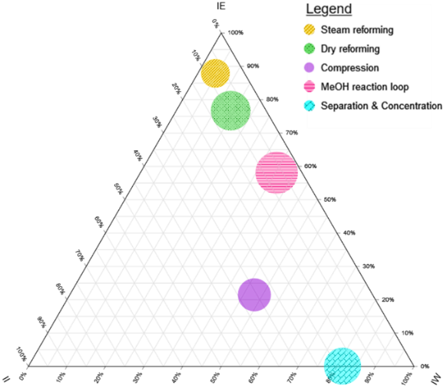
The COOPERE RBES tool aims to mimic the expert reasoning and to suggest structural improvement relying on the ternary exergy diagram analysis. Figure 4 displays the forward chaining reasoning based on the expert’s knowledge and analysis of the ternary chart; the RBR thus applied on the Sep. & Conc. section leads to the following improvement proposals. The high value of IW in this section is caused by: (a) utility that is release to the environment, (b) the purge of the first distillation’s column gas distillate and (c) the second distillation column’s wastewater. To reduce the IW (a), Pinch Analysis will be performed during Step 4 and then reduce the use of hot utility. The IW (b), mainly composed of chemical exergy, suggests to burn purged gas to produce combustion fumes, thus saving on hot utility. The IW (c) is a rich in methanol (48 % mol.) and could be recovered by installing another distillation column. The high value of II is caused by (d) heat exchangers, displaying a large difference between hot and cold streams that could be reduced by improving the Heat Exchanger Network, and (e) a pressure valve, which shifts the inlet stream pressure from 78 bar to 5 bar. A turbine would significantly improve the exergy efficiency. The proposed alternatives are thus compiled and added in the nominal process to end up with the process superstructure displayed in Figure 5.
Figure 3: Exergetic ternary diagram of the methanol production process based on natural gas and recovered CO₂

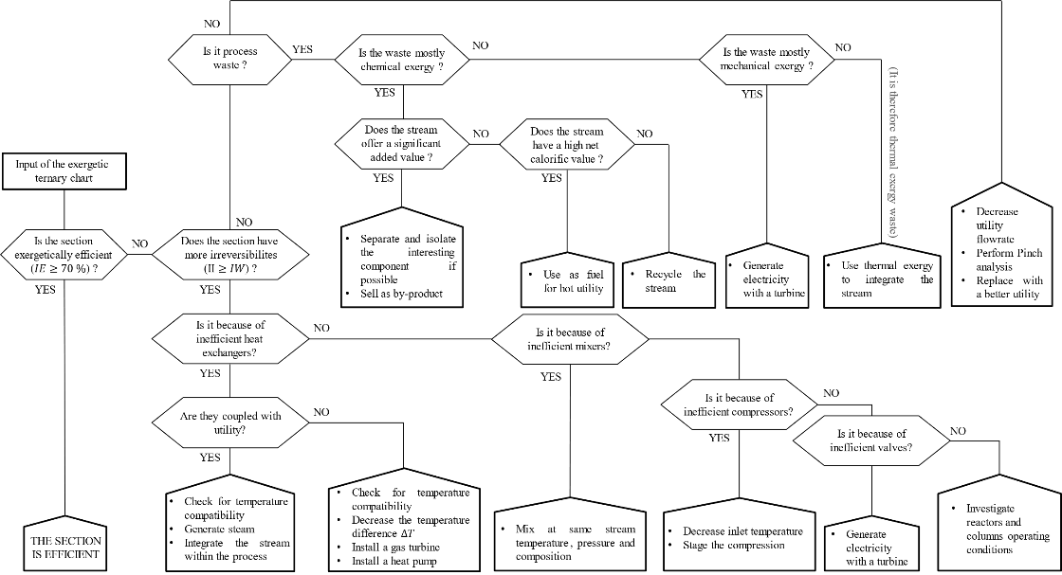
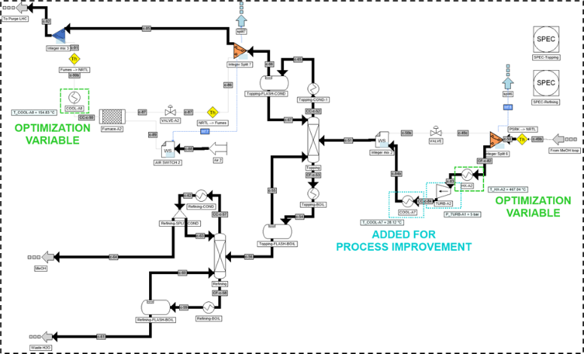
The MIDACO optimization, using both operational (real) and structural (integer) variables, lead to several optimal alternate scenarios that include suggested modifications. In our approach, we chose to maximize the process integrability and to minimize the required mechanical work. The optimization leads to a Minimal Hot Utility requirement, Minimal Cold Utility requirement and Minimal Work respectively equal to 19,975 kW, 149,525 kW and 44,973 kW. Table 1 summarizes the technical changes that were implemented in Figure 2 to reach the previously stated results.
Figure 4: Heuristics turned into a chain of questions
Figure 5: ProSimPlus superstructure simulation of the Separation & Concentration section
Table 1: Improved process new parameters and design details
Section | Layout | Description
Compression | 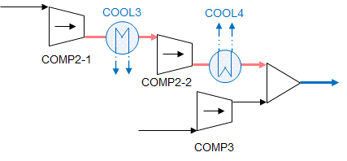 | Optimisation results in modifying $P_{COMP2-1}$ from 6 bar to 10.5 bar and $T_{COOL3}$ from 57.3 °C to 69.1 °C  Non-variable optimisation changes $T_{COOL4}$ from 115.8 °C to 30.0 °C to perform isothermal mixing
MeOH reaction loop | 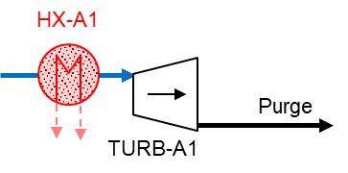 | Exchanger-turbine sequence added to both recover the purge’s mechanical exergy, and preheat the turbine inlet stream to introduce a new cold stream to the process  Optimisation results in setting $T_{HX-A1}=467.8 °C$ and $P_{TURB-A1}=67.4 bar$
Separation & Concentration | 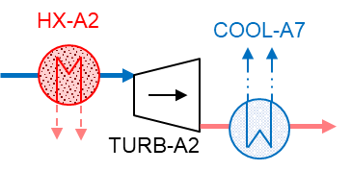 | Exchanger-turbine-exchanger sequence added on stream input of the Topping column to replace a pressure valve.  Optimisation results in setting $T_{HX-A2}=467.0 °C$  Process specifications gives $P_{TURB-A2}=5 bar$ and $T_{COOL-A7}=28.1 °C$
    - Step 4: Heat exchanger network design
In this last step, the improved scenario goes under a pinch analysis to determine an optimized heat exchanger network that includes all newly generated streams. The design of this network aims to get as close as possible to the Minimum Energy Requirement (MER). This step is performed using RREFlex, a software developed in Toulouse Chemical Engineering Laboratory (ADEME, 2020).

Table 2: Process comparison between the nominal case and the integrated improved case
Process | Nominal process consumption
 | Hot Utility (kW) | Cold Utility (kW) | Total Work (kW)
Reference | 232,744 | 323,629 | 64,340
Improved | 144,174 | 273,723 | 44,973
Table 2 displays the energy savings achieved thanks to the COOPERE method. Finally, the use of COOPERE approach enabled to save 38.1 % of hot utility, 15.4 % of cold utility and 30.1 % of work.
  - Conclusions
The COOPERE approach enables a significant reduction of energy and electric consumption thanks to the combination of complementary analyses, paving the way to a new economic profitability, provided that necessary investments are initially done. Greater results can be reached through a study extended to the whole process. Efforts should however be carried on the description of complex unit operations’ exergy balance, such as reactors, which were not regarded in this study but is talked in a research project entitled ANR NACREE. The question of a proper recovery of chemical exergy should be investigated further. Perspectives include the formulation of new rules based on other relevant process graphical representation such as the Grand Composite Curve.
References
ADEME, 2020. Synthèse de réseaux d’échangeurs de chaleur flexibles - Développement d’un outil de reconfiguration totale ou remodelage partiel du réseau existant [WWW Document]. La librairie ADEME.
M. Bachmann, S. Völker, J. Kleinekorte and A. Bardow, 2023. Syngas from What? Comparative Life-Cycle Assessment for Syngas Production from Biomass, CO2, and Steel Mill Off-Gases. ACS Sustainable Chem. Eng. 11, 5356–5366.
T. Blumberg, T. Morosuk and G. Tsatsaronis, 2017. Exergy-based evaluation of methanol production from natural gas with CO2 utilization. Energy 141, 2528–2539.
European Commission, 2019. Going climate-neutral by 2050: a strategic long term vision for a prosperous, modern, competitive and climate neutral EU economy. Publications Office of the European Union, LU.
S. Gourmelon, R. Thery Hetreux and P. Floquet, 2017. A systematic approach: Combining process optimisation exergy analysis and energy recovery for a better efficiency of industrial processes. International Journal of Exergy 23, 298.
S. Gourmelon, R. Théry Hétreux, P. Floquet, P. Baudet and O. Baudouin, 2014. Premises for a combined Exergy and Pinch Optimization within ProSimPlus® simulator. Computer Aided Chemical Engineering 33, 1507–1512.
I. C. Kemp, 2011. Pinch Analysis and Process Integration: A User Guide on Process Integration for the Efficient Use of Energy, 2nd edition. ed. Butterworth-Heinemann.
H. Nami, F. Ranjbar and M. Yari, 2019. Methanol synthesis from renewable H2 and captured CO2 from S-Graz cycle – Energy, exergy, exergoeconomic and exergoenvironmental (4E) analysis. International Journal of Hydrogen Energy 44, 26128–26147.
J. Prentzas and I. Hatzilygeroudis, 2007. Categorizing approaches combining rule-based and case-based reasoning. Expert Systems 24, 97–122.
V. Venkatasubramanian, 2019. The promise of artificial intelligence in chemical engineering: Is it here, finally? AIChE Journal 65, 466–478.
Y. Yang, J. Liu, W. Shen, J. Li and I.-L. Chien, 2018. High-efficiency utilization of CO2 in the methanol production by a novel parallel-series system combining steam and dry methane reforming. Energy 158, 820–829.

