Applicability of Energy Storage for Mitigating Variability of Renewable Electricity Considering Life cycle Impacts
Ayumi Yamaki ª, Shoma Fujii ª, Yuichiro Kanematsu ^{b}, Yasunori Kikuchi*^{a,b,c}
ª Institute for Future Initiatives, The University of Tokyo, 7-3-1 Hongo, Bunkyo-ku, Tokyo 113-8654, Japan
^{b} Presidential Endowed Chair for "Platinum Society", Organization for Interdisciplinary Research Project, The University of Tokyo, 7-3-1 Hongo, Bunkyo-ku, Tokyo 113-8656, Japan
^{c} Department of Chemical System Engineering, The University of Tokyo, 7-3-1 Hongo, Bunkyo-ku, Tokyo 113-8656, Japan
ykikuchi@ifi.u-tokyo.ac.jp
Abstract
To achieve carbon neutrality, power generation from variable renewable energy (VRE) has been accelerated. VRE variability can be mitigated by installing energy storage. This study aims to evaluate life cycle impacts of an energy storage system with battery, H₂ storage, or thermal energy storage. A model of the energy storage system with VRE was constructed and the annual energy flow was simulated. The energy storage system targeted in this study assumed that all the energy derived from VRE was stored in the energy storage and supplied to consumers. The amount of power to-be-sold from the energy storage system based on the VRE and the energy storage installation were calculated. A life cycle assessment was performed to evaluate the greenhouse gas (GHG) emissions, abiotic resource depletion (ARD), and intensity of GHG and ARD as life cycle impacts. The smallest life cycle impacts varied depending on the type and amount of energy storage. A quantitative evaluation of the energy supply capacity and the environmental impacts of the energy storage system could assist in designing an energy storage system with VRE, considering regional energy supply systems.
Keywords: battery, hydrogen storage, thermal energy storage, life cycle greenhouse gas emissions, abiotic resource depletion
  - Introduction
The installation of variable renewable energy (VRE) has expanded around the world toward the achievement of a sustainable society, although ensuring a stable power supply by power generation from VRE is a challenge because of lack of stability. To accelerate VRE penetration, there are projects underway to install energy storage, such as batteries, hydrogen (H₂) storage, and thermal energy storage (TES). Batteries store electricity, whereas H₂ storage and TES should be converted into electricity before use. Therefore, batteries can supply electricity more effectively than H₂ storage or TES. However, battery production has a relatively high environmental impact (Peters et al., 2017) and batteries require relatively high investment costs for long-term storage (Battke et al., 2013). Life cycle assessments (LCAs) of other energy storage methods have been conducted (Strazza et al., 2015, Oró et al., 2012). Because the environmental impacts of energy storage differ according to the characteristics of the region where the energy storage is installed, even for installing the same type and amount of energy storage (Yamaki et al., 2023), a model is needed to compare energy storage considering energy demand and the VRE characteristic of the region.
This study constructed a model of energy storage systems assumed to be required for batteries, H₂ storage, or TES; the systems were compared by LCA. An energy storage system is installed as a new energy supply system to mitigate the variability of VREs and connect to the grid. An energy storage system with the battery, H₂ storage, and TES is referred to as a battery system, H₂ system, and TES system, respectively. The model of the energy storage system was constructed to simulate the energy flows for a one-year period. We calculated the amount of power that would be sold from the energy storage system and analyzed life cycle impacts. For life cycle impacts, life cycle greenhouse gas (LC-GHG), abiotic resource depletion (ARD), and greenhouse gas (GHG) and ARD intensities were evaluated. We discuss the applicability of energy storage systems.
  - Materials and methods
    - Energy and material flows of the energy storage system
The energy and material flow of the energy storage systems targeted in this study is shown in Figure 1. In energy storage systems, VRE is assumed to be stored and supplied as electricity. In the battery system, electricity is assumed to be generated by a VRE, stored, and supplied. In the H₂ system, H₂ is assumed to be produced by electrolyzers using VRE electricity, stored as liquefied H₂ in a tank, and converted into power in fuel cells. In the TES system, heat is generated directly from VRE, stored in molten salts, and converted into steam in a heat exchanger for power generation in steam turbines.
An LCA was conducted for the cradle-to-grave energy storage and other facilities, assumed to have a new energy storage system installed. The LCA covered the facilities of power/heat generation from VRE, the battery in the battery system, the H₂ tank, electrolyzer, and fuel cell in the H₂ system and the molten salt, its tanks, heat exchanger, and steam turbine in the TES system. The functional unit was the annual VRE instability. The foreground data for the LCA was obtained through energy flow simulations. The background data, such as materials for the energy systems, were extracted from the Japanese LCA database, the inventory database for environmental analysis version 3.2 (IDEA) (AIST, 2019). LC-GHG and ARD were calculated by adding the GHG emission and ARD from production to disposal of each facility extracted from the data, respectively. The GHG and ARD intensities were expressed in LC-GHG and ARD per power to be sold. Although GHG emissions are reduced by VRE installation, ARD would increase due to rare metal utilization in the production of energy storage. Therefore, it is important to evaluate both GHG emissions and ARD.
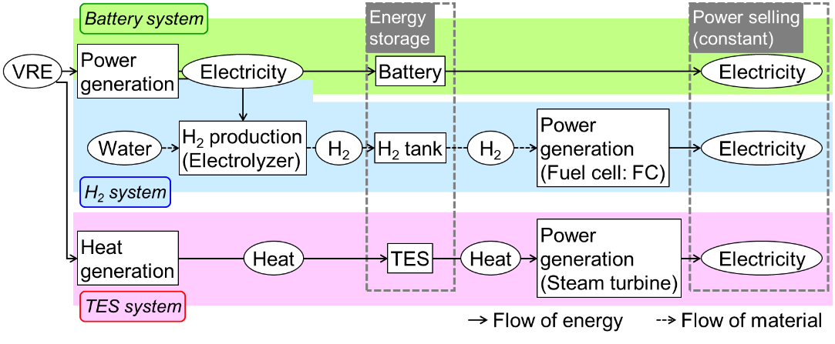
Figure 1 Energy and material flows of the energy storage systems.
    - Model of the energy storage systems
The model constructed in this study assumed that all VRE-derived energy was stored in energy storage and supplied electricity to consumers. The simulations were performed in Microsoft Excel. The energy flow was calculated hourly from 0:00 on January 1st to 24:00 on December 31st based on the model made by Yamaki et al. (2020). Life cycle impacts were calculated from the amount of energy storage and wind installation.
The amounts of energy storage and VRE installation were set, and then the maximum amount of power to be sold from the energy storage system was estimated. In the simulation, the stored energy was calculated hourly from the charge of VRE-derived power/heat and the discharge of power to be sold using Eq. (1).
$$Q_{storage}\left(t\right)=Q_{storage}\left(t-∆t\right)+Q_{in}\left(t\right)-Q_{out}\left(t\right)-Q_{leakage}\left(t\right)$$ | (1)
Here, Q_{storage}(t) is stored energy in the targeted energy storage at time t. Q_{in}(t) is input energy supplied from VRE, and Q_{out}(t) is output energy from the energy storage, which is calculated from the amount of power sales. Q_{leakage}(t) is energy leakage from energy storage, i.e., battery self-discharge, H₂ leakage, and heat leakage. The amount of power sales is adjusted to occur in periods of zero Q_{storage}, and the power sales value represents the maximum that the targeted energy storage system could sell. This study presents the value of power to be sold as a result of power sales. To supply electricity for more than one year, it was assumed that the amount of stored energy, i.e., the amounts of electricity in the battery, H₂ in the H₂ tank, and the temperature and amount of molten salt in the TES tank, were the same at 0:00 on January 1st and at 24:00 on December 31st.
    - Analysis settings
In energy flow simulations, wind energy was assumed to be delivered as a type of VRE. Facilities for power/heat generation from wind energy are assumed to be installed as wind turbines (WTs) or wind-thermal energy converters (WEC_{th}). A WEC_{th} directly converts wind-derived rotational energy into thermal energy (Okazaki et al., 2015).
In the battery system, the number of battery cells was assumed to be two. Cells were assumed to be incapable of charging and discharging simultaneously. In the H₂ system, the capacity of the electrolyzer was determined based on the capacities of the WT and the H₂ tank. When sufficient WTs and an H₂ tanks are installed, the electrolyzer capacity is assumed to be equal to the WT capacity. When a small H₂ tank is installed, it might not be able to store all the H₂ generated from WTs, so the electrolyzer capacity is limited to a scale that could produce the amount of H₂ that could be stored in the small H₂ tank. To avoid low-load operation, the electrolyzer was assumed to produce H₂ when power generation exceeded 50% of the electrolyzer capacity. For the installation of the 100.8 MW-WT, H₂ was assumed to be produced when generating power over 50.4 MW because the electrolyzer was 100.8 MW. If large volumes of H₂ are to be produced, several electrolyzers are assumed to be installed, configuring the total capacity of the electrolyzers.
The energy conversion rate was assumed to be fast enough to operate the energy storage system. In this study, all the wind energy input for one hour was assumed to be converted into the target energy, such as H₂ and heat, in one hour. Also, H₂ and heat were assumed to be converted into power depending on the amount of power sales.
  - Results and discussions
    - Power sold from the energy storage systems
The energy flows of the energy storage systems were simulated, and the power to be sold was calculated for various amounts of WT/WEC_{th} and energy storage. The maximum amount of power to be sold from the energy storage system was calculated when the amount of energy storage and WT/WEC_{th} installation were set.
The amount of power to be sold was assumed to be constant throughout the year. Regardless of the type of energy storage, the amount of power to be sold increased as the amount of WT/WEC_{th} and energy storage installed increased (Figure 2). However, if the large energy storage facilities were installed, the power sales increased slightly or decreased. In the case of the TES system in particular, the molten salt stored in the cold tank also releases heat due to its temperature of 290 °C. If an excessive TES was installed, the excess molten salt stored in the cold tank released heat, resulting in a decrease in the amount of power to be sold. Therefore, to use stored energy effectively, the amount of energy storage should be installed in proportion to the amount of WT/WEC_{th} installation.
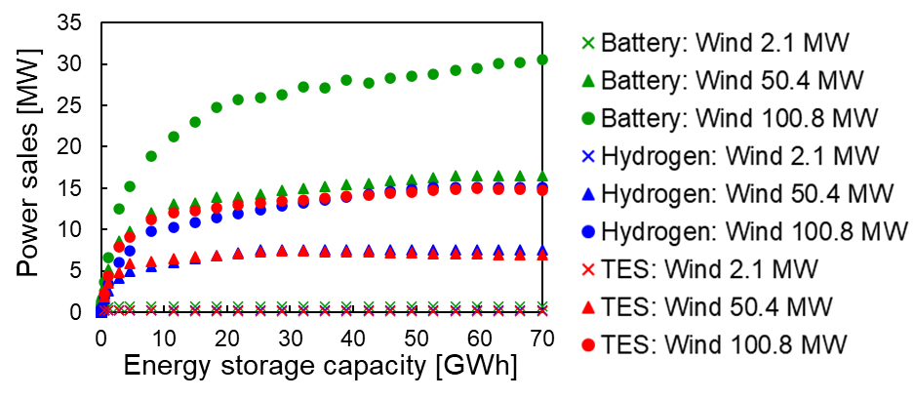
Figure 2 Power sold from the energy storage system.
    - Life cycle impacts of the energy storage systems
Life cycle impacts were evaluated for various amounts of WT/WEC_{th} and energy storage. The GHG and ARD intensities are shown in Figure 3. LC-GHG and ARD were considered from production to disposal of WT/WEC_{th}, energy storage, and other utilities. Other utilities included an electrolyzer and fuel cell in the H₂ system and a steam turbine and heat exchanger in the TES system. The GHG and ARD intensities were calculated from LC-GHG and ARD and expressed per power sales.
GHG intensities were compared in Figure 3 (a). In all systems, GHG intensities were high with small energy storages due to the large impact of WT/WEC_{th} production. When a few large energy storage facilities were installed, GHG intensities decreased because the amount of power sold increased. When excess energy storage facilities were installed, GHG intensities were high due to high GHG emissions from the production of energy storage facilities. For the H₂ system, in particular, although it showed the lowest GHG intensity with large energy storage in the three systems, it showed the highest GHG intensity with small energy storage. This is because GHG emissions from the production of the electrolyzer, which increased in scale with the WT installation, increased in order to use the wind-derived electricity for H₂ production. Therefore, even with smaller H₂ tanks, the GHG intensity was higher when a large WT was installed. In addition, when H₂ production increased due to a large H₂ tank, GHG emissions from liquefied H₂ were high. When WT/WEC_{th} was installed at 100.8 MW, the minimum GHG intensities were 0.42 kg-CO₂eq/kWh for a battery of 1.1 GWh, 0.34 kg-CO₂eq/kWh for 53 GWh-H₂ storage, and 0.17 kg-CO₂eq/kWh for 2.9 GWh-TES.
The ARD intensities of the energy systems are shown in Figure 3 (b). Like the GHG intensities, ARD intensities were high with small or excess large energy storage, but they were low with appropriate capacity of energy storage. However, ARD from the operation, such as H₂ liquefied, was low, so ARD from the production of the electrolyzer in the H₂ system, WT/WEC_{th}, and energy storages had a high impact. When WT/WEC_{th} was installed at 100.8 MW, the minimum ARD intensities were 0.011 g-Sbeq/kWh for 2.9 GWh-battery, 0.027 g-Sbeq/kWh for 53 GWh-H₂ storage, and 0.0066 g-Sbeq/kWh for 2.9 GWh-TES.
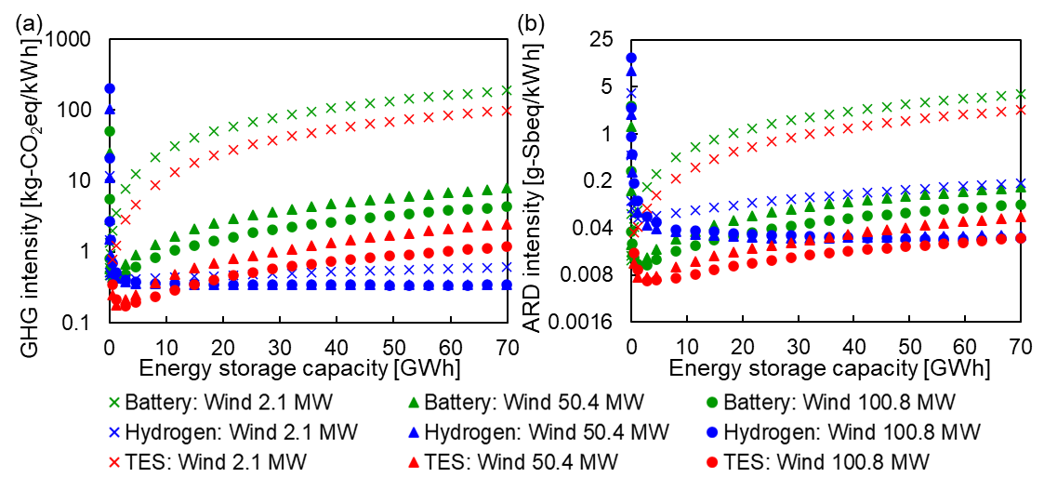
Figure 3 Life cycle impacts of the energy storage system. (a) GHG intensity for power sales. (b) ARD intensity for power sales.
    - Applicability of the energy storage systems
When a large WT/WEC_{th} and energy storage was installed, the H₂ or TES systems seemed to be suitable because of their smaller life cycle impacts than batteries. There was a trade-off between the H₂ and TES systems because the H₂ system had a lower GHG intensity, whereas the TES system had a lower ARD intensity. To decide whether to install an H₂ storage or TES, it is important to consider the demand for H₂ and heat in the region where the energy storage system is to be installed. H₂ is used as fuel for vehicles and materials for factories, and heat is used as an energy source for factories and houses. This study enabled a quantitative evaluation of the environmental performance of the energy storage system, including its operation, and detailed energy storage system installation plan.
In areas where the energy storage system is installed, life cycle impacts can be reduced and prevent from blackouts of conventional power plants due to natural disasters. Furthermore, installing new equipment, such as energy storage, would create employment opportunities to operate the energy storage systems, stimulate the local economy, and promote regional revitalization. Therefore, energy storage systems have many types of applicability, such as contributing to carbon neutrality and revitalizing the region.
In this study, the installed energy storage systems covered only one type of energy storage and the amount of power sales were constant. In addition, all facilities were assumed to be disposed of without recycling. The energy storage system has the possibility of improvement through recycling of the energy storage (Kikuchi et al., 2021) and operation change. Although optimizations are not enough to operate an energy storage system, in this study, low environmental impacts and efficient energy storage systems were expected to be designed by applying the simulation conducted here.
  - Conclusions
In this study, we developed a model of energy storage system installing VRE and conducted annual energy flow simulations and LCA. The amount of power sold and life cycle impacts of the energy storage systems were evaluated, and the smallest ones varied with the type and amount of energy storage. When WT/WEC_{th} was installed at 100.8 MW, the minimum GHG intensity was 0.17 kg-CO₂eq/kWh for 2.9 GWh-TES, and the minimum ARD intensity was 0.0066 g-Sbeq/kWh for 2.9 GWh-TES. The energy storage installed in a region should be selected based on the amount of power to be sold, i.e., the energy demand in the region, because the amount of power sold and the minimum GHG and ARD intensities differ depending on the type of energy storage.
Improvements in energy storage technology and its operation to accommodate the unstable nature of VRE could lead to more effective use of energy storage systems. Energy storage systems are expected to have many types of applicability, such as contributing to carbon neutrality and revitalizing the region. This study was able to quantitatively evaluate the environmental performance of energy storage systems, including their operation. Appropriate energy storage systems are expected to be designed by applying the simulation conducted in this study.
Acknowledgement
This study was financially supported by the New Energy and Industrial Technology Development Organization (NEDO) (Grant number, JPNP21026). This research contained the achievements of the JST-MIRAI Program Grant Number JPMJMI19C7, JST COI-NEXT (JPMJPF2003), JST PRESTO (Grant Number JPMJPR2278), JSPS KAKENHI (Grant Number JP21H03660), JSPS KAKENHI Grant-in-Aid for Early-Career Scientists (Grant Number JP22K18061), and the Environment Research and Technology Development Fund (Grant Number JPMEERF20213R01) of the Environmental Restoration and Conservation Agency of Japan. Activities of the Presidential Endowed Chair for “Platinum Society” at the University of Tokyo are supported by Mitsui Fudosan Corporation, Sekisui House, Ltd., the East Japan Railway Company, and Toyota Tsusho Corporation.
References
AIST (National Institute of Advanced Industrial Science and Technology), 2019, Inventory Database for environmental analysis version 2.3
B. Battke, T. S. Schmidt, D. Grosspietsch,V. H. Hoffmann, 2013, A review and probabilistic model of lifecycle costs of stationary batteries in multiple applications, Renew Sustain Energy Rev, 25, 240–250
Y. Kikuchi, I. Suwa, A. Heiho, Y. Dou, S. Lim, T. Namihira, K. Mochidzuki, T. Koita, C. Tokoro, 2021, Separation of cathode particles and aluminum current foil in lithium-ion battery by high-voltage pulsed discharge Part II: Prospective life cycle assessment based on experimental data, Waste Manag, 132, 86–95
T. Okazaki, Y. Shirai, T. Nakamura, 2015, Concept study of wind power utilizing direct thermal energy conversion and thermal energy storage, Renew Energy, 83, 332–338
E. Oró, A. Gil, A. de Gracia, D. Boer, L. F. Cabeza, 2012, Comparative life cycle assessment of thermal energy storage systems for solar power plants, Renew Energy, 44, 166–173
J. F. Peters, M. Baumann, B. Zimmermann, J. Braun, M. Weil, 2017, The environmental impact of Li-Ion batteries and the role of key parameters – A review, Renew Sustain Energy Rev, 67, 491–506
C. Strazza, A. Del Borghi, P. Costamagna, M. Gallo, E. Brignole, P. Girdinio, 2015, Life Cycle Assessment and Life Cycle Costing of a SOFC system for distributed power generation, Energy Convers Manag, 100, 64–77
A. Yamaki, S. Fujii, Y. Kanematsu,Y. Kikuchi, 2023, Life cycle greenhouse gas emissions of cogeneration energy hubs at Japanese paper mills with thermal energy storage, Energy, 270, 126886
A. Yamaki, Y. Kanematsu,Y. Kikuchi, 2020, Lifecycle greenhouse gas emissions of thermal energy storage implemented in a paper mill for wind energy utilization, Energy, 205, 118056

