Determining competition between LCA environmental impact categories through MILP single objective optimization - A case study on green hydrogen
Diego Larrahondo Chavez*^{a,b} , Catherine Azzaro-Pantel^{b} , Florent Montignacª , Alain Rubyª
ªUniv. Grenoble Alpes, CEA, Liten, DTCH, 38000 Grenoble, France
^{b}Laboratoire de Génie Chimique, Université de Toulouse, CNRS, INPT, UPS, Toulouse France *diego.larrahondochavez@cea.fr
Abstract
As the world faces the urgent need for sustainable energy solutions, understanding and mitigating the environmental impact of energy systems is critical. This involves considering several environmental factors, some of which may compete with each other, by either antagonism, correlation or co-benefit. This study presents a methodology, based on single objective optimization using mixed-integer linear programming (MILP). Its aim is to comprehensively assess and optimize various environmental impact categories derived from life cycle assessment (LCA) within energy systems, with the goal of minimizing them individually. The case study of a green hydrogen supply chain illustrates the proposed methodology using the PERSEE tool, developed at CEA. The results showed that minimizing climate change impact category could generate substantial co-benefits in areas related to energy resources and other impacts. However, conflicts might arise with other impacts, such as land use. Additionally, the study identified a high correlation between certain impacts such as land use and material resources. These outcomes can significantly facilitate downstream processes, including multi-objective optimizations and decision-making, for the deployment of hydrogen ecosystems.
Keywords: Optimization, LCA, MILP, Hydrogen
  - Introduction
As the quest for sustainable energy systems progresses, the interplay between technology, economics and the environmental impact of these systems requires a holistic understanding. Energy system simulation plays a key role in modeling and analyzing the intricate interactions of complex energy infrastructures. In addition, integrating Life Cycle Assessment (LCA) into the simulation of energy systems enables the quantification of environmental impacts throughout their entire life cycle. This sheds light on the overall ecological footprint, rendering it an indispensable tool for informed decision-making in strategies for transitioning energy.
In the field of energy systems, considering various categories of environmental impacts is increasingly essential. These impacts extend beyond carbon emissions, providing a comprehensive perspective of the environmental footprint associated with energy production. For example, eutrophication underscores the need to minimize the release of nutrients into water bodies, thus mitigating harmful algal blooms that endanger aquatic ecosystems. Acidification contributes to the degradation of soil and water quality, affecting biodiversity and ecosystem resilience. Ecotoxicity assesses the potential harm that energy-related substances pose to organisms, highlighting the significance of choosing materials and processes that minimize adverse effects on living systems. Depletion of energy and material resources informs us about the long-term availability of essential resources, urging the adoption of renewable and efficient energy sources. Assessing land and water use helps to safeguard natural habitats and freshwater resources, while analyzing ionizing radiation and ozone depletion highlights risks to human health and the atmosphere. The formation of particulate matter and photochemical ozone underscores the need to reduce atmospheric pollutants for human well-being, emphasizing the need for cleaner energy technologies.
Nevertheless, while energy transition strategies aim to be climate-friendly, they may overlook the broader scope of environmental protection. This oversight risks developing energy systems where climate friendliness comes at the expense of increasing other environmental impacts (Vandepaer et al. 2020). Hence, there is a crucial need to assess various environmental impacts of energy systems, to avoid unintended environmental consequences and devise strategies that are both climate and environmentally friendly.
Hydrogen emerges as a pivotal strategy in this context, serving as a versatile energy carrier with widespread recognition for its potential to mitigate environmental impacts across diverse energy sectors, particularly when produced via electrolysis. However, even in that case, hydrogen generated from electrolysis is associated with indirect carbon emissions (Mashi et al. 2023), through the way the electricity it uses is produced. This, in turn, has the potential to amplify other environmental impacts (Vandepaer et al. 2020).
For this purpose, a new methodological framework is proposed to integrate diverse environmental indicators based on the LCA method into single-objective MILP-based optimization of energy systems. Compared to existing tools, the novelty of this approach relies on a point that tends to be overlooked in LCA integration in optimization processes: how does the minimization of one specific environmental impact affect the other environmental impacts? This methodology is exemplified through the case study of a hydrogen supply chain. The aim is to identify a streamlined and representative set of environmental indicators in competition with each other to facilitate the downstream processes, including multi-objective optimizations and decision-making for the deployment of hydrogen ecosystems.

  - Methodology
This section outlines the process of integrating LCA indicators into the simulation of energy systems, to subsequently perform the individual optimization of each environmental objective and economic optimization. First, a detailed description of the primary tools utilized in this study is provided. Then, the case study and its parameterization are described. Next, the calculation of the different optimizations is presented. Finally, an analysis of the trade-offs between distinct environmental objectives is discussed. Figure 1 illustrates the sequential steps and the corresponding supporting tools.
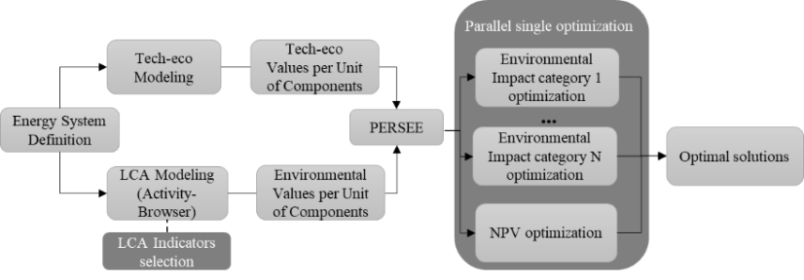
Figure 1. Methodology framework
    - Main Tools
      - LCA tool
To assess all components of the energy system, an Environmental Life Cycle Assessment (LCA) must be conducted. LCA, a standardized methodology (ISO 14040), evaluates the environmental impacts of products, processes, or systems. Brightway version 2, an open-source software tool based on Python, alongside its graphical interface Activity-Browser, is a widely used tool in the research community for LCA calculations. This software has been chosen for this study because of its flexibility to build parameterized environmental impact models.
      - PERSEE optimization tool
The optimization process presented in this paper is carried out with PERSEE software developed at CEA by members of LSET laboratory in Grenoble, France (Cuisinier et al. 2021). PERSEE is a tool for optimizing the sizing and management of multi-vector energy systems, using MILP formulation. This software allows the modeling and single optimization of energy systems based on either economic or environmental criteria. Upon user input, PERSEE creates a system of equations containing the objective function and all problem constraints. Subsequently, this system of equations is solved using a commercial solver, such as Cplex.
    - Case Study
      - System description
The case study is a theoretical small-scale hydrogen system based on some of the characteristics of the GreenHysland EU deployment project in Mallorca (Spain). This scenario involves solar and grid-powered PEM electrolysis, gas compression, and transportation to end applications (injection into the natural gas grid and refueling of hydrogen buses), as shown in Figure 2. Dynamic optimization is employed to accommodate variable inputs and outputs, considering flexible injection of hydrogen into Mallorca’s natural gas grid up to 4%_{vol}. Additionally, the analysis includes the consideration of the environmental impacts of existing technologies (such as natural gas combustion and diesel buses) to quantify the benefits of optimal hydrogen solutions. The optimization criteria encompass the sizing of the PV system and hydrogen storage, as well as the operational control of the entire system, including grid usage, PEM electrolyzer operating hours, hydrogen transport, and the amount of hydrogen injected into the natural gas grid. A comprehensive description of the case study, with model data and references, can be found in (Montignac et al. 2023).
      - Environmental modelling
The environmental boundaries considered for the case study are summarized in Figure 2. Here, “avoided emissions” refer to reductions in various environmental burdens or adverse effects compared to a baseline situation, specifically the fossil fuel scenario. The impacts from the production and use of diesel and natural gas that would have been emitted are included in these avoided emissions (the manufacturing of diesel buses, hydrogen buses, and gas generators is out of scope). The functional unit serves as the benchmark for comparing different solutions from an LCA perspective. The functional unit considered involves two uses: one for the buses and the other for the gas and hydrogen mixture, totaling 778,666 km of service per year and 178,109 GJ per year, respectively, as depicted in Figure 2. The impact assessment method selected is Environment Footprint (EF 3.1, covering 14 out of 19 impact categories, detailed in Figure 3.
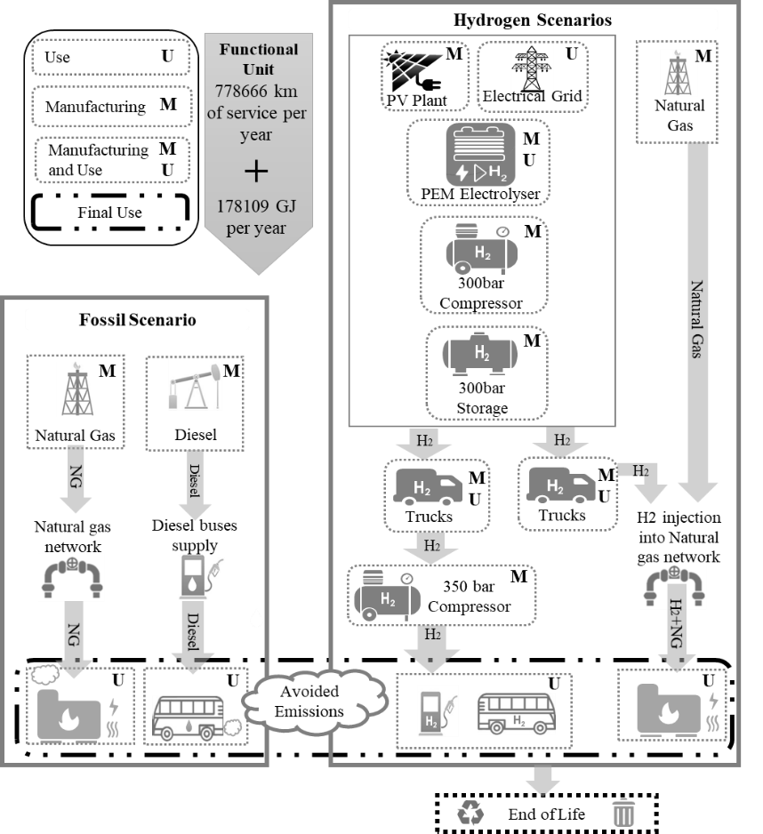
Figure 2.Case study description
  - Results
This section presents some significant results obtained from optimizing each environmental impact. Figure 3 showcases the diverse environmental impacts calculated for each optimal solution. Considering all assumptions, the results showed that all solutions except the economic one, yield negative NPV (Net Present Value), which means non profitable architectures. Notably, the scenario that optimized the economic aspect by maximizing the NPV exhibited the highest values across all impact categories (the magnitude of the environmental criteria is so high that it out of range of the figure's scale).
For example, concerning Global Warming Potential, it recorded 345,000 tonsCO₂-eq compared to the highest value of 18,100 tonsCO₂-eq generated by any other optimization based on environmental criteria. This underscores that, in this case study, optimizing any specific environmental impact coincides with reductions in other impacts, portraying the economic objective as a primary antagonist to each environmental objective.
Nevertheless, minimizing a single environmental objective does not mean optimal conditions for all other impacts or equal benefits. For instance, Figure 3 illustrates how the optimal solution for global warming also optimizes energy resource use, acidification, ozone depletion, and photochemical ozone creation. Moreover, impacts such as eutrophication, ecotoxicity, particulate matter, ionizing radiation and non-carcinogenic human toxicity are notably reduced but not optimized. Conversely, in the same optimization scenario, impacts related to water use, land use, material resources and carcinogenic human toxicity were considerably high.
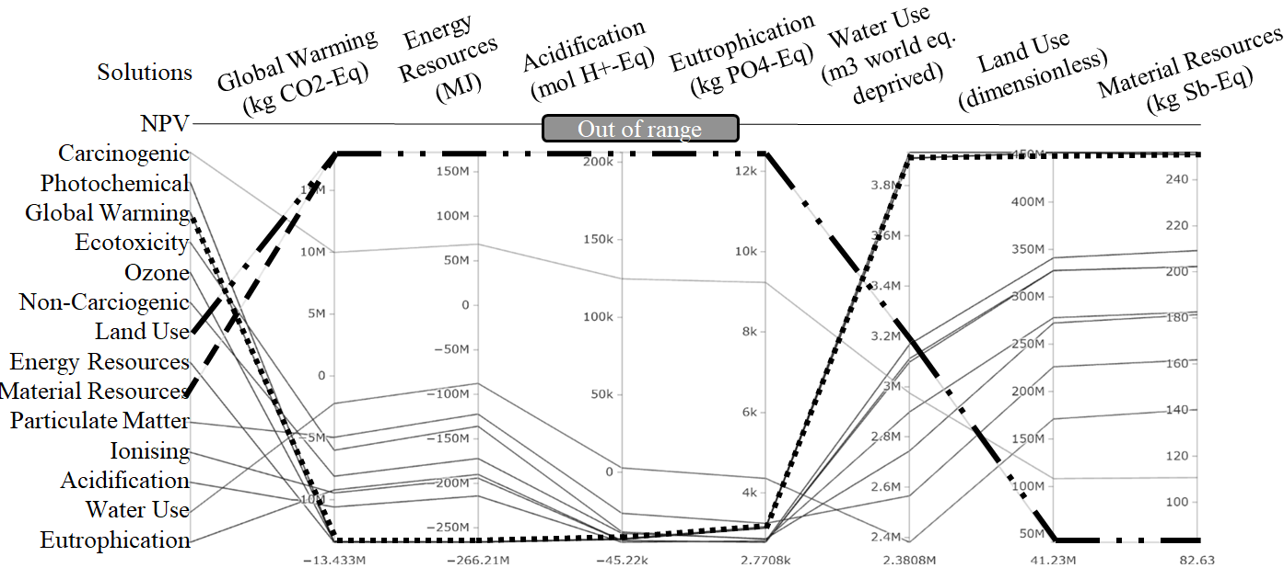
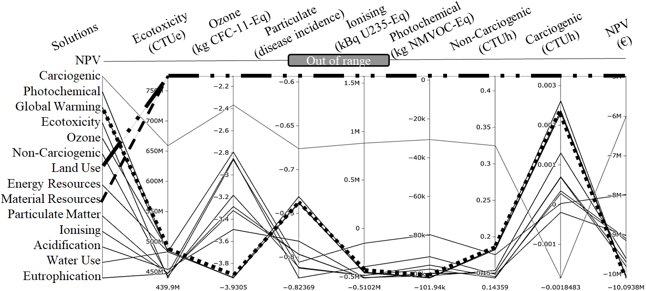
Figure 3. Optimal solutions for each environmental impact and their corresponding trade-offs with other impacts
Another significant aspect is illustrated in Figure 3 is the conflict between different optimal solutions. For example, the optimization of land use conflicts with various impacts linked to global warming solutions, and conversely, global warming optimization conflicts with various impacts linked to land use solutions. For instance, optimizing for global warming leads to a tenfold increase in land use impact (due to the maximization of PV plant size) compared to the optimization of land use impact itself. This highlights a significant point since there is a common tendency to solely prioritize global warming, often neglecting its antagonistic relationship with land use.
In addition, some instances showcase optimal solutions that overlap, such as the scenarios for land use and material resources. This is due to high degree of correlation between these impacts, meaning that optimizing one automatically yields the optimal solution for the other. This is highly relevant since it allows simplifying the computational processes by removing one environmental objective without losing its optimal solution, thereby streamlining the case study and reducing computational costs.
Another outcome analysed was the identification of key components contributing to various environmental impacts. These included the use of the electrical grid, PV plant, and hydrogen injection into natural gas grid. Across all optimizations of the environmental criteria, there was a consistent trend toward reducing grid reliance, attributed to the high fossil fuel content in Mallorca's current grid. Meanwhile, PV optimal size tended to vary depending on the environmental criteria. For instance, material resource optimization led to no PV plant (0 MWp) compared to energy resource optimization leading to 8.56 MWp (upper bound of the optimization domain). Regarding hydrogen injection, substituting natural gas by hydrogen does not generate similar reduced impacts across different environmental criteria. For example, while it significantly addressed particulate matter in some scenarios, its effect on others, such as ecotoxicity, was negligible.
  - Conclusions
The framework presented here provides a better understanding of the potential environmental and economic capabilities of energy systems. The results highlight the risk of designing a hydrogen system solely optimized from an economic viewpoint. Therefore, adopting a life-cycle perspective becomes essential when developing energy systems.
Furthermore, minimizing climate change can generate substantial co-benefits in areas related to energy resources, acidification, ozone depletion, and photochemical ozone creation. However, such minimization also involves environmental trade-offs, leading to increased impacts in terms of land use, water use, and material resources, requiring careful consideration. Additionally, the strong correlation between some impacts can simplify these issues without losing accuracy, thereby aiding in multi-objective optimization processes and decision-making. The methodology was rather easy to implement using existing tools, and without particular link to our test case, which shows good ability for further applications. Several perspectives can enhance the robustness of these approaches. This includes conducting end-of-life and prospective analysis for all components in the environmental inventory information. Additionally, uncertainties regarding all input types should be incorporated and managed in energy system optimization problems.

Acknowledgments
The authors acknowledge specially the University of Balearic Islands, in particular Dr. Vincent Canals for providing local grid data, as well as Calvera Hydrogen Company for providing equipment data. The authors thank the GreenHysland EU project. This project has received funding from the Fuel Cells and Hydrogen 2 Joint Undertaking (now Clean Hydrogen Partnership) under Grant Agreement No 101007201. This Joint Undertaking receives support from the European Union’s Horizon 2020 Research and Innovation programme, Hydrogen Europe and Hydrogen Europe Research. The content of this publication reflects only the authors' view, and the JU is not responsible for any use that may be made of the information it contains.
References
Cuisinier, Etienne, Cyril Bourasseau, Alain Ruby, Pierre Lemaire, and Bernard Penz. 2021. “Techno-Economic Planning of Local Energy Systems through Optimization Models: A Survey of Current Methods.” International Journal of Energy Research 45(4):4888–4931.
Mashi, Rocky, Yohan Vincotte, Sofía De-León Almaraz, and Catherine Azzaro-Pantel. 2023. “Optimization of Hydrogen Systems for Prospective Life Cycle Assessment: Well-to-Tank Approach.” Pp. 3211–17 in Computer Aided Chemical Engineering. Vol. 52, 33 European Symposium on Computer Aided Process Engineering, edited by A. C. Kokossis, M. C. Georgiadis, and E. Pistikopoulos. Elsevier.
Montignac, Florent, Maria-Candelaria Arpajou, Diego Larrahondo Chavez, and Alain Ruby. 2023. “Multi-Criteria Optimization of Hydrogen Energy Supply Chains Considering Economic and Environmental Impacts: Theoretical Case Study in the Context of Balearic Islands.” Proceedings.Com. doi: https://doi.org/10.52202/069564-0096.
Vandepaer, Laurent, Evangelos Panos, Christian Bauer, and Ben Amor. 2020. “Energy System Pathways with Low Environmental Impacts and Limited Costs: Minimizing Climate Change Impacts Produces Environmental Cobenefits and Challenges in Toxicity and Metal Depletion Categories.” Environmental Science & Technology 54(8):5081–92. doi: 10.1021/acs.est.9b06484.

