Pinch curves computation using differential continuation algorithm
Nataliya Shcherbakova^{a*}, Ivonne Rodriguez-Donis^{b}, Vincent Gerbaudª
ª Laboratoire de Génie Chimique, Université de Toulouse, CNRS, INP-ENSIACET, UPS Toulouse, France
^{b}Laboratoire de Chimie Agro-industrielle, LCA, Université de Toulouse, INRA, Toulouse, France
*nataliya.shcherbakova@ensiacet.fr
Abstract
The paper presents a novel algorithm for numerical computation of pinch curves in homogeneous ternary mixtures under assumption of constant molar flow in an infinitely long column. The method is based on the analysis of topological structures of the surfaces associated to the vapor-liquid equilibrium and pinch conditions in the 3D composition - temperature space. The computational problem is formulated in terms of a system of ordinary differential equations. The efficiency of this approach to compute the pinch curves and to detect the bifurcations of their structure is demonstrated with four examples of real mixtures covering ternary diagram classes 1.0-1a, 1.0-2 and 2.0-2b.

Keywords: pinch curves, bifurcation, homogenous extractive distillation, differential continuation
  - Introduction
Pinch curves are an important concept in the design of extractive distillation process since they are related to limiting operating conditions, which are essential for assessing process feasibility. They represent the set of compositions that remain constant along the increasing number of stages in the column, so that the separation becomes impossible once these compositions are reached. The location of pinch curves delimits the operation domain for a given set of operation parameters (reflux ratio and the entrainer flow rate) allowing to evaluate the performance of the entrainer using the Infinitely Sharp Split (ISS) method as described by Petlyuk et al. (2015) and Rodriguez-Donis et al. (2023).
This paper aims to present a new numerical algorithm for pinch curves computation based on the differential continuation method, which reduces the computation to the integration of a system of ordinary differential equations (ODE) instead of solving the systems of algebraic equations by an iterative procedure, as it is usually done. It represents the further development of the new algorithmic approach that was successfully applied to compute univolatility curves (Shcherbakova et al., 2017, Cots et al. 2021) and binodal curves (Shcherbakova et al., 2023) of ternary diagrams.
Starting from the code of Poellmann and Blass (1994), there were several attempts to construct the pinch curves via integration of ODE systems (Feldbab, 2012) or differential-algebraic systems of equations (DAE) (Skiborowski at al. 2016). The novelty of our approach comparing to the other authors consist in exploration of the topology and the mutual arrangement of the pair of surfaces associated to the vapor-liquid equilibrium (VLE) and pinch conditions in a complete 3D composition-temperature state space, under the standard assumptions of constant molar flow rates and the infinite height of the column. We show that in this setting the pinch curves are just projections on the 2D composition space of the intersection of these surfaces, and their singularities results from the common tangent points of these surfaces.
The described geometric model can be formalized in a set of ODE that can be solved by any conventional ODE solver. This reduces the computation time gaining in the numerical accuracy and flexibility of the code.
This paper is organized as follows. In Section 2 we present the detailed geometrical model of pinch curves. In particular, we derive the bifurcation condition for the pinch curves splitting caused by the change of operation parameters. In Section 3 four examples of different configurations of pinch curves of real ternary mixtures are presented. In Conclusion we discuss the possible practical issued of the presented algorithm.
  - Computational method
    - Pinch points and pinch curves in ternary extractive distillation
Assume that the extractive distillation of a ternary homogeneous mixture takes place in an infinitely high column with constant liquid and molar flow rates L and V. It is also assumed that the ratio of the entrained molar feed rate E and molar flow rate of the distillate D is fixed.
Pinch points of the distillation diagram associated to this process represent the critical state inside the column corresponding to the VLE between the vapor and the liquid phases at the same stage of the column, so that their further separation becomes impossible. The geometrical loci of such points form the pinch branches or pinch curves of the diagram. Pinch curves play the central role in the infinitely sharp split (ISS) method to identify the possible splits in a given mixture. For the detailed description the pinch points and the ISS method we refer the reader to papers cited above and references therein. In this paper we focus on the purely computational aspects, and to this end we first need to recall the main mathematical formulae used in the computations.
In what follows T is the temperature of the mixture, $x_{i}, y_{i}∈\left[0,1\right]$, i=1,2,3 denote the molar fractions of the three component mixtures in liquid and vapor phases so that $y_{i}=K_{i}\left(x_{1},x_{2}, x_{3}, T\right)x_{i}$, where the functions K_{i} represent the distribution coefficients of the component i. Since $\sum_{i=1}^{3}{x_{i}=1}$, only two of molar fraction are independent, so that below $x_{3}$ will be replaced by $x_{3}=1-x_{1}-x_{2}$ . The VLE condition then takes the form
$x_{1}K_{1}{(x}_{1},x_{2}, T)+x_{2}K_{2}{(x}_{1},x_{2}, T)$+ ${(1-x}_{1}-x_{2})K_{3}{(x}_{1},x_{2}, T)=1$ | (1)
According to Petlyuk et al. (2015), the pinch point condition associated to the first component that should be separated from the second one (using the third one as an entrainer) can be written in the form
$$x^{∆}=\frac{K_{1}{(x}_{1},x_{2}, T)-K_{2}{(x}_{1},x_{2}, T)}{1-K_{2}{(x}_{1},x_{2}, T)}x_{1}$$ | (2)
Here $x^{∆}∉[0,1]$ denoted the difference or delta point, it lies outside of the concentration triangle and represents a virtual concentration corresponding to the composition of the difference between the distillate and the entrainer feed of the column. Once the ratio E/D is fixed, the delta point is defined by the relation
$$\frac{E}{D}=\frac{x^{∆}-1}{x^{∆}}$$ | (3)
The set of points on the composition space verifying conditions Eqs. (1, 2) is called the pinch curve associated to the operating conditions expressed by Eq. (3). These curves are bounded by the binary sides of the composition triangle and by the univolatility curves $α_{ij}=1$ that represent the points where $K_{i}{(x}_{1},x_{2}, T)=K_{j}{(x}_{1},x_{2}, T)$. The pinch and univolatility curves can intersect only at azeotropic points of the diagram.
2.2 Geometrical model of pinch curves and their singularities
Eqs.(1-3) admit a very clear geometric interpretation. Indeed, denote by $Ω={\{x}_{i}∈\left[0,1\right], x_{1}+x_{2}≪1, i=1,2\}$ the composition triangle associated to the ternary mixture and consider a 3D cartesian space $Σ=\left\{z=\left(x_{1},x_{2}, T\right): \left(x_{1}, x_{2}\right)∈Ω \right\}$ over $Ω$ endowed with the coordinates $x_{1}$, $x_{2}$ and $T$. Define two functions
$$Φ{(x}_{1},x_{2}, T)=\sum_{i=1}^{3}{x_{i}{ K}_{i}{(x}_{1},x_{2}, T)}-1$$  $$Ψ{(x}_{1},x_{2}, T)=x_{1}^{∆}\left(1-K_{2}{(x}_{1},x_{2}, T\right))-x_{1}( K_{1}{(x}_{1},x_{2}, T)-K_{2}{(x}_{1},x_{2}, T))$$ | (4)
and consider the pair of surfaces associated to zero levels of these functions: $W_{Φ}=\left\{z∈ Σ : Φ\left(z\right)=0 \right\}$ and ${ W}_{Ψ}=\left\{z∈ Σ : Ψ\left(z\right)=0 \right\}$. The intersection of these surfaces defines a smooth curve $Γ$ in $Σ$. Comparing Eqs. (1, 2) with Eq. (4) one can easily see that $Γ$ projects on a pinch curve on $Ω$. Indeed, since $Γ=W_{Φ} {∩W}_{Ψ}$, it is generated by some vector field which is orthogonal to both normal vectors $N_{W_{Φ}}=∇Φ\left(z\right)$ and $N_{W_{Ψ}}=∇Ψ\left(z\right)$. In other word, at each point $z∈Γ$, the vector
$U\left(z\right)=∇Φ\left(z\right)×∇Ψ$(z) |  | (5)
belongs to the tangent space $Γ$. Therefore, knowing one pinch point $z_{0}∈Γ$ would be enough to construct the whole pinch curve by solving the following system of ODE
$${\dot{x}}_{1}=U_{1}\left(x_{1},x_{2},T\right), {\dot{x}}_{2}=U_{2}\left(x_{1},x_{2},T\right), \dot{T}=U_{3}\left(x_{1},x_{2},T\right)$$ | (6)
where, according to Eq.(5),
$$U_{1}=\frac{∂Φ}{∂x_{2}}\frac{∂Ψ}{∂T}-\frac{∂Φ}{∂T}\frac{∂Ψ}{∂x_{2}}, U_{2}=\frac{∂Φ}{∂T}\frac{∂Ψ}{∂x_{1}}-\frac{∂Φ}{∂x_{1}}\frac{∂Ψ}{∂T} , U_{3}=\frac{∂Φ}{∂x_{1}}\frac{∂Ψ}{∂x_{2}}-\frac{∂Φ}{∂x_{2}}\frac{∂Ψ}{∂x_{1}}$$ | (7)
Observe, that if $W_{Φ}$ and $W_{Ψ}$ have a common tangent plane at $z$, then $U\left(z\right)=0$ and such a point is a singular point of $Γ$. Moreover, due to Eq.(4), the gradient of the at any point of $W_{Φ}$ verifies $\frac{∂T}{∂x_{i}}=-{\frac{∂Φ}{∂x_{i}}}/{\frac{∂Φ}{∂T}}, i=1,2$. Combining this expression with Eq. (7) yields
$$U_{3}=U_{1}\frac{∂T}{∂x_{1}}+U_{2}\frac{∂T}{∂x_{2}}$$ | (8)
Hence the singular points of $Γ$ are in one-to-one correspondence with the singularities of the underlying pinch curve. Such isolated singular points can be of elliptic of hyperbolic type. The first case corresponds to a pinch curve shrinking into an isolated pinch point under certain operation conditions, whereas in the hyperbolic case there are four pinch branches meeting at the singular point. Examples of such configurations will be given in Section 3.
The topology of the pinch diagram is entirely determined by the value of E/F (and hence by $x^{Δ}$) and by the pressure in the column. The modification of one of these parameters will cause the transformation of the shape and of the mutual arrangement of the surfaces $W_{Φ}$ and $W_{Ψ},$leading to the transformation of the topological structure of the underlying pinch diagram. In particular, it may cause its bifurcation. According to the geometrical model described above, the bifurcation occurs when the curve $Γ$ has a critical point. In view of Eq. (8), the corresponding pinch point and operating conditions can be found by solving the following system of four equations
$$Φ\left(x_{1}, x_{2}, T\right)=0, Ψ\left(x_{1}, x_{2}, T\right)=0, { U}_{1}\left(x_{1}, x_{2}, T\right)=0,{ U}_{2}\left(x_{1}, x_{2}, T\right)=0$$ | (9)
with respect to $x_{1}, x_{2}, T,P$ or $x_{1}, x_{2}, T,x^{Δ}$, according to the type of bifurcation.
2.3 Numerical computation of pinch curves
Using Eq. (6) the whole pinch curve can be computed numerically using the standard Runge-Kutta schemes for ODE integration. Initial points for such integration can be found by solving Eqs. (1,2) on the binary sides of the composition triangle, by an iteration procedure. The dot symbol in the left-had side of Eq. (6) has the meaning of a derivative with respect to some scalar parameter. In practical computations, is would be convenient to normalize the vector field U and thus rewrite Eq. (6) with suspect to arc length s. This will also avoid an eventual stiffness problem along the integration.
The same computation can be performed with respect to another component, yielding other types of pinch curves. To this end, in Eq. (2) $x_{1}$ should be replaced by $x_{2}$ or $x_{3}$, modifying the indexes of distribution coefficients accordingly. Taking into account that a pinch curve may be composed of two branches, the complete pinch diagram of a given mixture can be obtained by the following steps:
- build a list of all pinch points on the boundary of $Ω$.
- for each binary pinch point from in the list compute the pinch curve issued from this point with an appropriate choice of the initial direction. The numerical integration should be continued until the boundary of $Ω$ is attained.
- exclude both initial and final points of the already computed pinch curve and continue until the list of binary pinch points is emptied.
The described algorithm allows to compute all pinch branches of the given ternary mixture that start from the binary pinch points. However, in some rare cases the mixture may have closed pinch curves entirely lying in the interior part of $Ω$. An example of such a situation is presented in the next section. In this case the pinch curve still can be computed by solving Eq. (6), but it will require to detect a pinch point in the inner part of $Ω$. The clear indicator of such a configuration is the existence of a bifurcation point of elliptic type inside $Ω$ for some value of E/D or pressure.
A numerical implementation of Eq. (7) requires the access to the derivatives of the expressions defining the thermodynamical model of the mixture: activity coefficients, vapor-temperature equation, etc. The complexity of such a computation is the main reason for which the differential continuation algorithms are very poorly used in Process Engineering compared to the other fields. In fact, the use of difference formulae for the derivatives do not satisfy the necessary accuracy requirements to guarantee the numerical stability and accuracy of computation. On the other hand, the automatic differentiation technology (Hasco and Pascual, 2012), already implemented in many other applications, can successfully build these expressions. A working example of a code based on the coupling of the differential continuation with automatic differentiation of the thermodynamic model is described in Cots et al. (2020) for the univolatility curves computation. For academic use, any package of symbolic computation can be employed. The results of pinch curves computation presented in the next section were done with Mathematica.

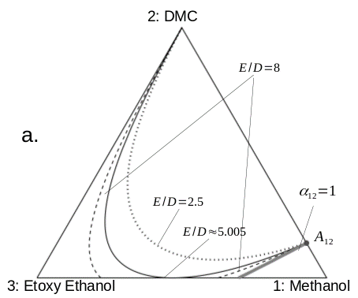 | 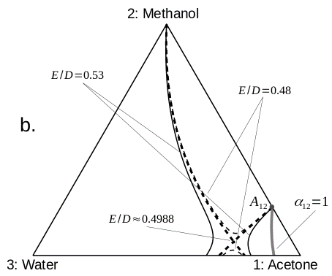
Figure 1. Serafimov’s class 1.01-a. Examples of possible evolution of the pinch diagrams with the variation of E/D parameter. Case a: regular splitting of the pinch curve. Case b : splitting caused by a saddle-type biffurcation.
  - Case studies
All the pinch diagrams presented below were computed using Mathematica 9 package. We present here 4 examples corresponding to Serafimov’s classes 1.01-a (Fig. 1), 1.02 and 2.02-b (Fig. 2). The DIPPR equation and database were used for the vapor pressure computation. For the mixtures shown in Fig. 1 and Fig. 2 a the non-random two-liquid (NRTL) thermodynamic model was used, the VLE binary coefficients of mixtures were taken from the Simulis Thermodynamics (Prosim, 2023). For the case shown in Fig. 2b the binary coefficients were estimated using the UNIFAC modified Dortmund 1993 model (Gmehling et al., 1993). The pressure is assumed constant and equal to 1 atm.
Fig1. shows two examples of ternary mixtures of Serafimov’s class 1.01-a. (Kiva et al., 2003). In the first case methanol is separated from dimethyl carbonate (DMC) using the ethoxy ethanol as an entrainer. The pinch curve is bounded from the right by the univolatility curve $α_{12}$ (thick grey curve) issued from the binary azeotrope $A_{12}$. A unique pinch curve exists for E/D smaller than 5.005. For greater values a part of the pinch curve lies behind of the composition triangle, causing the regular splitting of the unique pinch curve into two disjoin branches. The situation shown in Fig.1b is different. This example describes the separation of the acetone from methanol using water as the entrainer. Near the value 0.48 of E/D, the diagram has 2 pinch branches that meet each other when E/D=0.4988 in the interior of $Ω$, and then they split again in the other direction. This is the saddle-type splitting caused by the presence of the bifurcation point of hyperbolic type verifying Eq. (9).
Fig. 2a provides an example of a mixture of class 2.0-2b with two binary azeotropes. It shows the evolution of the pinch curve associated to the separation of component 2 from component 3 using component 1 as the entrainer. The pinch curves are limited from the left and from the right by two univolatility curves $α_{13}$ and $α_{23}$. Fig. 2b shows an example of class 1.0-2 exibiting closed type pinch curves in the zone comprised between two branches of the same univolatility curve $α_{13}$. Here toluene is separated from ethanol using acetone as an entrainer. The elliptic type bifurcation at the critical value E/D=0.017 causes the vanishment of the pinch curve for the greater values of E/D.
  - Conclusion
The new computational method presented in this paper assures an easy computation of pinch curves of ternary mixtures with high accuracy. It can be naturally generalized to compute the curves of more than three component mixtures. It is based on a geometrical
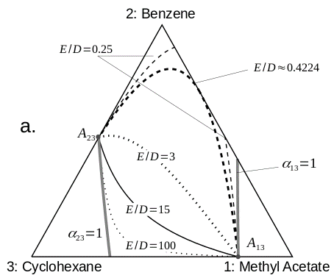 | 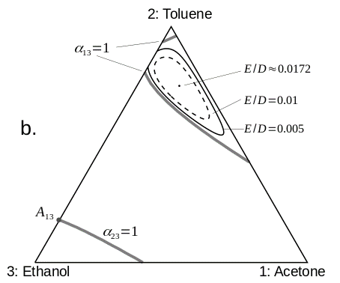
Figure. 2. Case a: Serafimov’s class 2.0 – 2b. Pinch curves associated to the separatiion of benzene from cyclohexane using methyl acetate as the entrainer. Case b : Serafimov’s class 1.0-2, pinch separtion of touluene from acetone using ethanol as an entrainer. Ellyptic-type biffurcation: closed pinch curves shrink into a single pinch point before disappearing.
model that allows to predict the bifurcation in the topological structure of pinch diagrams related to the change of operational conditions. Accurate computation of pinch branches facilitates the synthesis and design of an extractive distillation column since they give access to limiting values of reflux ratio and entrainer flow rate that help select entrainer and assess process feasibility.
References
O.Cots, N. Shcherbakova, J. Gergaud, 2021. SMITH: Differential homotopy and automatic differentiation for computing thermodynamic diagrams of complex mixtures. Comput. Aided Chem. Eng., 50, 1081–1086
N. Felbab, 2012. An Efficient Method of Constructing Pinch Point Curves and Locating Azeotropes in Nonideal Distillation Systems. Ind. Eng. Chem. Res, vol 51, pp. 7035-7055.
J. Gmehling, J. Li, M.A. Schiller, M.A., 1993. Modified UNIFAC Model 2.Present parameter matrix and results for different thermodynamic properties. Ind. Eng. Chem. Res. 32, 178–193.
L. Hasco and V. Pascual, 2012. The tapenade automatic differentiation tool: principles, model, and specification. Research report R-7957, INRIA, http://tapenade.inria.fr:8080/tapenade/
V.N. Kiva, E.K. Hilmen, S.Skogestad, 2003. Azeotropic phase equilibrium diagrams: a survey. Chem. Eng. Science, 58, 1903-1953.
Mathematica 9. URL http://www.wolfram.com/mathematica/.
F. Petlyuk, R. Danilov, J. Burger, 2015. A novel method for the search and identification of feasible splits pf extractive distillations in ternary mixtures, Chem. Eng.Res. Des., 99, 132 – 148
P. Poellmann, E. Blass, 1994. Best products of homogeneous azeotropic distillations. Gas Separation & Purification, 8, 194-228
I.Rodriguez-Donis, N. Shcherbakova, J. Abildskov, V.Gerbaud, 2024. Entrainer selection using the Infinitely Sharp Split method for separating binary minimum boiling azeotrope by extractive distillation (in preparation)
Simulis Thermodynamics; ProSim: Labege Cedex, France, 2023. https://www.prosim.net/
Skiborowski, M., Bausa, J., Marquardt W., 2016. A Unifying Approach for the Calculation of Azeotropes and Pinch Points in Homogeneous and Heterogeneous Mixtures. Ind. Eng. Chem. Res., 55, 6815−6834.

