Combining Predictive Models and Reinforcement Learning for Tailored Molecule Generation
Miriam Nnadiliª, Andrew N Okaforª, David Akinpelu^{b}, Teslim Olayiwolaª, Jose Romagnoliª
ªCain Department of Chemical Engineering, Louisiana State University, Baton Rouge, Louisiana 70803, United States.
^{b}Department of Mechanical & Industrial Engineering, Louisiana State University, Baton Rouge, Louisiana 70803, United States.

Correspondence to: jose@lsu.edu
Abstract
This study introduces a three-fold methodology that harnesses the capabilities of generative artificial intelligence (AI), predictive modelling, and reinforcement learning to craft customized molecules with desired properties. The model seamlessly integrates deep learning techniques with Self-Referencing Embedded Strings (SELFIES) molecular representation, constructing a generative model for producing valid molecules. In the framework, a graph neural network model was used to predict molecular properties and a combined Variational Autoencoder and reinforcement learning model to generate new molecules with specific attributes. Experimental data from a surfactant study validates the effectiveness of the framework. This innovative approach not only streamlines molecular design for surfactant systems but also anticipates transformative advancements in diverse scientific and industrial domains.
Keywords: Molecular design, Predictive modelling, Reinforcement learning
1. Introduction
Contemporary science and industry are deeply dependent on understanding the complex relationship between a molecule's structure and its function. Traditional methods frequently face difficulties in dealing with complicated molecular systems. However, the need to create molecules with specific properties offers both significant challenges and promising opportunities. In critical domains such as medicine and materials science, the significance of innovative and intelligent molecule design methods cannot be overstated. The spotlight has recently intensified on molecule generation and property prediction due to breakthroughs in deep generative model (Walters and Barzilay 2020). The pursuit of predicting and customizing molecular properties forms the crux of advanced research, propelling innovations and discoveries across diverse scientific domains (Zhang and Chen 2022). Accurately predicting molecular properties and generating molecules that meet specific criteria demand not only advanced computational models but also a profound understanding of molecule chemistry.
This study proposes a Reinforcement Learning (RL) methodology for inverse molecule design, where forward modeling predicts properties given a molecule, and inverse modeling infers molecules from given properties. The methodology integrates generative artificial intelligence (AI), predictive graph neural networks (GNN) modeling, and RL. The initial phase incorporates the Self-Referencing Embedded Strings (SELFIES) molecular representation, coupled with a deep generative model (Variational Autoencoder (VAE)). For property prediction, GNN approach is employed due to its superior performance, eliminating the need for informative descriptors typically found in quantitative structure-property relationships. RL serves as the pivotal guiding mechanism in our approach for molecule generation, using the Variational Autoencoder (VAE). A tailor-made RL learning algorithm is proposed to steer the VAE's latent representations to generate molecules with specific desired properties. Tanimoto similarity (or the Jaccard coefficient) was used to quantify the similarity and diversity between the original and generated molecular structures. To understand the features of the generated surfactant molecules that explain the Critical Micelle Concentration (CMC) values, saliency maps were generated for the selected surfactants. The feasibility of this approach is demonstrated in a case study focused on non-ionic surfactant molecules. Specifically, it targets the generation of new molecules with low CMC, a crucial surfactant characteristic.

2. Methodology
Figure 1 illustrates the graphical representation of the proposed architecture towards tailored molecules generation. The initial phase of the proposed architecture utilizes the Self-Referencing Embedded Strings (SELFIES) (Krenn, Häse et al. 2020) molecular representation, paired with deep generative model. Here, the VAE model encoded molecules into low-dimensional vectors in latent space as continuous and smooth probability distributions, and the decoder of VAEs converted these continuous vectors back to discrete molecular representations (Doersch 2016). The continuous representations of molecules allow sampling of the chemical space stepwise, leading to the successful optimization of molecules with desired properties. A GNN for property prediction is used to estimate the fitness of the generated molecules to the actual property. Lastly, RL (Wiering and Van Otterlo 2012), is finally used as a tool for optimizing an objective, in this case, RL is applied as a technique for fine-tuning target properties.
2.1 SELFIES
SELFIES is a string-based representation of a molecular graph, is one hundred percent robust because each SELFIES corresponds to a valid molecule, even entirely random strings. It is important to note, however, that validity is defined with respect to valency rules. As a result, molecules that are valid may not necessarily be stable. SELFIES are independent of the machine learning model and can be used as a direct input without any adaptations of the models.
2.2 Variational Autoencoder (VAE)
The Variational Autoencoder (VAE) (Xue, Gong et al. 2019) architecture used in this work is a neural network comprising two main components: an encoder and a decoder. The encoder processes the input data, which is represented as a one-hot encoding (OHE) of SELFIES and maps it to a lower-dimensional latent space (An and Cho 2015). This latent space is characterized by a set of continuous variables that represent the essence of the input data in a compact and meaningful way. Each point in the latent space corresponds to a potential molecular structure. The latent space is typically assumed to follow a multivariate Gaussian prior distribution. The decoder, on the other hand, reconstructs the original SELFIES representation of the molecule from the latent variables generated by the encoder. The decoder predicts the parameters (atom types, connectivity, and coordinates) of the reconstructed molecule. Simplified Molecular-Input Line-Entry System (SMILES) (Weininger 1988) is a notation that encodes molecular structures as strings to text. To perform unconstrained optimization for specific properties, the decoder is responsible for reconstructing from the latent vector to the SMILES with chemical validity. This allows VAEs to generate new samples while capturing the underlying structure of the input data.

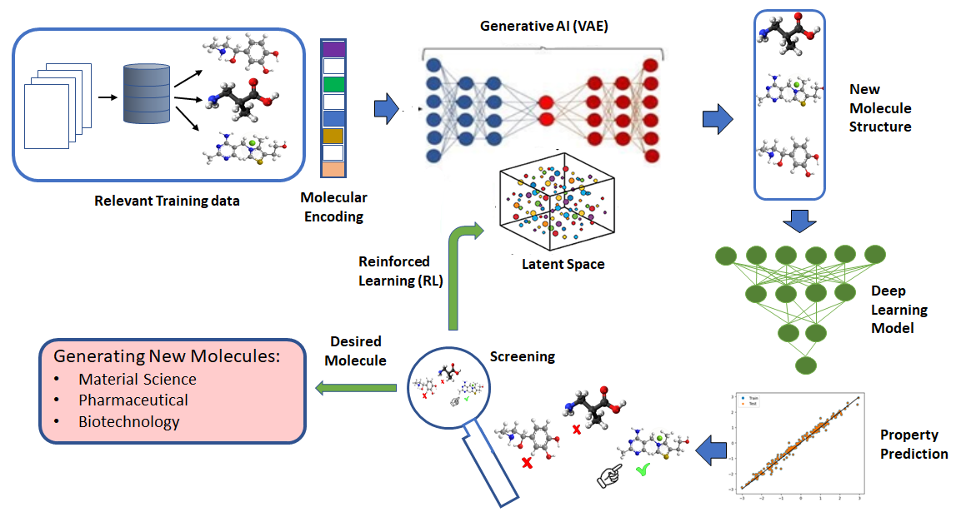
Figure 1: Schematic representation of methodology.

2.3 Predictive Model
In this study, the property prediction model adopted the GNN approach due to their superior performance and to avoid the need for informative descriptors as in quantitative structure-property relationships (QSPRs). The underlying structure of the adopted GNN model closely mirrors that proposed by Qin et. al. (Qin, Jin et al. 2021). At the outset, the GNN model integrates a sequence of graph network layers which adapt node features in a molecular graph based on those of interconnected atoms. For this study, an extensive set of atoms was considered. Consequently, the atom type was one-hot encoded (OHE) into 43 distinct features, grounded on a predetermined list of chemical elements. Although edge features (like bond type) weren't directly incorporated, they were represented indirectly through atom-specific attributes like hybridization and aromaticity. The overall representation hence consisted of 74 atom-based features. These encompass OHE atom type, OHE atom degree, OHE implicit Hydrogen count, formal charge, radical electron count, OHE atom hybridization categories (SP, SP2, SP3, SP3D, SP3D2), aromaticity indicators, and OHE total Hydrogen count. The final predictive model contains two (2) GNN layers, each having 256 hidden units, employed a ReLU activation function, and 3 fully connected layers to map the pre-processed input matrix to predict the critical micellar concentration.
2.4 Reinforcement learning (RL)
For molecule generation, we integrated RL with a VAE. The core objective is to harness the potential of RL in steering the VAE's latent representations to generate molecules possessing specific desired properties. The architecture of the RL component encompasses three fundamental elements: a policy network, a reward computation mechanism, and an optimization strategy. The policy network, referred to as 'Policy', stands as the keystone in modifying the latent representations of the VAE to guide the molecule generation process. Essentially, the policy network takes a latent vector 'z' and transforms it into decoded molecules through the VAE's decoder. The policy network operates as a neural network with the responsibility of determining actions in a given state. In the context of molecule generation, these actions correspond to modifications in the latent space that influence the VAE's output. We formulated our algorithm to follow the Markov decision process where the latent space of the VAE represents the states, and the actions corresponds to the generation of molecules, the rewards represent numerical values received after assessing the property of the molecule (Popova, Isayev et al. 2018). The architecture is designed to facilitate the policy's role in learning to produce latent vectors that align with the desired molecular properties.

3. Case Study
To verify the performance of the proposed methodology, we focused on the critical micelle concentration (CMC). The CMC property serves as key parameter to characterize surfactant behavior in solution and defines the concentration range below which surfactant is in solution as a monomer and above which practically all additional surfactant added to the solution forms micelles (Cifuentes, Bernal et al. 1997). Herein, we collected experimental dataset from published literature detailing CMC data for 285 surfactant molecules. Onward, this study hopes to create novel molecules exhibiting a low CMC, thereby enhancing efficiency, solubility, and stability. In the proposed framework, a Variational Autoencoder (VAE) model is required to create new molecules. To train a VAE model, a large database containing molecules of interest is required. Owing to small dataset, a transfer learning approach is proposed to leverage the knowledge acquired from the pretrained VAE model trained initially on a comprehensive dataset comprising over 20,000 polymer structures. This strategy demonstrates its effectiveness in generating meaningful representations for a wide range of molecular structures.

4. Result and Discussion
The fine-tuning process on a pretrained VAE using a smaller dataset expands the distribution in the latent space, surpassing the outcomes of training solely on the smaller dataset. Figure 2 visually illustrates the scatter plot that directly compares the predicted CMC values generated by the model with the experimental CMC values and the latent space inhabited by RL-generated molecules in the unconstrained space. Notably, VAE + RL-generated molecules form a distinct cluster (depicted in green), indicating the successful influence of the reinforcement learning strategy in steering the VAE to generate molecules meeting the specified property threshold of a CMC below 0.1mM.

The structural integrity of molecules generated by a model was rigorously validated to ensure adherence to fundamental chemical principles, including proper atomic coordination and avoidance of unusual valences. The process included an in-depth analysis of ring structures, assessing both cyclic structures and branched rings for the correct number of rings and their chemical plausibility in terms of size. Additionally, the practicality of these synthesized molecules for surfactant design was evaluated using Tanimoto similarity coefficients. This involved a quantitative comparison with surfactants from the training dataset, aiding in the selection of molecules with close resemblance to established surfactants. Saliency maps, used in deep learning to identify crucial image features for classification, were employed to discern key features of surfactant molecules affecting their CMC values. By calculating the input atom feature gradients and multiplying them with the input, the relative significance of each feature, particularly for atom presence or absence, was determined. This method helped identify the importance of various atom types on CMC predictions. Figure 3 showcases the saliency maps for selected surfactants, both original and newly generated, ensuring that the original ones met the CMC threshold for a valid comparison. Atoms in these maps are color-coded: red indicates a positive influence on CMC, while blue signifies a negative one. The maps reveal that polar atoms like O and N raise the CMC values, while nonpolar atoms like C lower them. Furthermore, the maps illustrate that surfactants with more branches tend to have smaller CMC values, especially when compared to those with long, unbranched tails, aligning with the understanding that increased polarity leads to higher CMC values.

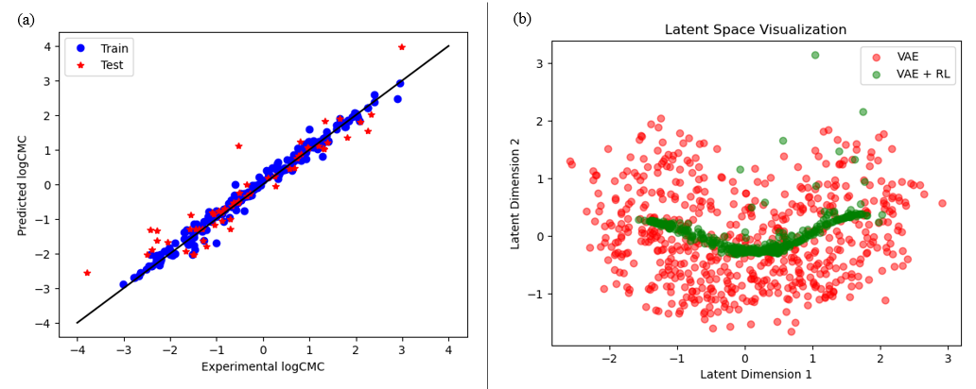
Figure 2: a) Cross plot of predicted and experimental CMC for the GNN model at best cross validation; b) Latent space visualization of the RL generated molecules in the unconstrained space. RL generated molecules are in a region within diverse space. The VAE + RL-generated molecules exhibited a distinctive cluster (green) implying that the reinforcement learning strategy successfully influenced the VAE to generate molecules meeting the desired property threshold of CMC below 0.1mM.
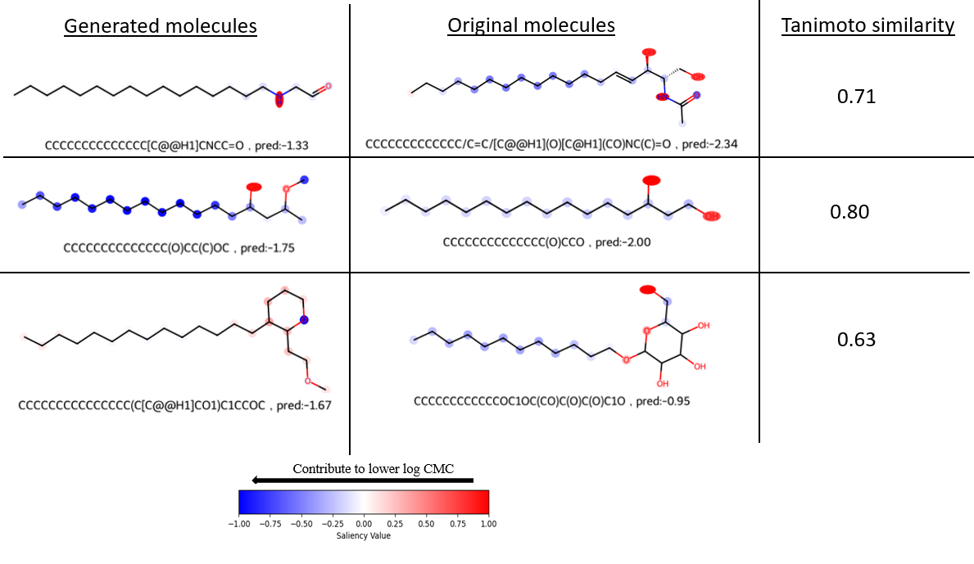
Figure 3: Molecular saliency maps of selected generated surfactants with the corresponding original surfactant molecule and their Tanimoto similarity values. The higher the value (darker red), the more a node contributes to a higher log CMC and vice versa. Herein, the gradients are computed for each node followed by normalization between −1 and 1.
4. Conclusions
In this article, we delved into an advanced machine learning approach, harnessing the power of Graph Neural Networks (GNN) for predictive modelling, and combining Variational Autoencoders (VAE) with policy-based Reinforcement Learning (RL) for the purpose of generating molecules with specific desired properties. Our focus cantered on surfactants, with a particular emphasis on achieving low Critical Micelle Concentration (CMC) values. The results demonstrated that the proposed framework effectively generates valid molecules within the specified property threshold values. Tanimoto similarity was used to quantify the similarity and diversity between the training datasets and generated molecular structures. Furthermore, in our endeavour to gain insights into the characteristics of the generated surfactant molecules, we generated saliency maps that shed light on the critical factors influencing the Critical Micelle Concentration (CMC) values. These observations align with our intuitive understanding, as surfactants tend to exhibit lower CMC values when characterized by extended, unbranched tail groups and higher values in cases of heightened polarity. This validation reinforces the framework's capacity to tailor molecules to desired specifications and enhances our understanding of molecular behaviour in surfactant systems.

References
An, J. and S. Cho (2015). "Variational autoencoder based anomaly detection using reconstruction probability." Special lecture on IE 2(1): 1-18.
Cifuentes, A., J. L. Bernal and J. C. Diez-Masa (1997). "Determination of critical micelle concentration values using capillary electrophoresis instrumentation." Analytical Chemistry 69(20): 4271-4274.
Doersch, C. (2016). "Tutorial on variational autoencoders." arXiv preprint arXiv:1606.05908.
Krenn, M., F. Häse, A. Nigam, P. Friederich and A. Aspuru-Guzik (2020). "Self-referencing embedded strings (SELFIES): A 100% robust molecular string representation." Machine Learning: Science and Technology 1(4): 045024.
Popova, M., O. Isayev and A. Tropsha (2018). "Deep reinforcement learning for de novo drug design." Science advances 4(7): eaap7885.
Qin, S., T. Jin, R. C. Van Lehn and V. M. Zavala (2021). "Predicting critical micelle concentrations for surfactants using graph convolutional neural networks." The Journal of Physical Chemistry B 125(37): 10610-10620.
Walters, W. P. and R. Barzilay (2020). "Applications of deep learning in molecule generation and molecular property prediction." Accounts of chemical research 54(2): 263-270.
Weininger, D. (1988). "SMILES, a chemical language and information system. 1. Introduction to methodology and encoding rules." Journal of chemical information and computer sciences 28(1): 31-36.
Wiering, M. A. and M. Van Otterlo (2012). "Reinforcement learning." Adaptation, learning, and optimization 12(3): 729.
Xue, D., Y. Gong, Z. Yang, G. Chuai, S. Qu, A. Shen, J. Yu and Q. Liu (2019). "Advances and challenges in deep generative models for de novo molecule generation." Wiley Interdisciplinary Reviews: Computational Molecular Science 9(3): e1395.
Zhang, J. and H. Chen (2022). "De novo molecule design using molecular generative models constrained by ligand–protein interactions." Journal of Chemical Information and Modeling 62(14): 3291-3306.

