Energetic Comparison of Electrochemical versus Mechanical Compression of Hydrogen
Georgia Ioanna Prokopou,ª Matthias Leon Mödden,ª Alexander Mitsos, ^{c,a,b} Dominik Bongartz ^{d,*}
ªRWTH Aachen University, Process Systems Engineering (AVT.SVT), Aachen, Germany
^{b}Forschungszentrum Jülich GmbH, Institute for Energy and Climate Research IEK-10: Energy Systems Engineering, Jülich, Germany
^{c}JARA-ENERGY, Aachen, Germany
^{d}Department of Chemical Engineering, KU Leuven, Leuven, Belgium
*dominikbongartz@alum.mit.edu
Abstract
Compression is a necessary step for the efficient storage and transportation of hydrogen. Mechanical compressors are a mature technology widely used for this purpose. Electrochemical hydrogen compression is also considered a promising alternative, however, as a novel technology, there are still open questions regarding to what extent it can be competitive with mechanical compressors. In the present work, we compare the energetic performance of these two compression technologies. We first build a model of a multi-stage mechanical compressor. Then we use the model together with our existing electrochemical compressor model to analyze and compare their energetic performance at different pressure levels. The results show that improvements in the membranes and the catalysts need to be made to make the electrochemical compressor energetically competitive with the mechanical compressor.

Keywords: Electrochemical compression, mechanical compression, energetic performance, hydrogen, modeling.
  - Introduction
Hydrogen exhibits low volumetric energy density at atmospheric conditions, presenting challenges for hydrogen storage for extended periods and long-distance transportation, particularly when large quantities of hydrogen are needed. Several methods exist to address this issue and increase the hydrogen energy density. Among them, the most widely used is compression (Sdanghi et al., 2019). Besides storage and transportation, compression is also crucial since high-pressure hydrogen is required in several industrial applications. Hydrogen compression is therefore an essential step of the hydrogen value chain.
Mechanical compressors are a mature technology that is widely used (Tahan, 2022), especially when significant hydrogen flow rates are required. However, they suffer from high capital and maintenance costs (Sdanghi et al., 2020). Lately, innovative emerging compression technologies have thus been proposed as alternatives to mechanical compressors, including the electrochemical hydrogen compressor (EHC) (Zou et al., 2020). To enable a wider penetration of EHC in the market (Toghyani et al., 2021), it is necessary to analyze their energetic performance. More specifically, it is unclear under which conditions they can compete with mechanical compressors.
To answer this question, we implement a standard model of a multi-stage mechanical compressor in the modeling language Modelica (Modelica Association, 2023). We use this model and a model of the EHC (Prokopou et al., 2023) to analyze hydrogen compression from 0.2 to 70 MPa. The objective is to evaluate the energy consumption of the two compressors and to identify the improvements that need to be made so that the EHC exhibits comparable energetic performance with the mechanical compressor.
  - Modeling
2.1 Electrochemical Compressor
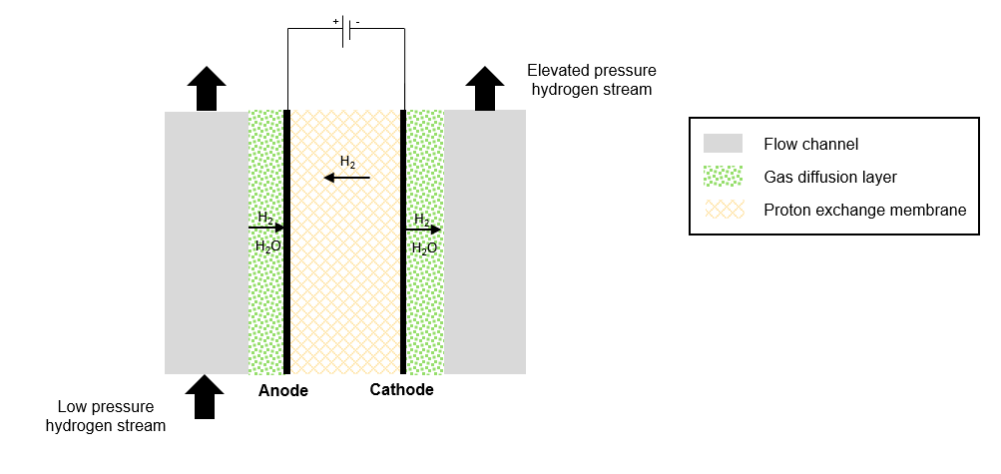
Figure 1: Schematic representation of an electrochemical hydrogen compressor
Figure 1 shows a schematic representation of the EHC. A potential difference is applied to an electrochemical cell in which low-pressure humidified hydrogen is fed at the anode. Hydrogen is oxidized at the anode and then the produced electrons are transferred through the external circuit to the cathode. The protons migrate from the anode to the cathode through the membrane and at the cathode, protons are recombined with electrons to form hydrogen at higher pressure. Due to the pressure difference between the cathode and the anode, hydrogen also permeates back into the membrane, a phenomenon known as back-diffusion, which is particularly relevant for high target pressures. The total cell voltage is equal to the sum of the Nernst potential, derived by the Nernst equation, the activation losses at the anode and cathode as well as the ohmic losses in the membrane.
In our recent work (Prokopou et al., 2023), we proposed a dynamic and spatially distributed (1D) model of the EHC in Modelica, accounting for the different overpotentials, namely Ohmic, activation, mass transport losses, and the back-diffusion effect. In the model, state-of-the-art catalysts (Stühmeier et al., 2021) and membranes (Nafion Association, 2023) are assumed. The model is fitted to literature experimental data (Nguyen et al., 2011), and the electrochemical parameters are determined via parameter estimation, enabling its use in a wide range of operating conditions.
2.2 Mechanical Compressor
For this work, a standard model of a multi-stage mechanical compressor is also implemented in Modelica. The compressor compresses hydrogen in multiple stages to a target pressure level. After each compression stage, hydrogen is cooled to the inlet temperature to minimize the compression work. In this way, the behavior of the process approaches the isothermal one. The number of stages of a multi-stage compressor is selected so that the temperature after each stage does not exceed 200 ºC. The compressor ratio $r_{p}$ per stage is given by
$r_{p}={\left(\frac{p_{out}}{p_{in}}\right)}^{1/{N_{stages}}},$
where $p_{out}$ is the target pressure level, $p_{in}$ is the inlet pressure, and $N_{stages}$ is the number of stages. The power of each stage, assuming an adiabatic process, can be calculated from the following equation:
$P_{i}=\dot{m}⋅\left(h_{i}-h_{i-1,\text{cool}}\right),$
where $\dot{m}$ is the compressor mass flowrate, $h_{i}$ is the enthalpy of hydrogen leaving stage i, and $h_{i-1,\text{cool}}$ is the enthalpy of hydrogen leaving the intercooler of stage i-1 and entering compressor stage i. A correlation for the isentropic efficiency $η_{is}$ (Rothuizen et al., 2014) is used, which is valid for 1.1 < $r_{p}$ < 5 and results in isentropic efficiencies in the range of 60-80%, which increase with the pressure ratio. The total compression power $P_{tot}$ is
$P_{tot}=\sum_{i=1}^{N_{stages}}{P_{i}}$.
Polynomial fittings for the specific enthalpy and the specific entropy of hydrogen as functions of pressure and temperature were done in MATLAB using the National Institute of Standards and Technology database (NIST, 2023) to describe the thermodynamic properties of hydrogen, for a pressure range of 0.1-100 MPa, and a temperature range of 0-250 ºC.
  - Case studies
The case of hydrogen compression via an electrochemical and a mechanical compressor is studied from an inlet pressure of 0.1 MPa to target pressures ranging from 0.2 to 70MPa.
The operating temperature of the electrochemical compressor is assumed to be 70 ºC, at which the electrochemical compressor demonstrates good performance (Prokopou et al., 2023). The performance of the EHC is evaluated at different current densities since the operating current density influences both the energy consumption and the economics of the compression system (Prokopou et al., 2023).
The energy consumption of the electrochemical compressor is compared with a 3-stage mechanical compressor for pressure levels up to 10 MPa, and a 7-stage mechanical compressor for pressure levels up to 70 MPa. For the mechanical compressor, we consider intercooling down to 20 ºC, as it performs better at low operating temperatures. The energy consumption of the mechanical compressor with intercooling down to 70 ºC is also presented for comparison reasons to understand better the performance differences.
  - Results and discussion
Figure 2 shows the specific energy consumption of a 3-stage and a 7-stage mechanical compressor compared to the energy consumption of an electrochemical compressor at different current densities. The operating temperature of the EHC is 70 ºC, while for the mechanical compressor intercooling down to 20 ºC is assumed. The energy consumption of the EHC is significantly higher than that of the mechanical compressor. At low pressure and current densities, the energy consumption of the EHC approaches the one of the mechanical compressor. As the target pressure increases, the energy consumptions of the
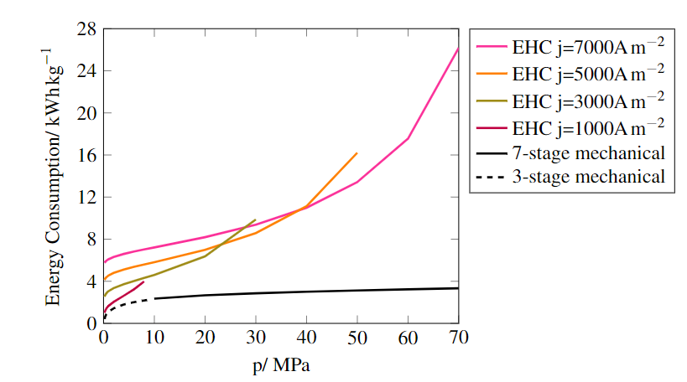
Figure 2: Energy consumption of a three-stage and seven-stage mechanical compressor, and an electrochemical compressor (EHC) for a target pressure range of 0.2-70 MPa and an inlet pressure of 0.1 MPa.

two compressors deviate more, mainly due to the back-diffusion loss of the EHC. In particular, the steep rise of the energy demand towards the ends of the solid lines shows the effect of the back-diffusion. At higher current densities, the energy consumption increases as well due to increased Ohmic and activation losses. Thus, operating at higher current densities increases the operating cost, while decreasing the capital cost.
To better understand the differences in the performance of the two compressors, in Figure 3 the energy consumption distributions of the electrochemical compressor at a temperature of 70 ºC and a current density of 100 A m⁻², and 2000 A m⁻², together with the energy consumption of a 3-stage mechanical compressor with intercooling down to 20 ºC and 70 ºC are represented. A very low current density (100 A m⁻²), to identify the range at which the energy consumption of the EHC is comparable to the mechanical, as well as a higher current density (2000 A m⁻²) near the optimal operating point (Prokopou et al., 2023) are chosen for the EHC.
At a very low current density (100 A m⁻², see Fig. 3a) and low-pressure levels, the energy consumption of the electrochemical compressor is lower than that of the mechanical compressor. This can be explained by the fact that at such low current density, the cell potential is close to the Nernst potential, which corresponds to the exergy increase of the isothermal compression. The Ohmic and activation losses have lower contributions, which are not significantly influenced by the pressure. When the pressure level is kept low, the contribution of back-diffusion losses is minor. As the pressure level increases and the back-diffusion effect becomes more prominent, the electrochemical compressor becomes less efficient than the mechanical. The results suggest that the electrochemical compressor can be competitive with the mechanical compressor in terms of energy demand when low-pressure levels and low flow rates are required so that the compressor can operate at low current densities. However, operating the compressor at low current densities increases the capital cost, and the effect of these two factors needs to be analyzed. Moreover, at higher target pressures, membranes with a lower back-diffusion effect would be also needed.
Regarding the effect of the operating temperature on energy consumption, 70 ºC was found to be a good compromise between conductivity, kinetics, and back-diffusion for the EHC (Prokopou et al., 2023). High operating temperatures are beneficial in terms of energy demand, as they reduce the activation and ohmic losses, except for very high-pressure levels and very low current densities, where the back-diffusion effect dominates (Prokopou et al., 2023). An intercooling temperature of 20 ºC is chosen for the mechanical compressor, as cooling down to low temperatures improves its energetic performance. Since lowering the temperature also reduces the minimum energy demand for compression, we compared the energy consumption of the mechanical compressor with cooling to 70 ºC with the one of EHC, to check whether this difference in operating temperature is a major factor in the observed performance differences. However, the results suggest that even with cooling down only to 70 ºC, the mechanical compressor is more efficient than the EHC for most target pressures.
At higher current density (2000 A m⁻², see Fig. 3b), the energy consumption of the electrochemical compressor is significantly higher than that of the mechanical compressor even at low target pressures. The higher the current density, the higher the Ohmic loss in the membrane and the activation loss. The back-diffusion effect is less prominent than in Figure 3a, as higher amounts of hydrogen are compressed and the Faradaic efficiency increases (Prokopou et al., 2023). The results suggest that there is a need to improve the membrane characteristics (thickness, conductivity), as well as the used catalysts to achieve energy consumption comparable to the mechanical ones.
It should be noted that the present analysis focuses only on the energetic aspect of the compression alternatives. Factors like the investment and maintenance cost of the two compressors must also be considered for a comprehensive assessment of the different options for specific applications.

a)
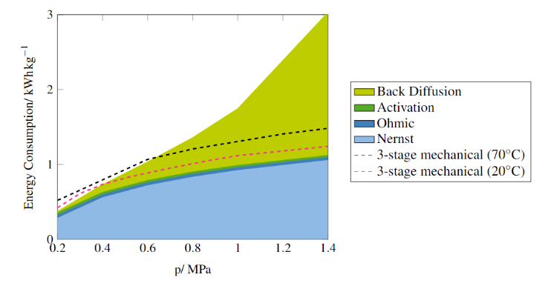

b)
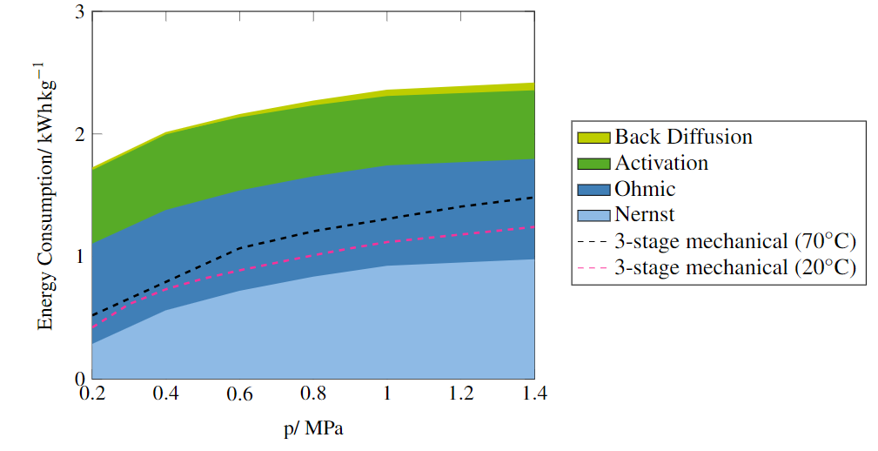
Figure 3: Energy consumption distribution of a three-stage mechanical compressor with intercooling down to 20 ºC and 70 ºC, and an electrochemical compressor at a current density of a) 100 A m⁻², and b) 2000 A m⁻², for a pressure range of 0.2-1.4 MPa at an operating temperature of 70 ºC.
  - Conclusion
The energetic performance of an electrochemical and a mechanical compressor for hydrogen compression from 0.1 MPa to different pressure levels was studied. The analysis shows that the energy demand of the electrochemical compressor is higher than that of the mechanical compressor, except for very low current densities and low-pressure levels. This suggests that EHC is mostly suitable for low-pressure applications where low hydrogen flow rates are required. Moreover, the results reveal the need to improve the membrane and the catalyst characteristics of the EHC to be competitive with the mechanical compressors at higher pressure levels. Finally, for a more comprehensive evaluation, it is important to consider both the energy and the investment cost when designing a compression system for specific applications, which will follow in future work.
Acknowledgments
The authors gratefully acknowledge the financial support by the German Federal Ministry for Education and Research (BMBF) within the project HyInnoSep of Zukunftcluster Wasserstoff.
References
Modelica Association, 2023, https://modelica.org/, Accessed on 24/11/2023.
Nafion Association, 2023, https://www.nafion.com/en, Accessed on 30/11/2023.
Nguyen M. T., Grigoriev S. A., Kalinnikov A. A., Filippov A. A., Millet P., & Fateev V. N., 2011, Characterization of an electrochemical hydrogen pump using electrochemical impedance spectroscopy, Journal of Applied Electrochemistry, 41(9), 1033–1042.
NIST (National Institute of Standards and Technology Standard Reference Data, 2023, https://webbook.nist.gov/chemistry/fluid/, Accessed on 13/11/2023
Prokopou G. I., Mödden M. L., Mitsos A., Bongartz D., 2023, Optimal Design and Operation of Electrochemical Hydrogen Compression. Submitted.
Rothuizen E., & Rokni M., 2014, Optimization of the overall energy consumption in cascade fueling stations for hydrogen vehicles, International Journal of Hydrogen Energy, 39(1), 582–592.
Sdanghi G., Maranzana G., Celzard A., & Fierro V., 2019, Review of the current technologies and performances of hydrogen compression for stationary and automotive applications. Renewable and Sustainable Energy Reviews, 102, 150–170.
Sdanghi G., Maranzana G., Celzard A., & Fierro V., 2020, Towards non-mechanical hybrid hydrogen compression for decentralized hydrogen facilities, Energies, 13(12).
Stühmeier B. M., Pietsch M. R., Schwämmlein J. N., & Gasteiger H. A., 2021, Pressure and Temperature Dependence of the Hydrogen Oxidation and Evolution Reaction Kinetics on Pt Electrocatalysts via PEMFC-based Hydrogen-Pump Measurements, Journal of The Electrochemical Society, 168(6), 064516.
Tahan M. R., 2022, Recent advances in hydrogen compressors for use in large-scale renewable energy integration, International Journal of Hydrogen Energy, 47(83), 35275–35292.
Toghyani S., Baniasadi E., & Afshari E., 2021, Performance assessment of an electrochemical hydrogen production and storage system for solar hydrogen refueling station. International Journal of Hydrogen Energy, 46(47), 24271–24285.
Zou J., Han N., Yan J., Feng Q., Wang Y., Zhao Z., Fan J., Zeng L., Li H., & Wang H.,2020, Electrochemical Compression Technologies for High-Pressure Hydrogen: Current Status, Challenges and Perspective, Electrochemical Energy Reviews, 3(4), 690–729.

