A Real-Time Risk-Based Optimization Framework for Safe and Smart Operations
Austin Braniffª, Sahithi Srijana Akundi^{b,c,d}, Yuanxing Liu^{b,c,d}, Faisal Khan^{b,c}, Efstratios N. Pistikopoulos^{b,d}, Yuhe Tian^{a*}
ª Department of Chemical and Biomedical Engineering, West Virginia University, Morgantown, WV, United States
^{b} Artie McFerrin Department of Chemical Engineering, Texas A&M University
^{c} Mary Kay O’Connor Process Safety Center, Artie McFerrin Department of Chemical Engineering, Texas A&M University, College Station, TX, United States
^{d} Texas A&M Energy Institute, Texas A&M University, College Station, TX, United States
Abstract
We present a systematic framework for real-time risk-based optimization via multi-parametric programming. A dynamic risk indicator is utilized to monitor online process safety performance and provide model-based prediction of risk propagation, as a function of safety-critical process variables. Risk-based explicit/multi-parametric model predictive control is then developed to generate fit-for-purpose control strategies for proactive risk management. Given the probabilistic nature of risk, the controller design is extended to adapt a chance-constrained programming setting coupled with Bayesian inference for continuous risk updating along the rolling time horizon. A hierarchical dynamic optimization formulation is further developed to integrate risk control, operational optimization, and fault prognosis across multiple temporal scales in an integral but computationally efficient manner. If a potential fault is detected and cannot be prevented by adjusting operating actions, an alarm will be raised well ahead of time with the controller and optimizer continuously performing to attenuate the fault propagation speed and severity. The potential and efficacy of the proposed framework are demonstrated on three safety-critical case studies with increasing level of complexity: (i) Tank filling, (ii) Batch reactor at T2 Laboratories, and (iii) Cyber-physical hydrogen water electrolysis prototype.
Keywords: Process safety management, Dynamic risk assessment, Explicit model predictive control, Multi-parametric programming, Cyber-physical energy system
  - Introduction
The ongoing transition towards industrial digitalization and smart manufacturing have posed new challenges to chemical process safety management as plants become substantially more complex, dynamic, and integrated (Lee et al., 2019). Thus, it is essential to augment safety-critical decision making with systems-based real-time operation which can proactively reduce process safety losses. Oriented from process control perspective, several works have leveraged receding horizon estimation to detect faults at the early developing stage and predict its propagation (Ahooyi et al., 2016; Bhadriraju et al., 2021). Theoretical developments have also been made to characterize a set of state variables, e.g. Lyapunov level set (Wu et al., 2018) and pertinent systems theory (Venkidasalapathy and Kravaris, 2020), for guaranteed safe and stable operations under uncertainty. Despite these efforts, key research gaps remain on: (i) Lack of a mechanistic-based understanding and metric to quantify real-time process safety performance while considering nonlinear process variable interactions, dynamic control, and uncertainties, (ii) Lack of a systematic methodology to prognostically detect fault while automatedly determining the risk control and mitigation strategy to reduce failure probability, (iii) Lack of a cyber-physical prototype to implement and demonstrate the methods toward safe and smart manufacturing systems.
To address these challenges, in this work, we introduce a dynamic risk-based control and optimization framework via multi-parametric programming (mp-P). The remainder of this paper is structured as follows: Section 2 introduces the methodology framework integrating dynamic risk assessment, stochastic model predictive control, and operational optimization. Section 3 demonstrates the proposed approaches on three safety-critical case studies including the filling of a tank, the quality control of an exothermic batch reactor, and a proton exchange membrane water electrolysis cyber-physical prototype.
  - Dynamic Risk-based Control Optimization
In this section, we present a holistic methodology framework which tackles three major research questions: (i) How to integrate dynamic risk assessment and model predictive control? (ii) How to address the probabilistic nature of risk in the control scheme? and (iii) How to identify the optimal operating trajectory accounting for process control, fault prognosis, and operational optimization which may take place over multiple time scales?
    - Dynamic Risk-based Multi-Parametric Model Predictive Control (mp-MPC)
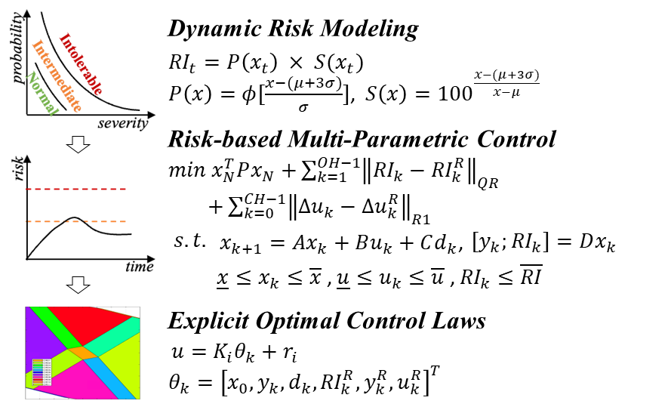
We first introduce the risk-based mp-MPC approach which sets the foundation for this framework. As shown in Fig. 1, a dynamic risk indicator ($RI$) is used to monitor online process safety considering fault probability and severity as a function of safety-critical process variables ($x_{t}$) deviation from nominal operating conditions (Bao et al., 2011). Risk-based MPC is then formulated which provides dual layers of risk management by incorporating: (i) safety-critical variable bounds as path constraints, (ii) risk as output variable to be controlled based on multivariate process dynamics under uncertainty. The receding horizon estimation also enables model-based risk propagation forecast, leading to prognostic risk mitigation by the controller. The risk-based MPC is then re-formulated to a multi-parametric mixed-integer quadratic programming problem, from which optimal control laws can be obtained offline a priori as piecewise affine functions of process states, risks, disturbances, etc. (Ali et al., 2023) The mp-MPC offline computation capability offers unique advantages to generate a quantitative understanding on the impact on risk of disturbances and control action even before operating the process online. The risk controller can thus be tuned fitting the purpose to maximize the safe operating region against disturbances.
Figure 1: Dynamic risk-based mp-MPC.
    - Stochastic Risk Control via Chance-Constrained Programming
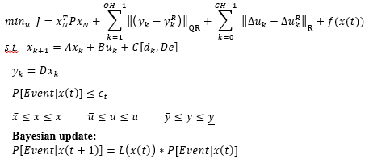
Herein, we extend the above risk-based mp-MPC approach with considerations of the probabilistic nature of risk. We propose a novel stochastic risk control approach via chance-constrained programming (SRC-CCP) as shown in Fig. 2, which stands as a versatile and adaptive method to manage uncertainties within complex systems. This approach seamlessly integrates crucial elements. Firstly, it employs Receding Horizon MPC, constantly adjusting control inputs by considering the system’s changing dynamics. Secondly, it integrates dynamic probabilistic constraints, tactically embedding real-time risk management within the control framework to ensure the system operates within specified risk boundaries. Additionally, it includes a Bayesian update mechanism, dynamically adapting these risk thresholds based on current system observations. The probabilistic constraints are deterministically incorporated via chance-constrained programming. This holistic strategy emphasizes safety while allowing the system to flexibly optimize performance amidst uncertain conditions, an effective solution crafted for modern engineering challenges. The method approximates probabilistic constraints by converting them into deterministic forms, focusing specifically on normal distributions. For the constraint, $P\left(h\left(t\right)>h_{max} | t\right)≤ϵ_{t},$a deterministic approximation is derived. $h\left(t\right)$ is a safety-critical process variable such as the tank liquid level adapted in Section 3.1. This involves calculating the inverse normal z-score ($z_{t}= φ^{-1}(ϵ_{t}))$ using standard deviation ($σ_{t})$and mean ($μ_{t})$of the current probability distribution. The resultant formulation in Eq. 1 sets a threshold for $h\left(t\right)$ based on $h_{max}$, z-score, and standard deviation $σ_{t}$, aiding in risk management within predefined limits.
Figure 2: SRC-CCP formulation.
s.t.
$h\left(t\right)>h_{max}+\left(z_{t}σ_{t}\right)$ (1)
    - Fault-Prognostic Control and Operational Optimization
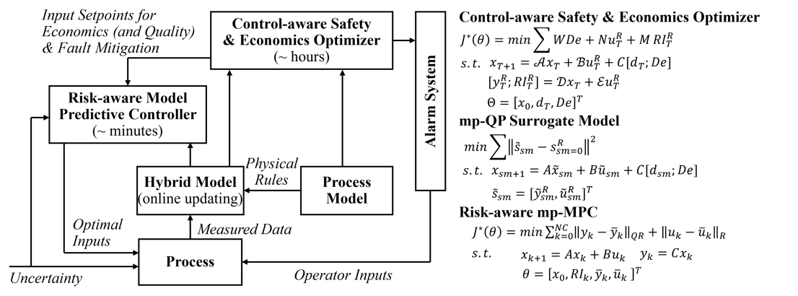
We present another key aspect of this framework to simultaneously account for risk management, process control, and operational optimization which occur at distinct characteristic time scales. For example, there may exist a trade-off on the optimal batch time between reaching the end-point product quality (after hours or days) versus maintaining the operation at a low risk level (for every second or minute). To this purpose, a hierarchical control optimization formulation (Fig. 3) is developed coupling a short-term risk controller with a long-term economics and safety optimizer. The optimizer also provides a longer fault prognosis horizon, which can be chosen tailored to the process-specific operator response time, independent of the control output horizon estimation. The decision making of the controller and optimizer are fully integrated. Namely, the optimal operating trajectory determined by the optimizer at large time steps (e.g., for real-time optimization, end-point quality control) are used to continually update the set points of the controller. On the other hand, the optimizer is aware of the controller decisions by using the process model with closed-loop control laws. In certain cases, the difference between these two time spans may be significant, such as in process systems with very fast dynamics and/or requiring long forecasting horizon. A time-bridging surrogate model becomes essential to smoothly transition the operating decisions of the optimizer at large time steps to be achievable set points for the controller at smaller time steps. The mathematical formulations for the controller, optimizer, and surrogate modeling are provided in Fig. 3, which are all solved via mp-P to obtain optimal decisions offline a priori as explicit functions of process variables. This is a key advantage to ensure computational efficiency for multi-time-scale dynamic optimization. Another online real-time risk-based optimization strategy has also been developed, the detail of which can be found in Ali et al. (2023).
Figure 3: Integrated risk control and operational optimization.
  - Illustrative Case Studies
    - Tank filling
The section implements SRC-CCP to manage a cylindrical storage tank system, which comprises a single inlet and outlet, storing a non-reactive, single-phase fluid. Central to this framework is the regulation of the safety-critical variable liquid level (h) in the tank at a setpoint (h_{sp}), facilitated by a control valve upstream of the tank. The remaining system variables and parameters include inlet volumetric flowrate (Q_{in)}, outlet volumetric flowrate (Q_{out}), cylindrical cross-sectional area (A). The control formulation is presented in Eq. 2. The optimization objective revolves around minimizing a cost function that considers the deviation of the level from setpoint. This includes a probabilistic assessment for safety through Chance-Constrained Programming. Bayesian updating is employed to refine the estimation of level changes over time, utilizing a likelihood function that supports a higher probability towards minimizing the difference between the current level and the setpoint.
$$\min_{u} J=\sum_{i=1}^{OH-1}{\left(\left({\left(h_{i}-h_{sp}\right)}^{2}\right)+INLF(h_{i},h_{sp})\right)}$$ | (2a) | Bayesian Update:  $P\left[Δh > 0 | t+1\right]=L\left(h\left(t\right)\right)*P[Δh > 0|t]$ for t in T  $L\left(h\left(t\right)\right)= \frac{1}{\sqrt{2π}σ}exp\left(-\frac{{\left(h\left(t\right)-h_{sp}\right)}^{2}}{2σ^{2}}\right)$ | (2e)
s.t. $h\left(i+1\right)= \left(1-\frac{k}{A}\right)h\left(i\right)+ \left(\frac{1}{A}\right)Q_{in}\left(i\right)$  $+\left(\frac{1}{A}\right)w(i)$ | (2b) |  | (2f)
$0≤h(i)≤h_{max}$ | (2c)
$P(Δh > 0|t)≤ϵ_{t}$ | (2d)
where $Δh$ is the current state (tank level) of the system with respect to the boundary $h_{max}$. This constraint helps the user to set a threshold $ϵ_{t}$ to the maximum risk allowed.
To evaluate the control efficacy, a closed-loop validation is performed and compared against the original open-loop tank level simulation (Fig. 4a). The results have showcased the remarkable stability of the tank level when employing Risk-informed Model Predictive Control via SRC-CCP. This approach consistently maintains the level within prescribed constraints, unlike the uncontrolled fluctuations in the open-loop scenario. While the tank levels remain within boundaries and close to reference value, the analysis focuses on the evolution of $ϵ_{t}$ (acceptable risk level or maximum allowable probability of failure) in Fig. 4b. This trend indicates a deliberate strategy shift, integrating Chance-Constrained Programming to introduce a calculated margin for potential safety constraint violations. This prioritizes system performance over rigid adherence to safety constraints, allowing adaptability to changing conditions and disturbances. The gradual increase in $ϵ_{t}$reflects the sought balance between safety and performance optimization, highlighting the pivotal role of SRC-CCP in managing this delicate trade-off in dynamic environments.
    - T2 batch reactor
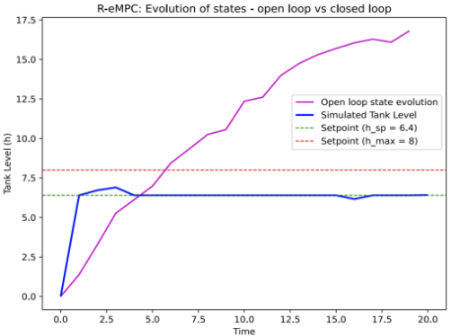
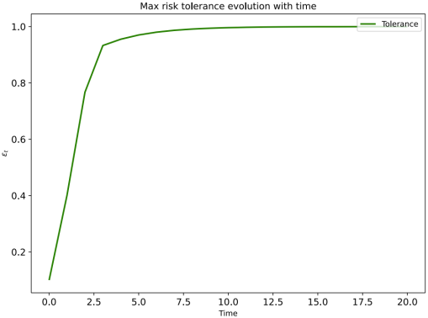
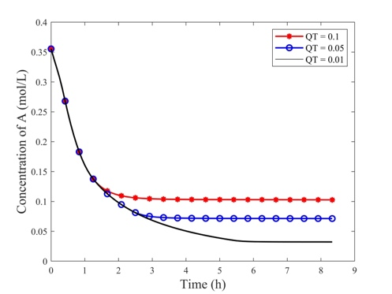
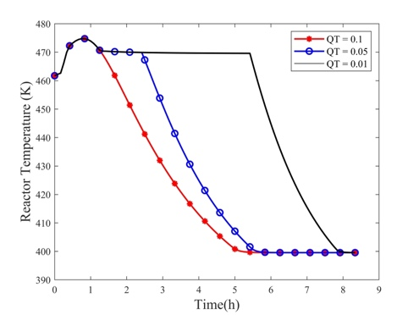
In what follows, we investigate a batch reactor adapted from the incident that occurred at T2 Laboratories in 2007. There are two exothermic reactions in this process. The main reaction produces sodium methylcyclopentadiene as the desired product. Due to the very large pre-exponential factor, the side reaction rate increases significantly at high reactor temperatures and ultimately leads to uncontrollable thermal runaway. As such, reactor temperatures beyond 480K are defined as the high-risk region in which runaway has a higher probability to occur. Dynamic risk is computed as a function of real-time temperature deviations from its nominal value (460K). The manipulated variable for risk control is the heat transfer coefficient which is in a pseudo-linear relationship with cooling utility flowrate. The control optimization objectives are to: (i) Control the reactor at low risk level throughout the batch, (ii) Optimize the operation while reaching pre-specified end-point product quality. Following Fig. 3, a short-term risk controller is designed with the control horizon as 5 min and output horizon as 10 min. A long-term quality optimizer is then formulated based on the closed-loop process dynamics forecasting the entire batch duration with an upper limit of 8 hours. We have firstly validated the effectiveness of the risk-aware controller to maintain the process at low risk level, without which open-loop operation will enter the high-risk region. Fig. 5 illustrates the integrated decision making with long-term quality optimizer. Fig. 5a presents the time profiles of reactant concentration at quality target specifications of 0.1, 0.05, and 0.01 mol/L. It can be inferred that our proposed methods are successful in meeting end-of-batch quality targets. By further examining the temperature trajectory in Fig. 5b, the optimizer adapts the maximum controllable risk (~ 470K) to meet end-product specifications efficiently and safely.
Figure 4b: Acceptable risk level with time.

Figure 4a: Open-loop and close-loop tank level.

Figure 5a: Concentration under various quality targets.
Figure 5b: Temperature profiles.

    - PEM water electrolysis
Proton exchange membrane water electrolysis (PEMWE) is a key technology for green hydrogen production, while ensuring its safe and efficient operation remains a challenge. To achieve this, several key components have been investigated as part of the framework:
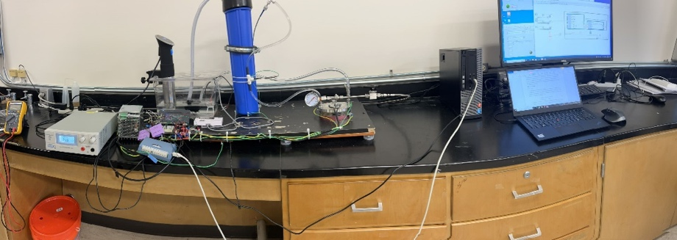
1. Lab-Scale Experimental Prototype: A lab-scale PEMWE experimental prototype is developed to gain a better understanding of the system behavior under different operating conditions. The experimental configuration has four main units: (1) water supply, (2) electrolyzer, (3) power supply, and (4) data acquisition and control unit. As shown in Figure 6, the experimental setup situated on the left generates the vital data, which is then transmitted to the target computer on the right for monitoring and control in real-time. It provides a platform to test system performance with different control strategies.
Figure 6: Experimental configuration of PEMWE system.
2. Digital Twin: A digital twin, based on the physical laws governing the PEMWE system, is developed. The virtual replica allows for real-time monitoring and control. This provides valuable insights into PEMWE system dynamics to optimize its performance.
3. Multi-parametric Control Optimization: To obtain optimal control strategies, multi-parametric programming is used for explicit model predictive control while considering multiple parameters and constraints to maximize efficiency and minimize risk.
4. Integration of mpMPC-on-a-chip Controller: The above mpMPC algorithm is then integrated into a microcontroller. This advanced controller enables real-time monitoring and control of the hydrogen production process, ensuring optimal performance and safety.
5. Risk Identification and Process Safety Management: Risk identification and process safety management are also performed using the Hazard and Operability (HAZOP) method. This method systematically analyzes the PEMWE system to identify potential hazards and risks and implements appropriate measures to mitigate them. The integration of risk assessment and safety management aims to enhance the overall safety of PEMWE.
  - Concluding Remarks
This work has presented a framework for dynamic risk-based control and optimization via multi-parametric programming. Ongoing work is investigating error-tolerant risk control using robust MPC and cyber-physical systems integration.
  - Acknowledgement
The authors acknowledge financial support from NSF RETRO Project CBET-2312457, Department of Chemical and Biomedical Engineering at West Virginia University, Mary O’Connor Process Safety Centre and Energy Institute at Texas A&M University.
References
T. M. Ahooyi, M. Soroush, J. E. Arbogast, W. D. Seider, U. G. Oktem. (2016). Model‐predictive safety system for proactive detection of operation hazards. AIChE J., 62(6), 2024-2042.
M. Ali, X. Cai, F. Khan, E. N. Pistikopoulos, Y. Tian. (2023). Dynamic risk-based process design and operational optimization via multi-parametric programming. Digital Chem. Eng., 7, 100096.
H. Bao, F. Khan, T. Iqbal, Y. Chang. (2011). Risk‐based fault diagnosis and safety management for process systems. Process Saf. Prog., 30(1), 6-17.
B. Bhadriraju, J. S. I. Kwon, F. Khan. (2021). Risk-based fault prediction of chemical processes using operable adaptive sparse identification of systems (OASIS). Comput Chem Eng, 152, 107378.
J. Lee, I. Cameron, M. Hassall. (2019). Improving process safety: What roles for Digitalization and Industry 4.0?. Process Saf. Environ. Prot., 132, 325-339.
Z. Wu, H. Durand, P. D. Christofides. (2018). Safe economic model predictive control of nonlinear systems. Syst. Control. Lett., 118, 69-76.
J. Venkidasalapathy, C. Kravaris. (2020). Safety-centered process control design based on dynamic safe set. J. Loss Prev. Process Ind., 65, 104126.

