A Systematic Analysis of Economic and Environmental Trade-Offs in Hydrogen Supply Chains with Resilience Considerations
Yasir Ibrahim^{a,b}, Elizabeth J. Abraham^{a,c,d}, Dhabia M. Al-Mohannadiª
ªDepartment of Chemical Engineering, Texas A&M University at Qatar, Education City, PO Box 23874, Doha, Qatar
^{b}Department of Multidisciplinary Engineering, Texas A&M University, College Station, 77843 TX, United States
^{c}Artie McFerrin Department of Chemical Engineering, Texas A&M University, 3122 TAMU, College Station, TX 77843, USA
^{d}Texas A&M Energy Institute, Texas A&M University, 1617 Research Pkwy, College Station, TX 77845, USA
dhabia.al-mohannadi@qatar.tamu.edu
Abstract
The global impacts of climate change have necessitated a shift in the production, distribution, and consumption of energy. To facilitate this transition in energy that will replace fossil fuels with more renewable sources, it is key to understand the role of energy storage in supply chains of the future energy mix. Due to the intermittent nature of renewable energy, hydrogen is gaining traction to store this energy and thereby plays a major role towards achieving greener energy systems. As multiple segments within the hydrogen supply chain are presently being investigated extensively to enable deployment at larger scales, there is considerable uncertainty associated with the progress of the supply chain as a whole. Furthermore, these supply chains will not only need to account for the uncertainties that come with the energy transition, but those that inherently exist for all supply chains. Accordingly, there is a need to incorporate resilience into the design and optimization of hydrogen supply chain networks that account for such uncertainties. Through this work, an optimization-based model is presented to analyze the trade-offs that exist between economic and environmental decision objectives when resilience is considered. In this manner, strategies for managing disruptions within the context of energy security and sustainable development can be developed to adapt to changing circumstances.
Keywords: Resilience, Hydrogen supply chain networks, Multi-objective optimization
  - Introduction
Hydrogen supply chain networks (HSCN) have become an integral part of global discussions on the energy transition. As a cleaner alternative to traditional energy sources, the drive to utilize hydrogen is reinforced by its ability to connect various energy sectors, enhancing the flexibility of systems through diverse transportation and distribution networks (Li et al, 2019). Hydrogen's adaptability with other forms of energy, such as ammonia, methanol, and liquid organic hydrogen carriers, further diversifies the energy sector. The range of sources for hydrogen production, from fossil fuels to renewables, and the associated technologies at various maturity levels, present a complex landscape for conversion technologies and transportation options, including ships, pipelines, and trucks. This complexity necessitates a holistic analysis of the different components of HSCNs, each with its unique functionalities.
In this work, we concentrate specifically on technology failure scenarios within HSCNs. Our analysis identifies technology failure as a prevalent and impactful uncertainty. These failures, ranging from total system shutdowns to gradual recoveries, effectively mirror a spectrum of real-time operational disruptions commonly encountered in the industry. While acknowledging the existence of various uncertainties in HSCNs, our focused approach on technology failures allows for a nuanced exploration of resilience strategies. This specificity enables a realistic assessment of critical conditions and resilience measures in response to technological disruptions. As HSCNs evolve to meet climate targets, uncertainties related to their implementation, influenced by a myriad of internal and external factors, become increasingly significant. To address these challenges, our study embraces the concept of resilience. The ability of HSCNs to anticipate, withstand, and recover from disruptive events, particularly technology failures, is crucial for maintaining system integrity. This resilience is assessed through both qualitative and quantitative approaches (Gasser et al., 2018), aiming to minimize adverse impacts and restore performance.
This paper introduces a novel superstructure-based optimization approach to design resilient HSCNs. We specifically address the vulnerabilities arising from the diverse and time-variant factors affecting HSCN's production and utilization pathways. This approach equips decision-makers to evaluate economic and environmental impacts under various disruption scenarios, aiming to identify optimal network configurations. The subsequent sections will detail our methodology, present a case study applying this approach, and conclude with our findings and directions for future work.
  - Methodology
The superstructure-based multi-objective optimization approach used in this work is adopted from Ibrahim and Al-Mohannadi (2023). Through their approach, the selection of the optimal production, storage, and transportation technologies can be determined, where each technology is represented as an input-output module. The selection of the technologies that can be considered for the design of the HSCN is based on the stage-gate process presented in Abraham et al. (2021). Each module is associated with operational capacities, capital and operating costs, and further is defined by a unique set of resources with given specifications. These resources can then be exchanged between different technologies to meet a set hydrogen demand target and carbon dioxide reduction targets for the HSCN, which are set as constraints. In the face of disruptive events, the impact is essentially on the capacity of the system. Either the system stops performing entirely or partially. To introduce resilience considerations in this model, we introduce a parameter called the operation phase, given by $θ$, which essentially defines the operational capacity of a unit as defined by Eq. (1).
$$Operational capacity=θ×Maximum operational capacity$$ | (1)
At different rates of the operation phase, ranging from complete outage (0.0) to full operation (1.0), the multi-objective optimization model will decide the optimal pathways to meet the set demand targets while accounting for economic and environmental trade-offs when disruptions in performance defined by capacity changes occurs.
Central to our approach is the concept of diversification, which is favored over redundancy as a resilience strategy. Diversification, in this context, refers to the integration and utilization of a wide array of technologies and resources within the HSCN. By embracing diversification, our model does not solely rely on redundant capacities (duplicate systems for backup) but rather explores a variety of pathways and technologies that can be activated or adjusted in response to disruptions. This diversification approach enhances the HSCN's robustness by enabling it to adapt to various disruptions without relying on a limited set of solutions. The model evaluates different production, storage, and transportation options to determine the most resilient network design. It also assesses the feasibility and impact of switching between energy sources, technologies, or logistical routes in response to changing conditions. This ensures that the HSCN remains functional and efficient under operational challenges, securing a sustainable and reliable energy supply.
  - Case Study
In pursuit of considering resilience in the design of the HSCN, we employed the proposed multi-objective optimization model to analyze the impact of imposing CO₂ emission reduction targets with technology failures and subsequent recovery phases. The HSCN is set to export 30,000 t of hydrogen. The data pertaining to the economic parameters was established from the works of Ibrahim and Al-Mohannadi (2023) and Ahmed et al. (2020). 3D Pareto surface plots were then obtained to illustrate the relationship between unit operational phases, total costs of producing and distributing hydrogen, and carbon reduction goals. The impact of disruptions was analyzed on units that represent production, transportation, and storage.
    - Pipeline Disruptions
In the first case, the impacts of disruptions on the transportation mode, namely, pipelines were analyzed. The Pareto plot obtained in this case is shown in Figure 1.
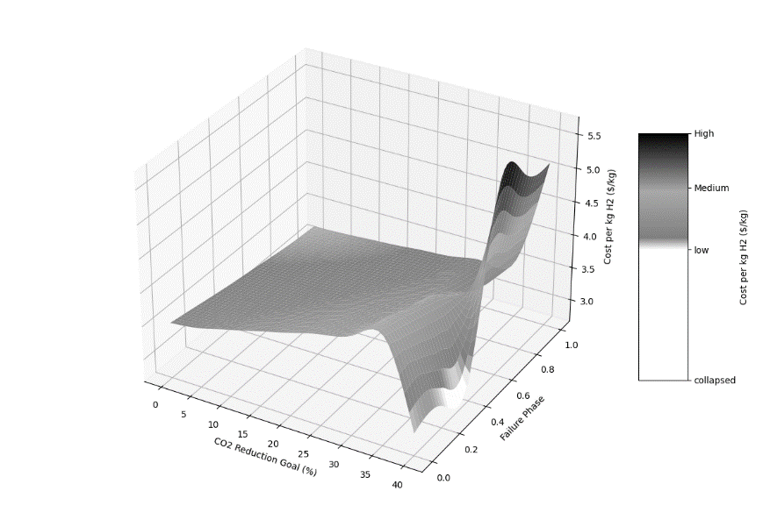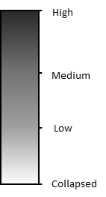
Figure 1: Pareto plot for the operational phases of the pipeline
For lower CO₂ reduction goals (0% to approximately 15%), the cost of hydrogen production and distribution decreases as the operational performance of the pipeline recovers. This is due to a gradual recovery in the pipeline mode as it is more cost-effective than other expensive alternative transportation means (such as trucks in this case). As the CO₂ reduction goal increased beyond 15% the cost became more volatile as more technologies for carbon capture needed to be deployed. There is a significant peak in cost associated with the most restrictive CO₂ reduction goal of 40% reaching 5.31 $/kg. Moreover, the plot shows collapsing phases (as highlighted in white) when the CO₂ reduction goal is at its maximum and the pipeline’s operational performance ranges from 0 to 40% operational phase. This highlights the network is more vulnerable to pipeline failures when it strives for aggressive CO₂ reduction goals.
    - Storage Disruptions
      - Hydrogen Storage
The Pareto plot in Figure 2 provides insights on the impact of disruptions on gaseous hydrogen storage when coupled with economic and environmental considerations.
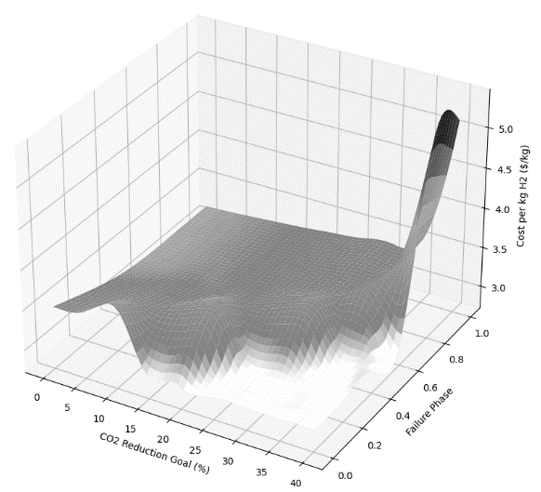
Figure 2: Pareto plot for the operational phases of hydrogen storage
In the early phases of operational recovery, the cost exhibits significant variability, which can be attributed to the reliance on more expensive hydrogen storage alternatives, such as liquid vessels, to compensate for the reduced operational capacity of gaseous hydrogen storage. Figure 2 shows that hydrogen storage is a more vulnerable portion of the HSCN due to the presence of more collapsing phases especially when higher CO₂ reduction goals need to be achieved. These white areas pinpoint critical stress points where urgent recovery actions are necessary to avoid system collapse. Furthermore, as expected, there is a gradual increase in the cost per kg of hydrogen as the CO₂ reduction goal increases. However, the cost initially remains relatively stable but spikes to $5.31/kg for ambitious targets due to the need for costlier carbon capture technologies or cleaner production methods.
      - Carbon Storage
As the carbon reduction targets of the HSCN play a pivotal role in achieving climate targets, the impact of disruptions on carbon storage which is vital to achieving these targets is analyzed. The Pareto plot indicating the influence of these disruptions is presented in Figure 3. At relaxed CO₂ reduction targets, the system is stable even at lower operational phases or capacities or higher performance losses. This suggests that the network relies on low-cost carbon emission mitigation technologies (i.e. SMR accompanied by carbon capture). As the CO₂ reduction goal intensifies, the graph shows an increase in the cost per kg of H₂, particularly at higher levels of operational impairment in CO₂ storage until the system collapses. However, the valleys or lower-cost areas in the operational phase axis indicate that there are levels of resilience built into the network, allowing for some degree of flexibility and cost control. These points correlate with the network's ability to leverage other CO₂ reduction measures that are less dependent on storage, such as low-carbon hydrogen production or enhanced utilization of CO₂.

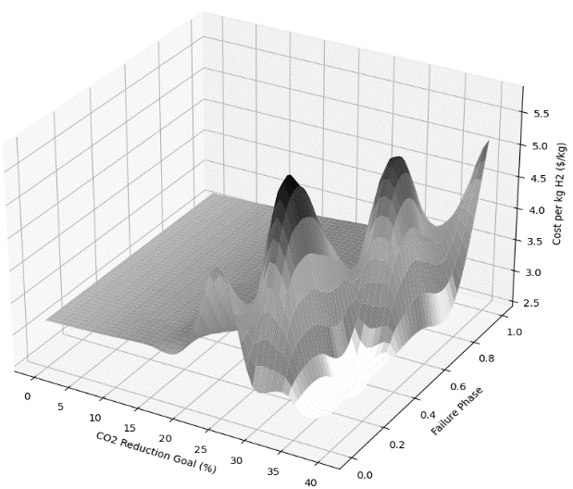
Figure 3: Pareto plot for the operational phases of carbon storage
Despite the inherent resilience and cost control mechanisms within the network, the observed white areas represent collapsing phases and signify critical points where the system fails to meet hydrogen demands under extreme CO₂ reduction goals. The inability to rely solely on carbon storage necessitates the activation of more costly carbon mitigation strategies. However, the increasing frequency and breadth of these collapsing phases suggest that the network's current flexibility does not suffice when faced with the duality of extensive CO₂ storage outages and rigorous environmental standards.
    - Production disruptions
To understand the impact imposed by disruptions on production units, Figure 4 depicts the failure of the SMR, which showcases a twofold challenge for the HSCN.
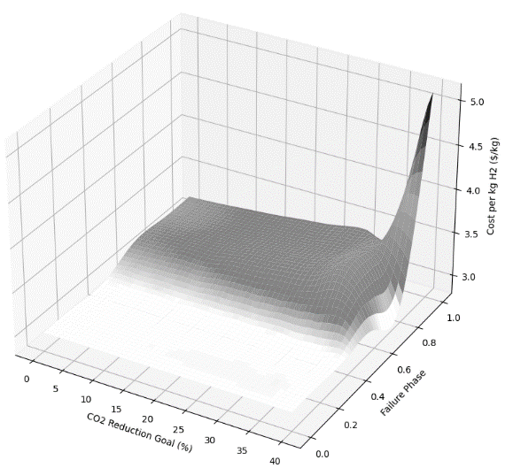
Figure 4: Pareto plot for the operational phases of the SMR
On one hand, the initial absence of SMR’s operational capacity (from 0 to almost 60%) and subsequent collapse of the system as shown by the expansive white region indicate the network’s substantial dependence on this technology to meet the hydrogen demand. Moreover, this further indicates that without the SMR, the network cannot meet production demand by solely depending on existing green and white production technologies, namely electrolysis and natural gas pyrolysis (Kvaerner process). On the other hand, the pursuit of more stringent CO₂ reduction goals further exacerbates the situation, as it drives the cost per kg of hydrogen to a peak of 5.31 $/kg. This rise in cost can be attributed to the network’s shift towards more CCUS technologies to adhere to stricter CO₂ emissions regulations.
  - Conclusions
This study presents a multi-objective optimization model for a HSCN that prioritizes cost efficiency, CO₂ emission thresholds, and network resilience. The model highlights the importance of integrating diverse hydrogen production technologies and demonstrates that while each component’s operational disruption impacts the network, there are some components that are more critical than others, such as the SMR in this. The network's resilience, as evidenced by its ability to recover and maintain functionality despite disruptions, underscores the need for robust and adaptable system designs that can withstand individual plant failures that still meet environmental and economic objectives. For future work, it is essential to extend the model's capabilities by incorporating recovery time metrics to provide a more nuanced understanding of system resilience. Additionally, measuring system reliability to predict the likelihood and timing of future failures will be a critical step forward to enhance the sustainability and reliability of HSCNs.
  - Acknowledgments
The authors gratefully acknowledge the support of Qatar National Research Fund (QNRF) grant NPRP14C-0920-210017 and the TAMUQ PhD Fellows Program.
References
E. J. Abraham, F. Ramadan, D. M. Al-Mohannadi, 2021, Synthesis of Sustainable Carbon Negative Eco-Industrial Parks, Frontiers in Energy Research, 9.
L. Li, H. Manier, M. Manier, 2019, Hydrogen supply chain network design: An optimization-oriented review, Renewable and Sustainable Energy Reviews, 103, 342-360.
P. Gasser, P. Lustenberger, M. Cinelli,W. Kim, M. Spada, P. Burgherr, S. Hirschberg, B. Stojadinovic, T. Y. Sun, 2019, A review on resilience assessment of energy systems, Sustainable and Resilient Infrstructure, 6, 5, 273-299.
R. Ahmed, S. Shehab, D. M. Al-Mohannadi, P. Linke, 2020, Synthesis of integrated processing clusters, Chemical Engineering Science, 227, 115922.
S. Cutter, 2018, Compound, Cascading, or Complex Disasters: What's in a Name?, Environment: Science and Policy for Sustainable Development, 60, 6, 16-25.
Y. Ibrahim, D. M. Al-Mohannadi, 2023, Optimization of low-carbon hydrogen supply chain networks in industrial clusters, International Journal of Hydrogen Energy, 48, 36, 13325–13342.

