Integration of real-time optimization and model-predictive control: Application to refinery diesel pool
Pelin Dologlu,^{a,*} A. Eren Vedin,ª Rıdvan Memiş,ª Sadık Ödemiş,^{b} Kemal Burçak Kaplan,ª Shaig Goyushov,^{c} Mehran Isgandarli,^{c}
ªSOCAR Turkey, Digital Transformation Department, Istanbul 34485, Turkey
^{b}SOCAR STAR Oil Refinery, Advanced Process Control Department, Aliaga, Izmir 35800, Turkey
^{c}SOCAR STAR Oil Refinery, Planning Department, Aliaga, Izmir 35800, Turkey
pelin.dologlu@socar.com.tr
Abstract
The manual adjustment of the refinery's diesel pool flash point to meet planning department quality specifications is challenging due to multiple input flows from units like HCU, KHT, and DHT. Operational changes, tank operations, and blending scenarios further complicate flash point management. Additionally, conditions like tank change operations in the diesel pool while the process is ongoing make it difficult to adjust flash points solely by intermittently taking samples to determine the tank's flash point. For this reason, maintaining the flash point close to the low specification limit reduces giveaway and maximizes profits. However, if the flash point value falls below the low limit, the product cannot be sold as it will be out of specification. Since managing such a sensitive operation with open-loop control is not feasible, integration of RTO and MPC for refinery diesel pool is studied in this paper. The RTO minimizes the giveaway coming from the deviation of the target flash points in the diesel pool tanks, where blends of HCU, KHT and DHT units’ middle products are stored. The optimizer determines the flash points at all blending and individual product flow points, which are then sent to the diesel pool. The optimizer sends the found flash point values as set points for the current operation directly to the MPC that controls the HCU naphtha product flow rate. Through the integration of RTO and MPC in the refinery diesel pool, significant financial improvements have been realized.
Keywords: real-time optimization, model-predictive control, hydrocracker unit, diesel pool, flash point
  - Introduction
Stringent environmental regulations, with the goal of reducing sulfur oxide emissions from land and sea vehicles, compel refineries to generate low sulfur fuels. The demand for ultra-low-sulfur (ULSD) diesel, ULSD gasoline, and low-sulfur marine grade fuels has surged in compliance with the latest Emission Control Area regulations (Iplik et al., 2021). To meet these evolving standards, refineries employ various processes, such as kerosene hydrotreatment (KHT), diesel hydrotreatment (DHT), and the hydrocracker unit (HCU). KHT focuses on improving the quality of kerosene, DHT targets enhancements in diesel properties, and HCU involves the conversion of heavy hydrocarbons into lighter, more valuable products. These processes collectively contribute to the production of low sulfur fuels, aligning with the imperative to minimize environmental impact. However, the manual adjustment of flash points in the diesel pool, where the outputs of KHT, DHT, and HCU are stored, poses a significant challenge. EN-590 ULSD fuel specifications ( E. C. for Standardization, 2009) necessitate the ULSD flash point to be above 55°C. Diesel produced from various units are being pooled into final product tanks. Traditionally, each unit adheres to planning instructions to ensure the final tank content meets the required specification. The flash point, fundamentally, is the lowest temperature at which a liquid can form an ignitable mixture in air. Contrary to conventional arithmetic blending, the flash points of components in a mixture don't linearly combine (Riazi, 2005). This non-linearity poses challenges. Operating safely often means maintaining a flash point significantly above the 55°C benchmark, which can lead to financial losses referred to as 'giveaway'. The financial implications are twofold: blending off-spec can be costly, and maintaining a flash point much higher than necessary results in the inclusion of excess high-value components, leading to giveaway. One primary factor influencing the flash point is the presence of light components in the mixture, particularly wild naphtha in the stripper column. Therefore, the challenge lies in optimizing the blend to include a greater proportion of naphtha – a lower value component – in the high-value diesel product, while simultaneously adhering to the flash point specifications.
In addition to these challenges, refineries produce a product known as heavy naphtha. This heavy naphtha can also be blended into the diesel pool. However, the inclusion of heavy naphtha necessitates meticulous formulation and a robust system for close monitoring of pool values. Using naphtha can effectively counteract the giveaway, further optimizing the value derived from the diesel pool. Compounding the challenge is the fact that the flash point of naphtha cannot be measured within the refinery's laboratory. To address these challenges, integration of real-time optimization (RTO) and model predictive control (MPC) for heavy naphtha addition to diesel pool is proposed minimizing giveaway coming from the deviation of the target flash points in the diesel pool tanks.
  - Materials and Methods
    - Flash Point Prediction of ULSD Fuel Blends
The non-additive nature of the flash point, as previously mentioned, precludes its calculation through simple arithmetic averages. This has led to numerous attempts to establish an index for the flash point of a given component, as documented in various studies. These indices help to linearize the problem of blending. Several noteworthy formulations from the literature include; flash point prediction proposed by Wickey and Chittenden shown in Eq. (1), and another method introduced by Hu and Burns shown in Eq. (2) (Riazi, 2005).
$\log\left(I_{FP}\right)=-6.1188+ \frac{2414}{T_{FP}+503.71}$ (1) | $I_{FP}={\left(T_{FP}\right)}^{\frac{1}{-0.06}}$ (2) | $F_{m}={\left[\sum_{i}^{n}{I_{FP}}*v_{i}\right]}^{-0.06}$ (3)
where $I_{FP}$, $T_{FP}$, $F_{m}$ and $v_{i}$ are the flash point index, the flash point of component, the flash point of mixture in (K) and the volume fraction of component $i$.
Among these, the formula developed by Hu and Burns demonstrates the most accurate alignment with our historical data. Moreover, the default power factor of -1/0.06 is consistently adjusted and fed back into the calculation based on the flash point measurements reported by the laboratory. This power factor parameter ($r$) is adaptively optimized based on residuals from the last 8 samples. After determining the index, the flash point of mixture is calculated using Eq. (3) (Riazi, 2005).
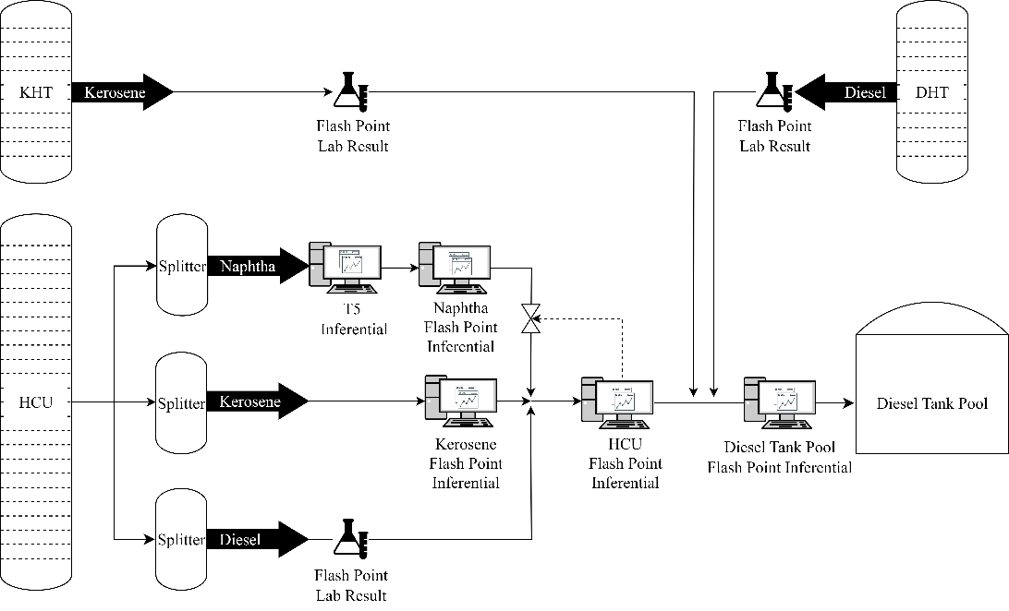
Figure 1. Diesel pool flow schema for proposed methodology
Diesel, kerosene and naphtha output flows from KHT, DHT, and HCU are blend and stored in diesel tank pool (see Figure 1). In order to adjust the flash point of diesel tank pool, it is important to know flash point of product flows simultaneously as a first step. Afterwards, blend flash points can be predicted. Flash point inferentials for naphtha and kerosene flows of HCU, HCU blended flow and diesel tank pool flow are created for closely monitoring. HCU diesel, KHT kerosene and DHT diesel laboratory samples are taken often enough, and not change too much, thus final lab results can be used for blends flash point. HCU kerosene flash point inferential is a soft sensor and its inputs are splitter bottom temperature, splitter top pressure and reboiler duty. HCU naphtha flash point inferential calculated via experimental equation calculated from %5 temperature (T5), since they are highly correlated. T5 inferential model is linear regression model which are inputs are naphtha splitter tray temperature and overhead pressure. HCU kerosene and naphtha flash point inferential models are developed via linear regression method, and then blending point flash points are calculated based on these models. Two blending point inferentials, which are HCU and diesel tank pool, are calculated via Eq. (3). All these individual product inferentials provide the most accurate and up-to-date result for the next blending point inferentials. Thus, the flash points of HCU and diesel tank pool are calculated to minimize giveaway in real-time according to the current product flow.
In addition to real-time flash point prediction for blending points, it is important to know the flash point of critical tank levels for the future. This enables the business unit to make decisions in advance regarding plant flows, especially in the HCU. Flash points of tank critical levels and tank closure for the future are forecasted in this work. This forecasting is done by assuming that if each plant flow and flash point of each plant is stable, then the flash point of the blended product will be calculated for each critical level and tank closure.
    - Integration of Real-Time Optimization and Model-Predictive Control
MPC is a control strategy that optimizes the control inputs of a system over a certain prediction horizon by solving an optimization problem at each time step. It involves manipulating variables (MV) and controlled variables (CV) to achieve desired performance while satisfying constraints.
RTO is a layer within the process automation hierarchy that provides set-points to a regulatory control layer determined through economic optimization (Darby et al., 2011). In this work, RTO-MPC integration is proposed, in which a prediction of the closed-loop response of the HCU naphtha flow MPC regulation is utilized within the RTO optimization formulation. “Implied" naphtha flashpoint is calculated based on adaptive optimization techniques that minimizes residuals from the blend prediction within given bounds. This provides the HCU diesel flash point as a set point to the underlying MPC level. In the developed MPC application, the CV is the flash point of the diesel coming out of the HCU, while the MV variable is the amount of naphtha added to the diesel (see Figure 1 and Eq. (7)). The RTO's objective function for a diesel production process is designed to minimizing giveaway, which is directly related to flash point minimization of diesel tank flash point. Displayed below are the objective function (Eq. (4)) and constraints (Eqs. (5-11)) utilized for solving the Nonlinear Programming (NLP) problem.
Min $F_{Diesel Tank }={\left[\sum_{i}^{n}{F_{i}}*v_{i}\right]}^{-r}$ | i∈[DHT, KHT, HCU] | (4)
$s.t. F_{Diesel Tank}$ ​≥ F_{min, Diesel Tank} |  | (5)
$F_{HCU}={\left[\sum_{j}^{n}{F_{j}}*v_{j}\right]}^{-r}$ | j∈[ HCU Naphtha, HCU Kerosene, HCU Diesel] | (6)
$F_{HCU Naphtha}$ = f($v_{HCU Naphtha}$) | (MPC Layer) | (7)
$F_{HCU Naphtha}$ = f(${T5}_{HCU Naphtha}$) |  | (8)
F_{min,k}​ ≤ F_{k}​ ≤ F_{max,k} | k∈[ DHT, KHT, HCU, HCU Naphtha, HCU Kerosene, HCU Diesel] | (9)
$v$ _{min,k}​ ≤ $v$ _{k}​ ≤ $v$ _{max,k} | k∈[ DHT, KHT, HCU Naphtha, HCU Kerosene, HCU Diesel] | (10)
0.04 ≤ $r$ ≤ 0.08 |  | (11)
where F is flash point, $v$ is flow rate ratio, and $r$ is hyperparameter that should be also regularized mentioned in Eq. (3). Gradient descent algorithm is used for solving that NLP problem. Our algorithm employs a heuristic approach that iteratively searches for the optimal solution within a predefined search space. While this approach does not guarantee global optimality, it is effective in reaching near-optimal solutions efficiently in practical refinery scenarios. When a sufficiently good result, often identified as a local minimum, is attained, the iterative process is brought to a halt.
  - Results and Discussion
This study delves into the optimization of diesel blending processes in refineries to meet the demand for ULSD fuels. The focus lies on addressing the complex issue of flash point adjustment in the diesel pool. Our investigation incorporates RTO and MPC, proposing a systematic approach to minimize financial losses associated with both blending off-spec and excessive use of high-value components. The primary objective is to strike a balance, ensuring the flash point remains above the mandated 56.5°C benchmark while maximizing the inclusion of lower-value components, such as wild naphtha.
The first aspect of this study involves the development and application of flash point prediction models for ULSD fuel blends. Figure 1 illustrates the proposed methodology, emphasizing the integration of diesel, kerosene, and naphtha flows from various refinery units into the diesel tank pool. Real-time flash point predictions are crucial in this process, considering the scarcity of laboratory samples and the need for constant monitoring. This approach involves the use of inferentials for naphtha and kerosene flows, creating a dynamic system that adapts to changing conditions and minimizes giveaway in real-time.
Furthermore, this study extends beyond immediate operational concerns to forecast future flash points of critical tank levels. A comparison of before and after the commissioning of this forecasting study can be seen in Figure 2a and 2b. Instead there are multiple tanks in diesel pool, one of the busiest tank closure flash point lab is selected and prediction model results is compared for selected tank. Tank closure flash point results are plotted as one year duration for each before and after the commissioning of this forecasting study. The average tank closure flash point before this study was 57.3 °C, flash point of tank closure is 56.75 °C with the help of this project. Since the target flash point is 56.5 °C because of buffer of lower flash point limit for this RTO, giveaway is minimized successfully. Additionally, the flash point for the diesel pool can be easily forecasted with this project, closely matching the actual tank closure lab results. While flash point prediction average is 56.77 °C, actual tank closure flash point lab result average is 56.75 °C for the same dates (Figure 2b). Since margin of error for the laboratory flash point experiment is 0.5 °C, 0.25 °C bias is quite acceptable improvement. With the help of this successful forecasting results, this proactive approach allows refineries to make informed decisions in advance, particularly in the context of the HCU.
Figure 2. Selected tank closure flash point result from diesel tank pool, a) before this project, b) after this project
The integration of RTO and MPC emerges as a key strategy in our proposed methodology. By utilizing the dynamic model of the system and considering constraints, we optimize control inputs over short prediction horizons. In the developed MPC application, the flash point of HCU blend serves as the controlled variable, with the manipulated variable being the amount of naphtha added to the diesel pool. The provided trend in Figure 3 represents a 5-days representative section where MPC is active on HCU. During this time interval, the planning instruction was given within the range of 50-52 °C, and the average of 15 HCU diesel and kerosene blending point (before naphtha is added) samples taken in total was realized as 50.3 °C, approaching the minimum target by as close as 0.3 °C on average (Figure 3a). Thanks to MPC applications, it is possible to provide external set points for CVs. As a result, it becomes much more frequent to reach the set point, within operational limits, and most importantly, in an automatic manner, thus significantly reducing giveaways compared to manual operations. This integrated approach not only ensures compliance with flash point specifications but also enhances the overall efficiency of the blending process (Figure 3b).
As delving into the specific results and observations, the proposed methodology holds promise in addressing the intricate challenges posed by environmental regulations while optimizing the economic value derived from the diesel pool.
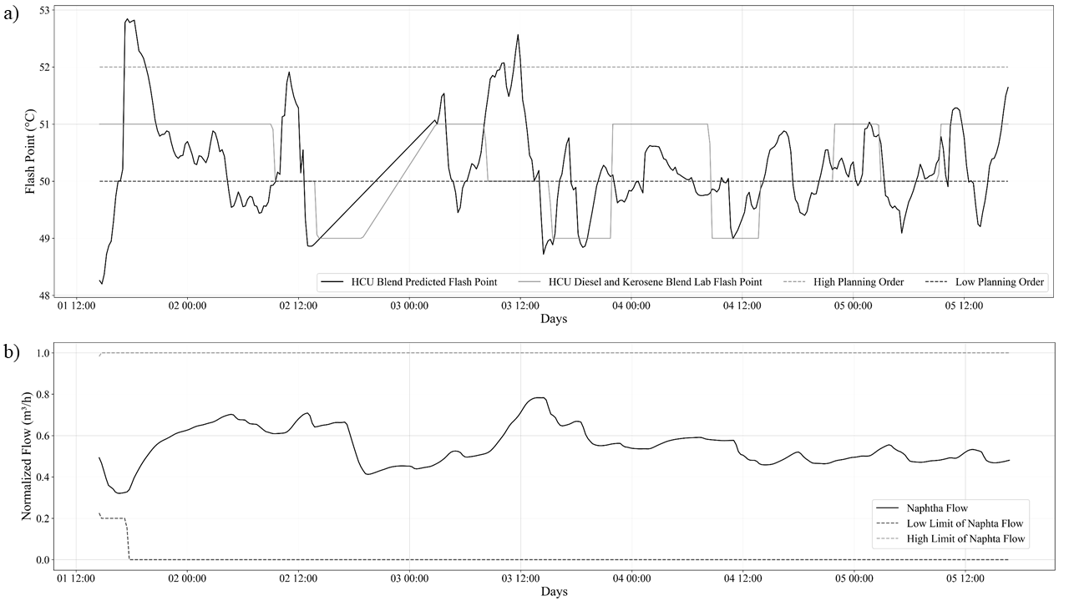
Figure 3. 5-days representative section where MPC is active on HCU a) HCU blending points flash point changes, b) adaptive naphtha flow to adjust flash point of HCU blend
  - Conclusions
In summary, this study navigates the optimization of diesel blending processes, with a primary focus on the intricate task of adjusting the flash point within the diesel pool. By leveraging real-time predictions and inferentials for naphtha and kerosene flows, the minimization of giveaway has been effectively achieved. Beyond immediate operational concerns, this study has successfully forecasted future flash points, resulting in a substantial reduction of average tank closure flash points from 57.3 °C to 56.75 °C.
The integrated approach extends to easy forecasting of the diesel pool flash point, aligning closely with actual lab results. The use of RTO and MPC has proven pivotal, as demonstrated in Figure 3, ensuring not only compliance with flash point specifications but also a significant enhancement in overall blending efficiency.
This proactive methodology does not just meet regulatory requirements; it strategically optimizes the economic value derived from the diesel pool. The success of the forecasting results and the automatic nature of the approach empower refineries to make informed decisions in advance, particularly in the dynamic context of the HCU. In essence, this study showcases the potential for addressing environmental challenges while simultaneously maximizing the economic efficiency of the diesel blending process.
References
Darby, M. L., Nikolaou, M., Jones, J., & Nicholson, D. (2011). RTO: An overview and assessment of current practice. Journal of Process Control, 21(6), 874–884. https://doi.org/10.1016/J.JPROCONT.2011.03.009
E. C. for Standardization (2009). EN-590: Automotive Fuels-Diesel-Requirements and test methods. European Committee for Standardization Brussels.
Iplik, E., Tsirikoglou, P., Aslanidou, I., & Kyprianidis, K. (2021). Parameter estimation and sensitivity analysis for a diesel hydro-processing model. Computer Aided Chemical Engineering, 50, 573–578. https://doi.org/10.1016/B978-0-323-88506-5.50091-7
Riazi, M. R. (2005). Characterization and properties of petroleum fractions (Vol. 50). ASTM international.

