Data-driven Process Variable Prediction Using Augmented Orthogonal Autoencoder
Junqing Xia*, Yoshiyuki Yamashita
Department of Applied Physical and Chemical Engineering,
Tokyo University of Agriculture and Technology,
2-24-16, Naka-cho, Koganei City, Tokyo 184-8588, Japan
xiajunqing@m2.tuat.ac.jp
Abstract
In recent years, data-driven soft sensors have grown in popularity as a means of measuring hard-to-obtain variables. However, many modelling methods for soft sensors encounter difficulties when dealing with highly correlated and nonlinear data found in chemical plants. This paper presents a simple and effective soft sensor modelling method based on orthogonal autoencoder neural network augmented with regression network structure. This configuration allows the findings of a low-dimensional latent space suitable for constructing a regression model for a process response variable. The Tennessee Eastman Process and Benchmark Simulation Model no.2 were used to evaluate the predictive performances of our proposed method, and the results demonstrated that our proposed method can provide benefits over conventional data-driven techniques for soft sensor modelling.
Keywords: Machine learning, variable prediction, soft sensor modelling.
  - Introduction
Reliable and timely measurement is a crucial aspect of ensuring plant-wide control and product quality managements. While modern hardware sensors can effectively cover a wide range of measurement tasks, measuring variables such as product concentrations in a chemical process still demands a substantial investment in equipment, not to mention the significant delay caused by the measurement. Software sensor (or soft sensor), utilising mathematical models and existing measurements, offers an alternative means of measurement alongside hardware sensors. Soft sensors based on first-principle models have been developed and deployed over the past few decades. Nevertheless, developing such a soft sensor requires a profound comprehension of the target process, as well as a large amount of time and efforts.
A preferable alternative to first-principle soft sensor is data-driven soft sensor constructed using collected process historical operation data. However, it has been widely recognised that data obtained from a typical chemical plant exhibits high correlations among its process variables. Therefore, direct application of regression techniques for soft sensor construction would result undesirable predictive results. Moreover, nonlinear characteristics of process data, as well as the correlations between latent variables and response variables, must be taken into consideration as well (Ching, et al., 2021).
In this study, we propose regression network structure based on an augmented orthogonal autoencoder architecture to address the aforementioned challenges of modelling soft sensors for chemical processes. Section 2 introduces some fundamental concepts, while section 3 describes our proposed modelling method in detail. In section 4, we examine the prediction performance of our approach using two industrial benchmarks.
  - Preliminaries
    - PCR and PLSR
Principal component analysis (PCA) is undoubtedly one of the most employed data compression techniques. A data matrix, consisting of n samples with m features, is projected onto a low-dimensional subspace T, formed by p (p < m) principal components:
(1)
These principal components can be further utilised as explanatory variables in constructing regression models. This technique is referred to as principal component regression (PCR), and it has been widely used for soft sensor modelling (Ebrahimi, et al., 2017). However, as the explanatory principal components are obtained solely from the decomposition of the process variable matrix X, necessary correlations with the response variables might be absent, thus adequate predictive performance of PCR cannot be assured.
Partial least squares regression (PLSR) was developed from the idea of compressing data akin to PCA and PCR. But instead of focusing on X alone, PLSR projects both explanatory and response variables onto two different low-dimensional subspaces (Eqs. 1 and 2). The decomposition of the two matrices is performed to maximize the covariance between the two projection matrices T and U.
(2)
    - Autoencoder and Orthogonal Autoencoder
Autoencoder (AE) is another well-known machine learning technique that can be used as a tool for data compression. A typical AE comprises an encoder and a decoder. If the dimensionality of the middle layer formed between encoder and decoder is smaller than that of the input, then the input data will be forcedly compressed using the encoder before being reconstructed again by the decoder. This procedure creates a bottleneck, leading to the capture of the underlying data features. Such features captured by the bottleneck layer can be referred to as latent features. In a typical AE with only one hidden layer (i.e. the bottleneck layer), the latent features can be obtained as:
(3)
where x and h are the vectors for input and the latent layers, W_{en} is the weight matrix of the encoder, b_{en} is the bias term, and f is the activation function for the neurons. One of the significant advantages of AE over PCA is its capability of obtaining nonlinear underlying data features via the use of nonlinear activation functions.
Recently, a modified version of AE called orthogonal autoencoder (OAE) has been utilised for the purpose of process fault detection and diagnosis (Davide and Kulahci, 2022). It was discovered that without the enforcement of the orthogonality regularisation L_{O}, there will be no warranty on the correlation issue, thus high-level correlation was observed among the extracted features from AE. As a solution to this issue, an additional regularisation term was added into the data reconstruction cost of AE training as the “cost of correlation” in Eq. 4.
(4)
where L_{O} and L_{AE} are cost for latent feature correlation and AE data reconstruction, respectively.
  - Proposed Method
Although the elimination of multi-collinearity among latent features can be guaranteed using OAE, similar to the limitation of PCR, the latent features of a regular OAE are obtained only through mapping of the process data matrix alone, without any feedback from response variable. Thus it is conceivable that a regression model constructed with such latent features as explanatory variables will not attain acceptable predictive accuracy for soft sensors.
Inspired by the concept of PLSR and its relation with PCR, this study presents a modified OAE network to model soft sensors. As shown in Figure 1, an additional network structure, starts from the bottleneck layer and ends at a single node, is integrated into a regular OAE network. Using this architecture, high dimensional data is firstly compressed into uncorrelated latent features by the OAE. Then through the newly added network, these latent features are utilised as explanatory variables to construct a regression model for the response variable. To ensure the correlations between latent features and the response variable, as well as optimal predictive capability of the entire model, an additional regularisation term L_{RG} is integrated into Eq. 4 as “the cost of regression performance:”
(5)
In this research, we employed the squared error between the measured value of response variable and its prediction as L_{RG}, and thus Eq. 5 can be written in details as:
(6)
where λ_{RG}, λ_{O}, and λ_{AE} are the predetermined weights of regression performance, orthogonality, and data reconstruction cost, respectively. y and ŷ denote the measured response variable and its prediction. h denotes the vector consisted of m explanatory latent features. I is a k×k identity matrix. x and x̂ are the sample vector and its reconstruction.
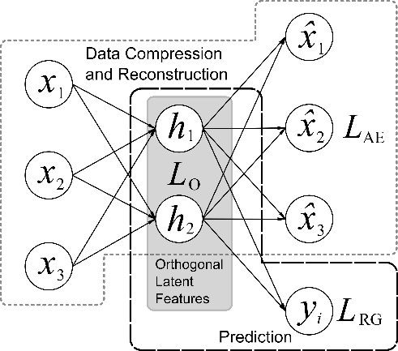

Figure 1 The architecture of our proposed modelling approach
Our proposed approach shares many similarities with PLSR, consequently benefiting from the numerous advantages offered by PLSR. The OAE section of our network is the equivalent to X = TP^{T} + E (Eq. 1) for compressing data, while the regression section resembles Y = UQ^{T} + F (Eq. 2). And the total training cost function has similar role to the manner of how data is decomposed in PLSR, which regulates OAE data compression in favour of finding uncorrelated explanatory latent features that have decent capabilities of modelling and predicting a response variable.
Beyond these similarities, our proposed approach provides two more advantages over PLSR and its nonlinear variants, therefore provides more flexibility for process engineers and operators: firstly, by choosing nonlinear activation functions such as ReLU and tanh for OAE and regression sections of the network, nonlinear mappings can be established with ease; secondly, the nature of neural network further allows our structure to be modified in needs of handling process data of various types and forms.
  - Case Studies
In order to assess the predictive performance of our proposed approach, case studies were conducted on two industrial benchmarks: the Tennessee Eastman Process (TEP) and the Benchmark Simulation Model No.2 (BSM-2). The TEP study primarily focused on the predictive performances under near-steady-state operations, whereas the BSM-2 study examined the predictions under nonlinear operating conditions. The weights of each regularisation term was set to λ_{RG} : λ_{O} : λ_{AE} = 1 : 1 : 1 for both studies. The predictive performances were evaluated by rooted mean squared error (RMSE) as well as coefficient of determination (R²), and the results were compared with PCR, PLSR, and linear regression utilising latent features from a regular OAE (OAE-LLR).
    - Tennessee Eastman Process and Case Study Results
The Tennessee Eastman Process (Downs and Vogel, 1993) is a widely recognised chemical process benchmark simulator with a total of 52 process variables. In this study, 33 variables (xmeas 1 ~ 22 and xmv 1 ~ 11) were used as model inputs, while the remaining variables (xmeas 23 ~ 41) were considered as response variables. The dataset under normal operating condition (Rieth, et al., 2017) acquired from an upgraded version of TEP (Reinartz, et al., 2021) were partitioned into two potions with an 80:20 ratio for training and testing. The number of latent features was set to 15 according to Davide and Kulahci’s work (2022) for all involved test methods.
The OAE section of our proposed approach consisted of an input layer (33 nodes), three encoder layers (75-50-30 nodes), a bottleneck layer (15 nodes), as well as the mirroring decoder and output layers. The augmented regression section started from the OAE bottleneck layer and concluded at the prediction output layer (1 node) with no hidden layer. For each of the 19 response variables, a neural network model was constructed. The linear activation function was selected based on preliminary tests. Due to spatial constraints, only a subsets of prediction results are presented in Table 1 and Figure 2.
    - Benchmark Simulation Model No.2 and Case Study Results
Benchmark Simulation Model No.2 (BSM-2) is another commonly utilised process simulator, that models a wastewater treatment plant featuring non-linear and long-term process dynamics (Gernaey, et al., 2014). In this research, 19 variables were used as model inputs (Table 2). Total nitrogen amount and dissolved nitrogen in the effluent were chosen as response variables due to their significant contributions to water pollution (Takeuchi and Yamashita, 2023). The dataset encompasses one year of operation with 15-minute sampling interval and has been partitioned into training and test portions with an 80:20 ratio. The number of latent features has been set to five for all involved test methods, since it was found by preliminary tests that 85% of total data information can be preserved with five principle components using PCA. The nodes of each layer in the OAE section of our proposed approach have been set to 19-36-24-12-5-12-24-36-19 using ReLU activation functions. The nodes in regression section has been set to 5-1 using linear activation functions. The predictive performances were listed in Table 3.
Table 1 RMSE and R² scores using various modelling approaches for TEP
Response  Variable | PCR |  | PLSR |  | OAE-LLR |  | Proposed Method
 | RMSE | R² | RMSE | R² | RMSE | R² | RMSE | R²
xmeas 23 | 0.665 | 0.572 | 0.633 | 0.672 | 0.662 | 0.575 | 0.578 | 0.676
xmeas 25 | 0.720 | 0.533 | 0.665 | 0.623 | 0.703 | 0.553 | 0.637 | 0.631
xmeas 26 | 0.827 | 0.331 | 0.795 | 0.473 | 0.813 | 0.379 | 0.733 | 0.474
xmeas 29 | 0.704 | 0.518 | 0.613 | 0.703 | 0.664 | 0.554 | 0.551 | 0.704
xmeas 38 | 0.719 | 0.511 | 0.709 | 0.637 | 0.721 | 0.511 | 0.606 | 0.650

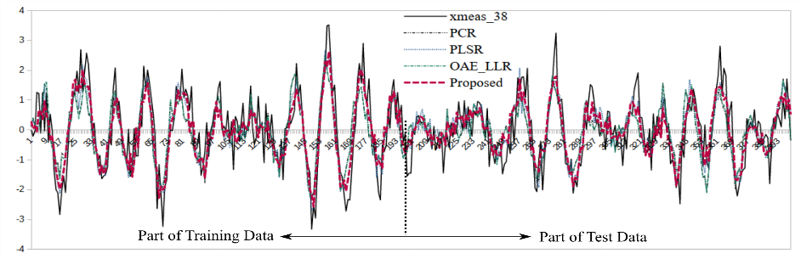
Figure 2 Part of predictions with various approaches for TEP xmeas-38

Table 2 Process variables of BSM-2 used for modelling
Flow rate (Influent) | Flow rate  (Reactor 1) | Total suspended solid  (Reactor 5) | Flow rate  (Dewater inflow)
Temperature (Influent) | Temperature  (Reactor 1) | Flow rate  (Reject) | Temperature  (Dewater inflow)
Flow rate  (Primary clarifier overflow) | Dissolved O₂  (Reactor 3) | Temperature  (Thickener inlet) | Flow rate  (Sludge)
Temperature  (Primary clarifier overflow) | Dissolved O₂  (Reactor 4) | Flow rate  (Thickener overflow) | Temperature  (Sludge)
Flow rate  (Primary clarifier underflow) | Dissolved O₂  (Reactor 5) | Flow rate  (Thickener underflow)

Table 3 RMSE and R² scores using various modelling approaches for BSM-2
Response Variable |  | PCR | PLSR | OAE-LLR | Proposed Method
RMSE | Total nitrogen in effluent | 0.998 | 0.956 | 0.940 | 0.848
 | Dissolved nitrogen in effluent | 0.697 | 0.652 | 0.671 | 0.562
R² | Total nitrogen in effluent | 0.002 | 0.148 | 0.07 | 0.335
 | Dissolved nitrogen in effluent | 0.232 | 0.346 | 0.117 | 0.575

    - Overall Discussions
From the results of both studies, it can be observed that modelling using the latent variables from OAE generally performed better than using these from PCA, possibly due to the improved capture of process data pattern by utilising OAE rather than PCA. Furthermore, it can be observed from Figure 3 that our proposed approach was able to predict the overall trend of response variable better than PCR, OAE-LLR, and PLS. These studies clearly demonstrated that by integrating the evaluation of regression performances into the procedure of finding uncorrelated latent features, not only the linear and non-linear latent features of processes can be captured during the training of network, correlations between these latent features and response variables can also be identified simultaneously, thus enabling better modelling of soft sensors with improved predictive performances.
  - Conclusions
Table 3 RMSE and R² scores using various modelling approaches for BSM-2
Response Variable |  | PCR | PLSR | OAE-LLR | Proposed Method
RMSE | Total nitrogen in effluent | 0.998 | 0.956 | 0.940 | 0.848
 | Dissolved nitrogen in effluent | 0.697 | 0.652 | 0.671 | 0.562
R² | Total nitrogen in effluent | 0.002 | 0.148 | 0.07 | 0.335
 | Dissolved nitrogen in effluent | 0.232 | 0.346 | 0.117 | 0.575

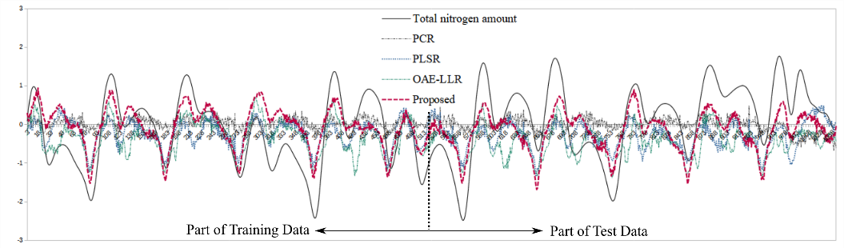
Figure 3 Part of predictions with various approaches for BSM-2 Total Nitrogen

In this study, we presented a simple, flexible, and effective approach for modelling data-driven soft sensors. An additional network structure was attached to the bottleneck layer of an orthogonal autoencoder for the purpose of predicting response variable. This proposed concept was tested by two industrial process benchmarks, demonstrating its capability of modelling soft sensors regardless of steady-state or nonlinear operation data. The results from the case studies illustrate the potential of our proposed method for modelling soft sensors, and we firmly believe that it can be further developed to fulfil various needs in process monitoring and operation.
References
P.M.L. Ching, R.H.Y. So, T. Morck, 2021, Advances in soft sensors for wastewater treatment plants: A systematic review, J. Water Proces. Eng., 44, 102367
C. Davide, M. Kulahci, 2022, A novel fault detection and diagnosis approach based on orthogonal auto-encoders, Compu. Chem. Eng., 163, 107853
J.J. Downs, E.F. Vogel, 1993, A plant-wide industrial process control problem. Comput. Chem. Eng., 17, 245 – 255
M. Ebrahimi, E.L. Gerber, T.D. Rockaway, 2017, Temporal performance assessment of wastewater treatment plants by using multi-variate statistical analysis, J. Environ. Manage., 193, 234 – 246
K.V. Gernaey, U. Jeppsson, P.A. Vanrolleghern, J.B. Copp, 2014, Benchmark of Control Strategies for Waste Water Treatment Plants, IWA Publishing, London, U.K.
C. Reinartz, M. Kulahci, O. Ravn, 2021, An extended Tennessee Eastman simulation dataset for fault-detection and decision support systems. Comput. Chem. Eng., 149, 107281
C.A. Rieth, B.D. Amsel, R. Tran, M.B. Cook, 2017, Additional Tennessee Eastman process simulation data for anomaly detection evaluation, Harvard Dataverse
A. Takeuchi, Y. Yamashita, Prediction of nitrogen content in effluent from waste water treatment plants using a data-driven model, 2023, The 66th Japan Joint Automatic Control Conference, October 7-8, 2023, Sendai, Japan

