Parameter estimation of multi-substrate biokinetic models of lignocellulosic microbial protein systems
Mason Banks,ª Mark Taylor,^{b} Miao Guo^{a*}
ªKing’s College London, Strand, London WC2R 2LS, United Kingdom
^{b}Marlow Ingredients Ltd, Nelson Ave, Billingham TS23 4HA, United Kingdom
*miao.guo@kcl.ac.uk
Abstract
The current global food system faces significant challenges related to waste production, carbon emissions, and resource inefficiency. This work aims to address these issues by focusing on the application of microbial protein technology for sustainable protein production from organic waste, thereby promoting a circular economy. The study focuses on a critical bottleneck in bioprocess development, specifically in waste carbon utilisation, emphasising the need for precise biokinetic models. Unstructured models are to be employed for their simplicity and widespread applicability, but challenges in parameter estimation persist, especially for multi-substrate systems. The research introduces an experimental-computational methodology for high-throughput screening, utilising absorbance spectroscopy and HPLC analysis from batch 96 well plate fermentations. The study expands parameter estimation techniques towards multi-substrate biokinetic models for the conversion of lignocellulosic hydrolysates to mycoprotein (Fusarium venenatum A3/5). Various experimental designs explore the influence of sugar composition, pre-culture environment, and substrate-to-biomass ratio on model performance. The ultimate goal is to inform decision-making for the viable scale-up of industrial waste-to-mycoprotein processes, considering sustainability and technoeconomic constraints.
Keywords: Lignocellulose, Microbial Protein, Parameter Estimation, Waste-to-Protein
  - Introduction
    - Background
The current global food system produces substantial waste and carbon emissions and relies on excessive use of arable land and freshwater supplies (Holden et al., 2018). These factors not only result in environmental degradation but also exacerbate the issues of increasing global hunger and protein deficiency according to a recent meta-analysis by Van Dijk et al. (2021). A potential solution to this global challenge was explored by Durkin et al. (2022) who demonstrated high potential for recovery of carbon and nutrients from global by-product streams (i.e. organic waste) using microbial protein technology to produce sustainable, high-quality protein while promoting a circular economy. However, despite increasing research attention in waste valorisation and microbial protein technologies, several critical bottlenecks exist at each stage of bioprocess development that hinder rapid and viable scale-up (Piercy et al., 2023). In the context of waste carbon utilisation, the development of precise and accurate biokinetic models is critical to informing decision makers in fermentation process design (Narayanan et al., 2019) but remains a challenging task due to compositional variation of feedstock substrates utilised via complex gene regulatory pathways which are experimentally demanding to characterise particularly for non-model microorganisms (Panikov, 2021), in addition to outstanding challenges in model identification and parameter estimation of microbial processes (Wieland et al., 2021).
    - Parameter estimation of biokinetic models
Biokinetic models describe the behaviour of a biological system, such as cell growth, substrate consumption, and product formation. Unstructured models predict microbial growth and metabolism without considering detailed intracellular processes or population structures (Muloiwa et al., 2020). Eq. (1) is the model empirically determined by Monod (1949), a hyperbolic expression relating specific growth rate ($μ$) to the concentration of the limiting substrate ($S$) defined by two parameters, the maximum specific growth rate ($μ_{max}$) and the half-saturation constant ($K_{s}$).
$$μ=μ_{max}\frac{S}{S+K_{s}}$$ | (1)
For a single substrate system, growth of biomass ($X$) and substrate depletion can be described by a pair of ODEs, Eq. (2). A yield coefficient ($Y_{X/S}$) is introduced as a third parameter to define the conversion efficiency from substrate to biomass.
$$\frac{dX}{dt} = μX \frac{dS}{dt} = -\frac{μX}{Y_{X/S}}$$ | (2)
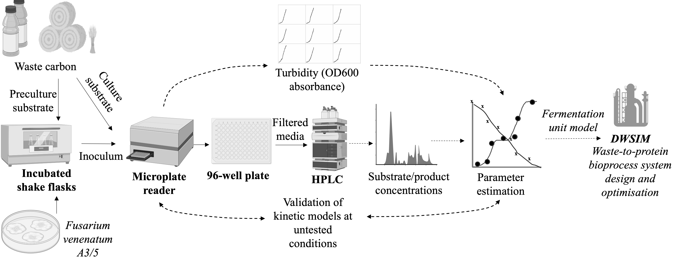
This unstructured model is predominantly employed for design and simulation of industrial bioprocesses due to its simplicity and good performance when applied to a wide range of microorganisms and environmental conditions. Previous research has focused on incorporating the influence of other variables into unstructured models, including pH and temperature (Infantes et al., 2012), cell maintenance (van Bodegom, 2007), endogenous decay (Bahar & Ciggin, 2016), substrate/product inhibition (Tan et al., 2000), and extending models to describe multi-substrate utilisation (Amrane et al., 2005; Chohji et al., 1984) and microbial consortia interactions (Hanly & Henson, 2013) to accurately model more complex systems. However, despite the advantages provided by unstructured models, several challenges hinder their effective implementation. Firstly, a long-standing research problem is the ability to determine unique estimates of $μ_{max}$, $K_{s}$, and $Y_{X/S}$ parameters. An excellent review by Kovárová-Kovar & Egli (1998) highlighted how parameter estimates with high goodness-of-fit from E. coli growth
Figure 1: Experimental-computational methodology workflow (Solid arrows = Material flows; Dashed arrows = Data flows).
experiments varied greatly between different publications, the result of differing experimental designs and parameter estimation methods. Furthermore, a ubiquitous method for reliably obtaining uncorrelated estimates of $μ_{max}$ and $K_{s}$ has not yet been developed (Liu & Zachara, 2001). Furthermore, despite their relevance to sustainable bioprocesses using complex sugar feedstocks, the development of rigorous unstructured multi-substrate models remains relatively underexplored compared to structured modelling approaches such as flux balance analysis, the development of which can be experimentally expensive and highly strain-dependent and therefore not always generalisable across processes (Qiu et al., 2023). Recent work by Manheim et al. (2019) in unstructured modelling of microbial kinetics have attempted to create a generalised methodology for parameter estimation and have demonstrated improved accuracy, predictive capacity and lower estimator bias when utilising global non-linear regression routines, particularly when employing metaheuristic optimisation algorithms (e.g. particle swarm optimisation), compared to local non-linear regression. However, only single-substrate models were investigated using this approach, leaving scope for future work exploring multi-substrate systems of key relevance to waste-recovery fermentation processes.
    - Extension of parameter estimation methodology towards multi-substrate biokinetic models of microbial protein production from lignocellulosic hydrolysates
This work aims to expand upon research efforts into accurate and precise parameter estimation techniques towards predictive modelling of multi-substrate systems. Our specific focus is to develop high fidelity mathematical models that describe the fermentation kinetics underpinning the conversion of synthetic lignocellulosic hydrolysate (containing primary monomeric sugars D-glucose and D-xylose) to mycoprotein using generally recognised as safe (GRAS) certified fungal strain Fusarium venenatum A3/5. To achieve this, we have implemented a hybrid experimental-computational methodology for high-throughput screening of biomass and substrate/by-product time-series profiles through on-line absorbance spectroscopy and off-line high performance liquid chromatography (HPLC) analysis respectively.
  - Materials and Methods
    - Biokinetic model parameter estimation methodology and experimental design
Experimental data will be used within a parameter estimation framework applied to an array of candidate unstructured biokinetic models describing dual-substrate depletion
and biomass growth. One example system is given by Eq. (3-4), which models consumption of substrates through semi-independent metabolic pathways using distinct growth parameters for each substrate, including constants $k_{s1}$ and $k_{s2}$ to capture transcriptomic inhibition effects of substrate pairs such as carbon catabolite repression.
$μ_{1}=μ_{max,1}\frac{S_{1}}{S_{1}+K_{s1}+k_{s2}S_{2}} μ_{2}=μ_{max,2}\frac{S_{2}}{S_{2}+K_{s2}+k_{s1}S_{1}}$ | (3)
$\frac{dX}{dt}={(μ}_{1}+μ_{2})X \frac{dS}{dt}=-μ_{1}\frac{X }{Y_{X/s1}}-μ_{2}\frac{X }{Y_{X/s2}}$ | (4)
Different experimental designs covering the space of lignocellulosic sugar composition of agricultural residues will be explored to determine the range of parameter values associated with waste resources of variable batch-to-batch valorisation potentials. In addition, the pre-culture environment and initial substrate to biomass ratio will also be varied to determine the influence of culture history and adaptation on the values of parameter estimates and model performance. The use of high-throughput 96-well plates provides a significant advantage when investigating several influencing factors. For example, using a full-factorial design, the three aforementioned factors can be investigated at three levels in triplicate in a six-point time series, the total number of experiments (wells) required can be calculated as the total number of conditions multiplied by the number of time points and replicates respectively (i.e. 3³ $×$ 6 $×$3 $=$ 486), thereby requiring only five 96-well plates in total to investigate the design space.
Different non-linear regression methods including the Levenberg-Marquardt algorithm, particle swarm optimisation, and differential evolution algorithms and will be compared in their ability to provide unbiased, accurate and precise parameter estimates, in addition to model goodness of fit and convergence speed. The open-source platform Pyomo will be used to optimise the objective function to minimise the sum of square errors between observed experimental data and the predicted values of the candidate biokinetic model systems as stated in Eq. (5), where $n$ is the number of data points, $y_{i}$ and $x_{i}$ are the output response and input at point $i$ respectively, and $f(x_{i},θ)$ is the non-linear system evaluated at point $x_{i}$ with the vector of parameter values $θ$.
$$minimise \sum_{i=1}^{n}{​{{[y}_{i}-f(x_{i},θ)]}^{2}}​$$ | (5)
Subsequently, the predictive accuracies of the candidate models and best parameter estimates are then evaluated through cross-validation with testing data partitioned from the original experimental dataset.
    - Experimental materials and methods
50 mL Erlenmeyer flasks containing 3 w/v% of carbon substrate in minimal salts media are inoculated with F. venenatum A3/5 from agar plates and incubated at 28 ºC with a shaking speed of 130 rpm. After 72 h, spores are harvested using a 100 μm cell strainer and spore concentration is determined using a hemocytometer and optical microscope, and subsequently diluted with sterile media to the desired concentration. Aliquots of stock solutions containing 300 g/L D-glucose and D-xylose are then added to minimal salts media to make up 5 mL vials containing 3 w/v% total substrate with varying ratios of the two sugars. The prepared dilution is then used to inoculate each of the vials with a predefined spore concentration. Wells of a clear, flat-bottom, non-treated 96 well plate are then filled with 200 μL of the vial contents. Each vial is used to make up 6 wells of the plate which are sequentially harvested at 6 time points over the course of 96 hours of batch fermentation. Each of the time points are repeated in triplicate. A microplate reader is used to measure the well absorbance at a wavelength of 600 nm at 28 ºC and 100 rpm using a double-orbital shaking mode. Optical density (OD) readings are taken every 20 min and subsequently converted to biomass concentrations using a predetermined calibration function. Extracellular media of the harvested wells is separated from cell material using Sartorius Claristep 0.2 μm filters into 2 mL vials. The liquid media from each well is analysed following a protocol for residual sugars and sugar alcohols. The column used for separation of compounds is the Biorad Aminex HPX-87H (300 x 7.8 mm) with mobile phase of dilute sulphuric acid (5 mM) at a flowrate of 0.6 mLmin⁻¹ and temperature of 50 ºC. The separated compounds are then detected by an in-line refractive index detector (RID) with absorbance wavelength of 210 nm to generate spectra, from which time-series concentrations are to be determined.
  - Results & Discussion
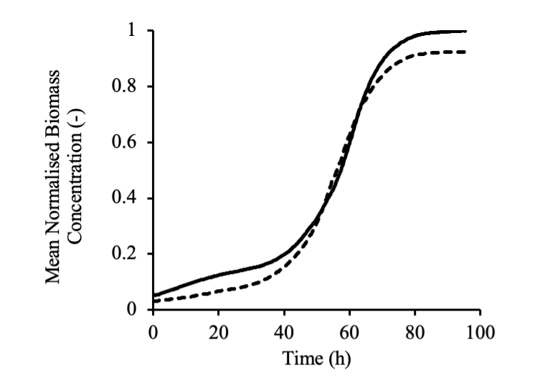 | 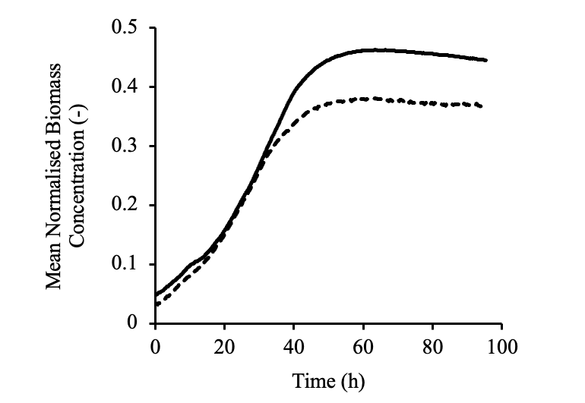
Figure 2: Mean biomass growth curves normalised relative to positive control using D-glucose (left panel) and D-xylose (right panel). Solid curves represent identical pre-culture substrate (e.g. glucose/glucose), while dashes lines represent alternate pre-culture substrate (e.g. xylose/glucose).

Preliminary research aimed to investigate the relative growth of F. venenatum A3/5 utilising D-glucose and D-xylose as sole substrates and the effect of preculture (inoculation) substrate environment on subsequent growth. The results demonstrate that the final biomass concentration achieved when utilising D-xylose is less than half of that of D-glucose, suggesting a lower substrate-to-biomass conversion efficiency (yield) despite a longer initial lag time when utilising D-glucose. Furthermore, results suggest that glucose is the preferred pre-culture substrate for this mixed sugar cultivation when the objective is to maximise the overall biomass yield, suggesting that D-xylose preculture potentially enhances production of by-products (e.g. ethanol) throughout the fermentation. However, upcoming work implementing HPLC analysis of media composition and rigorous model-based parameter estimation (as discussed in the previous sections) is required to test these hypotheses. Nevertheless, the initial results provide parameter intervals for $μ_{max,1}$ and $μ_{max,2}$ calculated from tangential approximation of the biomass curves to narrow the solution space of parameters thereby increasing the likelihood of locating the global optimum solution to the non-linear regression problem.
  - Conclusion
In conclusion, this research lays the groundwork for advancing microbial protein technology and waste valorisation. The ongoing work involves rigorous parameter estimation for multi-substrate systems, specifically focusing on lignocellulosic hydrolysate fermentation by fungal strain Fusarium venenatum A3/5 to produce microbial protein (mycoprotein). The proposed methodology integrates experimental data with computational models, aiming to enhance accuracy in predicting fermentation kinetics. Results from this ongoing research will contribute to the optimisation of bioprocess flowsheets, guiding decision-making for the sustainable and economically viable scale-up of waste-to-mycoprotein systems. Preliminary results demonstrate the feasibility of utilising lignocellulosic sugars for the growth of F. venenatum A3/5 biomass, including pentose substrates despite demonstrating lower overall growth yields. Future work will build upon this knowledge by investigating sugar consumption and by-product concentration throughout the fermentation for implementation within a parameter estimation framework to more comprehensively characterise and model the lignocellulosic fermentation system.
References
Amrane, A., Adour, L., & Couriol, C. (2005). An unstructured model for the diauxic growth of Penicillium camembertii on glucose and arginine. Biochemical Engineering Journal, 24(2), 125–133.
Bahar, S., & Ciggin, A. S. (2016). A simple kinetic modeling approach for aerobic stabilization of real waste activated sludge. Chemical Engineering Journal, 303, 194–201.
Chohji, T., Sawada, T., Nakamura, Y., & Kuno, S. (1984). Mathematical model for diauxic growth of microorganisms in mixed substrate medium. Journal of Chemical Engineering of Japan, 17(5), 478–485.
Durkin, A., Finnigan, T., Johnson, R., Kazer, J., Yu, J., Stuckey, D., & Guo, M. (2022). Can closed-loop microbial protein provide sustainable protein security against the hunger pandemic? Current Research in Biotechnology, 4, 365–376.
Hanly, T. J., & Henson, M. A. (2013). Unstructured Modeling of a Synthetic Microbial Consortium for Consolidated Production of Ethanol. IFAC Proceedings Volumes, 46(31), 157–162.
Holden, N. M., White, E. P., Lange, M. C., & Oldfield, T. L. (2018). Review of the sustainability of food systems and transition using the Internet of Food. Npj Sci Food, 2(18).
Infantes, D., González del Campo, A., Villaseñor, J., & Fernández, F. J. (2012). Kinetic model and study of the influence of pH, temperature and undissociated acids on acidogenic fermentation. Biochemical Engineering Journal, 66, 66–72.
Kovárová-Kovar, K., & Egli, T. (1998). Growth Kinetics of Suspended Microbial Cells: From Single-Substrate-Controlled Growth to Mixed-Substrate Kinetics. Microbiology and Molecular Biology Reviews, 62(3), 646–666.
Liu, C., & Zachara, J. M. (2001). Uncertainties of Monod Kinetic Parameters Nonlinearly Estimated from Batch Experiments. Environmental Science & Technology, 35(1), 133–141.
Manheim, D. C., Detwiler, R. L., & Jiang, S. C. (2019). Application of unstructured kinetic models to predict microcystin biodegradation: Towards a practical approach for drinking water treatment. Water Research, 149, 617–631.
Monod, J. (1949). The Growth of Bacterial Cultures. Annual Review of Microbiology, 3(1), 371–394.
Muloiwa, M., Nyende-Byakika, S., & Dinka, M. (2020). Comparison of unstructured kinetic bacterial growth models. South African Journal of Chemical Engineering, 33, 141–150.
Narayanan, H., Luna, M. F., von Stosch, M., Cruz Bournazou, M. N., Polotti, G., Morbidelli, M., Butté, A., & Sokolov, M. (2020). Bioprocessing in the Digital Age: The Role of Process Models. Biotechnology Journal, 15(1).
Panikov, N. S. (2021). Genome-Scale Reconstruction of Microbial Dynamic Phenotype: Successes and Challenges. Microorganisms, 9(11).
Piercy, E., Verstraete, W., Ellis, P. R., Banks, M., Rockström, J., Smith, P., Witard, O. C., Hallett, J., Hogstrand, C., Knott, G., Karwati, A., Rasoarahona, H. F., Leslie, A., He, Y., & Guo, M. (2023). A sustainable waste-to-protein system to maximise waste resource utilisation for developing food- and feed-grade protein solutions. Green Chemistry, 25(3), 808–832.
Qiu, S., Yang, A., & Zeng, H. (2023). Flux balance analysis-based metabolic modeling of microbial secondary metabolism: Current status and outlook. PLOS Computational Biology, 19(8), e1011391.
Tan, Y., Wang, Z.-X., & Marshall, K. C. (2000). Modeling Substrate Inhibition of Microbial Growth. Biotechnology and Bioengineering, 52(5), 602–608.
van Bodegom, P. (2007). Microbial Maintenance: A Critical Review on Its Quantification. Microbial Ecology, 53(4), 513–523.
Van Dijk, M., Morley, T., Rau, M. L., & Saghai, Y. (2021). A meta-analysis of projected global food demand and population at risk of hunger for the period 2010-2050. Nature Food, 2, 494–501.
Wieland, F.-G., Hauber, A. L., Rosenblatt, M., Tönsing, C., & Timmer, J. (2021). On structural and practical identifiability. Current Opinion in Systems Biology, 25, 60–69.

