Sustainable Production and Scale-Up of Succinic Acid from Cyanobacteria
Roja K,ª Yogendra Shastri^{a*}
ªDepartment of Chemical Engineering, Indian Institute of Technology, Mumbai, 400076, India
yshastri@iitb.ac.in
Abstract
Cyanobacteria, owing to their high growth rates, are considered promising candidates for CO₂ capture and its conversion to value-added chemicals and fuels. This work deals with the design of the cyanobacterial systems' sustainable process for succinic acid production. The downstream process involving separation and purification of succinic acid was designed based on the experimental data of disodium succinate productivity of 2 g/L from cyanobacteria. Two processes were considered for the purification of succinic acid: high and low temperature crystallization of succinic acid (Process I) and purification using methanol addition (Process II). The detailed commercial scale downstream process was designed and simulated in ASPEN Plus® for 100 t/y succinic acid production capacity. Cradle to gate life cycle assessment was also conducted using the experimental and simulation data in combination with Ecoinvent® 3.9 database. Environmental impacts are high for process I due to the large amount of feed requirement indicating that process II is more efficient than process I.
Keywords: cyanobacteria, succinic acid, life cycle assessment, crystallization
  - Introduction
With the growing population, there is an increase in the demand for energy, food, and other resources such as commodity materials, construction materials, and medicines. Humans mainly depend on fossil fuel-derived products to meet their daily requirements, such as fuel, clothing, plastic products, etc. On average, global energy consumption increases by 1-2 % yearly. The increasing consumption of fossil fuels has led to CO₂ emissions and impacted the environment and human health. Global emissions have rapidly grown, and 36.8 Gt of CO₂ was emitted in 2022 (IEA, 2023). Most fuels and chemicals such as ethanol, succinate, and fatty acids are obtained from petroleum-based chemical processes. In order to meet the energy demands of the growing population and to tackle the ongoing environmental issues, eco-friendly, renewable, and sustainable forms of energy sources and chemical production processes must be developed.
Presently, many feedstocks such as palm oil, sugarcane, corn, grass, and agricultural residue are being studied for the producing biofuels and value-added chemicals. Some of these feedstocks may impact food availability, while others are not viable as the pretreatment cost is very high (Hossain et al., 2019). Cyanobacteria are identified as a potential source to resolve the issue. These microorganisms can capture up to 10 % of solar energy (Niederholtmeyer et al., 2010). There is an increasing attraction towards these organisms because of their ability to produce biofuels and chemicals via genetic modification. Due to the ease of genetic modification and substantial stress tolerance, they are considered as potential cell factories. Several research studies show that various chemicals such as ethylene, succinate, ethanol, butanol, and hydrogen, are produced in a significant amount from genetically modified cyanobacteria. However, limited work has been done on studying the environmental impacts and economic feasibility of chemical production from cyanobacteria, even though a lot of experimental studies are being conducted on laboratory scale. This work focuses on the design of succinic acid production from cyanobacteria as well as to determine the environmental feasibility of the developed process.
  - Methodology
2.1 Process Description
The engineered cyanobacteria are cultured in a photo bio-reactor (PBR) using energy from a light source, nutrient (BG-11 medium), and air (CO₂) supply with a growth condition of 7.5 pH and 38 °C. At the end of the fifth day, growth of cyanobacteria and production of succinate is completed and the culture is harvested and the succinate salt is separated. The filtrated disodium succinate solution is preheated to 99 °C. Two methods are considered for the recovery of succinic acid from disodium succinate and purification of succinic acid. Process I uses high and low temperature crystallization, while process II uses purification via methanol addition.

2.1.1 Process I: High and Low Temperature Crystallization
Preheated feed is fed to a triple-effect evaporator in which feed is concentrated to 16 %. The concentrated solution is cooled down to 70°C and reacted with sulfuric acid producing succinic acid and sodium sulfate. The solution is concentrated and heated to obtain sodium sulfate concentration so that the sodium sulfate crystals are precipitated selectively. The precipitated sodium sulfate is filtrated. Succinic acid and uncrystallized sodium sulfate solution are cooled to 35 °C to precipitate succinic acid crystals (Fujita et al., 2009). Succinic acid crystals are filtrated and dissolved in water to remove the impurities. Pure succinic acid crystals are obtained by crystallization.
2.1.2 Process II: Purification using Methanol
Preheated feed is fed to a triple-effect evaporator in which feed is concentrated to 50 % (Berglund et al., 1999). The concentrated solution is cooled down to 40 °C and is fed to the reactor with sulfuric acid to obtain succinic acid and sodium sulfate. The pH is maintained at 1.5 – 1.8 to precipitate succinic acid. Succinic acid crystals are separated and the liquid stream containing sodium sulfate is processed to separate sodium sulfate. Methanol is added to the succinic acid crystals for further purification. Methanol is evaporated from the succinic acid stream and finally, succinic acid crystals are obtained. The methanol is recovered and recycled.
  - Design and Simulation of Succinic Acid Downstream Production Process
The detailed commercial scale downstream process is designed and simulated in ASPEN Plus® using Wilson vol. as the thermodynamic property package. The simulation provides the material and energy balances and equipment sizing details using the economic analyzer tool. The flowsheet's basis is 2 g/L of succinate productivity level from cyanobacteria. The production capacity of the plant based on current succinate productivity is 100 t/y of succinic acid. The evaporator is modeled using Aspen flash and heater. Filters given in the flow sheet are component separator’s based on split fractions. Steam flow for triple-effect evaporator system is calculated based on varying the steam flow rate to obtain the concentration in the last effect.
2.3. Life Cycle Assessment
2.3.1. Goal and Scope Definition
The present work focuses on studying the environmental impacts of succinic acid production from cyanobacteria via two purification processes. The impact assessment is conducted using OpenLCA 1.11 software with the EcoInvent® 3.9 database and data collected from the literature. Cradle to gate approach is used where the impact analysis from the extraction of raw materials to the production stage is determined. ReCiPe (H) midpoint using physical allocation is used as the impact assessment method as ReCiPe offers characterization elements that are representative for the global scale. The functional unit of this study is 1 kg of succinic acid. Cyanobacteria cultivation, feed preheating and evaporation, reaction, succinic acid separation, and purification is considered in the system boundary in both processes. The energy requirement in the evaporation process is calculated in terms of natural gas quantity for the boiler operation. Pure CO₂ is considered in the study with 0.135 vvm for the cultivation of cyanobacteria. The heating operations' energy is met through the energy recovered from the vapor from multi-effect evaporator. Cooling water and chilled water is considered as the source of cooling. The electricity source is from a conventional plant with production mix in India. Machinery manufacturing is not considered as a part of system boundary. The condensate from the boiler is recycled back with 5 % loss. The system boundaries for process I and process II are shown in Figure 1 and 2.
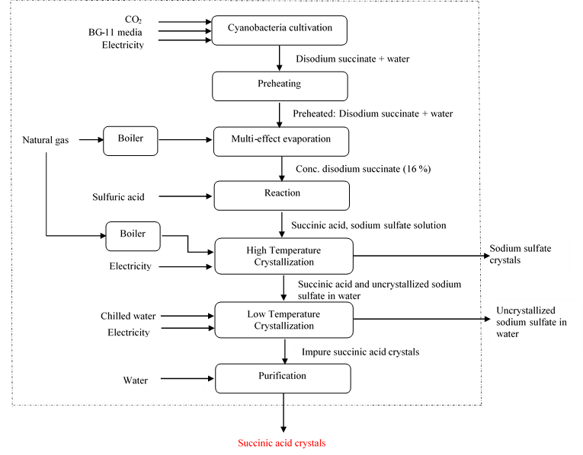
Figure 1. System boundary for succinic acid production via process I
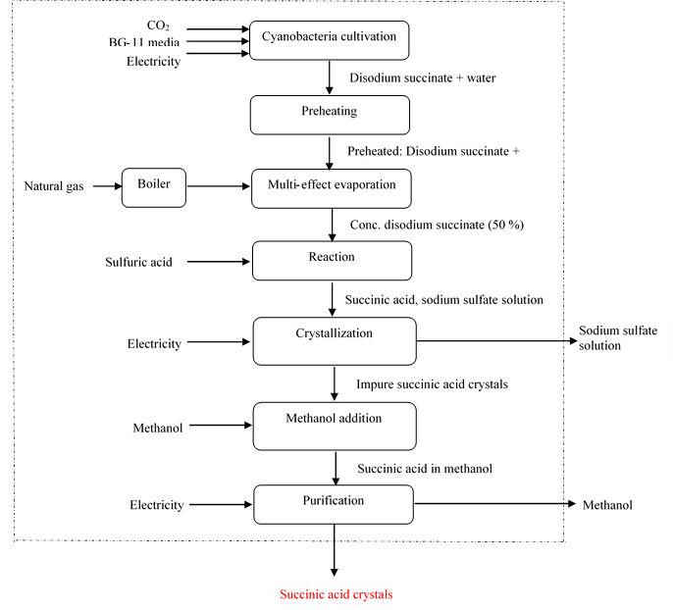
Figure 2. System boundary for succinic acid production via process II
  - Life Cycle Impact Analysis
The impact analysis is conducted for 1 kg of succinic acid production based on two downstream methods and is shown in Table 1.

Table 1. Life cycle impact analysis of succinic acid production from cyanobacteria
Impact category | Reference unit | Process I | Process II
terrestrial acidification potential (TAP) | kg SO₂-Eq | 0.013 | 0.006
global warming potential (GWP100) | kg CO₂-Eq | 6.540 | 2.835
freshwater ecotoxicity potential (FETP) | kg 1,4-DCB-Eq | 0.170 | 0.074
marine ecotoxicity potential (METP) | kg 1,4-DCB-Eq | 0.221 | 0.096
terrestrial ecotoxicity potential (TETP) | kg 1,4-DCB-Eq | 6.888 | 3.312
fossil fuel potential (FFP) | kg oil-Eq | 12.301 | 5.116
human toxicity potential (HTPc) | kg 1,4-DCB-Eq | 0.116 | 0.055
human toxicity potential (HTPnc) | kg 1,4-DCB-Eq | 5.631 | 2.351
ionising radiation potential (IRP) | kBq Co-60-Eq | 0.081 | 0.035
land use - agricultural land occupation (LOP) | m²*a crop-Eq | 0.040 | 0.018
surplus ore potential (SOP) | kg Cu-Eq | 0.331 | 0.159
particulate matter formation potential (PMFP) | kg PM2.5-Eq | 0.006 | 0.003
water use - water consumption potential (WCP) | m³ | 0.032 | 0.016
The total energy consumption for processes I and II are 2.88 MJ and 2.05 MJ per kg of succinic acid respectively as heat recovery is incorporated in the both processes. It is observed that the environmental impacts of process I are more than that of process II. The initial feed requirement for process I is higher than process II. There are two evaporation processes in process I, which resulted in higher energy consumption compared to process II. The water potential is high for process I as the process requires a higher amount of water for steam generation and for the cultivation of cyanobacteria. GWP of fossil-based succinic acid production process is 1.94 kg CO₂ eq/ kg of succinic acid which is lower than the processes considered in this study. The impacts of the both methods can be further reduced by improving the process operating conditions.
Figure 3 provides the impact contribution of Process I. 73 % of GWP100 and 94 % of FFP is due to the feed evaporation. Natural gas is the source of energy for evaporation. 45 % of the WCP and 77 % of TETP contributed by the cyanobacterial cultivation due to the use of chemicals for BG-11 media preparation.
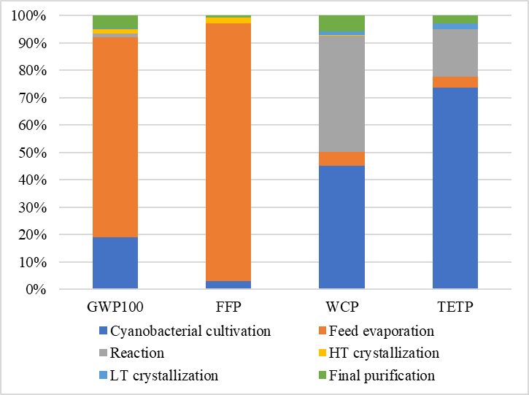
Figure 3. Impact contribution of Process I

The impact contribution of process II is provided in Figure 4. The highest contributor towards GWP100 (69 %), FFP (92 %) is the feed evaporation stage due to the use of natural gas as fuel source. The cultivation of cyanobacteria contributed towards WCP (44 %) and TETP (73 %) as similar to Process I. The cultivation stage requires huge amount of water and nutrients for the growth of cyanobacteria.

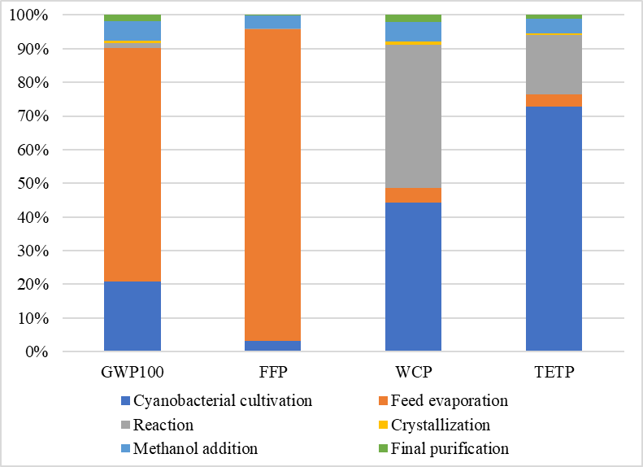
Figure 4. Impact contribution of Process II
  - Conclusions
In this work, the downstream processes for the production of succinic acid from the cyanobacterial system have been designed and simulated in ASPEN Plus software. Cradle to gate life cycle assessment of cyanobacterial succinic acid production has conducted. Energy consumption is highest for the feed evaporation process, and it contributed most to the total impacts in process I and II. FFP is highest for the feed evaporation stage for both processes as natural gas is used as fuel for steam generation. Environmental impacts are high for process I due to the large feed requirement, indicating that process II is more efficient than process I. The climate change impact for both processes are high when compared with the conventional petroleum route succinic acid production.

The work is being extended to perform techno-economic feasibility for the two processes which will provide concrete recommendations for scale-up. Opportunities to improve the economic and environmental performance are also being identified.
References
Berglund, K. A., Yedur, S., and Dunuwila, D. D., 1999, US Patent 5958744.
Hossain, N., Zaini, J., Mahlia, T.M.I., & Azad, A.K., 2019, Elemental, morphological and thermal analysis of mixed microalgae species from drain water, Renewable Energy,131, 617-624.
Ichiro Fujita and Kouichi Wada, 2009, US Patent 7915447.
International Energy Agency, 2023, CO₂ Emmisons in 2022.
Niederholtmeyer H., Wolfstadter B.T., Savage, D.F, 2010, Engineering cyanobacteria to synthesize and export hydrophilic products, Applied and Environmental Microbiology, 76, 3462-3466.

