Flexible relaxation method for infeasibility diagnosis in the optimization model of natural gas pipeline network sales considering component self-consumption gas
Xiaozheng Chen ª, Siyi Miª, Jiaming Guoª, Dingzhi Liu^{b} , Xiaoyong Gao^{a*}
ªDepartment of Automation, China University of Petroleum, Beijing 102249, China
^{b}PetroChina Planning and Engineering Institute, Beijing 100083, China
x.gao@cup.edu.cn
Abstract
With the formation of the "One Network Across the Nation" pattern in China's natural gas industry, the analysis of pipeline flow and flow direction has become more complex. Conducting optimization analysis of natural gas pipeline network sales is crucial for the efficient operation of the pipeline network. However, natural gas sales optimization models still have challenges regarding flow boundaries and component self-consumption. Infeasible solutions often arise due to inappropriate boundary condition parameters, making the recovery of feasibility a key aspect in engineering applications. To address these challenges, a quadratic solving method is adopted to establish an optimization model for natural gas pipeline sales considering component self-consumption gas. Additionally, a flexible relaxation method is designed to detect contradictions and restore feasibility in the optimization model. Experiments show that using the GUROBI solver to model and solve actual natural gas sales cases, in the 221-node case, the traditional method of introducing 0-1 variable modeling takes 9.70 seconds, while the quadratic solving modeling method only takes 0.22 seconds, which greatly accelerates the solving speed. Meanwhile, the designed flexible relaxation method automatically locates the contradictory constraints of the infeasible model of natural gas pipeline network sales according to users' needs. It quickly restores the feasibility of the model by providing specific and reasonable modification suggestions.
Keywords: Natural gas pipeline network, model optimization, infeasibility diagnosis, feasibility restoration
  - Introduction
The formation of the "One Network Across the Nation" pattern realizes the safe transportation and free flow of oil and gas resources in China(Liu et al., 2023). It has also created a nationwide large-scale natural gas pipeline transmission system, leading to increased complexity in analyzing the flow and direction of the pipeline network. Constructing an optimization model for natural gas sales in the pipeline network can optimize the flow and sales structure of natural gas, thereby improving the overall sales efficiency of the gas pipeline network.
Due to the complex topology of the natural gas pipeline network system, the constructed optimization model for the gas pipeline network has numerous constraints and is large in scale (Liu et al., 2021). Contradictions between constraints in the model may lead to infeasibility. Therefore, it is crucial to perform contradiction detection on the optimization model for natural gas sales, providing results and modification suggestions that lead to model infeasibility. Algorithms such as additive filter algorithm and deletion filter algorithm have been proposed to find at least one irreducible infeasible set (IIS) in the infeasible model (Chinneck and Dravnieks, 1991; Chinneck, 1997). Boundary tightening techniques are utilized in the literature (Puranik et al., 2016; Puranik and Sahinidis, 2017) to eliminate infeasible and irrelevant constraints from the model and further identify IIS on the simplified model. However, the IIS search was time-consuming and did not provide effective modifications to the infeasible modeling of the natural gas pipeline network.
In this work, we designed a flexible relaxation method for infeasibility diagnosis for infeasible models. This method can provide modification suggestions that meet user requirements in natural gas pipeline networks, thereby effectively restoring the feasibility of the model. In addition, the natural gas pipeline network sales optimization model considering component flow self-consumption and flow boundary discontinuity is established by quadratic solving to speed up the model solving speed.
  - Model and Methods
    - Model description
According to the actual transportation path of natural gas in the pipeline network, the natural gas pipeline network sales optimization model can be simplified into five components: nodes, gas sources, pipelines, gas storages, gas storage tanks, and clients. The other four components are connected through nodes to form the natural gas value chain network topology (Zhang, 2022). The optimization model for natural gas sales aims to maximize benefits while satisfying the equations of flow balance conservation, upper and lower boundary constraints, and capacity constraints. For detailed model variables and constraint settings, see Liu et al. (2021).
    - Natural gas pipeline network flow interval segmentation model
The pipelines, gas storage tanks, and gas storages components in the natural gas pipeline network all have bidirectional flow characteristics. Forward flow variables and backward flow variables are set in the model to represent the vector form of the flow (using positive and negative signs to indicate direction) and scalar form (absolute value of flow) of the flow for these components. This approach helps eliminate the computational difficulties caused by the nonlinearity of the absolute value of component flow. Taking the pipeline component as an example, we can construct equation (1) and equation (2):
$Q_{p}=q_{p,z}-q_{p,f}$ (1)
$\left|Q_{p}\right|=q_{p,z}+q_{p,f}$ (2)
In which, the value ranges of the variables $q_{p,z}$ and $q_{p,f}$ are the forward flow interval and the backward flow interval of the pipeline, respectively. Eq. (1) represents the true flow rate of the pipeline with direction. The absolute value of the pipeline flow rate in Eq. (2) is used to calculate the cost term. When the forward and backward flow intervals of the pipeline are discontinuous on a one-dimensional numerical axis, the above equations need to be modified into Eq. (3) and Eq. (4):
$Q_{p}=y⋅q_{p,z}^{seg}-\left(1-y\right)⋅q_{p,f}^{seg}$ (3)
$\left|Q_{p}\right|=y⋅q_{p,z}^{seg}+\left(1-y\right)⋅q_{p,f}^{seg}$ (4)
In which, the superscript $seg$ indicates that the pipeline is in a state of discontinuous flow intervals. By introducing binary variables $y$, the selection of positive and negative flow intervals in the pipeline is realized, accurately representing the segmented conditions of the pipeline flow intervals. This representation can also be applied to other components of the pipeline network where there are segmented flow intervals.
    - Quadratic solving model of natural gas pipeline network considering component self-consumption gas
Since the “13th Five-Year Plan”, China has actively promoted the construction of natural gas pipeline networks, with a total of $4.6×{10}^{4}$ kilometers of long-distance pipelines built. The total length of natural gas pipelines nationwide reaching $10.2×{10}^{4}$ kilometers (Liu et al., 2021). With the formation of a large-scale national natural gas pipeline network, the self-consumption of components in the pipeline network cannot be ignored. When a component is not in use, there is no flow self-consumption of the component. However, when the component is in use, different flow directions of natural gas will produce flow self-consumption of different values.
Since the flow self-consumption of the component cannot be determined before solving, the traditional method introduces additional 0-1 variables for the component to choose whether to produce self-consumption or not. This method will cause a large number of bilinear terms in the model, which greatly reduces the speed of the model solving. The quadratic solving method proposed in this paper modifies the basic model according to the results of the first solution and selectively introduces flow self-consumption terms in the objective function and constraints.
Take the case of self-consumption gas generated by the gas storage component as an example. The gas storage produces self-consumption gas when natural gas flows in and out. According to the first solving result, the flow self-consumption model of the gas storage is modified:
1) If the natural gas inflow and outflow at the gas storage are both zero, indicating that the component is not in use and there is no flow self-consumption. Set the constraint:
$q_{R,in}=q_{R,out}=0$ (5)
In which $q_{R,in}$ is the inflow flow from the gas storage and $q_{R,out}$ is the outflow flow from the gas storage.
2) If the natural gas inflow or outflow at the gas storage is greater than 0, indicating that natural gas is flowing into the component and there is positive self-consumption. Need to correct constraints:
$V_{R,min}-V_{R,init}+q_{R,c}+FW_{R,z}≤q_{R,in}≤V_{R,max}-V_{R,init}+q_{R,c}+FW_{R,z}$ (6)
$q_{R,in}>FW_{R,z}$ (7)
$R_{cost}=p_{R,in}⋅q_{R,in}+GC_{R}\left[V_{R,init}+\left(q_{R,in}-q_{R,c}-FW_{R,z}\right)/2\right]$ (8)
In which $V_{R,init}$,$V_{R,min}$ and $V_{R,max}$are respectively the initial storage capacity, minimum storage capacity and maximum storage capacity of the gas storage. $q_{R,c}$ is the fixed storage self-consumption of the gas storage. $FW_{R,z}$is the forward flow self-consumption of the gas storage.${ R}_{cost}$is the cost item of the gas storage.$p_{R,in}$ is the unit cost of gas storage inflow flows. $GC_{R}$ is the unit storage cost of the gas storage. Eq. (6) is the modified storage constraint, and Eq. (7) ensures that the flow of natural gas into the storage is greater than the flow self-consumption. The cost term in Eq. (8) includes the flow cost and the storage cost, where the storage cost is the product of the unit storage cost and the average of the natural gas volume before and after storage in the storage.
3) If the natural gas inflow or outflow at the gas storage is less than 0, indicating that natural gas is flowing out of the gas storage and there is reverse self-consumption. Need to correct constraints:
$V_{R,init}-V_{R,max}-q_{R,c}-FW_{R,f}≤q_{R,out}≤V_{R,init}-V_{R,min}-q_{R,c}-FW_{R,f}$ (9)
$q_{R,in}>FW_{R,f}$ (10)
$R_{cost}=p_{R,out}⋅q_{R,out}+GC_{R}\left[V_{R,init}-\left(q_{R,out}+q_{R,c}+FW_{R,f}\right)/2\right]$ (11)
In which $p_{R,out}$ is the unit cost of gas storage outflow flows and $FW_{R,f}$ is the backward flow self-consumption of the gas storage. The meaning of the above equation is consistent with the presence of positive self-consumption. The components in the pipeline network successfully constructed a quadratic solving natural gas pipeline network model considering self-consumption through the above method.
    - Flexible relaxation method
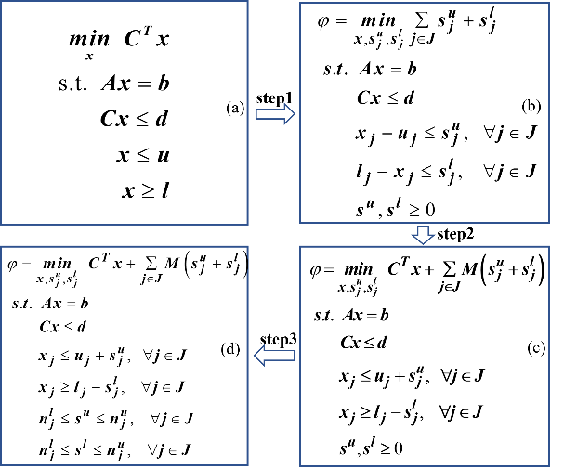
In order to solve the problem of infeasibility of solving the natural gas pipeline network model, this paper designs the flexible relaxation method to give suitable correction suggestions for the users. Since the natural gas pipeline network model is a specific type of supply chain, it can be simplified to the linear programming problem see Formula (a) in Fig. 1. In step 1, the minimization of the sum of upper and lower bound constraint violations for each variable is represented by adding slack terms to the variables, yielding Formula (b). The positive violation terms in Formula (b) provide quantitative information about infeasibility (Jatty, 2023). In step 2, the violation term is combined with the objective function of the original model in the form of a large penalty coefficient to obtain the contradiction detection Formula (c) for the minimum violation relaxation. Formula (c) can either compute the optimal solution for the feasible model or give the correction information for the infeasible model. In order to make the correction information satisfy the actual situation of natural gas pipeline network business or be accepted by the users, the violation term in Formula (c) is further restricted in step 3 to obtain Formula (d) of the flexible relaxation method.
Figure 1. Flexibility relaxation method derivation process
The flexibility of the flexible relaxation method is mainly reflected in the ability to obtain different corrections to the infeasible model according to the user's wishes or practical constraints, so that the model can be more correctly restored to feasibility. In addition, the relaxation method chooses to add violation terms to variables rather than constraints, so that the model can effectively give corrections on component variables. Moreover, the flexible relaxation method does not affect the solving results of the feasible model as the violation term of the model is zero at this time.
  - Results and Discussion
In this section, the quadratic solving method and the 0-1 solving method are used for the natural gas sales cases at 131-node and 221-node, respectively. Each node case contains data information for 18 years. All cases were solved using GUROBI (v 10.0.0) on an AMD Ryzen 7 5800H with Radeon Graphics, 3.20 GHz, RAM 16G PC. The final results of the solving are consistent. The comparison table of the solving time of two different node cases using different methods is shown in Figures 2 and 3. The quadratic solving method takes much less time than the 0-1 solving method from the chart.
In order to further analyze the differences between the two modeling methods. Table 1 provides a breakdown of the solution information for the two cases. The table includes the solving method, number of constraints, variables, and binary variables, total solution time for the 18-year period, as well as the minimum, maximum, and average time ratios. Each node case includes 18 time ratios, which are obtained by dividing the solution time of the 0-1 solving method by the solution time of the quadratic solving method.
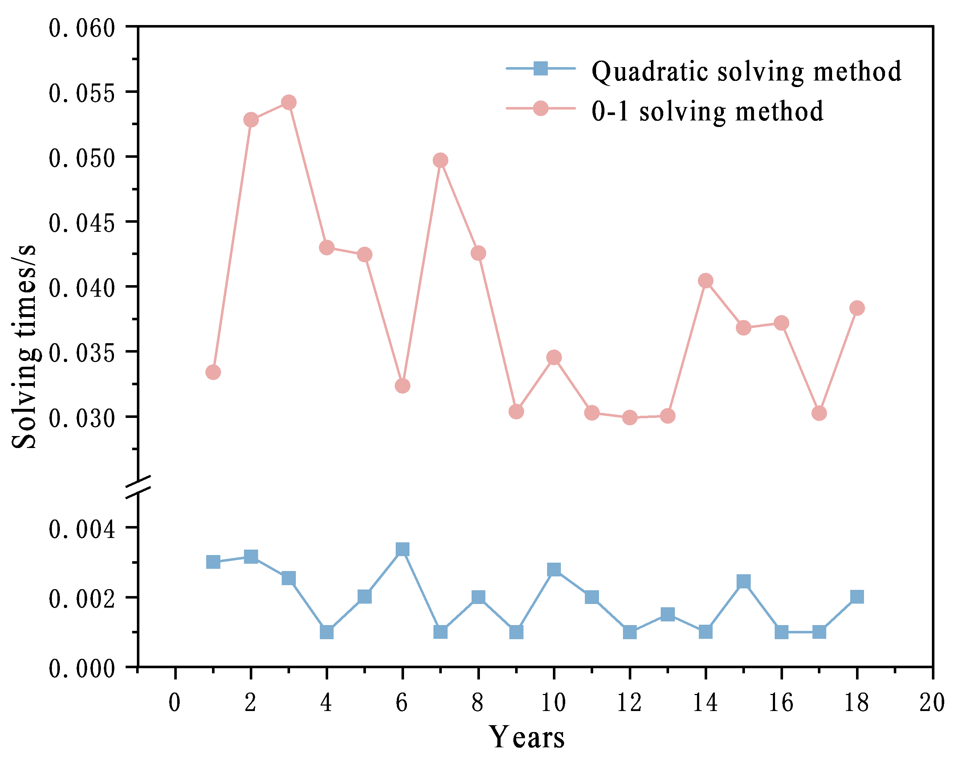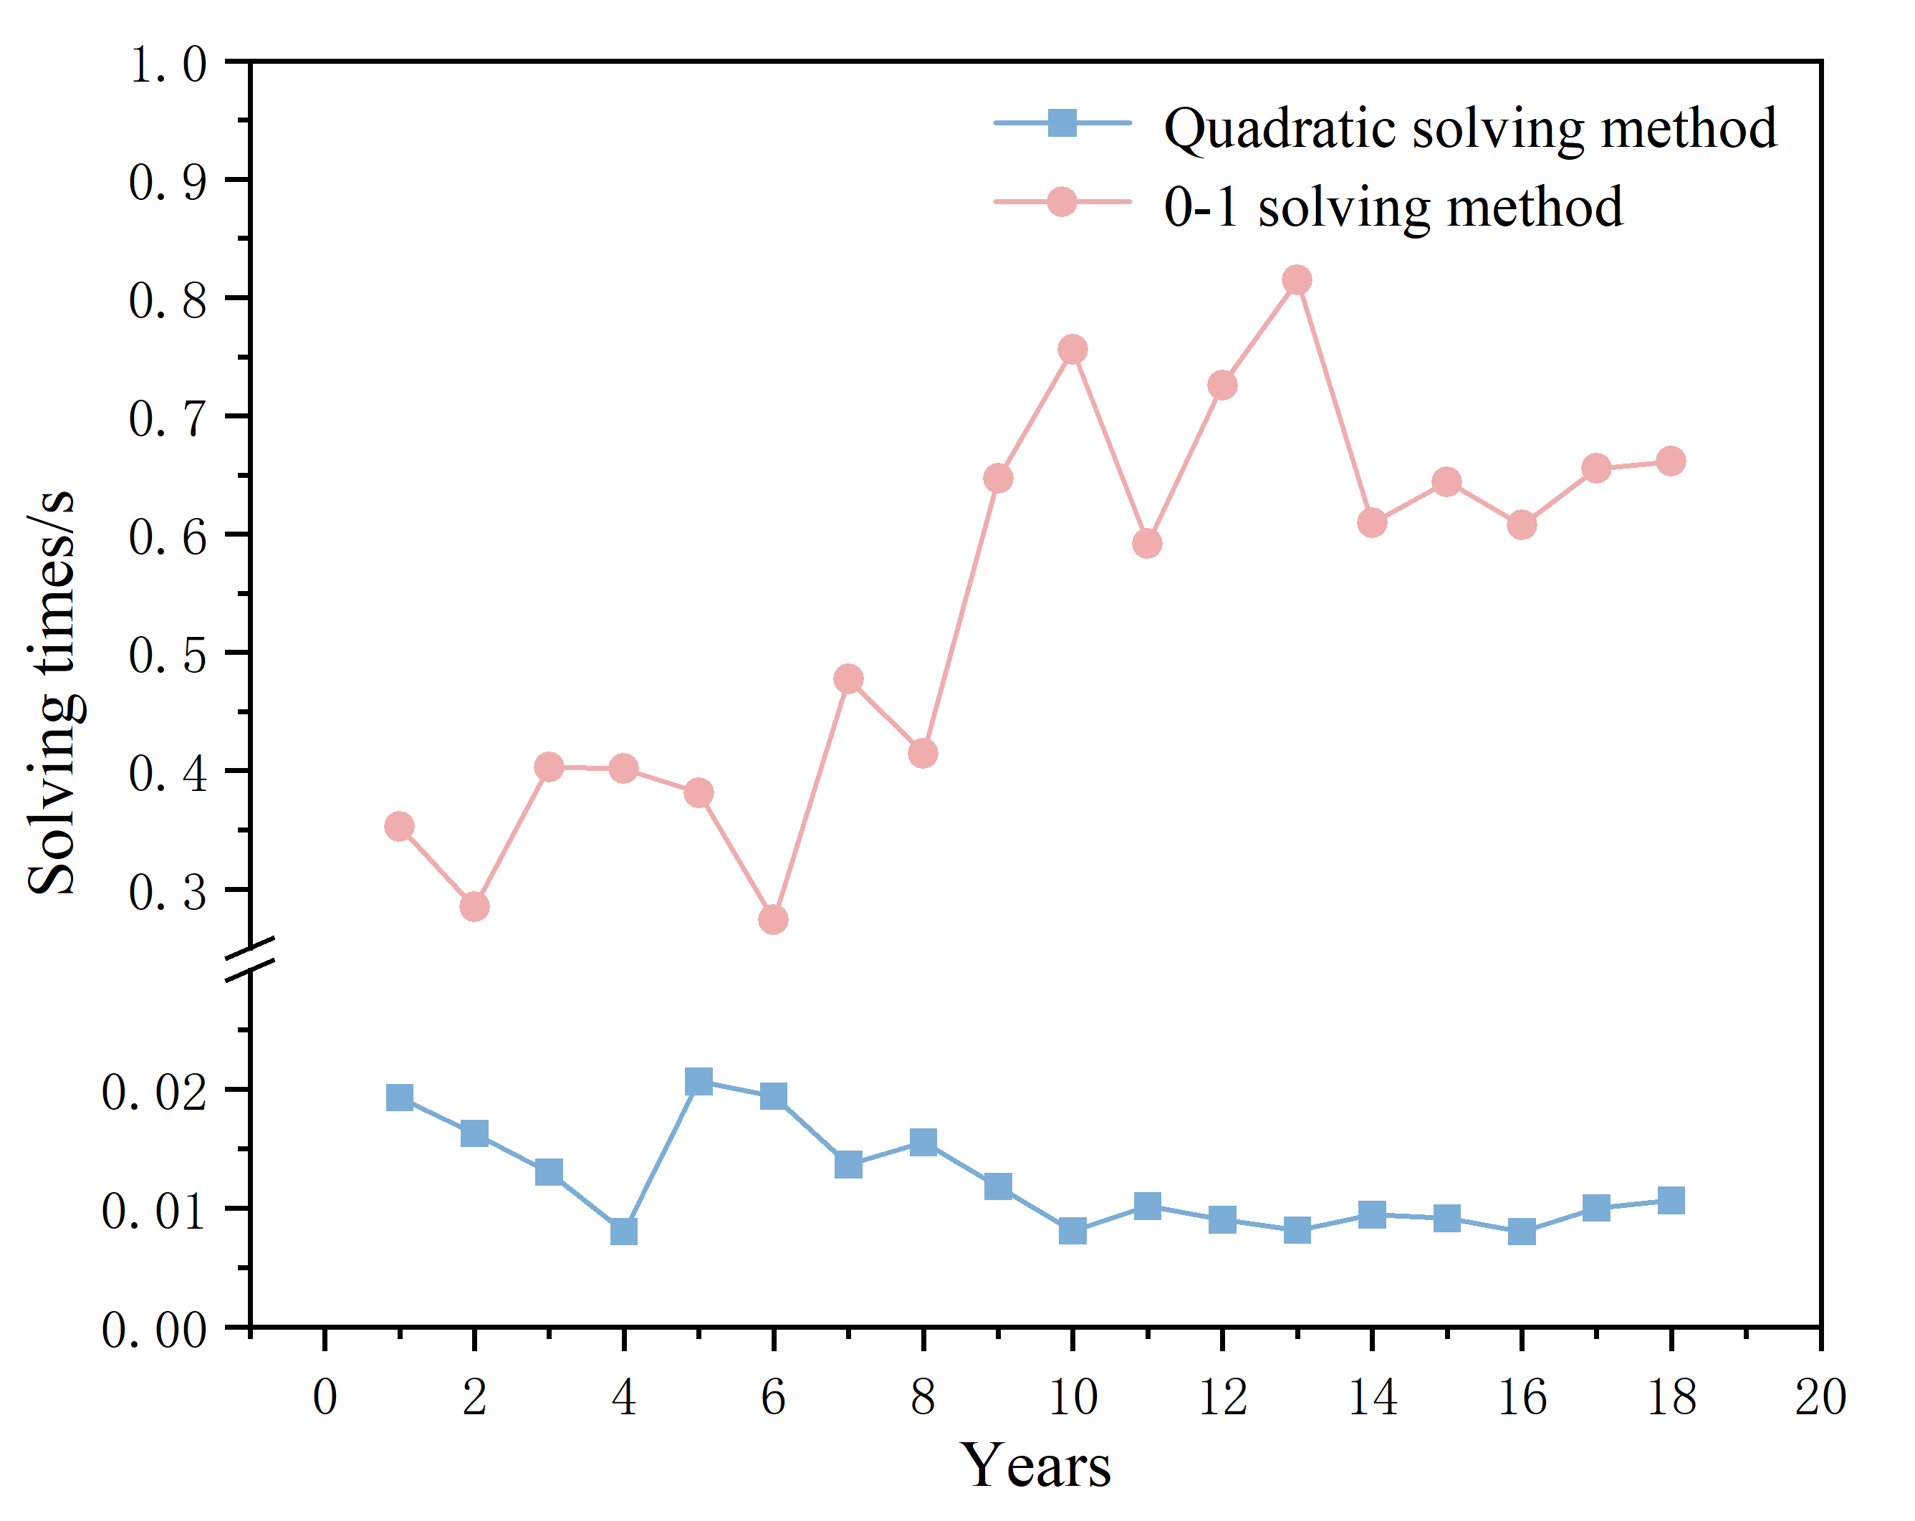
Figure2. Solution time of 131-node case Figure3. Solution time of 221-node case
Table 1 shows that the number of binary variables and total variables in the model constructed using the 0-1 solving method is much larger than that of the quadratic solving method. The key advantage of the quadratic solving method in terms of solving speed lies in the reduction of binary variables. The time ratios in the table crystallize the speed advantage of the quadratic solving even more. In the 131-node and 221-node cases, the solving speed of the quadratic solving method is more than 20 times and 50 times faster than that of the 0-1 variable method, respectively. Additionally, it can be noted that because of the disparity in the number of 0-1 variables, the quadratic solving increases in the minimum, maximum, and average time ratios as the size of the node case increases. This indicates that the quadratic solving method has a greater advantage in solving speed for large-scale cases.
Table 1 Statistics of solution for various node scale cases
Case size | Solving  mode | Constraints  number | Vars  number | 0-1 Vars  number | Solving time /s | Min time ratio | Max time ratio | Average time ratio
131- node | quadratic | 917 | 786 | 0 | 0.034 | 9.57 | 49.46 | 24.60
 | 0-1 | 917 | 1310 | 393 | 0.689
221- node | quadratic | 1721 | 1469 | 10 | 0.220 | 14.11 | 100.09 | 52.09
 | 0-1 | 1645 | 2453 | 756 | 9.702
To validate the effectiveness of the flexible relaxation method in restoring infeasible models to feasibility, a contradiction detection was performed on an infeasible case of 221-node for a specific year. Table 2 shows three modification options provided by the flexible relaxation method under different constraint conditions, which may consider pressure factors related to pipeline transportation or other practical business requirements. After the initial application of the minimum violation relaxation, the solution with the smallest modification was obtained for feasibility restoration. Subsequently, the flexible relaxation method provided additional modification options, where the modification amount of the model continued to increase, while the objective function value did not show a clear pattern of change.
Table 2 Contradiction detection information for the 221-node infeasible year case
Restrictions | Modify components | Direction | Bound | Modification | Modification  amount | Objective  function value
First solution | Gas storage 1 | Input | Upper | 1.33 to 1.45 | 0.12 | 36080.45
Gas storage 1 not adjustable | Gas storage 2 | Output | Upper | 0.28 to 0.40 | 0.24 | 36039.26
 | Pipeline 651 | Forward | Upper | 0.28 to 0.40
Pipeline 651 forward flow limit of 0.3 | Gas storage 2 | Input | Upper | 0.28 to 0.30 | 0.32 | 36162.93
 | Pipeline 556 | Backward | Upper | 0.00 to 0.10
 | Pipeline 731 | Backward | Upper | 0.00 to 0.10
 | Pipeline 806 | Backward | Upper | 0.00 to 0.10
  - Conclusions
In this study, the segmented flow intervals of natural gas transported by pipe segments is considered by introducing 0-1 variables. Additionally, the actual impact of component self-consumption on optimization of gas transportation was addressed using the quadratic solving method. This method significantly improves the solving speed compared to the traditional method of introducing 0-1 variables. For infeasible problems in the natural gas pipeline network model, the flexible relaxation method provides multiple alternative modification options, giving users sufficient choice space to restore the model to feasibility.
References
D.Liu, Y.Zhang, Y.Liang, G.Li, S.Liu, J.Q.Ni, X.Liu, 2021, Construction and application of the optimization model of natural gas pipeline transmission based on “national one network”, Petroleum and New Energy, 33(05), 64-70.
D.Liu, Y.Zhang, Y.Liang, 2023, A complete modeling method for nonlinear dynamic processes based on wiener structured neural network and wiener-hammerstein structured neural network, Control and Instruments in Chemical Industry, 50(05), 632-643+659.
J.W.Chinneck, E.W.Dravnieks, 1991, Locating minimal infeasible constraint sets in linear programs, ORSA Journal on Computing, 3(2), 157-168.
J.W.Chinneck, 1997, Finding a useful subset of constraints for analysis in an infeasible linear program, INFORMS Journal on Computing, 9(2), 164-174.
S.Jatty, N.Singh, I.E. Grossmann, L.S.dAssis, C.Galanopoulos, P.GarciaHerreros, B.Springub, N.Tran, 2023, Diagnosis of linear programming supply chain optimization models: Detecting infeasibilities and minimizing changes for new parameter value, COMPUTERS & CHEMICAL ENGINEERING, 171(1), 108-139.
Y.Puranik, N.V.Sahinidis, 2017, Deletion presolve for accelerating infeasibility diagnosis in optimization models, INFORMS Journal on Computing, 29(4), 754-766.
Y.Zhang, 2022, Modeling the optimization of natural gas supply and marketing plan based on value chain, China University of Petroleum(Beijing).
Y.Puranik, M.Kilinc, N.V.Sahinidis, T.Li, A.Gopalakrishnan, B.Besancon, T.Roba, 2016, Global optimization of an industrial gas network operation, AIChE Journal, 62(9), 3215-3224.

