Numerical simulation and experimental validation of a wind turbine using Generative Design
Martin Grardel ª, Cabrel Kengne Tokam ª, Maxime Denis ª, Olivier Bain ª, Arnaud Dujany ^{a*}

ª U2R 7511, Basins-Reservoirs-Resources (B2R), GéoLab, UniLaSalle - University of Picardie Jules Verne, Beauvais, France

*Arnaud.dujany@unilasalle.fr
Abstract
With an energy demand in continuous growth over the last decade and new climate change stakes, ways to create more power has been studied. Offshore winds turbine which creates energy out of the wind was thus studied. Many studies have been led about the optimization stake that wind turbine are facing as actually, more than half of the wind power is lost when exploited by a classic horizontal wind turbine (HAWT). A particular new technology is now used in industry and can be applied to this problematic: Generative Design. It refers to all the numerical conception methods that automatically perform a design exploration with constraints defined by the user. To evaluate the relevance of this new conception methods on this subject, it was decided to create two prototypes of blades using two Generative Design applications of CATIA, a computer aided design (CAD) software. The first application (called XGenerative Design) has permitted to create a simple blade design only by using 3D parametric modelling, which make the process easier than creating it with actual means, those requiring precision and time. The second application (called Parametric Design Study) has permitted to ameliorate this previous blade design by implementing parametric ameliorations, a method of topology optimization. Two blades were tested: the blade created on XGenerative Design and a second similar blade model, but this time optimized with topology optimization. The blades were assembled on two separate classic wind turbine models and were evaluated in the fluid dynamic simulation software XFlow under an equivalent wind. The results proved that the optimized model with parametric ameliorations has a slightly better rotation speed than the non-optimized one. However, as these technologies are very recent, it wasn’t possible to fully ameliorate the initial design. It was planned to ameliorate it by using mechanical evaluations methods of the blades. It seems that this conception method still needs some improvement in the future, even if in some other domains, it has already proved his efficiency.

Keywords: Wind turbine, Generative Design, topology optimization, Lattice-Boltzmann method, rotation speed

  - Introduction
For several decades, a real desire to develop renewable energies was born in the world to slow down climate change. Wind is one of these renewable energies, which is inexhaustible and clean. In 2022, wind energy created 7,6% of the world’s total electricity. In comparison, it produced less 2,4% of it 10 years earlier, in 2012, according to Ember Climate. Wind can be exploited by wind turbines located on land (onshore) or at sea (offshore). Offshore wind turbines are more developed in the industry as it provides a better general yield (it can reach 40% for an offshore model while the best yield of an onshore wind turbine is 25%). In cause, the wind is faster and steadier at sea due to the lack of obstacle (Li et al., 2020).

Wind turbines are subject to studies to improve their yield, as a big part of the wind force is lost during energy transformation by the motor. Most of these studies talked about blades. The possibility of using other industrial blades (Lachenal et al., 2013) or other composite materials (Thomas et Ramachandra, 2018) were studied, however, these studies didn’t permit to considerably ameliorate the best industrial designs already existing. Also, a large part of studies concerned vertical axis wind turbine (VAWT) models which are cheaper but less effective than a classic horizontal turbine (HAWT) (Marzec et al., 2023; Akbari et al., 2022). Generally, the blades are modelized using a CAD (computer aided design) software and then tested numerically using algorithms such as the BEM (blade element momentum) (Bavanish et Thyagarajan, 2013). Once a correct model is obtained, the blade is constructed and tested under real conditions in a wind tunnel. Now, with progress in the domain of (CAD), some studies were conducted about blades of HAWT turbines using topology optimization (Zhu et al., 2021). This method is part of the Generative Design which corresponds to all the numerical conceptions methods that explore design automatically under user-defined constraints (Tyflopoulos et al., 2018). These methods are difficult to handle as it requires advanced knowledge in the industrial domain. The purpose of this study is to create a blade model, without considering a typical industrial blade conception, and then optimize it as much as possible to evaluate the impact of Generative Design on the base design. For this purpose, a blade is modelized and optimized in CATIA using Generative Design conception methods. Two models, one optimized and one not, are then tested into the numerical simulation software XFlow to study their rotation speed. The goal is to demonstrate the advantages of Generative Design on an industrial-based subject.

  - Environment
To evaluate the performance of the wind turbine created, it was decided to simulate the wind conditions near the city of Quend, Somme department, France. This area was chosen because it was once subject to a project of an offshore wind farm construction in 2010. At the time it was decided to abort this project as offshore wind farms weren’t as developed as of today and thus didn’t convince locals. Also, with the strong oceanic currents, the Atlantic coastline of the north of France presents very strong winds. In fact, there are already big wind farms in Le Tréport and Fécamp (still in construction) a few hundred kilometers away from Quend (Pezy et al., 2020). Relooking at this subject can bring a new look about this abandoned project.

  - Model conception
The wind turbine model was created on CATIA, a CAD software developed by Dassault Systems. This software is widely used in industry nowadays.

    - Blade construction using XGenerative Design

The first step is to create a blade model using the XGenerative Design application, integrated in the 3DExperience platform, a cloud linked to CATIA. It uses parametric representation to permit an easy modification of forms created (Figure 1 (a)). Ultimately, it can allow the creation of complex 3D models. It was decided to create a blade from scratch only using this application. The blade construction followed 4 steps : The first step was to create the outlines of the blade (Figure 1 (b)). For this, a typical blade section was implemented and duplicated as well as circular sections to create the base of the blade. The second step was to implement a deformation and rotation of theses outlines to create a spiral movement which will permit a faster rotation during simulations (Figure 1 (c)). The third step was to close the blade by creating a hull which link these shapes together (Figure 1 (d)). The last creation step consisted of the extraction of construction parameters using specific functions.

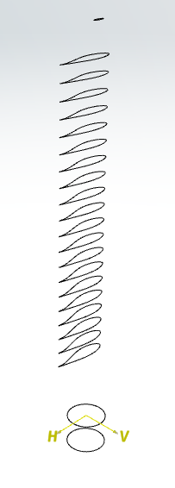
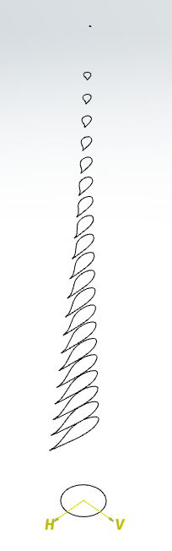
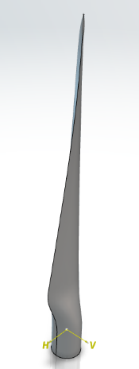
(a)
(b)
(c)
(d)

Figure 1 : Parametric representation of the first step (a), Visualization of the first step (b), second step (c) and third step (d) of creation of the blade
    - Blade optimization using Parametric Design Study

Parametric Design Study application was used to optimize the model previously created. This application uses two types of variables to ameliorate a 3D model: geometric variables and response variables. The first category corresponds to parameters that will be modified by the design exploration while response variables correspond to results parameters that will characterize the success of the study. These variables can correspond to lengths, areas, volumes, stresses, etc.

In this study, geometric variables are directly exported from XGenerative Design parameters. They correspond to the rotation angle and spacing between each blade section, the diameter and deformation ratio of the blade’s tip and the total number of sections which defines the blade’s height. With the response parameters, the objective of this study was to maximize the intrados area of the blade (the side that is facing the wind) while keeping a similar volume. At the end, two blades are obtained, one created with just XGenerative Design and the same one but optimized using the Parametric Design Study application.

    - Wind turbine assembly using Assembly Design

These two blades are assembled on the Assembly Design application. Blades are added to two prototypes of classic wind turbines composed of a hub, a nacelle and a tower. (Figure 2 (a)).
  - Numerical validation
To evaluate the efficiency of the two models created, the software XFlow was used. This computational fluid dynamics (CFD) software resolves the Lattice-Boltzmann method (LBM) to permit complex fluid simulations. The LBM method was preferred to the Navier Stokes method as it presents the best results for simple wind turbine models (Xu, 2016). For complex models, it may however not be the best solution (Schubiger et al., 2020).

Each wind turbines were tested separately on the same conditions corresponding to an average wind of 8 km.h⁻¹ equal to a typical wind observed at sea next to Quend. A mobile part composed of the rotor (the 3 blades and the hub) is defined while the rest of the wind turbine is considered motionless. The mobile section follows rigid body dynamics laws, meaning the movement will be dependent of the defined density of the composite material. Here, the density was defined to obtain a rotor weight of 61 t, which is a typical industrial rotor weight. The wind mesh chosen for this study is categorized as adaptative refinement meaning it will be smaller through contact with blades (0.25 m²) and bigger further away (8m² at maximum) (Figure 2 (b)). It was chosen because the object of study is the rotation speed and not the wind turbulence. The direct impact of this choice is a better simulation of the wind comportment as the impact of the wind on the turbine’s rotation speed will be more realistic. The turbine is then positioned in front of the wind.

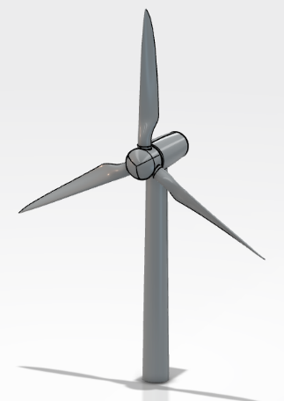
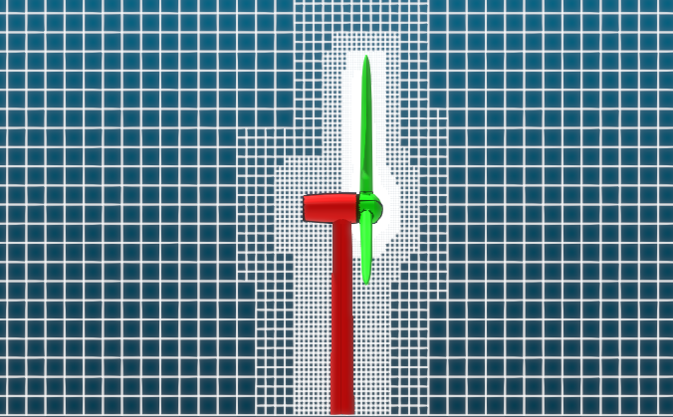
(b)
(a)

Figure 2 : Assembly of the wind turbine with optimized blades (a), mesh used in XFlow (b)

  - Results
After simulations, the first model only created with XGenerative Design had a rotation speed of 12,71 deg.s⁻¹ or 2,12 revolutions per minute while the second model had a rotation speed of 12,71 deg.s⁻¹ or 2,16 revolutions per minute (Figure 3).
The two models presented similar final results. However, the optimized model with Parametric Design study has a slightly better rotation speed. Unfortunatly some elements of the XGenerative Design modelling couldn’t be exported into Parametric Design Study which prevented a more realistic optimization. Moreover, Mechanical Scenario Creation application of CATIA was used to evaluate the resistance of the blades to different levels of stress, but excessive uncertainties prevented us from obtaining robust results.

Figure 3 : Graphic of the rotation speed of the turbines depending on the time.
Conclusions
The Generative Design applications of CATIA allowed the creation of two simple blades. One of those was optimized using additional topology optimization methods. As it is recent technologies, it seems that the different applications have trouble communicating between each other meaning the results can still be ameliorated to obtained a more in-depth study. The XGenerative Design application has permitted a creation of a quick and easily modifiable wind turbine blade. It is a real advancement in industry as it accelerates and simplify the difficult conceptions steps of a piece. The conception method using Generative Design applications may be a revolution for future but still needs improvement. As already a big number of studies evocated that a significant amelioration of wind turbine may be compromised (Chehouri et al., 2015), this method enabled us to quickly and easily recover the optimization performed by industrial engineers on wind turbine blades. Moreover, Generative Design has already proven his efficiency in other industrial domains such as build information modelling (BIM) (Gan, 2022) or aerospace (Pilagatti et al., 2023).

References
V. Akbari, M. Naghashzadegan, R. Kouhikamali, F. Afsharpanah, W. Yaïci, 2022, Multi-Objective Optimization and Optimal Airfoil Blade Selection for a Small Horizontal-Axis Wind Turbine (HAWT) for Application in Regions with Various Wind Potential, Machines 10, 687
B. Bavanish, K. Thyagarajan , 2013, Optimization of power coefficient on a horizontal axis wind turbine using bem theory, Renewable and Sustainable Energy Reviews 26, 169-182
A. Chehouri, R. Younes, A. Ilinica, J. Perron, 2015, Review of performance optimization techniques applied to wind turbines, Applied Energy 142, 361-388
Ember Climate. (2023). Global Electricity Review 2023. https://ember-climate.org/insights/research/global-electricity-review-2023/
V.J.L. Gan, 2022, BIM-based graph data model for automatic generative design of modular buildings, Automation in Construction 134, 104062
X. Lachenal, S. Daynes, P. Weaver, 2013, Review of morphing concepts and materials for wind turbine blade applications, Wind energy 16, 283-307
H. Li , A.Teixeira, C. Guedes Soares, 2020, A two-stage Failure Mode and Effect Analysis of offshore wind turbines, Renewable Energy 162, 1438-1461
Ł. Marzec, Z. Buliński, T. Krysiński, J. Tumidajski, 2023, Structural optimisation of H-Rotor wind turbine blade based on one-way Fluid Structure Interaction approach, Renewable Energy 216, 118957
J. Pezy, A. Raoux, J. Dauvin, 2020, An ecosystem approach for studying the impact of offshore wind farms: a French case study, ICES Journal of Marine Science 77, 1238-1246
A.N. Pilagatti, E. Atzeni, A. Salmi, 2023, Exploiting the generative design potential to select the best conceptual design of an aerospace component to be produced by additive manufacturing, The International Journal of Advanced Manufacturing Technology 129, 5597-5612.
A. Schubiger, S. Barber, H. Nordborg, 2020, Evaluation of the lattice Boltzmann method for wind modelling in complex terrain, Wind Energy Science 5, 4, 1507-1519
L. Thomas, M. Ramachandra, 2018, Advanced materials for wind turbine blade- A Review, Materialstoday : proceedings 5, 1, 2635-2640
E. Tyflopoulos, F.D. Tollnes, M. Steinert, A. Olsen, 2018, State of the art of generative design and topology optimization and potential research needs, NordDesign, Linköping, Sweden
J. Xu, 2016, Wake Interaction of NREL Wind Turbines Using a Lattice Boltzmann Method, Sustainable Energy 4, 1-6
J. Zhu, X. Cai, D. Ma, J. Zhang, X. Ni, 2021, Improved structural design of wind turbine blade based on topology and size optimization, Low-Carbon Technologies 17, 69-79

