Minimal Target Indices for Cyanobacteria-Based Biorefineries and Optimal Design of the Metabolic Network
Matías Ramos^{a,b}, Fernando Ramos^{a,b}, Romina Lasry Testa^{a,b}, Vanina Estrada^{a,b}, Maria Soledad Diaz^{a,b,*}
ªPlanta Piloto de Ingeniería Química (PLAPIQUI CONICET-UNS), Camino La Carrindanga km. 7, Bahía Blanca, Argentina
^{b}Departamento de Ingeniería Química, Universidad Nacional del Sur (UNS), Bahía Blanca, Argentina
*Corresponding Author’s E-mail: sdiaz@plapiqui.edu.ar
Abstract
In this work we propose a mixed integer nonlinear programming multiobjective (MOO) model for the determination of minimal target indices for the sustainable design of an integrated cyanobacteria-based biorefinery and its heat exchanger network (HEN), for the production of phycocyanin and zeaxanthin, PHB, fourth-generation bioethanol, biogas, hydrogen and diethyl ether. The main objective is to determine Synechocystis sp’s minimal target indices (productivity, yield, titer) that should be reached in order to achieve a sustainable biorefinery design by imposing lower bounds on a multi-criteria sustainability metric (Sustainability Net Present Value, SNPV). In the case of strain in-silico design, a bilevel programming problem that identifies gene knockouts in a genome scale Synechocystis sp. PCC6803 metabolic model (GEM) to couple growth and product synthesis has been formulated. Through this approach, the target indices of alternative in-silico strains are compared to their minimum required values. Numerical results show that minimal targets are largely surpassed, for the case of a Synechocystis wild-type strain modelled through the GEM and a tailored strain designed for ethanol production. These results offer promising insights into cyanobacteria biorefineries.
Keywords: MINLP, Synechocystis sp. PCC 6803, Cyanobacteria-based biorefinery, In-silico cyanobacteria
  - Introduction
Biofuels have emerged as an alternative to complement renewable energy sources to increasingly complement fossil fuels paving the way to CO₂ emissions reduction and mitigation of the environmental impact. At present, commercial biofuels are derived from agricultural crops (first-generation) and lignocellulosic biomass (second-generation) but both have disadvantages like the known controversy of competing with food for the first-generation case, or not being economically feasible for the second case (Sarwer et al., 2022). Biofuels produced from algae biomass are considered third-generation, but are not yet commercially produced due to the high production costs, leading to the need of improving production rates and separation processes efficiency. Recent studies have been reported for macroalgae-based integrated biorefineries (Pedrozo et al., 2022) showing that they can be economically feasible. In this sense, fourth-generation biofuels, which are produced directly by genetically modified microorganisms, constitute a more recently studied alternative (Ramos et al., 2023).
In this context, photoautotrophic microorganisms like cyanobacteria, stand out as potential cell factories, thriving on atmospheric/industrial CO₂, inorganic phosphorus (P), and nitrogen (N), using solar and/or artificial light as energy source. Among its value-added products is phycocyanin, an intense blue pigment sought after by food and nutraceutical industries. Additionally, certain cyanobacteria store carbon as PHB, a biopolymer similar to polypropylene with a wide range of applications.
In this work, we aim to assess the viability of three in-silico strains of Synechocystis sp. PCC6803, developed in previous work (Lasry Testa et al., 2019, 2022), in a large scale biorefinery. We propose a mixed-integer nonlinear programming (MINLP) multiobjective model for the simultaneous optimal plant design and heat exchanger network synthesis (HEN) of a cyanobacteria-based integrated biorefinery for pigments (phycocyanin and zeaxanthin), PHB, biofuels, hydrogen, diethyl ether (DEE) and biofertilizers. The objective is to minimize the target indices of the in-silico strains, productivity-titer-yield, in order to achieve a sustainable biorefinery design, measured by the SNPV metric (Zore et al., 2018). The idea behind obtaining the minimal targets is to evaluate the performance of the developed in-silico strains and determine if it is worth the effort to design them in-vivo based on metabolic engineering strategies in the laboratory.
  - Process description
    - Synechocystis strains
In this study, three different Synechocystis strains constitute the main “cell factories” for the biorefinery superstructure, as we aim at assessing in-silico developed strains’ efficiency within the frame of an integrated biorefinery. S1 is a wild type strain (no ethanol production) represented by its genome-scale metabolic model (GEM). The GEM comprises 784 reactions and 535 metabolites, with 80 exchange reactions that include cytoplasm, carboxisome, tillacoidal lumen, tillacoidal membrane, cytoplasmatic membrane, periplasm and extracellular space. S2 includes the reactions codified by the genes pdc and adh from Zymomonas mobilis, and produces ethanol coupled to growth, and S3 produces PHB coupled to growth (Lasry Testa et al., 2019, 2022). The coupled strains were designed by formulating a bilevel optimization problem that identifies gene deletions to achieve the desired coupling. Coupling production to growth has the objective of turning the desired product’s production into a subproduct of growth, so that it becomes necessary for the microorganism’s metabolic function. In the bilevel optimization problem, the outer objective function is to maximize product synthesis rate, while setting an upper bound to the number of gene deletions (represented through binary variables), and the inner optimization problem minimizes product synthesis rate subject to the metabolic network model (LP). The problem has been reformulated as a single level optimization problem by applying duality theory; i.e., replacing the inner LP by a set of equations comprising the primal LP constraints, its dual problem constraints and imposing the strong duality condition (primal LP objective function equal to dual problem objective function). The resulting Mixed Integer Linear Programming (MILP) problem solution renders a genetically engineered strain that couples ethanol production to cell growth through fourteen genetic intervention in the case of S2 and with sixteen genetic interventions for PHB production in the case of S3 (Lasry Testa et al., 2019, 2022).
    - Process superstructure
The proposed superstructure of a cyanobacteria-based biorefinery for the potential production of pigments (phycocyanin and zeaxanthin), PHB, bioethanol, biogas, hydrogen, DEE and biofertilizers is shown in Fig. 1. It includes three main continuous processing stages: production, separation and purification. These processing stages comprise the cultivation in open ponds and harvesting through microfiltration membranes (S2 strain only) or centrifugation (S1 and S3), are described in detail in Ramos et al. (2023). Ethanol separation and purification section (S2 strain only), carried out with PDMS membranes for pervaporation, a vapor compression distillation system and ceramic membranes, follows the technologic route proposed by Lopes et al. (2019). Pigments extraction and purification section (S1 and S2), also refers to the same author, and includes a detailed description of the technological pathway. Regarding the residual biomass outlet from the cell disruption process in the pigment extraction section, for the three strains, the main stream of harvested biomass can be directly fed to an anaerobic digestor for the production of fertilizers and biogas, and also to recycle nutrient streams to the cultivation stage at the Open Pond system (García Prieto et al., 2017). The PHB extraction and purification section (S3 strain only) is described in detail in Ramos et al. (2017). Fuel-grade bioethanol with a concentration of 99.5 % obtained from the purification stage can be directly sold or further processed. The superstructure considers two different alternatives: the conversion of bioethanol into DEE or into green Hydrogen. The first case contemplates the production of DEE in an isothermal tubular packed-bed reactor, using Ru-HBZ as catalyst. Equations for this section have been taken from Charoensuppanimit et al. (2021) and included in the process superstructure. The second case considers a steam reforming process in the biorefinery. This technological route model equations have been taken from those proposed by Khamhaeng et al. (2021).
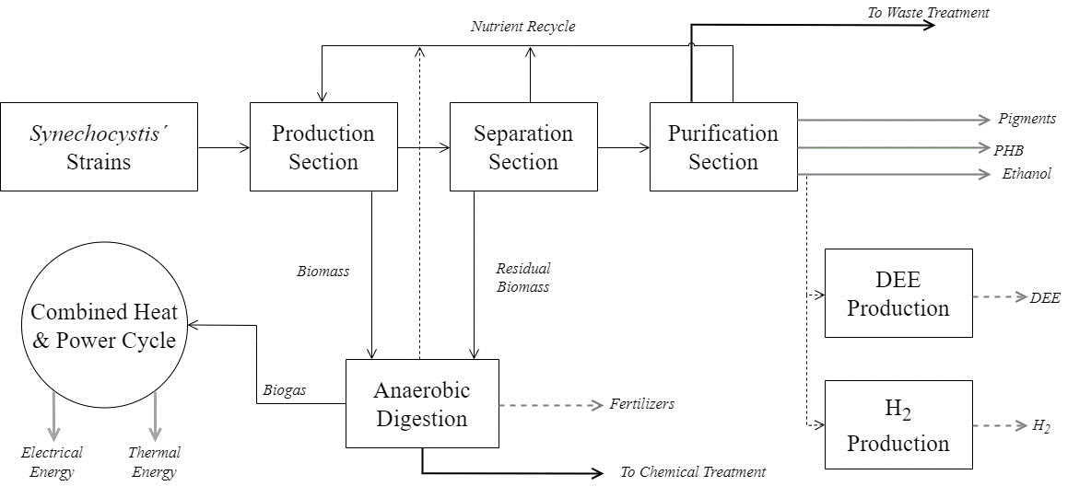
Figure 1. Cyanobacteria-based integrated biorefinery simplified superstructure
  - Mathematical model
The proposed superstructure is formulated as a mixed-integer nonlinear programming (MINLP) problem and implemented in GAMS 35.2.0 (McCarl et al., 2022) in order to determine the optimal design of an integrated cyanobacteria-based biorefinery and its HEN as presented in Pedrozo et al. (2022). The problem is formulated as a multiobjective MINLP, whose objective functions include minimization of the different target indices to be reached to ensure a sustainable biorefinery design, by imposing a lower bound on the sustainability metric SNPV. It is worth noting that, for scenarios where two indices are minimized, like biomass and bioethanol productivities, the epsilon constraint method is used to solve the multiobjective optimization problem (MOO). The proposed superstructure includes mass and energy balances for the integrated biorefinery process, as well as its HEN design and connection equations to link process design variables with HEN variables. Binary variables are associated to potential units and to heat exchanger matches.
  - Numerical results
The MINLP multiobjective model formulated for minimal target indices determination in terms of sustainability optimization and simultaneous process and HEN design includes 9,131 discrete variables, 52,521 continuous variables and 71,854 constraints. It was solved with the epsilon constraint methodology, for alternative scenarios A, B and C, which correspond to minimal biomass productivity for strain S1, minimal biomass and ethanol productivities for strain S2, and minimal biomass productivity for strain S1 and minimal PHB productivity for strain S3, respectively. The solver used was DICOPT, with CONOPT and CPLEX as nonlinear and linear subsolvers, respectively (Grossmann et al., 2003). Table 1 shows the alternative strain indices obtained by a bioreactor model that takes into account light limitation due to the increase in cellular density of the culture that is simulated with a dFBA (Dynamic Flux Balance Analysis) model, considering the growth and production rates of each of the strains. For a more detailed description of the GEM, the resolution of the bilevel optimization problems and an analysis of the in-silico mutant strains refer to Lasry Testa et al. (2019, 2022).
Table 1. S1, S2 and S3 strain indices obtained by dFBA simulations based on in-silico design (Lasry Testa et al., 2019, 2022)
Index | S1 | S2 | S3
Biomass productivity (g/L/d) | 1.375 | 0.669 | 0.224
Ethanol productivity (g/L/d) | 0 | 0.875 | 0
PHB productivity (g/L/d) | 0 | 0 | 0.116
Biomass titer (g/L) | 5.580 | 2.753 | 0.535
Ethanol titer (g/L) | 0 | 3.498 | 0
PHB titer (g/L) | 0 | 0 | 0.238
Biomass yield (g Product/g CO₂) | 0.471 | 0.229 | 0.078
Ethanol yield (g Product/g CO₂) | 0 | 0.300 | 0
PHB yield (g Product/g CO₂) | 0 | 0 | 0.041
In scenario A, a required production of 180 t/y of phycocyanin (industrial level) was fixed. The minimal target indices of S1 strain that led to a positive SNPV value (SNPV > 0 lower bound), resulted in a biomass productivity of 0.0762 g_{biomass}/L/d, titer of 0.383 g_{biomass}/L and a yield of 0.0261 g_{biomass}/g_{CO2}. The indices achieved through metabolic mathematical modelling for strain S1 (1.375 g_{biomass}/L/d, 5.580 g_{biomass}/L and 0.471 g_{biomass}/g_{CO2,} for biomass productivity, titer and yield, respectively, Table 1), are considerably higher compared to those obtained by solving the superstructure MINLP problem in this work, demonstrating the industrial potential of this Synechocystis strain. In scenario B, a minimum bioethanol production of 1,750 t/y was considered along with a fixed production of 180 t/y of phycocyanin. In this scenario, the MINLP multiobjective model was solved implementing the epsilon constraint method to consider the minimization of two objective functions, S2 biomass and ethanol productivity. In Figure 2 (a) the Pareto frontier for a positive SNVP value is presented. It is noteworthy that there are four solutions from the Pareto frontier (0.462, 0.583, 0.703, 0.823 g_{ethanol}/L/d) that resulted in a lower ethanol productivity when compared to the one reported in Table 1 (0.875 g_{ethanol}/L/d). Similar results were obtained regarding the minimal biomass productivity for any solution, as it can be seen in the Pareto frontier. The maximum bioethanol that could be produced for an ethanol productivity of 0.823 g/L/d, is 3,293 t/y. The biorefinery optimal design for each solution, considers directly selling the bioethanol, instead of further processing it into DEE or green hydrogen conversion. Finally, in scenario C a fixed production of 180 t/y of phycocyanin and 10,000 t/y of PHB, cultivating strains S1 and S3 at the open pond system, were considered. In this case, the MINLP multiobjective model was solved with the epsilon constraint method to minimize biomass and PHB productivity for strains S1 and S3, respectively. Figure 2 (b) presents the Pareto frontier with these two objectives, for a positive SNVP value. For each nondominated solution, it was observed that it was necessary to reach a PHB productivity of 0.757 g/L/d, 550 % higher than the determined by solving the bilevel optimization problem for in-silico design (0.116 g_{PHB}/L/d, Table 1). This result is in agreement with Price et al. (2022), where they concluded that there are still significant technical and economic barriers to be solved before PHB production from cyanobacteria can be economically feasible. It is worth mentioning that, although a sensitivity analysis should be performed in order to evaluate the impact of uncertainty in model parameters, similar biorefineries studies (García Prieto et al., 2017) underscore that pigments selling price, such as phycocyanin, exert the main influence on the objective function.
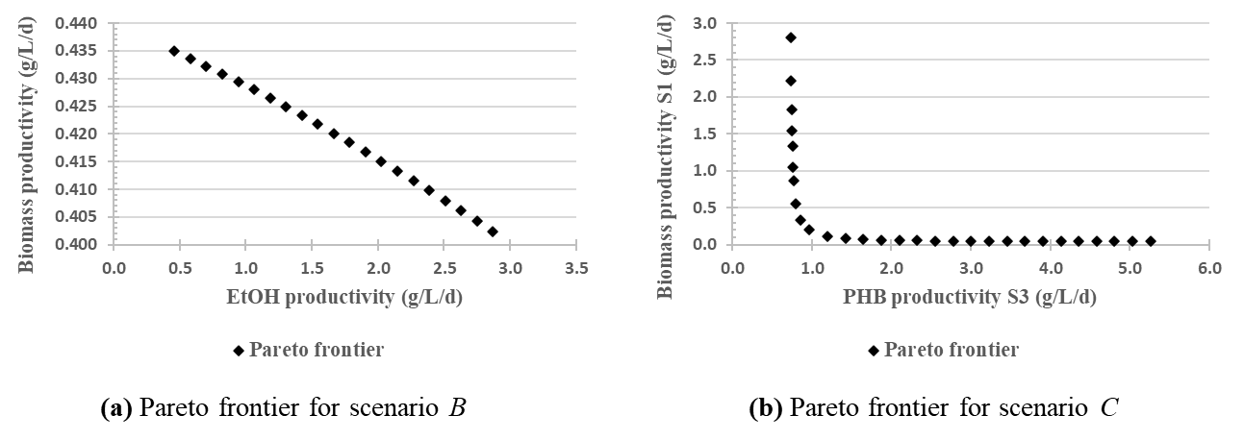
Figure 2. (a) Nondominated solutions (Pareto front) for scenario B for minimization of biomass and ethanol productivity (S2 strain), (b) Scenario C for minimization of biomass and PHB productivity of strains S1 and S3
  - Conclusions
In this work, we have addressed minimal target indices of alternative Synechocystis sp. PCC 6803 strains, required to be surpassed in order to obtain sustainable biorefinery designs, for the production of pigments, biofuels, PHB, DEE, green hydrogen and biofertilizers, by a mixed integer nonlinear programming (MINLP) multiobjective model including HEN design. A sustainable biorefinery design that produces pigments and biogas was attainable by cultivating strain S1, where the minimal target indices were significantly lower than those achieved by the in-silico proposal. Similarly, by a multiobjective optimization (MOO) approach, the model was solved to minimal biomass and bioethanol productivities for strain S2, that were achievable and outperformed by the productivities resulting from the previously designed in-silico strain. Conversely, for the case of a biorefinery that produces pigments (S1) and PHB (S3), it was found that it is necessary to further improve the considered strains in order to achieve a minimal PHB productivity required for any of the solutions obtained through the MOO problem. Overall, numerical results are encouraging into in-vivo testing for Synechocystis sp. strains S1 and S2, and further improving the strategies for identification of gene knockouts, aiming for optimal metabolic pathways for PHB production.
References
P. Charoensuppanimit, B. Chaiapha, S. Assabumrungrat, B. Jongsomjit, 2021. Incorporation of Diethyl Ether Production to Existing Bioethanol Process: Techno-Economic Analysis. J. Clean. Prod. 327 (May), 129438.
C. V. García Prieto, F. D. Ramos, V. Estrada, M. A. Villar, M. S. Diaz, 2017. Optimization of an integrated algae-based biorefinery for the production of biodiesel astaxanthin and PHB. Energy. 139, 1159-1172.
I. E. Grossmann, J. Viswanathan, A. Vecchietti, R. Raman, E. Kalvelagen, 2003. GAMS/DICOPT: A discrete continuous optimization package. Washington, DC, USA.
P. Khamhaeng, N. Laosiripojana, S. Assabumrungrat, P. Kim-Lohsoontorn, 2021. Techno-Economic Analysis of Hydrogen Production from Dehydrogenation and Steam Reforming of Ethanol for Carbon Dioxide Conversion to Methanol. Int. J. Hydrog. Energy, 46 (60), 30891–30902.
R. Lasry Testa, C. Delpino, V. Estrada, M. S. Diaz, 2019. Bioethanol Production with Cyanobacteria by a Two-Stage Fermentation Strategy. Comp. Aided Chem. Eng. 46, 499-504.
R. Lasry Testa, C. Delpino, V. Estrada, M. S. Diaz, 2022. Development of in silico strategies to photoautotrophically produce poly-β-hydroxybutyrate (PHB) by cyanobacteria. Algal Res. 62, 102621.
T. F. Lopes, C. Cabanas, A. Silva, D. Fonseca, E. Santos, T. L. Guerra, C. Sheahan, A. Reis, F. Girio, 2019. Process simulation and techno-economic assessment for direct production of advanced bioethanol using a genetically modified Synechocystis sp. Bioresour. Technol. 6, 113-122.
B. A. McCarl, A. Meeraus, P. van der Eijk, M. Bussieck, S. Dirkse, P. Steacy, F. Nelissen, 2022. McCarl Expanded GAMS user guide, Washington, DC, USA.
H. A. Pedrozo, A. I. Casoni, F. D. Ramos, V. Estrada, M. S. Diaz, 2022. Simultaneous design of macroalgae-based integrated biorefineries and their heat exchanger network. Comp. Chem. Eng. 164, 107885.
S. Price, U. Kuzhiumparambil, M. Pernice, P. Ralph, 2022. Techno-economic analysis of cyanobacterial PHB bioplastic production. J. Environ. Chem. Eng., 10, 107502.
M. Ramos, R. Lasry Testa, F. D. Ramos, V. Estrada, M. S. Diaz, 2023. Simultaneous design of integrated cyanobacteria-based biorefinery and its heat exchanger network. Comput. Aided Chem. Eng. 52, 2075-2080.
F. D. Ramos, M. A. Villar, M. S. Diaz, 2017. Optimal Design of Poly(3-hydroxybutyrate) Production using alternative Carbon Sources. Comput. Aided Chem. Eng. 40, 877-882.
A. Sarwer, M. Hussain, A. H. Al-Muhtaseb, A. Inayat, S. Rafiq, M. S. Khurram, N. Ul-Haq, N. S. Shah, A. Alaud Din, I. Ahmad, F. Jamil, 2022. Suitability of Biofuels Production on Commercial Scale from Various Feedstocks: A Critical Review. ChemBioEng Rev. 9 (5), 423–441.
Ž. Zore, L. Čuček, D. Širovnik, Z. Novak Pintarič, Z. Kravanja, 2018. Maximizing the Sustainability Net Present Value of Renewable Energy Supply Networks. Comp. Chem. Eng. 131, 245–265.

