Robust stability analysis of Koopman based MPC system
Gajanand Verma,ª William Heath,^{b} Constantinos Theodoropoulos^{a*}
ªSchool of Chemical Engineering and Analytical Science,The University of Manchester, M13 9PL, UK
^{b}School of Electrical and Electronic Engineering, University of Manchester, Manchester, M13 9PL, UK
k.theodoropoulos@manchester.ac.uk
Abstract
Linearization of complex large-scale non-linear systems offers several advantages from the perspective of Model predictive control (MPC). The Koopman operator is an infinite dimensional operator which globally linearizes a non-linear dynamical system, however a finite dimensional approximation of the Koopman operator is required for its employment in MPC. The reduction of dimensionality introduces unstructured uncertainty in the system and hence robust stability analysis is required to ensure the system remains stable. In our work, we have developed a linear MPC for a non-linear tubular reactor system based on a neural network approximated Koopman operator. Subsequently, we investigate the robust stability of the system utilizing the Integral Quadratic Constraint (IQC) methodology.
Keywords: Robust stability, Koopman operator, model predictive control, large-
scale systems, integral quadratic constraints
  - Introduction
Model Predictive Control (MPC) is an advanced control strategy that leverages a predictive model of the process to compute optimal control input trajectories. Its widespread adoption in various engineering branches is attributed to its capability of handling system constraints and multi-input multi-output (MIMO) systems. Nevertheless, MPC is challenged by the computational demands associated with real-time optimization.

With the technological advancements, chemical engineering systems have become more diverse and intricate, involving large scale non-linear systems or distributed parameter systems (DPS). Despite the advancements in computing facilities, the real time optimal control of such systems poses a multitude of challenges. The classical approach to handle large scale non-linear systems is based on dimensionality reduction (Theodoropoulos, 2011) (Theodoropoulos 2010) and model linearization. While dimensionality reduction reduces the computational burden of MPC associated with real time optimization, linear model is favoured as there exists several classical techniques to handle linear systems.

The traditional techniques of linearization are based on local-linearization or Carleman linearization (Korda and Mezić 2018). Koopman operator (KO) on the other hand globally linearizes a non-linear dynamical system in the infinite dimensional space of state functions. Since KO is an infinite dimensional operator, a finite dimensional approximation is required for its exploitation in MPC. The approximated linear system is of great significance from the control perspective as it can be utilized directly in MPC formulation of non-linear systems to reduce the complexity and computational efforts of MPC. Recently, KO based techniques have emerged for MPC formulation of non-linear systems (Korda and Mezić 2018).

Dynamic mode decomposition (DMD) based techniques were reported initially for finite approximation of KO (Kutz et al. 2016). Recently (2018), DMD has been extended to exploit KO for linear predictors or MPC (Korda and Mezić 2018). However, such methods usually require manual selection of lifting functions which may limit the prediction accuracy (Wang et al. 2022). Deep learning (DL)-based KO approximation methods inherently resolve this issue. Therefore, several DL based methods have also been reported for KO approximation and subsequent MPC formulation (Wang et al. 2022). Both DMD and Deep learning are equation free approaches and can be suitably applied to the systems where process model is either difficult or impossible to obtain.

While the finite dimensional KO approximation can simplify a complex non-linear dynamical system to a significant extent, such simplification can introduce unstructured uncertainty and destabilize the system (García et al. 2012). It is not trivial to guarantee robustness under such uncertainty (W. P. Heath and Li 2010). Therefore, the stability analysis post simplification becomes necessary to ensure the robust MPC performance (Bemporad and Morari 1999).

Uncertainties are effectively addressed through input-output stability analysis. The Integral quadratic constraints (IQCs) (Megretski and Rantzer 1997) is a unified approach to handle various kinds of uncertainties. The original IQC theorem was introduced in the frequency domain which can be converted to a linear matrix inequality (LMI) through the (Megretski and Rantzer 1997). The guaranteed stability is then subjected to existence of a symme Koopman Operator tric matrix $P=P^{T}$ satisfying the LMI. In this study, we conduct an IQC analysis (Petsagkourakis et al. 2020) to evaluate the robustness performance of the Koopman-based MPC.

  - Koopman Operator
The Koopman operator allows the linear evolution of state functions (or observables) in an infinite dimensional Hilbert space, along the trajectories of a given non-linear dynamics. Consider a discrete time non-linear dynamical system given by:
$$x_{k+1}=f\left(x_{k}\right)$$ | (1)
Where $x$ is the state of the system $(x_{k}∈R^{n}))$ and k is the integer index. $f$ is a non-linear map ($f :R→ R$). The Koopman operator $(K: H →H)$ acts on the functions of state $(ξ)$
linearly as following:
$$ξ\left(x_{k+1}\right)=Kξ\left(x_{k}\right)$$ | (2)
Since $K$ is an infinite dimensional operator, the Koopman eigenfunctions $(ψ)$ can be obtained to encompass the Koopman invariant subspace for finite dimensional approximation of Koopman operator.

$$ψ\left(x_{k+1}\right)=K^{'}ψ\left(x_{k}\right)$$ | (3)
where K' is the finite approximation of infinite dimensional Koopman operator K. Now consider a non-linear dynamical system with control input u as following
$x_{k+1}=f\left(x_{k},u_{k}\right)$ | (4)
From the perspective of MPC we are interested in the linear predictor of the form:
$$ψ_{k+1}=Aψ_{k}+Bu_{k}$$ | (5)

where $(x∈R^{n})$, $(u∈R^{m})$, $(ψ∈R^{N})$ is the lifted state $\left(N≫n\right)$.

We have employed Neural networks to approximate matrices A and B. The obtained linear model was then exploited for model predictive control of exit temperature of a tubular reactor.
  - Integral quadratic constraints (IQC) analysis
The IQC approach introduced by Megretski and Rantzer (1997), is powerful framework for analyzing robust stability and performance of systems in the presence of uncertainties or non-linearities. It unifies all the classical methods for stability analysis and thus can capture important properties of uncertainties or non-linearities. In IQC framework, the system is considered as a interconnection of a LTI system and a uncertain/non-linear perturbation whose input/output behaviour can be described by IQC (Pfifer and Seiler 2015). Two signals p and q satisfy the IQC defined by $Π$ if the following condition holds
$$\left\langle \left[\begin{aligned}\hat{p} \\ \hat{q}\end{aligned}\right],Π \left[\begin{aligned}\hat{p} \\ \hat{q}\end{aligned}\right] \right\rangle = \int_{-∞}^{∞}{{\left[\begin{aligned}\hat{p} \\ \hat{q}\end{aligned}\right]}^{*}}Π\left(jω\right) \left[\begin{aligned}\hat{p} \\ \hat{q}\end{aligned}\right] dω ≥ 0$$ | (6)
Where $\hat{p}$ and $\hat{q}$ represent the Fourier transformations of signals $p$and $q$. For further information on IQCs one can refer to (Megretski and Rantzer 1997). The Kalman–Yakubovich–Popov (KYP) lemma converts the frequency domain criteria to a LMI criteria.
The introduction of frequency domain IQCs was followed by the development of time domain IQCs, through the factorization of the multiplier Π(jω) and the application of dissipation theory (Pfifer and Seiler 2015). The time domain IQC theory is notably applicable to hard IQCs, which remain valid over any finite time period. The factorization for time domain IQCs is given as follows:
$Π = ψ*Mψ$ (6a)

According to (W. Heath et al. 2005) any MPC with input constraints only satisfy the IQC with following multiplier:
$Π =\left[\begin{matrix}0 & I \\ I & -2H\end{matrix}\right]$ (6b)
where -ɸ^{T}Hɸ + ɸ^{T}f $≥$ 0 is the result of KKT conditions ((W. Heath et al. 2005))
  - Application
We applied the Koopman based MPC framework to a tubular reactor (with recycle ratio r) where an irreversible, exothermic first order chemical reaction $( A →B )$ takes place. The system exhibits oscillations (Hopf bifurcation) at recycle ratio of 0.5 (Jensen and Ray 1982). The governing dimensionless equations are as follows:

$$\frac{∂C}{∂t}=\frac{1}{Pe_{m}}\frac{∂^{2}C}{∂x^{2}}-\frac{∂C}{∂x}-Da\left(1+C\right)\exp\left(\frac{γT}{1+T}\right)$$ | (7)
$$\frac{∂T}{∂t}=\frac{1}{Pe_{h}}\frac{∂^{2}T}{∂x^{2}}-\frac{∂T}{∂x}+cDa\left(1+C\right)\exp\left(\frac{γT}{1+T}\right)+β\left(u_{w}-T\right)$$ | (8)
while the boundary conditions are given as

$${\left.\frac{∂C}{∂x}\right|}_{x=0}=-Pe_{m}\left[\left(1-r\right)C_{0}+rC{\left.​\right|}_{x=1}-rC{\left.​\right|}_{x=0}\right]$$ | (9)
$${\left.\frac{∂T}{∂x}\right|}_{x=0}=-Pe_{h}\left[\left(1-r\right)T_{0}+rT{\left.​\right|}_{x=1}-rT{\left.​\right|}_{x=0}\right]$$ | (10)
$${\left.\frac{∂T}{∂x}=\frac{∂C}{∂x}\right|}_{x=1}=0$$ | (11)
Here $C$and T are dimensionless concentration and temperature, $u_{w}$ is the wall temperature which was divided into 3 sectors to control the temperature of the system. $Pe_{m}=Pe_{h}=7.0$, $Da = 0.1$, $γ=10,c=2.5,β=2,x∈\left[0,1\right].$
The discretized system was lifted from 30 state variables to 51 state variables using neural networks and subsequently finite dimensional Koopman operator was obtained to linearize the system. The linearized system was then used in MPC formulation to control the exit temperature of the reactor. Figure 1 depicts the performance of PDE based MPC (NMPC) and Koopman based MPC. As it can be seen, the Koopman-based MPC can successfully achieve performance very close to the NMPC one with significant computational savings.
  - Conclusions and future work
This work successfully demonstrates the efficacy of a Koopman-based MPC system for a non-linear tubular reactor. By employing a neural network to approximate the Koopman operator, we were able to linearize the non-linear dynamics of the reactor effectively. This linearization significantly simplified the control problem, allowing us to use a linear MPC approach. Our findings indicate that despite the dimensionality reduction and associated unstructured uncertainties the controller was able to dampen the oscillations and achieve the set point. Figure 1(a) demonstrates the system's response without MPC, showing significant oscillations with recycle (r=0.5), while Figure 1(b) reveals the stabilizing effect of the Koopman MPC in comparison to the PDE based MPC (NMPC) and open-loop responses, highlighting its efficacy in controlling the exit temperature of the system with linearized model. The control input profiles in Figures 1(c) and 1(d) depicts the control input trejectories for NMPC as well as Koopman MPC. We are currently investigating the robust stability analysis using the IQC methodology described in Section 3. The IQC study will ensure the theoretical guarantee of robustness within certain bounds.

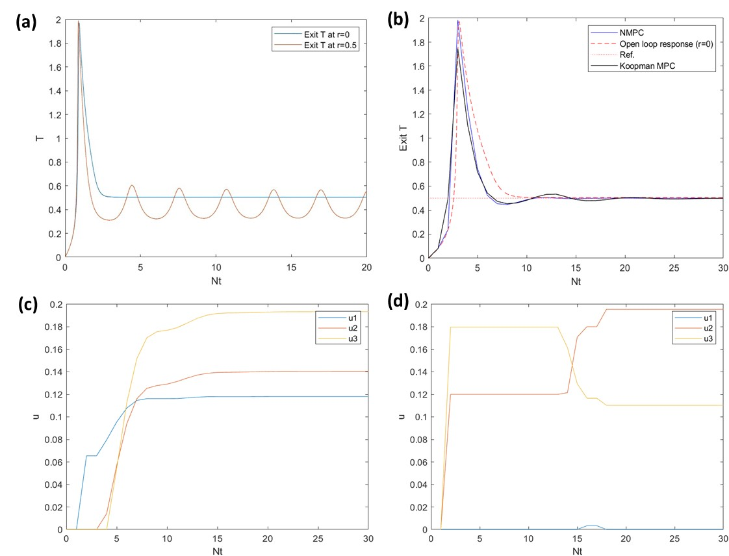

Figure 1: (a): Exit temp. of reactor at r = 0 and r = 0.5 without MPC; (b) Exit temp.
profile with non-linear MPC and Koopman MPC; (c) Control input profile obtained from
NMPC; (d) Control input profile obtained from Koopman MPC

References

Bemporad, A., and M. Morari. 1999. ‘Control of Systems Integrating Logic, Dynamics, and Constraints’. Automatica 35 (3): 407–27.
García, M. R., C. Vilas, L. O. Santos, and A. A. Alonso. 2012. ‘A Robust Multi-Model Predictive Controller for Distributed Parameter Systems’. Journal of Process Control 22 (1): 60–71.
Heath, W. P., and G. Li. 2010. ‘Multipliers for Model Predictive Control with Structured Input Constraints’. Automatica 46 (3): 562–68.
Heath, WP, G Li, AG Wills, and B Lennox. 2005. ‘IQC Analysis of Linear Constrained MPC’. In IEEE Sponsored Colloquium on Predictive Control, University of Sheffield.
Jensen, K. F., and W. H. Ray. 1982. ‘The Bifurcation Behavior of Tubular Reactors’. Computers and Chemical Engineering 37: 199–222.
Korda, M., and I. Mezić. 2018. ‘Linear Predictors for Nonlinear Dynamical Systems: Koopman Operator Meets Model Predictive Control’. Automatica 93 (July): 149–60.
Kutz, J. N., S. L. Brunton, B. W. Brunton, and J. L. Proctor. 2016. Dynamic Mode Decomposition: Data-Driven Modeling of Complex Systems. Society for Industrial and Applied Mathematics.
Megretski, A., and A. Rantzer. 1997. ‘System Analysis via Integral Quadratic Constraints’. IEEE Transactions on Automatic Control 42 (6): 819–30.
Pfifer, H., and P. Seiler. 2015. ‘Robustness Analysis of Linear Parameter Varying Systems Using Integral Quadratic Constraints’. International Journal of Robust and Nonlinear Control 25 (15): 2843–64.
Petsagkourakis P., WP Heath, and C Theodoropoulos 2020 ' Stability analysis of piecewise affine systems with multi-model predictive control' Automatica 111, 108539.
Theodoropoulos, C. 2010. ‘Optimisation and Linear Control of Large Scale Nonlinear Systems: A Review and a Suite of Model Reduction-Based Techniques’. Coping with Complexity: Model Reduction and Data Analysis, 37–61.
Wang, M., X. Lou, W. Wu, and B. Cui. 2022. ‘Koopman-Based MPC with Learned Dynamics: Hierarchical Neural Network Approach’. IEEE Transactions on Neural Networks and Learning Systems.

