Reduction of an aerated fermenter CFD model using proper orthogonal decomposition
Pedro M. Pereira,ª* Rui C. Martins,ª Bruno S. Ferreira,^{b} Fernando P. Bernardo,ª
ªCIEPQPF, Department of Chemical Engineering, University of Coimbra, R. Sílvio Lima, 3030-790 Coimbra, Portugal.
^{b}Biotrend SA, Biocant Park Núcleo 04, Lote 2, 3060-197 Cantanhede, Portugal
pedro.mesquita.pereira@tecnico.ulisboa.pt
Abstract
The development of CFD + reaction models has been accepted as an important tool to solve the problems of fermentation scale-up, however the computational cost of multiphase CFD makes simultaneous solution unfeasible. In this work a method for model reduction of CFD models for aerated stirred tanks is proposed as a fast and reliable model for the fluid dynamics. The CFD model took one week to simulate 11 seconds on 20 cpu cores. The reduced model can be reconstructed in less than one second with an error of 10% on the velocity of the water and 20 % on the velocity of the air. With the least well described areas of the tank being also the least relevant to the application. These results show great promise for the use of POD + regression reduced models for aerated stirred tank CFD.
Keywords: CFD, Proper orthogonal decomposition, Fermentation, Aerated stirred tank.
  - Introduction

The scale-up of fermentation processes is an active area of research in bioprocess engineering. As in other applications, the increase in scale of fermentation from bench to pilot and then to commercial scale introduces inefficiency in the mixing process, namely undesired and hard to predict heterogeneities in critical parameters such as dissolved oxygen concentration. Detailed process models are thus required to resolve the spatial gradients in large scale bioreactors, and for that purpose the most useful tool is computational fluid dynamics (CFD) coupled with transport equations for the most relevant species and kinetics of the biochemical reactions.
The major barriers to the development of such CFD + kinetic models are the different time scales of the phenomena taking place and the high computational cost of CFD simulations. The characteristic time for liquid circulation in the reactor and gas-liquid mass transfer is in the order of 10 s while the characteristic time for the biochemical reactions may be as large as 10⁴ s (Amanullah et al 2003). With such separate time scales, the two model components can be decoupled (Yamamoto, 2013) by first calculating a representative set of stationary fields obtained from CFD simulations and then solving on top of these the biochemical kinetics.
The alternative here presented is the creation of a computationally light, reduced order model, able to capture the main fluid dynamics aspects of the system. This reduced model will then allow future extensions to a parametric reduced model, with parameters being fed-batch operation variables and also design variables, and as such the model can be used to support scale-up decisions. Such parametric reduced CFD models have been described for equally complex systems, for example in aerospace applications (Chen et al, 2019).
Proper orthogonal decomposition (POD) is a well-established method to construct reduced versions of large-scale CFD models (Holmes et al, 2012), and therefore is the method used in this work. In the context of CFD, POD is traditionally used to identify, study and model the dynamics of spatial structures of the turbulent velocity field. POD creates the key spatial ingredients, called modes, that compose the dynamics of the system. With the time-dependent combination of modes, the reduced model can dynamically recreate the coherent structures and by extension the fluid flow (Holmes et al, 2012). Equation 1 represents the form of a POD decomposition, with $\vec{U}\left(x,t\right)$ being the velocity field calculated from the higher order CFD model, which is then approximated by a linear combination of $p$ orthogonal functions named eigenvectors (or modes) ${\vec{ϕ}}_{k}$. The combination is weighted by $a_{k}$ time varying coefficients that capture the system dynamics, while vectors ${\vec{ϕ}}_{k}$ retain the spatial distribution of state variables, in this case the fluid velocity.
$$\vec{U}\left(x,t\right)≈{\vec{U}}_{POD}\left(x,t,p\right)=\sum_{k=1}^{p}{a_{k}\left(t\right){\vec{ϕ}}_{k}\left(x\right)}$$ | (1)
Multiple authors have applied POD in the context of stirred tank fluid dynamics. One example of this is the work of Lammote et al (2018), that performed POD to CFD and experimental results of stirred tanks for identification of the dominant spatial and time characteristic of flow dynamics in stirred tanks, including the simulation of the free-surface. The authors observed some limitations of k-ε RANS simulations to predict the energy-containing higher modes. Due to its computational efficiency this method is still employed in this work. Other authors like Jin and Fan (2020) also applied POD to experimental data of fluid flow in stirred tanks. Mendonza et al (2018) used experimental and CFD results with POD to study the transitional flow regime in stirred tanks. The work of Janiga (2019) can be seen as a landmark work on POD in stirred tanks due to its use of higher fidelity Large eddy simulations with highly detailed description of coherent structures in the flow at varying Reynolds numbers. The more recent work of Arosema and Solsvik (2023) presents a similar approach with investigation of the effect of bubbly flows and the modelled shape of the bubbles. Tabib and Joshi (2008) also studied the flow of multiple pieces of equipment with experimental data, LES and POD. Mikhaylov et al (2023) propose an innovative use of POD for reconstruction of the instantaneous 3D velocity field from sparse pressure measurements at the impeller blades.
The work of Mayorga et al (2022) is one of the first to propose what is also adopted in this work, the reconstruction of the model and not just the use of POD as an analytical tool for stirred tanks, this work only included single phase stirred tanks while in the present work aerated flows are studied.
The reconstruction of the model can be based on projection methods like the Galerkin projection or interpolative/regression methods. The Galerkin projection requires a great degree of manipulation of the higher order CFD model. For a greatly complex multiphase CFD model this was not deemed practical and for this reason a regression-based method was used to recreate the $a_{k}\left(t\right)$ function. Due to the existence of fluctuating stationary fields $a_{k}\left(t\right)$ are expected to be periodic functions as observed by Mayorga et al (2022) for single phase stirred tanks. Fourier series are well established to approximate periodic functions and as such are here used to approximate $a_{k}\left(t\right)$.
  - Methods
    - CFD methods
The CFD model used is an Euler-Euler model with a mass conservation and momentum conservation equation for each phase as seen in Eq. 2,3 and 4. The two phases share the same pressure field and exchange momentum with each other. The interphase drag is modelled by the Schiller and Naumann model (1933) and the virtual mass forces are modelled by a constant coefficient model.
$$\frac{∂}{∂t}(α_{k}ρ_{k})+∇∙(α_{k}ρ_{k}U_{k})=0$$ | (2)
$$\frac{∂}{∂t}(α_{k}ρ_{k}U_{k})+∇∙(α_{k}ρ_{k}U_{k}U_{k})=-α_{k}∇p+∇∙(α_{k}τ_{k})+α_{k}ρ_{k}g+M_{jk}$$ | (3)
$$\frac{∂}{∂t}(ρ_{m}k_{m})+∇·(ρ_{m}{\tilde{U}}_{m}k_{m})=∇·μ_{mt}σ_{m}∇k_{m}+P_{k}^{m}-ρ_{m}ε_{m}+Sk_{m}$$ | (4)
The turbulence model is Reynolds Averaged Navier-Stokes with mixture k-ε closure (Behzadi et al 2004). The rotation of the impellers is modelled by a multiple reference frame (MRF) model. The geometry of the bioreactor here studied was replicated from the description of the equipment used by Warmoeskerken and Smith (1985). The mesh was produced with the openFOAM® tools blockMesh and snappyHexMesh. The mesh was refined to achieve recommended values of y⁺ for the used wall functions and composed of 517868 elements. Predicting the power spent by the impeller was done by a custom openFOAM® function. The operating conditions modelled are: rotation speed of the impeller constant at 3 rotations per second and the gas flow-rate at 2x10⁻⁴ m³s⁻¹ corresponding to 0.2 vvm on a 7L filled volume tank.
    - POD and regression methods
The construction of the reduced basis with POD started with the construction of the $3L×N$ sized matrix of snapshots $\underline{M}$. The reduced basis was constructed with the snapshot method. This method starts with the construction of the correlation matrix $\underline{R}$ as seen in Eq. 5. This was followed by the solution of the eigenvalue problem in Eq. 6. With Y being the matrix whose columns are the eigen vectors of the correlation matrix and $\vec{E}$ being a vector of the eigenvalues of the correlation matrix. The coefficient array $T$ that contain the values of $a_{k}\left(t\right)$ for each time $t_{n}$ for each snapshot was calculated by equation 7. Finally the matrix $Φ$ containing the modes ${\vec{ϕ}}_{k}\left(x\right)$ as columns was constructed with equation 8.
$$\underline{R}={\underline{M}}^{T}\underline{M}$$ | (5)
$$\underline{R}Y=Y\vec{E}$$ | (6)
$$T=Y{\vec{E}}^{\frac{1}{2}}$$ | (7)
$$Φ=\underline{M}T$$ | (8)
$$a_{k}\left(t\right)=a_{0,k} +a_{1,k}cos\left(w_{k}t\right)+a_{2,k}cos\left(2w_{k}t\right)+a_{3,k}cos\left(3w_{k}t\right)+b_{1,k}sin\left(w_{k}t\right)+b_{2,k}sin\left(2w_{k}t\right)+b_{3,k}sin(3w_{k}t)$$ | (9)

The python Library “modred” was used to perform these steps and a small python script was created to construct the matrix of snapshots. To reconstruct the 3D fields a continuous function for each $a_{k}\left(t\right)$ is necessary. From the POD results the array $T$ was obtained which contains the values of $a_{k}\left(t\right)$ for the times corresponding to the snapshots. To construct a continuous function from this data a regression method was used. The data was fitted to a third order Fourier Series approximation, with the form presented in equation 9 using the python library “symfit”.
  - Results and Discussion
The use of POD in the literature is mostly applied to find coherent structures in pseudo-stationary or fully developed turbulent flow. Works including this type of analyses include those of Lamote et al (2018) and Mayorga et al (2022). Another use of POD is for analysis of dynamics of CFD results. In figure 1 are presented the results of instantaneous power developed by the impeller and a(t) for the 4 principal modes obtained from POD of the full domain of time up to 11.5 s including start-up. Power expended in agitation is a well established indicator of the operating conditions of an aerated stirred tank (Paul et al 2003). As such the stabilization of the expended power is a good indicator that the system arrived at a pseudo-stationary state. For the two most important modes 0 and 1, a(t) stabilizes at 6 s of aerated flow as the aerated power also stabilizes. Further POD analyses were done from 6 s of simulation for these reasons. The a(t) profiles present a step perturbation with a plateau from 2 s to 3.6 s, this coincides with the transition of the impeller from operating in the regime with 6 equally sized trailing air cavities to 3 larger and 3 smaller sized trailing air cavities.
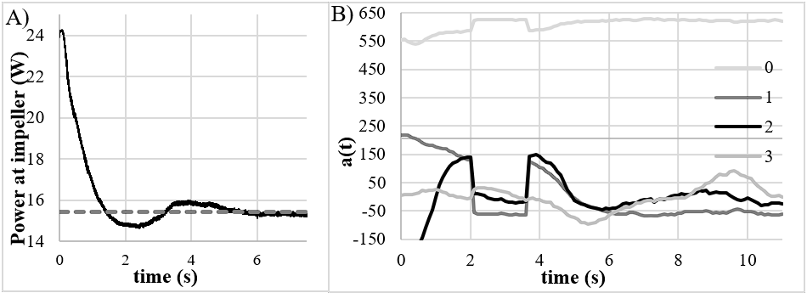
POD was performed based on the snapshots from 6 s to 11.5 s, the sampling rate was 10 s⁻¹ which corresponds to 55 snapshots. The vector fields of velocity of air (${\vec{u}}_{air}$) and velocity of water (${\vec{u}}_{water}$) were decomposed. For each of the velocity fields 11 modes were necessary to effectively represent the CFD data. These 11 modes represent more than 99% of the eigen values of both correlation matrices, the advised threshold (Chen et al, 2019).
Figure 1 A) Power spent on agitation calculated online with CFD simulation B) a(t) of the main 4 modes of the 0 s to 11 s POD.

The values of a(t) of the most important modes in both vector fields represent a constant profile independent of time. For ${\vec{u}}_{water}$ α(t) of the first mode is 630 and for ${\vec{u}}_{air}$ it is 766. The other 3 most important modes are presented in figure 2. These modes present an oscillatory behaviour as is expected, but the profile of the curves is not well conforming to simple periodic functions, as has been observed for non-aerated flows (Mayorga et al 2022). Reconstruction of the vector fields using equation 8 was done to investigate the error associated with POD alone. Error was defined as seen in equation 10. The average error over the space and time domains was 7% for $u_{air}$ 5% for $u_{water}$.

$$e_{rel}=\frac{\left\|U_{POD}-U_{CFD}\right\|}{\left\|U_{CFD}\right\|}$$ | (10)
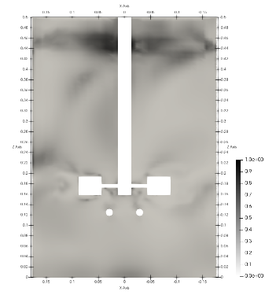
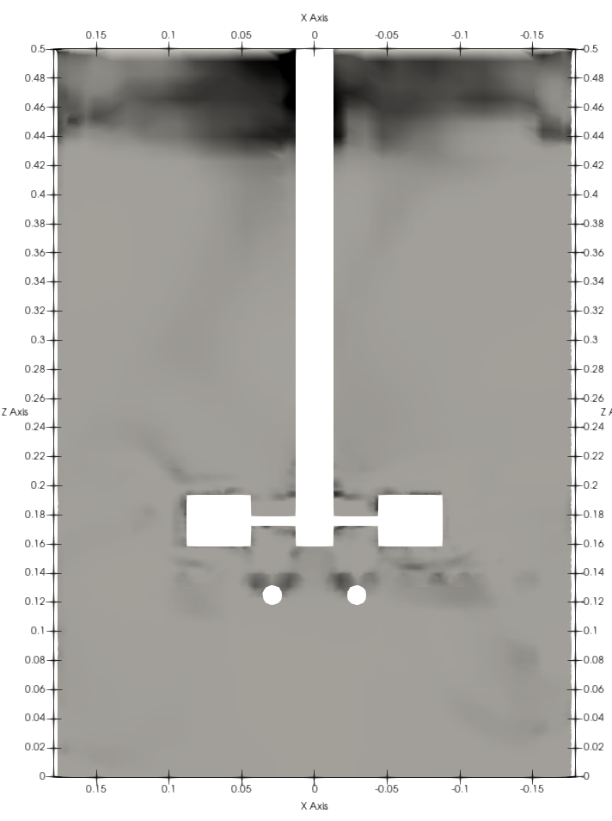
The regression of the discrete values of a(t) seen as points in figure 2 was done for all 11 modes for ${\vec{u}}_{air}$ and${\vec{u}}_{water}$. In general good fits were obtained with r² greater than 0.9. The relative error for ${\vec{u}}_{water}$ was of 10 % and 20% for ${\vec{u}}_{air}$ averaged over space and time. To verify the spatial distribution of the relative error a time average and spatial discretized map of relative error is presented in figure 3. From this image it’s observed that the regions of greater relative error in the prediction are located in the air headspace of the tank. This is a good indication as this area is not directly relevant for modelling of a reaction occurring in the liquid phase. If the headspace is not accounted the error goes to 13% for ${\vec{u}}_{air}$ and 8 % for ${\vec{u}}_{water}$. The errors in estimation of velocity imply error in estimation of local residence time for bubbles, fluid and biomass. This influences the estimation of gas-liquid mass transfer and estimation of concentration gradients for the fermentation model. The simulation is speed-up from taking one week to simulate the 11s of the full order model to less than one second to reconstruct the POD + regression model.
A)
B)
Figure 2 Evolution of a(t) of the 2nd, 3rd and 4th most important modes for: A) ${\vec{u}}_{water}$ and B) ${\vec{u}}_{air}$.
Figure 3 Map of the relative error on a cut of the stirred tank: A) of ${\vec{u}}_{water}$B) of ${\vec{u}}_{air}$.
A)
B)
  - Conclusion
The results here presented show that application of POD to aerated stirred tanks is feasible. In particular the use of POD-Regression methods appears as a viable option for model reduction of multiphase CFD results. This also opens the possibility of application on reaction modelling of fermentation with fine spatial discretization. This spatially fine discretization compared to other surrogate models such as compartment models allows the modelling of concentration gradients deemed as central for the effects of scale-up. Ultimately, also parametric models should be possible. The data-set here presented is somewhat limited, as such, further investigation is necessary on the effects of the reactor operating regime and the construction of models sufficiently robust to allow for extrapolation.
  - References

Amanullah, A., et a(2003). Mixing in the fermentation and cell culture industries. Handbook of industrial mixing: science and practice, 1071-1170.
Arosemena, Arturo A., and Jannike Solsvik. “Proper Orthogonal Decomposition Modal Analysis in a Baffled Stirred Tank: A Base Tool for the Study of Structures.” Flow, vol. 3, Cambridge UP (CUP), 2023.
Behzadi, A. et al., 2004, Modelling of dispersed bubble and droplet flow at high phase fractions. Chemical Engineering Science, 59.4: 759-770
Chen, Z., et al (2019). Parametric reduced-order modeling of unsteady aerodynamics for hypersonic vehicles. Aerospace Science and Technology, 87, 1-14.
Holmes, Philip. Turbulence, Coherent Structures, Dynamical Systems and Symmetry. Cambridge UP, 2012.
Janiga, Gábor. “Large-eddy Simulation and 3D Proper Orthogonal Decomposition of the Hydrodynamics in a Stirred Tank.” Chemical Engineering Science, vol. 201, Elsevier BV, June 2019, pp. 132–44.
Jin, Jie, and Ying Fan. “PIV Experimental Study on Flow Structure and Dynamics of Square Stirred Tank Using Modal Decomposition.” Korean Journal of Chemical Engineering, vol. 37, no. 5, Springer Science and Business Media LLC, Apr. 2020, pp. 755–65
Lamotte, Anne de, et al. “Identifying Dominant Spatial and Time Characteristics of Flow Dynamics Within Free-surface Baffled Stirred-tanks From CFD Simulations.” Chemical Engineering Science, vol. 192, Elsevier BV, Dec. 2018, pp. 128–42
Mayorga, C., et al. “Reconstruction of the 3D Hydrodynamics in a Baffled Stirred Tank Using Proper Orthogonal Decomposition.” Chemical Engineering Science, vol. 248, Elsevier BV, Feb. 2022, p. 117220.
Mikhaylov, Kirill, et al. “Decomposition of Power Number in a Stirred Tank and Real Time Reconstruction of 3D Large-scale Flow Structures From Sparse Pressure Measurements.” Chemical Engineering Science, vol. 279, Elsevier BV, Sept. 2023, p. 118881
Paul, Edward L., et al. Handbook of Industrial Mixing. John Wiley and Sons, 2004
Warmoeskerken, M. M. C. G.; Smith, John M. Flooding of disc turbines in gas-liquid dispersions: A new description of the phenomenon. Chemical Engineering Science, 1985, 40.11: 2063-2071
Schiller, Links. A drag coefficient correlation. Zeit. Ver. Deutsch. Ing., 1933, 77: 318-320
Tabib, Mandar V., and Jyeshtharaj B. Joshi. “Analysis of Dominant Flow Structures and Their Flow Dynamics in Chemical Process Equipment Using Snapshot Proper Orthogonal Decomposition Technique.” Chemical Engineering Science, vol. 63, no. 14, Elsevier BV, July 2008, pp. 3695–715.
Yamamoto, M. (2013). Multi-physics CFD simulations in engineering. Journal of Thermal Science, 22(4), 287-293.

