Process intensification opportunity for reactive-extractive distillation: A new configuration for ternary azeotropic separation
Zong Yang Kong,ª Yu-Ying Chen,^{b} Juan Gabriel Segovia-Hernández,^{c} Hao-Yeh Lee^{b,}*
ªDepartment of Engineering, School of Engineering and Technology, Sunway University, Bandar Sunway 47500, Selangor, Malaysia
^{b}National Taiwan University of Science and Technology, Department of Chemical Engineering, No.43, Keelung Rd., Sec.4, Da'an Dist., Taipei City 106335, Taiwan
^{c}Universidad de Guanajuato, Campus Guanajuato, División de Ciencias Naturales y Exactas, Departamento de Ingeniería Química, Noria Alta s/n, 36050, Guanajuato, Gto, Mexico
haoyehlee@mail.ntust.edu.tw
Abstract
A common problem in all intensified reactive-extractive distillation (RED) systems, like the dividing-wall double column RED (DW-DCRED), is the inability to provide energy savings, which sets it apart from conventional distillation systems. To address this limitation, we propose a new alternative configuration, i.e., an extractive-reactive distillation (ED-RD) by rearranging the column sequence in the original RED system. The ED-RD offers potential cost savings of up to 4 % and its corresponding intensified configuration, i.e., the dividing-wall ED-RD (DW-ED-RD), was able to provide significant energy and cost saving up to 21 and 26 %, respectively, in contrast to the limitations observed in conventional RED systems. This reflects the potential intensification opportunity of the proposed configuration for azeotropic separation.
Keywords: Reactive-extractive distillation, Ternary azeotropic mixture, Process Intensification, Energy-saving, Resource conservation
  - Introduction
The hybrid reactive-extractive distillation (RED) has garnered substantial attention as an innovative hybrid method, which combines chemical reaction and azeotropic separation into a single unit operation. Such method first appeared in 2020 in the form of a triple-column RED (TCRED) (Su et al., 2020), and soon afterward, a double-column RED (DCRED) was proposed in subsequent studies, streamlining the process from three columns (Wang et al., 2021). In comparison to the conventional extractive or pressure-swing distillation, the hybrid RED has been proven to provide significant improvement in the energy consumption and cost (i.e., total annual cost (TAC)) by at least half. Since the introduction of TCRED and DCRED, the field has witnessed a growing body of research. A comprehensive review of these RED studies can be found in literature for those interested (Kong et al., 2022b, 2022a). Moreover, some studies have explored the combination of RED with other process intensification (PI) techniques, such as dividing-wall (Liu et al., 2022) and side-stream (Yang et al., 2023), to maximize energy recovery. Nonetheless, a notable challenge present in all the existing intensified studies on RED is the absence of demonstrated energy savings in comparison to DCRED (Yang et al., 2023, 2022). This contrasts with intensified studies on conventional distillation, where significant reductions in energy consumption (e.g., up to 30 %) have been reported through intensified configurations that eliminate remixing effects. Remixing effect arises when the distillate product of the subsequent column reaches its peak purity in the prior column and then decreases. This signifies that the component is not collected at its maximum purity level, which necessitate extra energy to purify the component again. This clarifies why the remixing effect is commonly linked to increased energy consumption in the process. For example, Yang et al. (2022) worked on the dividing-wall DCRED (DW-DCRED) and demonstrated that despite the lower TAC and CO₂ emission achieved, these advantages were traded-off by increased energy consumption when compared to the DCRED. This paper endeavors to investigate an alternative configuration whose intensified counterpart holds potential for conserving energy. Just as TCRED and DCRED marked the initiation of RED studies, this work lays the foundation for more comprehensive research on its application in ternary azeotropic mixture separation.
  - Methodology
    - Process configuration for base case
Figure 1(a) shows the DCRED process reproduced from Zhang et al. (2021) for the separation of tetrahydrofuran (THF), ethanol (Eth), and water. It was selected as base case since it is one of the earliest works on RED. The first column is a reactive-extractive distillation column (REDC) where the fresh feed enters at 100 kmol h⁻¹. The water reacts with the externally injected ethylene oxide (EO), resulting in the formation of ethylene glycol (EG) according to Eq. (1). The produced EG is subsequently used as solvent for the azeotropic separation in the same column. Note that the quantity of the externally injected EO is equivalent to that of water to facilitate complete water removal. In addition to the produced EG, extra EG is introduced into the REDC to ensure an adequate supply of solvent for the azeotropic separation. The distillate from the REDC is expected to achieve a THF purity of 99.6 mol%. The remaining mixture (Eth + EG) proceeds to the solvent regeneration column (SRC), where Eth of 99.6 mol% is obtained as the distillate, and EG of 99.92 mol% is recovered as the bottom product. The regenerated EG is cooled before recycled back to the REDC and any surplus solvent is purged from the system.
$$EO+Water→EG$$  $$r_{1}\left(\frac{mol}{{s*cm}^{3}}\right)=3.15 × {10}^{9}exp\left(\frac{-9547}{T}\right)x_{water}x_{EO}$$ | (1)
Figure 1(b) shows the DW-DCRED modified from the base case (Figure 1(a)). In the DW-DCRED, the initial SRC containing 10 stages is integrated with the REDC, forming the upper section of the DW-DCRED. This results in an increase in the number of stages for the SRC from 10 to 60 and the elimination of the reboiler at the bottom of the SRC. This integration approach aligns with similar methodologies applied in prior research (Wu et al., 2013) and the objective is to identify potential energy consumption savings directly from the TAC. The removal of the original SRC reboiler due to integration necessitates the introduction of a vapor-liquid interconnection flowrate between the left and right side of the column (separated by the dividing wall). This leads to a portion of water and EO originally in the left side of the column to escape to the right side before a complete reaction according to Eq. (1) occurs, which significantly impacts product purity. To rectify this issue, it is necessary to effectively distribute the reaction throughout the entire DW-DCRED. Such an approach has not been explored in previous studies on intensified RED. From Figure 1(b), the total reboiler energy consumption of the DW-DCRED amounts to 1120 kW, marking a 6 % increase compared to the base case. Such observation is consistent with prior research, which suggests that intensified DCRED typically do not yield energy savings (Yan et al., 2022; Yang et al., 2022), even after it has been optimized.
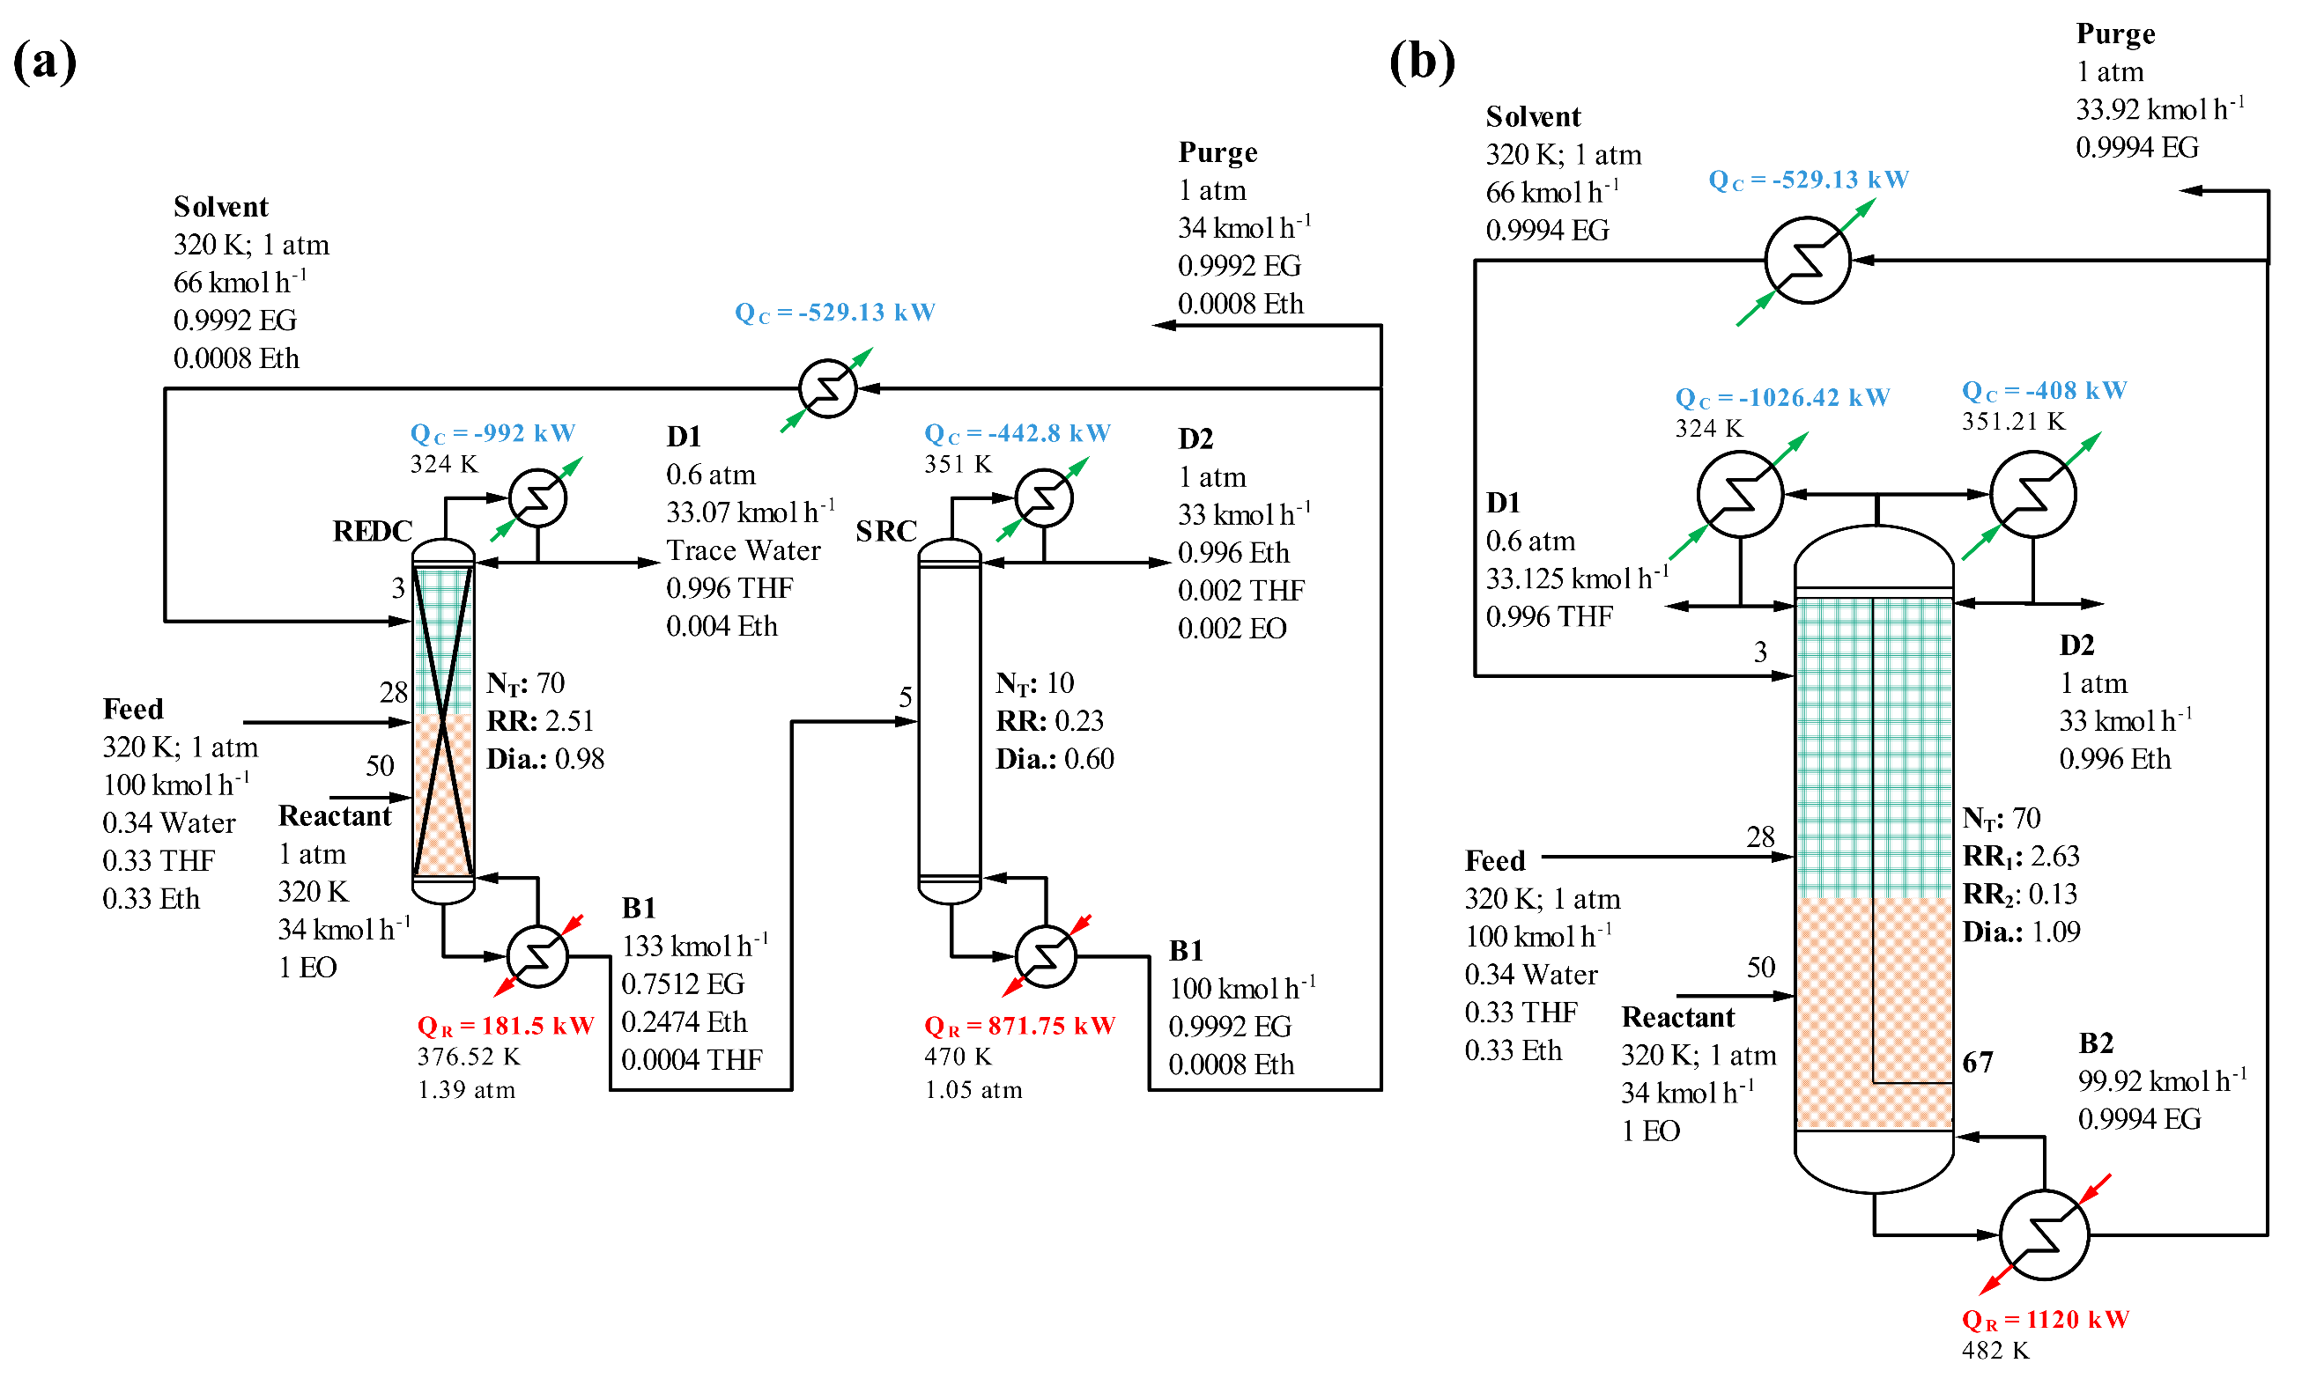
Figure 1. The separation of THF, Eth, and water using (a) DCRED reproduced from Zhang et al. (2021) and (b) the intensified DW-DCRED.
    - Process simulation and evaluation
The simulations were carried out using Aspen Plus V12.1. The fresh feed flowrate, composition, and thermodynamic package were maintained at the same value as the base case, allowing for a fair and consistent comparison. Here, note that the DCRED from previous work was not subjected to optimization and the study relied on a “Rule of Thumb” approach to determine the total stages of distillation columns. This approach was designed to ensure that the number of stages was equivalent to or fewer than those in their reference base cases, thus facilitating fair economic performance comparisons. In this study, we follow a similar methodology because our objective is to introduce an alternative conceptual design. The rest of the design parameters (i.e., feed stage location) are manipulated individually to attain the minimum energy consumption. Note that our new configuration already exhibits a lower TAC than the previous DCRED, even before process optimization (further detailed results will be provided in Section 3.1). The performance of the newly proposed process is evaluated using both the total reboiler energy consumption and economic indicators (TAC). The TAC is calculated using Eq. (2), following the approach of Douglas (1988)’s textbook.
$$TAC= \frac{Total capital cost (TCC)}{Payback period (3 years)}+Total operating cost (TOC)$$ | (2)
  - Results and discussion
    - Proposed hybrid extractive-reactive configuration
Figure 2 shows the proposed ED-RD, featuring an inversion in the ED and RD sequence compared to the DCRED (Figure 1(a)). The first column serves as an extractive distillation column (EDC) where fresh feed, accompanied by the EG solvent, is introduced into the EDC, yielding a high-purity THF distillate. The residual mixture proceeds to the second column, acting as a reactive distillation column (RDC) for further separation. In the RDC, the water undergoes hydration reaction with externally added EO (Eq. (1)). This reaction effectively eradicates the azeotrope, ensuring that all the water is completely converted. Eth is collected as the distillate while the generated EG retrieved from the bottom is conveniently cooled and recycled back to the EDC, mirroring the base case procedure. The TAC of the ED-RD is approximately $0.52 million per year, signifying a notable 4 % decrease in TAC in contrast to the DCRED. This reduction primarily stems from a 22 % decrease in the TCC due to the utilization of fewer stages in the proposed setup. The TOC for the ED-RD is only marginally higher than the base case, even though there is a 22 % increase in energy consumption within the ED-RD configuration. This is predominantly attributed to the primary use of cost-efficient low-pressure (LP) steam in the EDC, as opposed to the base case, which heavily relies on pricier high-pressure (HP) steam in the SRC. Also, the second column in the DCRED required nearly five times more energy than the first column while in the ED-RD, this energy difference is less pronounced due to the absence of simultaneous reaction and azeotropic separation. Note that the ED-RD already demonstrates a lower TAC even before process optimization, emphasizing its superiority over the previous DCRED. Consequently, optimization of the process will likely amplify the advantages of this innovative configuration (Giuliano et al., 2015).
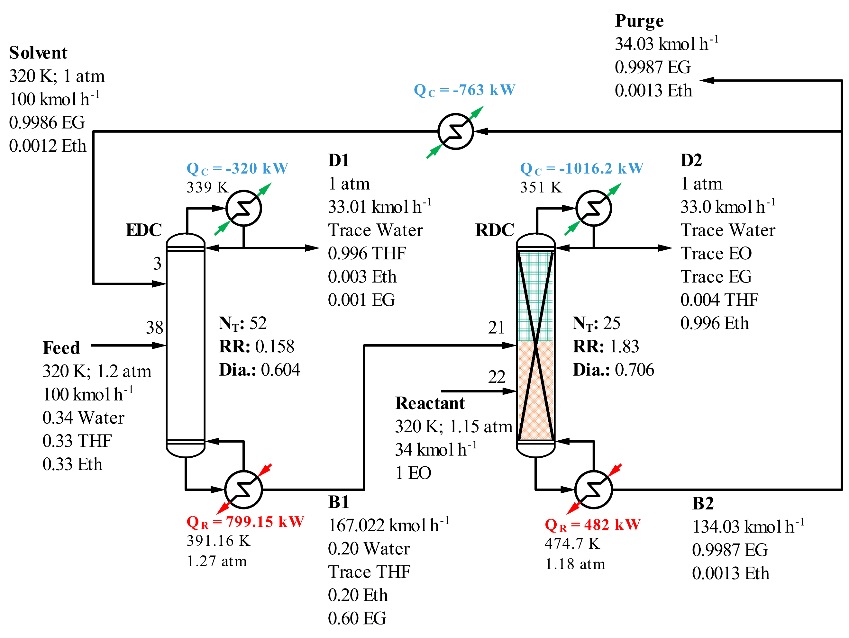
Figure 2. The proposed ED-RD configuration for the ternary azeotropic separation of THF, Eth, and water.
    - Dividing-wall double column extractive-reactive configuration
Figure 3 illustrates the intensified dividing-wall double column extractive-reactive distillation (DW-ED-RD), with a TAC of approximately $0.40 million per year, marking a significant 23 % reduction compared to the proposed ED-RD. This reduction primarily results from the decrease in energy consumption of about 35 %. Such tremendous decrease in energy consumption was attributed to the exceptional ability of DW-ED-RD to eliminate the remixing effect, which sets it apart from the TC-DCRED, where remixing is not eliminated (Figure 4). Also, both in DW-ED-RD and DW-DCRED systems, the reaction zone is distributed throughout the column for the complete reaction of Eq. (1). However, what makes the DW-ED-RD even more intriguing is that having the reaction zone throughout the column enhances EO hydration more than in DW-DCRED, as reflected by the higher product purities achieved (99.9 mol%), surpassing the specified requirement of 99.6 mol%. We consider this an acceptable outcome, given that it attains a higher product quality with a lower energy consumption and a lower TAC.
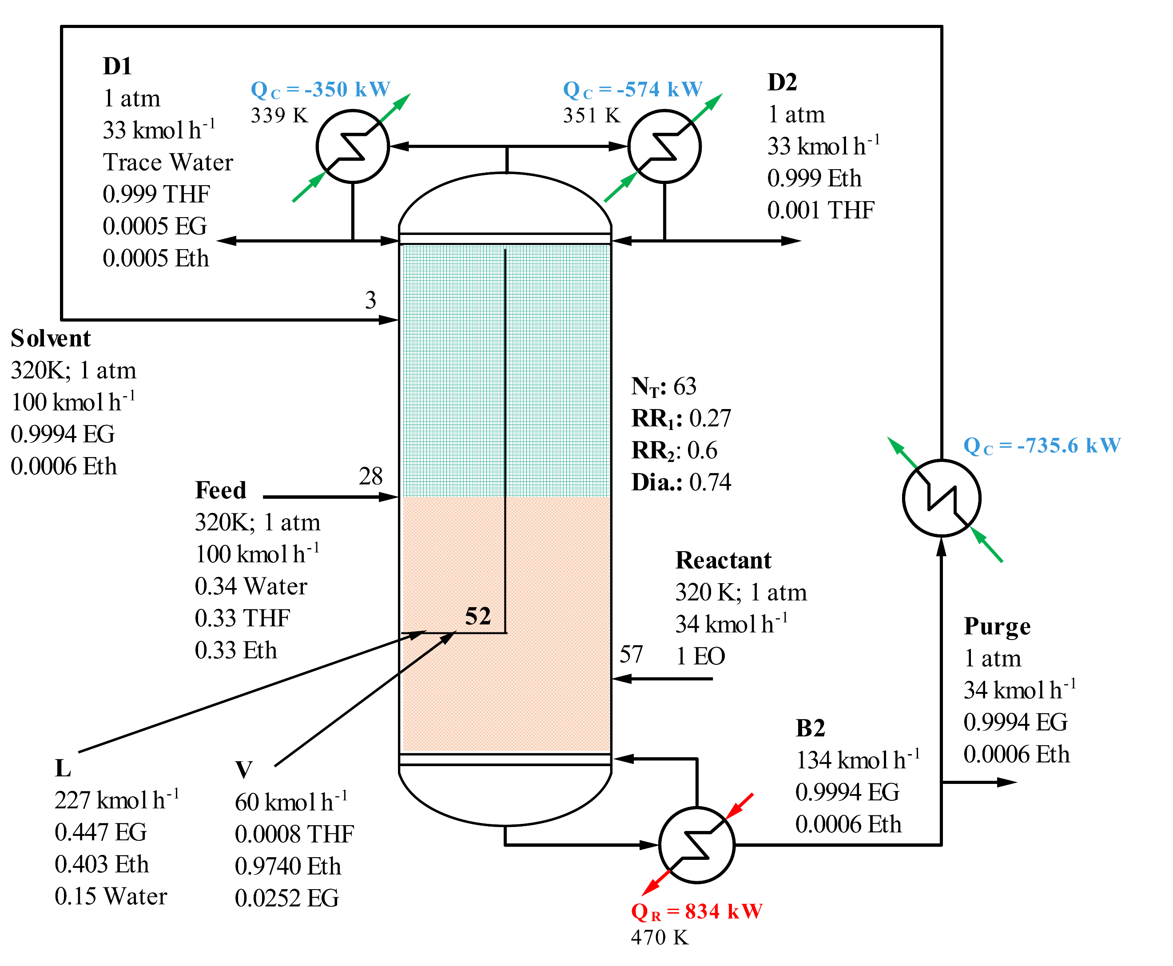
Figure 3. The intensified DW-ED-RD configuration for the ternary azeotropic separation of THF, Eth, and water.
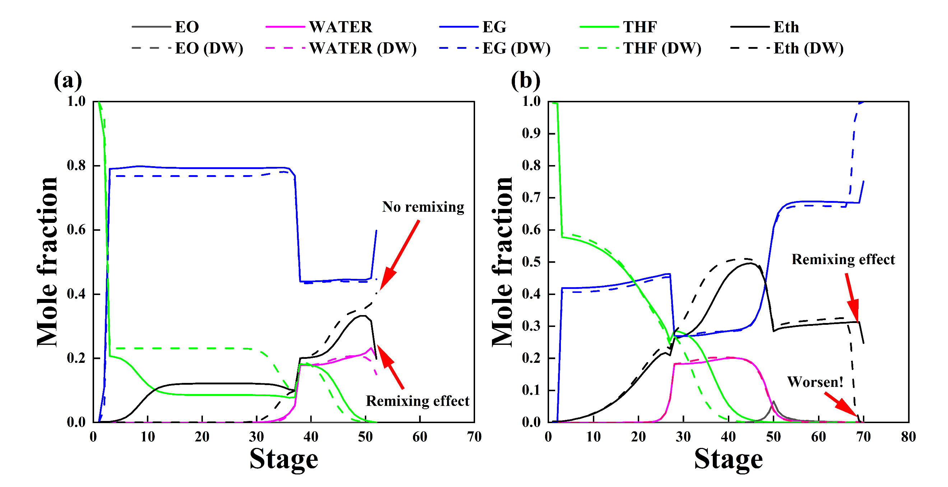
Figure 4. The composition profile of (a) newly proposed ED-RD/DW-ED-RD and (b) DCRED/DW-DCRED.
  - Conclusion
This research introduces an innovative configuration for RED by altering the column sequence, resulting in an ED-RD configuration. The primary aim is to explore potential PI opportunities, addressing the existing challenge of achieving energy savings in intensified RED processes. The ED-RD configuration proposed in this work provides a 4 % reduction in the TAC compared to the traditional DCRED. Moreover, the intensified DW-ED-RD configuration outperforms the ED-RD configuration by achieving a remarkable 23 % reduction in TAC. Overall, the DW-ED-RD configuration demonstrates an impressive 21 % reduction in total reboiler energy consumption and a 26 % decrease in TAC compared to the base case. This reflects its potential for substantial energy and cost savings through PI, presenting a viable alternative to the conventional DCRED.
  - References
Douglas, J.M., 1988. Conceptual design of chemical processes. McGraw-Hill.
Giuliano, A., Poletto, M., Barletta, D., 2015. Process design of a multi-product lignocellulosic biorefinery, in: 12th International Symposium on Process Systems Engineering and 25th European Symposium on Computer Aided Process Engineering. Elsevier, Copenhagen, pp. 1313–1318.
Kong, Z.Y., Sánchez-Ramírez, E., Yang, A., Shen, W., Segovia-Hernández, J.G., Sunarso, J., 2022a. Process intensification from conventional to advanced distillations: Past, present, and future. Chemical Engineering Research and Design 188, 378–392. https://doi.org/https://doi.org/10.1016/j.cherd.2022.09.056
Kong, Z.Y., Sunarso, J., Yang, A., 2022b. Recent progress on hybrid reactive-extractive distillation for azeotropic separation: A short review. Frontiers in Chemical Engineering 4.
Liu, J., Yan, J., Liu, W., Kong, J., Wu, Y., Li, X., Sun, L., 2022. Design and multi-objective optimization of reactive-extractive dividing wall column with organic Rankine cycles considering safety. Sep Purif Technol 287, 120512. https://doi.org/https://doi.org/10.1016/j.seppur.2022.120512
Su, Y., Yang, A., Jin, S., Shen, W., Cui, P., Ren, J., 2020. Investigation on ternary system tetrahydrofuran/ethanol/water with three azeotropes separation via the combination of reactive and extractive distillation. J Clean Prod 273, 123145. https://doi.org/https://doi.org/10.1016/j.jclepro.2020.123145
Wang, C., Zhuang, Y., Liu, L., Zhang, L., Du, J., 2021. Design and comparison of energy-saving double column and triple column reactive-extractive hybrid distillation processes for ternary multi-azeotrope dehydration. Sep Purif Technol 259. https://doi.org/10.1016/j.seppur.2020.118211
Wu, Y.C., Hsu, P.H.C., Chien, I.L., 2013. Critical assessment of the energy-saving potential of an extractive dividing-wall column. Ind Eng Chem Res 52, 5384–5399. https://doi.org/10.1021/ie3035898
Yan, J., Liu, J., Ren, J., Wu, Y., Li, X., Sun, T., Sun, L., 2022. Design and multi-objective optimization of hybrid reactive-extractive distillation process for separating wastewater containing benzene and isopropanol. Sep Purif Technol 290, 120915. https://doi.org/https://doi.org/10.1016/j.seppur.2022.120915
Yang, A., Kong, Z.Y., Sunarso, J., 2023. Design and optimisation of novel hybrid side-stream reactive-extractive distillation for recovery of isopropyl alcohol and ethyl acetate from wastewater. Chemical Engineering Journal 451, 138563. https://doi.org/https://doi.org/10.1016/j.cej.2022.138563
Yang, A., Su, Y., Sun, S., Shen, W., Bai, M., Ren, J., 2022. Towards sustainable separation of the ternary azeotropic mixture based on the intensified reactive-extractive distillation configurations and multi-objective particle swarm optimization. J Clean Prod 332. https://doi.org/10.1016/j.jclepro.2021.130116
Zhang, Y.R., Wu, T.W., Chien, I.L., 2021. Intensified hybrid reactive-extractive distillation process for the separation of water-containing ternary mixtures. Sep Purif Technol 279. https://doi.org/10.1016/j.seppur.2021.119712

