Waste-to-Methanol-to-Ethylene for Future Circular Plastics
Cecilia Salahª, Robert Istrate^{b}, Anders Bjørn^{c}, Gonzalo Guillén-Gosálbez^{a*}
ª Institute for Chemical and Bioengineering, Department of Chemistry and Applied Biosciences, ETH Zürich, 8093 Zürich, Switzerland
^{b} Institute of Environmental Sciences (CML), Department of Industrial Ecology, Leiden University, 2300 RA Leiden, The Netherlands
^{c} Center for Absolute Sustainability, Department of Environmental and Resource Engineering, Technical University of Denmark, 2800 Kongens Lyngby, Denmark
* gonzalo.guillen.gosalbez@chem.ethz.ch
Abstract
The global demand for polymers is increasing at a fast pace, which creates a clear need for alternative pathways to produce them more sustainably. Specifically, the linear nature of the current plastics economy based on fossil carbon poses a threat to the environment, as it is highly resource and carbon intense. In this work, we assess the environmental performance of an alternative circular carbon strategy for plastics based on chemical recycling routes with high technology readiness level, whereby polymer waste is first converted into methanol via gasification, and the latter is subsequently transformed into building blocks for plastics production. Results showcase that the circular route based on chemical recycling enables a significant reduction of the life-cycle emissions of the plastics economy, more so in the future as power mixes get decarbonized.
Keywords: ethylene, chemical recycling, life cycle assessment, prospective life cycle assessment.
  - Introduction
The increasing demand for polymers, notably in the plastic packaging sector, is coupled with large amounts of waste generated globally, with only a small fraction being recycled (Geyer et al., 2017). Moreover, polymers production is carbon and resource intensive, following a mostly linear economy, with most polymers deriving from fossil feedstock. The need for a circular polymer economy has motivated the development and implementation of new recycling technologies aiming to extend the lifetime of materials and decrease the detrimental environmental effects caused by mismanaged plastic waste (Ellen MacArthur Foundation, 2016).
For instance, Meys et al. (2021) have explored pathways to enable net-zero plastics, heavily relying on renewable energies, carbon capture and utilization, and increasing recycling rates up to 70%. However, their study excludes high technology readiness level (TRL) technologies for chemical recycling, focusing instead on low TRL routes that have not been deployed at scale yet and, thus, are affected by more pronounced uncertainties. Moreover, this study omitted how expected changes in the economy, e.g., due to decarbonization trends in power systems, will influence the performance of the investigated chemical recycling technologies.
We here study the emission-reduction potential of closing the ethylene loop by deploying high TRL technologies based on waste polymers-to-methanol and methanol-to-olefins routes. We find that this route enables polymers with a lower carbon footprint than the current plastics economy, notably in a future with low-carbon power mixes.
  - Methodology
The chemical recycling route consists of the gasification of plastic waste to produce syngas (Salah et al. 2023), which is then converted into methanol and further transformed into ethylene based on the work by Ioannou et al. (2023). We implemented detailed process simulations in Aspen v12 and computed the mass and energy balances of the waste-to-methanol-to-olefins process to build the life cycle inventory needed for the environmental assessment.
The life cycle assessment (LCA) was carried out in Brightway2, using Ecoinvent v3.8, following a cradle-to-grave approach. The aforementioned circular route was compared to the business-as-usual (BAU) fossil ethylene obtained from naphtha steam cracking. Both systems considered the production of ethylene, its transformation to polyethylene, collection, sorting and end-of-life treatment. The BAU end-of-life was defined considering the global average waste management of waste polymers in 2015 described by Geyer et al. (2017). In the circular route, it is necessary to account for losses of the waste-to-methanol-to-olefins process in order to close the mass balance. For that reason, this scenario also accounts for a make-up of BAU ethylene.
The climate change impact of both routes was calculated according to the IPCC 2021 GWP100 method. Additionally, we explored the evolution of environmental impacts with time, by performing the LCA in 2020 and 2050 using scenario information from an integrated assessment model (IAM) for the background system. Specifically, this prospective assessment was carried out for the climate policy scenario PkBudg500 of the socioeconomic pathway SSP2, following the REMIND framework.
  - Results and Discussion
Implementing the chemical recycling technology for circular polymers in 2020 would enable a 17.5% reduction of the global warming impact (GWI) relative to the BAU scenario. Analysing the process contributions to the overall GWI (Figure 1), we find that the emissions linked to the incineration of waste polymers are the main contributor to the GWI in the BAU scenario, followed by electricity and the direct emissions of the fossil route deployed for ethylene production. Analogously, more than half of the circular polymers’ GWI comes from the electricity used in its life cycle.
Moreover, following the decarbonization pathway PkBudg500 of REMIND, we find that the emissions gap between the circular economy of polymers and the BAU will grow in the future substantially. This is because the former is much more sensitive to the carbon footprint of the power mix, which will be drastically reduced in the future.
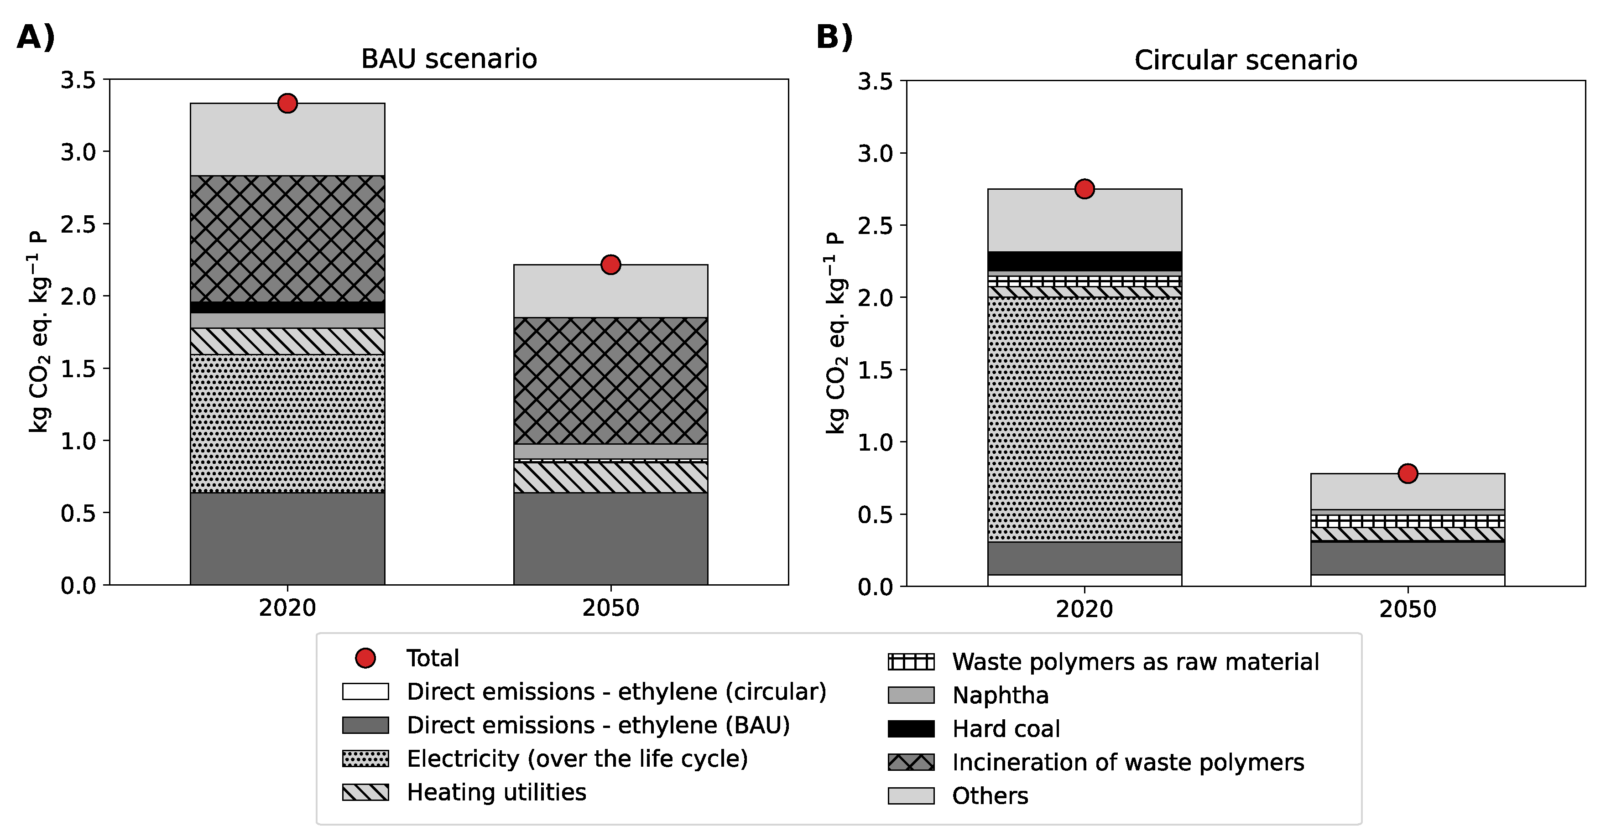
Figure 1. Global warming impact of the BAU (A) and circular (B) scenarios in 2020 and 2050 following the REMIND decarbonization pathway PkBudg500.
  - Conclusions
Our work studied the environmental potential of implementing a high-TRL chemical recycling route to decarbonize the plastics economy. We found that the waste-to-methanol-to-olefins route already outperforms the BAU technology at present (17.5% less carbon footprint). Moreover, the gap between both will most likely grow substantially in the future due to decarbonization trends across sectors. We therefore highlight the need to further investigate circular carbon models for plastics production. Moreover, our results underscore the importance of conducting prospective life cycle assessments to support decision- and policy-making more effectively in the quest for a circular plastics economy.
Acknowledgements
This publication was created as part of NCCR Catalysis (grant 180544), a National Centre of Competence in Research funded by the Swiss National Science Foundation.
References
Ellen MacArthur Foundation, 2016, ﻿The New Plastics Economy - Rethinking the Future of Plastics.
C. Salah, S. Cobo, J. Pérez-Ramírez, G. Guillén-Gosálbez, 2023, Environmental Sustainability Assessment of Hydrogen from Waste Polymers, 11, ﻿3238-3247.
I. Ioannou, J. Javaloyes-Antón, J.A. Caballero, G. Guillén-Gosálbez, 2023, Economic and Environmental Performance of an Integrated CO₂ Refinery, ACS Sustainable Chemistry & Engineering, 11, 1949-1961.
R. Geyer, J. Jambeck, K. Law, 2017, Production, Use, and Fate of All Plastics Ever Made, Science Advances, 3, ﻿e1700782.
R. Meys, A. Kältelhorn, M. Bachmann, B. Winter, C. Zibunas, S. Suh, A. Bardow, 2021, Achieving net-zero greenhouse gas emission plastics by a circular carbon economy, Science, 374, 71-76.

