Continuous Production of Recombinant Adeno-associated Viral Vectors via Transient Transfection of HEK293 Cells in Perfusion Bioreactor
Damdae Park^{a†}, Tam N.T. Nguyen^{a†}, José Sangerman^{b}, Prasanna Srinivasan^{b}, Rui Wen Ou^{b}, Georgios Katsikis^{c}, Moo Sun Hongª, Paul W. Barone^{b},
Caleb Neufeld^{b}, Jacqueline M. Wolfrum^{b}, Stacy L. Springs^{b},
Anthony J. Sinskey^{b,d}, Richard D. Braatz^{a,b*}
ªDepartment of Chemical Engineering, Massachusetts Institute of Technology, Cambridge, MA 02139, United States
^{b}Centre for Biomedical Innovations, Massachusetts Institute of Technology, Cambridge, MA 02139, United States
^{c}Koch Institute for Integrative Cancer Research, Massachusetts Institute of Technology, Cambridge, MA 02139, United States
^{d}Department of Biology, Massachusetts Institute of Technology, Cambridge, MA 02139, United States
braatz@mit.edu | †These authors contributed equally.
Abstract
Gene therapy offers a promising approach to remedy genetic deficiencies by introducing missing genes into the patient’s body. Recombinant adeno-associated virus (rAAV) is one of the most widely used gene carriers, whose therapeutic doses reach up to ~10¹⁵ viral genomes (vg) per patient. However, existing technology imposes limitations on rAAV production, necessitating a large-scale and cost-effective manufacturing process. In this paper, we propose a continuous manufacturing process and a model-based control strategy for transient transfection of HEK293 cells. A dynamic model of the system is developed and utilized for soft sensing of the component concentrations in cell culture. Based on which, key operational decisions including transfection timing, plasmid dosages, and perfusion rates are made. We demonstrate that the proposed system and control strategy efficiently produce rAAV at a scale comparable to the conventional batch process of the same volume. Recommendations and insights are provided for further process intensifications and optimizations of the proposed system.
Keywords: continuous production, gene therapy, transient transfection.
  - Introduction
In recent decades, extensive investigations on the human genome have unveiled numerous genes associated with genetic diseases and consequently led to the emergence of a therapeutic approach called gene therapy. In gene therapy, genetic disorders are cured by introducing missing genetic material (e.g., DNA or RNA) directly into a human body. Recombinant adeno-associated virus (rAAV) is one of the most widely used gene carriers, where its exponential reproducing nature is exploited to amplify the cure genes.
However, the yield from conventional batch-type rAAV manufacturing processes falls short of the required dosages for clinical and commercial applications, mainly due to their low productivity, difficulties in system scale-up, and high-level impurity in products (Shupe et al., 2022). These challenges directly influence the market price of gene therapy medicine, limiting access to gene therapy.
A potential breakthrough for this is to develop a continuous process that provides mass production with higher flexibility and thereby reduces operating costs (Hong et al., 2018). Our previous research on repeated transfections of rAAV in shake-flask cultures (Nguyen et al., 2023) shows the possibility of improving the process through continual waste removal and plasmid feeding. Such a repeated transfection strategy has been explored in a few previous studies, with applications for recombinant protein production and virus-like particle production (Cervera et al., 2015). However, a continuous manufacturing system for rAAV and the transfection protocol for leveraging high-cell density culture have not yet been proposed.
To this end, we propose a continuous manufacturing system including a perfusion system and build protocols for rAAV production via high-density HEK-293 cell transfection, that results in increased efficiency and productivity of viral vectors at scale. A dynamic model for the system is developed and used to estimate the concentrations of the key components in cell culture. Based on which key operational decisions are made, such as transfection timing, plasmid dosages, and perfusion rates, while balancing the trade-offs existing in the system.
  - Materials and Methods
    - Materials
FreeStyle™ 293-F cells, culture medium FreeStyle™ F17 Expression Medium, and Gibco™ l-glutamine (200 mM) were purchased from Thermo Fisher Scientific (Waltham, MA, USA). A set of plasmids for AAV5 production, including pAAV-GFP (Part No. AAV-400), pRC5 (Part No. VPK-425) and pHelper (Part No. 340202), were purchased from Cell Biolabs (San Diego, CA. USA). The transfection reagent PEI Max™ is the transfection grade linear polyethylenimine hydrochloride with a molecular weight of 40,000 and was purchased from Polysciences (Warrington, PA, USA). The detailed preparation procedure can be found in our previous work (Nguyen et al., 2023).

    - Development of continuous manufacturing process
      - Bioreactor setup and operating conditions
Cell cultivation, transient transfection, and viral production were performed in a 500 mL stirred-tank bioreactor (Getinge, Rochester, NY, USA) with a 300 mL working volume. The reactor was equipped with a three-blade marine impeller and a micro-sparger. The Operating conditions were maintained using my-Control console (Getinge, Rochester, NY, USA) where the controller settings are described in Table 1. Antifoam C from MilliporeSigma (Burlington, MA, USA) was used to break the foam when the foam was detected. FreeStyle™ 293-F cells were used, which were stored in liquid nitrogen, thawed in a 37°C water bath, and then transferred to 30 mL FreeStyle™ 293 expression medium in a 125 mL shake flask. The cells were inoculated to the bioreactor after they reached a total density of 3 × 10⁵ cells/mL, and then grown to reach the cell density of 1 × 10⁶ cells/mL before the first transfection.

Table 1. Operating conditions and controller settings made.
Control loop | Setpoint / bounds | Actuator (-) | Actuator (+)
pH | 7 ± 0.1 | CO₂ | 0.5M NaHCO₃
Agitation rate | 125 rpm
Temperature | 37 ± 1°C | Condenser | Heating jacket
dO₂ | 40% saturated air |  | Air, O₂

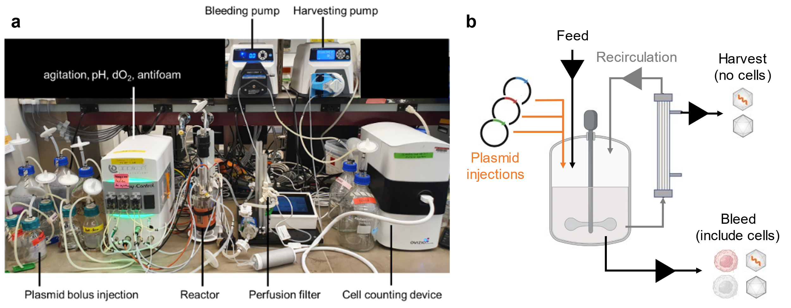
Figure 1. (a) Bioreactor system developed and (b) its schematic.

      - Perfusion system
The schematic of the perfusion system developed is shown in Figure 1. It includes a tangential flow filtration (TFF) system consisting of a 0.2 μm hollow membrane filter (Artemis Biosystems, Quincy, MA, USA) driven by a magnetic pump (Levitronix, Framingham, MA, USA). The working volume, which includes the volume inside the vessel, a perfusion system, and the recirculation tubing, was 370 mL. The cell-free harvest line is connected to the filter and driven by a controllable peristaltic pump (Masterflex, Radnor, PA, USA). The cell-containing bleed line is drawn through a dip tube directly from inside the vessel via a controllable peristaltic pump (Masterflex, Radnor, PA, USA). Through bleeding, the desired cell health and culture environment can be maintained. During the perfusion operation, the flow rates of harvest and bleed lines were controlled to achieve the desired cellular density and maintain steady and non-limiting nutrient levels. The feed media flow rate is controlled to maintain a constant volume via a level sensor. The perfusion rate was maintained at 1–3 vvd during the perfusion operation.

    - Mathematical modeling of bioreactor
A dynamic model consisting of 44 state variables is developed and utilized to trace the concentration profiles of key components in the cell culture.
$$\frac{dX}{dt}=\frac{X_{i}}{V}\left(F_{i}+\frac{V_{b}\left(t\right)}{dt}\right)-\frac{X}{V}\left(F_{b}+{δF}_{h}+\frac{V_{s}\left(t\right)}{dt}\right)+r_{X}$$ | (1)
$$\frac{dV}{dt}=F_{i}-F_{b}-F_{h}+\frac{V_{b}\left(t\right)-V_{s}\left(t\right)}{dt}$$ | (2)
where $X$ and $X_{i}$ are the concentrations of the interest inside the reactor and inlet feed media, $V$ is the working volume of the system, $V_{b}$ and $V_{s}$ are the bolus injection and sampling volumes, and $F_{i}$, $F_{h}$, and $F_{b}$ are the flowrates of feed line, harvest line, and bleed line, respectively. δ is a component-specific factor where δ = 1 if a given component can penetrate the membrane (e.g., plasmids and metabolites), otherwise δ = 0 (cells). The volumetric reaction rate $r_{X}$ is given by the kinetic model developed in our previous work (Nguyen et al., 2023), with some adjustments in parameter values: $k_{Rep syn}=5.2×{10}^{4}$, $k_{Cap syn}=1.2×{10}^{2}$, $k_{secrete, cyto}=3.6$, $k_{secrete, media}=2×{10}^{-2}$, $k_{rep,licaiton, DNA}=5.7×{10}^{2}$, and $k_{pack, DNA}=1.24×{10}^{-1}$.

    - Transient transfection
The cells were transfected by discrete injections of transfection boluses, where the amount of plasmids is determined based on the cell density at the time of each transfection. The detailed procedures can be found in our previous work (Nguyen et al., 2023). The transfection was performed when the concentrations of extracellular PEI/plasmid complexes dipped to zeros or close to zeros. At each point of transfection, the cell culture was diluted by bleeding to reach the desired transfection cell density. After each transfection, we stopped the perfusion operation (no bleeding/harvest) and incubated the cells to give sufficient time for transfection.

    - Sampling and analytical methods
The samples were taken from the culture by 6mL every 24 hours, where 1mL sample with smaller intervals were additionally collected to monitor the health of cell culture. Detailed procedures for the quantification of cell counts, metabolites, AAV5 capsids, and genome titers can be found in our previous work (Nguyen et al., 2023).

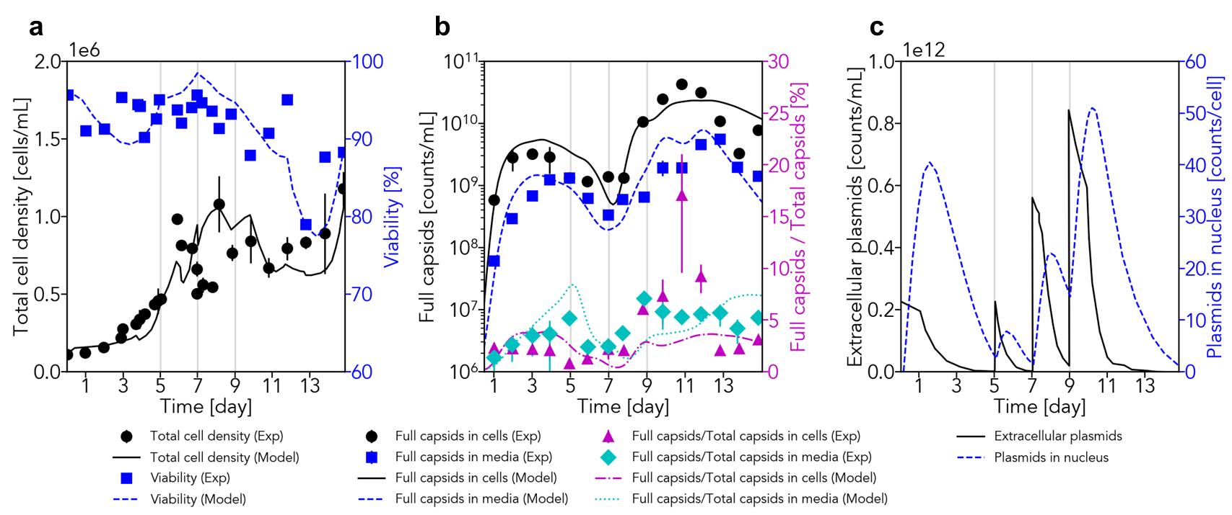
Figure 2. Trajectories of (a) total cell density and viability, (b) full capsids and the fractions over total capsids, and (c) plasmids outsides the cells and inside the nucleus.
  - Results
    - Model-based transfection design and continuous production of rAAV
The developed dynamic model of the system was able to predict the trends of key components inside the cell culture, including the cell density (Figure 2a) and capsid concentrations (Figure 2b). Based on the estimated extracellular concentration profiles (Figure 1c), timings for subsequent transfection after the first transfection were determined as day 5, 7, and 9. The plasmid dosages and incubation periods were manually set as in Table 3. With the developed system and transfection strategy, we were able to maintain cell viability more than 90% up to day 11. Furthermore, the system shows the ability of recovery from low viability caused by high plasmid dosage of fourth transfection, demonstrating its potential in continuous and stable production of rAAV. It is observed that, compared to the third transfection, the fourth transfection, which has the same plasmid dosage per cells but 50% larger in terms of volumetric concentration, gave detrimental effects on cells (Table 2). This emphasizes the significance of transfection design and suggests the potential benefits of employing dynamic optimization to achieve optimal transfection timing and dosages.

Table 2. Designed transfection scheme. The volume [mL] in denominator is working volume.
Time  [day] | Culture cell density  [M cells/mL] | Plasmid dosage  [μg/mL] | Plasmid dosage  [μg/M cells] | Incubation period  [h]
0 | 1.1 | 2 | 2 | 24
5 | 4.7 | 2 | 0.43 | 0
7 | 5.1 | 5.1 | 1 | 12
9 | 7.6 | 7.6 | 1 | 24

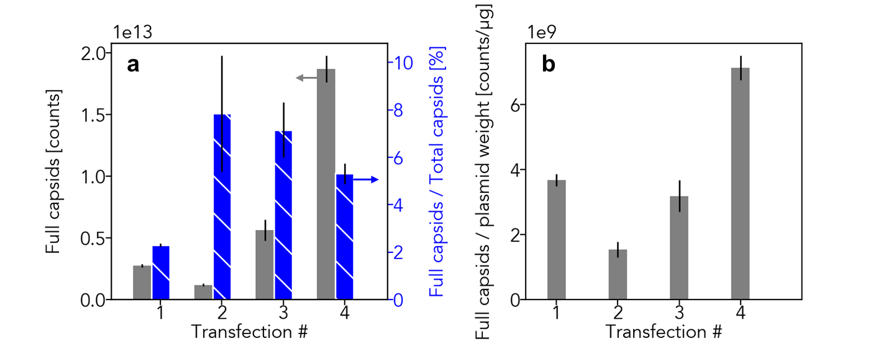
Figure 3. Total titer obtained from each transfection. (a) Full capsid yields and the fractions of full capsids over total capsids. (b) Full capsids yield per plasmid weight.

    - Mass production of rAAV
It is found that transfections at high densities can yield over a magnitude order more product than the conventional design (Figure 2b). The total amount of full/total capsids produced over the operation are estimated using the system model, by assuming that the TFF system allows 100% of the viral particles to pass through to the harvest system. The total yield of the first transfection was 2.7 ×10¹² vg, which is comparable to the yield from batch production in a suspension bioreactor that typically yields 10⁹–10¹⁰ vg/mL [12, 9, 13] – 3.7×10¹¹–3.7×10¹² when 370 mL reactor volume is assumed. The total yield obtained from the second transfection was half the yield of the first transfection.
The plasmid concentration profiles in Figure 1 suggests that the low yield may be attributed to low plasmid uptake resulting from a lower plasmid dosage per cell and the absence of an incubation time. Remarkably, the third and fourth transfections yielded more than two and six times more vector genomes than the first transfection, respectively, (Figure 3a) which is equivalent to a batch production. This result demonstrates that the developed system and protocols enable the transfection at high cell density in the same amount of time, and potentially enable mass production of rAAV. Moreover, as shown in Figure 3b, the fourth transfection had almost twice the productivity than the first transfection. Together with the third transfection, the back-to-back transfections at high cell density resulted in 32% higher plasmid usage efficiency, lowering the development cost and therapeutic cost. The calculation of total product purity shows that the third and fourth transfection product at high cell density transfection had three times as high of full capsid in harvest than the first transfection, which is comparable to a conventional batch transfection (Figure 3c).
  - Conclusions
This study pioneers the development of a continuous manufacturing system for rAAV, strategically designed to surmount the productivity limitations of conventional batch-type processes. We propose a model-guided continuous manufacturing approach, and demonstrate its efficiency and productivity against the batch process. Notably, our findings underscore the substantial potential of the developed model in informing crucial operational decisions, including transfection timing and plasmid dosages. This unveils the potential for dynamic optimization, where the optimal trajectories of the operation variables are systematically evaluated. The proposed continuous processing system and control strategy are anticipated to be applicable to manufacturing processes for other virus-based gene therapy products.
Acknowledgement
This work was supported by the Korea Institute for Advancement of Technology (KIAT) with a grant funded by the Korean Government (MOTIE) (P0017304, Human Resource Development Program for Industrial Innovation) and the U.S. Food and Drug Administration (Grant ID: 1R01FD006584-02, Continuous Viral Vector Manufacturing based on Mechanistic Modeling and Novel Process Analytics). T.N.T.N. was partially supported by a MathWorks Engineering Fellowship. A.J.M. was partially supported by the National Science Foundation (NSF) Graduate Research Fellowship Program under grant number 1122374. This research was also supported by a grant from the Massachusetts Life Sciences Center as part of the Building Breakthroughs Program.
References
L. Cervera, S. Gutiérrez‐Granados, N.S. Berrow, M.M. Segura, F. Gòdia, 2015, Extended gene expression by medium exchange and repeated transient transfection for recombinant protein production enhancement, Biotechnol. Bioeng., 112, 934–946, https://doi.org/10.1002/bit.25503.
M.S. Hong, K.A. Severson, M. Jiang, A.E. Lu, J.C. Love, R.D. Braatz, 2018, Challenges and opportunities in biopharmaceutical manufacturing control, Comput. Chem. Eng., 110, 106–114.
T.N.T. Nguyen, S. Sha, J. Sangerman, G. Katsikis, M.S. Hong, J. Ng, P.W. Barone, C. Neufeld, J.M. Wolfrum, S.L. Springs, A.J. Sinskey, R.D. Braatz, (submitted), Multi-stage transfection increases full capsid ratio in rAAV viral vector production via triple transfection in HEK293 cells Multi-stage transfection for rAAV production, Mol. Ther. - Methods Clin. Dev.
J. Shupe, A. Zhang, D.C. Odenwelder, T. Dobrowsky, 2022, Gene therapy: challenges in cell culture scale-up, Curr. Opin. Biotechnol., 75, 102721.

