Intimately Coupled Photocatalysis and Biodegradation Hybrid Systems in Tetracycline Removal

Rachel Mugumo,a Shepherd M. Tichapondwa,a Evans M.N. Chirwaa

aWater Utilisation and Environmental Engineering Division, Department of Chemical Engineering, University of Pretoria, South Africa

Email: rachel.mugumo@tuks.co.za

Abstract

The presence of tetracycline in wastewater is a global concern due to its pervasive nature, persistence, and harmful effects on both humans and aquatic ecosystems, even at extremely low concentrations. The shortcomings of traditional wastewater treatment methods have prompted the exploration of Advanced Oxidation Processes such as photocatalysis. However, these processes are often hindered by their inability to completely mineralise wastewater pollutants. Hence, this study aims to introduce and implement an innovative, environmentally friendly, cost-effective, and sustainable solution through an intimately coupled photocatalysis and biodegradation (ICPB) hybrid system. The primary objective is to enhance the removal and achieve complete mineralisation of recalcitrant pollutants. The metal-sulphide/ZnO photobiodegradation system, when subjected to visible irradiation, demonstrated a remarkably impressive 100 % tetracycline removal. This study therefore presents a groundbreaking effective approach to establish a robust ICPB system that combines cost effectiveness with superior degradation efficiency, offering potential applications at a large scale.

**Keywords**: photocatalysis, biodegradation, tetracycline, photo-biodegradation, visible light irradiation.

* 1. Introduction

Antibiotics have become prominent pollutants in natural aquatic environments globally, primarily driven by the escalating misuse of these drugs. This misuse is a consequence of the growing demand for pharmaceuticals and the swift advancements in the drug and medical industry, and animal husbandry (He et al., 2021). Tetracycline is a broad-spectrum antibiotic that has frequently been identified in landfills, sludge, sediments, groundwater, drinking water, surface water and wastewater (Shao and Wu, 2020).

The presence of tetracycline hinders the growth and development of aquatic species and has the potential to accumulate in the food chain, posing a risk to human health. This can result in various health issues such as central nervous system defects, nephropathy, joint disease, endocrine disruption and mutagenicity (Xu et al., 2021). Hence, it is imperative to identify a practical and efficient technology for the degradation of tetracycline in water environments.

Photocatalysis as an advanced oxidation process (AOP) has garnered significant interest for the degradation of antibiotics as an eco-friendly green technology due to its cost-effectiveness and environmental friendliness (Wu et al., 2020). While numerous noteworthy strides have been taken in the field of photocatalysis, it suffers many limitations such as wide band gaps that can be activated by UV-light that only accounts for 5 % of the solar spectrum, and it has fast recombination rates of the photoinduced charge carriers (He et al., 2021). Moreover, although photocatalysis has the ability to convert antibiotics into easily biodegradable compounds or less toxic organic molecules, it fails to completely mineralise organic compounds (Wu et al., 2020).

This compels the need to further treat the photodegraded effluent with bacteria adaptable to feed on the generated products. Li et al. (2022) investigated the degradation of tetracycline using 0.3 gL-1 recyclable cellulose nanofibrils/polyvinyl alcohol/Fe3O4 hybrid hydrogel as a photo-Fenton catalyst (PVA/CNF/Fe3O4)and achieved 98 % removal in 120 min. Another study conducted by Gopal et al. (2019) reported photo-assisted removal of tetracycline using bio-nanocomposite-immobilised alginate beads (Fe3O4 and TiO2 nanoparticles along with dead biomass of *Acinetobacter sp.*) and measured 98 % 10 mgL-1 tetracycline removal.

In this study, visible-light-active Ag2S/ZnO nanocomposites were synthesised using a solid-phase combustion method. The physicochemical properties of the synthesised material were characterised using XRD, SEM, TEM and BET. Tetracycline, a notorious antibiotic resistant to degradation was employed as a target pollutant and its photodegradation tested under visible light irradiation. Herein, to the best of our knowledge a microbial consortium predominantly *Clostridium bifermentans* and *Klebsiella pneumoniae* have never been reported for this purpose were adopted for subsequent biodegradation. The two-step hybrid photo-biodegradation technique was interestingly effective in the removal of tetracycline and holds significant potential in wastewater treatment applications.

* 1. Materials and method
     1. Materials

Silver (II) nitrate hexahydrate [Ag(NO3)2.6H2O] and zinc oxide (ZnO) were purchased from Glassworld (Johannesburg, South Africa). Thiourea [(NH2)2CS] (sulphur precursor and oxidant fuel) were purchased from Sigma-Aldrich (St Louis, MO, United States). Silver (II) nitrate hexahydrate was used as the silver precursor in the synthesis of the photocatalyst. Tetracycline ≥ 95 % HPLC (the model organic pollutant) was purchased from Sigma-Aldrich South Africa. Methanol and acetonitrile used as mobile phases for the HPLC were purchased from VWR BDH chemicals (France), and phosphoric acid and persulphate used as mobile phase for the TOC-V analyser were purchased from Merck Schuchardt (Germany) and ACE (Johannesburg) respectively. All reagents were used without further purification. Deionised water (DI) was used as a solvent throughout this study.

* + 1. Photocatalyst synthesis

According to the one-pot synthesis method reported by Mugumo et al. (2023), ZnO, Ag(NO3)2.6H2O and (NH2)2CS were respectively weighed in a 2:1:0.25 ratio and transferred to a clean crucible. The mixture was subsequently calcined for 30 min at 400 ⁰C. A pastel and mortar was used to grind the obtained product into a powdery photocatalyst.

* + 1. Bacterial preculture

Chimhundi et al. (2021) prepared preculture cultured from a contaminated soil sample from an automotive battery recycling plant borehole situated in Gauteng, South Africa. *Clostridium bifermentans and Klebsiella pneumoniae* were the primary predominant bacterial species identified from the conducted cultured microbial consortium analysis and characterisation.

* + 1. Material characterisation

The X-ray diffraction (XRD) spectra of the prepared sample was analysed using the PANalytical X’Pert Pro powder diffractometer in θ–θ configuration with an X’Celerator detector and variable divergence- and fixed receiving slits with Fe filtered Co-Kα radiation (λ=1.789Å). Scanning electron microscope (SEM) images were captured on a Zeiss Ultra PLUS FEG SEM and the optical absorption spectra of the synthesised nanomaterials was measured using a Hitachi U-3900 single monochromatic double-beam system. Transmission electron microscopy (TEM) imaging was captured using a JOEL JEM 2100F, 200 kV analytical electron microscope. The Brunuaer-Emmett-Teller (BET) surface areas of the prepared material was determined using a micrometrics TriStar II 3020 Version 3.02 BET system. A Shimadzu TOC-V analyser was used to measure (total organic carbon) TOC removal rate.

* + 1. Photocatalytic studies

The synthesised Ag2S/ZnO nanocomposite photocatalytic performance was investigated by measuring the removal of 100 mgL-1 tetracycline under visible light irradiation. The experimental set-up was conducted in a Lelesil Innovative Systems photoreactor connected to a 450 W visible light lamp controller. The photodegradation tests were conducted using a 1 gL-1 Ag2S/ZnO catalyst loading. The suspension was stirred for 60 min in the dark to allow for adsorption-desorption equilibrium prior to 2 h of visible light irradiation. Aliquot samples of 2 mL were extracted every half hour for centrifugation at 9,000 rpm for 10 min. 0.45 µm Millipore microfilters were used to filter the collected solution which was subsequently analysed using a High-Performance Liquid Chromatography (HPLC – waters 2695 separation module, 2996 Photodiode Array detector), with Empower software. The parameters for detection of tetracycline were PAH C18 (4.6 x 250 mm, 5 µm) column, injection volume of 10 µL, a flow rate of 1.0 mLmin-1, a wavelength of 360 nm, and a mobile phase of 100 % methanol and 100 % acetonitrile. The photodegradation efficiency was calculated using Eq. (1) below.

|  |  |
| --- | --- |
| $$\% Degradation=\frac{(C_{o}-C_{t})}{C_{o}}×100$$ | (1) |

where Co is the initial tetracycline concentration and Ct is tetracycline concentration at time, t.

* + 1. Biodegradation studies

TOC was measured initially before photodegradation and after the conducted photocatalysis. Microbial consortium (*Clostridium bifermentans and Klebsiella pneumoniae*) was fed into the photodegraded solution to investigate the efficiency of bacteria in the reduction of carbon content present in solution. This solution was further analysed after 24 h of biodegradation using a Shimadzu TOC-V analyser. An HPLC was subsequently used to measure tetracycline removal after bacteria was fed into the system.

* 1. Characterisations
     1. XRD

Figure 1 depicts the crystalline phases of the synthesised nanomaterials (ZnO and Ag2S/ZnO). The narrow intense sharp peaks are indicative of high crystallinity and purity of the synthesised materials. The intense diffraction peaks at 37⁰, 40⁰, 42⁰ and 56⁰ correspond to (100), (002), (101), and (110) planes of hexagonal wurtzite ZnO (JCPDS 36-1451). The observed highest peak (101) suggests anisotropic growth, an indication of preferred crystallites orientation. Additional peaks on the Ag2S/ZnO spectra noted at 2ϴ values of 44⁰ and 52⁰ correspond to Ag2S which confirms successful doping of Ag2S onto ZnO (Subash et al., 2012).



*Figure 1: XRD spectra of ZnO and Ag2S/ZnO.*

* + 1. SEM and TEM

The composite synthesis method determines the morphological and structural properties of the synthesised material. The structure and morphology of ZnO modified with Ag2S is depicted in Figure 2. The SEM image Figure 2(a) depicts a combination of nanorods and porous spherical sheets exhibiting a wide distribution of particle sizes. Furthermore, the TEM image Figure 2(b) confirms the presence of hexagonal rod-like and well-defined spherical structures observed in the SEM analysis.

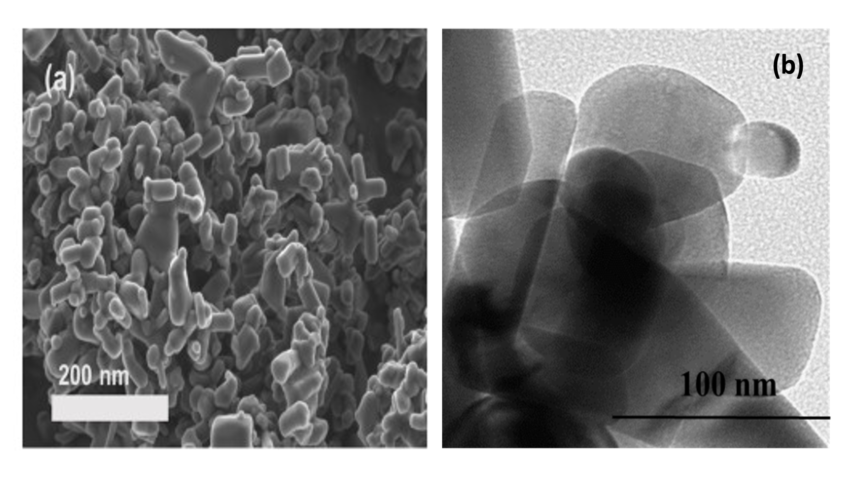

*Figure 2: (a) SEM image and (b) TEM image of the synthesised Ag2S/ZnO.*

* + 1. BET

The material surface area is a crucial parameter that influences photocatalytic activity. Specific surface area of ZnO and Ag2S/ZnO was measured using BET analysis and reported as 50 m2/g and 46 m2/g, respectively. The noted slight surface area reduction can be attributed to the coating of Ag2S particles onto ZnO surface. This leads to the collapse in pores and subsequently agglomeration of particles.

* 1. Photo-biodegradation studies

Photocatalysis was conducted as a pre-treatment method followed by biodegradation as a post-treatment method and the results shown in Figure 3. The photocatalytic performance of the synthesised Ag2S/ZnO was investigated a 100 mgL-1 tetracycline solution using 1 gL-1 catalysts loading in a 500 ml volume under visible light irradiation. The prepared solution was left stirring in the dark for 60 min to achieve adsorption-desorption equilibrium. The reactor was then subjected to visible light illumination for 120 min and an outstanding 96 % tetracycline removal was measured. An anaerobic microbial consortium was then fed into the system for biodegradation to occur. The solution after biodegradation was reanalysed using the HPLC and measured an excellent 100 % tetracycline removal. A TOC analysis was subsequently conducted to determine the carbon content present before photodegradation, after photodegradation and after biodegradation and reported carbon content of 5140 mgL-1 (100 %), 2310 mgL-1 (45 %) and 1050 mgL-1 (20 %), respectively. This confirms that although photocatalysis is a promising water treatment technique, it suffers drawbacks of incomplete mineralisation which can be postulated to the formation of intermediates during treatment. Therefore, biodegradation as post-treatment method proved efficient in complete tetracycline removal and the reduction of the measured carbon content.



*Figure 3: Hybrid photo-biodegradation efficiency in tetracycline removal.*

* 1. Conclusions

Tetracycline removal was investigated using a two-step treatment technique. Photocatalysis was adopted as a pre-treatment method where a visible-light-active Ag2S/ZnO photocatalyst was applied in the removal of tetracycline. A microbial consortium was then fed into the reactor for biodegradation which was employed as post-treatment method. It is interesting to note that although 96 % tetracycline removal was noted after photocatalysis and 55 % carbon content reduction, a post-treatment technique is therefore crucial to further lower the carbon content. The achieved results promote further research into identifying and testing bacteria efficient enough to completely remove any remaining carbon content after photocatalysis, and this study shows the potential implementation of a hybrid photo-biodegradation system for commercial use.

* 1. Acknowledgements

This study is based on research financially supported by the National Research Foundation (NRF) through Grant No. EQP180503325881 and Rand Water Company, through Grant No. RW01413/18 awarded to Prof E.M.N. Chirwa, and The NRF Thuthuka Fund Grant No. TTK18024324064 awarded to Prof S.M. Tichapondwa at the University of Pretoria.

References

J. Chimhundi, C. Hörstmann, E.M. Chirwa, H.G. Brink, 2021, Microbial Removal of Pb (II) Using an Upflow Anaerobic Sludge Blanket (UASB) Reactor, *Catalysts,* 11**,** 512.

G. Gopal, N. Roy, N. Chandrasekaran, A. Mukherjee, 2019, Photo-assisted removal of tetracycline using bio-nanocomposite-immobilized alginate beads, *ACS omega,* 4**,** 17504-17510.

X. He, T. Kai, P. Ding, 2021, Heterojunction photocatalysts for degradation of the tetracycline antibiotic: a review, *Environmental Chemistry Letters,* 19**,** 4563-4601.

Y. Li, H. Cao, W. Liu, P. Liu, 2022, Effective degradation of tetracycline via recyclable cellulose nanofibrils/polyvinyl alcohol/Fe3O4 hybrid hydrogel as a photo-Fenton catalyst, *Chemosphere,* 307**,** 135665.

R. Mugumo, E.O. Ichipi, S.M. Tichapondwa, E.M. Chirwa, 2023, Bandgap tailoring of ZnO using metallic sulphides for enhanced visible-light-active photocatalytic water treatment, *Chemical Engineering Transactions,* 103**,** 829-834.

S. Shao, and X. Wu, 2020, Microbial degradation of tetracycline in the aquatic environment: a review, *Critical reviews in biotechnology,* 40**,** 1010-1018.

B. Subash, B. Krishnakumar, V. Pandiyan, M. Swaminathan, M. Shanthi, 2012, An efficient nanostructured Ag2S–ZnO for degradation of Acid Black 1 dye under day light illumination, *Separation and Purification Technology,* 96**,** 204-213.

S. Wu, H. Hu, Y. Lin, J. Zhang, Y.H. Hu, 2020, Visible light photocatalytic degradation of tetracycline over TiO2, *Chemical Engineering Journal,* 382**,** 122842.

L. Xu, H. Zhang, P. Xiong, Q. Zhu, C. Liao, G. Jiang, 2021, Occurrence, fate, and risk assessment of typical tetracycline antibiotics in the aquatic environment: A review, *Science of the total Environment,* 753**,** 141975.