Deep Learning for Fast Inference of Mechanistic Models’ Parameters
Maxim Borisyak*ª Stefan Bornª Peter Neubauerª Mariano Nicolás Cruz-Bournazouª
a Technische Universität Berlin, Straße 17 des Juni 135, 10623 Berlin, Germany
maxim.borisyak@tu-berlin.de
Abstract
Inferring parameters of macro-kinetic growth models, typically represented by Ordinary Differential Equations (ODE), from the experimental data is a crucial step in bioprocess engineering. Conventionally, estimates of the parameters are obtained by fitting the mechanistic model to observations. Fitting, however, requires a significant computational power.
Specifically, during the development of new bioprocesses that use previously unknown organisms or strains, efficient, robust, and computationally cheap methods for parameter estimation are of great value. In this work, we propose using Deep Neural Networks (NN) for directly predicting parameters of mechanistic models given observations. The approach requires spending computational resources for training a NN, nonetheless, once trained, such a network can provide parameter estimates orders of magnitude faster than conventional methods.
We consider a training procedure that combines Neural Networks and mechanistic models. We demonstrate the performance of the proposed algorithms on data sampled from several mechanistic models used in bioengineering describing a typical industrial batch process and compare the proposed method, a typical gradient-based fitting procedure, and the combination of the two. We find that, while Neural Network estimates are slightly improved by further fitting, these estimates are measurably better than the fitting procedure alone.
Keywords: mechanistic models, inference, deep learning
  - Introduction
Mechanistic growth models play an important role in bioprocess development. These models are derived from the first principles and their parameters are readily interpretable. Such models also enable computer-aided design and control of bioprocesses. Most of the models are expressed as systems of Ordinary Differential Equations (ODE). Examples include models by Lin et al. (2001), Neubauer et al. (2003) and Anane et al. (2017). Typically, such ODE systems do not admit analytical solutions and, therefore, one has to rely on dedicated ODE solvers. Since the systems tend to be highly non-linear, a solver needs to perform a large number of integration steps. This is especially the case, when models contain both, fast and slow dynamics (Anane et al., 2017).
Estimation of mechanistic models' parameters is conventionally done by fitting the model to observations following the Maximum Likelihood principle:
$$L\left(θ\right)=-\log{P\left(x | θ\right)}=-\sum_{i}{\log{P\left(x_{i} | θ\right)}→\min_{θ};}$$ | (1)
where $x,θ$ are observations and parameters of the model.
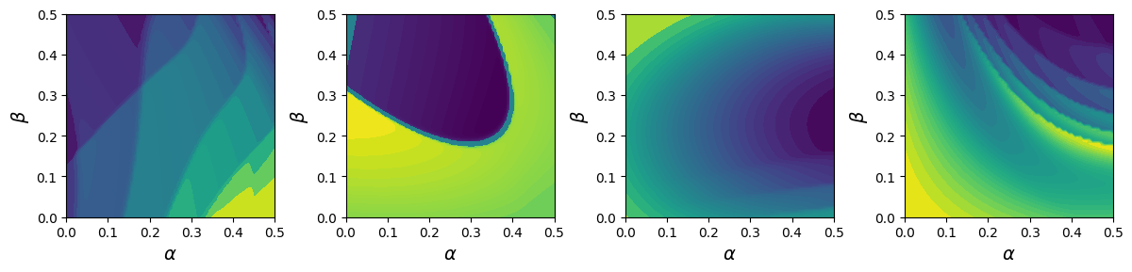Figure 1: Random slices of the loss function for an E. coli cultivation. For each of the slices, three random parameter vectors are drawn from within the corresponding ranges, the loss function is evaluated on linear combinations of these parameters with coefficients α and β. For illustration purposes, levels are set such that each level contains roughly the same area.
The optimisation is typically carried out by gradient or quasi-Newton methods such as the BFGS algorithm (see, for example, Fletcher, 2000). Firstly, gradient of an ODE solution tends to take noticeably more computational time than just obtaining the forward solution. Secondly, the non-linear nature of the models tends to induce a highly complex landscape of the loss function, Figure 1 illustrates this effect. This might lead to a significant increase in the number of steps an optimiser needs to perform for convergence. Moreover, the loss function seems to have a significant number of local minima, which is typically addressed by the multi-start algorithm (see, for example, Fletcher, 2000), deterministic (Lin et al., 2006) or nondeterministic (Da Ros et al., 2013) global optimisation methods. Multiple shooting also proved to reduce this problem in this context (Peifer at al., 2007). In this paper, we consider multi-start as our baseline as it offers a more direct comparison with the proposed method.
All of the features of mechanistic models described above generally lead to a high demand for computational resources when performing fitting. Bayesian methods, like Monte-Carlo Markov chains, are fairly similar to Maximum Likelihood fitting procedures in terms of computational resources, although they might require substantially more computational power. Additionally, please, notice that the mentioned algorithms display a limited degree of parallelism: both gradient optimisation and ODE solver are inherently sequential, albeit methods like multiple shooting partially alleviate the problem (Gander et al., 2007).
High usage of resources might limit online applications such as monitoring, control and, especially, online design of experiments. Currently, modern hardware seems to provide enough computational power for such applications assuming a small number of unknown parameters and good initial estimates (for instance, see Kemmer et al. 2022, Krausch et al., 2022), nonetheless, more complex mechanistic models or a need for a more frequent response might prove difficult.
In this work, we propose a novel inference method that dramatically reduces the computational burden: training a Neural Network to directly predict parameters of a mechanistic model given observations. To the best knowledge of the authors, there is no prior literature describing such an approach.
  - Deep Learning for inference
All of the fitting algorithms mentioned above are general-purpose methods, they place weak assumptions on the loss function and work practically with any reasonable model, treating the latter as a black box that provides trajectories, values of the loss function, gradients at arbitrary points etc.
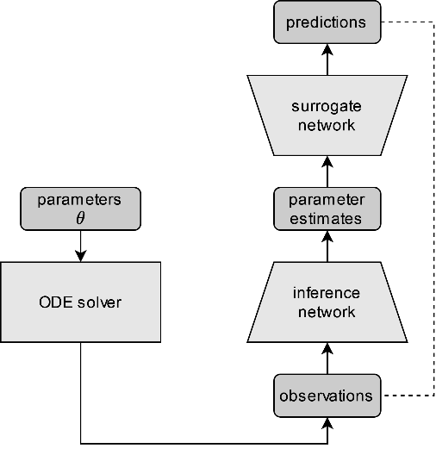 | 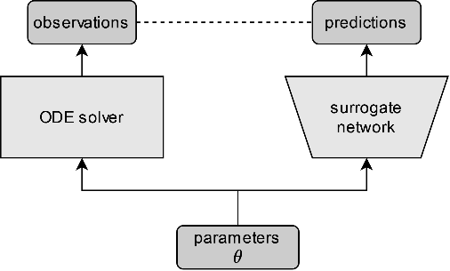
Figure 2: Schematic representation of the proposed method. Arrows represent flow of the data, “inference network” and “surrogate network” are represented by neural networks. Dashed lines indicate which quantities are used for the loss computation. (Left) Inference network training procedure, surrogate network is frozen during training. (Right) “Surrogate network” training.
If one, however, considers a particular model, then the inference task, Eq. (1), can be viewed as a mapping from observations x to the optimal parameters $θ^{\text{*}}\left(x\right)$:
$θ^{*}\left(x\right)=\underset{\text{θ}}{\text{arg min}}\left[-\log{P\left(x | θ\right)}\right]$; | (2)
and, therefore, can be cast as a regression problem with the loss function:
$$L\left(ψ\right)=-\sum_{i}{\log{P\left(x_{i} | f\left(x_{i} | ψ\right)\right)}→\underset{\text{ψ}}{\text{min}};}$$ | (3)
where f denotes the regressor parametrised by ψ. The regressor f can be represented by a neural network, which we call the inference network. Please, notice that, unlike typical regression problems, Eq. (3) defines a loss function that closely resembles that of an auto-encoder (Kramer, 1991): the inference network provides parameter estimates $θ\left(x\right)=f\left(x | ψ\right)$, which are then passed into the mechanistic model M to make predictions $μ=M\left(f\left(x | ψ\right)\right)$, and, in a sense, are “decoded into” predictions, and the latter are compared against observations using the noise model $P_{n}\left(x | μ\right)$:
$-\log{P\left(x | θ=f\left(x | ψ\right)\right)}=-\log{P_{n}\left(x | μ=M\left(f\left(x | ψ\right)\right)\right)}$. | (4)
    - Surrogate network
The major downside of the proposed algorithm is that networks typically require a large number of steps for training which greatly exceeds the number of training samples, and each step the algorithm requires evaluation of the mechanistic model and its gradient, which cannot be precomputed as they depend on network’s predictions. In order to circumvent the need for the mechanistic model during NN training, we propose replacing the model with a surrogate network which is trained to approximate the output of the mechanistic model.
To train the surrogate network we sample a large dataset of model’s parameters: parameters are drawn randomly within the ranges that cover biologically feasible values. It is worth noting that more advanced methods such as Kriging (Press, 2007) could also be employed. The parameters are then used for generating a dataset of observations. The surrogate network $g\left(t,θ\right)$ is trained to map observations’ timestamps $t_{i}$ and parameters $θ_{i}$ to observations $x_{i}$ by minimizing the negative log likelihood:
$$L=-\sum_{i}{\log{P_{n}}\left(x_{i} | g\left(t_{i},θ_{i}\right)\right)}.$$ | (5)
Once trained, the surrogate network offers a fast approximation of the mechanistic model, which is used to guide the inference network (Figure 2). In our experiments, such a procedure results in decent inference networks, however, approximation errors of the surrogate network prevent it from reaching precise solutions. Thus, we additionally retrain the inference network trained with a surrogate network with the mechanistic model when it is not too costly.
  - Numerical experiment
To evaluate the performance of the proposed method, we simulate data from two mechanistic models: Michaelis–Menten kinetics (MMK) and the E. coli growth model by Anane et al. (2017), both expressed as ODE systems. For each model we sample parameters from a wide prior distribution that covers biologically feasible values, obtain trajectories and from each trajectory we generate a small number of observations for each of the observed channels, overall, 14 observations for MMK, 30 observations for the E. coli model. Observations’ timestamps are randomly distributed within the corresponding range: 2 hours for MMK, 6 hours for E. coli. For emulating realistic conditions, channel observations are not aligned, i.e., only one channel is measured per sample. Initial conditions are assumed to be unknown and inferred along with models’ parameters. For each of the models, we draw just above a million training samples. As shown below, conventional fitting procedures take a significant amount of time, thus, we use only around a thousand of test samples, any significantly larger number of test sample would make experiments unfeasibly long. Nonetheless, the test sample is sufficiently large to keep the estimation errors small (Table 1).
For the inference networks we utilise Deep Set architecture (Zaheer et al., 2017) and employ triplet encoding (Yalavarthi et al. 2022) for processing asynchronous observations. To improve training, we apply an invertible transformation that maps prior distribution of parameters and initial conditions into the standard normal distribution, thus, bringing all parameters to the same scale.
As a baseline we employ the BFGS optimisation algorithm (see, for example, Fletcher, 1987). We set a limit of 1024 iterations per sample to reflect the real-world time constraints of an online application. Additionally, we perform a multi-start procedure with a varying number of initial guesses. To assess the improvement potential for the proposed method, we also fine-tune predictions of the networks by running a fitting algorithm starting from the networks’ estimates.
Table 1 Results of the numerical experiments. R² is computed based on squared errors normalised by variances of the noise in each individual channel. “MM” denotes fine-tuning with the corresponding mechanistic model, “Deep Inference + BFGS” denotes the fitting procedure (a single start) with initial guess produced by the network. When applicable, time measurements are given for GPU / CPU evaluations, CPU only otherwise.
Method | MMK |  | E. coli
 | R² | time per samp. | R² | time per samp.
BFGS, 1 start | 0.928 ± 0.010 | 50 msec | 0.442 ± 0.108 | 2.04 sec
BFGS, 2 starts | 0.957 ± 0.001 | 93 msec | 0.930 ± 0.016 | 3.59 sec
BFGS, 4 starts | 0.958 ± 0.001 | 180 msec | 0.984 ± 0.002 | 8.15 sec
BFGS, 8 starts | 0.958 ± 0.001 | 344 msec | 0.989 ± 0.001 | 16.5 sec
Deep Inference | 0.949 ± 0.001 | 10 μsec / 37 μsec | 0.945 ± 0.007 | 18 μsec / 260 μsec
Deep Inference + MM | 0.954 ± 0.001 | 10 μsec / 37 μsec | - | -
Deep Inference + BFGS | 0.958 ± 0.001 | 41 msec | 0.990 ± 0.001 | 1.3 sec
We evaluate performance of the algorithms on 1024 independently drawn test samples. We also measure inference speed: BFGS-based methods are evaluated on a CPU (AMD Ryzen 5 5600X), all networks – also on a GPU (NVIDIA GeForce RTX 3070).
Results of our experiments are summarised in Table 1. Results show that even for simple models, such as Michaelis–Menten kinetics, optimisation algorithms are sometimes stuck in local minima (as shown by the gains of the multi-start). The proposed method achieves a lower average loss than a single fitting run and performance comparable to the multi-start procedure. Fine-tuned predictions are on par with the best multi-start results. Importantly, please, note the difference in the inference speed: the network is faster by 3 orders of magnitude for the simplest of the models, and by 6 orders for the E. coli model. Additionally, we observe that the fitting procedure aided by the inference network tend to converge faster.
The time measurements in Table 1 represent a lower bound on response time of online algorithms that use parameter estimation as their first step. Please, note that the computational time of conventional fitting algorithms approaches measurement frequency of some devices (for example, 30 seconds for pH and DOT measurements, Hans et al., 2020). Moreover, in an online application, parameter estimation is often followed by other computationally demanding algorithms such as Model Predictive Control (see, for example, Krausch et al., 2022), potentially making the parameter estimation step a bottleneck in the data processing pipeline.
  - Conclusion
We present an alternative framework for quickly and reliably estimating models’ parameters given observations. Based on Deep Learning techniques, it speeds up Maximum Likelihood estimations by several orders of magnitude while preserving accuracy of optimisation-based techniques. Additionally, our experiments indicate that the proposed method does not suffer from the local minima problem. The proposed method has a potential to significantly improve online applications, such as monitoring, control of bioprocesses and design of experiments by providing nearly instantaneous parameter estimations. Moreover, fast inference enables the use of much more complex and precise models, potentially leading to overall improvement of bioprocess development.
Acknowledgements
We gratefully acknowledge the financial support of the German Federal Ministry of Education and Research (01DD20002A – KIWI biolab).
References
Anane E, Neubauer P, Bournazou MN. 2017 Modelling overflow metabolism in Escherichia coli by acetate cycling. Biochemical Engineering Journal. 15;125:23-30.
H.Y. Lin, B. Mathiszik, B. Xu, S.O. Enfors, P. Neubauer, 2001, Determination of the maximum speciﬁc uptake capacities for glucose and oxygen in glucose-limited fed-batch cultivations of Escherichia coli, Biotechnol. Bioeng. 73 347–357
P. Neubauer, H.Y. Lin, B. Mathiszik, 2003, Metabolic load of recombinant protein production: inhibition of cellular capacities for glucose uptake and respiration after induction of a heterologous gene in Escherichia coli, Biotechnol. Bioeng. 83
Fletcher, R., 2000. Practical methods of optimization. John Wiley & Sons.
Peifer, M., and Timmer, J. (2007). Parameter estimation in ordinary differential equations for biochemical processes using the method of multiple shooting. IET Systems Biology 1, 78–88. 10.1049/iet-syb:20060067.
Da Ros, S., Colusso, G., Weschenfelder, T.A., de Marsillac Terra, L., de Castilhos, F., Corazza, M.L., and Schwaab, M. (2013). A comparison among stochastic optimization algorithms for parameter estimation of biochemical kinetic models. Applied Soft Computing 13, 2205–2214. 10.1016/j.asoc.2013.01.019.
Gander, M.J. and Vandewalle, S., 2007. Analysis of the parareal time-parallel time-integration method. SIAM Journal on Scientific Computing, 29(2), pp.556-578.
Kemmer, A., Fischer, N., Wilms, T., Cai, L., Groß, S., King, R., Neubauer, P. and Cruz-Bournazou, M.N., 2022. Nonlinear state estimation as tool for online monitoring and adaptive feed in high-throughput cultivations.
Krausch, N., Kim, J.W., Barz, T., Lucia, S., Groß, S., Huber, M.C., Schiller, S.M., Neubauer, P. and Cruz Bournazou, M.N., 2022. High‐throughput screening of optimal process conditions using model predictive control. Biotechnology and Bioengineering, 119(12), pp.3584-3595.
Kramer, M.A., 1991. Nonlinear principal component analysis using autoassociative neural networks. AIChE journal, 37(2), pp.233-243.
Fletcher, R., 1987, Practical Methods of Optimization (2nd ed.), New York: John Wiley & Sons, ISBN 978-0-471-91547-8
Zaheer, M., Kottur, S., Ravanbakhsh, S., Poczos, B., Salakhutdinov, R.R. and Smola, A.J., 2017. Deep sets. Advances in neural information processing systems, 30.
Yalavarthi, V.K., Burchert, J. and Schmidt-Thieme, L., 2022, October. DCSF: Deep Convolutional Set Functions for Classification of Asynchronous Time Series. In 2022 IEEE 9th International Conference on Data Science and Advanced Analytics (DSAA) (pp. 1-10). IEEE.
Lin, Y. and Stadtherr, M.A., 2006. Deterministic global optimization for parameter estimation of dynamic systems. Industrial & engineering chemistry research, 45(25), pp.8438-8448.
Press, W.H., 2007. Numerical recipes 3rd edition: The art of scientific computing. Cambridge university press.
Hans, S., Ulmer, C., Narayanan, H., Brautaset, T., Krausch, N., Neubauer, P., Schäffl, I., Sokolov, M. and Cruz Bournazou, M.N., 2020. Monitoring parallel robotic cultivations with online multivariate analysis. Processes, 8(5), p.582.

